Supplementary Information

MRI of ASCT2-mediated amino acid uptake in xenograft tumor models

Behnaz Ghaemi^{1,2}, Balaji Krishnamachary¹, Natalie Dillman¹, Kirsten N. Bains Williams¹, Yuki Hodo³, Yuguo Li⁴, Marie-France Penet Vidaver¹, Martin G. Pomper⁵, Caitlin M. Tressler¹, Zaver M. Bhujwalla¹, Michael T. McMahon⁴, Jeff W.M. Bulte^{1,2}, Peter C.M. van Zijl^{1,4}, Aline M. Thomas^{1,2}

¹Department of Radiology and Radiological Sciences, Johns Hopkins University, Baltimore, MD, USA; ²Cellular Imaging Section and Vascular Biology Program, Institute for Cell Engineering, Johns Hopkins University School of Medicine, Baltimore, MD, USA; ³Department of Biomedical Engineering, Johns Hopkins University, Baltimore, MD, USA; ⁴F.M. Kirby Research Center, Kennedy Krieger Institute, Baltimore, MD, USA. ⁵ Department of Radiology, University of Texas Southwestern Medical Center, Dallas, TX

*Corresponding author:
Correspondence to Aline M. Thomas
Department of Radiology and Radiological Sciences
The Johns Hopkins University School of Medicine
Broadway Research Building Rm 643
733 N Broadway
Baltimore, MD 21205
Email: athom110@jhu.edu

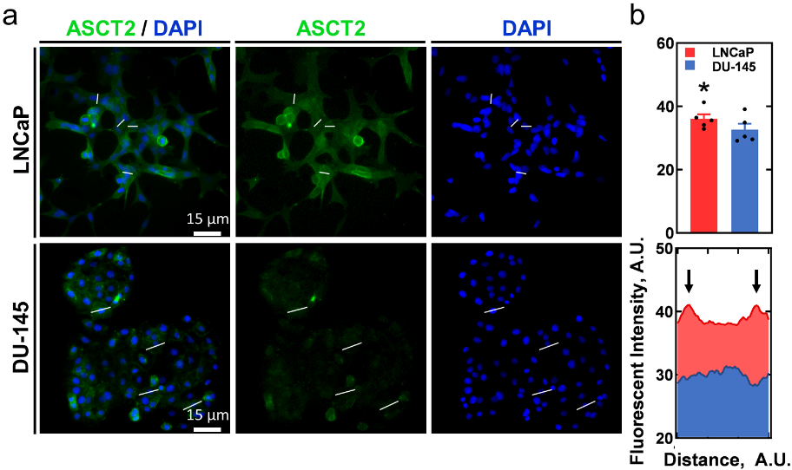
Fig. S1: Expression of ASCT2 in prostatic cancer cell lines. (A) Visualization of ASCT2 expression in (Top) LNCaP and (Bottom) DU-145 (n=5). Lines indicate the cells that were linearly profiled in ‘B’. (B) Quantification of expression in these cell lines. (Top) Mean fluorescent intensity and (Bottom) average line profile of the fluorescent intensity of 4 representative cells, indicated in the images using white lines. Arrows indicate the location of the cellular border (cell membrane). * = p < 0.05. Mean ± s.e.m. n = 5 each.
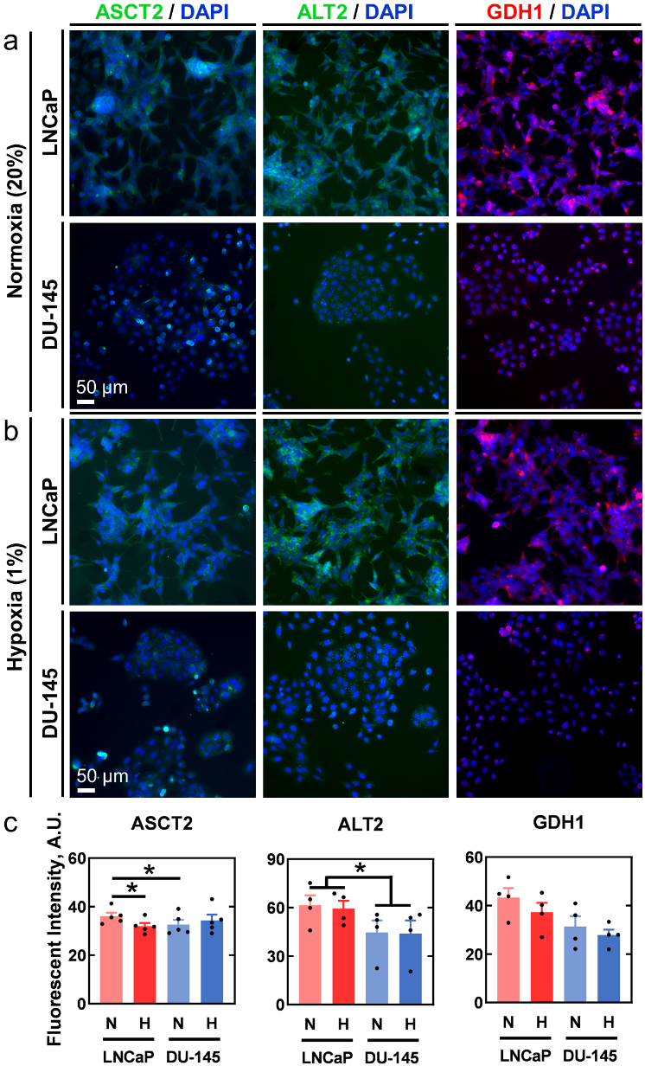
Fig. S2: Expression of transporter ASCT2 and enzymes ALT2 and GDH1 in prostatic cancer cell lines in normoxia (20%) and hypoxia (1%). (A,B) Visualization of ASCT2 (n=5) and downstream metabolic enzymes for alanine (n=4) in DU-145 and LNCaP cells exposed to (A) normoxic (N) and (B) hypoxic (H) incubating conditions for 24 hours. (C) Mean fluorescent intensity. * = p < 0.05. Mean ± s.e.m. n = 5 for the ASCT2 characterization and n = 4 for the ALT2 and GDH1 characterization.

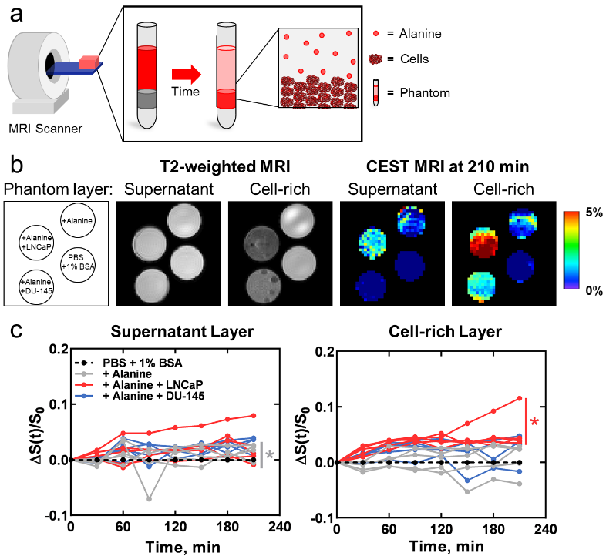
Fig. S3: Dynamic CEST enhancement in prostate cells after alanine injection. (A) Schematic illustrating the transport of alanine from the supernatant layer (top: 400 μL volume) to the cell-rich layer (middle: 100 μL volume) in a cell phantom. A layer of agarose (bottom) was used to position these layers. The temperature of phantoms was maintained at 37 °C. (B) Visualization of ALAwCEST enhancement in the supernatant and cell-rich layers at the +3.2 ppm frequency 210 minutes after the first scan. T2-weighted images and schematic of phantom layout for reference. (C) Quantification of CEST enhancement over the course of the scan in LNCaP- and DU-145-containing phantoms compared to control phantoms that contained PBS and 1% BSA with or without 10 mM alanine. * = p < 0.05. Mean ± s.e.m. n = 5 each.

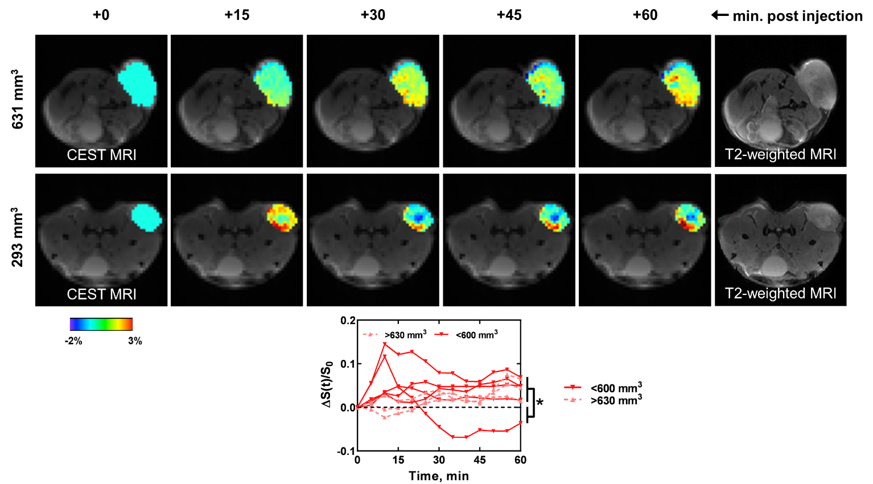
Fig. S4: Effect of tumor size on alanine-enhanced CEST MRI in LNCaP tumors. Visualization of CEST signal enhancement at the +3.1 ppm frequency in a (Top) large and (Middle) small tumor. T2-weighted images are shown for reference. (Bottom) Quantification of enhancement when tumors were stratified by size. * = p < 0.05. n = 5 and n = 3 for LNCaP tumors that were < 600 mm³ and > 630 mm³, respectively.

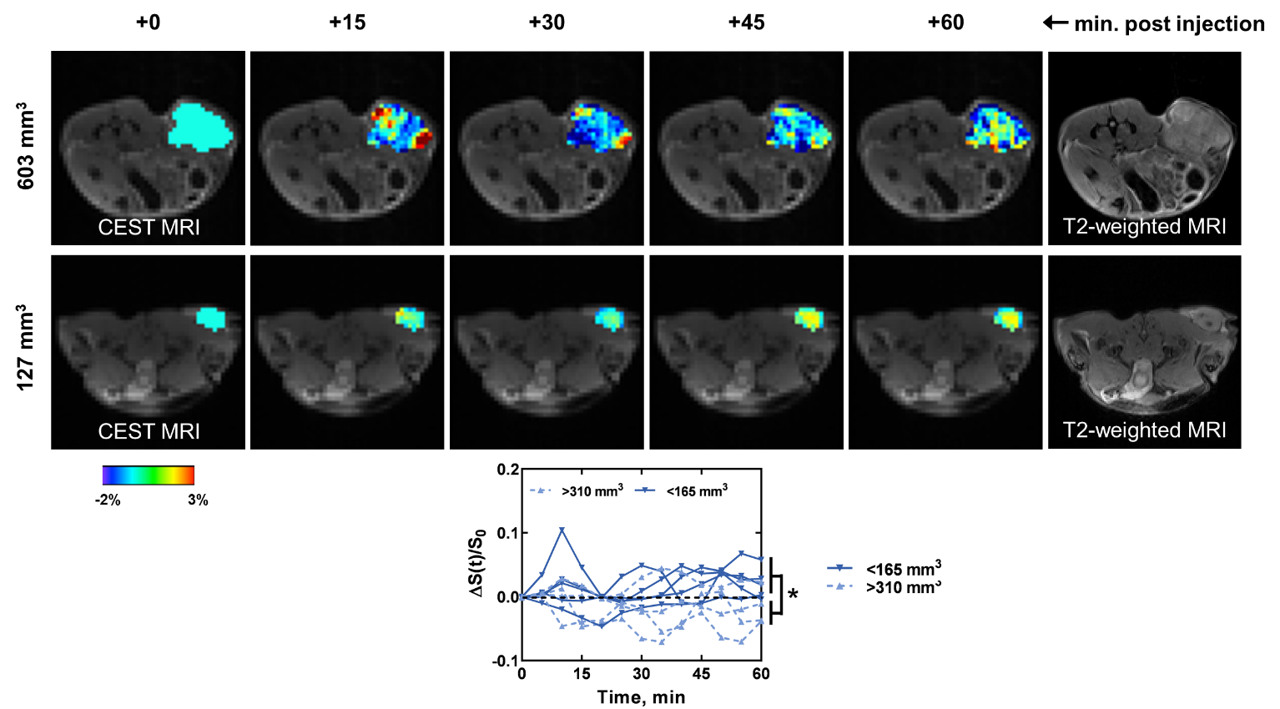
Fig. S5: Effect of tumor size on alanine-enhanced CEST MRI in DU-145 tumors. Visualization of CEST signal enhancement at the +3.1 ppm frequency in a (Top) large and (Middle) small tumor. T2-weighted images are shown for reference. (Bottom) Quantification of enhancement when tumors were stratified by size. * = p < 0.05. n = 5 and n = 4 for DU-145 tumors that were < 165 mm³ and > 310 mm³, respectively.
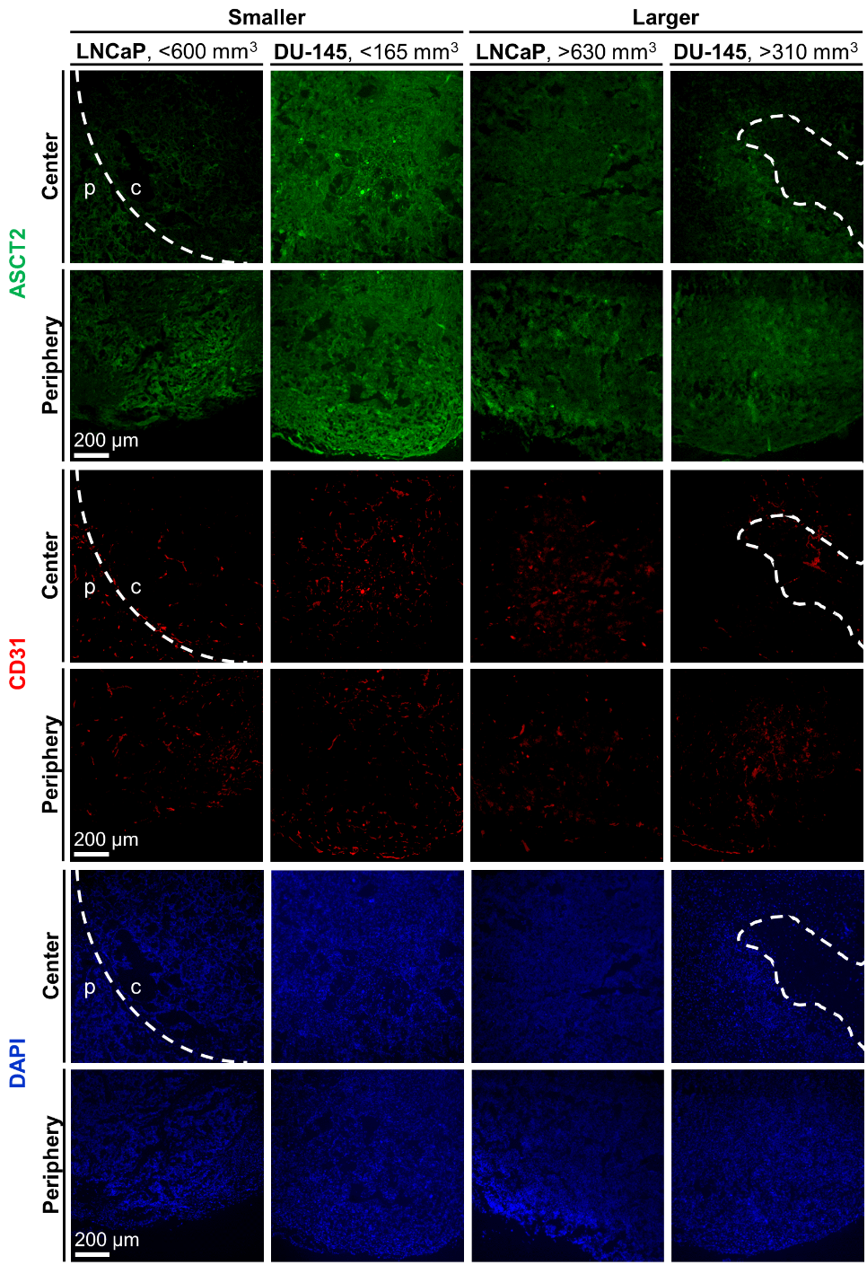
Fig. S6: Expression of ASCT2 and CD31 in prostate tumors. Visualization of (top: green) ASCT2, (middle: red) CD31 and (bottom: blue) DAPI in (left) smaller and (right) larger DU-145 and LNCaP at the center region (c) or periphery (p) of the tumor. Dash lines highlight boundaries of the ring-like expression pattern observed in smaller LNCaP tumors and of the acellular lesions observed in larger DU-145 tumors.

