Supplementary Material
State dependence and an emergent constraint on warming after zero emissions

Sofia Palazzo Corner, Zebedee Nicholls, Chris Smith, Chris D. Jones, Joeri Rogelj

Contents
Section S1: Parameter ensemble, output and correlations in MAGICC 2
Section S2: Core dynamics and ZEC in MAGICC 3
Frameworks to understand how and why ZEC occurs 7
Evolution of core processes after net zero 8
Section S3: Linear regression model 9
Model performance improves as we approach net zero 15
Section S4: Observational data 16
Supplementary References 18

Section S1: Parameter ensemble, output and correlations in MAGICC

Table S1.1 | List of outputs in MAGICC that map to observables

Subgroup | Variable | Unit
Carbon cycle | CO2_LAND_POOL | GtC
Carbon cycle | CO2_SOIL_POOL | GtC
Carbon cycle | CO2_DETRITUS_POOL | GtC
Carbon cycle | CO2_PLANT_POOL | GtC
Carbon cycle | CO2_CURRENT_NPP | GtC / yr
Carbon cycle | CO2_TOTALRESPIRATION | GtC / yr
Carbon cycle | Net Atmosphere to Ocean Flux|CO2 | GtC / yr
Carbon cycle | Net Atmosphere to Land Flux|CO2 | GtC / yr
Carbon cycle | Atmospheric Concentrations|CO2 | ppm
Radiative forcing | TOTAL_RF | W/m²
Radiative forcing | TOTAL_EFFRF | W/m²
Radiative forcing | TOTAL_ERF | W/m²
Radiative forcing | Effective Radiative Forcing|Aerosols | W/m²
Radiative forcing | Radiative Forcing|Solar | W/m²
Radiative forcing | Radiative Forcing|Aerosols | W/m²
Radiative forcing | Radiative Forcing|Land-use Change | W/m²
Radiative forcing | Radiative Forcing|Anthropogenic | W/m²
Ocean | Heat Uptake|Ocean | W/m²
Ocean | Heat Content|Ocean | ZJ
Ocean | Heat Content|Ocean|Depth 1 | ZJ
Ocean | Heat Content|Ocean|Depth 2 | ZJ
Ocean | UPWELLING_RATE | m/yr
Temperature and other heat terms | Surface Air Temperature Change | K
Temperature and other heat terms | Surface Air Ocean Blended Temperature Change | K
Temperature and other heat terms | Heat Uptake|Non-Ocean | W/m²
Temperature and other heat terms | Heat Content|Non-Ocean | ZJ

Note on parameter ensemble
There is no correlation between the initial parameter values in the MAGICC ensemble and absolute or fractional ZEC.

Section S2: Core dynamics and ZEC in MAGICC
Figure S2.1 | Relationship between global mean surface temperature at net zero and absolute and fractional ZEC₅₀. 600 ensemble members are run for each of the three cumulative emissions (750, 1000 and 2000 PgC) under two emissions pathways: 1% (panels a and b, in blue) and bell (panels c and d, in orange). Panels a and c show surface air temperature against absolute ZEC₅₀ for the 1% and bell runs respectively. Panels b and d show the same but for fractional ZEC₅₀.
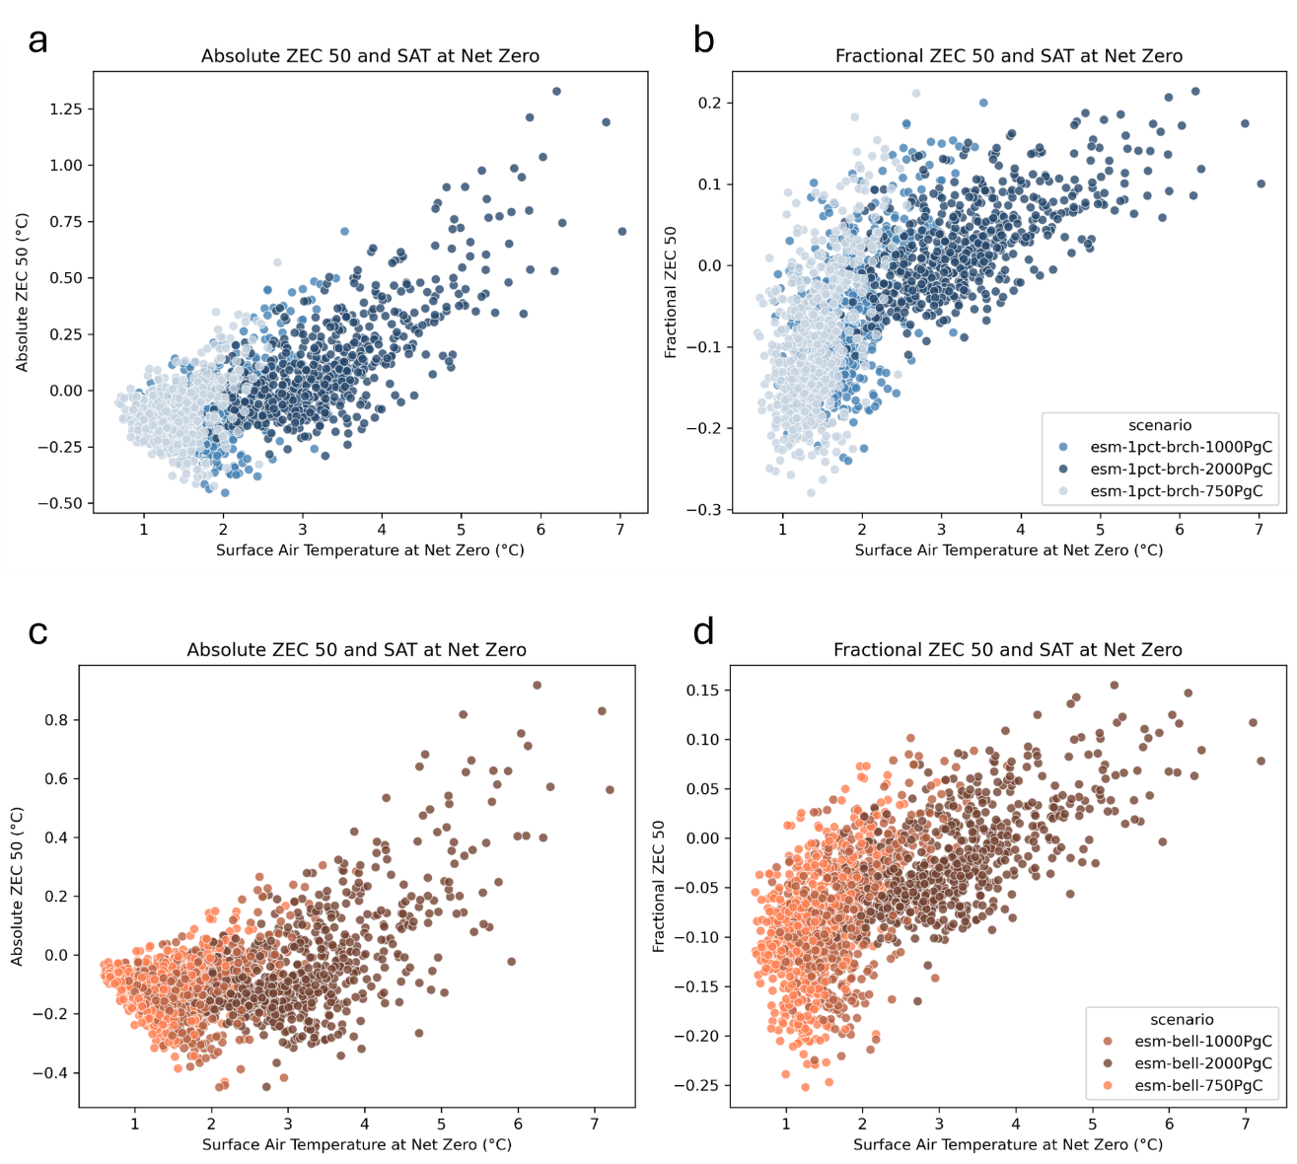
Text to support Figure S2.1: Figure S2.1 shows a positive relationship between cumulative emissions and ZEC, where higher cumulative emissions correlate with more positive absolute and fractional ZEC (see also Figure 2 in main text). This is in agreement with the majority of models run in ZECMIP, with the exception of three EMICs: DCESS, IAPRAS, P.GENIE, which showed decreasing ZEC with increasing emissions ¹. These models, however, also show unusual behaviour elsewhere. IAPRAS is labelled as an outlier in ref. ¹ (see figure 9 within) as it shows no correlation between the three terms pre- and post-net zero. IAPRAS and P.GENIE also show a large energy flux contribution from ocean carbon uptake. This factor was found to be a weak predictor in MAGICC, which may also explain why their ZEC values are not well predicted by our regression model.

Figure S2.2 | Difference in timing of peak warming between 1pct and bell emissions, for those runs that peak before or within the first 100 years after net zero. Cumulative emissions of 1000 PgC are run for both bell and 1% pathways. Out of the 600 configurations, 62 do not peak within the first 100 years in the bell-shaped pathway, and 73 do not peak within the first century for the 1% pathway.
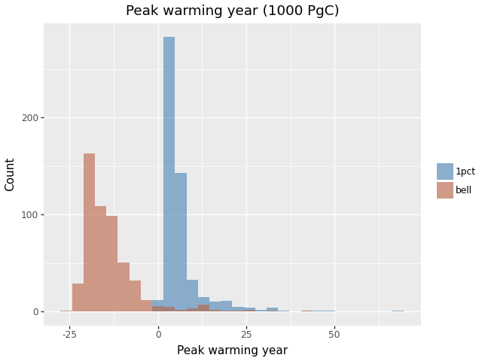

Figure S2.3 | Difference in value and year of peak warming between 1pct and bell emissions pathways for the same configuration and cumulative emissions (1000 PgC) (for those runs that peak before or within the first 100 years after net zero). Out of the 600 configurations, 62 do not peak within the first 100 years in the bell-shaped pathway, and 73 do not peak within the first century for the 1% pathway.
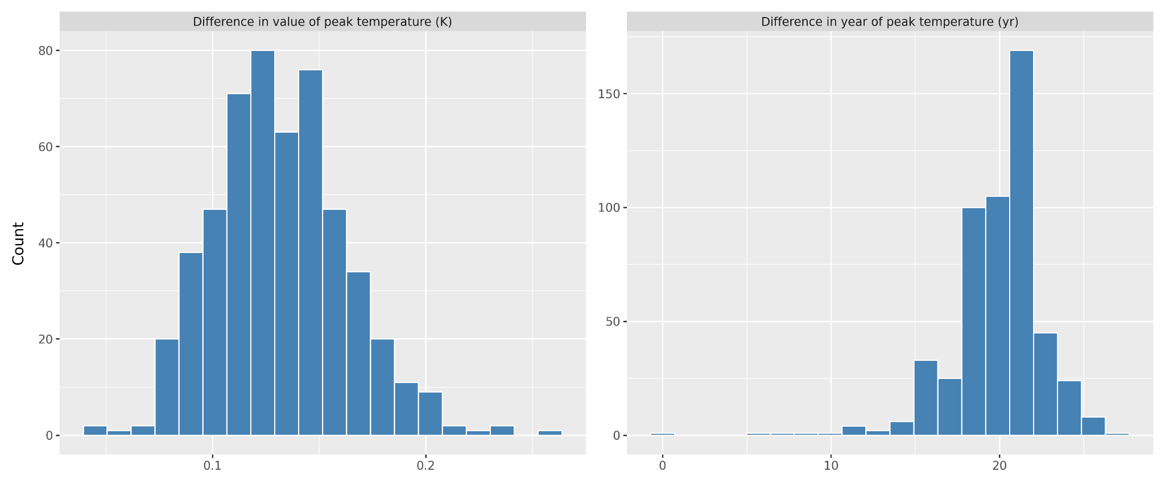
Figure S2.4 | Probability of positive ZEC₅₀ as a function of global mean surface air temperature at net zero. Piecewise linear plot for the bell-shaped pathways. The vertical red band identifies the point where ZEC is more likely to result in warming than cooling (>50%). This falls at 3.5-3.6ºC for these emissions scenarios. There are 391 ensemble members that do not reach the 3.5-3.6ºC threshold under 2000 PgC. Of these, 70 have a positive fractional ZEC 50, and the other 321 a negative value. The positive runs can be considered additional positive entries when extended to higher emissions scenarios, and the negative unknown until higher emissions experiments are available.
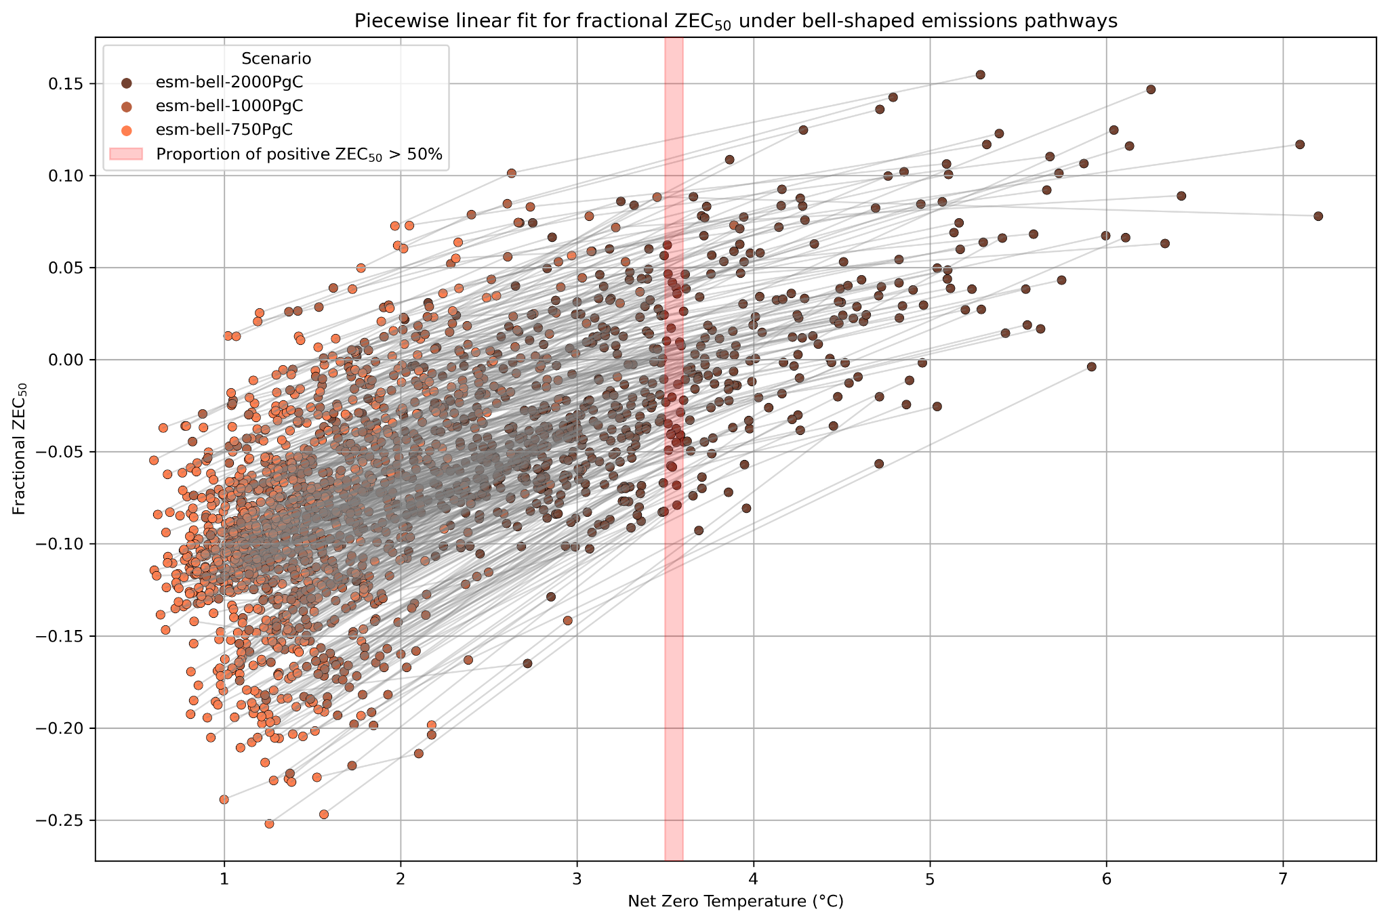
Figure S2.5 | ZEC as the net balance of energy fluxes - applying the energy balance framework to MAGICC. Reproduction of Figure 7 from ref. ¹ (left), and results from the same framework applied to MAGICC (right). This figure shows the energy fluxes for the 1000 PgC 1% experiment in the 50 years since net zero and their relationship to ZEC₅₀. The top panel plots the energy fluxes due to change in ocean heat uptake (dark blue), and change in radiative forcing due to ocean carbon uptake (light blue) and land carbon uptake (green). The bottom panel shows the value of absolute ZEC₅₀ for each of those ensemble members. The model runs are organised in ascending order of ZEC₅₀ from left to right.

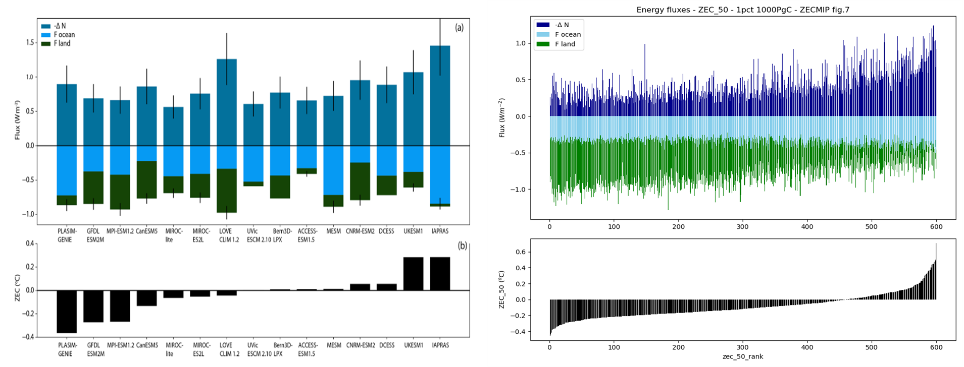

Figure S2.6 | ZEC as the product of carbon, radiative and thermal terms. Extract from ref ² on the left, and the same values in MAGICC on the right.
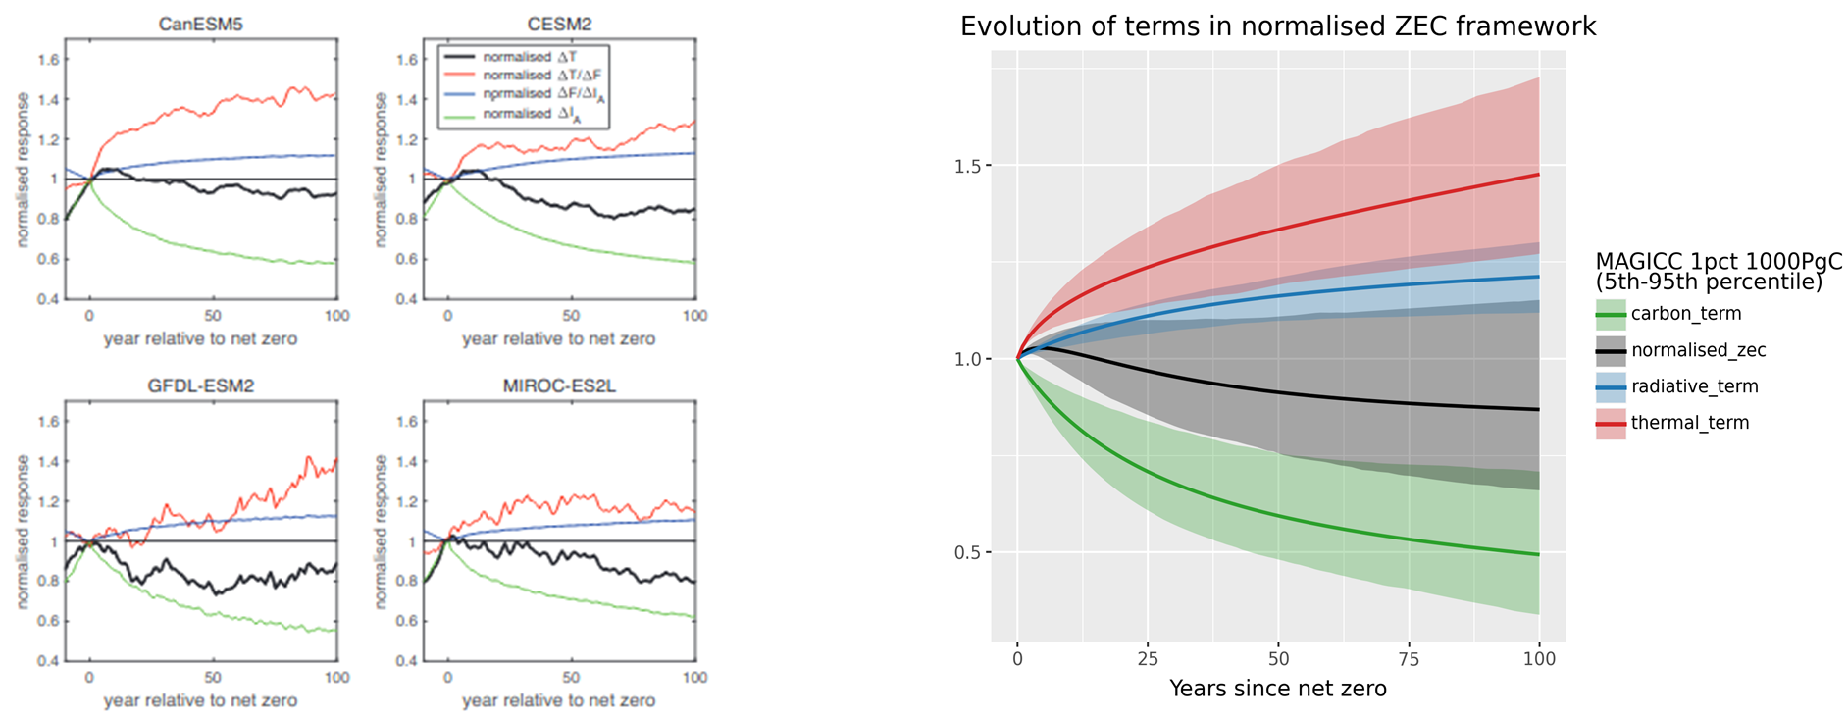

Frameworks to understand how and why ZEC occurs
Text S2.7:
The energy flux framework shows a clear trend for ZEC in MAGICC, but isn’t a firm rule. Expressing land and ocean carbon uptake as a negative energy flux, and reduced ocean heat uptake as a positive energy flux, we can stack the three terms to assess the net energy imbalance (Fig. S2.5). Ref. ¹ suggests that this net energy flux corresponds with absolute ZEC 50, where a positive energy flux would imply additional warming. In Figure S2.5, we see how the hypothesized relationship between the energy fluxes and ZEC are made clear in the MAGICC runs, where the balance between positive and negative energy fluxes falls in line with positive and negative ZEC. The majority of the change in energy imbalance is explained by the land carbon flux and ocean heat uptake, with a smaller portion attributable to the ocean carbon uptake. Although, as an ensemble, most negative ZEC runs show a large land carbon uptake term and a small ocean heat uptake contribution (and vice versa), this is not true for all runs, and the balance may result from a different combination of the three terms. The energy flux framework hence shows a clear trend for what determines ZEC in MAGICC, but not a firm rule.

The normalised ZEC framework maps well to the group of observational terms we find to have predictive skill. In the normalised ZEC framework ² (Figure S2.6), ZEC is expressed as the product of a thermal, radiative and carbon term at each point in time. Here, it is again the combination of the three terms, as opposed to the absolute values of each, that result in the overall ZEC value. In MAGICC, the ensemble shows a larger variation in the carbon and thermal terms than the radiative term, which corresponds to the results reported in ref. ², reproduced in part in Figure S2.6.

Evolution of core processes after net zero

MAGICC transfers heat between layers in the ocean and carbon in the land between three interacting pools: plant, soil and detritus.

Figure S2.8 | Example of ocean heat transport and carbon exchange within the land in MAGICC. Ocean heat transport and carbon pool components for one ensemble member under the 1pct 1000PgC scenario.
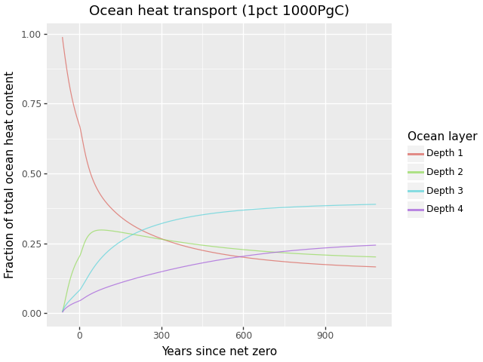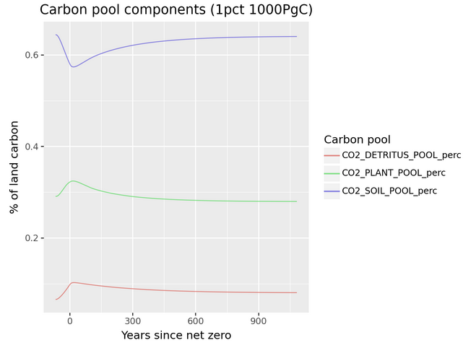

Under the 1pct 1000PgC, we see how the ocean starts with all of the additional heat content in the surface layer (depth 1), with the heat being transferred to depth 2 as emissions increase, peaking for this configuration in this layer just after zero emissions, and then decreasing as heat continues to be transferred to depth three which easily holds the majority of ocean heat content by the end of the millennium after net zero.

Figure S2.9 | The relationship between ZEC and the TCR/ECS ratio

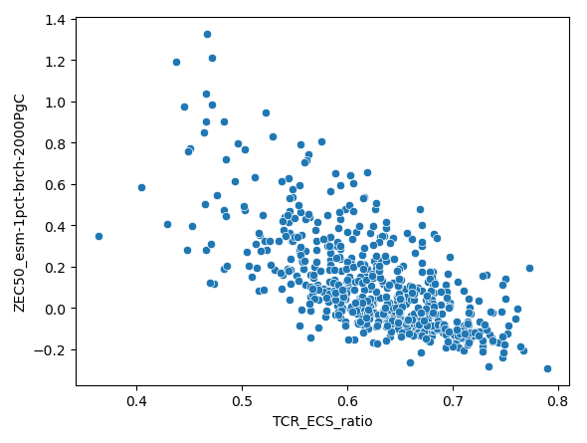

Section S3: Linear regression model

Figure S3.1 | Relationship between fractional ZEC₅₀ and three observables under the 1000 PgC 1% scenario. All three terms are averages taken over the 20 years prior to net zero. They are: (a) net atmosphere to land carbon flux, (b) ocean heat uptake as a fraction of effective radiative forcing, and (c) surface air temperature change as a fraction of total effective radiative forcing.
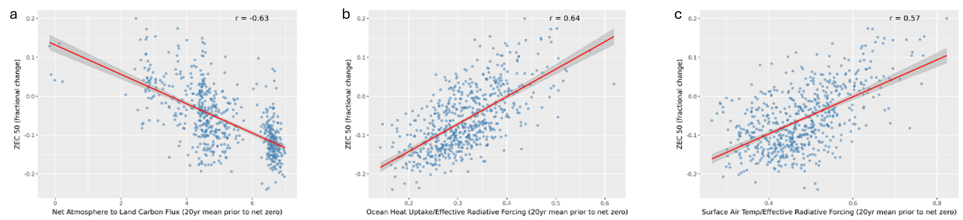

Figure S3.2 | Fractional ZEC 50 (1% 1000PgC). In panel a, the performance of the linear regression model in the test sample in MAGICC, where actual ZEC is plotted on the x, and predicted ZEC on the y. The dotted grey line marks x=y, i.e. perfect prediction. In panel b, the sign and relative importance of each of the features of the linear regression model. Scaling here is via scikitLearn’s StandardScaler, which scales each of the variables to have a mean of zero and a standard deviation of 1. The model is built on the scaled variables.

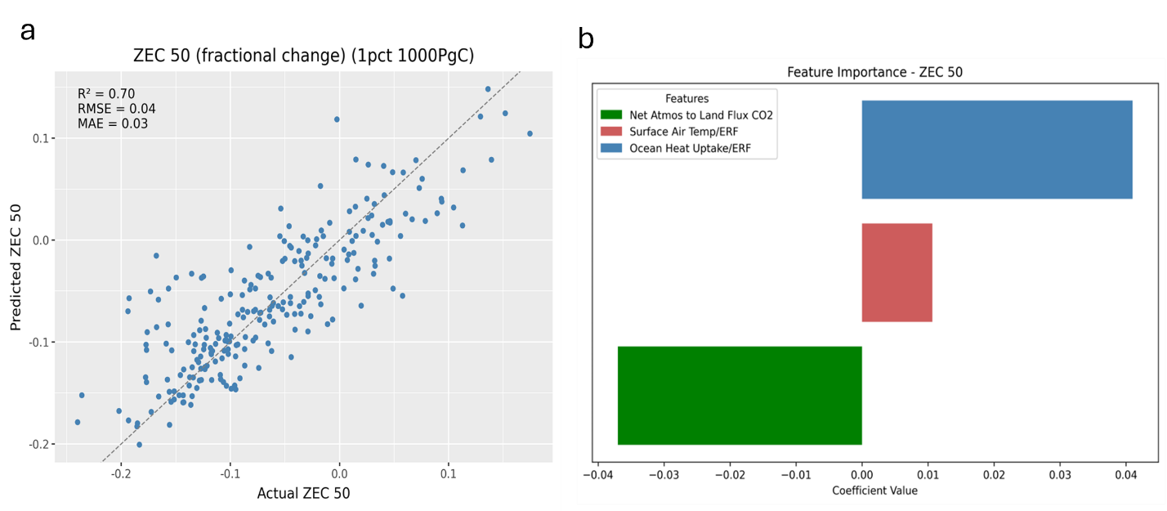

Table S3.3 | Coefficients of the linear regression model for fractional ZEC₅₀ in the 1% 1000 PgC scenario. Fractional ZEC₅₀ = k₀ + k₁⋅F_{A-L} + k₂⋅(OHU/ERF) + k₃⋅(SAT/ERF)

Coefficient | Unit | Value
k₀ | dimensionless | -0.152
k₁ | PgC yr⁻¹ | -0.0279
k₂ | dimensionless | 0.5789
k₃ | ºC W⁻¹m² | 0.1099

Figure S3.4 | Fractional ZEC 100 (1% 1000PgC). In panel a, the performance of the linear regression model in the test sample in MAGICC, where actual ZEC is plotted on the x, and predicted ZEC on the y. The dotted grey line marks x=y, i.e. perfect prediction. In panel b, the sign and relative importance of each of the features of the linear regression model.

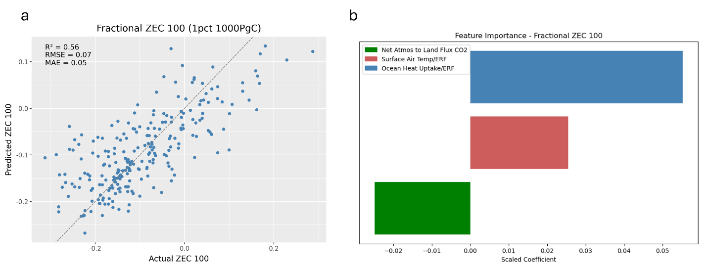
Figure S3.5 | Fractional ZEC 1000 (1% 1000PgC). In panel a, the performance of the linear regression model in the test sample in MAGICC, where actual ZEC is plotted on the x, and predicted ZEC on the y. The dotted grey line marks x=y, i.e. perfect prediction. In panel b, the sign and relative importance of each of the features of the linear regression model.

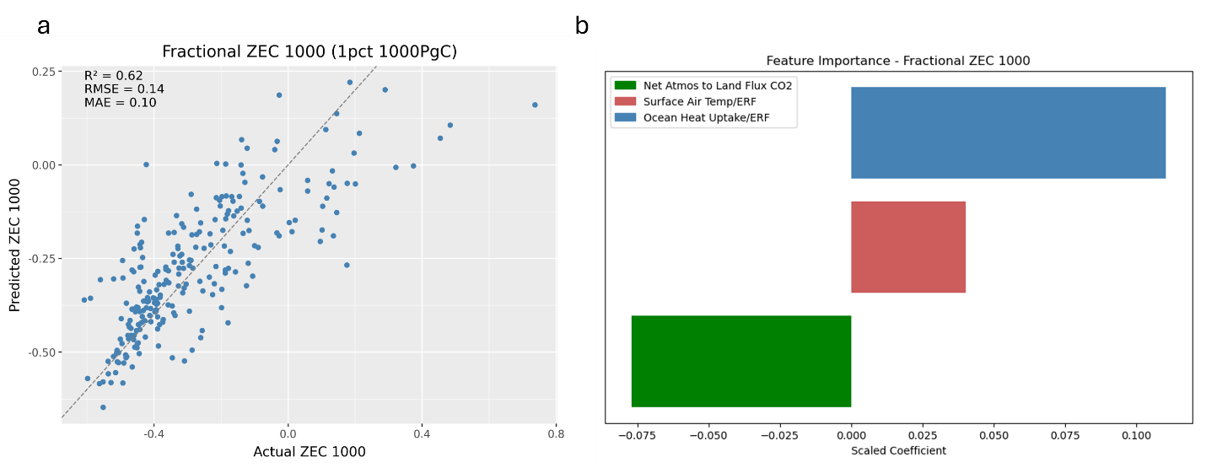
Figure S3.6 | Fractional ZEC 50 (1% 2000PgC). In panel a, the performance of the linear regression model in the test sample in MAGICC, where actual ZEC is plotted on the x, and predicted ZEC on the y. The dotted grey line marks x=y, i.e. perfect prediction. In panel b, the sign and relative importance of each of the features of the linear regression model.

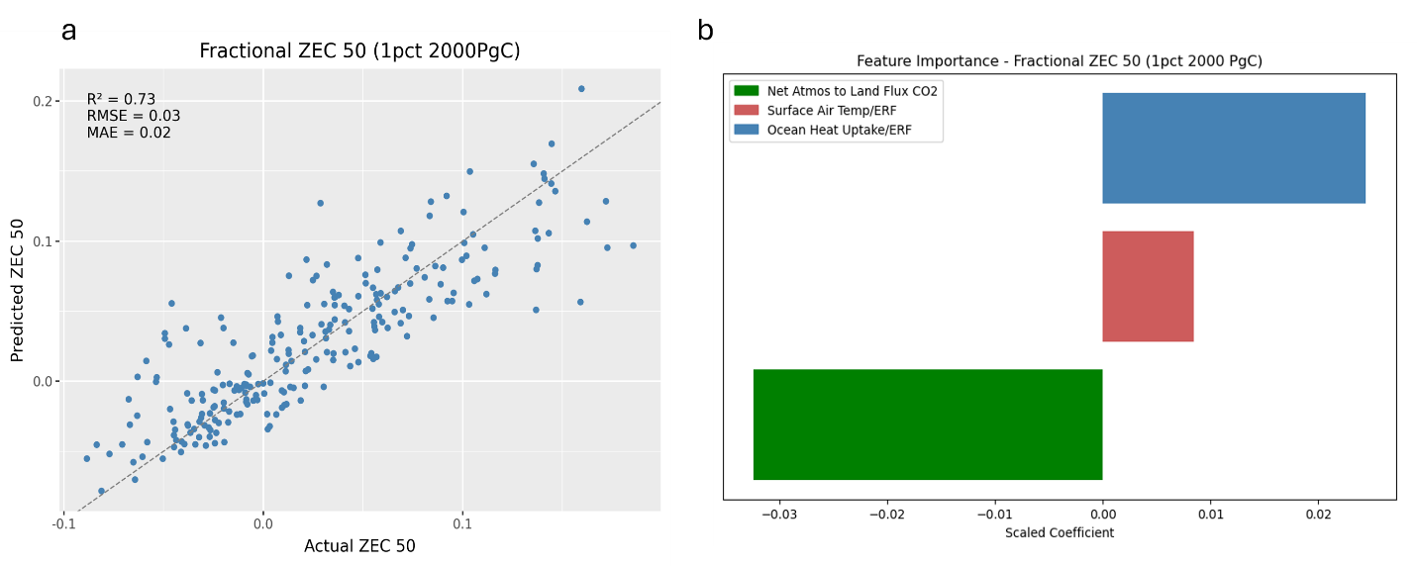

Figure S3.7 | Fractional ZEC 50 (1% 750PgC). In panel a, the performance of the linear regression model in the test sample in MAGICC, where actual ZEC is plotted on the x, and predicted ZEC on the y. The dotted grey line marks x=y, i.e. perfect prediction. In panel b, the sign and relative importance of each of the features of the linear regression model.

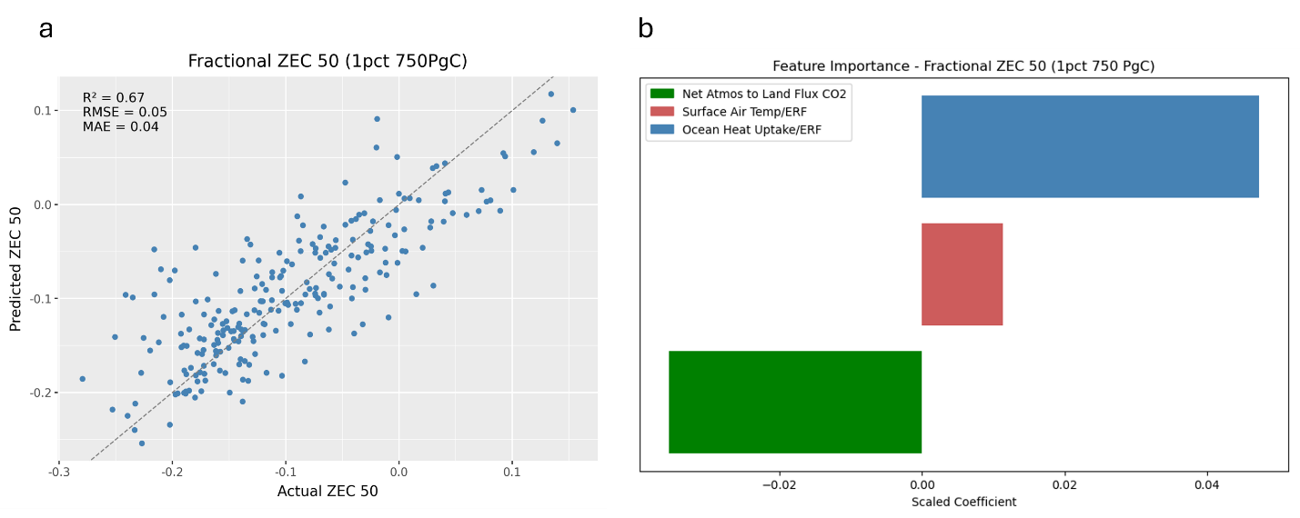

Model performance improves as we approach net zero

Table S4.5 | Linear regression performance for two emissions scenarios (750 and 2000 PgC under the bell emissions pathway). Emissions follow a bell-shaped pathway within a 100 year window.

Scenario: esm bell 750PgC
Year | Total cumulative emissions at midpoint (PgC) | As a percentage | R² | RMSE | MAE
30-50 | 212 | 28% | 0.38 | 0.05 | 0.03
40-60 | 390 | 52% | 0.37 | 0.05 | 0.03
50-70 | 563 | 75% | 0.36 | 0.05 | 0.03
60-80 | 677 | 90% | 0.35 | 0.05 | 0.04
70-90 | 730 | 97% | 0.41 | 0.04 | 0.04
80-100 | 746 | 99% | 0.61 | 0.04 | 0.03
90-110 | 750 | 100% | 0.84 | 0.02 | 0.02

Scenario: esm bell 2000PgC
Year | Total cumulative emissions at midpoint (PgC) | As a percentage | R² | RMSE | MAE
30-50 | 566 | 28% | 0.45 | 0.04 | 0.03
40-60 | 1042 | 52% | 0.50 | 0.04 | 0.03
50-70 | 1503 | 75% | 0.54 | 0.04 | 0.03
60-80 | 1808 | 90% | 0.60 | 0.03 | 0.03
70-90 | 1946 | 97% | 0.67 | 0.03 | 0.02
80-100 | 1989 | 99% | 0.78 | 0.02 | 0.02
90-110 | 2000 | 100% | 0.86 | 0.02 | 0.02

Section S4: Observational data
Observational data and sources
To find the data relevant to the CO₂-only ZEC, we have scaled global values in line with the fraction of total effective radiative forcing attributable to CO₂. This scaling factor is used for ocean heat uptake and surface air temperature. Net atmosphere to land carbon flux is unchanged.

Table S4.1 | Observations of the climate today
Taken from data covering the years 2004.5 to 2023.5.

Variable | Unit | Description | Value | Standard deviation
Net atmosphere to land carbon flux | GtC/yr | 20 year weighted mean taken from the multi-model mean in the Global Carbon Budget 2024 | 3.19 | 0.203
Total ocean heat uptake(CO₂)/ERF(CO₂) | ZJ/Wm⁻² | 20 year ocean heat uptake, scaled by the weighted average fraction of ERF due to CO₂/total ERF, divided by the 20 year weighted average of ERF due to CO₂ | 100.39 | 18.14
GMST(CO₂)/ERF(CO₂) | ºC/Wm⁻² | GMST is scaled by the fraction of ERF due to CO₂/total ERF each year, then divided by the ERF due to CO₂ in that year. 20 year weighted mean of this calculation. | 0.407 | 0.0203

Table S4.2 | Data sources

Variable | Source | Notes
Net atmosphere to land carbon flux (GtC/yr) | Global Carbon Budget 2024 ³  Terrestrial land sink, multi-model mean and model spread (standard deviation) | -
Effective radiative forcing (CO₂) | Indicators of Global Climate Change 2024 ⁴ and associated data, accessible via zenodo ⁵. | Used to scale OHU and GMST to approximate the CO₂-only portion. 5th and 95th percentiles are given in the raw data - these are used to generate the standard deviation assuming gaussian distribution of uncertainty.
Ocean heat uptake | Indicators of Global Climate Change 2024 ⁴ and associated data, accessible via zenodo ⁵.  Earth energy imbalance dataset, ocean full depth. | Change in ocean heat content between years X and X+19. This is to reduce the error in the calculation as ocean heat uptake each year is on the same order as the error in the measure of total ocean heat content.
Surface Air Temperature | Indicators of Global Climate Change 2024 ⁴ and associated data, accessible via zenodo ⁵.  Global mean temperature annual averages | Scaled each year according to the ratio of ERF(CO₂) to ERF(total).  Not reported with an uncertainty range.

Supplementary References

1. MacDougall, A. H. et al. Is there warming in the pipeline? A multi-model analysis of the Zero Emissions Commitment from CO2. Biogeosciences 17, 2987–3016 (2020).
2. Williams, R. G., Goodwin, P., Ceppi, P., Jones, C. D. & MacDougall, A. A normalised framework for the Zero Emissions Commitment. EGUsphere 1–30 (2025) doi:10.5194/egusphere-2025-800.
3. Friedlingstein, P. et al. Global Carbon Budget 2024. Earth Syst. Sci. Data 17, 965–1039 (2025).
4. Forster, P. M. et al. Indicators of Global Climate Change 2024: annual update of key indicators of the state of the climate system and human influence. Earth Syst. Sci. Data 17, 2641–2680 (2025).
5. Smith, C. et al. Indicators of Global Climate Change 2024. Zenodo https://doi.org/10.5281/ZENODO.7883757 (2025).

