Supporting information
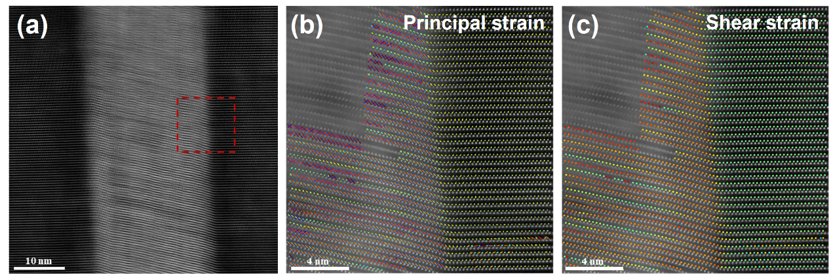
Fig. S1 (a) HAADF image of a region at the interface between a stripe and layered structure region. (b) Principal strain and (c) shear strain maps of the highlighted region in (a).

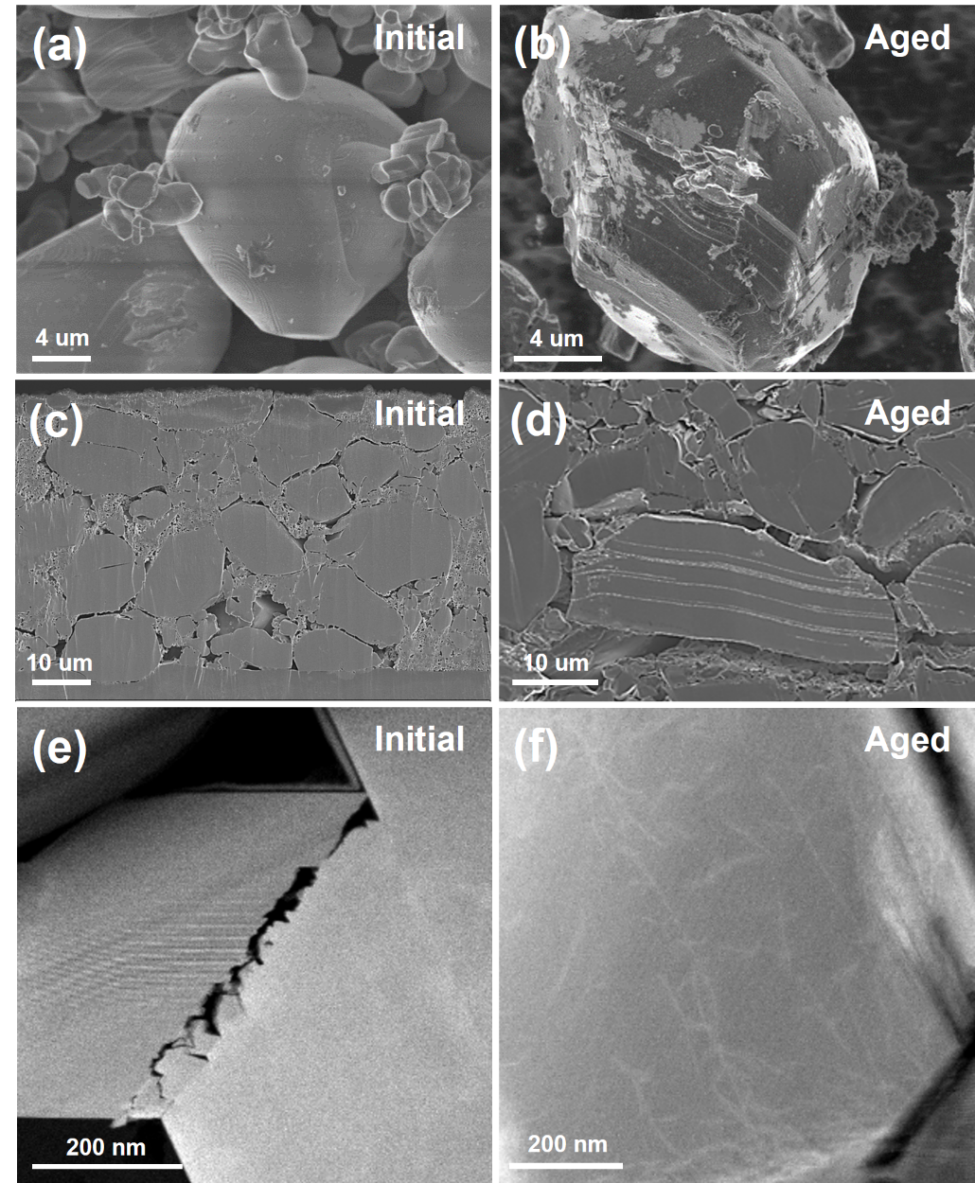
Fig. S2 (a-b) SEM SE images of the initial and aged LCO particles, respectively. (c-d) SEM BSE images of the cross sections of the initial and aged LCO particles, respectively. (e-f) STEM HAADF images of the initial and aged LCO lamellae. The initial LCO particles are collected from the initial LCO pouch cell before the storage.

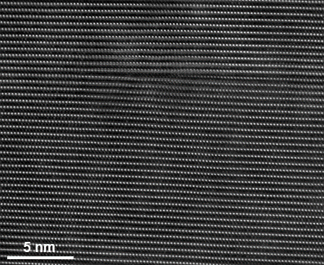
Fig. S3 Atomic-resolution STEM HAADF image of the edge dislocation in the bulk region.

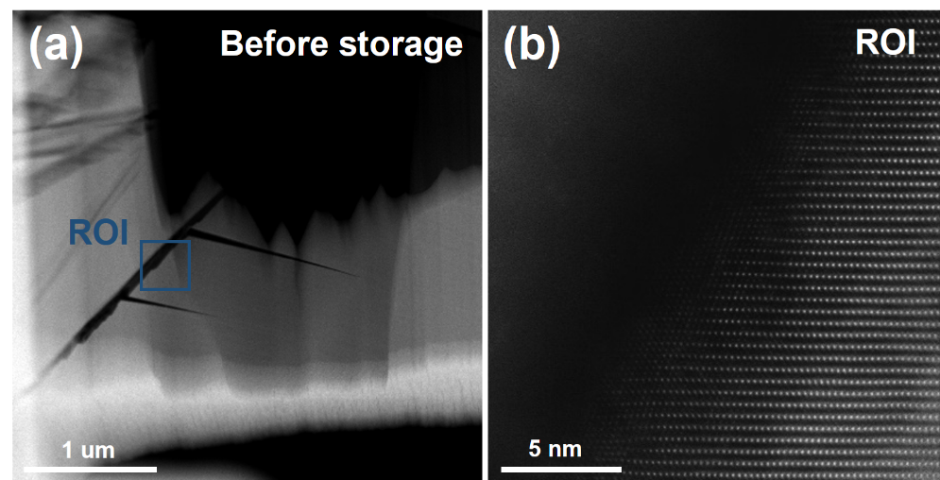
Fig. S4 (a) STEM HAADF image of the cracks of the initial LCO particle. (b) Atomic-resolution STEM HAADF image of the surface at the cracks shown in (a).

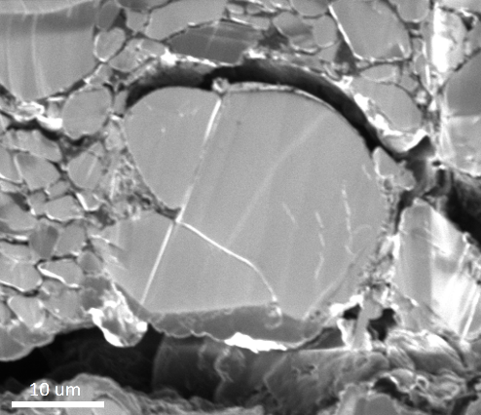
Fig. S5 Simultaneous SEM image of the cross section of the aged LCO.

