Highly stretchable and conformal bioinspired kirigami structural epidermal electrodes for ECG recording during daily activities
Ziying Wang^{1*#}, Ze Chen^{2#}, Jiameng Li¹, Dagong Jia¹, Xiaoming Hou^{3*}, Zhangyi Li^{3*}, Haojun Fan^{1*}
¹School of Disaster and Emergency Medicine, Tianjin University, Tianjin 300072, PR China.
²Department of Mechanical Engineering, Baotou Vocational & Technical College, Baotou 014035, PR China.
³Tianjin Fifth Central Hospital, PR China.
*Corresponding authors: E-mail: wangzy91@tju.edu.cn; jason.able@foxmail.com; adonis1105@126.com; fanhj@tju.edu.cn
# These authors contributed equally to the work.

Calculation of SNR for resting
For the calculation of SNR, we obtained the power spectral density (PSD) of the signal by Welch's method in MATLAB software ¹. We set the parameters for the pwelch function to a 1000-point Hanning window (sampling frequency) and a 50% overlap. Since the frequency range of interest for ECG signals is typically below 100-120 Hz, the region below 100 HZ was used to represent our signal in the calculation. the power was summed over those frequencies and normalized to be in units of dB. The noise was averaged from the range of 400-500 Hz and this range was chosen because it was obviously in the noise floor. The following formula is used to convert the ratio of the signal and noise to power in dB:
$$SNR=10*\log_{10}\frac{P_{(s)}}{P_{(n)}}$$
where P_{(s)} is the power of the ECG and P_{(n)} is the power of the noise.
Calculation of SNR for motion
Due to the signals recorded during motion had obvious motion artifacts, motion artifacts to be isolated and treated as noise to calculate the SNR. All the filters utilized were Butterworth filters in the calculations. The specific method is: first, the motion artifact signal is extracted by eliminating the majority of the ECG signal from the raw signal using a 1st order low-pass filter with a cutoff frequency of 3 Hz. Second, the raw signal is filtered using a first-order bandpass filter with a cutoff frequency ranging from 400 to 500 Hz to obtain a noisy signal. This value has been selected to align with the noise range used in the previous SNR calculations. Third, the synthesized noise signal is obtained by adding the extracted artifacts to the noise signal during the time period when the motion artifacts occur. Last, the SNR is obtained by calculating the the ratio of the root-mean-square (RMS) values of the signal after artifact removal and the synthesized noise signal. The following formula is:
$$SNR=20*\log_{10}\frac{V_{rms(s)}}{V_{rms(n)}}$$
where V_{rms(s)} is the rms values of the signal after artifact removal and V_{rms(s)} is the rms values of the synthesized noise signal.
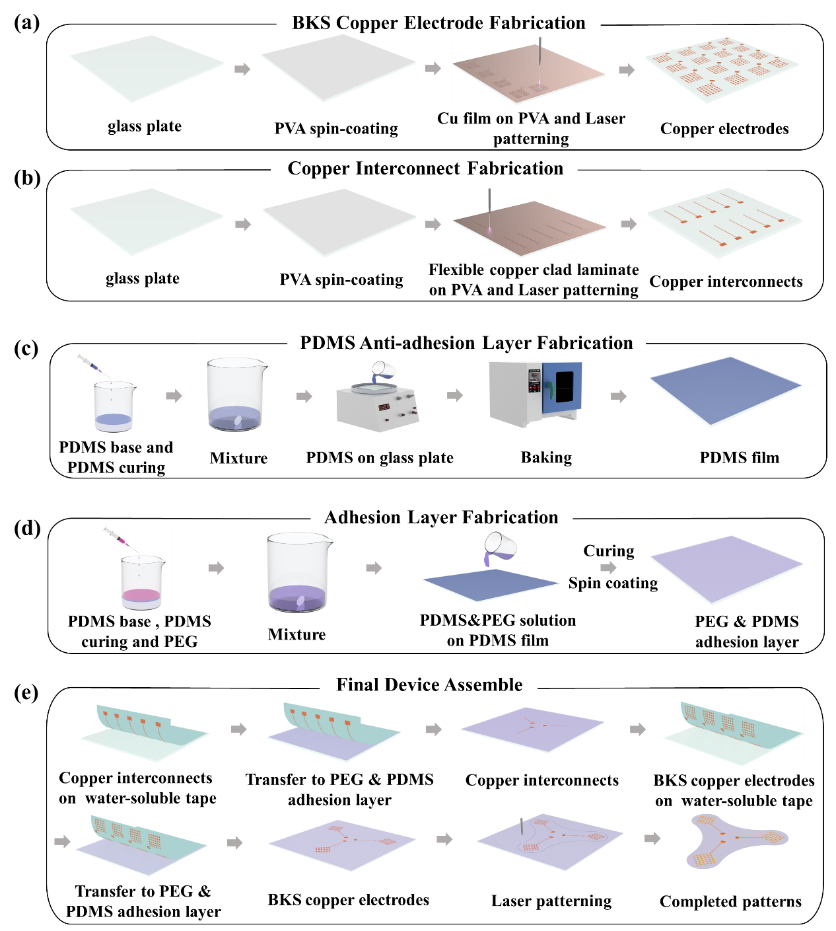
Fig. S1. Diagram of fabrication and assembly process of BKSEE. Fabrication of (a) BKS copper electrodes, (b) copper interconnects, (c) PDMS anti-adhesion layer, (d) PEG & PDMS adhesion layer and (e) the assembly process of BKSEE.

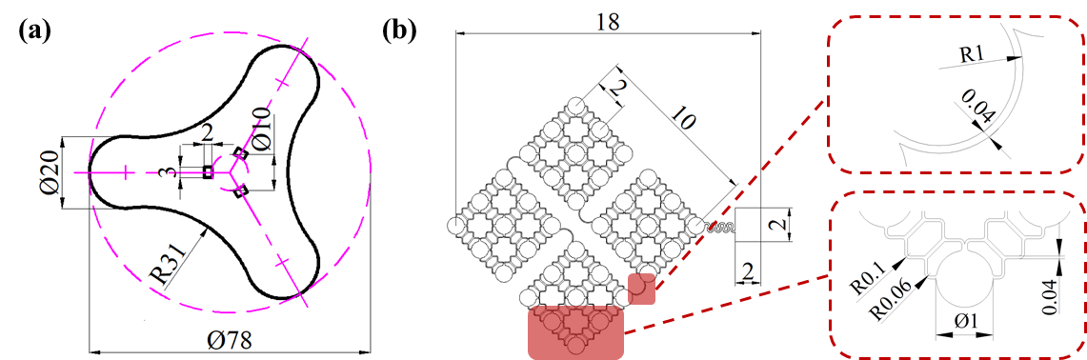
Fig. S2. Diagram of the structure and dimensions. (a) Structure and dimensions of Janus adhesive patch. (b) Structure and dimensions of BKS copper electrode. The red dotted boxes show the two different structures.

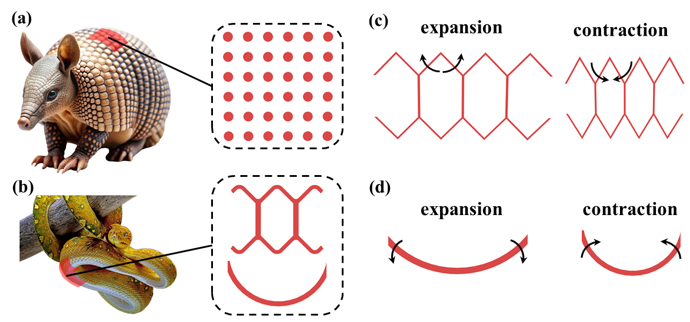
Fig. S3. Diagram of biomimetic structure. (a) The rigid tiles of the electrode are inspired by the carapaces of armadillos. (b) The flexible joints are inspired by the hexagonal pattern of snake's abdomen. (c) Principle of deformation in kirigami flexible joint. (d) Principle of deformation in arc-shaped flexible joint.

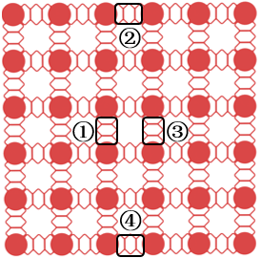
Fig. S4. The electrode consists of Kirigami 2 flexible joints and rigid tiles.

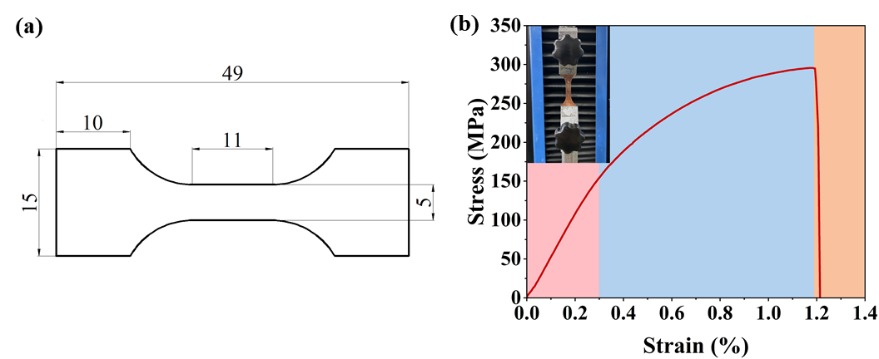
Fig. S5. Tensile testing of copper foil. (a) Dimensions of the type of copper foil. (b) Stress-strain curve of copper foil. The pink area represents elastic deformation, the blue area indicates yield deformation, and the orange area signifies rupture.

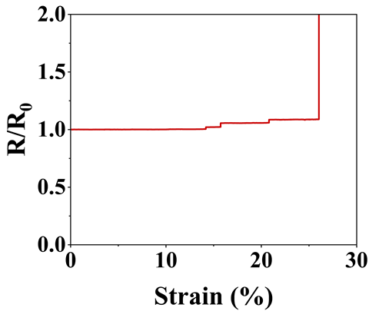
Fig. S6. Change in the resistance of the Kirigami2 flexible joint.

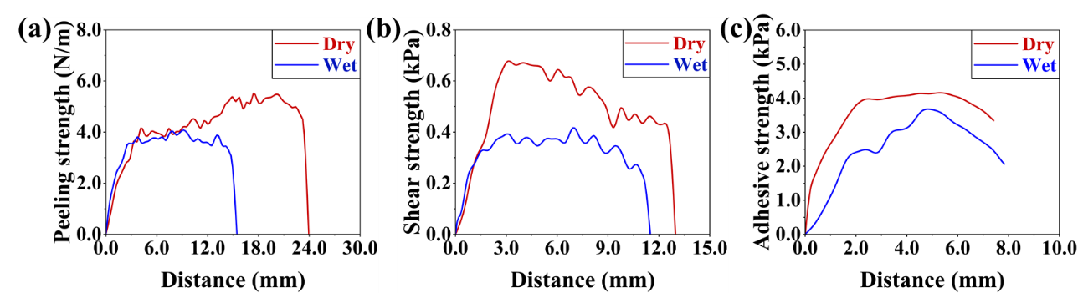
Fig. S7. Adhesive ability of adhesive films at a ratio of 1:9. (a) Tensile strength of films measured through peel Tests. (b) Tensile strength of films measured through shear tests. (c) Tensile strength of films measured through pull-off tests.

Fig. S8. Change in pull-off force on arm skin after varying durations of wear for films at a ratio of 2:8.

Fig. S9. Change of elongation at break with different ratios.

Fig. S10. Change of modulus with different ratios.

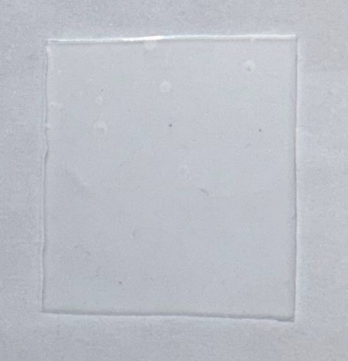
Fig. S11. Photos of janus adhesive patch.

Fig. S12. Zoomed-in view of of boxed portion in Fig. 5E and Figure 5F which showing clear P, Q, R, S and T waves.

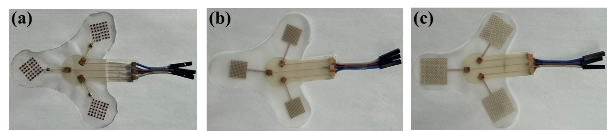
Fig. S13. Photos of epidermal electrodes. (a)BKSEE. (b) fractal-structured epidermal electrode. (c) mesh-structured epidermal electrode.

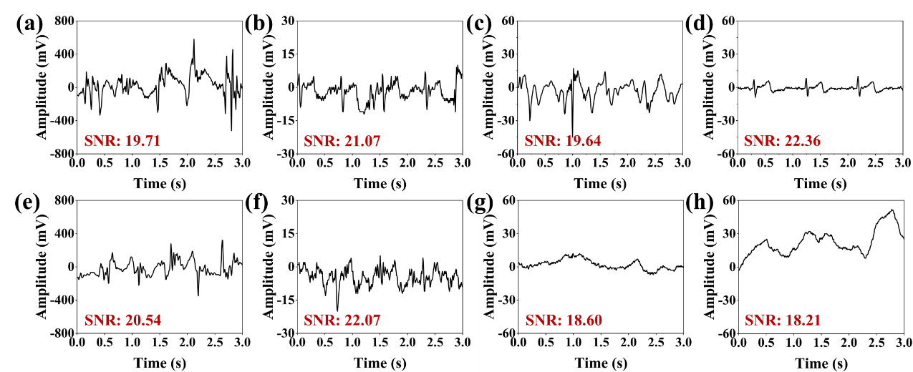
Fig. S14. ECG under various conditions. ECG measurements obtained using a fractal-structured epidermal electrode during (a) walking, (b) standing, (c) riding, and (d) sitting. ECG measurements obtained using a mesh-structured epidermal electrode during (e) walking, (f) standing, (g) riding, and (h) sitting.

Fig. S15. Comparison of the SNR of various epidermal electrodes across five distinct states.

Table S1. Comparison of recent studies on epidermal electrodes
Ref | Materials | Structure | Adhesion strength | Elongation | Active surface | Applications | Measurements in motion
This work | PDMS/PEG/Cu/PI | BKS | 6.48kPa/Dry 5.02 kPa/Wet (pull-off tests) | 53.82% | 32.66% | ECG | Yes
2 | Silicone/ fabric medical  tape/Au/Cu | Fractal | 4.5 N m⁻¹/Dry (peel tests) | 108% | - | EEG/EOG/EMG | No
3 | Graphite polyurethane | Fractal | - | 20% | - | ECG | No
4 | Sterile dressing/Au/PI | Serpentine mesh | - | 26% | 40.47% | EMG | No
5 | PEG-LA-DA/POCO/Mo | Fractal | 0.3N/Dry (peel tests) | 70% | 30% | improve growth of cardiac cells | -
6 | Fabric/Cu/Au/PI | Fractal | 9 J m⁻²/Dry 5 J m⁻²/Wet (peel tests) | 15% | - | EMG | Yes
7 | TPU/Silicone/PI/Au | Serpentine mesh | 10.299 J m⁻²/Dry (peel tests) | 30% | 66.93% | EMG | No

References
1 Ershad, F. et al. Ultra-conformal drawn-on-skin electronics for multifunctional motion artifact-free sensing and point-of-care treatment. Nature Communications 11, 3823 (2020).
2 Kwon, S. et al. At-home wireless sleep monitoring patches for the clinical assessment of sleep quality and sleep apnea. Science Advances 9, eadg9671 (2023).
3 Bhattacharya, S. et al. A Chest‐Conformable, Wireless Electro‐Mechanical E‐Tattoo for Measuring Multiple Cardiac Time Intervals. Advanced Electronic Materials 9, 2201284 (2023).
4 Gong, Q., Jiang, X., Liu, Y., Yu, M. & Hu, Y. A Flexible Wireless sEMG System for Wearable Muscle Strength and Fatigue Monitoring in Real Time. Advanced Electronic Materials 9, 2200916 (2023).
5 Ryu, H. et al. Materials and Design Approaches for a Fully Bioresorbable, Electrically Conductive and Mechanically Compliant Cardiac Patch Technology. Advanced Science 10, 2303429 (2023).
6 Kim, H. et al. AR‐Enabled Persistent Human–Machine Interfaces via a Scalable Soft Electrode Array. Advanced Science 11, 2305871 (2023).
7 Wang, C. et al. Stretchable, Multifunctional Epidermal Sensor Patch for Surface Electromyography and Strain Measurements. Advanced Intelligent Systems 3, 2100031 (2021).

