Biodegradable and Biocompatible Subcutaneous Implants Consisted of pH-sensitive Mebendazole-Loaded/Folic acid-targeted Chitosan Nanoparticles for Murine Triple Negative Breast Cancer Treatment
Amirhosein Kefayat ¹, Maryam Hosseini ², Fatemeh Ghahremani ³, Mohammad Rafienia ^{2,5}*
¹ Department of Oncology, Cancer Prevention Research Center, Isfahan University of Medical Sciences, Isfahan 81746-73461, Iran.
² Department of Chemistry, Amirkabir University of Technology (Tehran Polytechnic), Tehran 1591634311, Iran.
³ Department of Medical Physics and Radiotherapy, Arak School of Paramedicine, Arak University of Medical Sciences, Isfahan, Iran.
⁴ Department of Chemistry, University of Isfahan, Isfahan 81746-73441, Iran.
⁵ Biosensor Research Center, Isfahan University of Medical Sciences, Isfahan, Iran

Corresponding author *:
Mohammad Rafienia
Tel: +983137922480
Postal code: 81746-73461
E-mail: m_rafienia@med.mui.ac.ir
Running title: CS-FA-MBZ nanoparticles made implants for breast cancer treatment

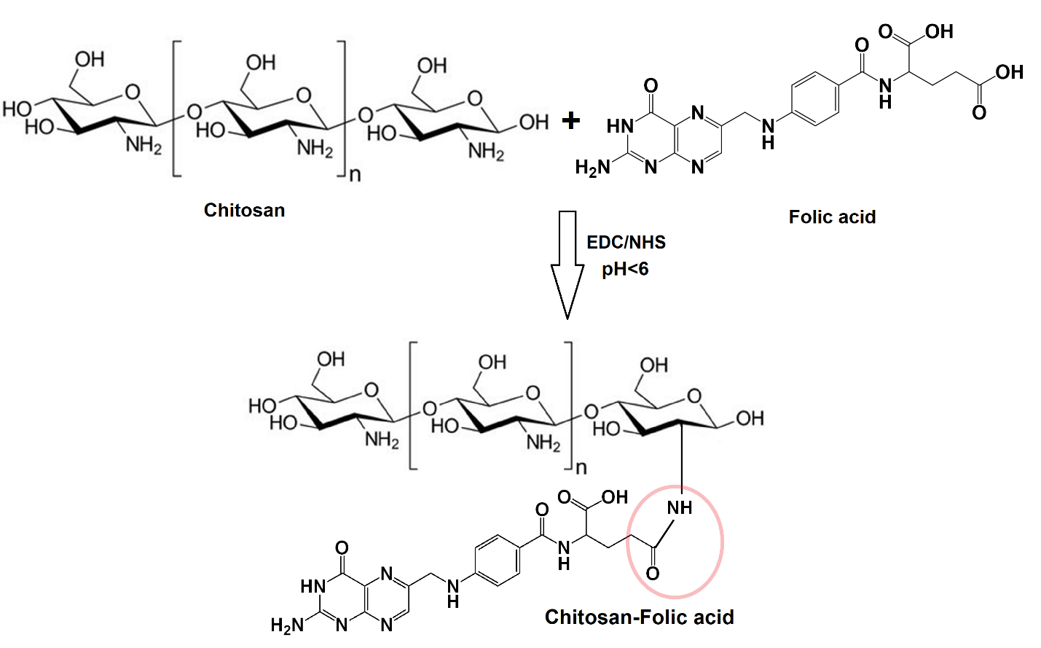
Figure S1: Schematic illustration of folic acid conjugation to chitosan in presence of EDC as carboxyl activating agent to produce CS-FA.

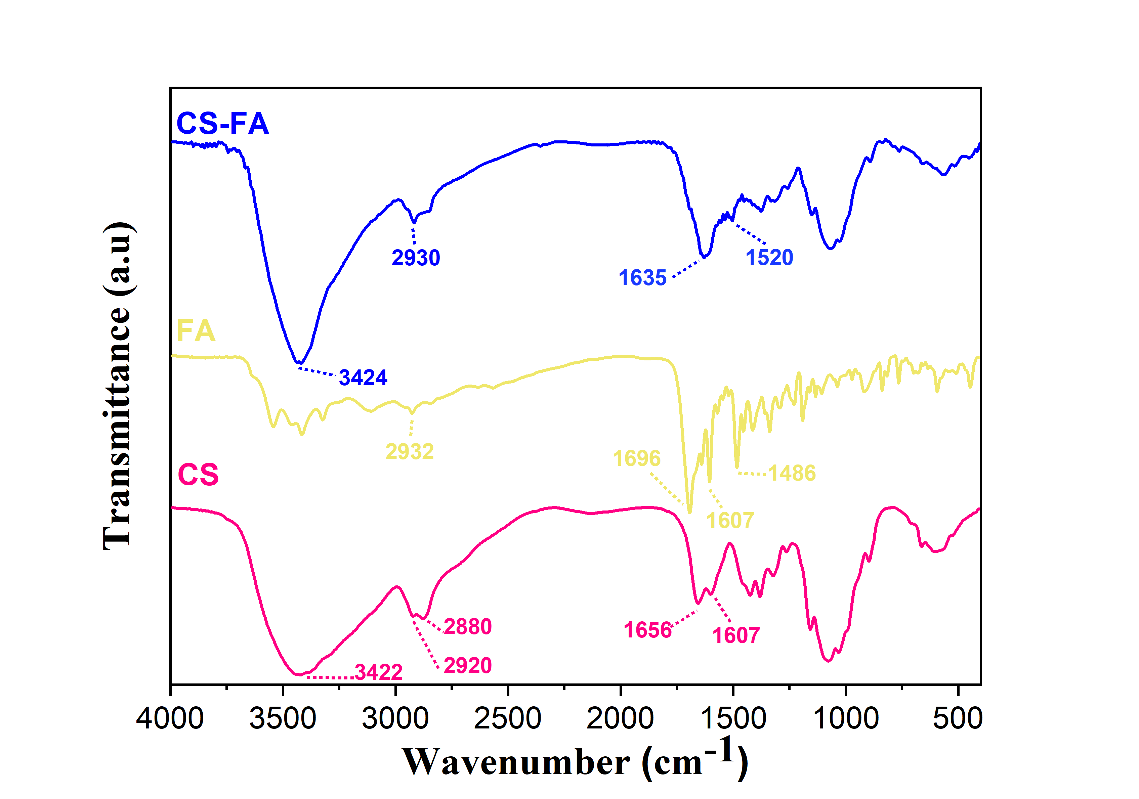
Figure 2S: The FTIR spectra of CS, FA, and CS-FA.

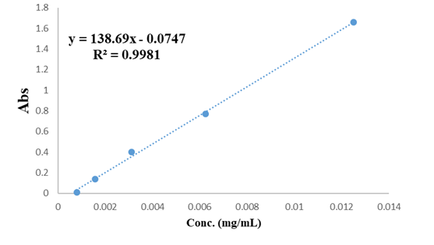
Figure S3: Standard calibration curve of MBZ.

Table 1S. General appearance and behavioral observations for Control and CS-Fa-MBZ groups (n=5).
Parameters | Control | CS-FA-MBZ
Food/Water refuse | Absent | Absent
Aggressiveness | Absent | Absent
Eye and ears | Normal | Normal
Convulsion | Absent | Absent
Salivation | Absent | Absent
Diarrhea | Absent | Absent
Breathing | Normal | Normal
Heart beat | Normal | Normal
Activity | Active | Active
Anorexia | Absent | Absent
Cachexia | Absent | Absent
Mortality | Absent | Absent

