Supplementary Figures:

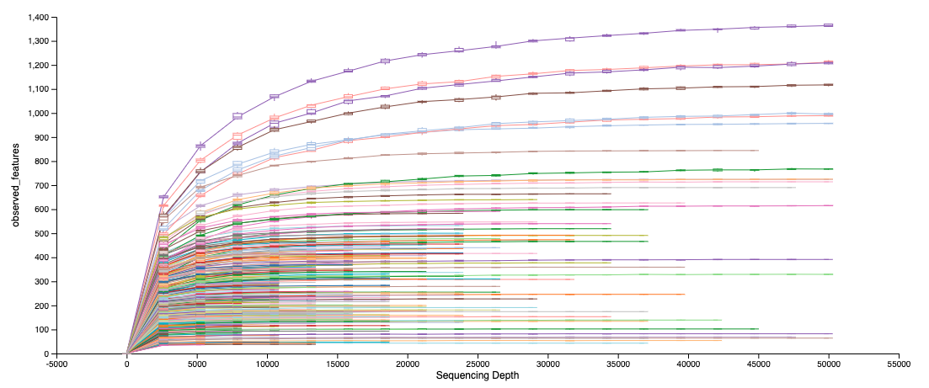
Fig. 1: Rarefaction curves created in Qiime2 by using qiime diversity alpha-rarefaction command.
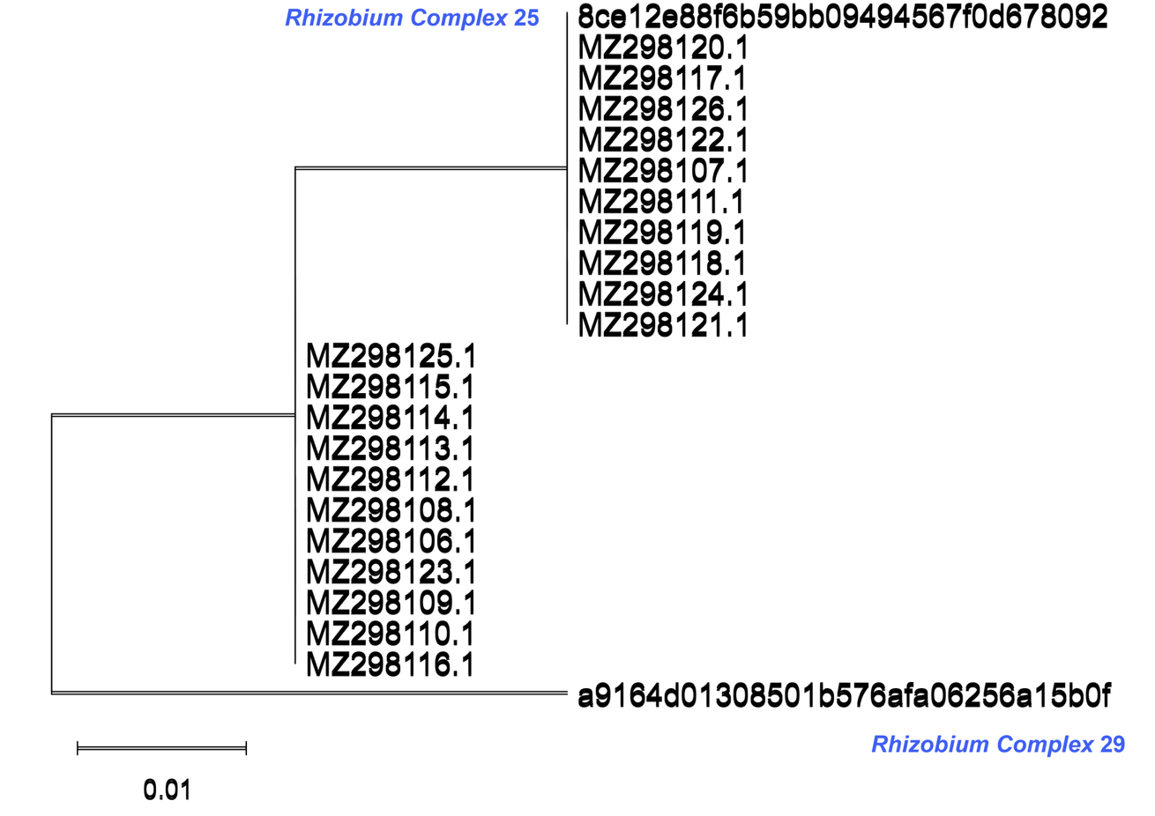Fig.2: Pathogen sequence matching. ASV annotated as Rhizobium Complex 25 match with the 16S rRNA V4 sequence of previously identified rhizogenic Agrobacterium bv. 1 strain isolated from HRD-infested greenhouses.
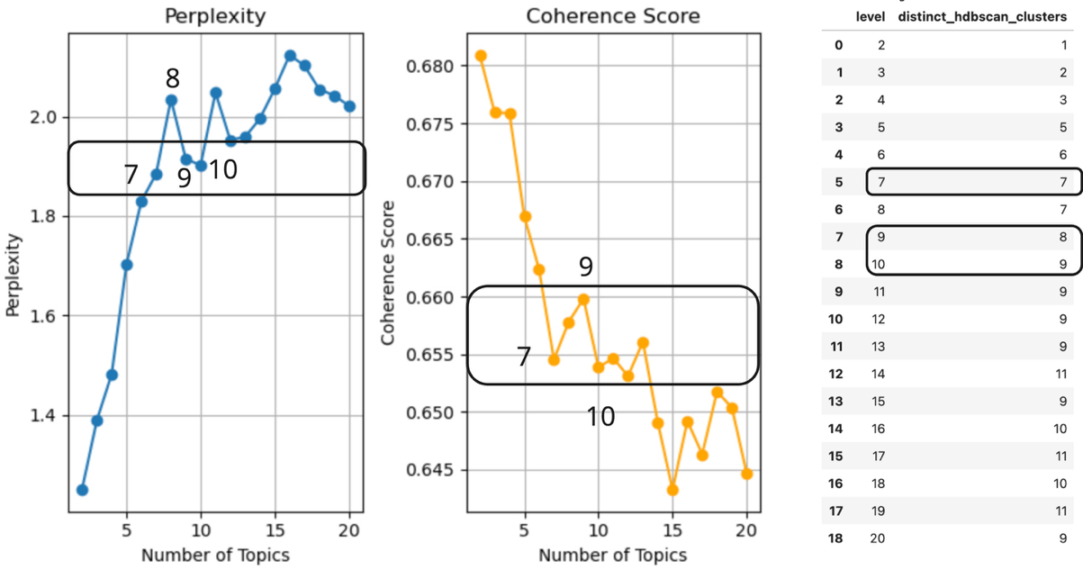
Fig. 3: Metrics of model selection, from left to right are Perplexity, Coherence Score and Persistent MC clusters within each model.

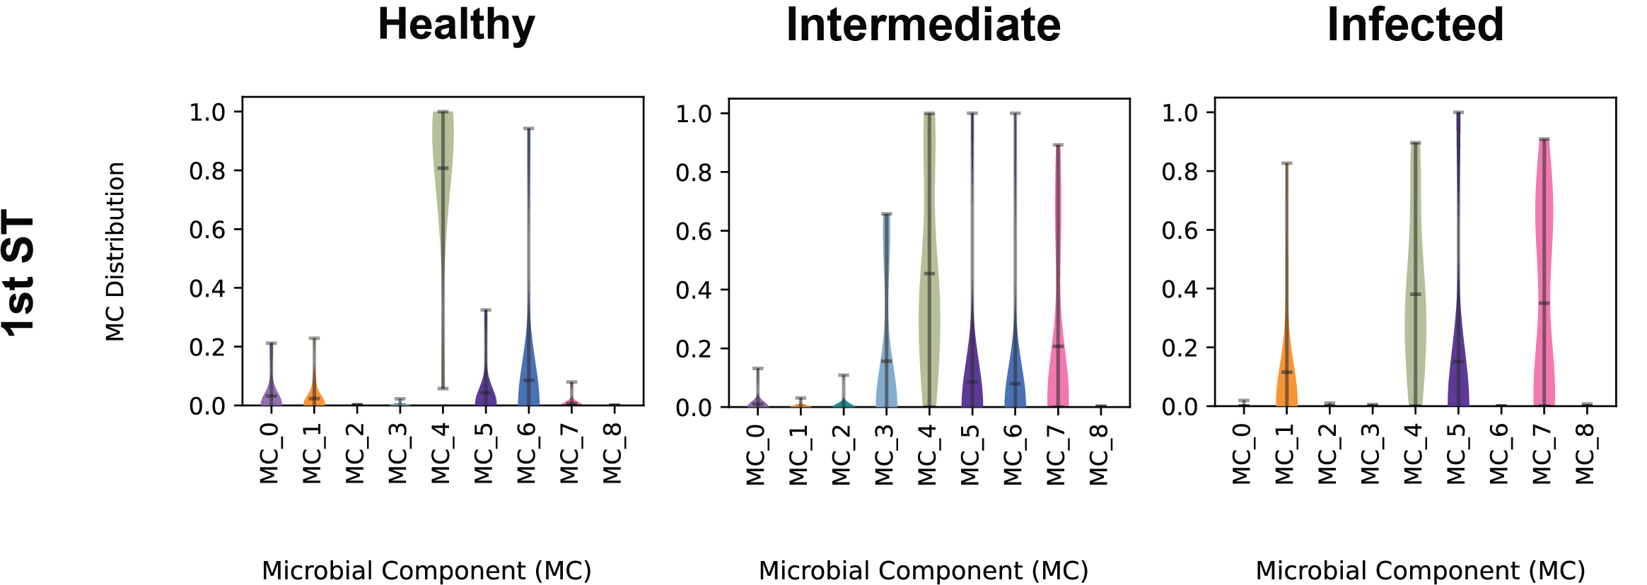
Fig. 4: MC distribution among three different types of greenhouses in the first sampling time point.

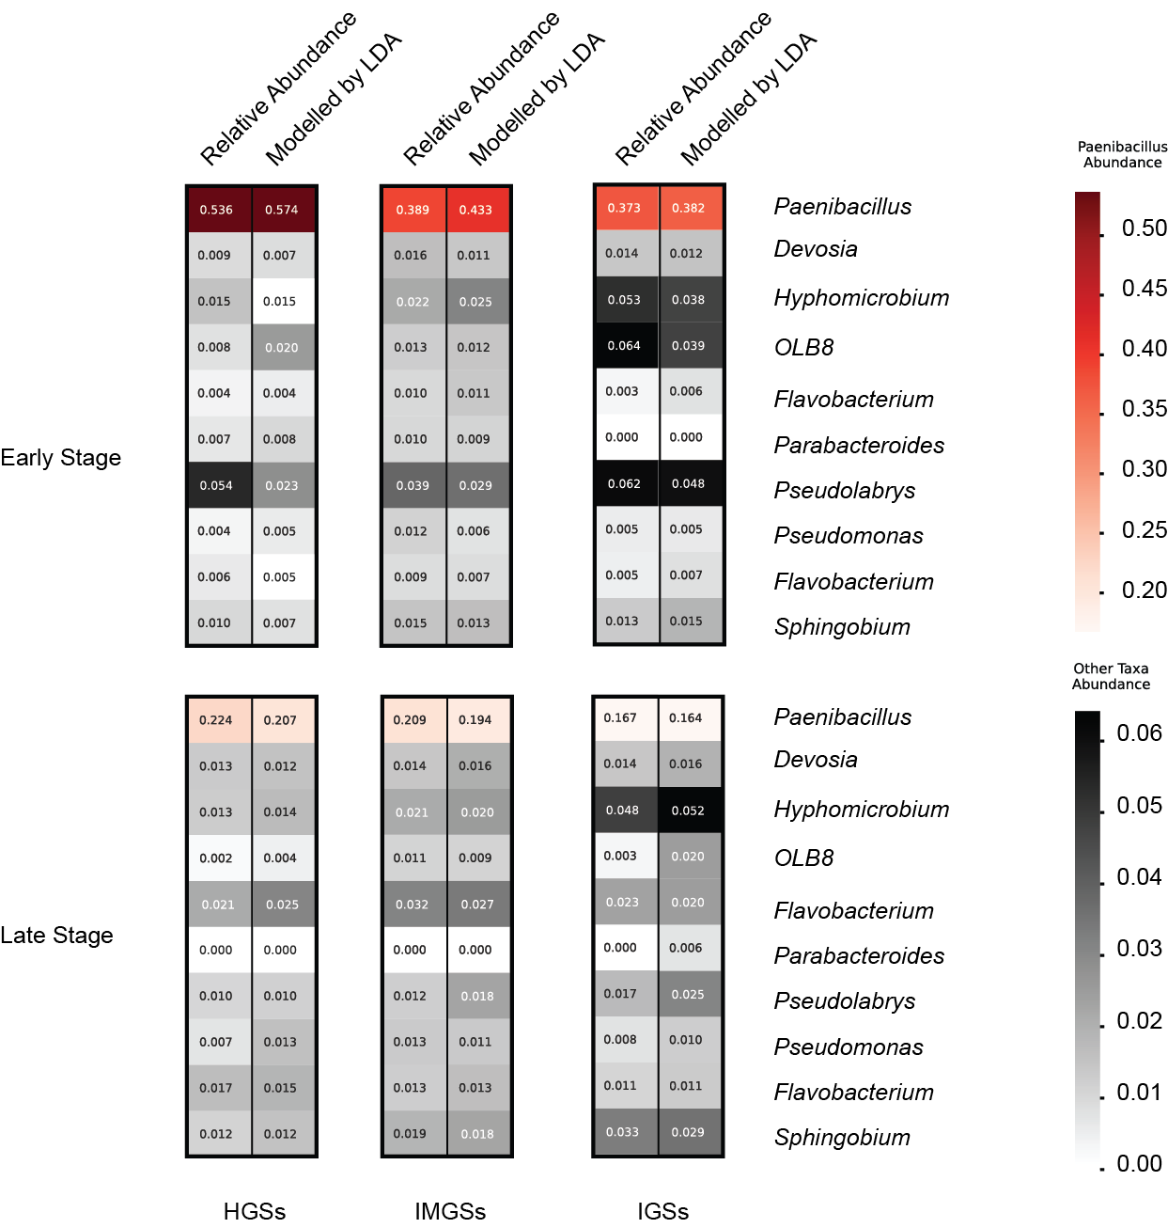
Fig.5: Comparison between relative abundance and modelled relative abundance by LDA regard to top ten bacterial genera. HGSs: healthy greenhouses samples; IMGSs: intermediate greenhouses samples; IGSs: infected greenhouses samples.

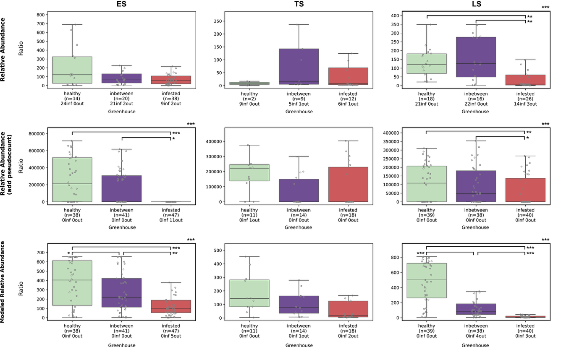

Fig.6: Abundance ratios of Paenibacillus ASV11 to Rhizobium complex ASV25 across greenhouse categories. It shares the same layout as Fig. 7 in the main text.
Supplementary Tables:
Table 1: Greenhouses’ metadata

Table 2: statistical test of temporal and diagnosis patterns. Only significant results are listed.

