Interactive heatmap visualization used during data analysis. Available at https://marimo.io/p/@peiyang-huo/notebook-rvkcan (For the application view, please click the three-dot menu in the top right and turn off ’show code’). Different heatmap ordering strategies are available through a dropdown menu, and brushing selection is available.
Below are static heatmaps by different ordering strategies.

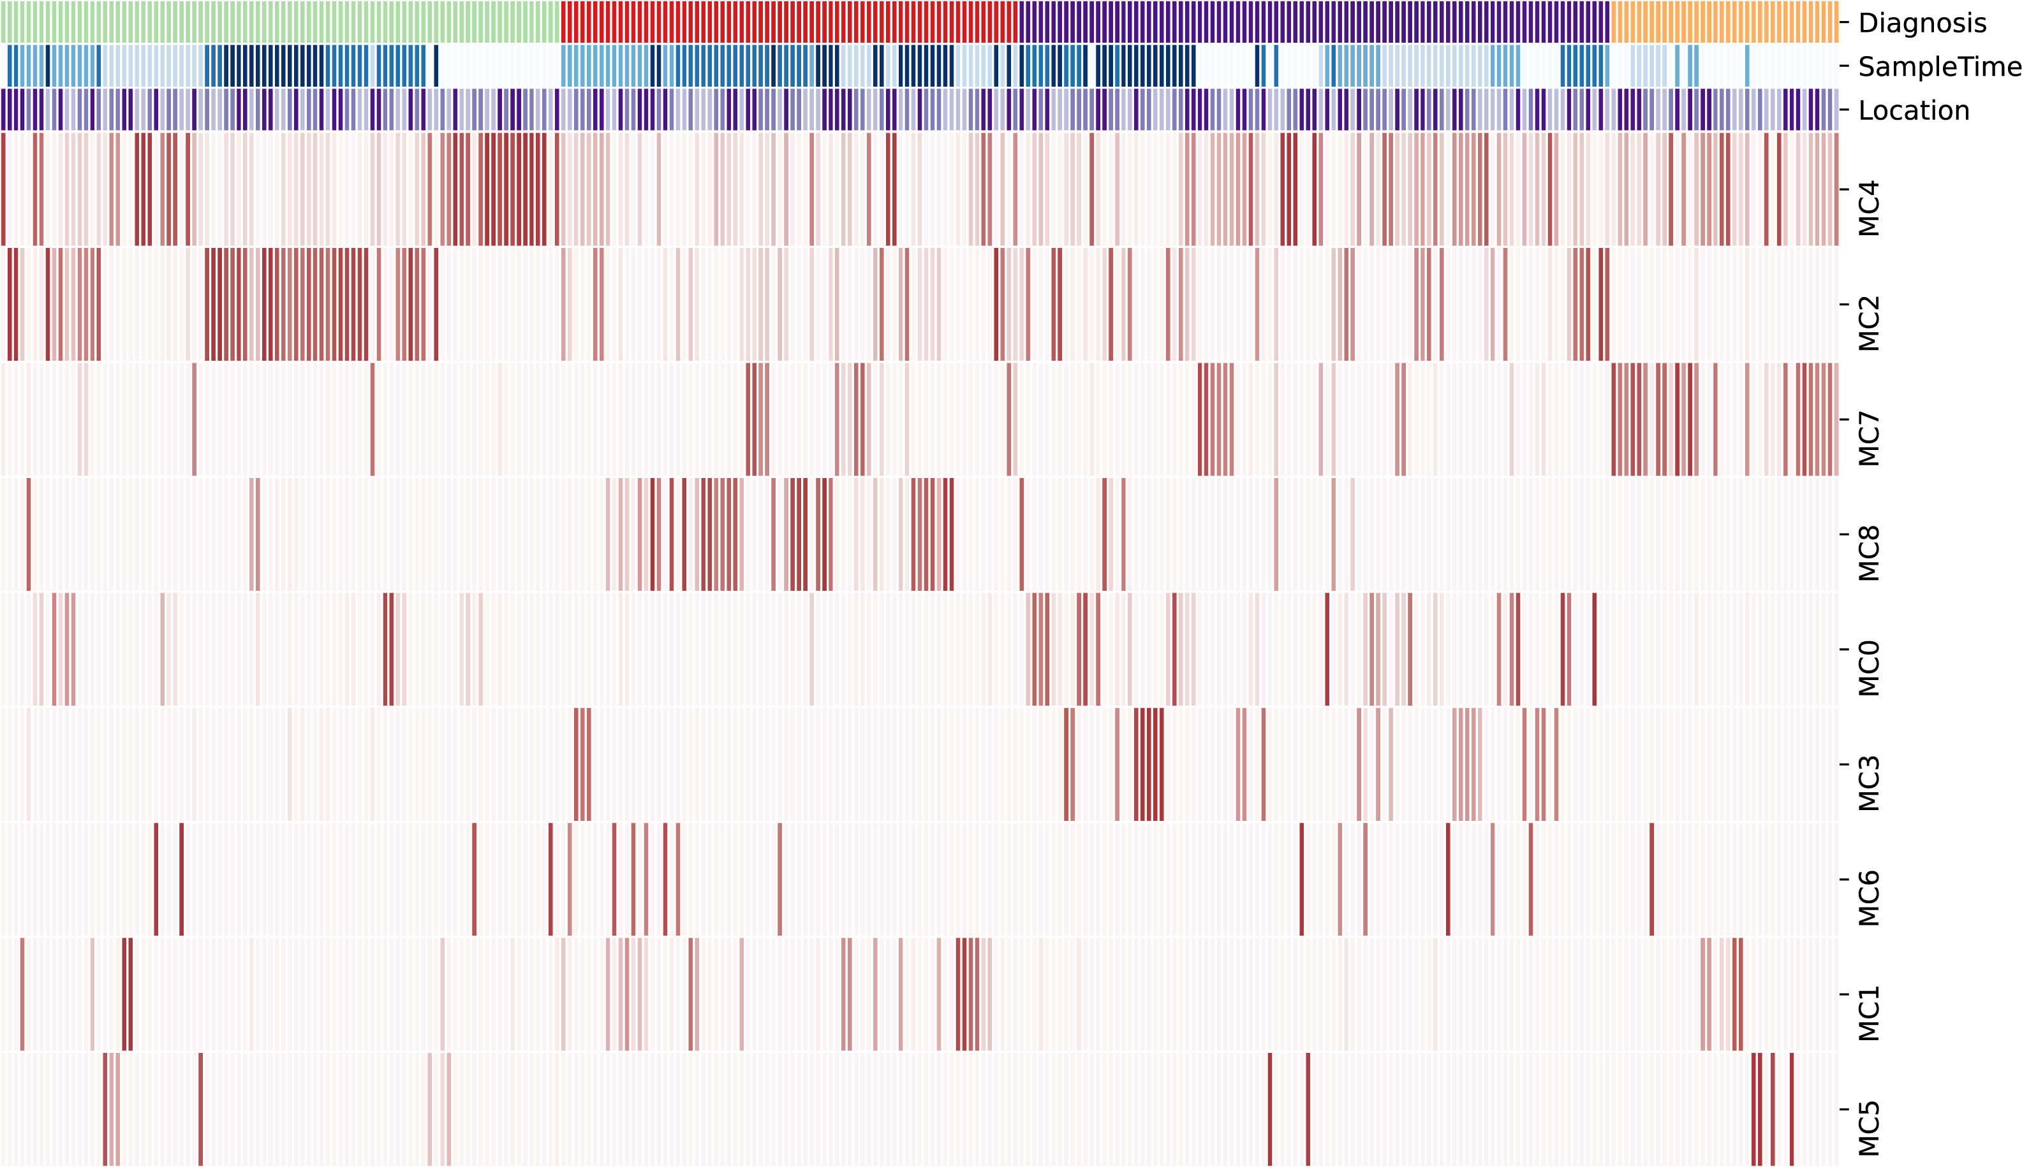
Fig. 1: Sample-MC heatmap ordered by Diagnosis. Sharing legend with Fig. 3 in the main manuscript.
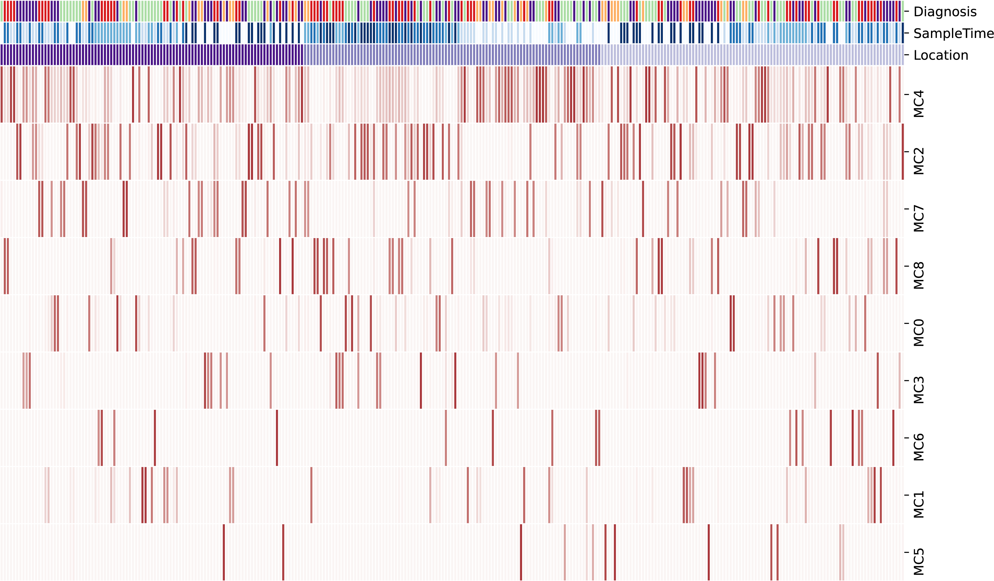
Fig. 2 : Sample-MC heatmap ordered by Location. Sharing legend with Fig. 3 in the main manuscript.

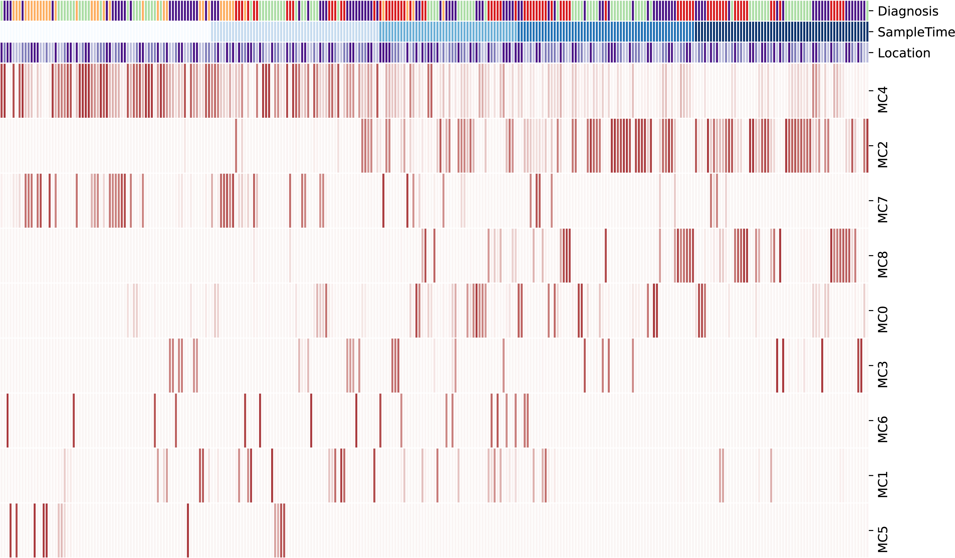
Fig. 3: Sample-MC heatmap ordered by Sample Time point. Sharing legend with Fig. 3 in the main manuscript.

