Supplementary Materials:

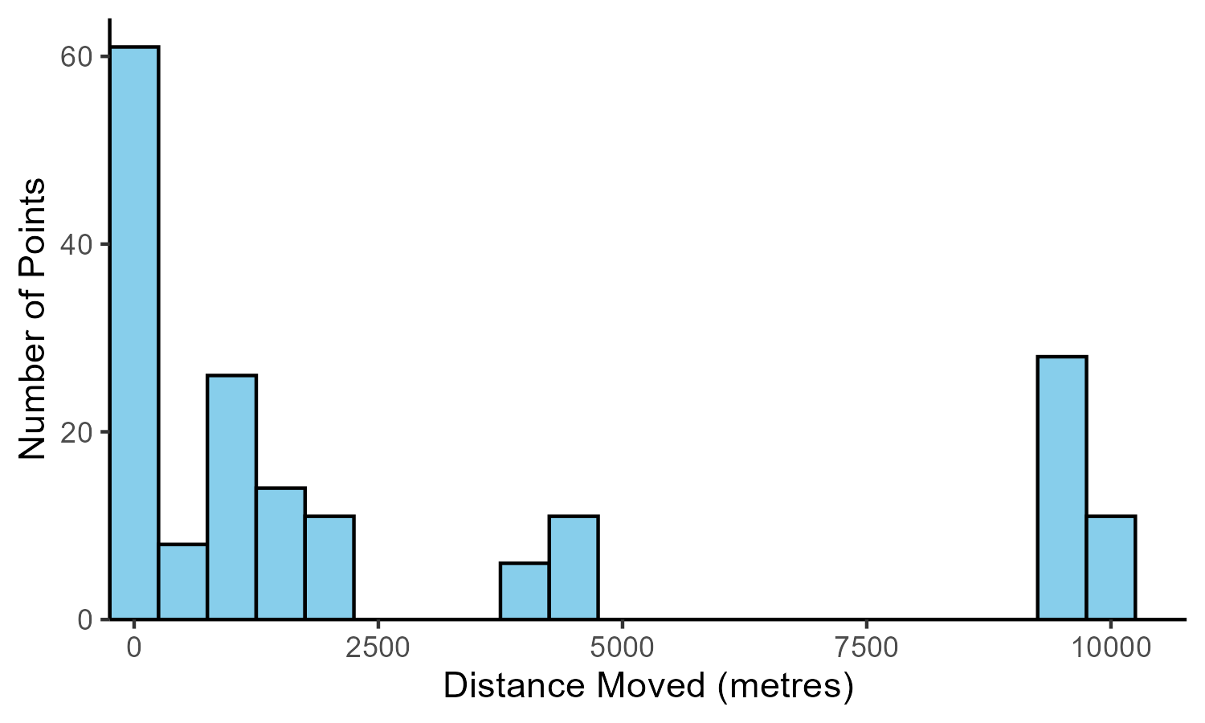
Figure S1. Distribution of distances points were moved to intersect with river data raster. Maximum distance was 10,050m.

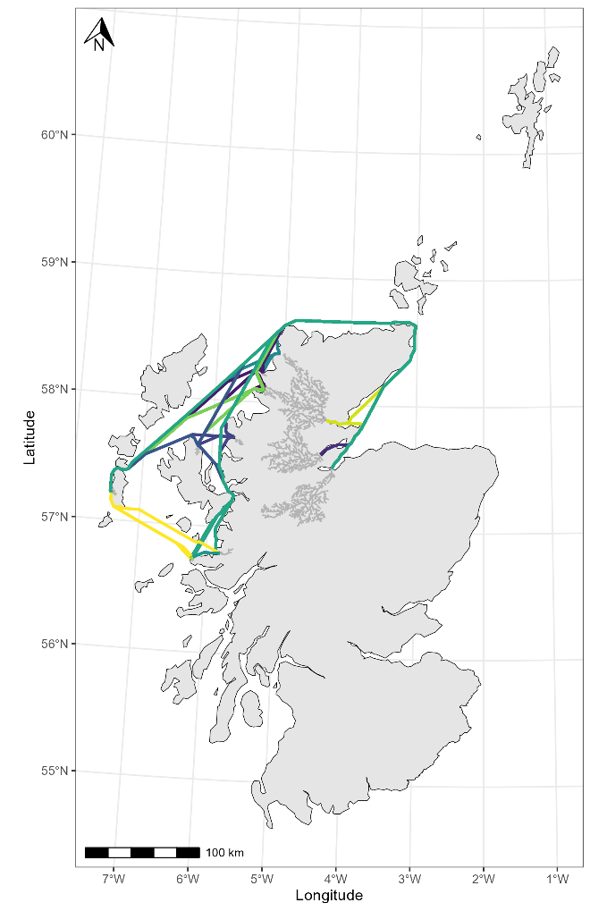
Figure S2. Visualisation of the least-cost paths between sampled Margaritifera margaritifera populations in population genomic analysis. Final measurement of least-cost path includes from sampling location to river mouth. Specific locations of mussels are sensitive due to the risk of pearl-fishing therefore the full river network for each population is depicted here.
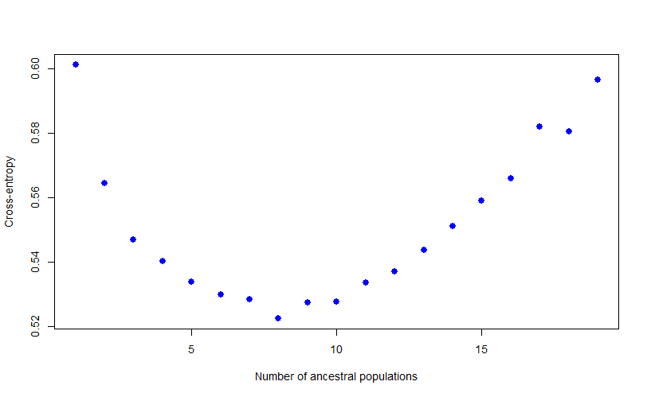
Figure S3. Cross-entropy for sparse non-negative matrix factorisation of 3456 SNPs pruned for linkage-disequilibrium from 156 freshwater pearl mussels collected across Scotland.
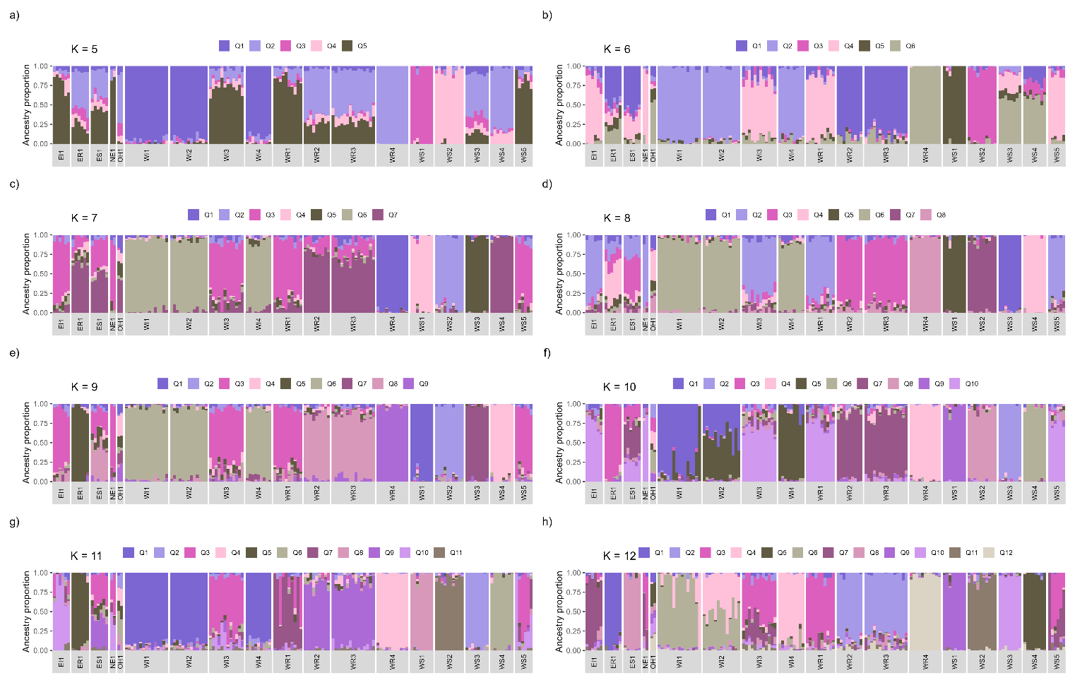
Figure S4. Individual ancestry proportions (N=156 Margaritifera margaritifera, 3456 SNPs) calculated by sparse non-negative matrix factorisation, where each bar represents an individual and colour represents ancestry makeup. K=9 had the lowest cross-entropy value of 0.526 (range: 0. 520-0. 538). Individuals are clustered into populations dependant on sampling location. Population names are anonymised by vice-county to retain confidentiality of the specific site. Vice counties are: East Inverness-shire (EI); East Ross (ER); East Sutherland (ES); North Ebudes (NE); Outer Hebrides (OH); West Inverness-shire (WI); West Ross (WR); West Sutherland (WS).
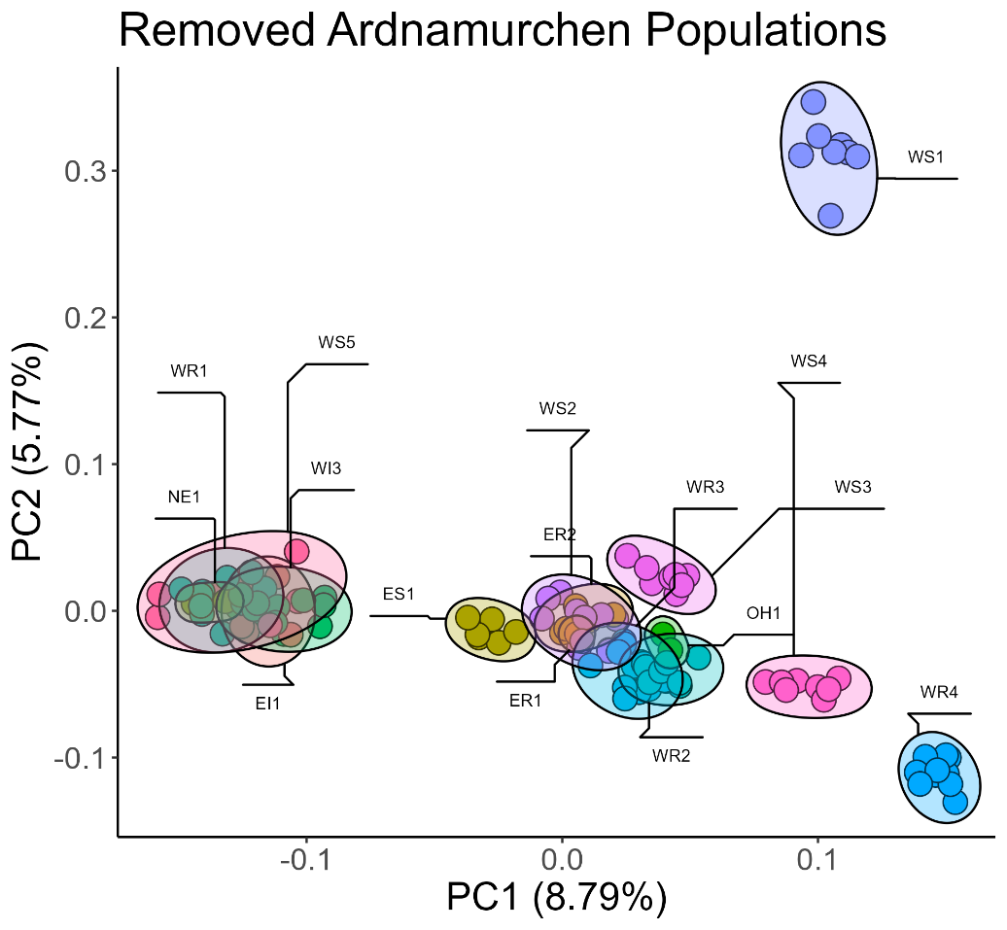
Figure S5. Subset West Inverness-shire populations out of the PCA.

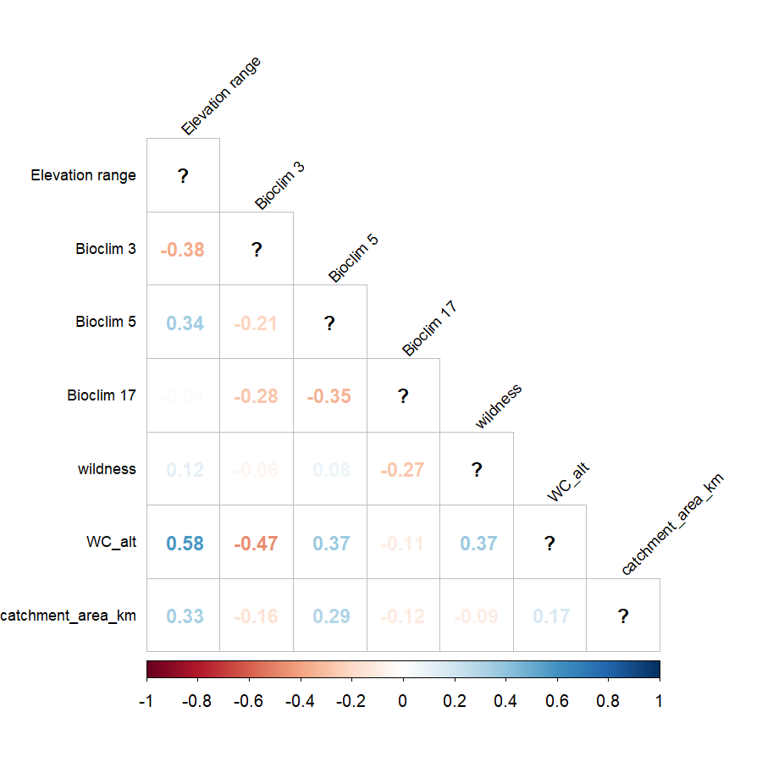
Figure S6. Correlations of predictor variables used in redundancy analysis based on 5486 SNPs across 156 individual Margaritifera margaritifera in Scotland. RDA equation as follows: rda(SNPs ~ elevation range + catchment area + wildness + altitude +BIOCLIM3 (Isothermality, calculated as BIOCLIM2/BIOCLIM7 × 100) + BIOCLIM5 (maximum temperature of the warmest month) + BIOCLIM17 (precipitation of the driest quarter) +Condition(Host).
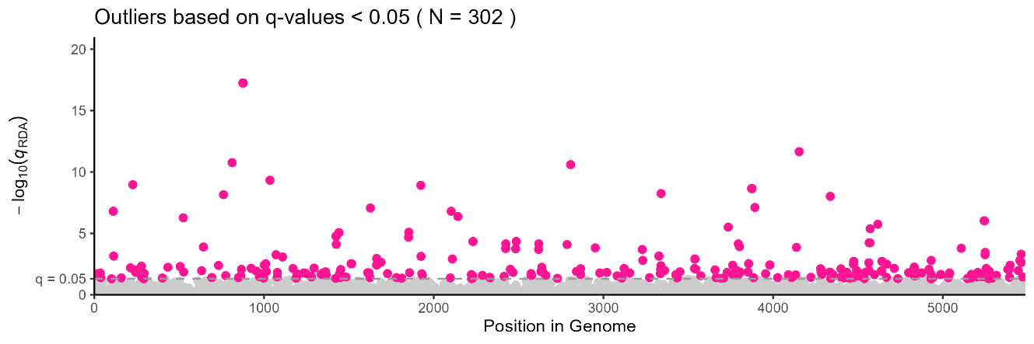
Figure S7. Genome-wide distribution of SNPs along the x-axis and -log10(q.values) from redundancy analysis based on 5486 SNPs across 156 individual Margaritifera margaritifera in Scotland. RDA equation as follows: rda(SNPs ~ elevation range + catchment area + wildness + altitude +BIOCLIM3 (Isothermality, calculated as BIOCLIM2/BIOCLIM7 × 100) + BIOCLIM5 (maximum temperature of the warmest month) + BIOCLIM17 (precipitation of the driest quarter) +Condition(Host). Grey dots represent neutral SNPs whereas pink dots represent 302 outlier SNPs with q-values <0.05, in other words a false positive rate of 5%. Grey dotted line is at q=0.05.

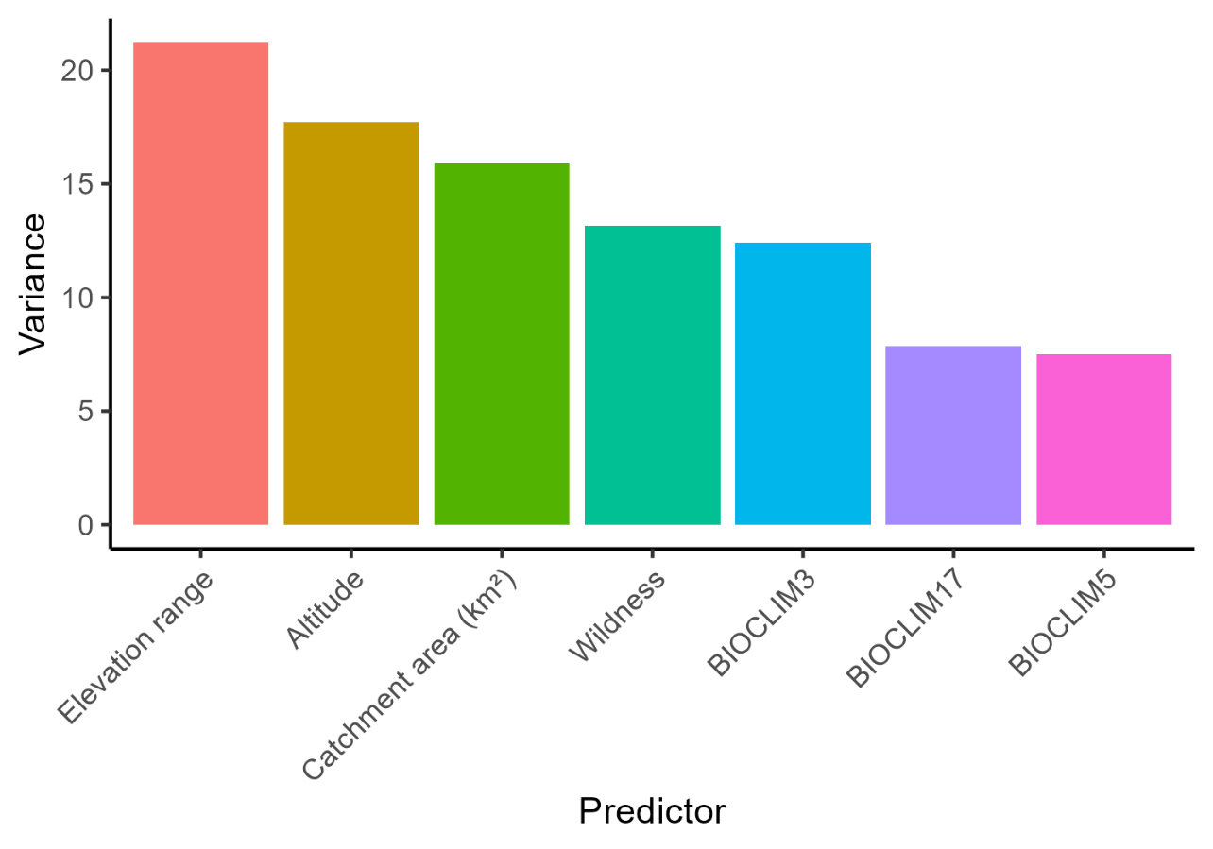
Figure S8. Proportional variance explained by terms in an RDA model based on 302 outlier SNPs across 156 individuals Margaritifera margaritifera in Scotland. RDA equation as follows: rda(outlier.SNPs ~ elevation range + catchment area + wildness + altitude +BIOCLIM3 (Isothermality, calculated as BIOCLIM2/BIOCLIM7 × 100) + BIOCLIM5 (maximum temperature of the warmest month) + BIOCLIM17 (precipitation of the driest quarter) +Condition(Host)

Population | Q1 | Q2 | Q3 | Q4 | Q5 | Q6 | Q7 | Q8 | Q9 | Ancestry >75%
EI1 | 0.67 | 3.56 | 3.05 | 2.40 | 5.44 | 1.61 | 0.85 | 76.8 | 5.60 | Q8
ER1 | 0.71 | 0.01 | 1.22 | 1.92 | 0.01 | 1.94 | 93.44 | 0.01 | 0.74 | Q7
ES1 | 1.95 | 1.44 | 0.9 | 4.11 | 42.31 | 1.80 | 16.64 | 24.53 | 6.32 | Mixed
NE1 | 1.61 | 2.02 | 5.84 | 0.01 | 1.72 | 0.01 | 4.1 | 84.25 | 0.44 | Q8
OH1 | 22.29 | 4.57 | 15.51 | 12.98 | 1.21 | 24.64 | 15.46 | 0.01 | 3.32 | Mixed
WI1 | 1.33 | 92.93 | 0.57 | 1.4 | 1.44 | 0.71 | 1.14 | 0.26 | 0.21 | Q2
WI2 | 0.65 | 91.2 | 1.43 | 1.01 | 1.07 | 2.29 | 0.81 | 0.39 | 1.14 | Q2
WI3 | 3.75 | 2.03 | 4.12 | 1.29 | 3.93 | 5.19 | 4.88 | 69.81 | 5.00 | Mixed
WI4 | 0.72 | 86.17 | 4.65 | 1.77 | 1.72 | 2.50 | 0.29 | 0.51 | 1.65 | Q2
WR1 | 1.67 | 1.36 | 3.90 | 3.43 | 4.83 | 2.53 | 3.02 | 77.58 | 1.69 | Q8
WR2 | 4.15 | 0.30 | 2.74 | 2.28 | 83.00 | 3.96 | 1.68 | 0.79 | 1.10 | Q5
WR3 | 4.33 | 1.90 | 2.02 | 2.06 | 81.11 | 2.05 | 2.09 | 2.23 | 2.20 | Q5
WR4 | 96.67 | 0.03 | 0.33 | 0.43 | 0.83 | 0.51 | 0.39 | 0.41 | 0.40 | Q1
WS1 | 0.87 | 0.29 | 0.37 | 95.48 | 0.01 | 1.14 | 0.04 | 0.78 | 1.02 | Q4
WS2 | 1.27 | 1.46 | 0.46 | 1.12 | 1.43 | 0.32 | 2.03 | 0.33 | 91.59 | Q9
WS3 | 1.37 | 0.26 | 95.76 | 0.51 | 0.14 | 0.35 | 1.15 | 0.35 | 0.11 | Q3
WS4 | 1.01 | 0.92 | 0.07 | 0.29 | 1.09 | 95.35 | 0.69 | 0.06 | 0.52 | Q6
WS5 | 0.77 | 2.21 | 1.96 | 2.33 | 1.78 | 1.84 | 1.2 | 80.72 | 7.19 | Q8
Table S1. Averaged ancestry proportions for each population calculated by sparse non-negative matrix factorisation for N=156 Margarifiera margaritifera, 3456 SNPs. K=9 had the lowest cross-entropy value of 0.526 (range: 0. 520-0. 538). Population names are anonymised by vice-county to retain confidentiality of the specific site. Vice counties are as follows: East Inverness-shire (EI); East Ross (ER); East Sutherland (ES); North Ebudes (NE); Outer Hebrides (OH); West Inverness-shire (WI); West Ross (WR); West Sutherland (WS).

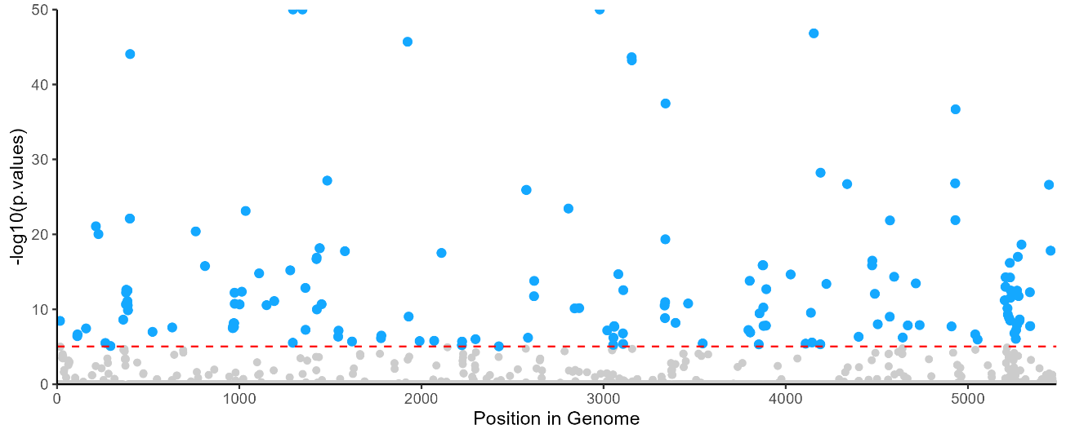
Figure S9. 5486 single nucleotide polymorphisms (SNPs) from Scottish Margaritifera margaritifera against pcadapt (Luu et al. 2017) generated p-values. SNPs are highlighted in blue if they are over a Bonferroni adjusted threshold of 0.05 (red dashed line).

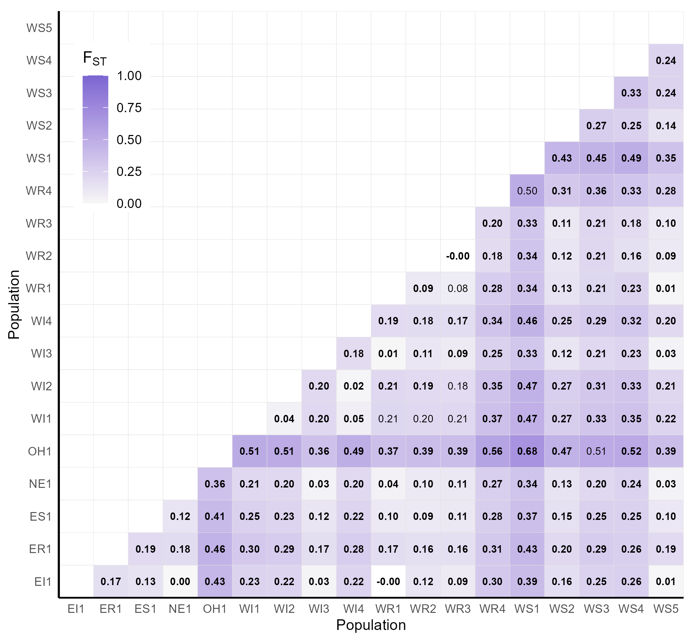
Figure S10. FST based on populations randomly subset to 2 samples each. Bold values are p<0.05

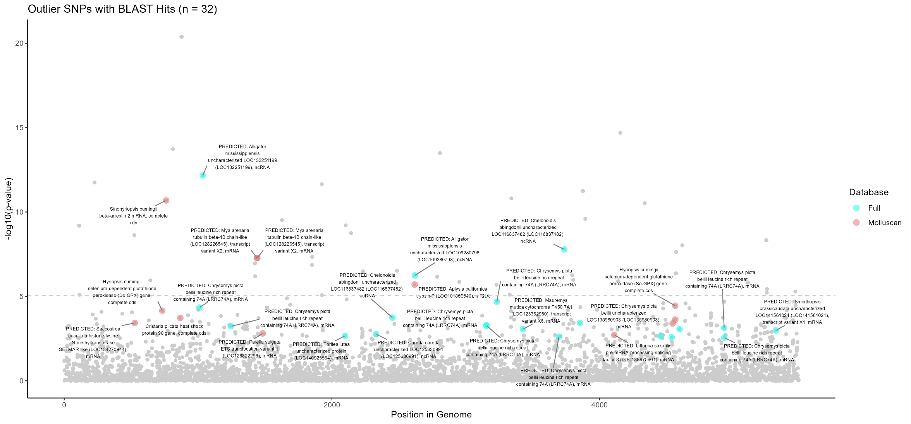
Figure S11. NCBI BLAST results of 1000bp flanks of outlier SNPs in the context of RDA p-values of all 5486 SNPs across 18 M. margaritifera populations. 32 of the 302 outlier SNPs had hits and of those, 12 were of molluscan origin.

Table S2. Filtered BLAST hits (E-value ≤ 1e-5) for 302 RDA outlier SNPs in Margaritifera margaritifera. For each SNP, the top match was retained based on shortest flank length (100/500/1000 bp, “Proximity”) and lowest E-value, with hits from the molluscan database versus the full NCBI nucleotide (nt) prioritised and identified by the “Database” column. Query_ID represents the SNP name its associated flanking region. SNP represents the SNP name in this dataset. Subject_ID provides the identifier for the matched sequence, including the GenInfo identifier, database source (e.g., RefSeq [ref] or GenBank [gb]), and the accession number. Description gives the matching sequence annotation, E-value represents the level of match with the search sequence. P_value is derived from RDA loadings using a Mahalanobis distance-based chi-squared test. Top predictor variable with the highest absolute Pearson correlation coefficient is listed in the Predictor column; corresponding absolute correlation value is shown in the Correlation column.
SNP | Query_ID | Subject_ID | Description | E_value | P-value | Predictor | Absolute correlation | Database | Proximity
scaf1227_1036742_T | scaf1227_1036742_T::JAQPZY010001227.1:1036241-1037242 | gi|2669151899|ref|XM_062753214.1| | PREDICTED: Saccostrea cucullata histone-lysine N-methyltransferase SETMAR-like (LOC134270944), mRNA | 1.817e-11 | 0.000377 | Catchment Area | 0.273 | Molluscan | 500bp
scaf1666_676460_A | scaf1666_676460_A::JAQPZY010001666.1:675959-676960 | gi|333906199|gb|JF412718.1| | Hyriopsis cumingii selenium-dependent glutathione peroxidase (Se-GPX) gene, complete cds | 1.337e-47 | 6.972e-05 | Altitude | 0.527 | Molluscan | 500bp
scaf1666_7864421_T | scaf1666_7864421_T::JAQPZY010001666.1:7863920-7864921 | gi|1199278592|gb|KX824065.1| | Sinohyriopsis cumingii beta-arrestin 2 mRNA, complete cds | 1.766e-31 | 2.054e-11 | BIOCLIM5 | 0.428 | Molluscan | 500bp
scaf1582_2585350_A | scaf1582_2585350_A::JAQPZY010001582.1:2584849-2585850 | gi|595094254|gb|KF997091.1| | Cristaria plicata heat shock protein 90 gene, complete cds | 1.395e-17 | 0.000187 | BIOCLIM3 | 0.253 | Molluscan | 500bp
scaf1264_1189805_A | scaf1264_1189805_A::JAQPZY010001264.1:1189304-1190305 | gi|2739719310|ref|XM_008164907.4| | PREDICTED: Chrysemys picta bellii leucine rich repeat containing 74A (LRRC74A), mRNA | 1.218e-164 | 4.569e-05 | BIOCLIM3 | 0.298 | Full | 500bp
scaf1279_1348607_C | scaf1279_1348607_C::JAQPZY010001279.1:1348106-1349107 | gi|2580404678|ref|XR_009463094.1| | PREDICTED: Alligator mississippiensis uncharacterized LOC132251199 (LOC132251199), ncRNA | 3.484e-145 | 6.844e-13 | BIOCLIM3 | 0.313 | Full | 500bp
scaf1646_2912875_G | scaf1646_2912875_G::JAQPZY010001646.1:2912374-2913375 | gi|2739719310|ref|XM_008164907.4| | PREDICTED: Chrysemys picta bellii leucine rich repeat containing 74A (LRRC74A), mRNA | 8.327e-72 | 0.00059 | Altitude | 0.477 | Full | 500bp
scaf1554_3485386_C | scaf1554_3485386_C::JAQPZY010001554.1:3485285-3485486 | gi|2427456052|ref|XM_052936480.1| | PREDICTED: Mya arenaria tubulin beta-4B chain-like (LOC128226545), transcript variant X2, mRNA | 1.448e-25 | 5.249e-08 | BIOCLIM3 | 0.332 | Molluscan | 100bp
scaf1554_3485425_T | scaf1554_3485425_T::JAQPZY010001554.1:3485324-3485525 | gi|2427456052|ref|XM_052936480.1| | PREDICTED: Mya arenaria tubulin beta-4B chain-like (LOC128226545), transcript variant X2, mRNA | 3.090e-32 | 5.249e-08 | BIOCLIM3 | 0.332 | Molluscan | 100bp
scaf1457_2574556_C | scaf1457_2574556_C::JAQPZY010001457.1:2574055-2575056 | gi|2506331227|ref|XM_050551096.2| | PREDICTED: Patella vulgata ETS translocation variant 1 (LOC126822296), mRNA | 6.352e-31 | 0.001566 | Elevation Range | 0.222 | Molluscan | 500bp
scaf1119_375430_G | scaf1119_375430_G::JAQPZY010001119.1:374429-376430 | gi|2960424137|ref|XM_073375497.1| | PREDICTED: Porites lutea uncharacterized protein (LOC140925564), mRNA | 1.817e-11 | 0.00216 | BIOCLIM17 | 0.173 | Full | 1000bp
scaf0933_662787_C | scaf0933_662787_C::JAQPZY010000933.1:662286-663287 | gi|2263229029|ref|XR_007354850.1| | PREDICTED: Caretta caretta uncharacterized LOC125630991 (LOC125630991), ncRNA | 1.496e-19 | 0.001726 | BIOCLIM3 | 0.384 | Full | 500bp
scaf1260_20211_T | scaf1260_20211_T::JAQPZY010001260.1:19710-20711 | gi|3018996564|ref|XR_004376704.2| | PREDICTED: Chelonoidis abingdonii uncharacterized LOC116837482 (LOC116837482), ncRNA | 1.307e-114 | 0.00018 | BIOCLIM3 | 0.471 | Full | 500bp
scaf1508_3148850_G | scaf1508_3148850_G::JAQPZY010001508.1:3147849-3149850 | gi|871214176|ref|XM_013079188.1| | PREDICTED: Aplysia californica trypsin-7 (LOC101855546), mRNA | 3.660e-31 | 1.981e-06 | BIOCLIM5 | 0.256 | Molluscan | 1000bp
scaf1508_3148961_T | scaf1508_3148961_T::JAQPZY010001508.1:3148860-3149061 | gi|2580385100|ref|XR_002087217.2| | PREDICTED: Alligator mississippiensis uncharacterized LOC109280798 (LOC109280798), ncRNA | 6.927e-41 | 5.68e-07 | BIOCLIM5 | 0.255 | Full | 100bp
scaf1671_8070694_G | scaf1671_8070694_G::JAQPZY010001671.1:8070193-8071194 | gi|2739719310|ref|XM_008164907.4| | PREDICTED: Chrysemys picta bellii leucine rich repeat containing 74A (LRRC74A), mRNA | 0.000e+00 | 0.000531 | Catchment Area | 0.215 | Full | 500bp
scaf1671_8070714_C | scaf1671_8070714_C::JAQPZY010001671.1:8070213-8071214 | gi|2739719310|ref|XM_008164907.4| | PREDICTED: Chrysemys picta bellii leucine rich repeat containing 74A (LRRC74A), mRNA | 0.000e+00 | 0.000531 | Catchment Area | 0.215 | Full | 500bp
scaf1377_1110708_A | scaf1377_1110708_A::JAQPZY010001377.1:1110207-1111208 | gi|2739719310|ref|XM_008164907.4| | PREDICTED: Chrysemys picta bellii leucine rich repeat containing 74A (LRRC74A), mRNA | 0.000e+00 | 2.062e-05 | Wildness Index | 0.27 | Full | 500bp
scaf1293_672002_A | scaf1293_672002_A::JAQPZY010001293.1:671901-672102 | gi|2129504297|ref|XM_045003589.1| | PREDICTED: Mauremys mutica cytochrome P450 7A1 (LOC123362980), transcript variant X6, mRNA | 7.176e-16 | 0.000876 | BIOCLIM3 | 0.232 | Full | 100bp
scaf1389_703561_G | scaf1389_703561_G::JAQPZY010001389.1:703460-703661 | gi|2739719310|ref|XM_008164907.4| | PREDICTED: Chrysemys picta bellii leucine rich repeat containing 74A (LRRC74A), mRNA | 3.155e-54 | 0.00245 | Altitude | 0.433 | Full | 100bp
scaf0809_437852_T | scaf0809_437852_T::JAQPZY010000809.1:436851-438852 | gi|1820709337|ref|XR_004376704.1| | PREDICTED: Chelonoidis abingdonii uncharacterized LOC116837482 (LOC116837482), ncRNA | 7.987e-50 | 1.641e-08 | BIOCLIM5 | 0.229 | Full | 1000bp
scaf0948_472202_T | scaf0948_472202_T::JAQPZY010000948.1:471701-472702 | gi|2739616589|ref|XR_010597830.1| | PREDICTED: Chrysemys picta bellii uncharacterized LOC135980903 (LOC135980903), ncRNA | 7.436e-152 | 0.000373 | BIOCLIM5 | 0.26 | Full | 500bp
scaf1151_978085_G | scaf1151_978085_G::JAQPZY010001151.1:977084-979085 | gi|2868689553|ref|XM_070348318.1| | PREDICTED: Littorina saxatilis pre-mRNA-processing-splicing factor 8 (LOC138975601), mRNA | 9.893e-52 | 0.001928 | BIOCLIM3 | 0.425 | Molluscan | 1000bp
scaf1604_1600255_A | scaf1604_1600255_A::JAQPZY010001604.1:1599754-1600755 | gi|2739719310|ref|XM_008164907.4| | PREDICTED: Chrysemys picta bellii leucine rich repeat containing 74A (LRRC74A), mRNA | 3.363e-170 | 0.002294 | Elevation Range | 0.317 | Full | 500bp
scaf1556_3856035_A | scaf1556_3856035_A::JAQPZY010001556.1:3855534-3856535 | gi|2739719310|ref|XM_008164907.4| | PREDICTED: Chrysemys picta bellii leucine rich repeat containing 74A (LRRC74A), mRNA | 0.000e+00 | 0.002649 | BIOCLIM3 | 0.247 | Full | 500bp
scaf1609_5207798_G | scaf1609_5207798_G::JAQPZY010001609.1:5207297-5208298 | gi|333906199|gb|JF412718.1| | Hyriopsis cumingii selenium-dependent glutathione peroxidase (Se-GPX) gene, complete cds | 1.705e-56 | 0.000398 | BIOCLIM3 | 0.239 | Molluscan | 500bp
scaf1699_10054571_T | scaf1699_10054571_T::JAQPZY010001699.1:10053570-10055571 | gi|333906199|gb|JF412718.1| | Hyriopsis cumingii selenium-dependent glutathione peroxidase (Se-GPX) gene, complete cds | 1.262e-60 | 3.553e-05 | BIOCLIM3 | 0.237 | Molluscan | 1000bp
scaf1699_10054620_A | scaf1699_10054620_A::JAQPZY010001699.1:10053619-10055620 | gi|333906199|gb|JF412718.1| | Hyriopsis cumingii selenium-dependent glutathione peroxidase (Se-GPX) gene, complete cds | 1.262e-60 | 0.000236 | BIOCLIM3 | 0.212 | Molluscan | 1000bp
scaf1699_21205447_A | scaf1699_21205447_A::JAQPZY010001699.1:21204946-21205947 | gi|2739719310|ref|XM_008164907.4| | PREDICTED: Chrysemys picta bellii leucine rich repeat containing 74A (LRRC74A), mRNA | 0.000e+00 | 0.000872 | Catchment Area | 0.37 | Full | 500bp
scaf1504_2299173_A | scaf1504_2299173_A::JAQPZY010001504.1:2298172-2300173 | gi|2739719310|ref|XM_008164907.4| | PREDICTED: Chrysemys picta bellii leucine rich repeat containing 74A (LRRC74A), mRNA | 0.000e+00 | 0.000729 | Altitude | 0.202 | Full | 1000bp
scaf1504_2299177_A | scaf1504_2299177_A::JAQPZY010001504.1:2298176-2300177 | gi|2739719310|ref|XM_008164907.4| | PREDICTED: Chrysemys picta bellii leucine rich repeat containing 74A (LRRC74A), mRNA | 0.000e+00 | 0.002743 | Elevation Range | 0.189 | Full | 1000bp
scaf1669_2784911_T | scaf1669_2784911_T::JAQPZY010001669.1:2784410-2785411 | gi|2990512829|ref|XM_074299964.1| | PREDICTED: Sminthopsis crassicaudata uncharacterized LOC141561024 (LOC141561024), transcript variant X1, mRNA | 1.962e-08 | 0.001044 | Catchment Area | 0.197 | Full | 500bp

Table S3. Comparative table using previous SNP-based studies. Data from Massachusetts comes from Farrington et al. (2020) and Iberian Peninsula comes from Perea et al. (2022)
Metric | Massachusetts | Iberian Peninsula | Scotland
Sample size | 59 | 130 | 156
Geographic sites | 6 | 26 | 18
Number of SNPs used | 300 | 31,692 | 5,432
Ancestral populations (K) | 1 | 3 | 9
F_{ST} | 0.00-0.14 | 0.17-0.22 | 0.00-0.14
H_{O} (Observed Het.) | 0.161-0.266 | 0.045-0.066 | 0.050-0.267
H_{E} (Expected Het.) | 0.157-0.202 | 0.043-0.059 | 0.035-0.248
Private alleles | None | 25-225 | 576-3161
F_{IS} (Inbreeding) | 0.322 | -0.015-0.004 | -0.047-0.262
Isolation by distance | Absent | Present | Absent
Nucleotide diversity (π) | Not reported | 0.045-0.059 | 0.017-0.124

