Table 1. Baseline Characteristics of Participants
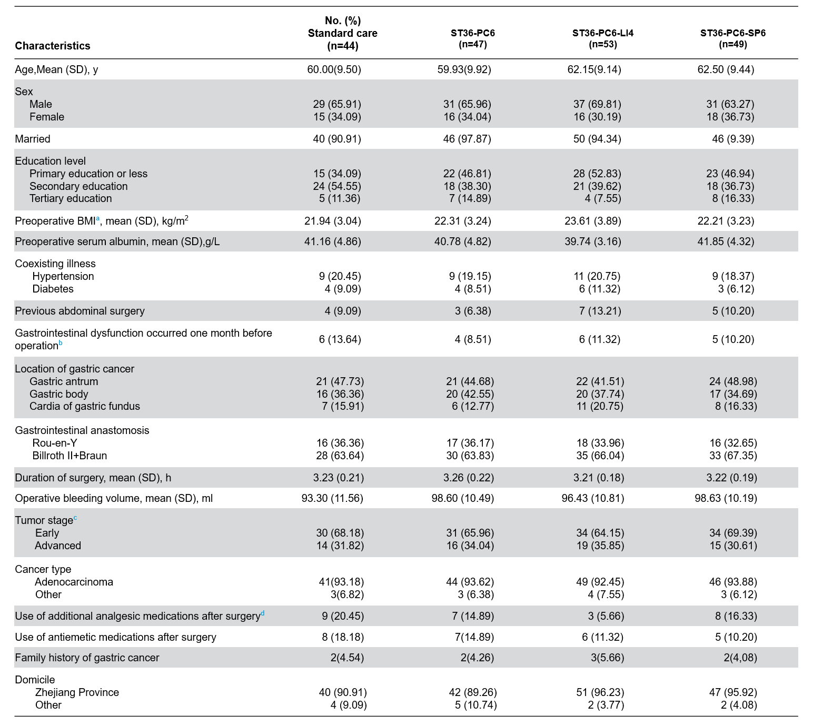 ªBMI, body mass index.
^{b}Preoperative gastrointestinal disturbances primarily included nausea, vomiting, abdominal distension, and constipation, with symptom documentation standardized for the 30-day period preceding surgery.
^{c}The early-stage tumor classification comprises Stage I and Stage II, the advanced-stage classification comprises Stage III.
^{d}All enrolled participants received standardized postoperative analgesia comprising a patient-controlled analgesia (PCA) pump loaded with ropivacaine hydrochloride (375 mg) and parecoxib sodium powder injection (40 mg twice daily via intravenous administration). Supplemental analgesic use was systematically recorded.
No statistically significant differences in baseline characteristics were observed between groups (all P value > 0.05).

Table 2. Primary Outcome and Secondary Outcomes
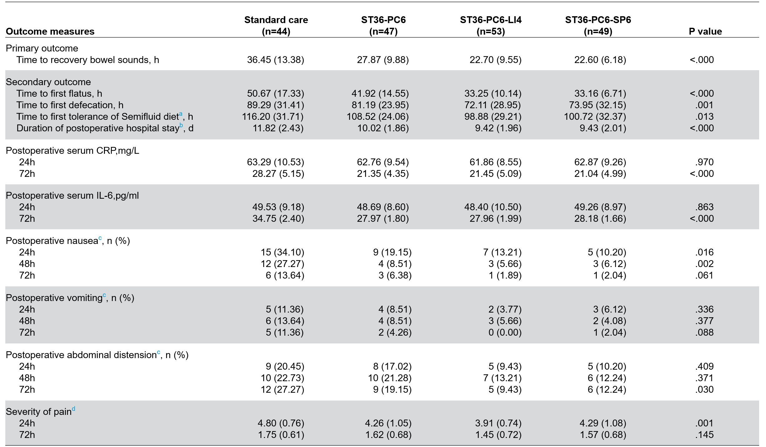
All values are presented as mean (standard deviation, SD) unless otherwise specified. Multiple pairwise comparisons were controlled via the Bonferroni correction to maintain the family-wise error rate. Categorical variables were assessed using chi-square tests or Fisher's exact test (as appropriate based on expected cell frequencies).
ªThe participants were required to document the precise timing of their initial postoperative semi-liquid diet intake. Tolerance to the semi-liquid diet was determined if no signs of nausea or vomiting manifested within a 4-hour observation window following ingestion.
^{b}The postoperative hospital stay duration was defined as the interval spanning from the completion of laparoscopic surgery to formal patient discharge.
^{c}Patients were required to submit regular self-reports detailing the occurrence and timing of postoperative nausea, vomiting, and abdominal distension. The collected data represent the total number of individuals exhibiting any of these three symptoms within specified postoperative time intervals.
^{d}Pain levels were quantified using a standardized 100-mm VAS, with measurements documented in records.

Table 3. Outcomes With Pairwise Comparisons
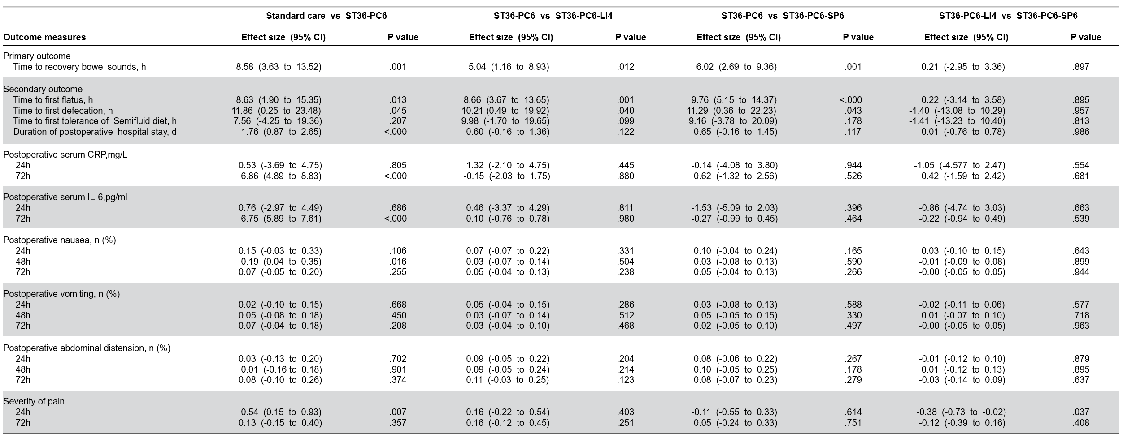
Differences in continuous variables, along with confidence intervals (CIs) and P values, were analyzed using analysis of covariance (ANCOVA) adjusted for Domicile and family history of gastric cancer. Pairwise comparisons were executed following the sequence procedure planned at nominal α level，without further adjustments. Categorical variables with post-hoc pairwise comparisons conducted through marginal effect-based logistic regression models adjusted for domicile and family history of gastric cancer.

