Supplementary Table 1. Location of Acupoints
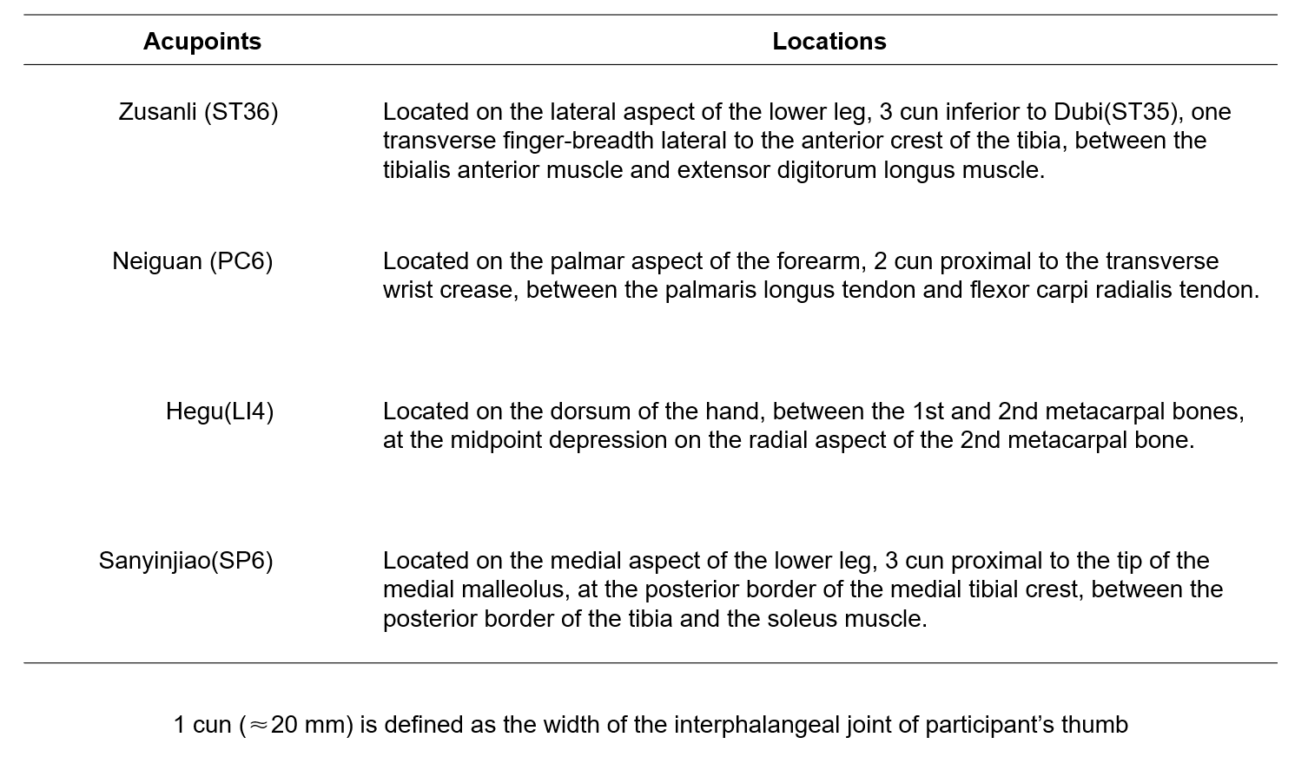

Supplementary Table 2. Univariate and Multivariate Logistic Regression Models
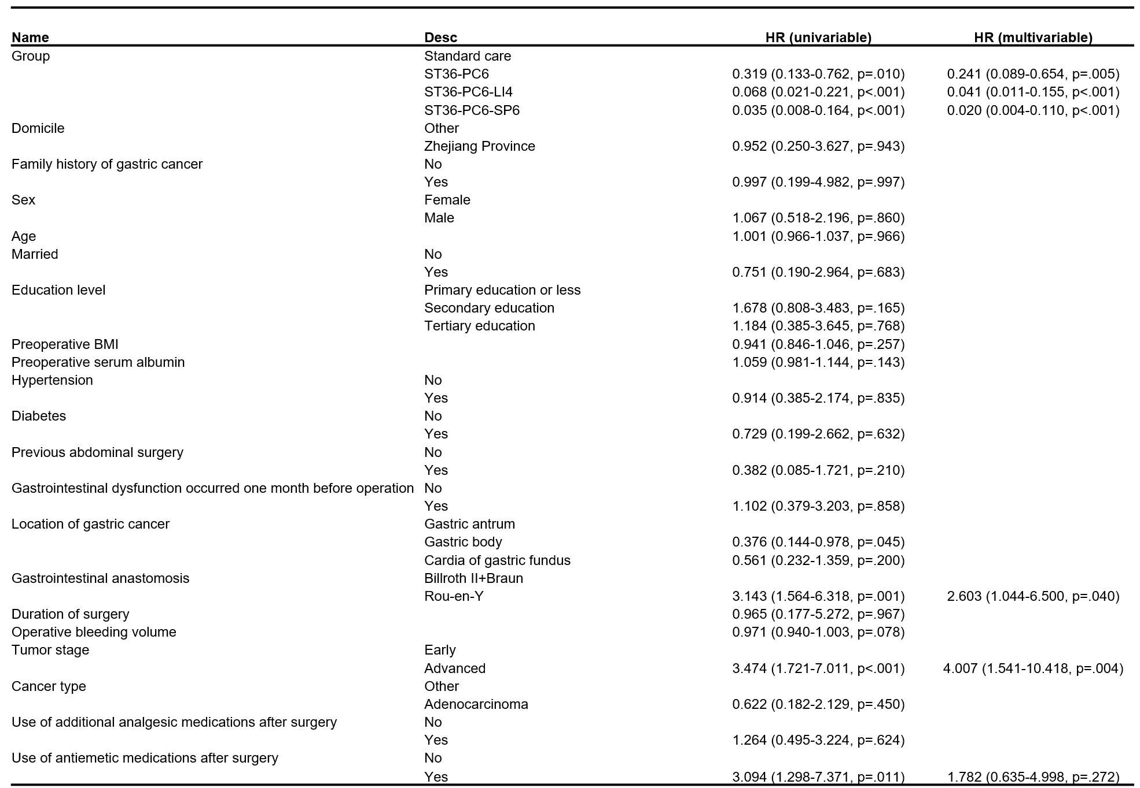
A Logistic regression model incorporating all baseline characteristics and group allocation variables was constructed to identify factors associated with prolonged POI.

Supplementary Table 3. Subgroup Analyses for the Primary Outcome
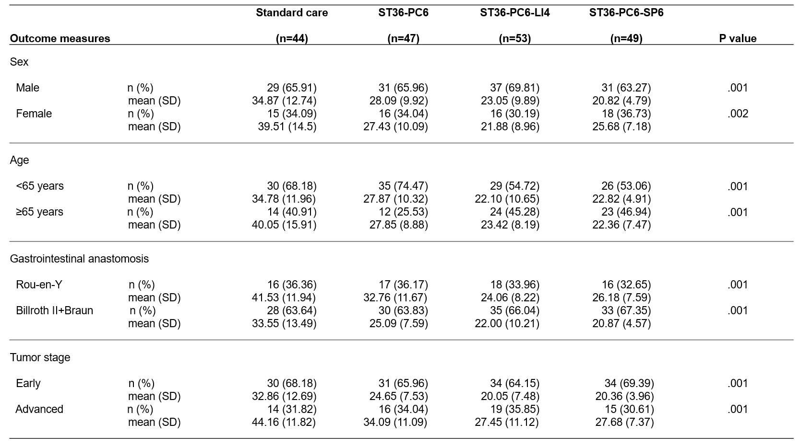
P values, differences, and confidence intervals were based on analysis of covariance adjusted for domicile, family history of gastric cancer. According to fixed sequence procedure planned for primary analyses, pairwise comparisons were made at nominal α level without further adjustment.

Supplementary Table 4. Subgroup Analysis of Paired Comparison
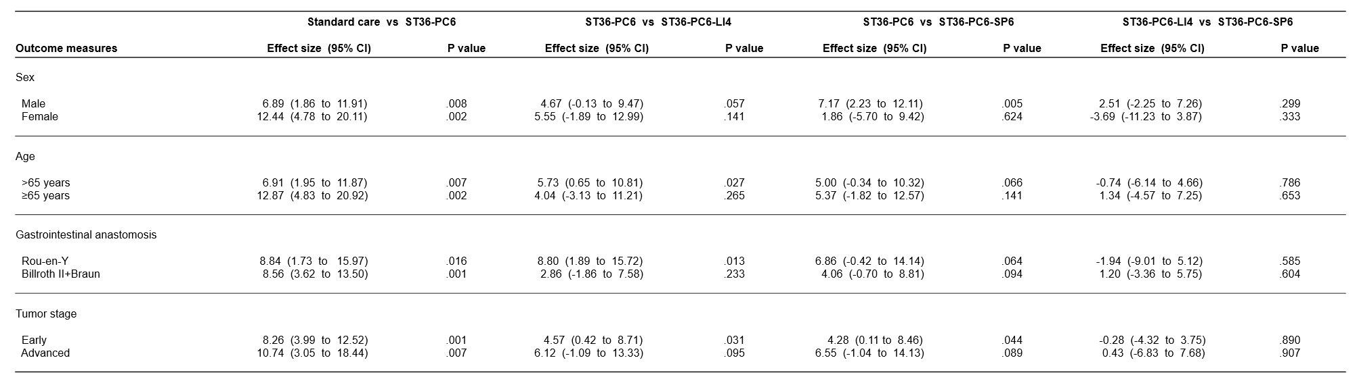
P values, mean differences, and 95% confidence intervals were derived from analysis of covariance (ANCOVA) adjusted for domicile and family history of gastric cancer. Pairwise comparisons were executed following the sequence procedure planned at nominal α level，without further adjustments.

Supplementary Table 5. AEs Related and Unrelated to Treatment 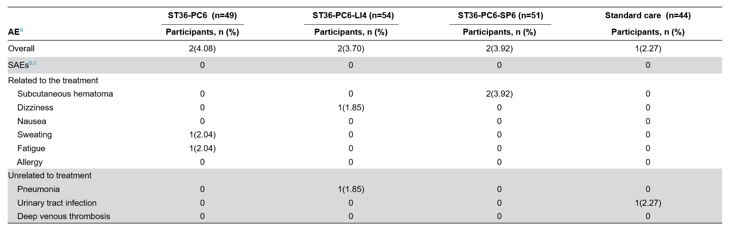
ªAEs for participants were categorized by type rather than frequency. Distinct types of AEs occurring in a single participant were counted as separate events, while recurrent instances of the same AE type within a participant were recorded as a single AE.
^{b}SAE, serious adverse event.
^{c}SAE is defined as an AE that results in hospitalization, surgery, deterioration of preexisting disease, or death.

Supplementary Figure 1. Physical Drawing of Press Needle
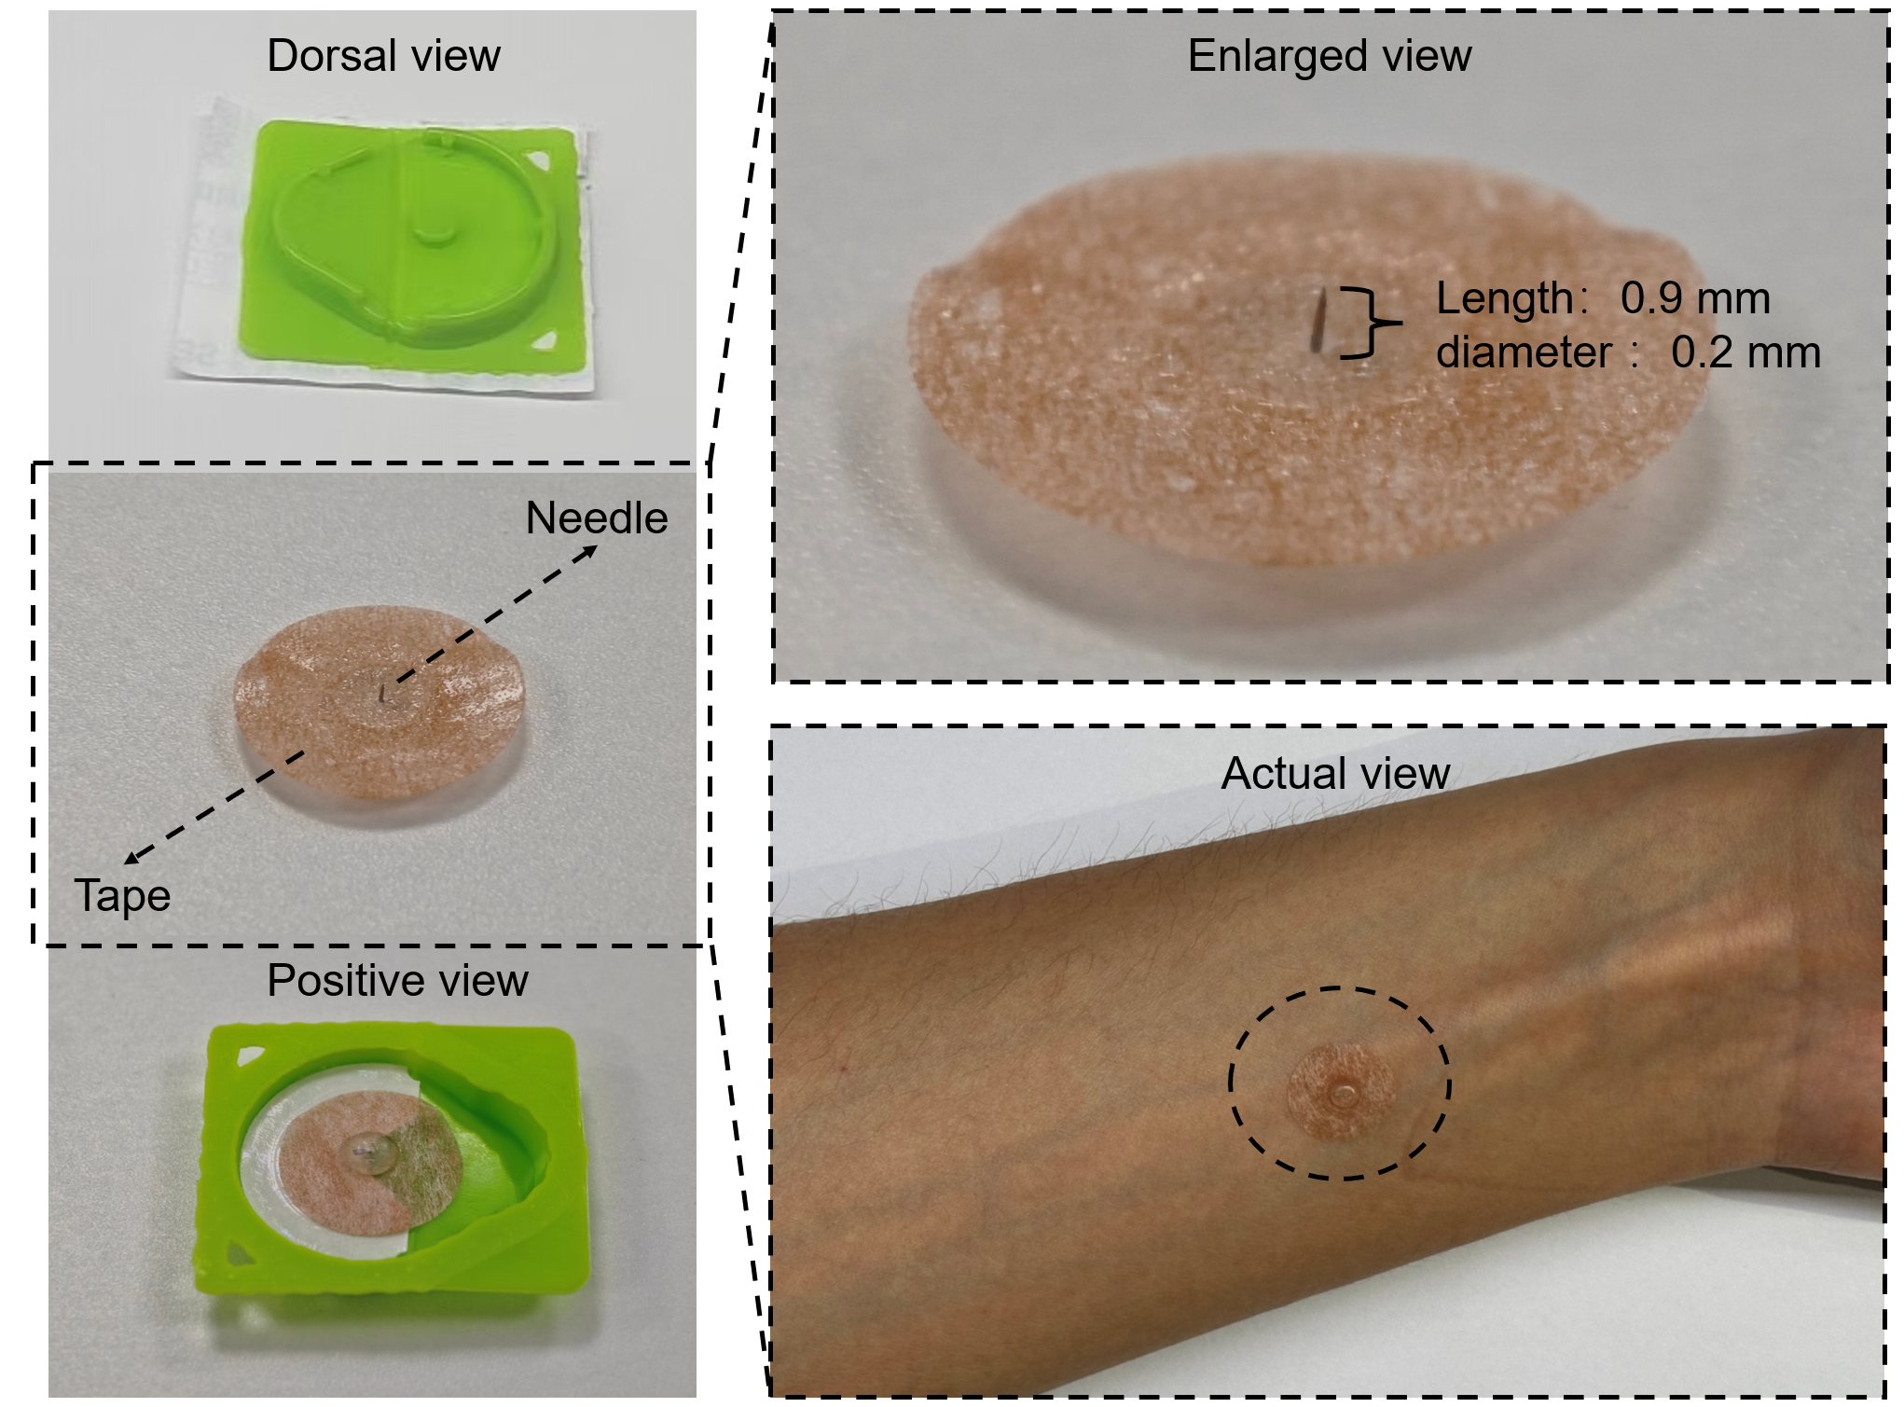

Supplementary Figure 2. Acupoint Locations
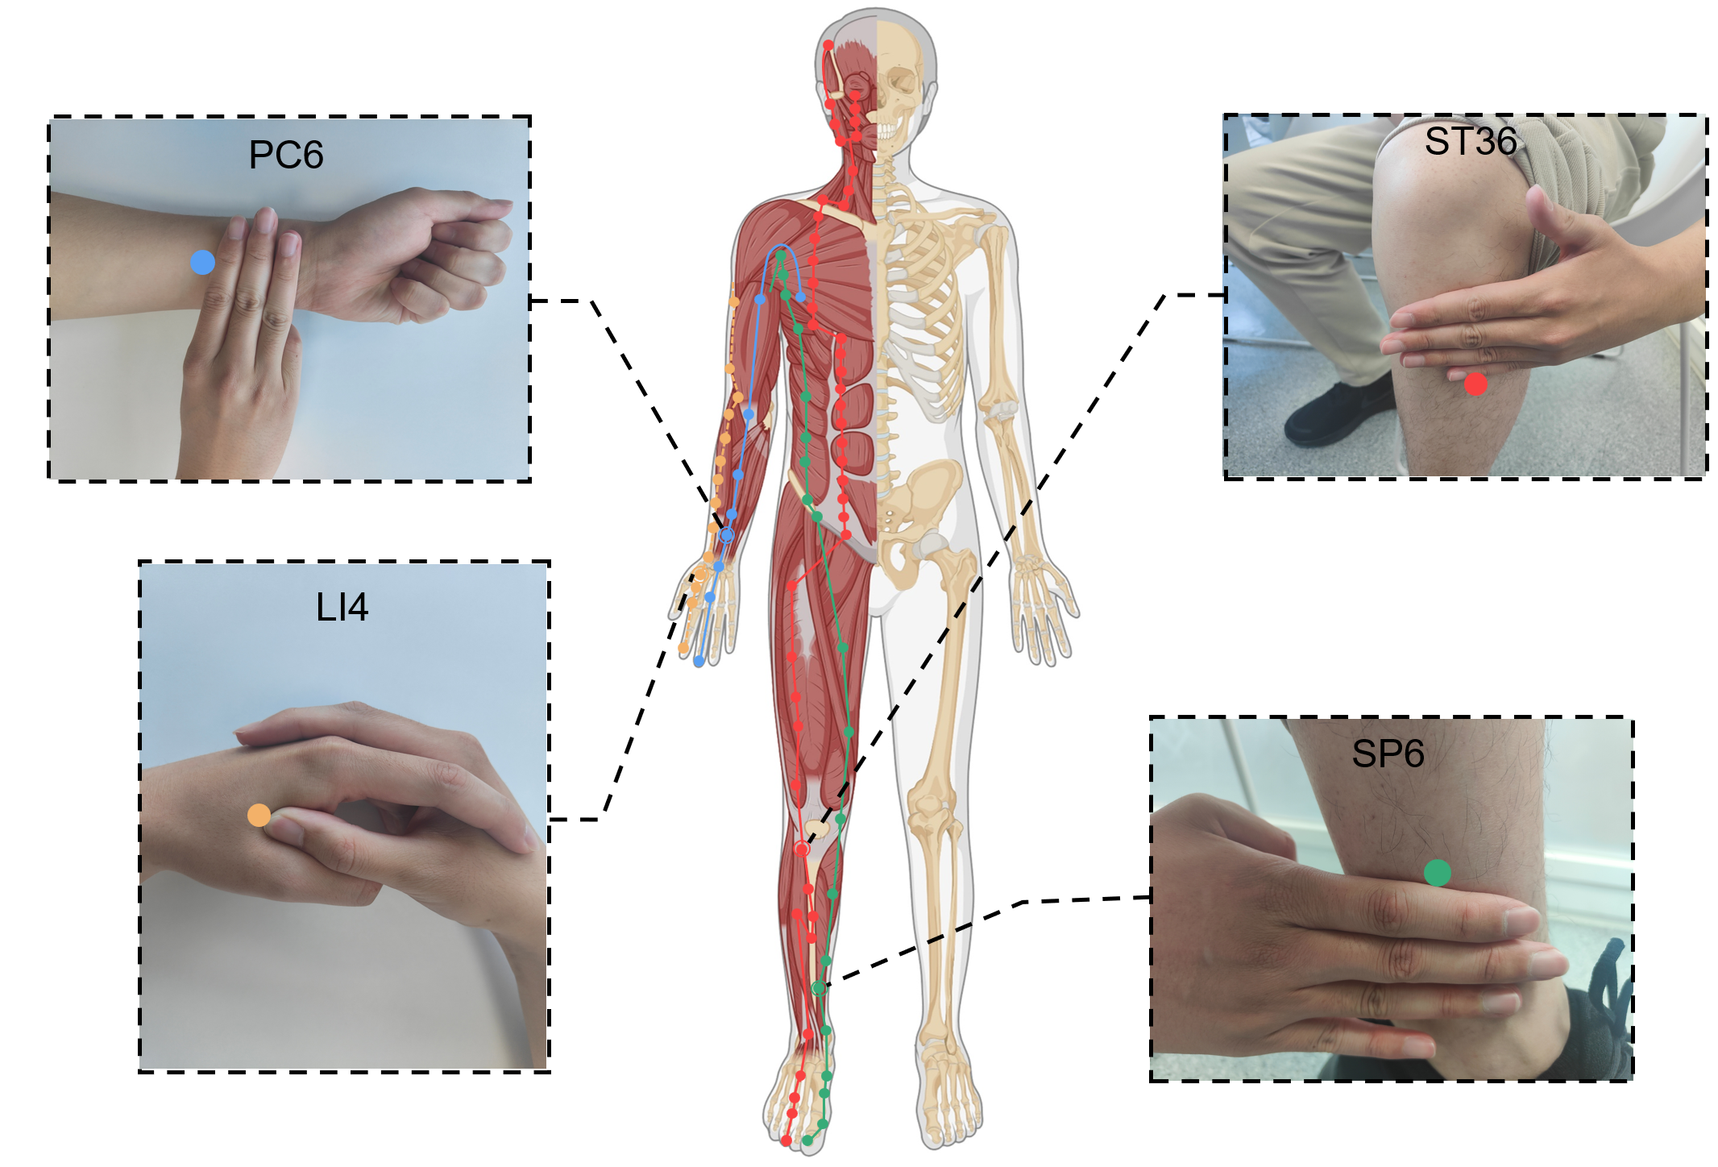

Supplementary Figure 3. Schematic Diagram of Bowel Sounds Monitoring
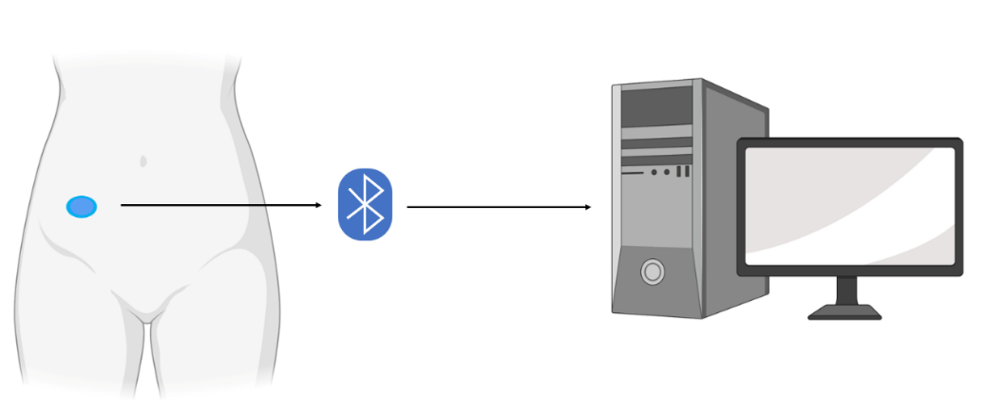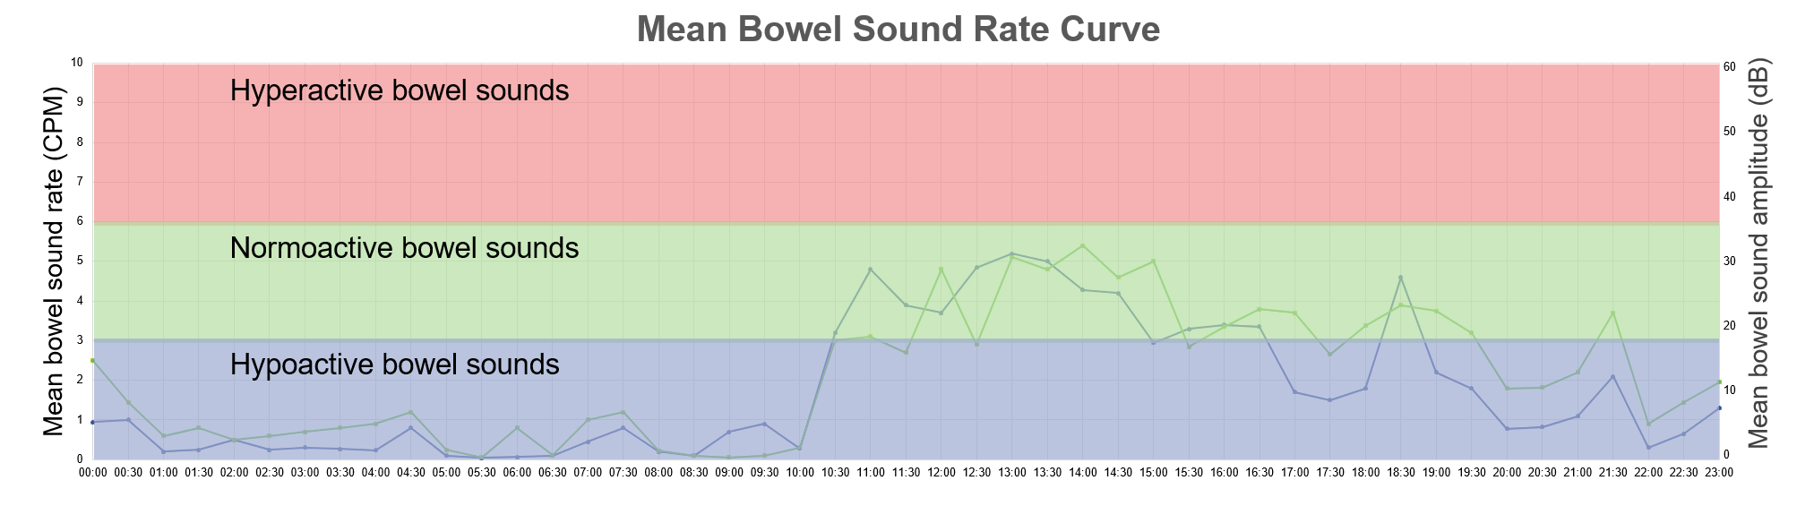
The figure below is a schematic diagram of the continuous auscultation recorder device in use; the figure above shows the results after device analysis, divided into three regions: the red area represents "Hyperactive bowel sounds", the green area represents "Normoactive bowel sounds", and the blue area represents "Hypoactive bowel sounds".
Supplementary Figure 4. Kaplan−Meier Analysis of the Primary Outcome
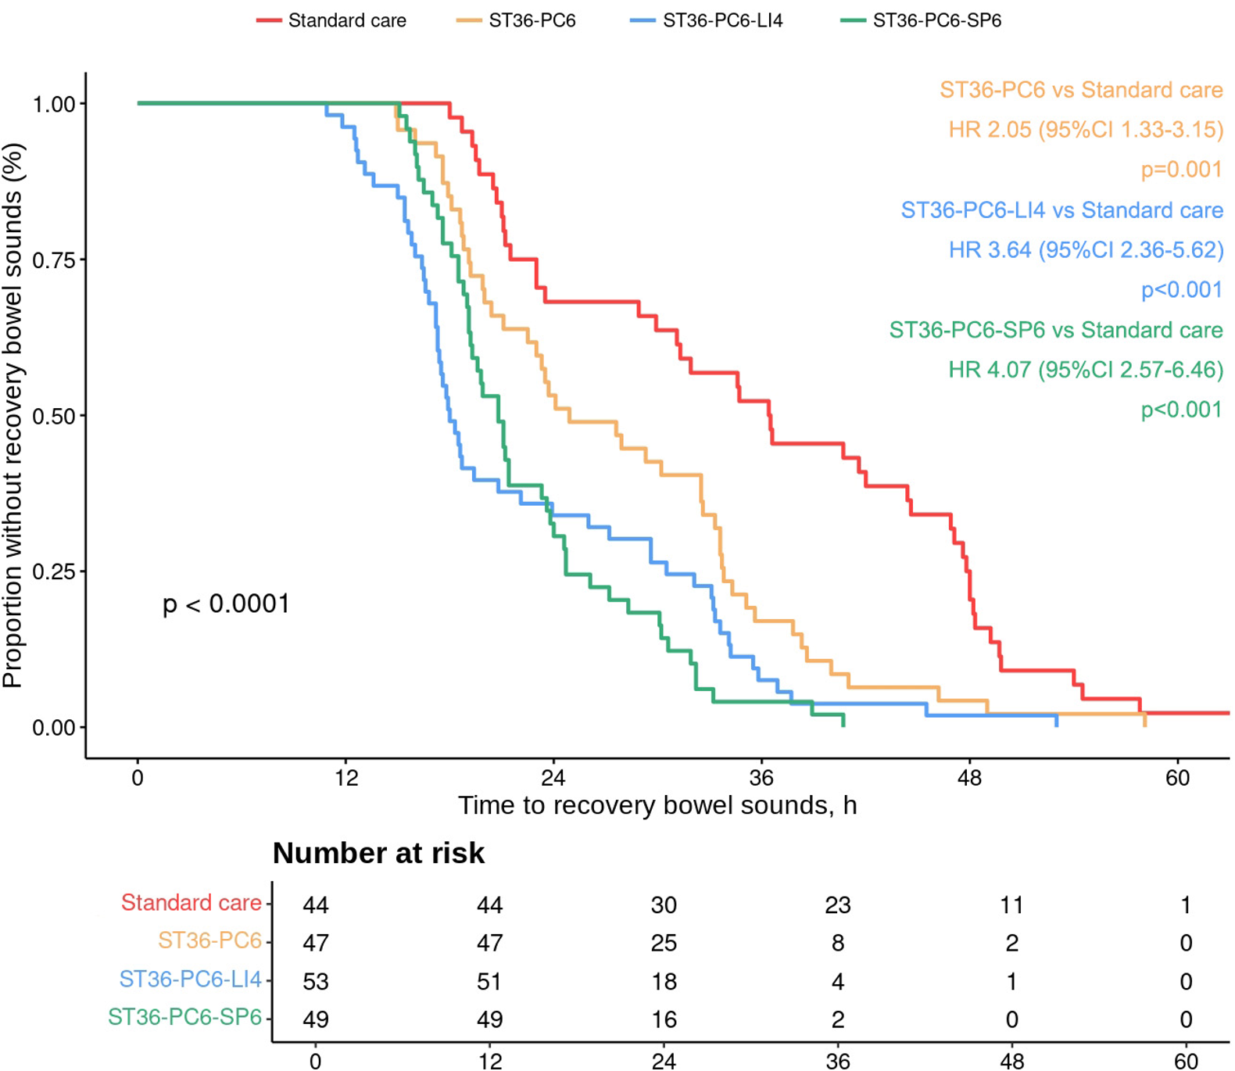
Considering that the primary endpoint was time-dependent and to visualize changes more intuitively, we employed Kaplan-Meier analysis and compared groups using Cox proportional hazards models adjusted for recruitment site and family history of cancer.

