Supporting Information
Spatial Distribution and Time Series Analysis of COVID-19 Pandemic in Italy: A Geospatial Perspective
¹Muhammad Farhan Ul Moazzam, ²Tamkeen Urooj Paracha, ³Ghani Rahman, ¹Byung Gul Lee, ,⁴Nasir Farid,
⁵Adnan Arshad
¹Department of Civil Engineering, College of Ocean Sciences, Jeju National University, Jeju, South Korea
²Department of Pharmacy, Hamdard University, Islamabad, Pakistan
³Department of Geography, University of Gujrat, Gujrat, Pakistan
⁴Department of Geography, University of Peshawar, Peshawar, Pakistan
⁵College of Resources and Environmental Sciences, China Agricultural University, Beijing, China

The Supporting Information (SI) is organized as follows. Section SI 1 shows details of the media frames used for making the animation video about the geographically spread of the disease and its various variables. Section SI 2 show the details of epidemiological data used for time series analysis of various COVID-19 variables. Section SI 3 shows the details about the correlation of population density with different variables of COVID-19 using scatterplot.

A. Data. The present study is based exclusively on publicly available data. The main source of the data is the Italian Civil Protection Department, GitHub repository in which the data related to COVID-19 is updated on daily basis. The database contains the data starting from February 24, 2020 for each region.

The data used in this study was from 2nd March to 3rd June, 2020.

terapia_intensiva patients in ICU
dimessi_guariti cumulative number of recovered patients
deceduti cumulative number of deaths
totale_casi cumulative number of confirmed cases
totale_positivi cumulative number of active cases

Moreover, starting from March. 3rd, 2020, the database used is the cumulative number of confirmed cases, deaths, active cases, recoveries and serious cases which is reported for each Italian region.

B. Geography of COVID-19 spread. The Supporting video 1 (Data animation) is an animation of the maps representing the spread of COVID-19 in Italy at the region level, spanning the time period from March 2nd to June 3rd 2020. The quantity represented the spread of disease with 15-day temporal period for the variables of active cases, serious cases, recovered cases, total deaths and total confirmed cases. The frames of the animation are collected in Fig. SI 1.

C. Time Series Analysis Data. The time series analysis of COVID-19 variables data is publicly available. The main source of the data is the (our world in data) in which the data related to COVID-19 is updated on daily basis. The database contains the data for the whole world including:

Total Cases Daily Cases
Total Deaths Daily Deaths
Total active cases Daily Active Cases
Total Recovered Cases Daily Recovered Cases

The data used for time series analysis in this study was from 24 February to 3rd June 2020.

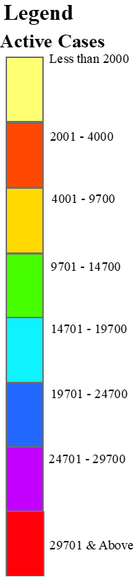
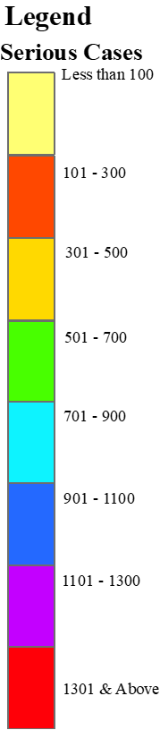
(a)
(b)
(c)

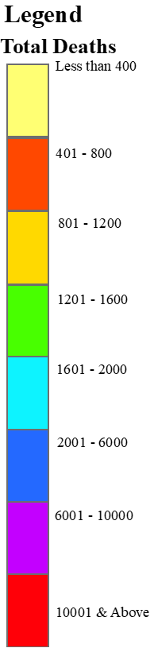
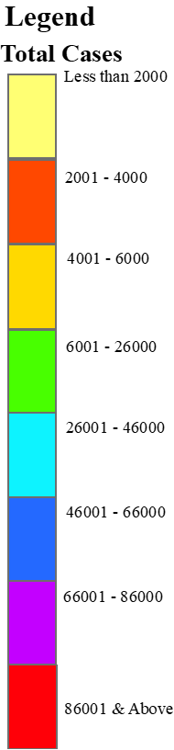
(d)
(e)

Figure SI 1 Frames of media (a) Active coronavirus cases (b) Serious cases (c) Recovered cases (d) Total deaths (e) Total confirmed cases

(a)
(b)
(c)
(d)

Figure SI 2 COVID-19 situation in Italy (a) COVID-19 cases (b) COVID-19 deaths (c) Daily cases and daily recovered cases (d) Daily cases and deaths (e) COVID-19 overview in Italy

(a)
(b)
(c)
(d)

Figure SI 3 Scatterplot between population density and COVID-19 variables (a) Active cases (b) Serious cases (c) Recovered cases (d) Total deaths & (e) Total confirmed cases

