The isomerization characteristics and fundamental physicochemical properties of the molecule
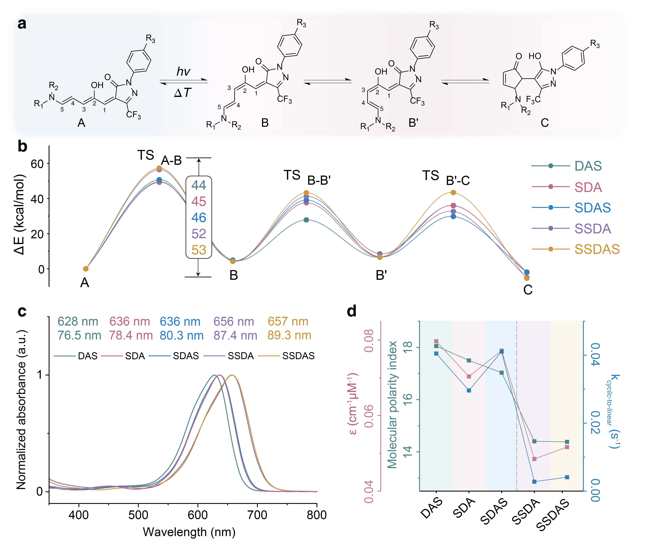
Extended Data Fig. 1 | The spectral and photoisomerization property of DASAs. a Schematic illustration of typical isomerization process between linear and cyclic DASAs. b Calculated energy landscape for the DASAs through the linear-to-cyclic isomerization based on M06-2X/6-311G(d) (Grimme’s D3 dispersion model using the SMD solvent model in TCB (Eps=2.25))⁵⁸⁻⁶². c Normalized absorption spectra of DAS, SDA, SDAS, SSDA, and SSDAS in TCB. The corresponding maximum absorption wavelengths and full width at half maximum (FWHM) values are labelled above each curve. d Calculated molecular polarity index (MPI, green axis on the left), molar absorption coefficient (red axis on the left) and cyclic-to-linear isomerization rate constants for the DASAs (blue axis on the right).

The photoisomerization of DASAs was studied before integrating into STM-BJ. Due to the push-pull nature, all the DASAs exhibit strong absorption bands in the visible light region beyond 620 nm (Extended Data Fig. 1c). The high molar absorption coefficients (~0.08 cm⁻¹μm⁻¹) indicates excellent color-developing ability of DASAs, suggesting their potential applications in the dye industry (Supplementary Figs. 17-22). Under irradiation of 635 nm red light, the linear-to-cyclic isomerization of DASAs dramatically drops the absorption bands, which induces a colored-to-colorless transition and is generally recognized as a typical characteristic of negative photochromism (Supplementary Figs. 17-21). Typical linear-to-cyclic isomerization of DASAs could be briefly resolved into three transition steps (Extended Data Fig. 1a): (1) A-B transition is a light-dominated process that includes the C2-C3 inversion, the energy barrier for the transition state (TS) determines the thermodynamical favorability of this step; (2) B-B` transition with the C3-C4 rotation is generally regarded as a spontaneous process, while B` is a relatively stable intermediate which could be observed during the isomerization; (3) B`-C transition includes intramolecular proton transfer is critical for the generation of cyclic isomer, it should be notably the intermediate C with the enolate structure is unstable and spontaneously switches to cyclic via tautomerization.
Interestingly, the introduced thiomethylic groups significantly affect the isomerization behavior of DASAs by altering the absorption spectra and molecular energy during the isomerization process. The computed energy landscapes show that the energy barrier for the C2-C3 inversion (TS of A-B transition) is significantly increased after introducing two thiomethylic groups on the donor (SSDA and SSDAS), which sharply increases the time required for the backward cyclic-to-linear isomerization by one order of magnitude from tens of seconds to hundreds of seconds (Extended Data Fig. 1b and 1d, Supplementary Figs. 17-21). These indicate the thermodynamics and kinetics of the isomerization between linear and cyclic DASAs could be modulated by controlling the substituted groups on the electron donor and acceptor. Moreover, SSDA and SSDAS exhibit much red-shifted and broadened absorption spectra compared with the single-anchored DASAs (DAS and SDA) and SDAS (Extended Data Fig. 1c and Supplementary Fig. 15). The absorption maxima progressively shift from 628 nm (DAS) to 657 nm (SSDAS), while the full width at half maximum (FWHM) increases from 78.4 nm to 89.3 nm. This trend suggests enhanced overlap of π-π* and n-π* transitions with stronger push-pull effects. The red-shift and spectral broadening thus directly reflect the electronic structural modifications introduced by thiomethylic group substitution.
Notably, it was found that a consistent trend emerges when comparing the spectral shifts and broadening, cyclic-to-linear isomerization kinetics, and molar extinction coefficients of DASAs, where a clear boundary was noticed between the DASAs with two thiomethylic groups on the donor (SSDA and SSDAS) and the others (Extended Data Fig. 1c and 1e, Supplementary Fig. 16). To understand the interrelationships, the molecular polarity indices (MPI) for the linear isomers are calculated, which demonstrates the lowest molecular polarity for SSDA and SSDAS (Extended Data Fig. 1e). Therefore, while the molecular structure is systematically modified, the electronic distribution on the π-bridge might be the essential factor governing the spectral property and isomerization behavior of DASAs. These findings indicate that the rational tuning of DASAs structure can modulate both spectral response and isomerization performance, offering a predictive framework for the design of photoresponsive molecules.

