Table 1 Comparison of Network Selection Algorithms
Study | Network Selection Parameters | Heterogeneous Networks | Use of AI | Use of SDN | Simulation Environment | Traffic-Type Specificity | Real-Time Adaptation
[4] | bandwidth, delay, delay jitter, packet loss ratio, service cost | UMTS, LTE, WLAN, and WiMAX | ✘ | ✘ | Matlab | ✘ | ✘
[5] | delay, bandwidth, packet loss, cost | UMTS, WLAN, GPRS, and WiMAX | ✘ | ✘ | Python | ✘ | ✘
[6] | coverage area, power consumption, user speed, data rate, data cost | WiFi, 5G |  | ✘ | Python | ✘ | ✘
  ✔
[8] | RSS, data rate, bandwidth, speed, dwell time, movement direction, distance from Point of Attachment (PoA) | LTE, WiMAX |  | ✘ | Matlab | ✘ | ✘
  ✔
[10] | RSS, Bandwidth, Velocity, Cost, User Preference | WiFi, WiMax, 3G/B3G |  | ✘ | ---- | ✘ | ✘
  ✔
[15] | WiFi signal strength, 3G signal strength, WiFi network load | WiFi, 3G |  | ✘ | Matlab | ✘ | ✘
  ✔
[16] | Throughput, availability, security, delay, loss ratio, cost, energy consumption | 3GPP, WiMAX, WLAN |  | ✘ | ---- | ✘ | ✘
  ✔
[17] | Cost, Bandwidth, RSS, Velocity, User Preferences | UMTS, WiMAX, WLAN |  | ✘ | ---- | ✘ | ✘
  ✔
Proposed Method | Data rate, Latency, Call Blocking Ratio | 802.15.6, 802.11.n |  |  | Riverbed  (Opnet)
  ✔
  ✔
  ✔
  ✔

Table 4 Algorithm of the Study
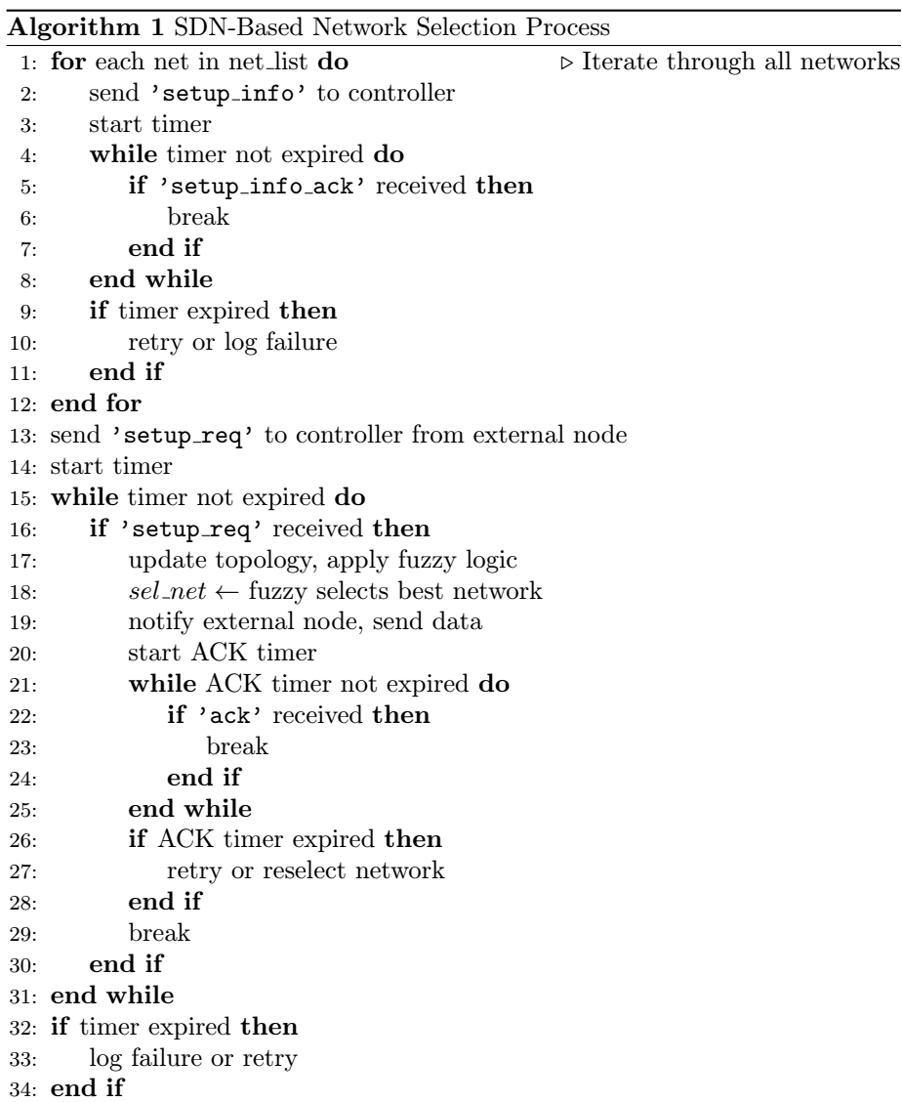

Table 5 Scenario 1 Simulation Parameters
Parameter | Value
Simulation time | 600 s x 4 (each traffic type)
Region | 300 m × 300 m
Frequency | 2400 to 2483.5 GHz
Number of nodes | 41 nodes, 4 BS, 1 Controller
MAC protocol | CSMA/CA
Bandwidth | 1 MHz
Data rate | 971.4 kbps
Packet size | 100 Byte
Scenario 1 | Traffic Type | Inter-Arrival Time (s) | Packet Size (Byte)
Scenario 1 | Voice | 0.02 s | 100 Byte
Scenario 1 | Video | 0.01 s | 1500 Byte
Scenario 1 | Sensor | 1 s | 50 Byte
Scenario 1 | Emergency | 0.01 s | 200 Byte

