Supplementary files

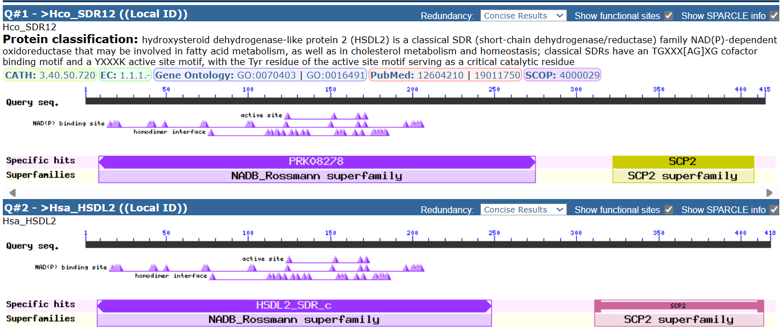

Fig S1: The domain identification of Hco_SDR12 and Hsa_HSDL2.

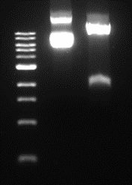
Fig. S2 – Control restriction of vector pET-22b(+)_sdr12. Sample 1 contained control undigested plasmid. Sample 2 contained a restricted plasmid with restriction endonucleases used in cloning (Ndel, Xhol) with band corresponding to the size of vector pET-22b(+) (5000 bp) and target gene (1248 bp).
Kbp

3
1 2

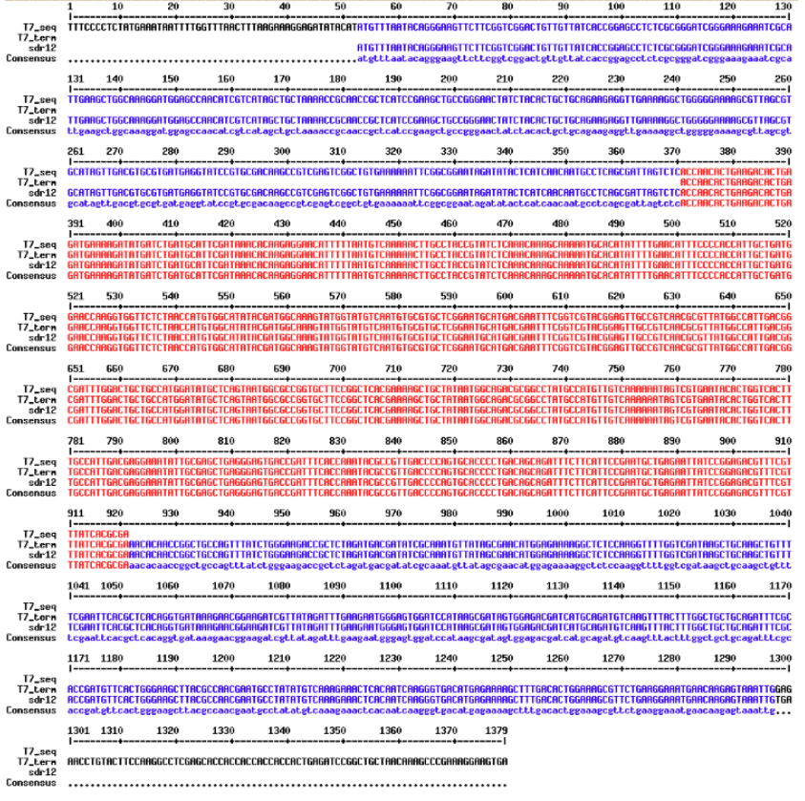

Fig. S3 – Sequences comparison of sdr12 reference gene and results from sequencing of final vector pET-22b(+)_sdr12 (A) with T7 forward and terminal primer, matching sequences are shown in red.

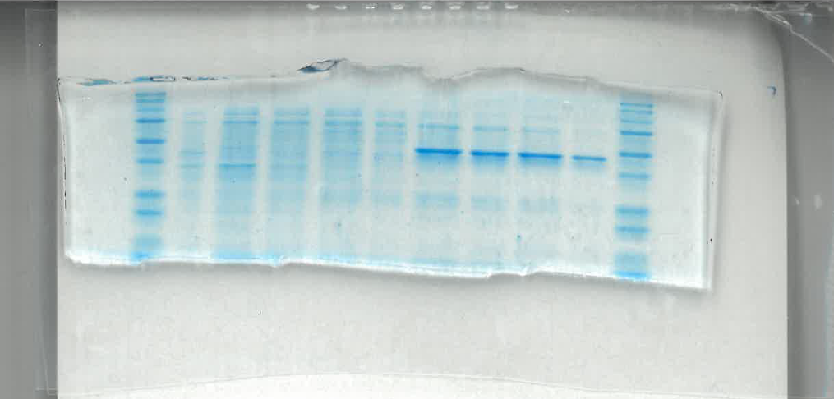
Fig. S4 –SDS-PAGE analysis of purified fractions - full gell image corresponding to the Fig. 2A in the main text of the manuscript.

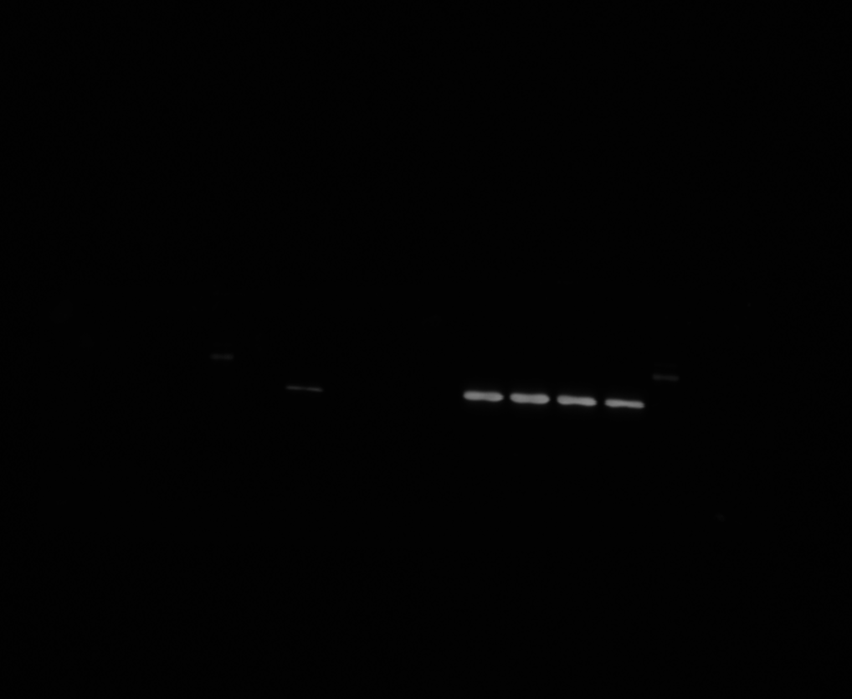
Fig. S5 Western blot – full image as taken, corresponding to Fig. 2B in the main text of the manucript. Confirmed the presence of the Hco_SDR12 (~45.09 kDa). A distinct band of the expected molecular weight was detected, with the strongest signal observed in the elution fractions (samples 6–9). A weaker signal was also visible in the unpurified sample (sample 1), indicating partial presence of the protein before purification.

Methodology
Analysis of FLU reduction
The reactions were prepared in a total volume of 100 µL, and each sample contained 2-5 µg of the protein (Hco_SDR12), FLU as substrate (10 µM) pre-dissolved in DMSO, NADPH (1 mM) pre-dissolved in DMSO and 0.1 M Na-phosphate buffer, pH 7. The reactions were performed at 37 °C for 4 or 8 h under aerobic conditions to produce sufficient FLU-R for detection. After 4 or 8 h, the reaction was stopped by adding 300 µL of ice-cold 100% ACN and centrifuged at 15,000 × g for 15 min at 4 °C. The supernatant was removed and, after the addition of FLU-D3 as an internal standard (IS), the solvent was evaporated using a centrifuge concentrator (Concentrator Plus, Eppendorf, Germany) set to vacuum-alcohol mode at 30 °C for 5 h, and the residue was stored at -20 °C. Samples were processed with 6 technical replicates in 3 independent experiments.
UHPLC‒MS/MS Analysis
A Nexera X2 UHPLC system, consisting of a binary pump, vacuum degasser, temperature-controlled autosampler (set to 15 °C), and a temperature-controlled column compartment (set to 40 °C), was employed for the separation process (Shimadzu, Kyoto, Japan). A Zorbax Bonus RP C18 column (2.1 mm × 150 mm, 1.8 μm particle size) paired with a matching guard column (Agilent Technologies, Waldbronn, Germany) was used for analyte separation at a flow rate of 0.4 mL/min. The injection volume for all analyses was 1 µL. Samples were separated using a linear gradient elution method with solutions A (dH2O + 0.1% FA) and B (ACN + 0.1% FA). The gradient procedure was as follows: an initial 1-minute treatment with 20% B, followed by a linear increase to 95% B over 3 minutes. These conditions were maintained for 2 min before returning to the starting condition of 20% B, with an additional 5-minute equilibration phase. The total run time was 10 minutes. MS/MS analysis was performed using a triple quadrupole mass spectrometer (LCMS-8030; Shimadzu, Kyoto, Japan) with an ESI ionisation source operating in positive SRM mode. The ESI parameters were optimised based on the experimental design to determine the best ionisation conditions for each compound. The ionisation source was configured with the following settings: capillary voltage of 0.5 kV for FLU-R and 1.5 kV for FLU and FLU-D3; heat block temperature at 400 °C; DL line at 250 °C; nebulising gas flow rate at 2.5 L/min; and drying gas flow rate at 12 L/min. Nitrogen was used as both the nebulising and drying gas, while argon was employed as the collision gas (at a pressure of 270 kPa) for the MS/MS analysis. Data acquisition and processing were performed using LabSolution LCMS software version 5.109 (Shimadzu, Kyoto, Japan).

Table 1 List of analytes and their characteristics [retention time, (tR), precursor ion and production ions with collision energy
Compound name | Molecular formula | tR [min] | Precursor ion [M+H]+, m/z | Product ion [M+H]+, m/z (collision energy [eV]
FLU | C16H12FN3O3 | 3.82 | 314.10 | 281.80 (−22); 122.95 (−39); 94.95 (−50)
FLU-D3 | C16D3H9FN3O3 | 3.82 | 317.10 | 281.90 (−24); 122.85 (−40); 94.95 (−53)
FLU-R | C16H14FN3O3 | 2.11 | 316.10 | 283.95 (−26); 97.00 (−46); 124.90 (−38)

