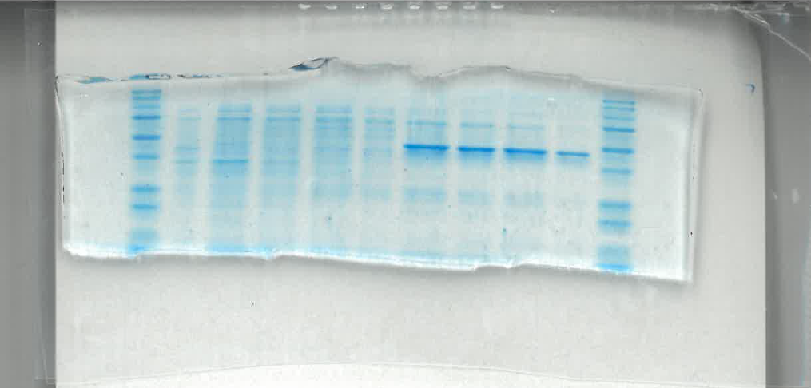
Fig. S4 –SDS-PAGE analysis of purified fractions - full gell image corresponding to the Fig. 2A in the main text of the manuscript.

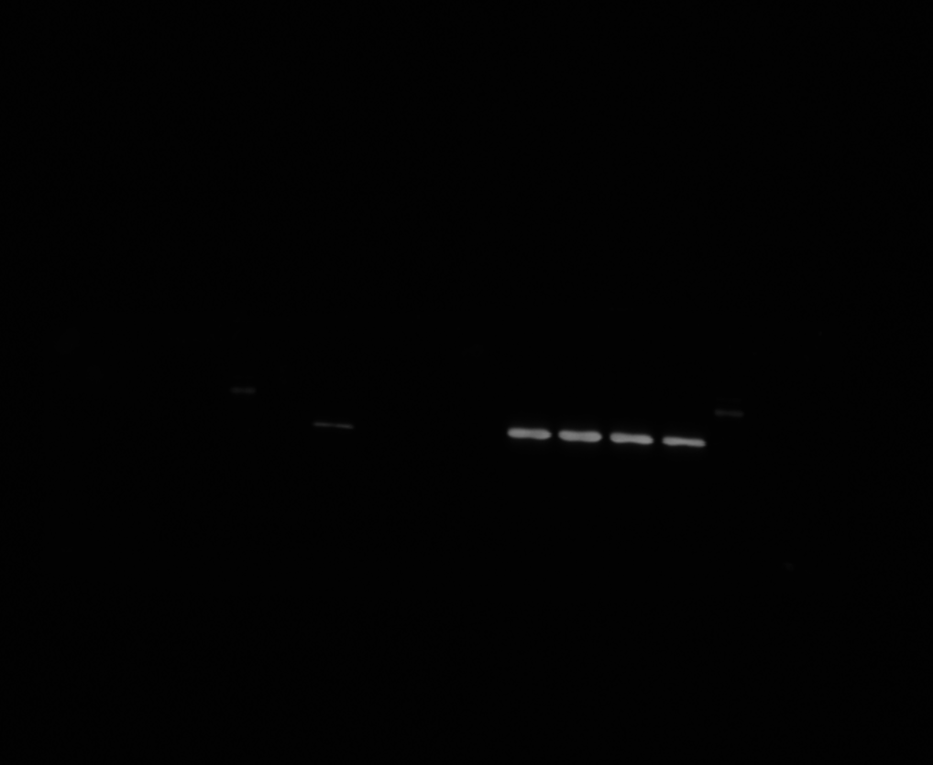
Fig. S5 Western blot – full image as taken, corresponding to Fig. 2B in the main text of the manucript. Confirmed the presence of the Hco_SDR12 (~45.09 kDa). A distinct band of the expected molecular weight was detected, with the strongest signal observed in the elution fractions (samples 6–9). A weaker signal was also visible in the unpurified sample (sample 1), indicating partial presence of the protein before purification.

