Supplementary Material 1:
The brain sub-regions segmentation module is implemented using a deep learning algorithm based on a 3D VB-NET network. The data preprocessing module performs a series of operations, including rotation, resampling, resizing, skull stripping, image non-uniform correction, histogram matching, and gray-scale normalization, on the MRI images of five types (AD, sMCI, pMCI, PD, NC) used for training and testing. All images are standardized to the size of 256*256*256*1 mm³ in the standard Cartesian LPI coordinate system, and the gray-scale range is within the interval (-1, 1).
The network training module uses an end-to-end deep convolutional neural network, taking each sample image and its corresponding brain substructure partition atlas as the training sample. The sample image is the network input, and the output label is the brain atlas correspondent to the sample image. The network parameters are adjusted according to the difference between the output brain division and the actual brain division, and the training continues until the network basically converges and the output label image is substantially consistent with the partition image corresponding to the sample. In the overall network training process, a coarse-to-fine cascading segmentation strategy is used, simplifying the complexity and difficulty of the brain segmentation problem by step decomposition, providing extra information to the lower level network by the upper level network to enhance the network's segmentation performance, and achieving fine segmentation of the large brain region, medium brain region, and brain substructures on a stage-by-stage basis.
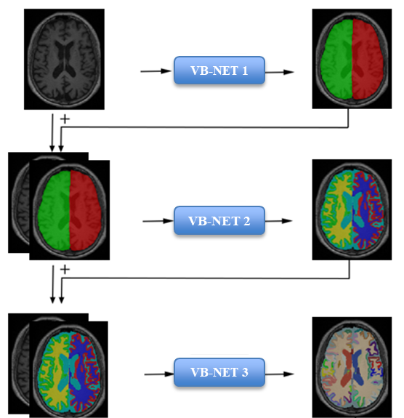
Fig S1 Cascading neural network framework

Region | DK109
1 | Precentral_L
2 | Precentral_R
3 | Postcentral_L
4 | Postcentral_R
5 | Paracentral_L
6 | Paracentral_R
7 | Frontal_Sup_L
8 | Frontal_Sup_R
9 | Frontal_Mid_Rostral_L
10 | Frontal_Mid_Rostral_R
11 | Frontal_Mid_Caudal_L
12 | Frontal_Mid_Caudal_R
13 | Frontalpole_L
14 | Frontalpole_R
15 | Orbitofrontal_Lat_L
16 | Orbitofrontal_Lat_R
17 | Orbitofrontal_Med_L
18 | Orbitofrontal_Med_R
19 | Parsopercularis_L
20 | Parsopercularis_R
21 | Parsorbitalis_L
22 | Parsorbitalis_R
23 | Parstriangularis_L
24 | Parstriangularis_R
25 | Insula_L
26 | Insula_R
27 | Cingulum_Ant_L
28 | Cingulum_Ant_R
29 | Cingulum_Mid_L
30 | Cingulum_Mid_R
31 | Cingulum_Post_L
32 | Cingulum_Post_R
33 | Isthmuscingulate_L
34 | Isthmuscingulate_R
35 | Hippocampus_L
36 | Hippocampus_R
37 | Parahippocampal_L
38 | Parahippocampal_R
39 | Amygdala_L
40 | Amygdala_R
41 | Caudate_L
42 | Caudate_R
43 | Putamen_L
44 | Putamen_R
45 | Pallidum_L
46 | Pallidum_R
47 | Thalamus_L
48 | Thalamus_R
49 | Accumbens_Area_L
50 | Accumbens_Area_R
51 | VentralDC_L
52 | VentralDC_R
53 | Choroid_Plexus_L
54 | Choroid_Plexus_R
55 | Ventricle_Lat_L
56 | Ventricle_Lat_R
57 | Ventricle_Inf_Lat_L
58 | Ventricle_Inf_Lat_R
59 | Parietal_Sup_L
60 | Parietal_Sup_R
61 | Parietal_Inf_L
62 | Parietal_Inf_R
63 | Cuneus_L
64 | Cuneus_R
65 | Entorhinal_L
66 | Entorhinal_R
67 | Fusiform_L
68 | Fusiform_R
69 | Lingual_L
70 | Lingual_R
71 | Pericalcarine_L
72 | Pericalcarine_R
73 | Precuneus_L
74 | Precuneus_R
75 | Supramarginal_L
76 | Supramarginal_R
77 | Temporal_Sup_L
78 | Temporal_Sup_R
79 | Temporal_Mid_L
80 | Temporal_Mid_R
81 | Temporal_Inf_L
82 | Temporal_Inf_R
83 | Temporalpole_L
84 | Temporalpole_R
85 | Temporal_Sup_Banks_L
86 | Temporal_Sup_Banks_R
87 | Transversetemporal_L
88 | Transversetemporal_R
89 | Occipital_Lat_L
90 | Occipital_Lat_R
91 | Cerebral_WM_L
92 | Cerebral_WM_R
93 | Cerebellum_Cortex_L
94 | Cerebellum_Cortex_R
95 | Cerebellum_WM_L
96 | Cerebellum_WM_R
97 | Ventricle_3rd
98 | Ventricle_4th
99 | Pons
100 | CSF
101 | Optic_Chiasm
102 | CC_Anterior
103 | CC_Mid_Anterior
104 | CC_Central
105 | CC_Mid_Posterior
106 | CC_Posterior
107 | Midbrain
108 | Medulla
109 | SCP
Table S1. DK109
Supplementary Material 2:
In addition, the cortical features including average thickness, average surface area and average curve are extracted from a total of 68 brain sub-regions. The detailed 68 gray matter sub-regions are listed as followed,

Region | GM sub-region
1 | Precentral_L
2 | Precentral_R
3 | Postcentral_L
4 | Postcentral_R
5 | Paracentral_L
6 | Paracentral_R
7 | Frontal_Sup_L
8 | Frontal_Sup_R
9 | Frontal_Mid_Rostral_L
10 | Frontal_Mid_Rostral_R
11 | Frontal_Mid_Caudal_L
12 | Frontal_Mid_Caudal_R
13 | Frontalpole_L
14 | Frontalpole_R
15 | Orbitofrontal_Lat_L
16 | Orbitofrontal_Lat_R
17 | Orbitofrontal_Med_L
18 | Orbitofrontal_Med_R
19 | Parsopercularis_L
20 | Parsopercularis_R
21 | Parsorbitalis_L
22 | Parsorbitalis_R
23 | Parstriangularis_L
24 | Parstriangularis_R
25 | Insula_L
26 | Insula_R
27 | Cingulum_Ant_L
28 | Cingulum_Ant_R
29 | Cingulum_Mid_L
30 | Cingulum_Mid_R
31 | Cingulum_Post_L
32 | Cingulum_Post_R
33 | Isthmuscingulate_L
34 | Isthmuscingulate_R
35 | Hippocampus_L
36 | Hippocampus_R
37 | Parahippocampal_L
38 | Parahippocampal_R
59 | Parietal_Sup_L
60 | Parietal_Sup_R
61 | Parietal_Inf_L
62 | Parietal_Inf_R
63 | Cuneus_L
64 | Cuneus_R
65 | Entorhinal_L
66 | Entorhinal_R
67 | Fusiform_L
68 | Fusiform_R
69 | Lingual_L
70 | Lingual_R
71 | Pericalcarine_L
72 | Pericalcarine_R
73 | Precuneus_L
74 | Precuneus_R
75 | Supramarginal_L
76 | Supramarginal_R
77 | Temporal_Sup_L
78 | Temporal_Sup_R
79 | Temporal_Mid_L
80 | Temporal_Mid_R
81 | Temporal_Inf_L
82 | Temporal_Inf_R
83 | Temporalpole_L
84 | Temporalpole_R
85 | Temporal_Sup_Banks_L
86 | Temporal_Sup_Banks_R
87 | Transversetemporal_L
88 | Transversetemporal_R
89 | Occipital_Lat_L
90 | Occipital_Lat_R
Table S2. 68 gray matter sub-regions

