Efficiency of surface-active natural rubber latex (NRL) films in capturing sludge wastes in seawater and river water
ªNur Ayunni Ahmad Shahrul Amin, ªNeettha Nai Sem, ªAzura A. Rashid, ^{c}Ahmad Shaiful Abdul Razak, ªMohamad Danial Shafiq*

ªSchool of Materials and Mineral Resources Engineering, Engineering Campus, Universiti Sains Malaysia,14300 Nibong Tebal, Penang, Malaysia
^{b}School of Industrial Technology, Universiti Sains Malaysia, 11800, Penang, Malaysia
^{c}ACME Chemicals (M) Sdn Bhd, 606, Persiaran Raja Lumu, Kawasan 10, 42000 Pelabuhan Klang, Selangor, Malaysia

*Corresponding Author Email ID: danialshafiq@usm.my

Abstract
The management of sludge waste remains a critical challenge, as improper disposal can contaminate soil and water sources, impacting ecosystems and human health. In this study, polyaluminum chloride (PACl), coagulant was used to enhance the capturing process of domestic sludge waste using surface-active natural rubber latex (NRL) films. The NRL films were manufactured using the compounding and curing methods. The surface-active NRL film facilitated sludge removal by utilizing electrostatic interactions between the film and sludge particles. The incorporation of coagulant increased the sludge particle size and reduced the zeta potential of sludge water, enhancing aggregation. FTIR analysis confirmed the presence amines, proteins and peptides on the NRL film surface after the capturing process, indicating the captured sludge on the surface. The sludge deposition on the NRL films surfaces is more pronounced when the coagulant was incorporated. These findings demonstrate the effectiveness of surface-active NRL films in sludge waste removal, highlighting their potential for water treatment applications.
Keywords Coagulant-assisted, sludge capturing process, NRL film, surface-active latex, wastewater treatment

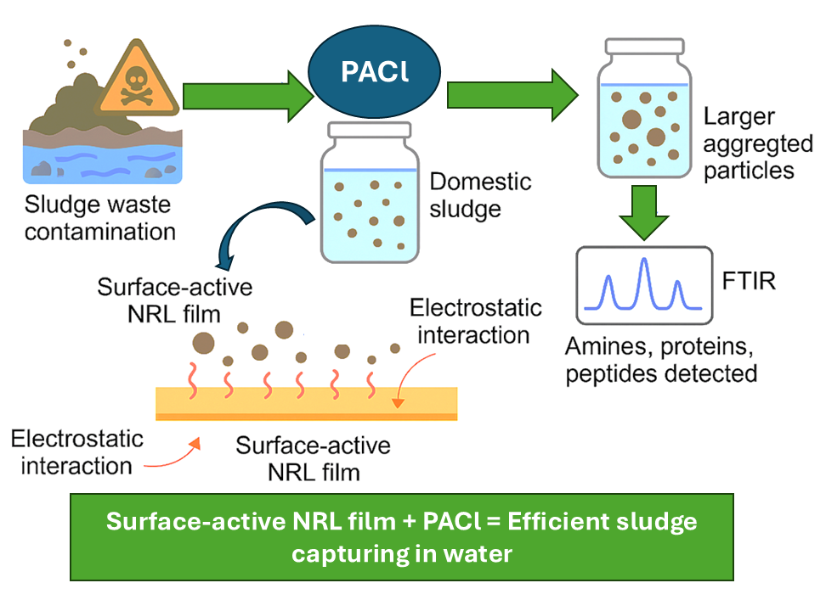

Figure 1. Illustration of PACl coagulant-assisted sludge capturing using surface-active NRL film

