Comparative analysis of ChAdOx1 nCoV-19 and Ad26.COV2.S SARS-CoV-2 vector vaccines

Supplemental Material

Stephan Michalik^{1,*}, Florian Siegerist^{2,*}, Raghavendra Palankar^{3,*}, Kati Franzke^{4,*}, Maximilian Schindler², Alexander Reder¹, Ulrike Seifert⁵, Clemens Cammann⁵, Jan Wesche³, Leif Steil¹, Christian Hentschker¹, Manuela Gesell-Salazar¹, Emil Reisinger⁶, Martin Beer^{7,§}, Nicole Endlich^{2,§}, Andreas Greinacher^{3,§}, Uwe Völker^{1,§}
*shared first authors
§shared last authors

¹Interfaculty Institute of Genetics and Functional Genomics, Department Functional
Genomics, University Medicine Greifswald, Greifswald, Germany
²Institute for Anatomy and Cell Biology, University Medicine Greifswald, Greifswald, Germany
³Institute of Immunology and Transfusion Medicine, Department of Transfusion Medicine, University Medicine Greifswald, Greifswald, Germany
⁴Institute of Infectiology, Friedrich-Loeffler Institut, Greifswald-Insel Riems,
Germany
⁵Friedrich Loeffler-Institute of Medical Microbiology-Virology, University Medicine Greifswald, Greifswald, Germany.
⁶Division of Tropical Medicine and Infectious Diseases, Center of Internal Medicine II, Rostock University Medical Center, Rostock, Germany
⁷Institute of Diagnostic Virology, Friedrich-Loeffler Institut, Greifswald-Insel Riems,
Germany

Supplemental Figures
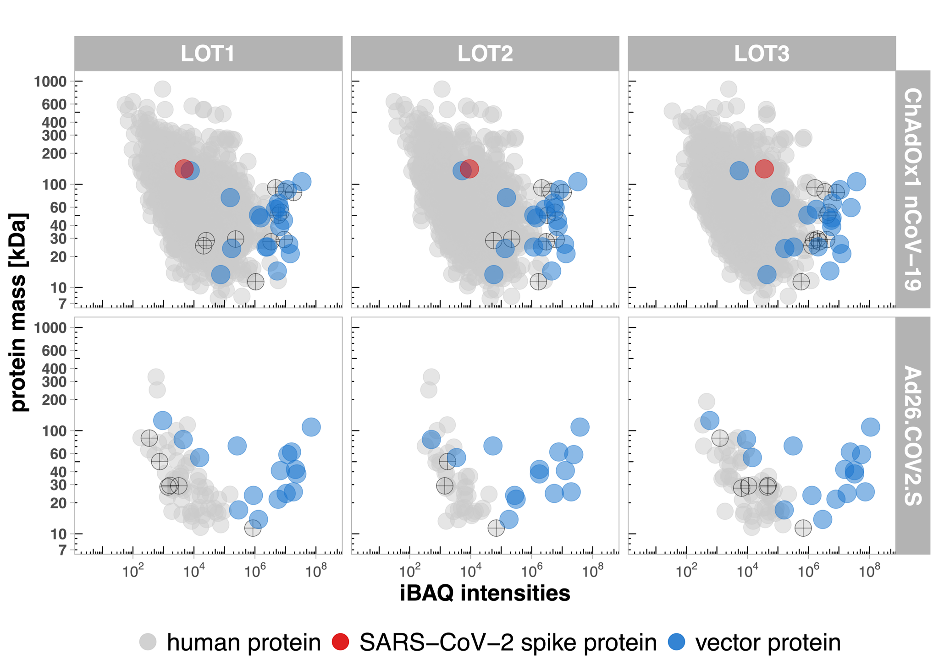
Supplemental Figure 1: Proteome profiling of ChAdOx1 nCoV-19 and Ad26.COV2.S vaccine revealed major differences in host cell protein content. iBAQ protein intensities and theoretical molecular mass of identified proteins. Protein intensities of vaccine LOTs 1-3 for ChAdOx1 nCoV-19 or Ad26.COV2.S vaccine were calculated using the iBAQ algorithm (min. 3 unique peptides per protein) and plotted against the theoretical molecular mass. Proteins were color-coded according to their respective class. Blue dots indicate vector proteins, gray proteins represent human proteins and the red dot indicates the SARS-CoV-2 spike protein. Points marked with a cross are those used in the Western blot analysis.

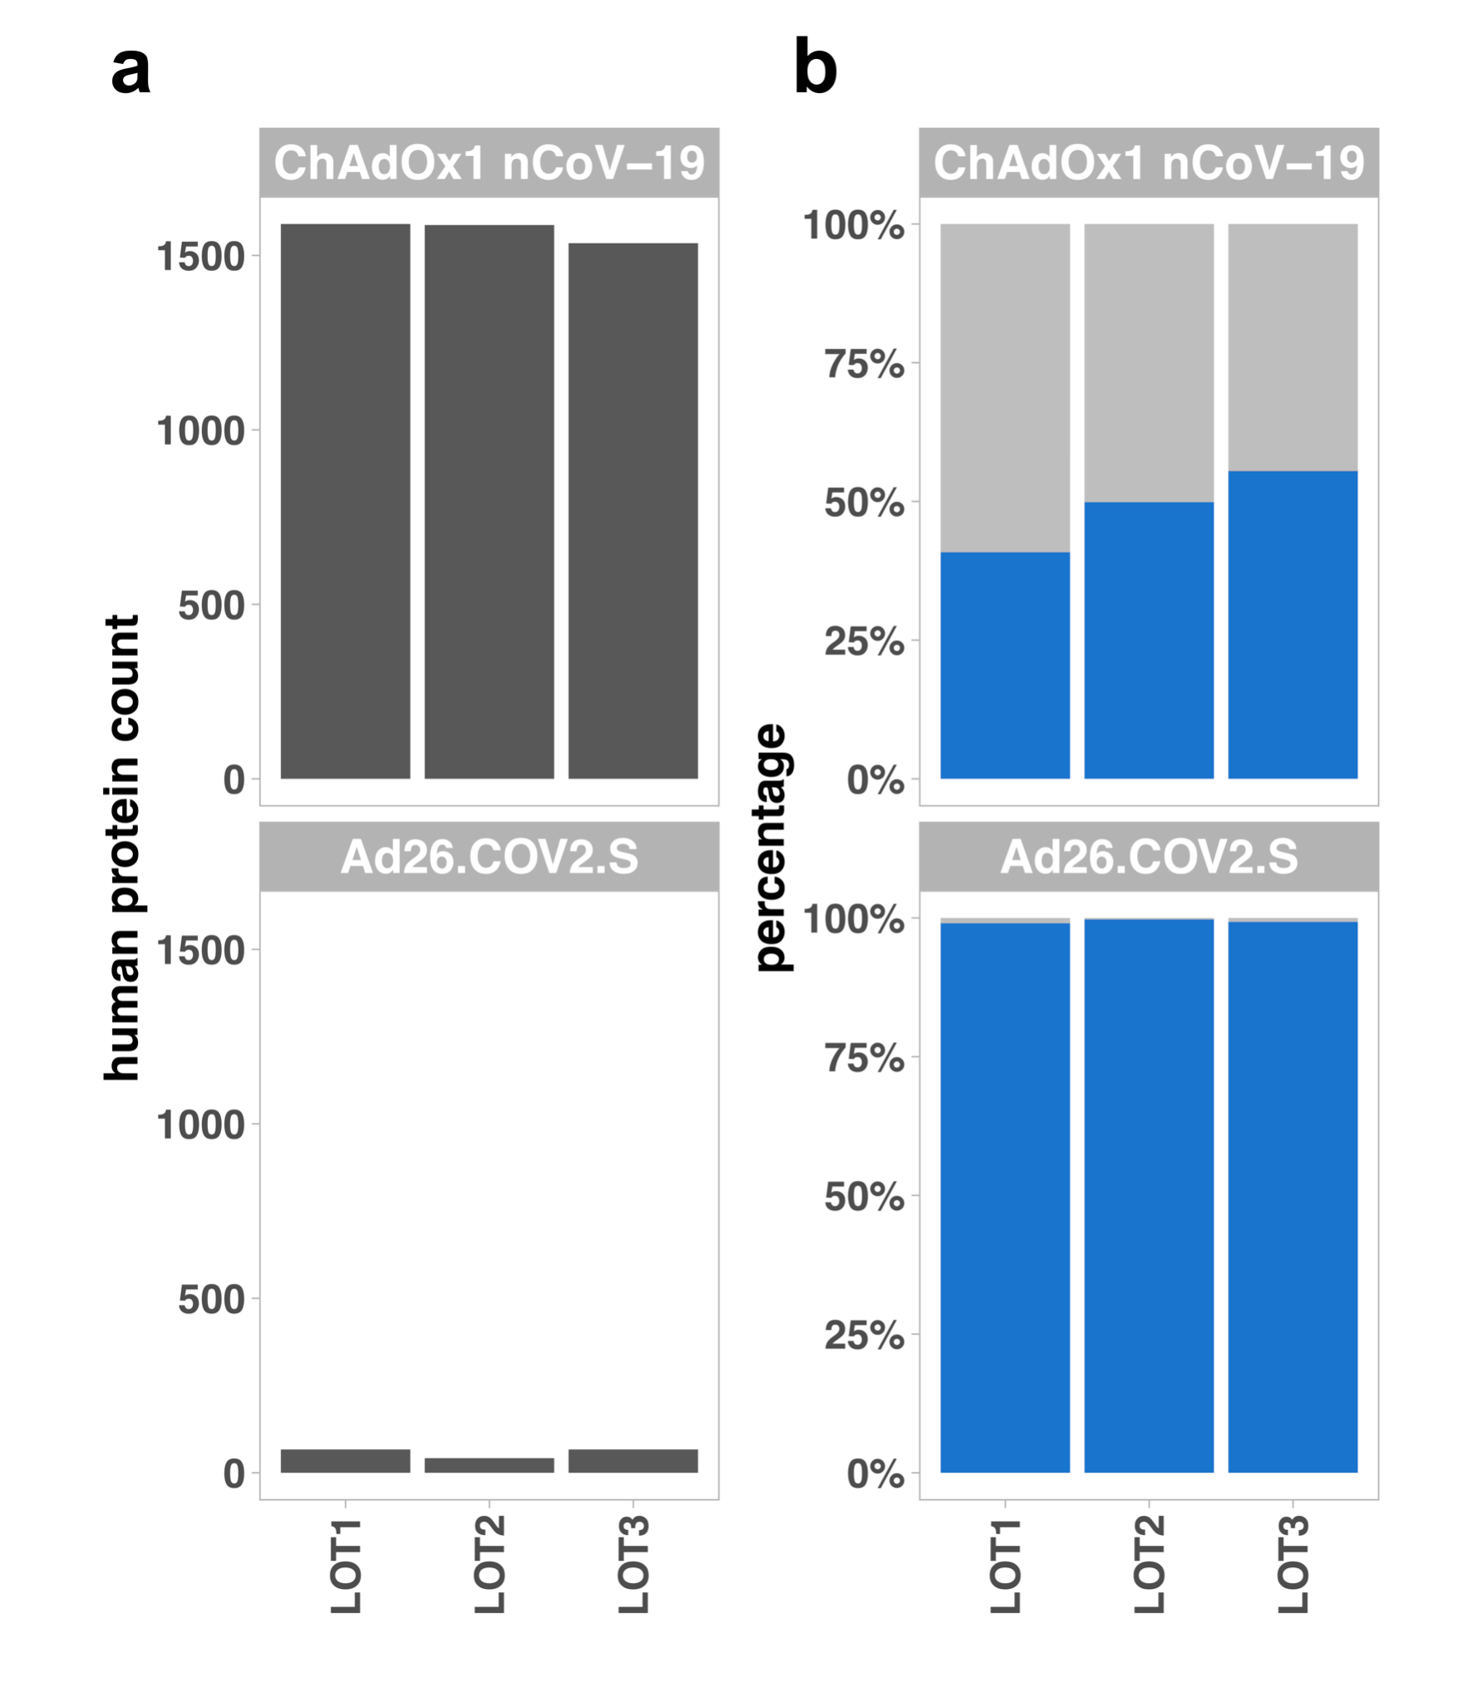
Supplemental Figure 2: Host cell protein count and HCP percentage (a) Host cell protein (HCP) identification count for ChAdOx1 nCoV-19 or Ad26.COV2.S vaccines. Host cell proteins (HCP) with at least 3 peptides were counted per LOT and displayed in a bar plot. (b) iBAQ protein intensities of human and vector proteins. For vaccine LOTs 1-3 for ChAdOx1 nCoV-19 or Ad26.COV2.S, iBAQ protein intensities were summed per protein class and resulting percentages were calculated and displayed in a stacked bar plot (grey = human proteins, blue = vector proteins).

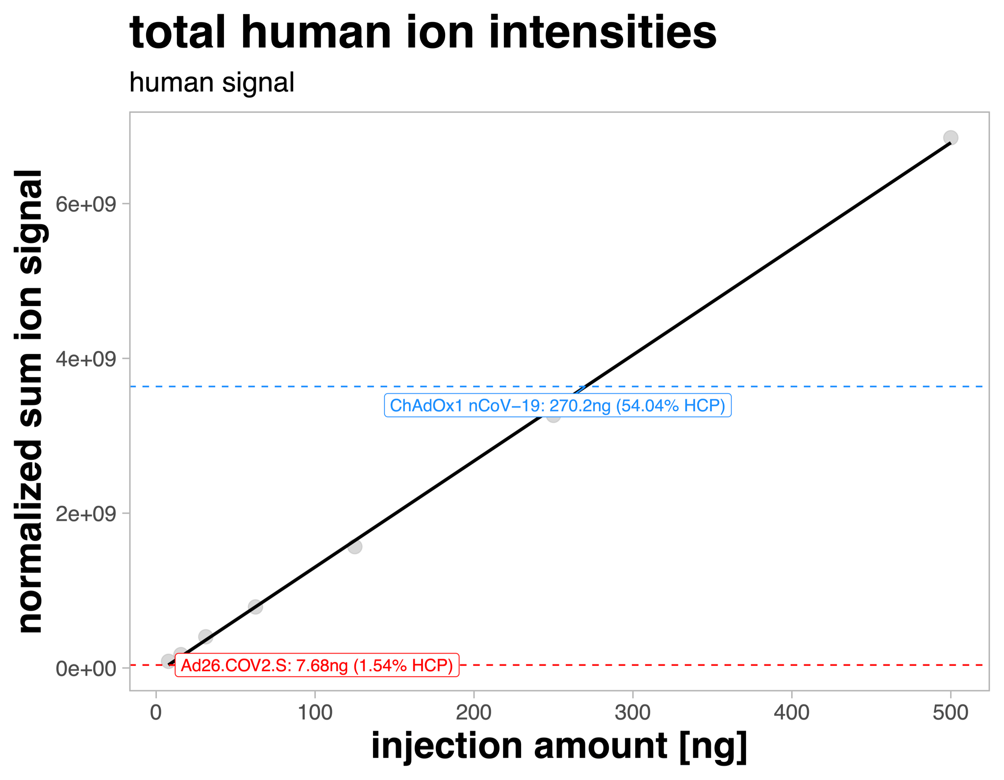
Supplemental Figure 3: HCP DIA-MS analysis of the dilution series of ChAdOx1 nCoV-19 and Ad26.COV2.S vaccines
Normalized sum of identified HEK293 human ion signals per injection amount was used for the linear regression (black line = regression; single points = grey). The ion signals were used to estimate the amount of human signal in 500 ng of vaccine (dashed lines; ChAdOx1 nCoV-19 = blue, Ad26.COV2.S = red).

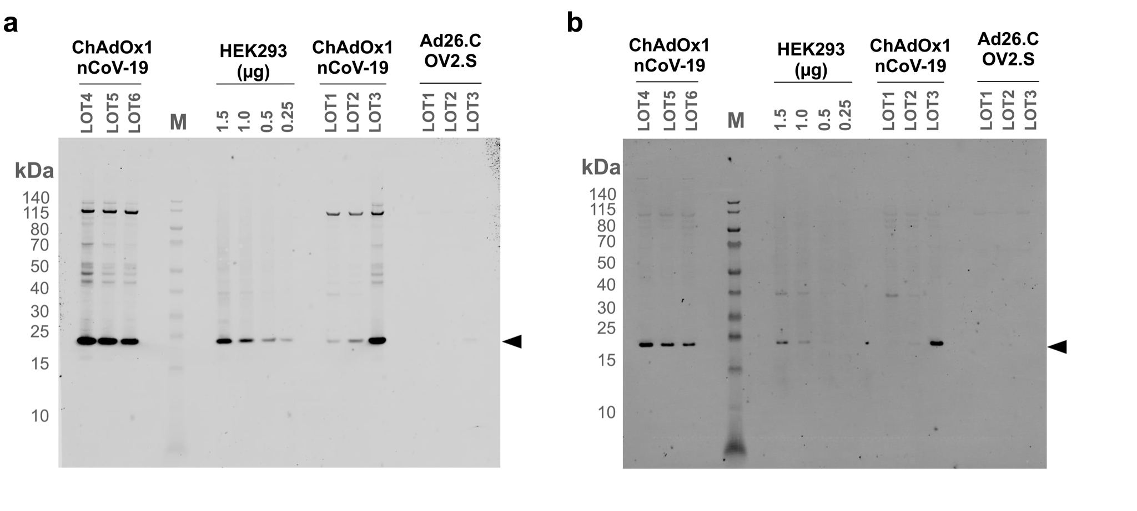
Supplemental Figure 4: Western blot analysis of protein proteasome subunit abundances in vaccines
(a) Western blot shown for proteasome subunit beta type-5 protein (PSMB5 - MB1). (b) Western blot shown for proteasome subunit beta type-6 protein (PSMB6 - Beta-1 delta). ChAdOx1 nCoV-19 LOT6 was not included in the calculations because no proteasome activity measurement is available for this LOT.

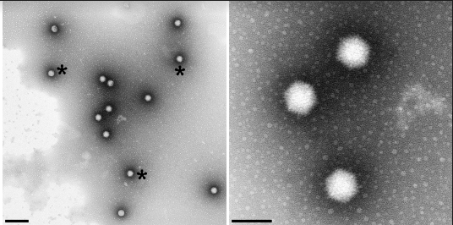

Supplemental Figure 5: Electron micrograph of purified adenovirus particles from ChAdOx1 nCov-19 vaccine in different magnifications. Asterisks exemplarily indicate adenoviral particles. Scale bars represent 300 nm and 100 nm from left to right panel.

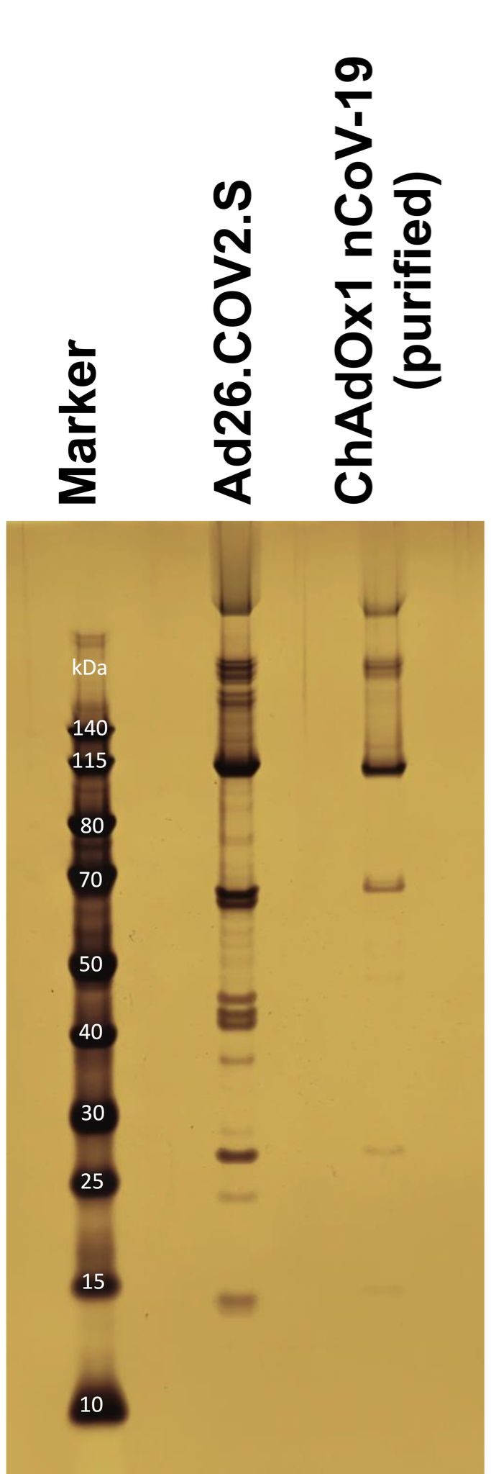

Supplemental Figure 6: Protein pattern of the Ad26.COV2.S and the purifiedChAdOx1 nCoV-19 vaccine. A silver nitrate-stained SDS-PAGE gel is shown for Ad26.COV2.S and purified ChAdOx1 nCoV-19. First lane: molecular weight marker, second lane: 10 µL Ad26.COV2.S. third lane: 4 µl aliquot of ChAdOx1 nCov-19 purification from density gradient centrifugation.

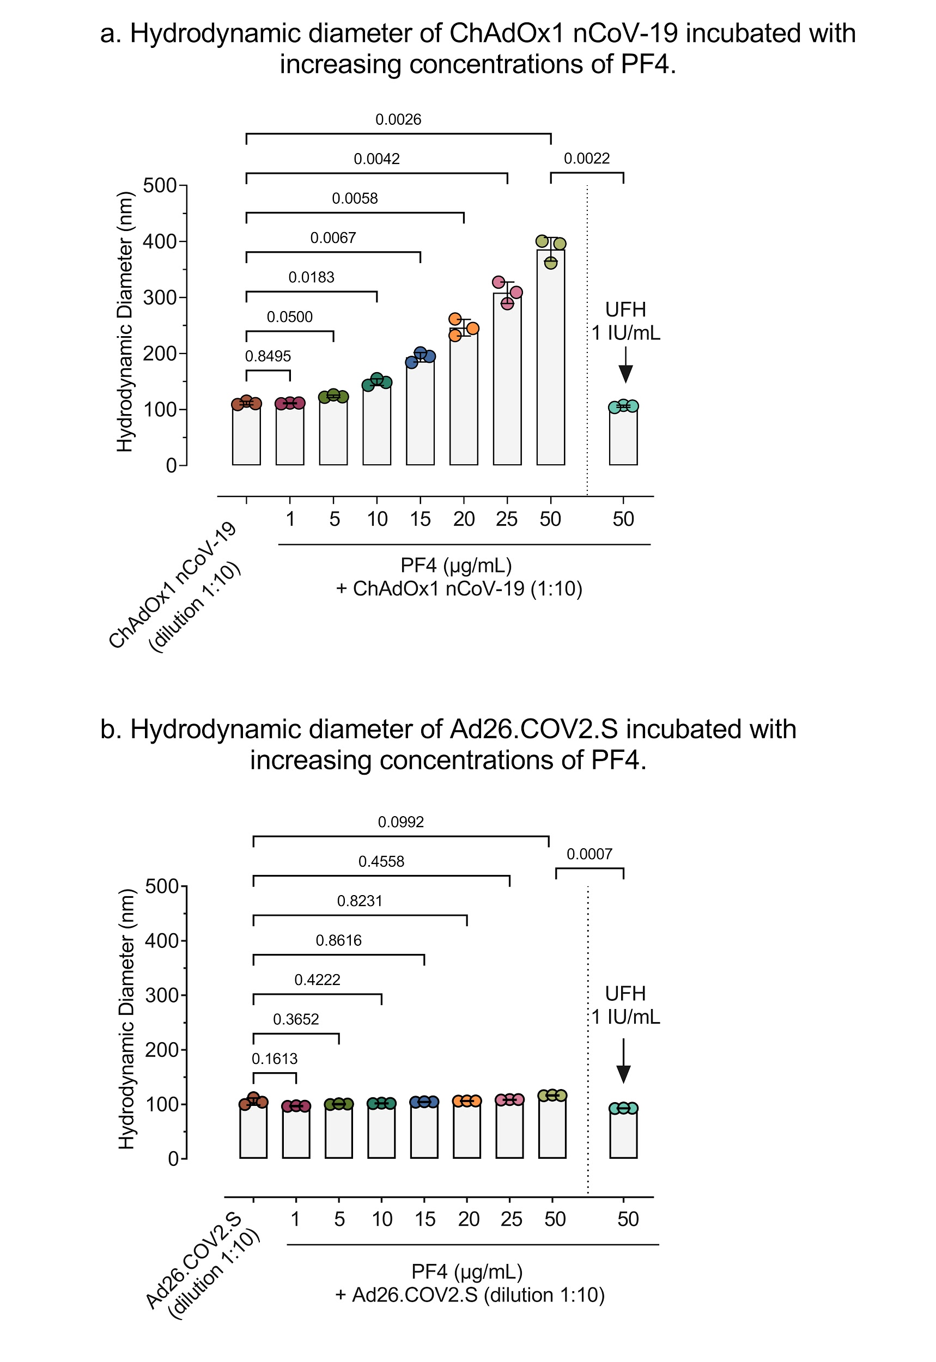

Supplemental Figure 7: Comparison of hydrodynamic diameter of ChAdOx1 nCov-19 vaccine and Ad26.COV2.S incubated with different concentrations of PF4. (a) ChAdOx1 nCov-19 incubated with PF4 shows a concentration dependent exponential increase in hydrodynamic diameter measured by DLS but not with (b) Ad26.COV2.S, that is disrupted by the addition of UFH.

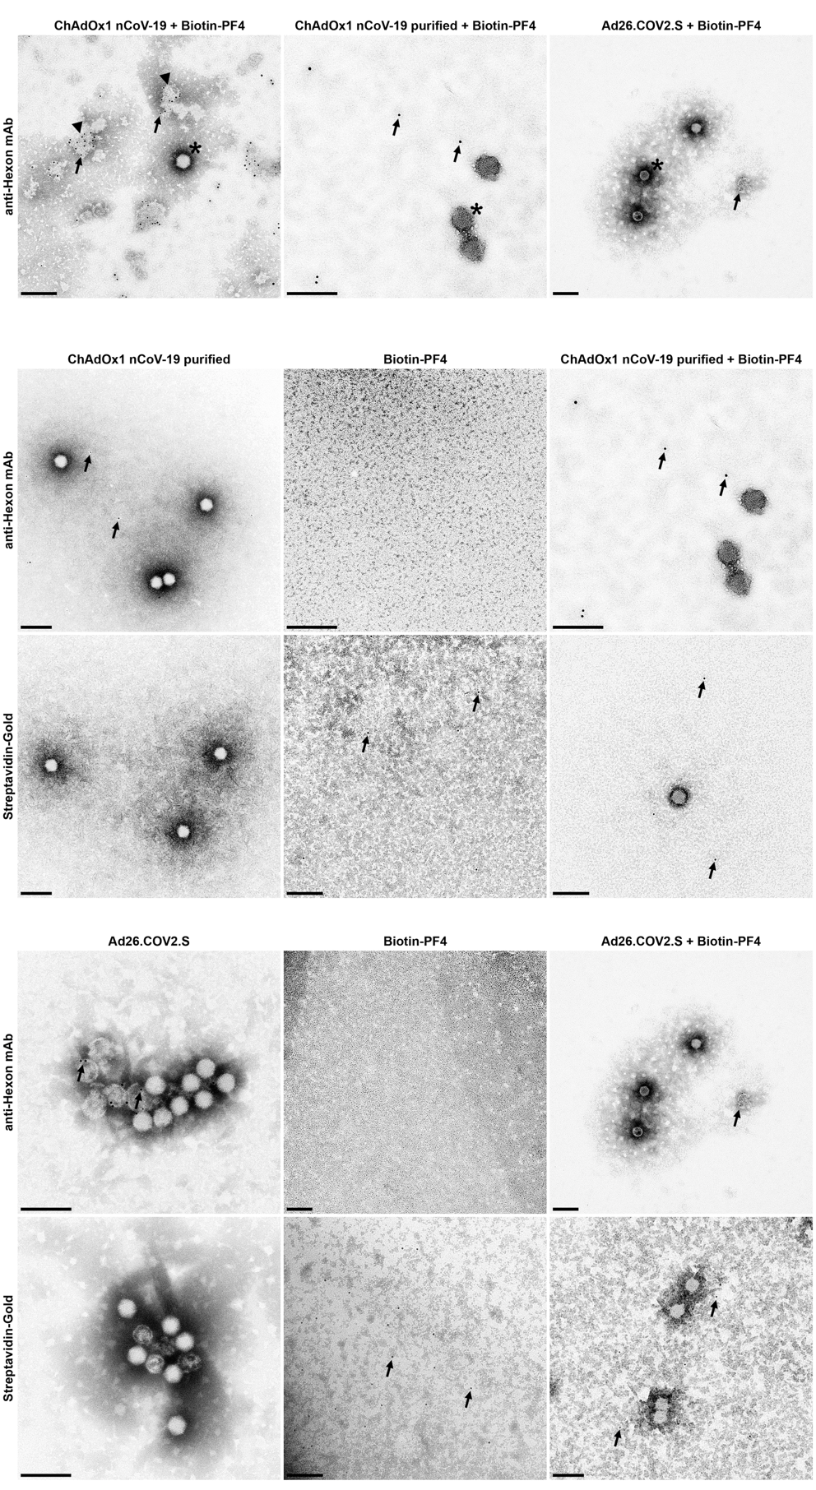

Supplemental Figure 8: Purified ChAdOx1 nCov-19 vaccine and Ad26.COV2.S were incubated with biotinylated PF4 and stained with anti-hexon mAb and streptavidin-gold conjugate. In immunoelectron microscopy the anti-hexon mAb binds to an epitope that is located inside the capsid of an intact virion. Binding events were only seen with defect virions or not assembled hexon protein. Arrows indicate single gold particles. Bars represent 200 nm.

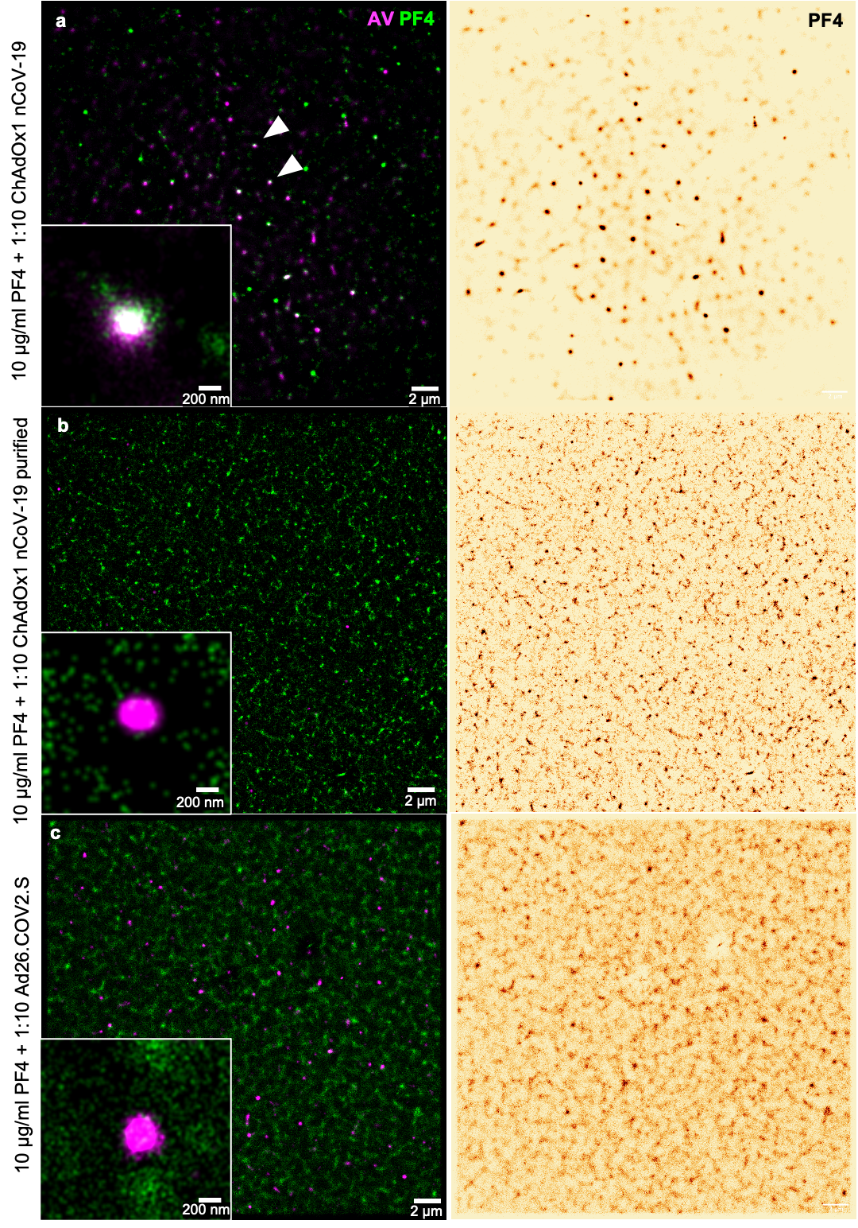
Supplemental Figure 9: Full field of view of of immuno-labeled PF4 and hexon polypeptide after incubation with either native ChAdOx1 nCoV-19 (a), purified ChAdOx1 nCoV-19 (b) or Ad26.COV2.S (c) acquired by SMLM and reconstructed as average shifted histograms. After incubation with ChAdOx nCoV-19 (a), PF4 can be visualized as dense clusters that colocalize with the hexon polypeptide (arrowheads). In contrast, after incubation with either purified ChAdOx1 nCoV-19 (b) or Ad26.COV2.S (c), PF4 formed a rather homogenous layer on glass slides and only single and small complexes were found.

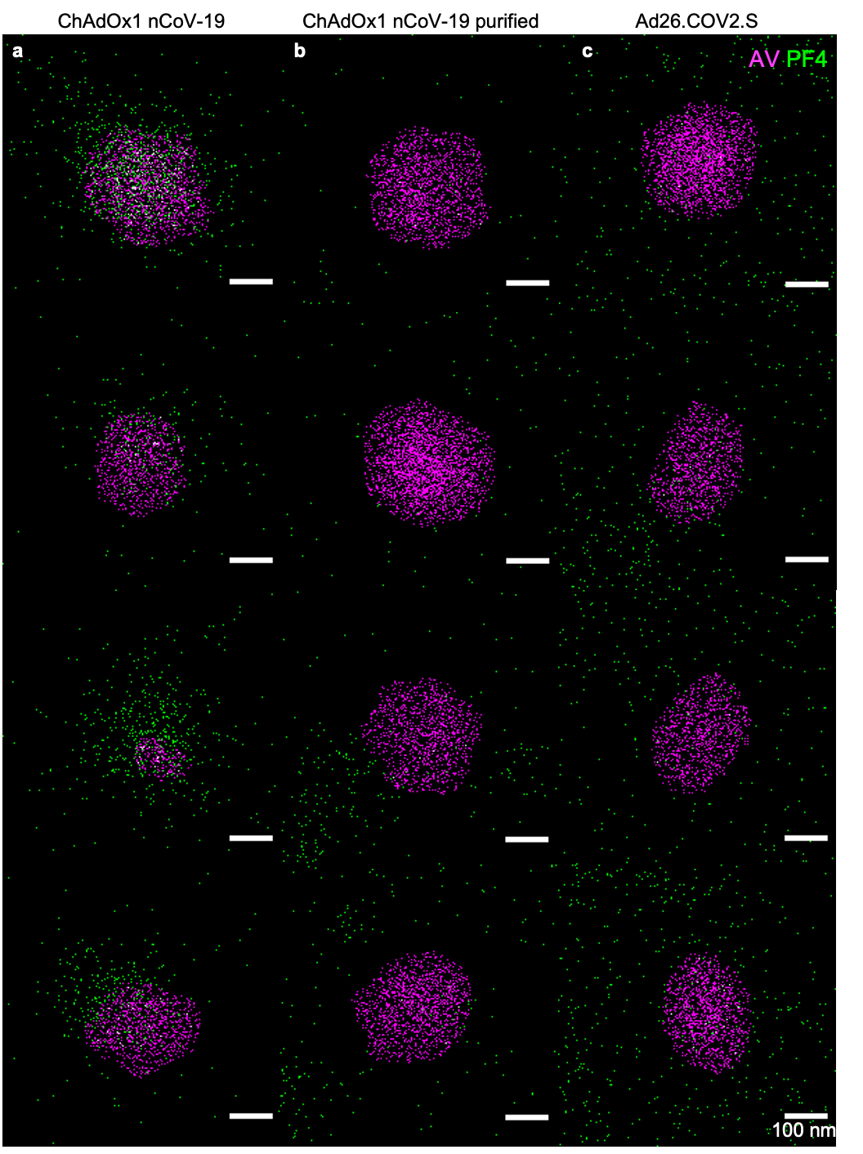
Supplemental Figure 10: Dual-channel single-molecule scatterplots of the PF4 (green) and the adenoviral hexon polypeptide (magenta). Herein, each spot represents one fluorophore localization. Clearly, distinct clustering of PF4 molecules can only be seen in native ChAdOx1 nCoV-19 (a) which shows a high PF4 density either directly on, or in direct vicinity of particles staining for hexon proteins. In contrast PF4 molecule density is very similar inside or outside hexon-localizations in purified ChAdOx1 nCoV-19 and Ad26.COV2.S (b, c). For comparative quantification of molecule density see main Fig. 4, i.

Supplemental Legends

Supplemental Video 1
Supplemental video 1 shows intramuscular microinjections in adjacent myotomes of a zebrafish tail. Special care was taken not to injure the adjacent caudal vein or segmental arteries.

Supplemental File 1
Supplemental file 1 summarizes the Westernblot analysis. Left panel shows the Westernblot and the right panel displays the corresponding Revert 700 total protein stain scan.

Supplemental Table 1
Supplemental table 1 contains the resulting iBAQ intensities of identified proteins of the comparison of ChAdOx1 nCoV-19 and Ad26.COV2.S.

Supplemental Table 2
Top10 human protein impurities for ChAdOx1 and Ad26.COV2.S vaccine based on mean iBAQ protein intensity per vaccine. The red-white-green iBAQ color gradient shows the iBAQ intensities from high-middle-low abundant proteins respectively.

