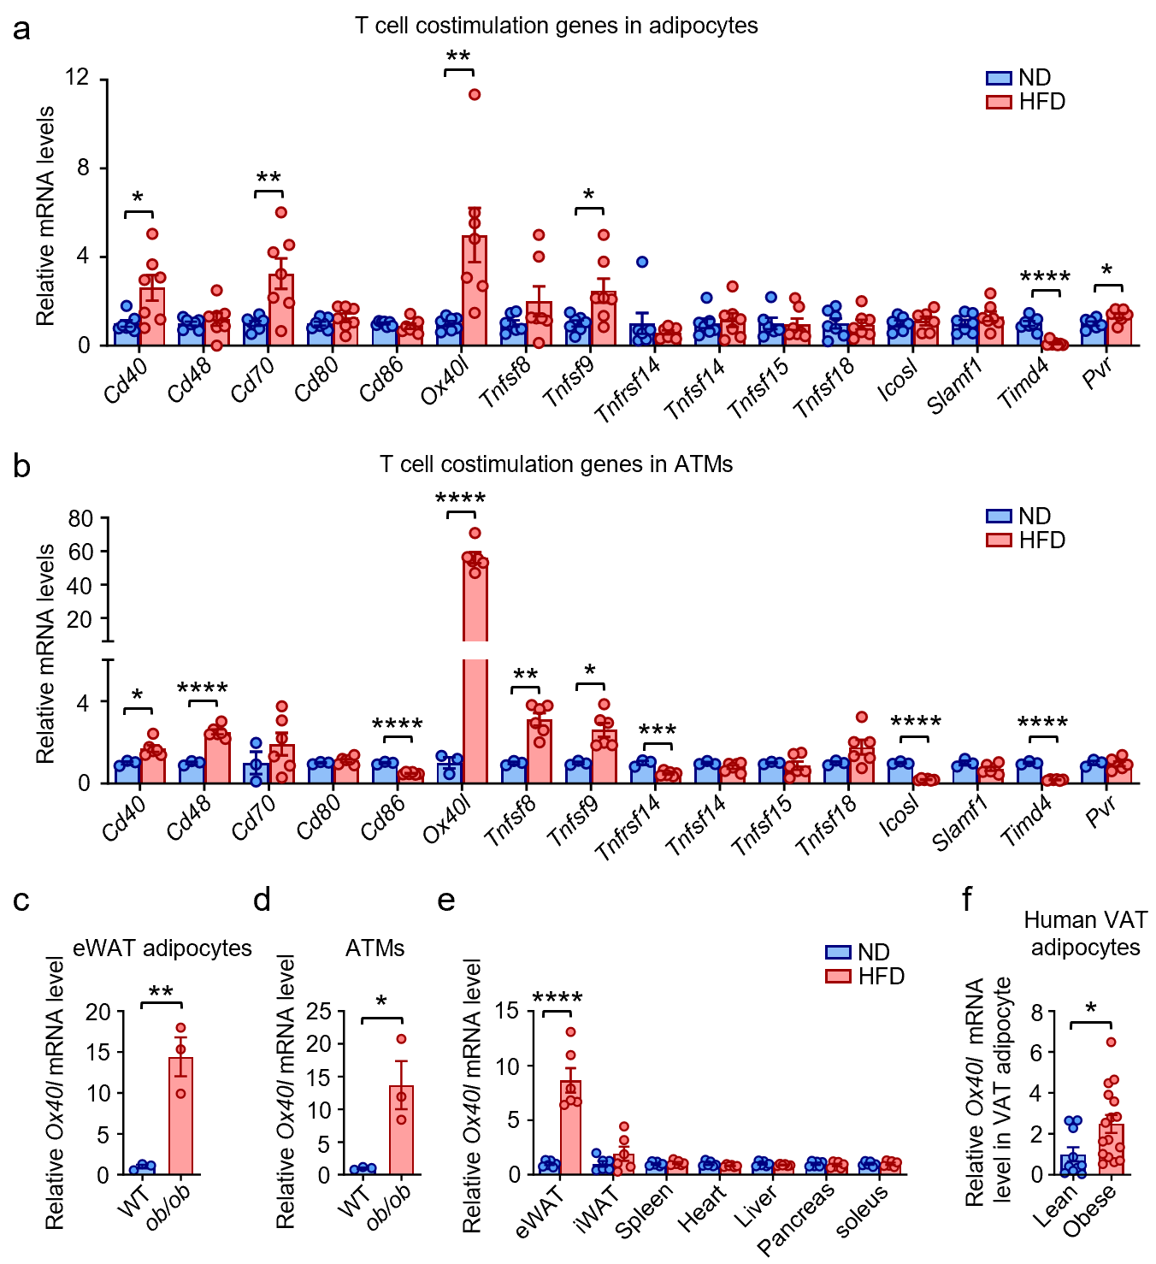
Supplementary Fig. 1 Obesity induces OX40L expression in adipocytes and ATMs. (a) RT-qPCR analysis of mRNA expression of various costimulatory molecules in eWAT adipocytes from 12-weeks ND and HFD mice (n = 6–7 per group). (b) RT-qPCR analysis of mRNA expression of various costimulatory molecules in eWAT macrophages from 12-weeks ND and HFD mice (n = 3–6 per group). (c) RT-qPCR analysis of OX40L mRNA expression in eWAT adipocytes from WT and ob/ob mice (n = 3 per group). (d) RT-qPCR analysis of OX40L mRNA expression in eWAT macrophages from WT and ob/ob mice (n = 3 per group). (e) RT-qPCR analysis of OX40L mRNA expression in various tissues from 12-weeks ND and HFD mice (n = 6 per group). (f) RT-qPCR analysis of OX40L mRNA expression in human VAT adipocytes (n = 10–16 per group). Data represent mean ± SEM. *P < 0.05, **P < 0.01, ***P < 0.001, and ****P < 0.0001.

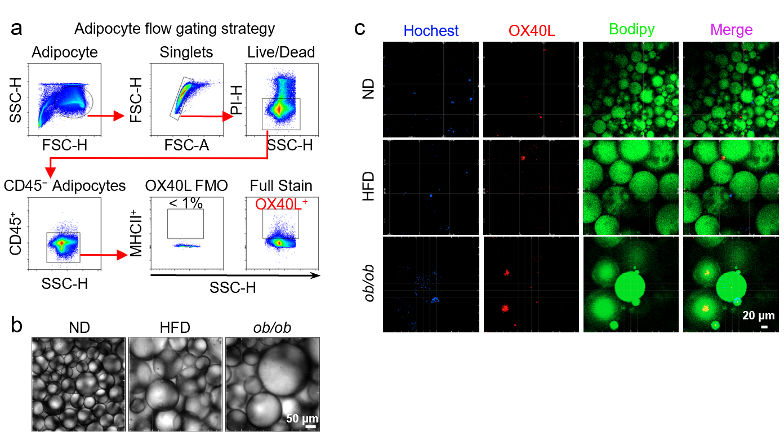 Supplementary Fig. 2 Characterization of adipocytes by flow cytometry. (a) Adipocyte flow gating strategy. (b) Bright-field images of adipocytes following flow cytometry staining (scale bar: 50 μm). (c) Representative fluorescence images of adipocytes stained for OX40L (scale bar: 20 μm).

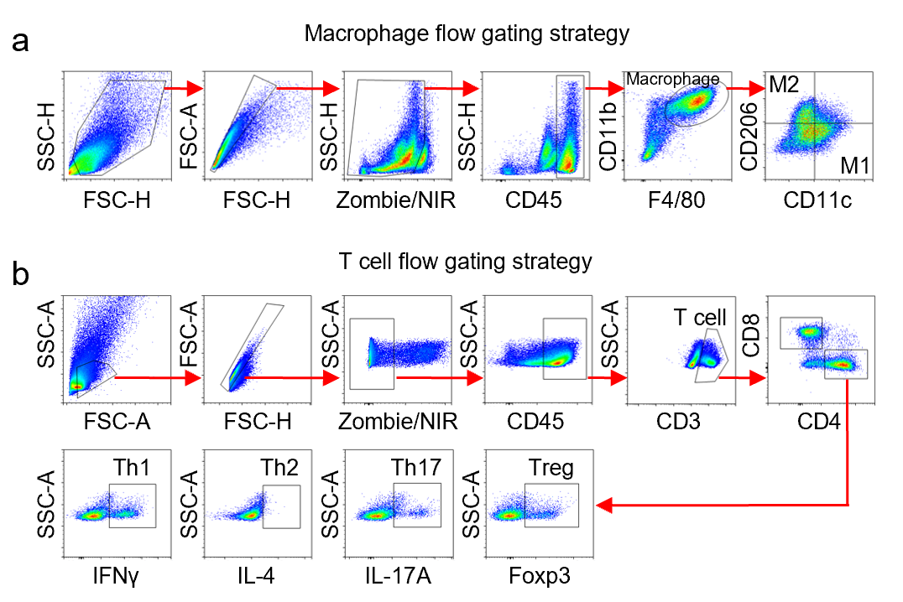 Supplementary Fig. 3 Flow cytometry gating strategy for T cells and macrophages. (a) Macrophage flow gating strategy. (b) T cell flow gating strategy.

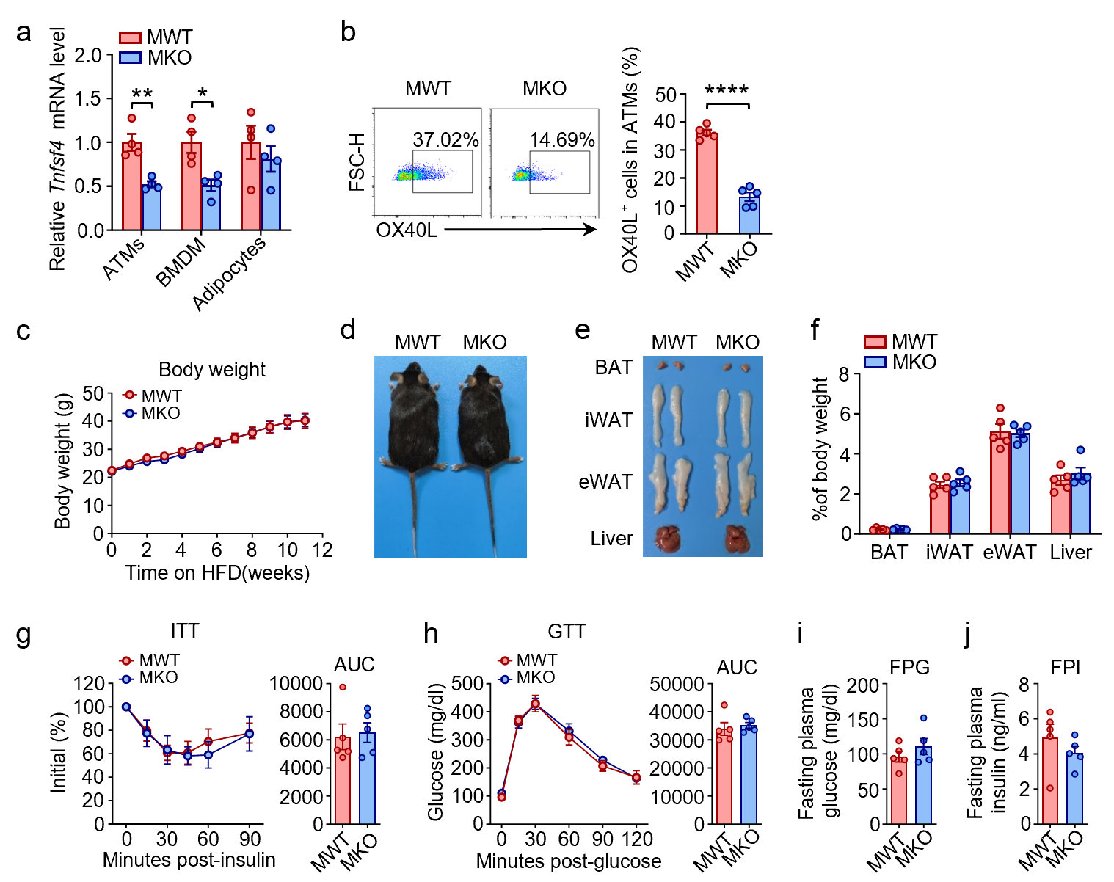
Supplementary Fig. 4 Macrophage-specific OX40L deficiency does not affect HFD-induced insulin resistance. Macrophage-specific OX40L knockout (MKO) and littermate control (MWT) mice were fed an HFD for 12 weeks. (a) RT-qPCR analysis of OX40L mRNA expression in eWAT ATMs, BMDMs, and eWAT adipocytes from MKO and MWT mice (n = 4 per group). (b) Flow cytometry analysis of OX40L⁺ cell proportions in eWAT macrophages from MKO and MWT mice (n = 5 per group). (c) Body weight of MKO and MWT mice (n = 5 per group). (d) Representative images of MKO and MWT mice. (e) Representative images of BAT, iWAT, eWAT, and liver from MKO and MWT mice. (f) Weight percentages of BAT, iWAT, eWAT, and liver relative to body weight (n = 5 per group). (g) ITT results for MKO and MWT mice (n = 5 per group). (h) GTT results for MKO and MWT mice (n = 5 per group). (i) FPG levels of MKO and MWT mice (n = 5 per group). (j) FPI levels of MKO and MWT mice (n = 5 per group). Data represent mean ± SEM. *P < 0.05, **P < 0.01, and ****P < 0.0001.

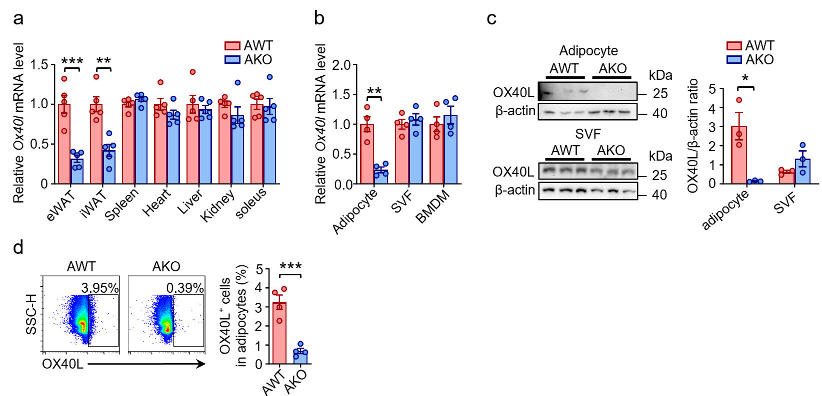 Supplementary Fig. 5 The establishment of adipocyte-specific OX40L knockout mice model. AKO and AWT mice were fed an HFD for 12 weeks. (a) RT-qPCR analysis of OX40L mRNA expression in various tissues from AKO and AWT mice (n = 5 per group). (b) RT-qPCR analysis of OX40L mRNA expression in eWAT adipocytes, SVF, and BMDMs from AKO and AWT mice (n = 4 per group). (c) Western blot analysis of OX40L protein expression in eWAT adipocytes and SVF from AKO and AWT mice (n = 3 per group). (d) Flow cytometry analysis of OX40L⁺ cell proportions in eWAT adipocytes from AKO and AWT mice (n = 4 per group). Data represent mean ± SEM. *P < 0.05, **P < 0.01, and ***P < 0.001.

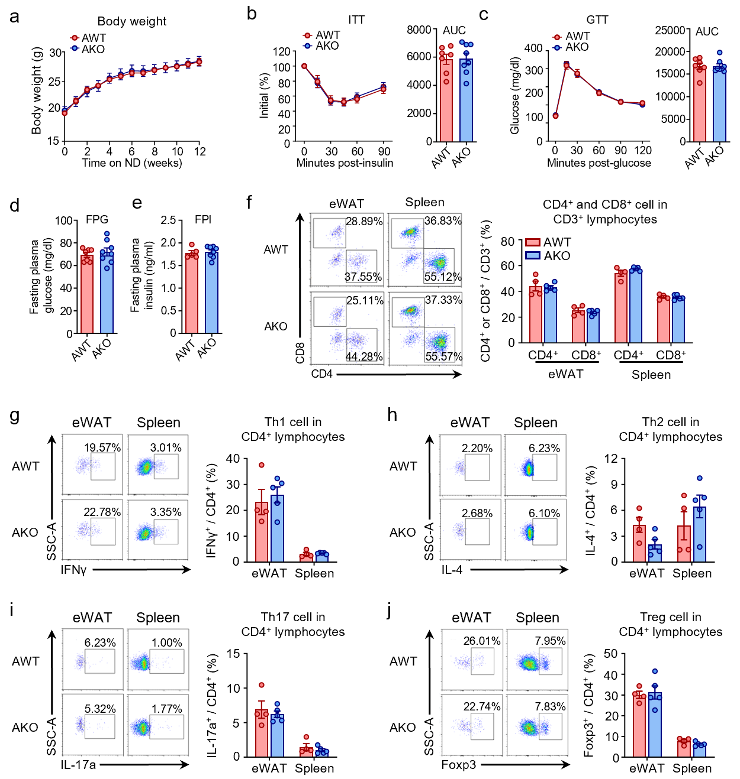
Supplementary Fig. 6 Adipocyte-specific OX40L deficiency has no effect on insulin sensitivity and T cell accumulation in adipose tissue under ND-fed condition. AKO and AWT mice were fed an ND for 12 weeks. (a) Body weight of AKO and AWT mice (n = 7–8 per group). (b) ITT results for AKO and AWT mice (n = 7–8 per group). (c) GTT results for AKO and AWT mice (n = 7–8 per group). (d) FPG levels of AKO and AWT mice (n = 7–8 per group). (e) FPI levels of AKO and AWT mice (n = 5–8 per group). (f) Flow cytometry analysis of CD4⁺ and CD8⁺ T cell populations in eWAT and spleen from AKO and AWT mice (n = 4–5 per group). (g) Flow cytometry analysis of Th1 cell populations in eWAT and spleen from AKO and AWT mice (n = 4–5 per group). (h) Flow cytometry analysis of Th2 cell populations in eWAT and spleen from AKO and AWT mice (n = 4–5 per group). (i) Flow cytometry analysis of Th17 cell populations in eWAT and spleen from AKO and AWT mice (n = 4–5 per group). (j) Flow cytometry analysis of Treg cell populations in eWAT and spleen from AKO and AWT mice (n = 4–5 per group). Data represent mean ± SEM.
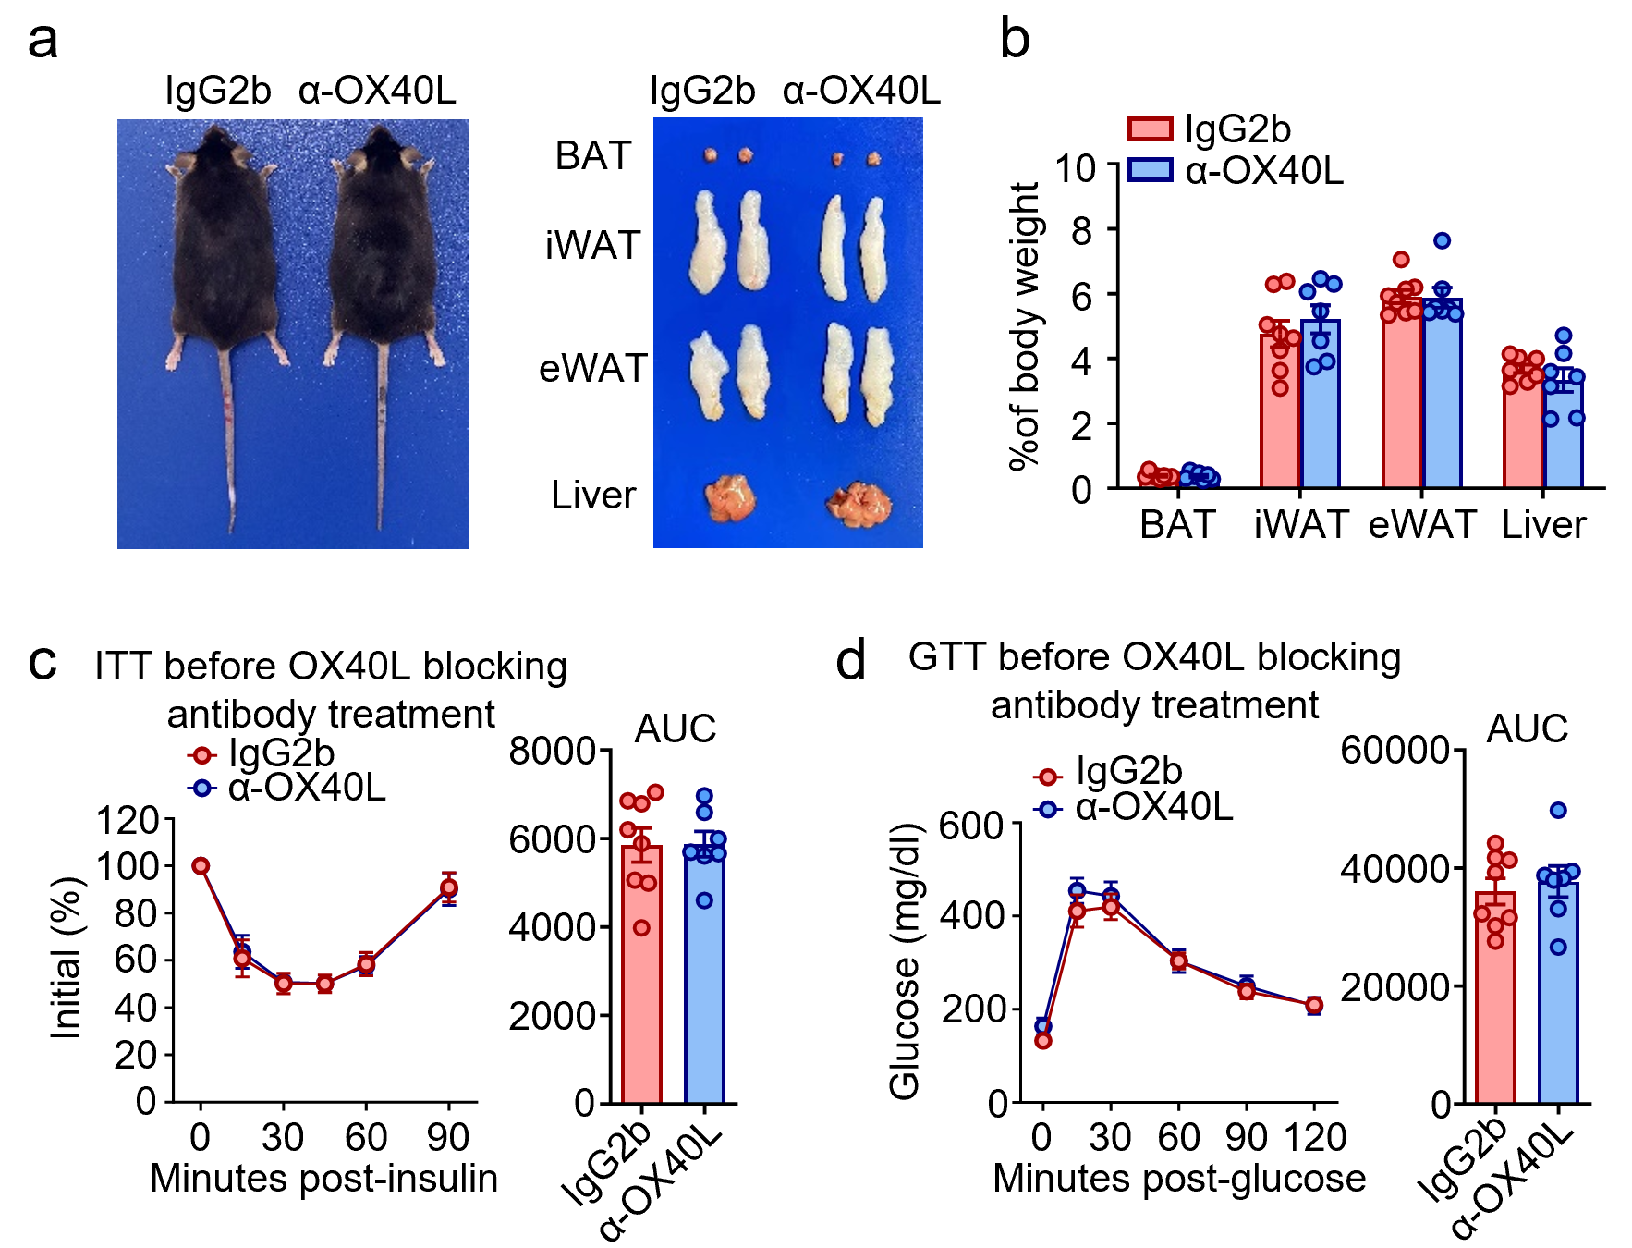
Supplementary Fig. 7 OX40L blocking antibody does not alter body composition, and baseline metabolic profiles showed no intergroup differences. (a) Representative images of α-OX40L and IgG2b-treated mice and their BAT, iWAT, eWAT, and liver. (b) Weight percentages of BAT, iWAT, eWAT, and liver relative to body weight (n = 7–8 per group). (c) ITT results before antibody treatment (n = 7–8 per group). (d) GTT results before antibody treatment (n = 7–8 per group). Data represent mean ± SEM.

