Supporting Information
Enaminone-Linked Quasi-One-Dimensional Covalent Organic Frameworks for CO2 Photoreduction with Water
Junxian Bai, Yuxin Hu, Fangyuan Si, Yan Li, Guijie Liang, Tingting Hou*, Yingwei Li*

Results and discussion
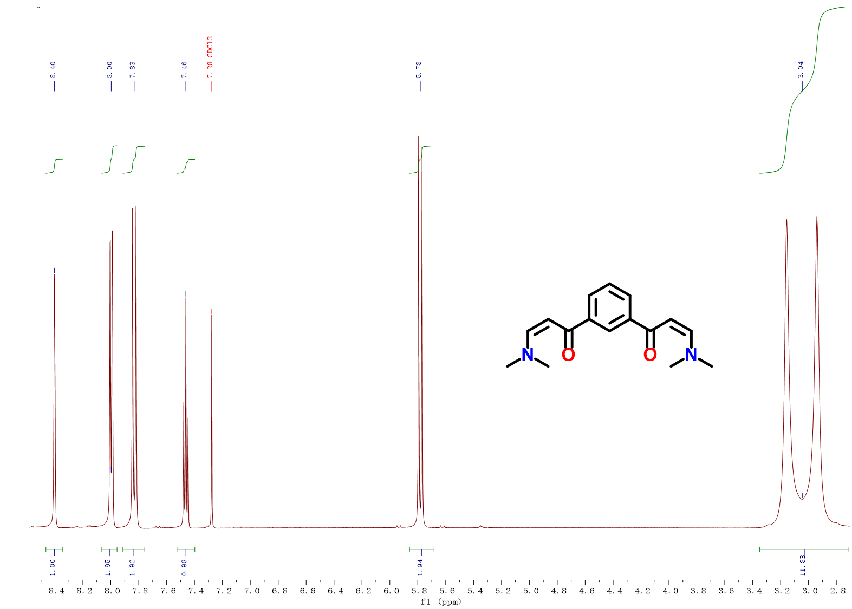

Figure S1. The ¹H NMR spectrum of PDP.

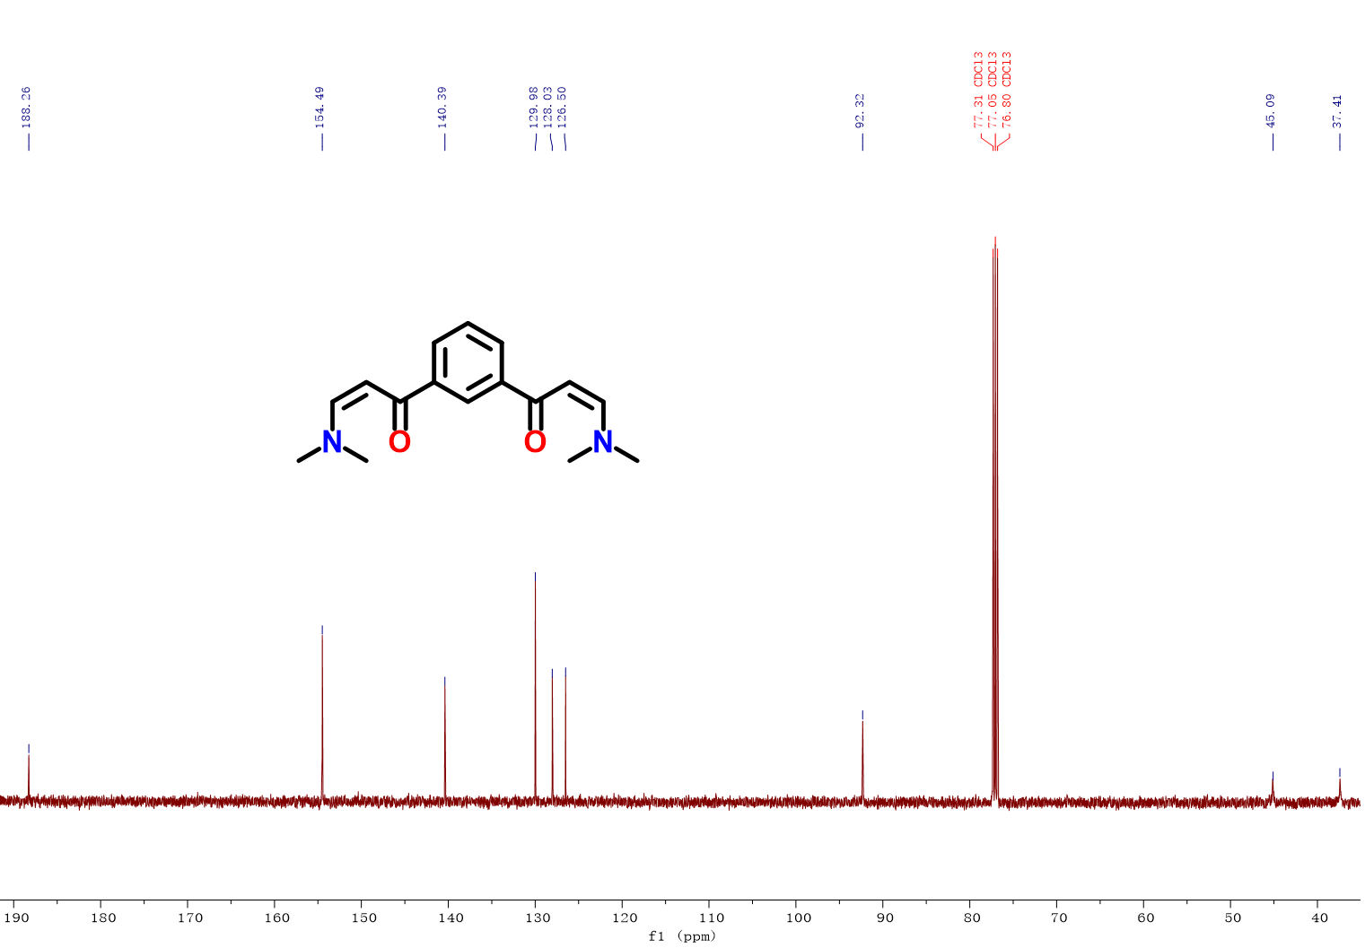

Figure S2. The ¹³C NMR spectrum of PDP.

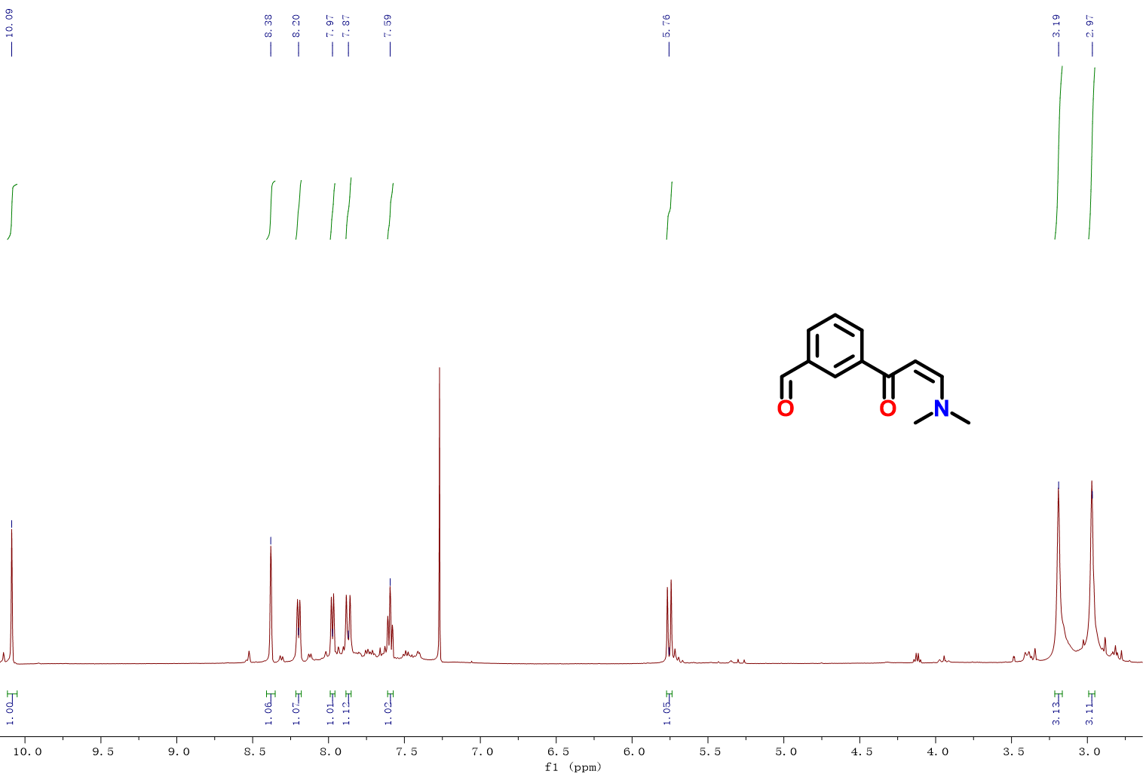
Figure S3. The ¹H NMR spectrum of BDP.

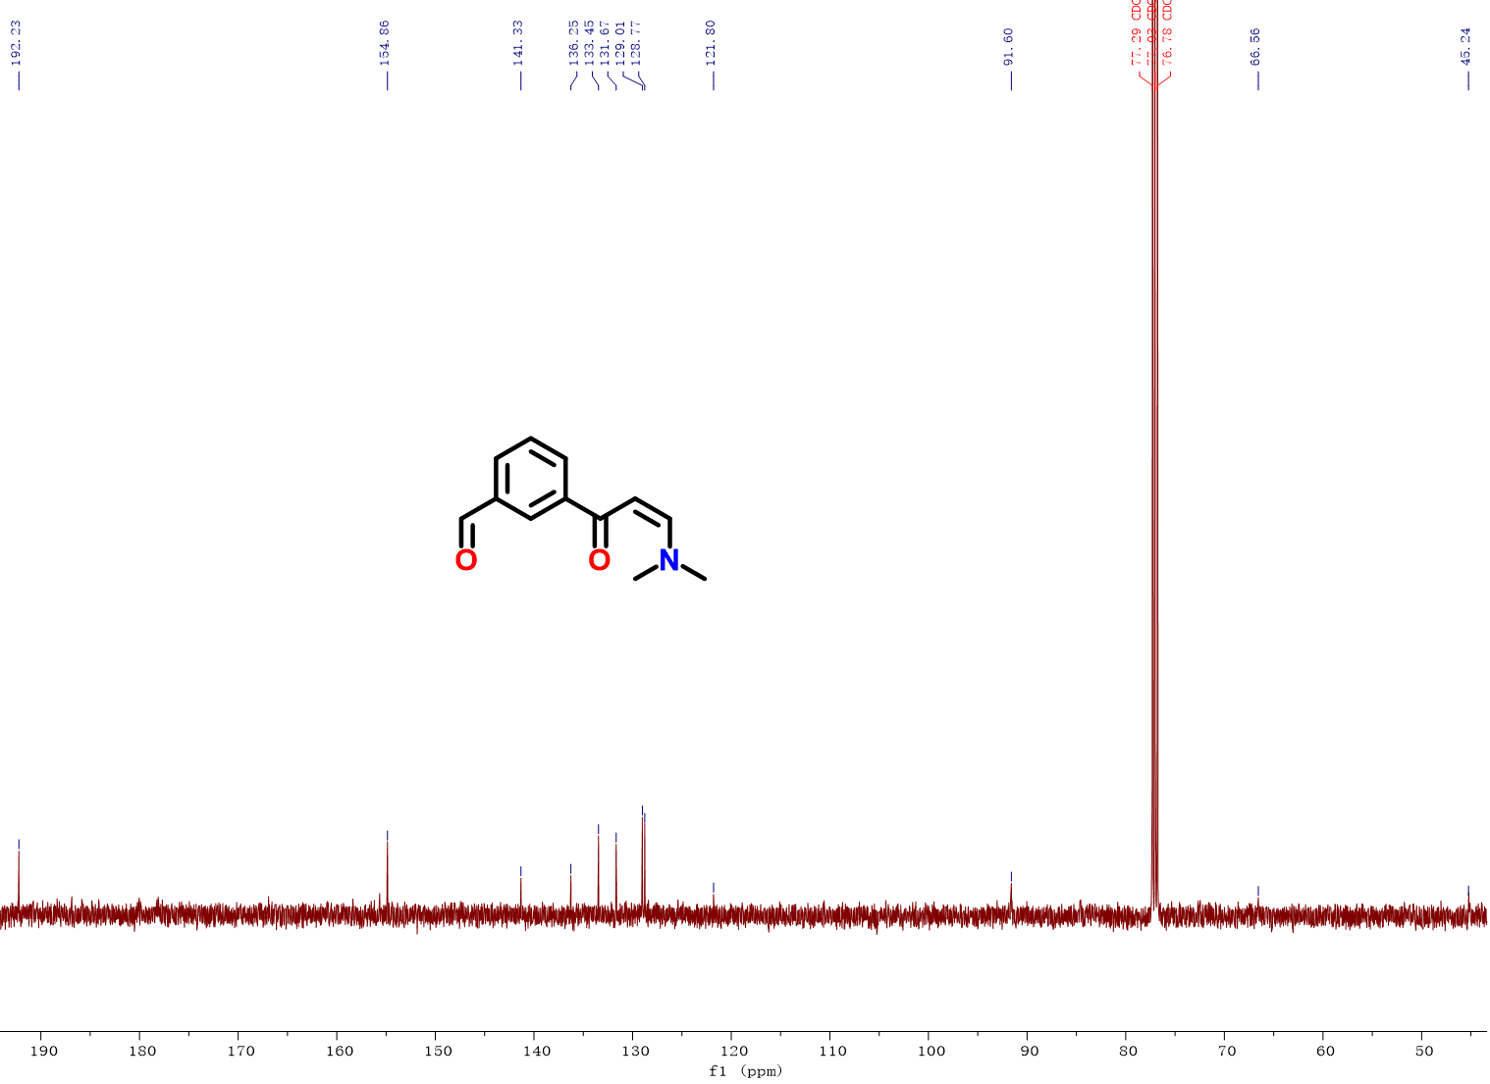
Figure S4. The ¹³C NMR spectrum of BDP.

=

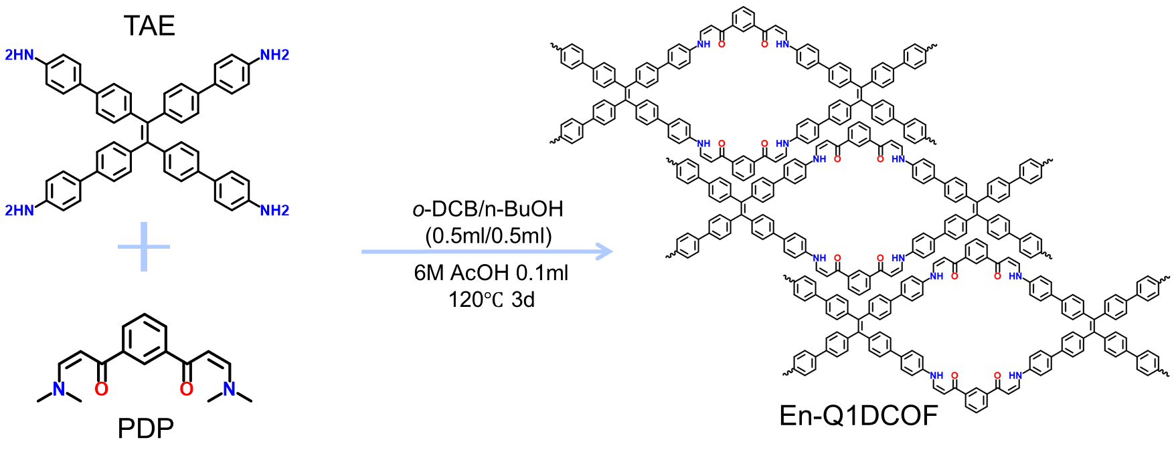
Figure S5. Synthesis of En-Q1DCOF.
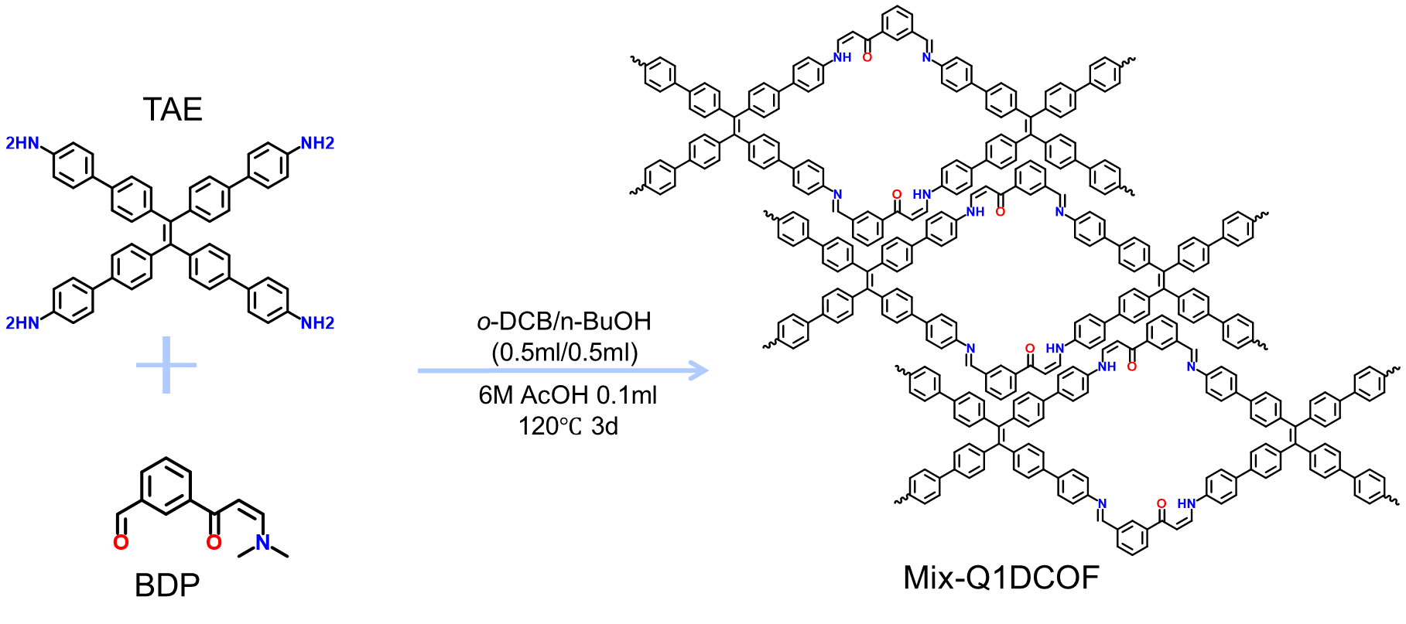
Figure S6. Synthesis of Mix-Q1DCOF.

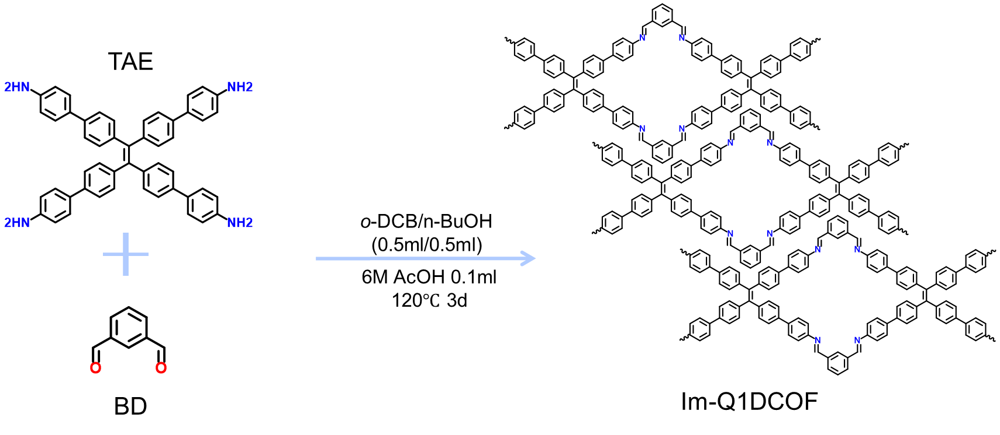

Figure S7. Synthesis of Im-Q1DCOF.

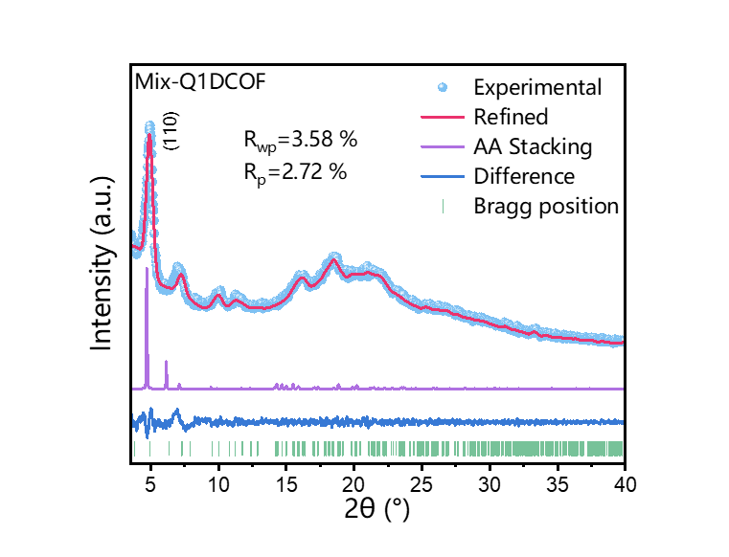

Figure S8. Experimental and Pawley refined PXRD of Mix-Q1DCOF crystal structure on the basis of the AA stacking models.
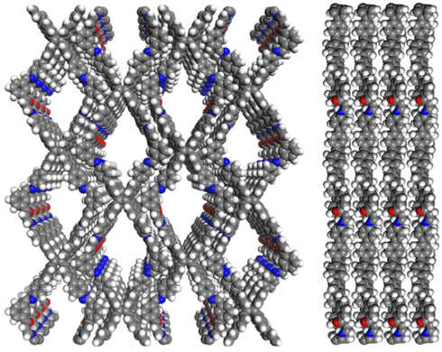

Figure S9. Mix-Q1DCOF top view and side view of the AA stacking structure based on PXRD and modeling.

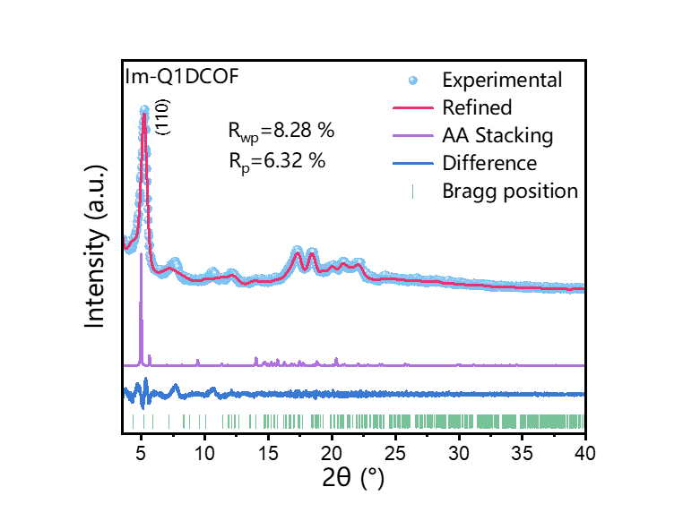
Figure S10. Experimental and Pawley refined PXRD of Im-Q1DCOF crystal structure on the basis of the AA stacking models.

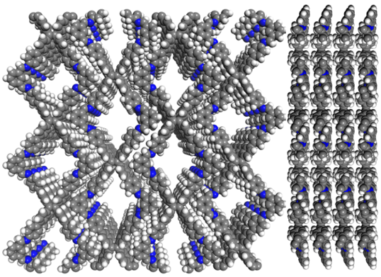

Figure S11. Im-Q1DCOF top view and side view of the AA stacking structure based on PXRD and modeling.

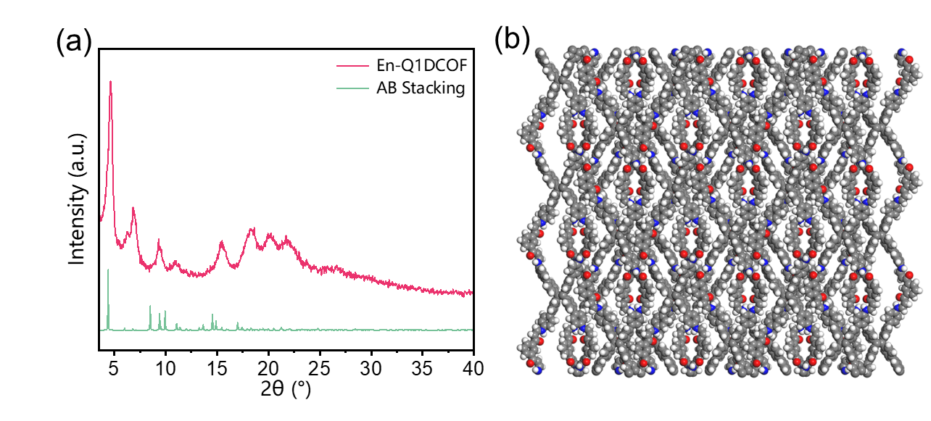
Figure S12. (a) Experimental and simulated powder X-ray diffraction patterns (AB stacking) and (b) ideal structure of En-Q1DCOF.

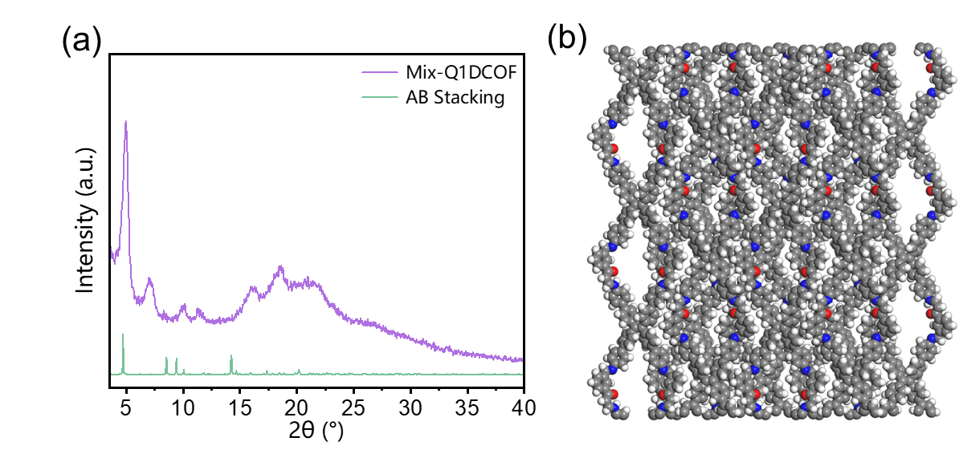
Figure S13. (a) Experimental and simulated powder X-ray diffraction patterns (AB stacking) and (b) ideal structure of Mix-Q1DCOF.

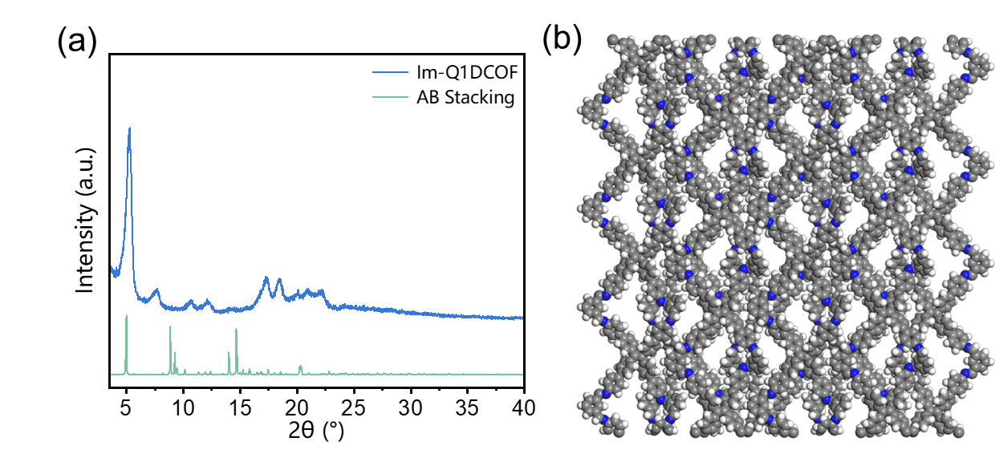
Figure S14. (a) Experimental and simulated powder X-ray diffraction patterns (AB stacking) and (b) ideal structure of Im-Q1DCOF.

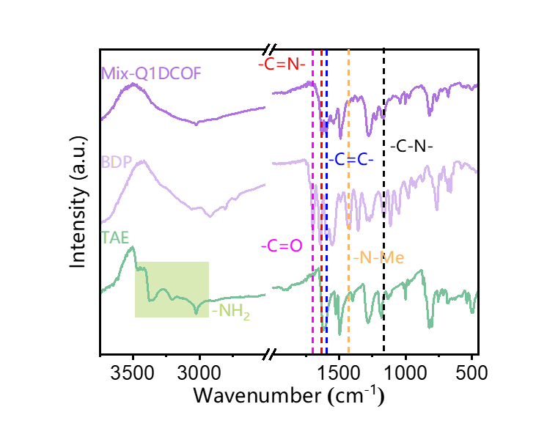
Figure S15. Comparison of the FTIR spectra of Mix-Q1DCOF.

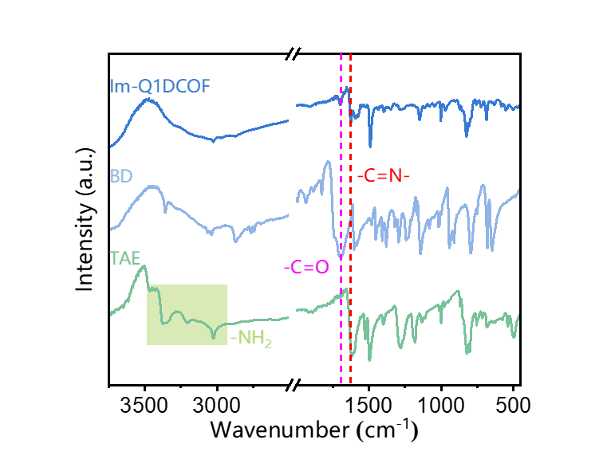

Figure S16. Comparison of the FTIR spectra of Im-Q1DCOF.

Figure S17. Comparison of the FTIR spectra of Q1DCOFs.

Figure S18. The ¹³C CP/MAS spectra of Mix-Q1DCOF.

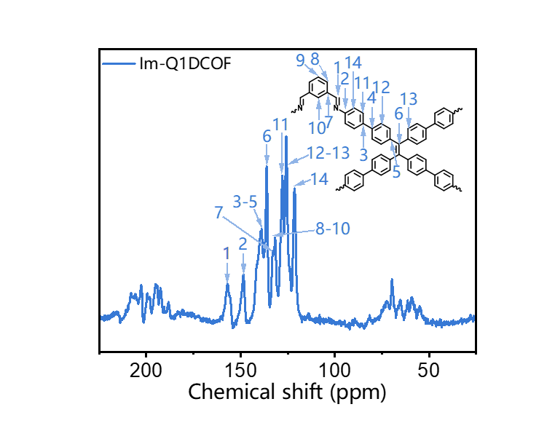
Figure S19. The ¹³C CP/MAS spectra of Im-Q1DCOF.

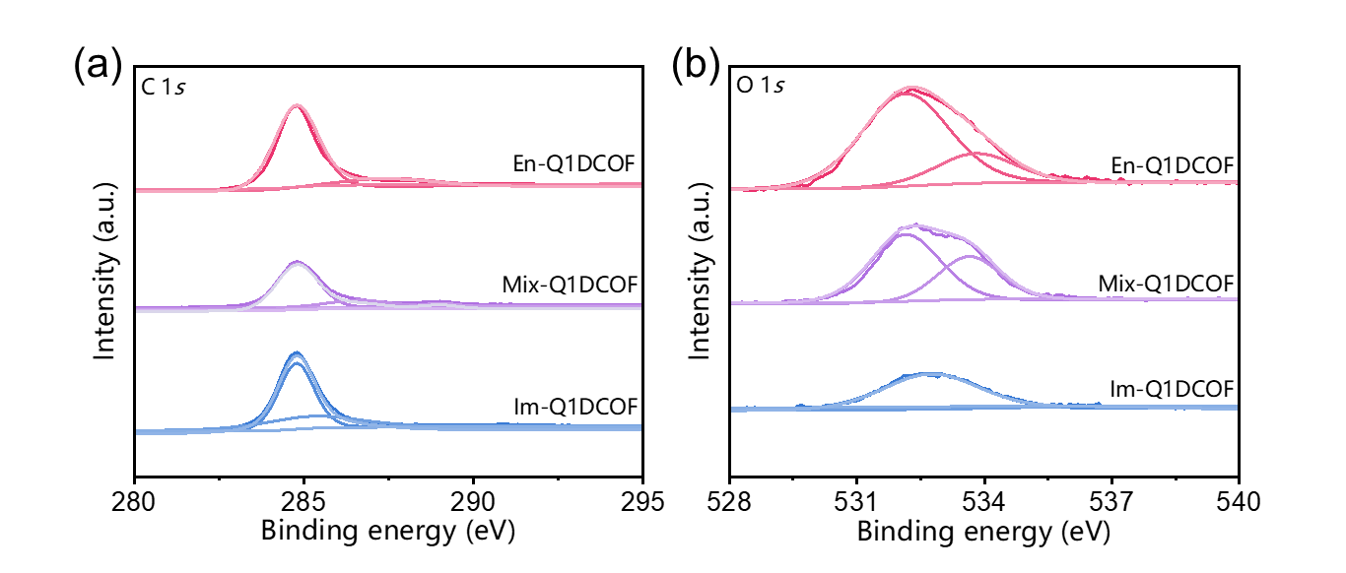
Figure S20. High-resolution XPS spectra of (a) C 1s and (b) O 1s.

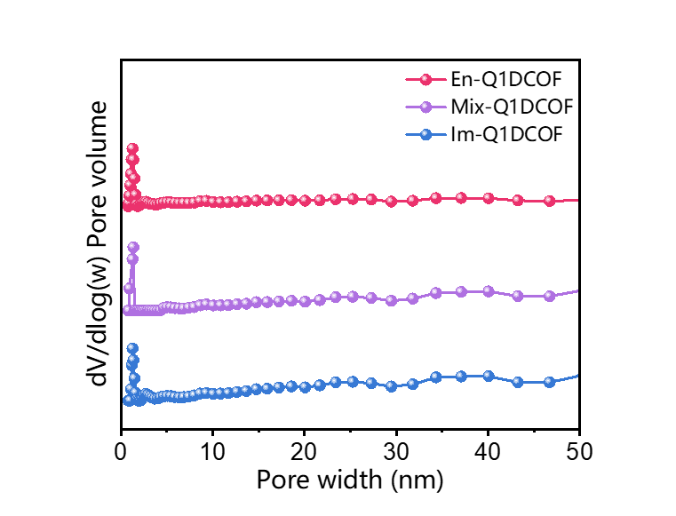

Figure S21. The pore-size distribution of Q1D-COFs.

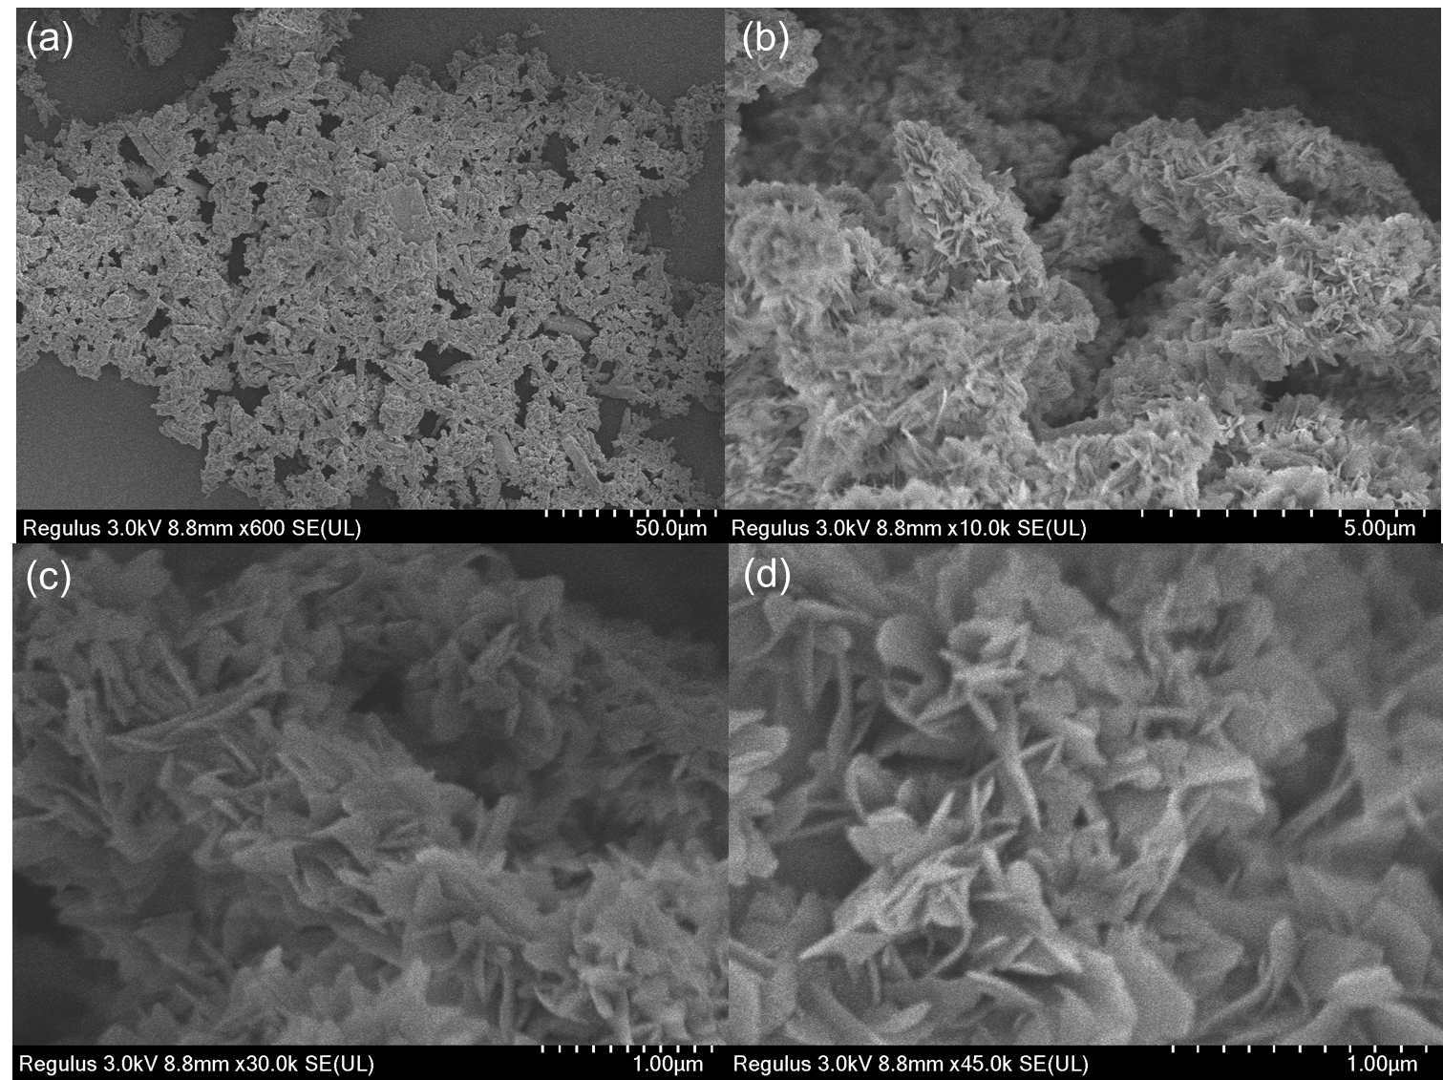
Figure S22. SEM images of En-Q1DCOF.

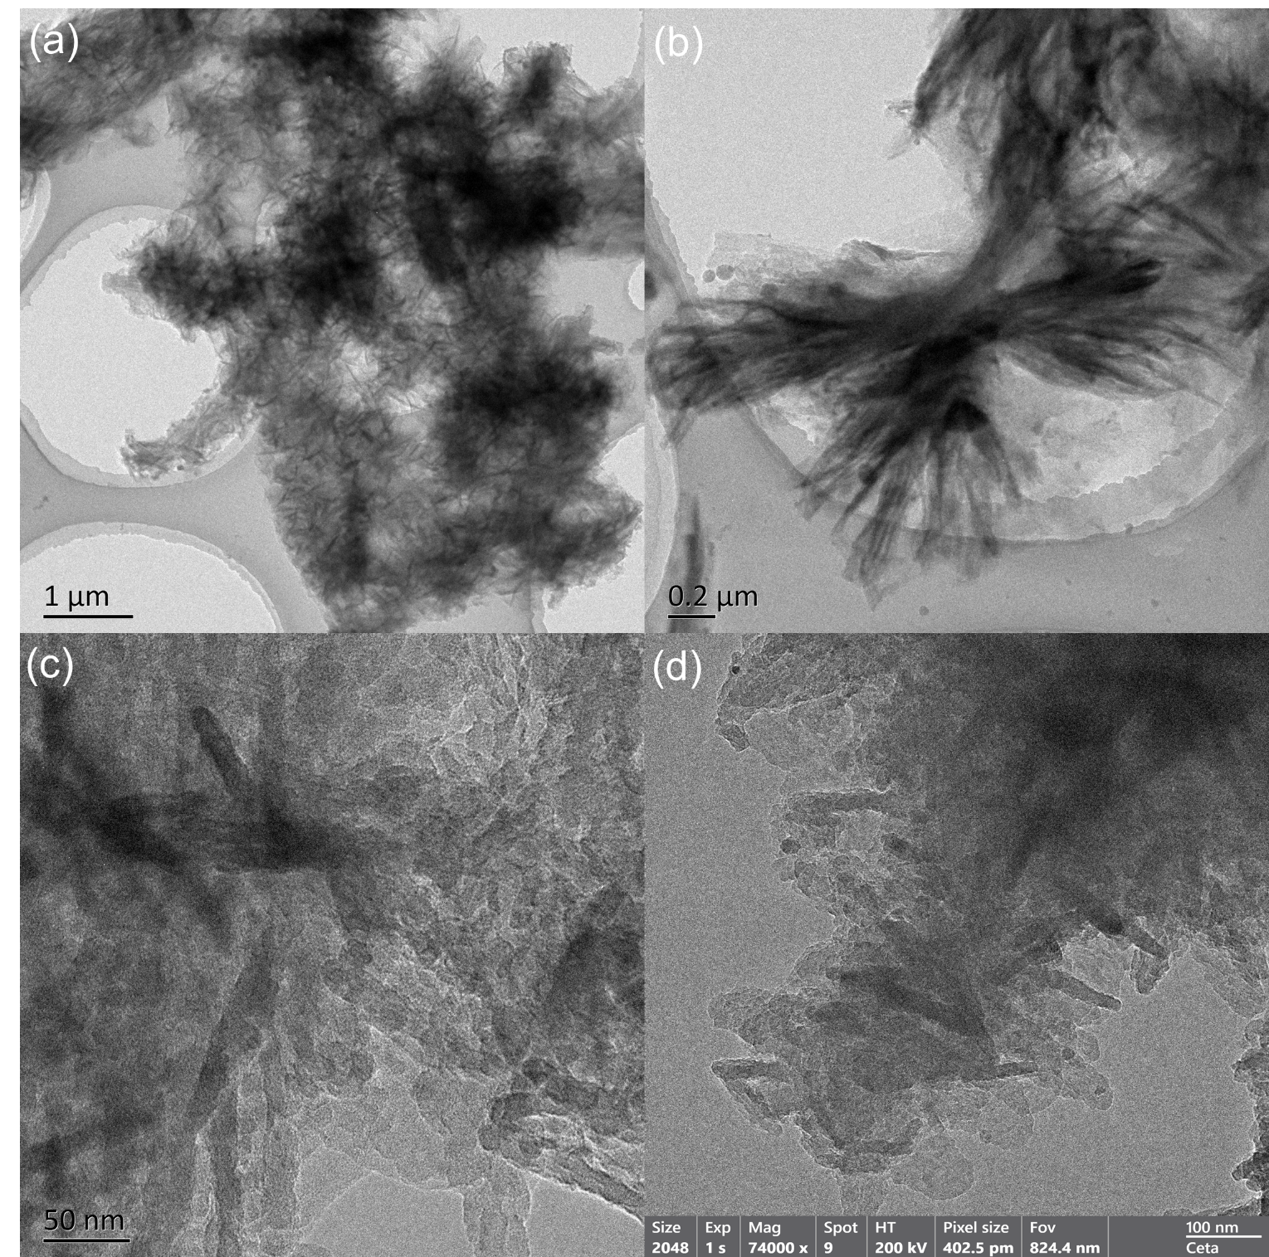
Figure S23. TEM images of En-Q1DCOF.

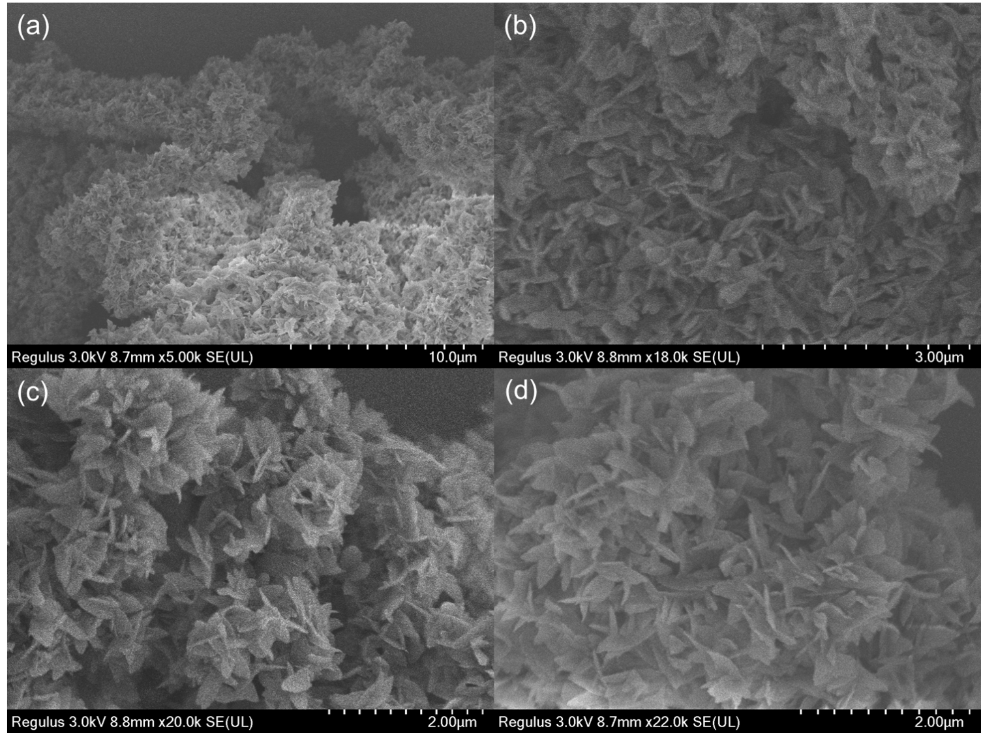
Figure S24. SEM images of Mix-Q1DCOF.

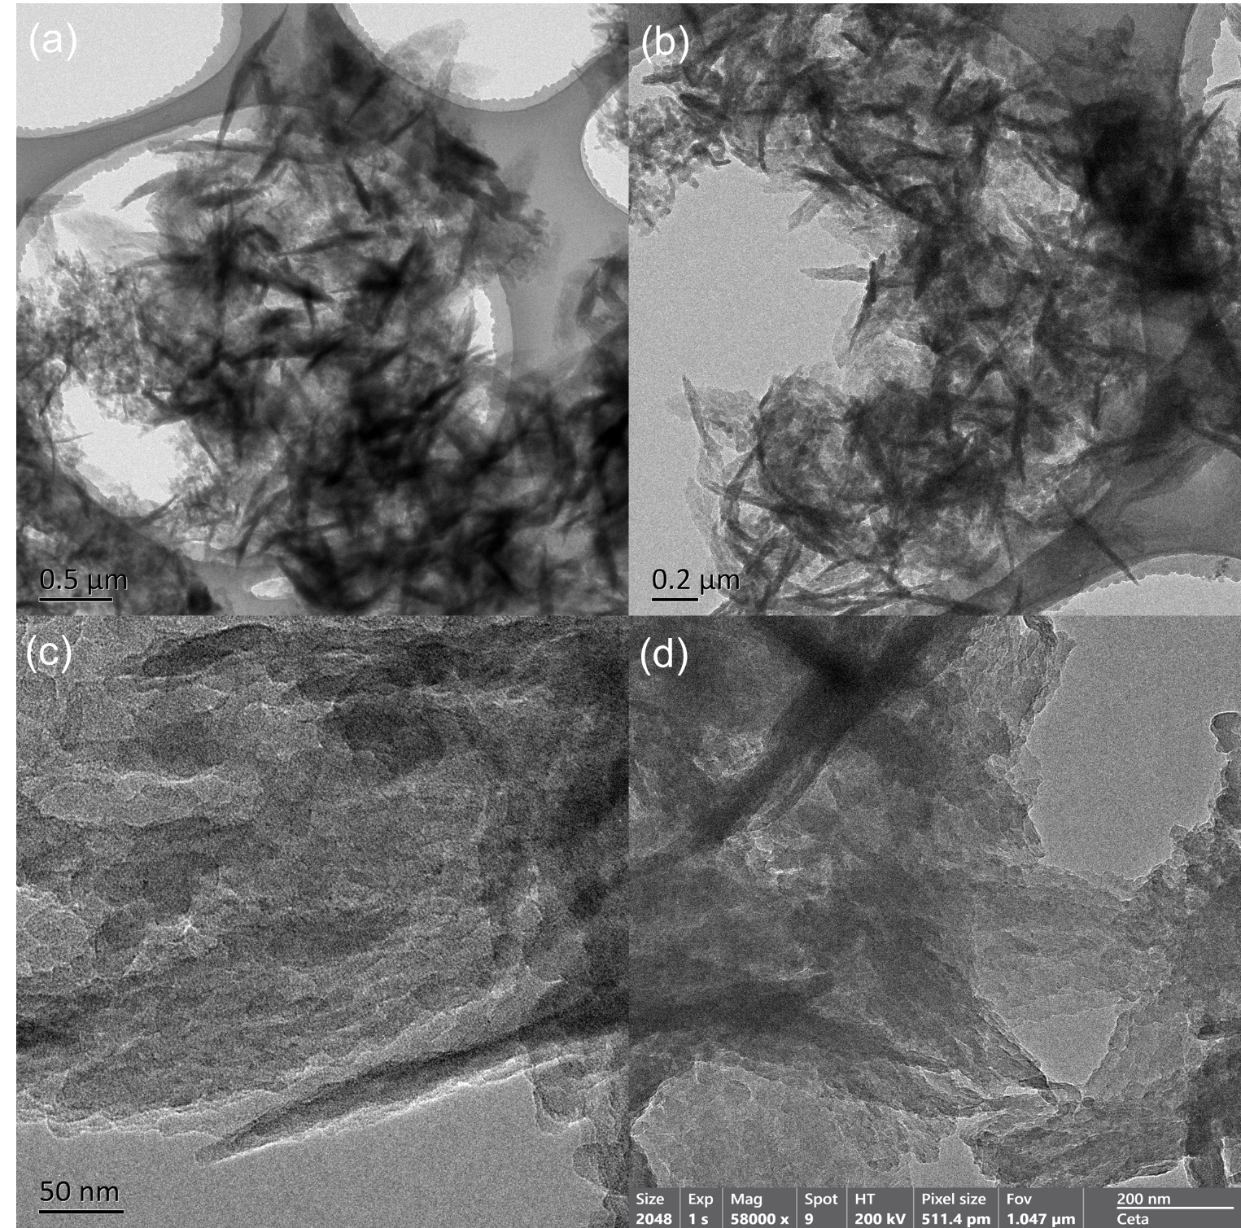
Figure S25. TEM images of Mix-Q1DCOF.

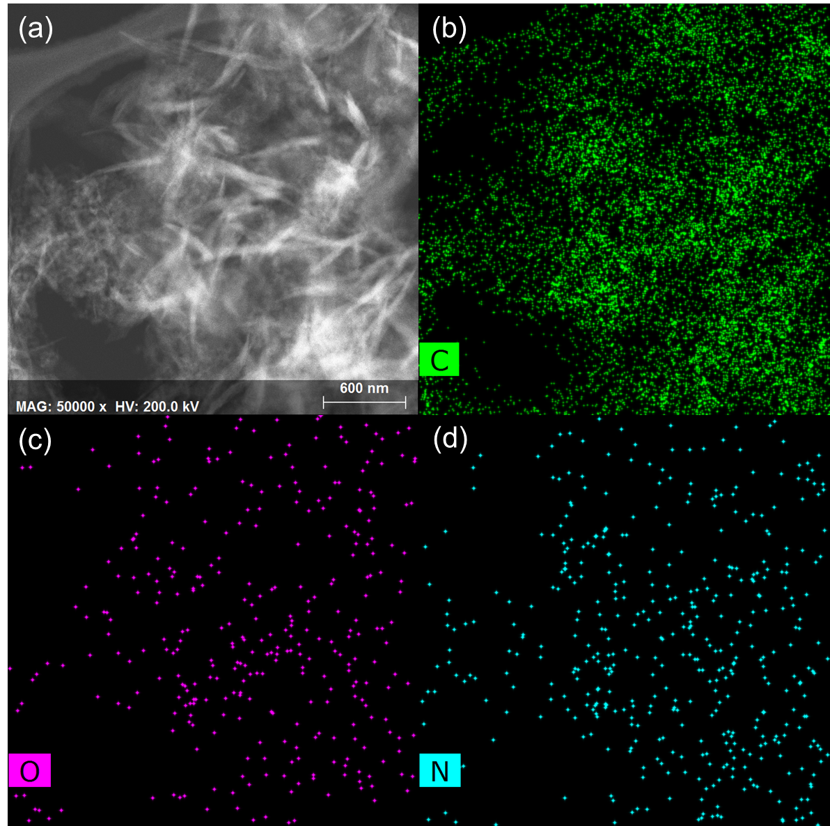
Figure S26. Elemental mapping images of Mix-Q1DCOF.

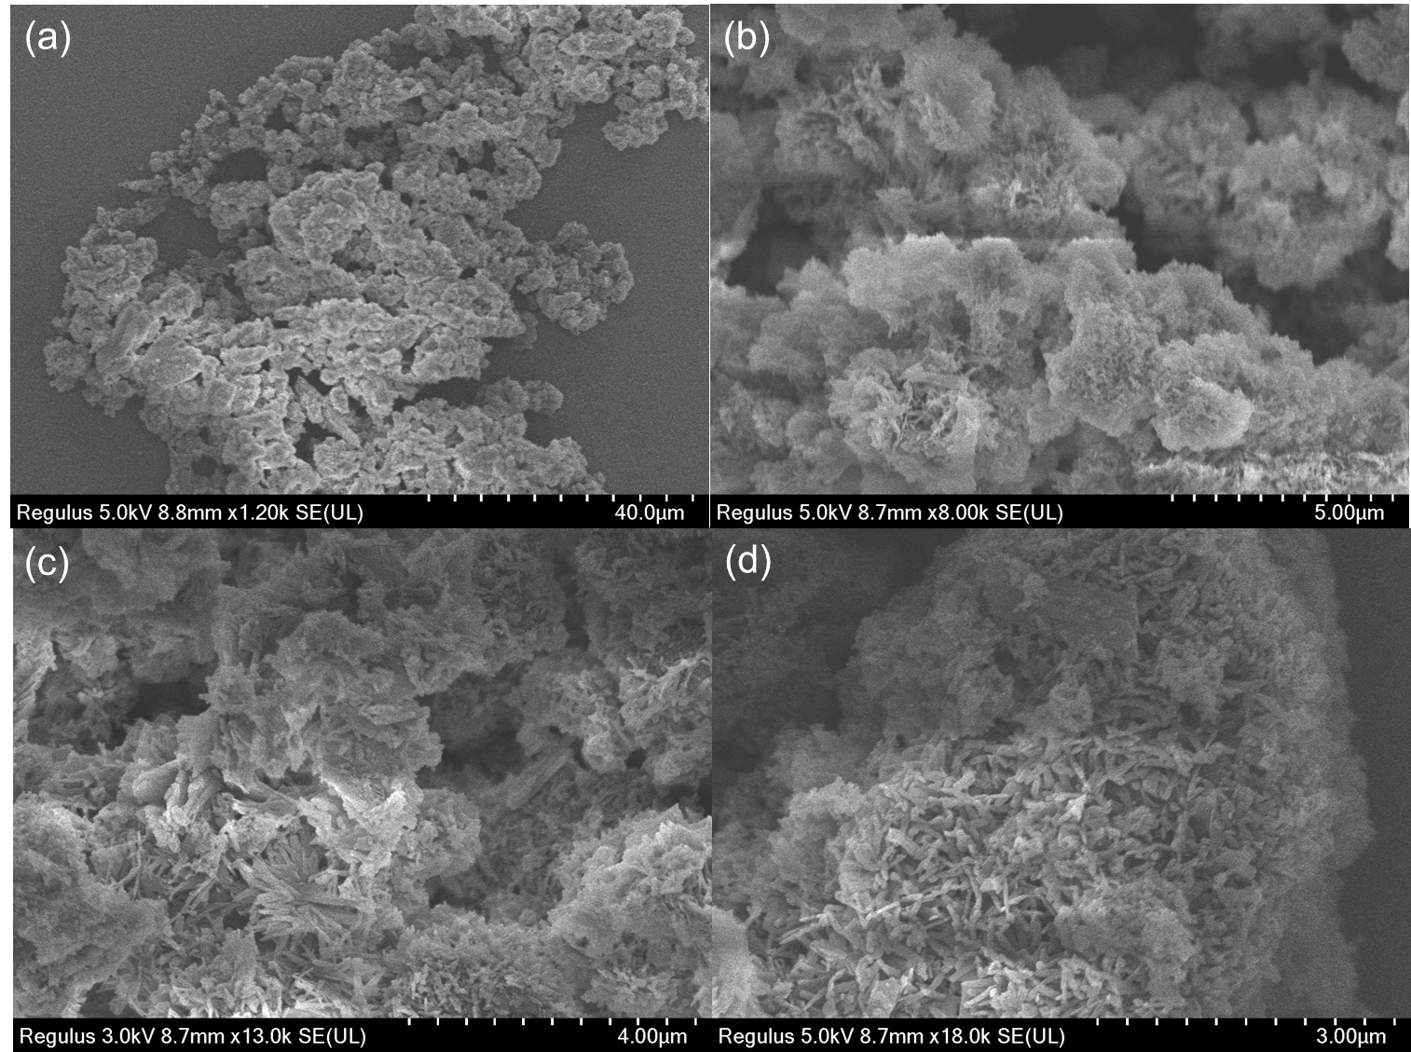
Figure S27. SEM images of Im-Q1DCOF.

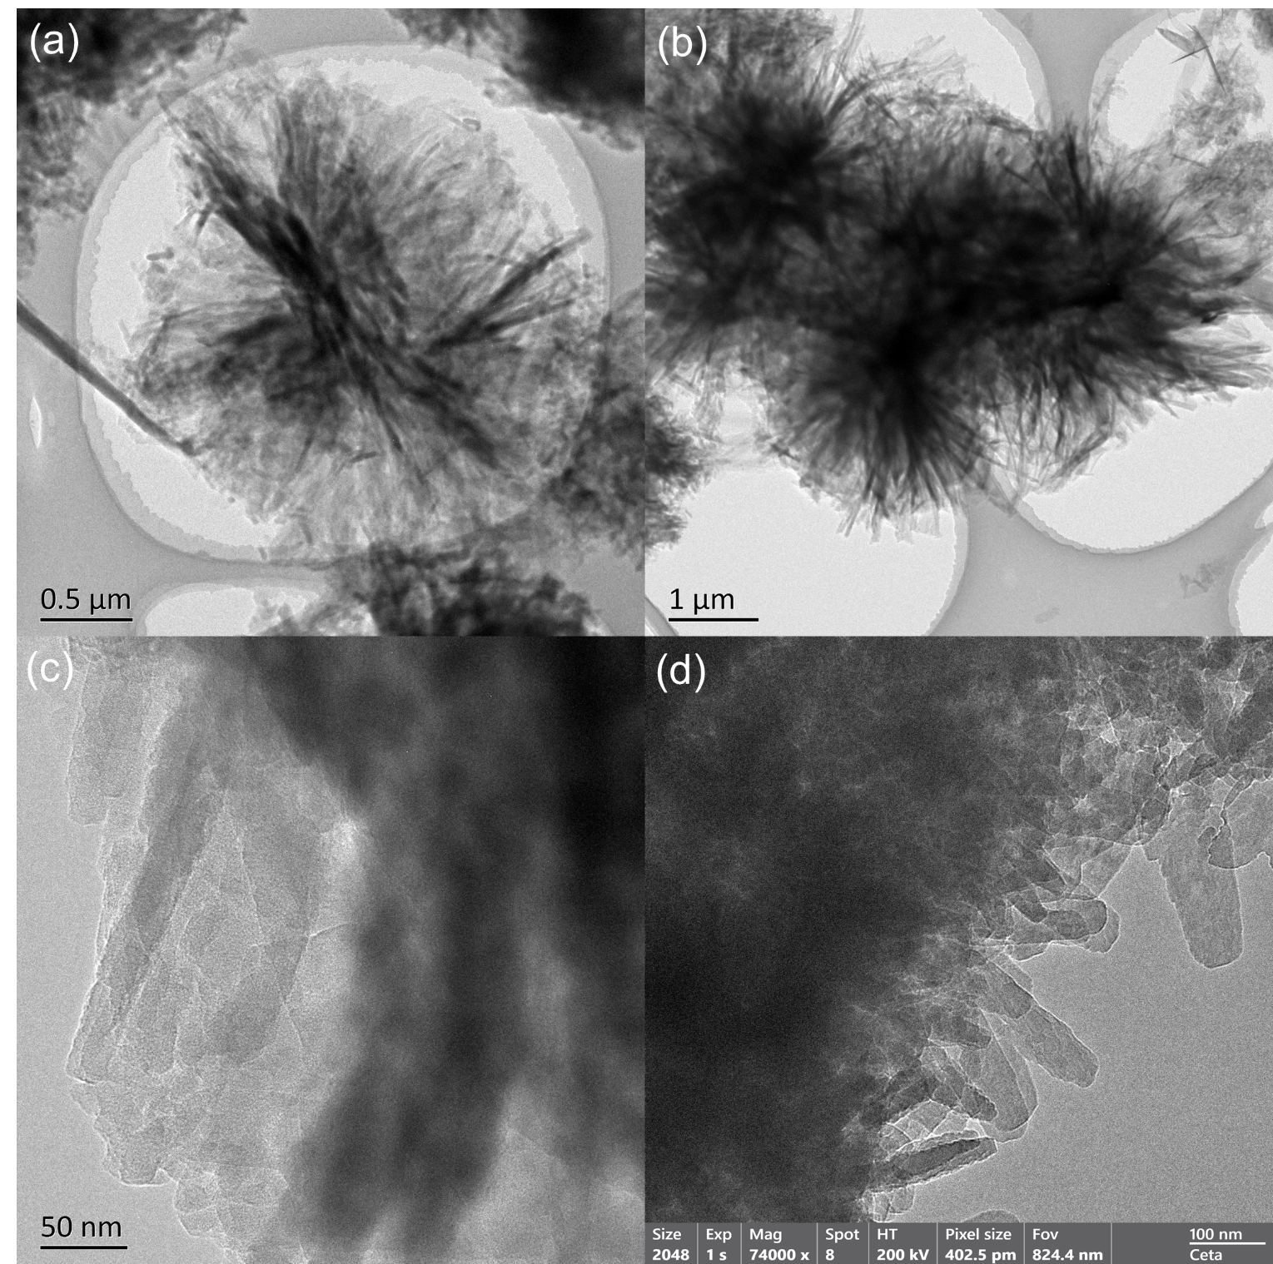
Figure S28. TEM images of Im-Q1DCOF.

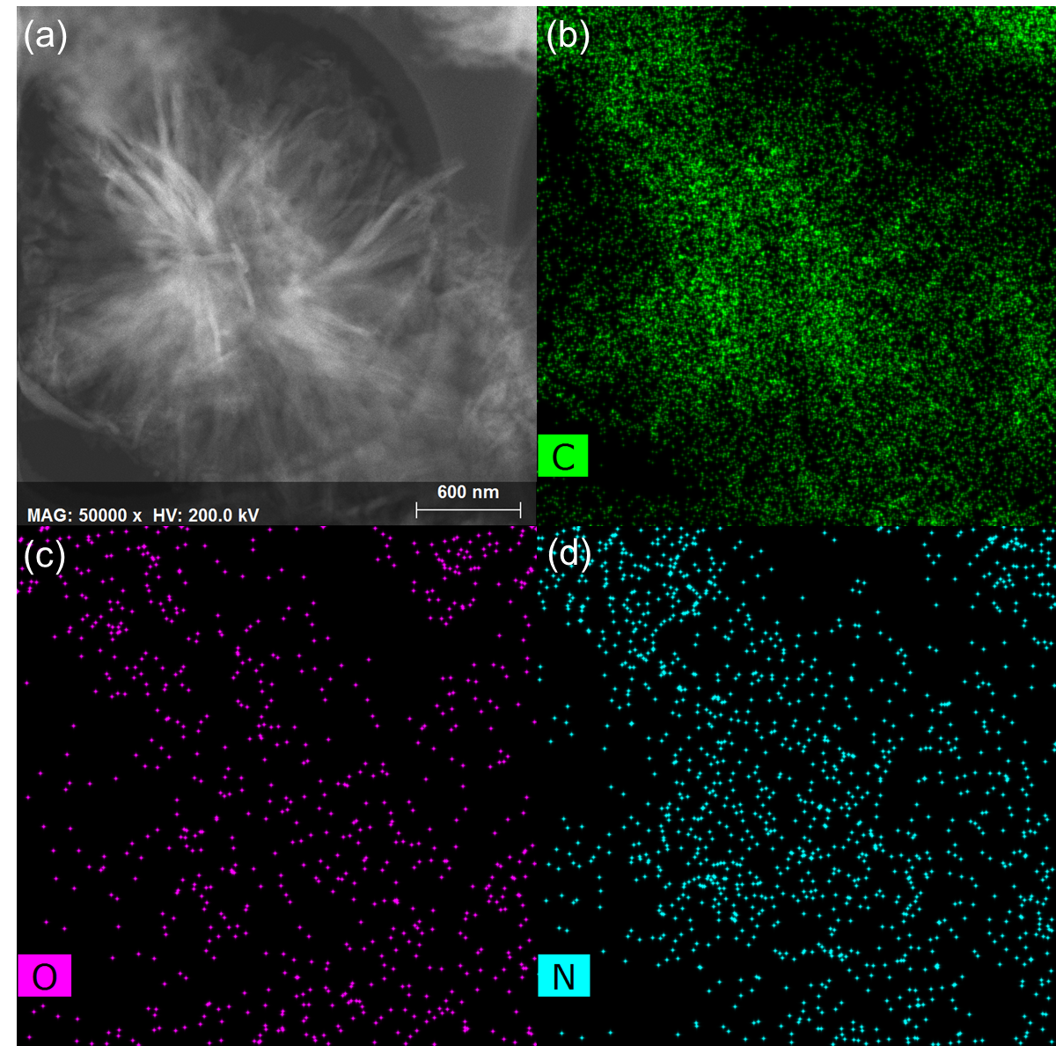
Figure S29. Elemental mapping images of Im-Q1DCOF.

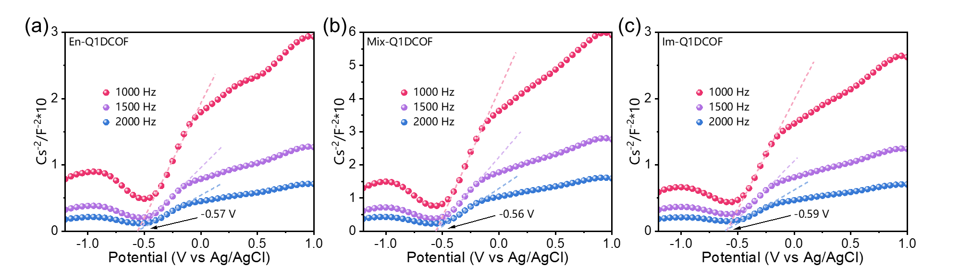Figure S30. Mott-Schottky plots of (a) En-Q1DCOF, (b) Mix-Q1DCOF and (c) Im-Q1DCOF.

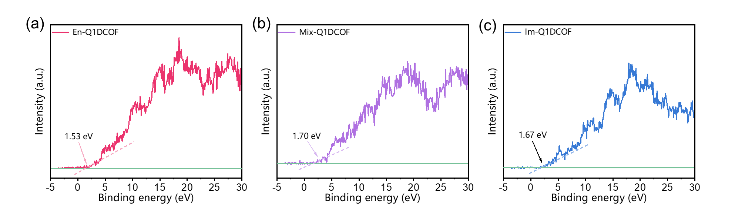
Figure S31. Valence band XPS spectra of (a) En-Q1DCOF, (b) Mix-Q1DCOF and (c) Im-Q1DCOF.

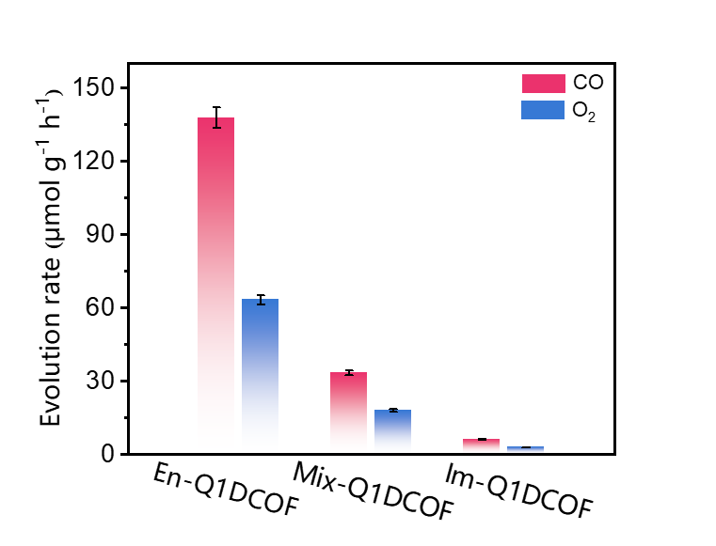
Figure S32. CO and O₂ evolution rates of En-Q1DCOF, Mix-Q1DCOF and Im-Q1DCOF.

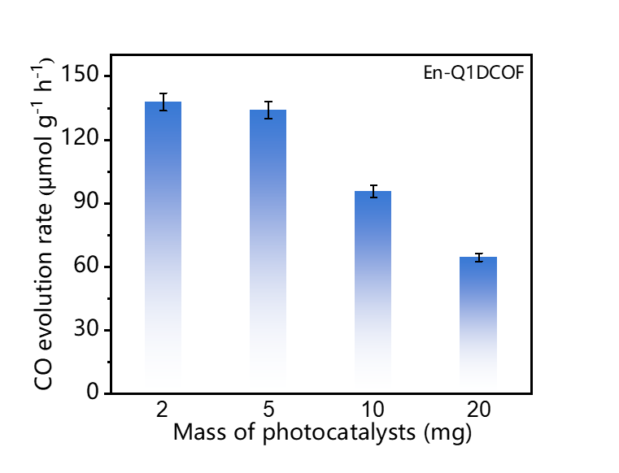
Figure S33. Dependence of the CO evolution rate for En-Q1DCOF with different masses.

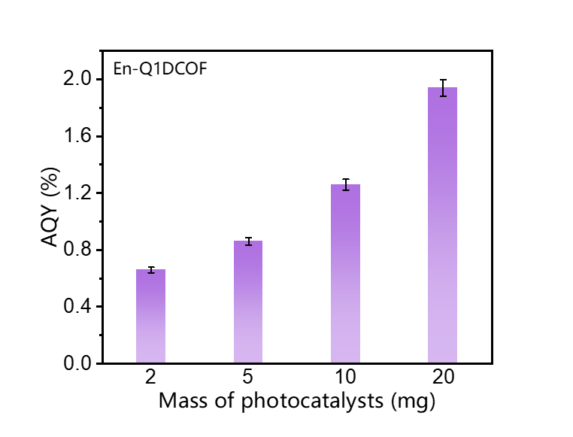
Figure S34. Mass‐dependent AQY of photocatalytic CO evolution for En-Q1DCOF.

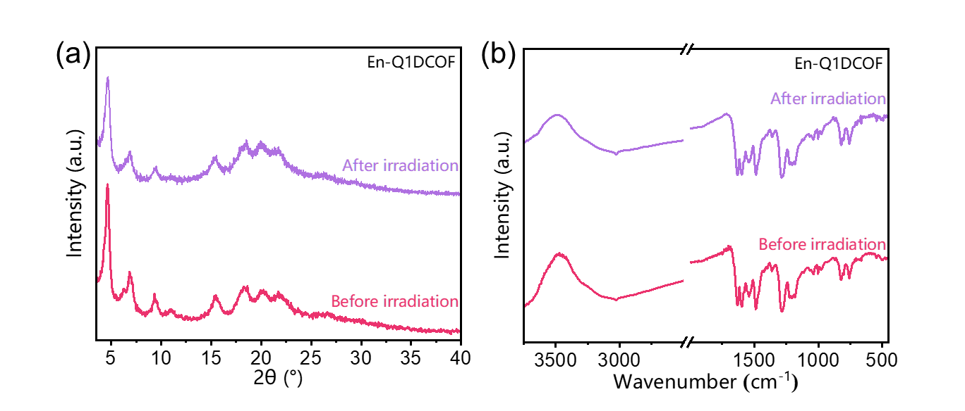
Figure S35. (a) PXRD patterns of En-Q1DCOF before and after photocatalytic reaction. (b) FTIR spectra of En-Q1DCOF before and after photocatalytic reaction.

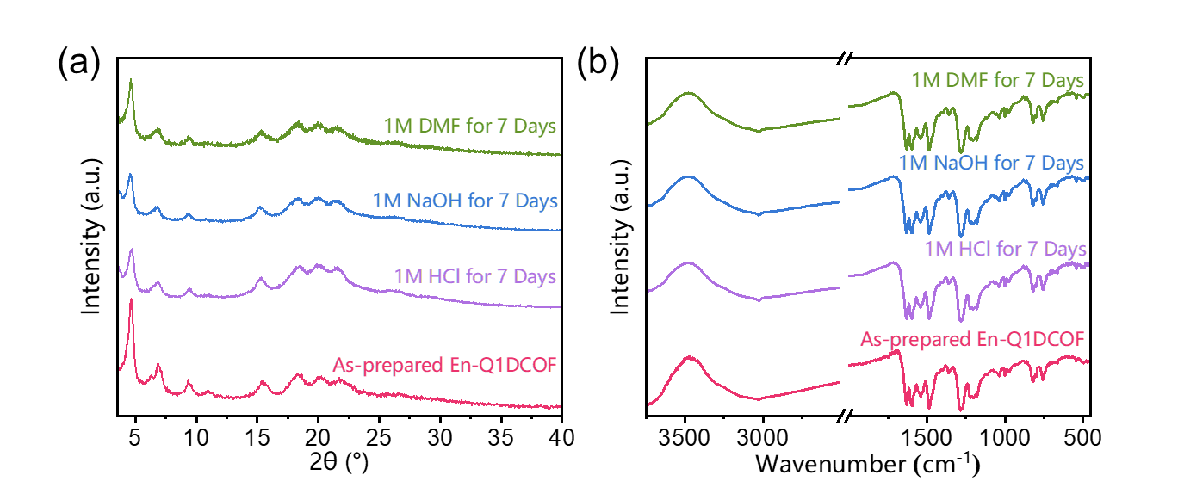
Figure S36. Chemical stability of En-Q1DCOF. (a) PXRD patterns and (b) FTIR spectra of En-Q1DCOF after treatment in 1M NaOH, 1M HCl or 1M DMF for 7 days.

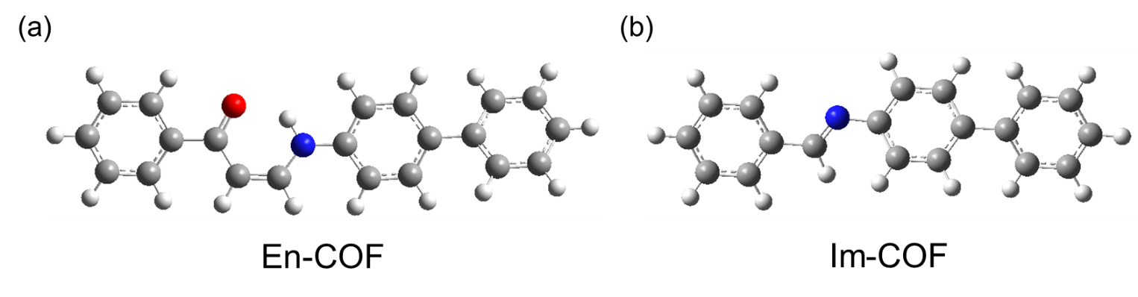
Figure S37. (a) En-COF and (b) Im-COF used for the calculation of the minimal fragment (Grey for C atoms, white for H atoms, red for O atoms and blue for N atoms).

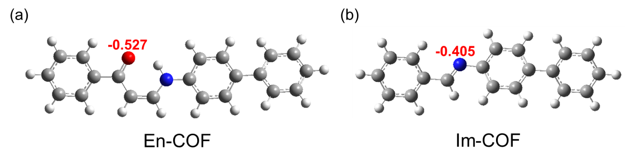
Figure S38. Charge of CO₂ adsorption sites in (a O-site) En-COF and (b N-site) Im-COF.

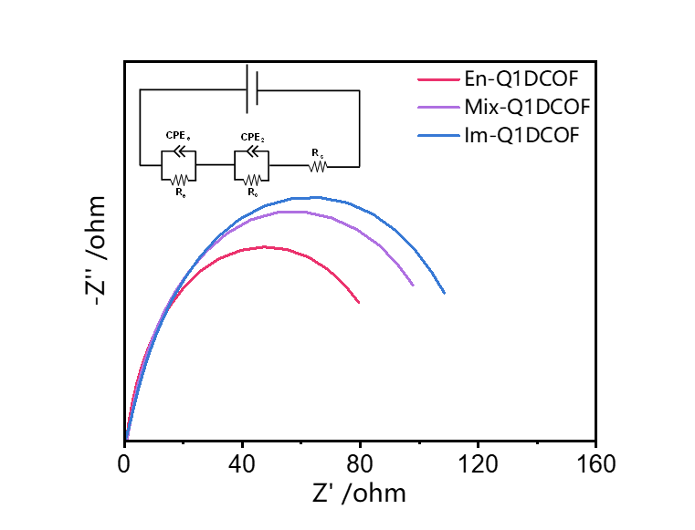
Figure S39. EIS Nyquist plots, with an inset showing the electrical equivalent circuit of the Nyquist plots.

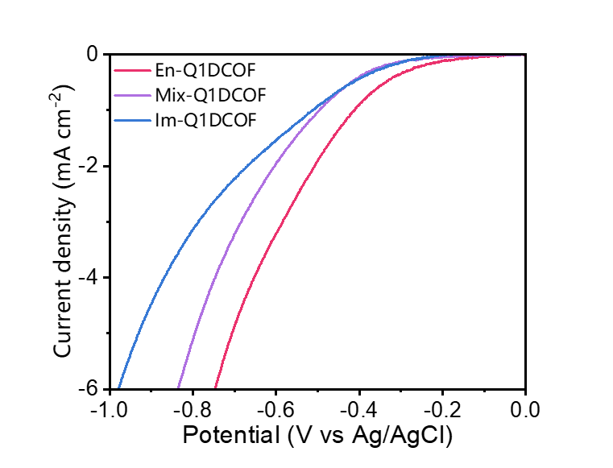
Figure S40. Polarization curves.

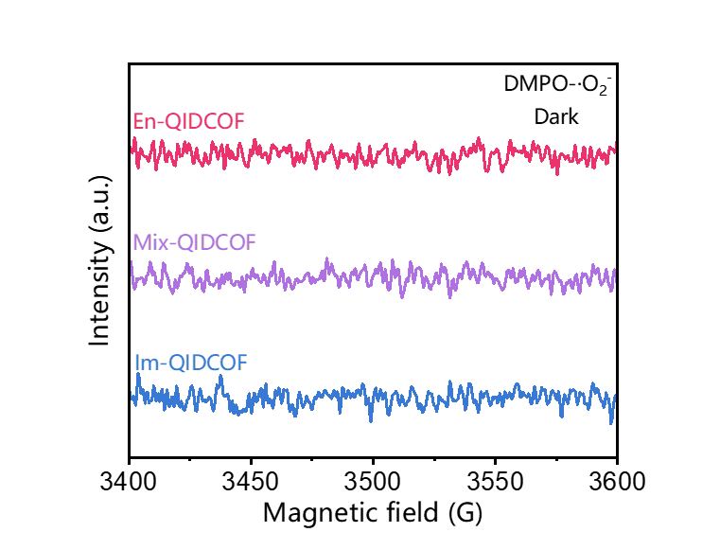
Figure S41. Electron paramagnetic resonance spectra of DMPO‐•O₂⁻ of the samples in dark.

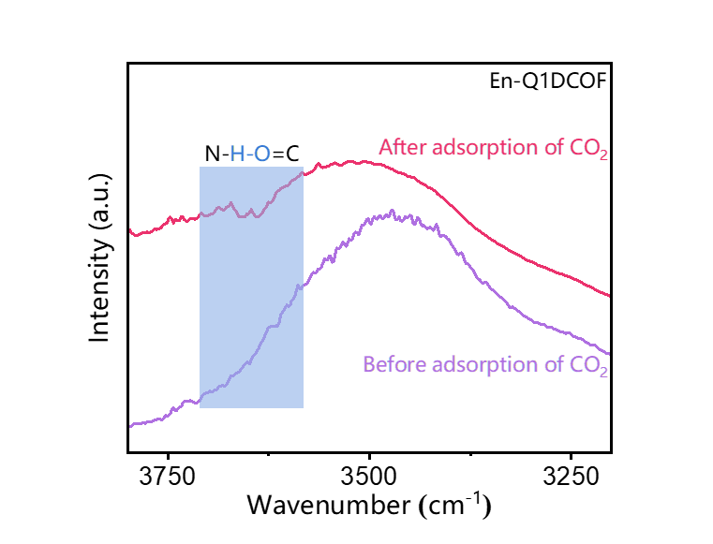
Figure S42. In situ ATR FTIR spectra of dry CO₂ interactions with En-Q1DCOF under dark.

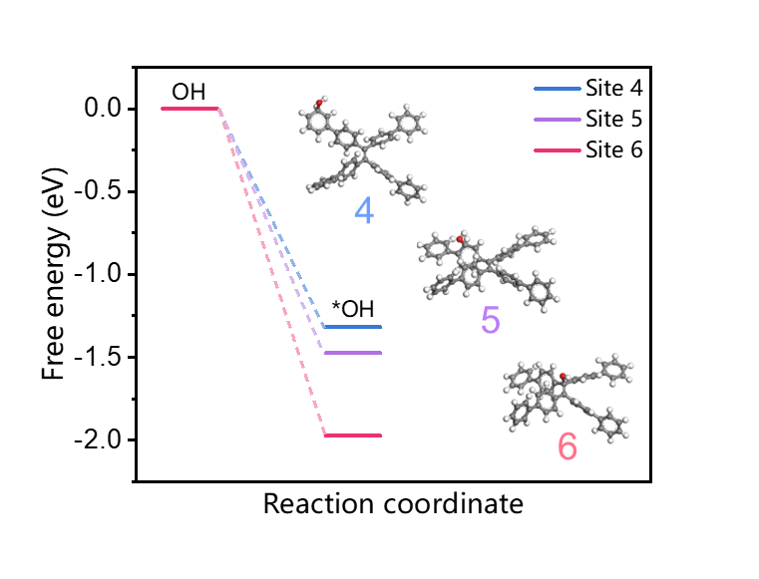
Figure S43. Gibbs free energy at different OH adsorption sites of Q1DCOFs.
Table S1. Fractional atomic coordinates for the unit cell of En-Q1DCOF with AA stacking.
Space group PMA2
Calculated cell parameters
 | a=29.4992Å | b= 27.3954Å | c= 6.0908Å
 | α= 90.0000° | β= 90.0000° | γ= 90.0000°
 | Rp= 2.96% | Rwp=3.83%
Atom | x | y | z
C1 | -0.97577 | 0.1005 | 0.25335
O2 | -0.96888 | 0.07597 | 0.42419
C3 | -0.96696 | 0.07988 | 0.04508
C4 | -0.94802 | 0.0338 | 0.00095
N5 | -0.93293 | 0.00294 | 0.15887
C6 | -0.91403 | -0.04187 | 0.1328
C7 | -0.88857 | -0.06064 | 0.30983
C8 | -0.86675 | -0.10622 | 0.29411
C9 | -0.87018 | -0.135 | 0.10166
C10 | -0.89686 | -0.11643 | -0.07248
C11 | -0.9183 | -0.07076 | -0.05824
C12 | -0.84737 | -0.18034 | 0.08054
C13 | -0.84483 | -0.21418 | 0.25598
C14 | -0.82122 | -0.25857 | 0.2338
C15 | -0.79954 | -0.27068 | 0.03456
C16 | -0.80355 | -0.23815 | -0.14373
C17 | -0.82606 | -0.19335 | -0.11948
C18 | -1.3 | -0.64262 | -0.00566
C19 | -1.32267 | -0.63127 | -0.20352
C20 | -1.34743 | -0.58758 | -0.22483
C21 | -1.34979 | -0.55379 | -0.04952
C22 | -1.3282 | -0.56611 | 0.15042
C23 | -1.30424 | -0.61012 | 0.17285
C24 | -1.37294 | -0.50883 | -0.06954
C25 | -1.41785 | -0.50627 | -0.15044
C26 | -1.44151 | -0.4616 | -0.15447
C27 | -1.42085 | -0.41826 | -0.07736
C28 | -1.37528 | -0.42037 | -0.00798
C29 | -1.35168 | -0.46489 | -0.00378
N30 | -1.4414 | -0.37419 | -0.0565
C31 | -1.48614 | -0.36323 | -0.06197
C32 | -1.50284 | -0.31724 | 0.00181
C33 | -1.47683 | -0.27588 | 0.06059
O34 | -1.4356 | -0.27381 | 0.01058
C35 | -1.49458 | -0.23622 | 0.18213
C36 | -0.77421 | -0.31419 | 0.01422
C37 | 1.47866 | 1.18793 | 0.1478
C38 | 1.4929 | 1.14836 | 0.28115
C39 | 1.52426 | 1.1582 | 0.45105
C40 | 1.54102 | 1.2055 | 0.48619
C41 | 1.52649 | 1.2441 | 0.35226
H42 | -0.97544 | 0.10005 | -0.09029
H43 | -0.94512 | 0.02418 | -0.16064
H44 | -0.93501 | 0.01488 | 0.30759
H45 | -0.8852 | -0.04084 | 0.45142
H46 | -0.84775 | -0.1178 | 0.42437
H47 | -0.90093 | -0.13616 | -0.21303
H48 | -0.93723 | -0.05915 | -0.18848
H49 | -0.86027 | -0.20693 | 0.40233
H50 | -0.81985 | -0.28197 | 0.36428
H51 | -0.78968 | -0.24657 | -0.29252
H52 | -0.82628 | -0.17008 | -0.25051
H53 | -1.32119 | -0.65472 | -0.33381
H54 | -1.36338 | -0.58044 | -0.37038
H55 | -1.32986 | -0.54313 | 0.28267
H56 | -1.28985 | -0.61815 | 0.32094
H57 | -1.43403 | -0.5371 | -0.20376
H58 | -1.47396 | -0.46122 | -0.2124
H59 | -1.35896 | -0.38945 | 0.04389
H60 | -1.31876 | -0.4649 | 0.04959
H61 | -1.4217 | -0.34718 | -0.02172
H62 | -1.50934 | -0.38947 | -0.10181
H63 | -1.53738 | -0.31438 | 0.01242
H64 | 1.45551 | 1.18172 | 0.02569
H65 | 1.53519 | 1.13075 | 0.55123
H66 | 1.56354 | 1.21196 | 0.61043
H67 | 1.53883 | 1.27827 | 0.38442

Table S2. Fractional atomic coordinates for the unit cell of Mix-Q1DCOF with AA stacking.
Space group PMA2
Calculated cell parameters
 | a=28.7365Å | b= 24.7115Å | c= 6.2289Å
 | α= 90.0000° | β= 90.0000° | γ= 90.0000°
 | Rp= 2.72% | Rwp=3.58%
Atom | x | y | z
C1 | -0.99388 | 0.17817 | 0.13628
O2 | -0.97559 | 0.16765 | -0.0418
C3 | -0.99081 | 0.14163 | 0.31004
C4 | -0.96966 | 0.09034 | 0.31098
N5 | -0.94937 | 0.0677 | 0.13634
C6 | -0.92813 | 0.01873 | 0.11941
C7 | -0.9047 | 0.00764 | -0.07481
C8 | -0.88068 | -0.04143 | -0.10526
C9 | -0.8796 | -0.08168 | 0.05678
C10 | -0.90417 | -0.07071 | 0.24919
C11 | -0.92771 | -0.0215 | 0.2808
C12 | -0.85449 | -0.13071 | 0.02939
C13 | -0.82953 | -0.15411 | 0.20213
C14 | -0.80508 | -0.20293 | 0.17737
C15 | -0.80178 | -0.22854 | -0.02439
C16 | -0.82688 | -0.20587 | -0.19729
C17 | -0.85325 | -0.15832 | -0.16996
C18 | -1.30036 | -0.67498 | -0.05751
C19 | -1.32109 | -0.65645 | -0.24928
C20 | -1.34466 | -0.60647 | -0.2556
C21 | -1.34762 | -0.57303 | -0.07141
C22 | -1.32726 | -0.59243 | 0.12066
C23 | -1.30486 | -0.64284 | 0.12834
C24 | -1.37106 | -0.52257 | -0.07252
C25 | -1.41466 | -0.51631 | -0.17551
C26 | -1.44027 | -0.46807 | -0.15455
C27 | -1.42331 | -0.42492 | -0.02827
C28 | -1.37822 | -0.42899 | 0.05874
C29 | -1.35247 | -0.47709 | 0.03681
N30 | -1.44845 | -0.38017 | 0.02024
C31 | 0.51675 | 1.22845 | 0.15625
C32 | 0.56149 | 1.23228 | 0.24986
C33 | 0.58421 | 1.28239 | 0.26688
C34 | 0.56222 | 1.32963 | 0.19344
C35 | 0.51715 | 1.32753 | 0.10256
C36 | 0.49513 | 1.27651 | 0.08264
C37 | 0.49523 | 1.37595 | 0.03984
C38 | 0.2251 | 1.72386 | -0.04752
H39 | -1.00517 | 0.15341 | 0.45318
H40 | -0.97012 | 0.06993 | 0.45357
H41 | -0.94976 | 0.08966 | 0.00821
H42 | -0.90457 | 0.03565 | -0.19599
H43 | -0.86343 | -0.04701 | -0.24721
H44 | -0.90545 | -0.09863 | 0.36998
H45 | -0.9446 | -0.01588 | 0.42314
H46 | -0.8287 | -0.13581 | 0.34917
H47 | -0.78957 | -0.21962 | 0.30893
H48 | -0.8264 | -0.22388 | -0.34454
H49 | -0.87178 | -0.14414 | -0.29809
H50 | -1.31906 | -0.67914 | -0.38568
H51 | -1.35949 | -0.59459 | -0.39688
H52 | -1.32891 | -0.57019 | 0.2587
H53 | -1.29141 | -0.65572 | 0.27104
H54 | -1.42884 | -0.54723 | -0.26293
H55 | -1.4716 | -0.46475 | -0.23049
H56 | -1.36424 | -0.39742 | 0.14339
H57 | -1.32008 | -0.47875 | 0.10482
H58 | 0.57807 | 1.19857 | 0.30583
H59 | 0.61663 | 1.2845 | 0.33377
H60 | 0.57923 | 1.36574 | 0.21003
H61 | 0.46267 | 1.27428 | 0.01518
H62 | 0.51523 | 1.40981 | 0.0194

Table S3. Fractional atomic coordinates for the unit cell of Im-Q1DCOF with AA stacking.
Space group PMA2
Calculated cell parameters
 | a=31.2157Å | b= 21.5565Å | c= 6.0374Å
 | α= 90.0000° | β= 90.0000° | γ= 90.0000°
 | Rp= 6.32% | Rwp=8.28%
Atom | x | y | z
C1 | -0.92031 | 0.06888 | -0.02978
C2 | -0.87795 | 0.06838 | 0.05023
C3 | -0.85225 | 0.01518 | 0.02681
C4 | -0.86819 | -0.03927 | -0.07623
C5 | -0.90934 | -0.03618 | -0.17436
C6 | -0.93488 | 0.01723 | -0.15251
C7 | -0.84463 | -0.09549 | -0.07167
C8 | -0.82329 | -0.11356 | 0.12491
C9 | -0.80062 | -0.16962 | 0.13737
C10 | -0.7971 | -0.20898 | -0.04826
C11 | -0.81919 | -0.19233 | -0.24342
C12 | -0.84262 | -0.13653 | -0.25479
C13 | -1.29715 | -0.6809 | -0.01104
C14 | -1.30221 | -0.63844 | -0.18691
C15 | -1.32675 | -0.58422 | -0.15963
C16 | -1.34762 | -0.57092 | 0.0433
C17 | -1.34244 | -0.61405 | 0.21839
C18 | -1.31774 | -0.66806 | 0.19188
C19 | -1.37326 | -0.51703 | 0.06891
C20 | -1.41256 | -0.51934 | 0.186
C21 | -1.43864 | -0.46657 | 0.20857
C22 | -1.42667 | -0.40947 | 0.11172
C23 | -1.38728 | -0.40638 | -0.00204
C24 | -1.36096 | -0.45912 | -0.02243
N25 | -1.45062 | -0.35699 | 0.11902
N26 | 0.44495 | 1.11854 | 0.02268
C27 | 0.48812 | 1.12162 | 0.04146
C28 | 0.50965 | 1.17597 | 0.10813
C29 | 0.55316 | 1.17247 | 0.17279
C30 | 0.57524 | 1.22546 | 0.24515
C31 | 0.5541 | 1.28288 | 0.25448
C32 | 0.51069 | 1.28849 | 0.18972
C33 | 0.48899 | 1.23446 | 0.11668
C34 | 0.49051 | 1.34694 | 0.19964
C35 | 0.72714 | 1.26425 | -0.03532
H36 | -0.86582 | 0.10623 | 0.13121
H37 | -0.82182 | 0.01638 | 0.08984
H38 | -0.92177 | -0.07338 | -0.25772
H39 | -0.96437 | 0.0178 | -0.22475
H40 | -0.8244 | -0.08633 | 0.26343
H41 | -0.78676 | -0.18148 | 0.28433
H42 | -0.81843 | -0.22088 | -0.37833
H43 | -0.8582 | -0.12613 | -0.39887
H44 | -1.28826 | -0.64681 | -0.33686
H45 | -1.32957 | -0.55476 | -0.29155
H46 | -1.35665 | -0.60666 | 0.36845
H47 | -1.31497 | -0.69806 | 0.32213
H48 | -1.42299 | -0.55983 | 0.2554
H49 | -1.46639 | -0.47062 | 0.29626
H50 | -1.37746 | -0.3655 | -0.07193
H51 | -1.3325 | -0.45454 | -0.10487
H52 | 0.50568 | 1.08227 | 0.01527
H53 | 0.5692 | 1.1311 | 0.17014
H54 | 0.60665 | 1.2222 | 0.29191
H55 | 0.57089 | 1.32064 | 0.30921
H56 | 0.45758 | 1.23769 | 0.06944
H57 | 0.50691 | 1.38313 | 0.26835

Table S4. Comparison of CO production rate with that catalyzed by other metal-free COF photocatalysts and photocatalytic systems
Sample | Reaction condition | CO Production rate (μmol g⁻¹ h⁻¹) | Selectivity (%) | Ref
En-Q1DCOF | gas-solid system  visible light ≥420 nm | 137.6 | ~100 | This work
Mix-Q1DCOF | gas-solid system  visible light ≥420 nm | 33.5 | ~100 | This work
Im-Q1DCOF | gas-solid system  visible light ≥420 nm | 6.5 | ~100 | This work
CT-COF | gas-solid system  visible light ≥420 nm | 102.7 | ~100 | ^{[1]}
2,3-DhaTph CONs | gas-solid system  visible light ≥420 nm | 132.2 | ~100 | ^{[2]}
TAPBB-COF | gas-solid system  visible light 200-1000 nm | 24.6 | 95.6 | ^{[3]}
TT-TAPP | H₂O, TEOA/800>λ>200 nm | 18 | 90 | ^{[4]}
TOT-TAPP | H₂O, TEOA/800>λ>200 nm | 34.8 | 90 | ^{[4]}
En-COF-TAPB-TDOEB | gas-solid system  visible light ≥420 nm | 69 | ~100 | ^{[5]}
TFB-BDF-COF | gas-solid system  visible light ≥420 nm | 49.5 | ~100 | ^{[6]}
TFPT-BDF-COF | gas-solid system  visible light ≥420 nm | 158.1 | ~100 | ^{[6]}
2N-COF | gas-solid system  visible light ≥420 nm | 98 | ~100 | ^{[7]}

References
[1] K. Lei, D. Wang, L. Ye, M. Kou, Y. Deng, Z. Ma, L. Wang, Y. Kong, ChemSusChem 2020, 13, 1725.
[2] Y. Guo, Q. Zhang, S. Gao, H. Wang, Z. Li, J. Qiu, Y. Zhao, Z. Liu, J. Wang, Green Chem. 2022, 24, 9530.
[3] L. j. Wang, R. l. Wang, X. Zhang, J. l. Mu, Z. y. Zhou, Z. m. Su, ChemSusChem 2020, 13, 2973.
[4] D. Zhou, Q. Chen, J. Zhang, T. Wang, Z. Q. Liu, Angew. Chem. Int. Ed. 2025, 137, e202500329.
[5] J. Bai, M. Zhang, F. Si, Y. Li, G. Liang, T. Hou, Y. Li, Adv. Funct. Mater. 2025, 35, 2420218.
[6] J. Sheng, Y. He, J. Li, C. Yuan, H. Huang, S. Wang, Y. Sun, Z. Wang, F. Dong, ACS Nano 2020, 14, 13103.
[7] S. Gao, Q. Zhang, X. Su, X. Wu, X. Zhang, Y. Guo, Z. Li, J. Wei, H. Wang, S. Zhang, J. Am. Chem. Soc. 2023, 145, 9520.

