Table S1 presents the strain isolation results and morphological characteristics, including optimal growth temperatures, colony morphology (size, color, and form) for each isolated strain.
Table S1. Isolation results and morphological characteristics of strains
Strain number | Culture temperature | Medium type | Morphological characteristics
LB1 | 40℃ | bacteria | The size of the colony is 1 ~ 2 mm, the color is light yellow, the edge is rough, the shape of the colony is irregular round, the colony is dull and opaque.
LB2 | 40℃ | bacteria | The colony size is 2 ~ 3 mm, the color is light yellow, the edge is smooth, the colony shape is round, the colony is dull and opaque.
LB3 | 40℃ | bacteria | The size of the colony is 1.5 ~ 2 mm, the color is light yellow, the edge is rough, the shape of the colony is nearly round, the colony is dull and opaque.
LB4 | 50℃ | bacteria | The colony size is 1 ~ 2 mm, the color is light yellow, the edge is smooth, the colony shape is nearly round, the colony is dull and opaque.
LB5 | 50℃ | bacteria | The colony size is 1 ~ 4 mm, the color is beige, the edge is rough, the colony shape is nearly round, the colony is dull and opaque.
J-1-1 | 40℃ | bacteria | The colony size is 1.5 ~ 2 mm, the color is light yellow, the edge is smooth, the colony shape is round, the colony is dull and translucent.
J-1-2 | 40℃ | bacteria | The size of the colony is 1 ~ 3 mm, the color is light yellow, the edge is irregular, the shape of the colony is nearly round, the colony is dull and opaque.
J-2-1 | 40℃ | bacteria | The colony size is 1.5 ~ 2 mm, the color is light yellow, the edge is smooth, the colony shape is round, the colony is dull and translucent.
J-2-4 | 50℃ | bacteria | The size of the colony is 1 ~ 2 mm, the color is light yellow, the edge is rough, the shape is nearly round, the colony is dull and opaque.
MR1 | 50℃ | fungus | The size of the colony is 1.5 ~ 6 mm, the color is light yellow, the edge is rough, the shape of the colony is nearly round, no mycelia, the colony is dull and opaque.
F1 | 40℃ | actinomycetes | The colony size is 0.5 ~ 2 mm, the color is light white, the edge is smooth, the colony shape is round, the colony is dull and translucent.
F2 | 50℃ | actinomycetes | The colony size is 3 ~ 4 mm, the color is light white, the edge is smooth, the colony shape is round, the hydrolysis ring is obvious, dull, translucent.

The sequence similarity of Cd-immobilizing microorganisms in chicken manure was analyzed through 16S rDNA sequencing. Sequence comparisons were conducted using BLAST, followed by phylogenetic tree construction with MEGA 7.0 software (Table S2) for taxonomic classification. Results revealed that the isolated microorganisms predominantly belonged to five genera, exhibiting >98% sequence similarity. The distribution was as follows: Escherichia (LB1, LB2, F2); Bacillus (J-1-1, J-1-2, J-2-1, J-2-4, F1); Enterobacter (LB3, LB4); Micrococcus (LB5); and Saccharomyces (MR1). Detailed identification results are presented below.

LB1 was identified as Escherichia coli, a conditionally pathogenic bacterium capable of causing intestinal infections or urinary tract diseases in humans and animals under favorable conditions. LB2 was identified as Escherichia fergusonii, a pathogenic bacterium capable of infecting both humans and animals and disrupting hepatic metabolism. LB3 was identified as Enterobacter hormaechei, a commensal bacterium in the intestinal tract of humans and animals. Certain strains possess the ability to degrade carotenoids, metabolize carbohydrates, and produce penicillinase. LB4 was identified as Enterobacter cloacae, a ubiquitous bacterium that colonizes diverse environments and serves as commensal flora in human and animal intestinal tracts. LB5 was identified as Micrococcus yunnanensis, a Gram-positive bacterium belonging to the six recognized species of the genus Micrococcus. This species can be isolated from the rhizosphere of Polyporus plants. J-1-1 and J-1-2 were identified as Bacillus velezensis, a well-characterized, non-pathogenic bacterium widely used in agricultural safety and animal husbandry applications. J-2-1 was identified as Bacillus amyloliquefaciens, a bacterium with sterilization and freshness-preservation properties. It is environmentally safe, non-polluting, and does not induce resistance. Additionally, it poses no harm to humans. J-2-4 was identified as Bacillus siamensis, a strain first isolated from cured crabs and initially reported in 2010. This bacterium exhibits broad-spectrum antimicrobial activity, demonstrating significant potential for research and practical applications. MR1 was identified as Saccharomyces cerevisiae, a probiotic yeast that improves intestinal homeostasis. With an optimal growth temperature of 37°C, it produces significant amounts of acetic acid, which inhibits various enteric pathogens. Clinically, it is widely used in pediatric acute diarrhea treatment. F1 was identified as Bacillus subtilis, a non-pathogenic, environmentally adaptable microorganism with rapid growth kinetics. This strain utilizes proteins and sugars as carbon sources for tryptophan degradation, demonstrating both metabolic versatility and biosafety. F2 was identified as Escherichia fergusonii, a pathogenic bacterium capable of infecting both humans and animals and impairing hepatic metabolic functions.

Table S2. Identification results of 12 microbial species at the species level
Strain number | Similarity | The most homologous model bacterium | Strain level identification results
LB1 | 99% | Escherichia coil strain SW | Escherichia coil
LB2 | 99% | Escherichia fergusonii strain CICC-24137 | Escherichia fergusonii
LB3 | 99% | Enterobacter hormaechei subsp | Enterobacter hormaechei
LB4 | 98% | Enterobacter cloacae strain T137 | Enterobacter cloacae
LB5 | 99% | Micrococcus yunnanensis strain KNUC422 | Micrococcus yunnanensis
J-1-1 | 99% | Bacillus velezensis strain FDJ2 | Bacillus velezensis
J-1-2 | 99% | Bacillus velezensis strain LHSB1 | Bacillus velezensis
J-2-1 | 99% | Bacillus amyloliquefaciens strain W9 | Bacillus amyloliquefaciens
J-2-4 | 99% | Bacillus siamensis strain Ye39 | Bacillus siamensis
F1 | 99% | Bacillus subtilis strain Y17B | Bacillus subtilis
F2 | 98% | Escherichia fergusonii strain Sum4 | Escherichia fergusonii
MR1 | 99% | Saccharomyces sp | Saccharomyces

The electrophoresis results of PCR-amplified sequences from compost samples (Fig. S1) demonstrated clear bands for all treatments, meeting high-throughput sequencing quality standards.
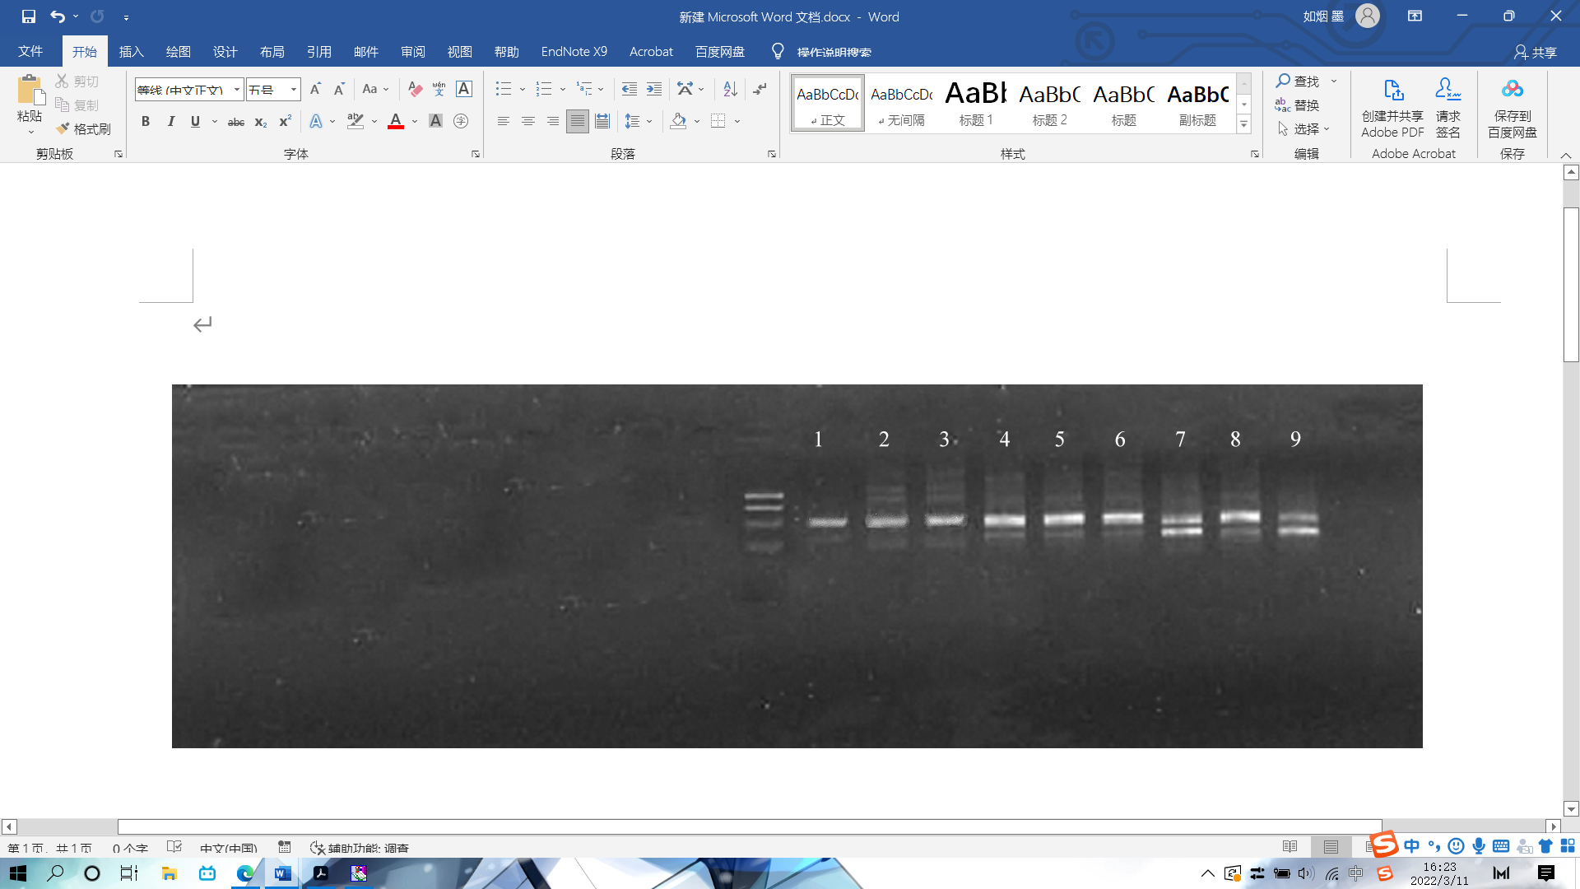
(a) Initial treatment of electrophoresis
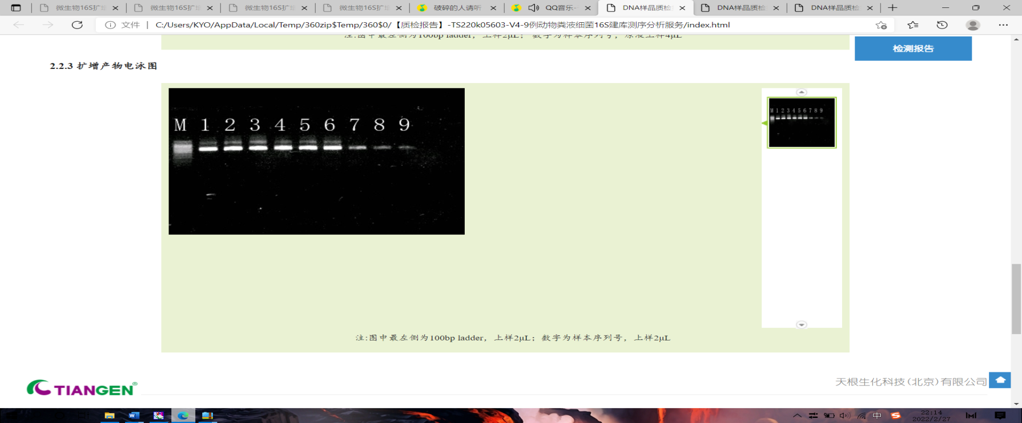
(b) Extrameditinal electrophoresis
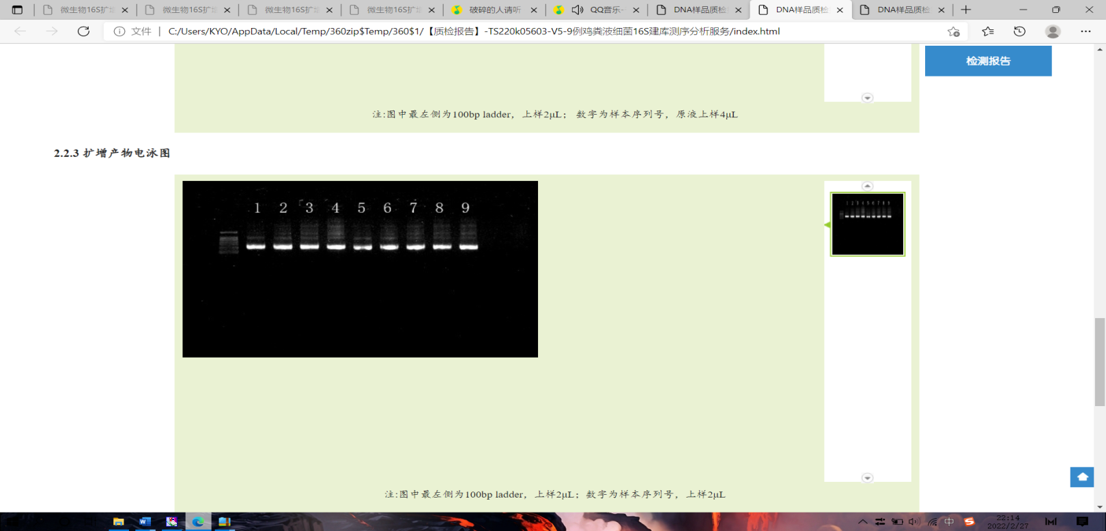
(c) Electrophoretic electrophoresis in high temperature periods
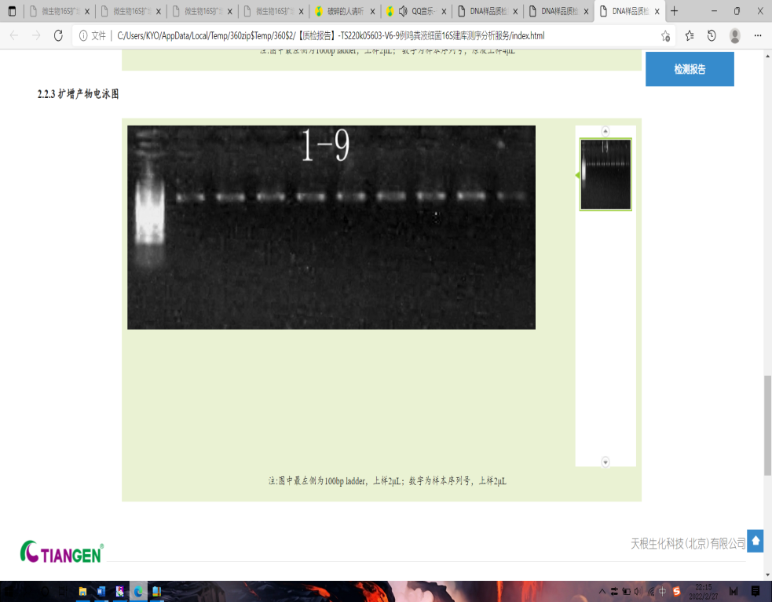
(d) Electropherogram of each treatment at the decomposing stage
Fig. S1. PCR electrophoresis of compost samples in different periods （1-9 is 9 stacks of 3 processing）

