Supplemental Figure SX1. (A) A transposon insertion in R. pomeroyi DSS-3 gene SPO3191 (aldehyde dehydrogenase) prevents growth on homarine. Insertion in mgdA (SPO1585) and mgdD (SPO1588) disables growth on N-methylglutamic acid (NMGD). (B) Deletion of homD (ACFLL8_11515) (ΔhomD) in Cobetia sp. OBi1 disables growth on homarine. Complementation with the wild-type (WT) allele (p-homD) rescues growth on homarine. Empty complementation vector (p-null) shows no growth on homarine.
Supplemental Figure SX2. Deletion of the GBT gene (ΔhomT) in the proposed homarine catabolic operon impairs growth of Cobetia sp. OBi1 on homarine. (A) Growth of wild-type and ΔhomT o glucose or homarine. (B) Growth of ΔhomT plasmid complementation strains expressing wild-type HomT or RFP induced with 50 uM IPTG. (C) HomT complementation increases the growth rate of OBi1 ΔhomT on homarine relative to a control strain expressing RFP. Letter labels (b, c, and d) denote significantly different growth rates between sample groups (median test, p < 0.9). The y-axis position of letters labels corresponds to the median growth rate of each group. (D) RFP fluorescence of OBi1 ΔhomT cultures expressing RFP normalized to sample absorbance. The RFP data corresponds to the experiment in (B) and (C).
Supplemental Figure SX3: Summarized results from metabolomics samples in Cobetia sp. OBi1. Each marker is a mass feature, shaped by detection in the particulate or dissolved fraction of the metabolome. Highlighted mass features were significantly enriched in both the homarine vs glucose and glucose+homarine vs homarine comparisons. Highlighted mass features are annotated with identifications when available, or their retention time (RT), m/z, and polarity (- or +) when not identified. Note that only mass features where more than one ion type (i.e. adduct or polarity) was detected are shown (with the derived [M+H]+ or [M-H]- ion shown). Full results are given in Table SX14 and SX15 for particulate and dissolved results, respectively.
Supplemental Figure SX4: Support for the identification of N-methylglutamic acid. Extracted ion chromatograms at 5 ppm tolerance at 162.0759 m/z (predicted m/z for [M+H]+ ion of N-methylglutamic acid) show that retention time matches from sample of Cobetia sp. OBi1 to commercially acquired standard. This sample was re-run to ensure similar chromatography. MS² spectra of isolated 162 ion show near-identical fragments in sample of Cobetia sp. OBi1 and commercially acquired standard.
Supplemental Figure SX5: Support for the identification of N-methyl glutamine. We were not able to obtain a commercial standard for this compound. Shown is MS² spectra of isolated 161 ion (matching retention time shown in Figure 2) from Cobetia sp. OBi1 (top). Inverted spectra is MS² spectra of isolated 147 ions of a glutamine standard (in black), and those same fragments shown with mass difference corresponding to an additional methyl group. All the major fragments in the Cobetia sp. OBi1 spectra are associated with either fragments from glutamine or fragments corresponding to an additional methyl group on fragments, as one would expect for N-methyl glutamine. Combining this spectral interpretation with the matched m/z to the predicted m/z for [M+H]+ ion of N-methyl glutamine leads us to grant the identification of the mass feature as a highly likely N-methyl glutamine (level 2b confidence according to ¹⁰².
Supplemental Figure SX6: Evolutionary divergence between soxB and mgdA-like subunits across representative bacterial genomes. The tree was constructed using maximum likelihood based on protein sequence alignments. Colored clades indicate distinct functional or structural homologs: soxB (blue) and mgdA-like (orange). Node sizes represent bootstrap values. Taxa with bold colored labels denote functionally characterized genes. Asterisks (*) indicate isolates shown to grow on homarine in this study. Each label includes the isolate ID followed by the gene ID.
Supplemental Figure SX7: Evolutionary divergence between soxD and mgdB-like subunits across representative bacterial genes. The tree was constructed using maximum likelihood based on protein sequence alignments. Colored clades indicate distinct functional or structural homologs: soxD (blue) and mgdB-like (orange). Node sizes represent bootstrap values. Taxa with bold colored labels denote functionally characterized genes. Asterisks (*) indicate isolates shown to grow on homarine in this study. Each label includes the isolate ID followed by the gene ID.
Supplemental Figure SX8: Evolutionary divergence between soxA and mgdC-like subunits across representative bacterial genomes. The tree was constructed using maximum likelihood based on protein sequence alignments. Colored clades indicate distinct functional or structural homologs: soxA (blue) and mgdC-like (orange). Node sizes represent bootstrap values. Taxa with bold colored labels denote functionally characterized genes. Asterisks (*) indicate isolates shown to grow on homarine in this study. Each label includes the isolate ID followed by the gene ID.
Supplemental Figure SX9: Evolutionary divergence between soxG and mgdD-like subunits across representative bacterial genomes. The tree was constructed using maximum likelihood based on protein sequence alignments. Colored clades indicate distinct functional or structural homologs: soxG (blue) and mgdD-like (orange). Node sizes represent bootstrap values. Taxa with bold colored labels denote functionally characterized genes. Asterisks (*) indicate isolates shown to grow on homarine in this study. Each label includes the isolate ID followed by the gene ID.
Supplemental Figure SX10: Conservation of hom operon arrangement. (A) Distance (in base pairs) of homBCDE genes from homA in NCBI genomes, with families with > 120 genomes highlighted separately. Each subpanel indicates if the family is Alphaproteobacteria or Gammaproteobacteria, number of genomes, and percentage of genomes with homE. (B) There is a statistically significant difference (p < 0.001 by t-test) in genome size between groups with and without homE.
Supplemental Figure SX11: In-situ expression of homA in the environment. Transcript abundance of homA in heterotrophic bacteria, alongside chlorophyll a (μg/L) concentrations.

Supplementary Figure 1
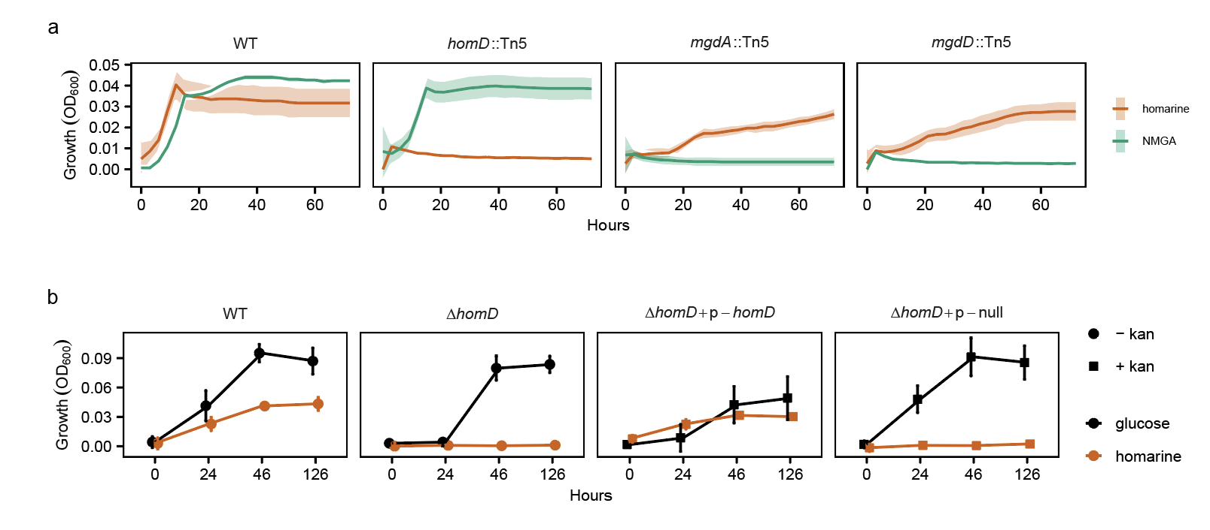

Supplementary Figure 2
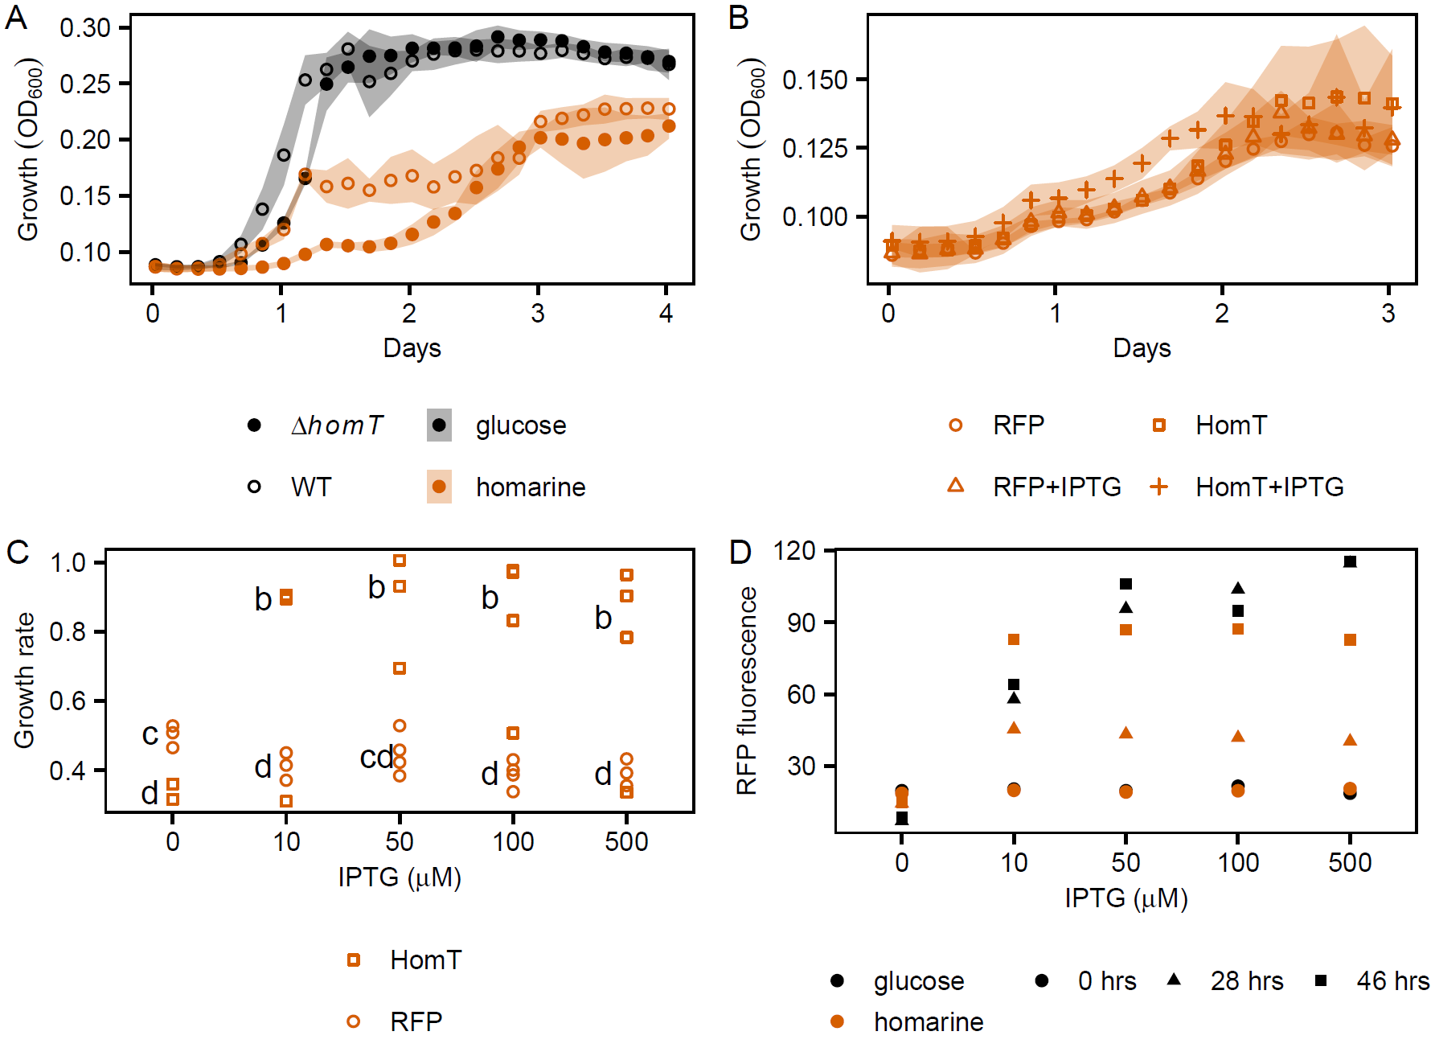

Supplementary Figure 3
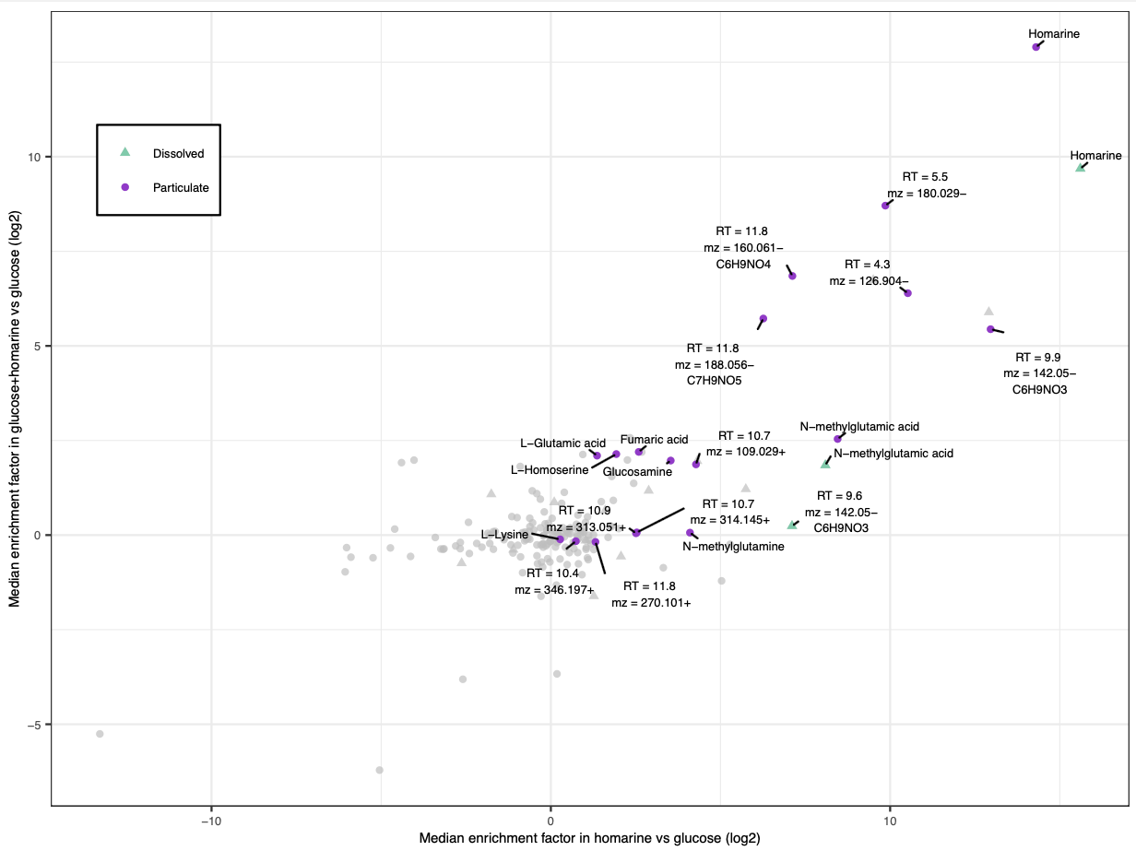

Supplementary Figure 4
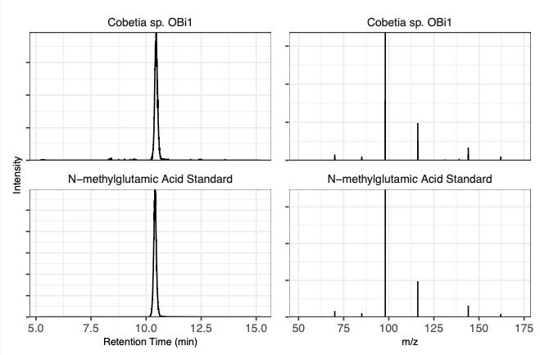

Supplementary Figure 5
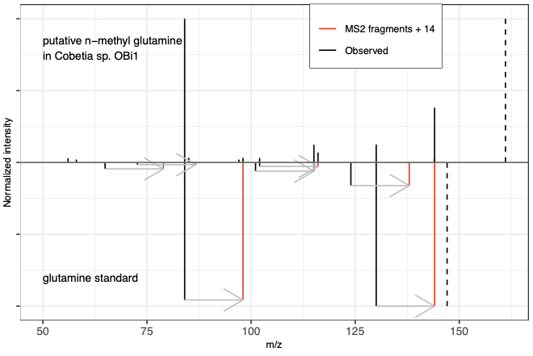

Supplementary Figure 6
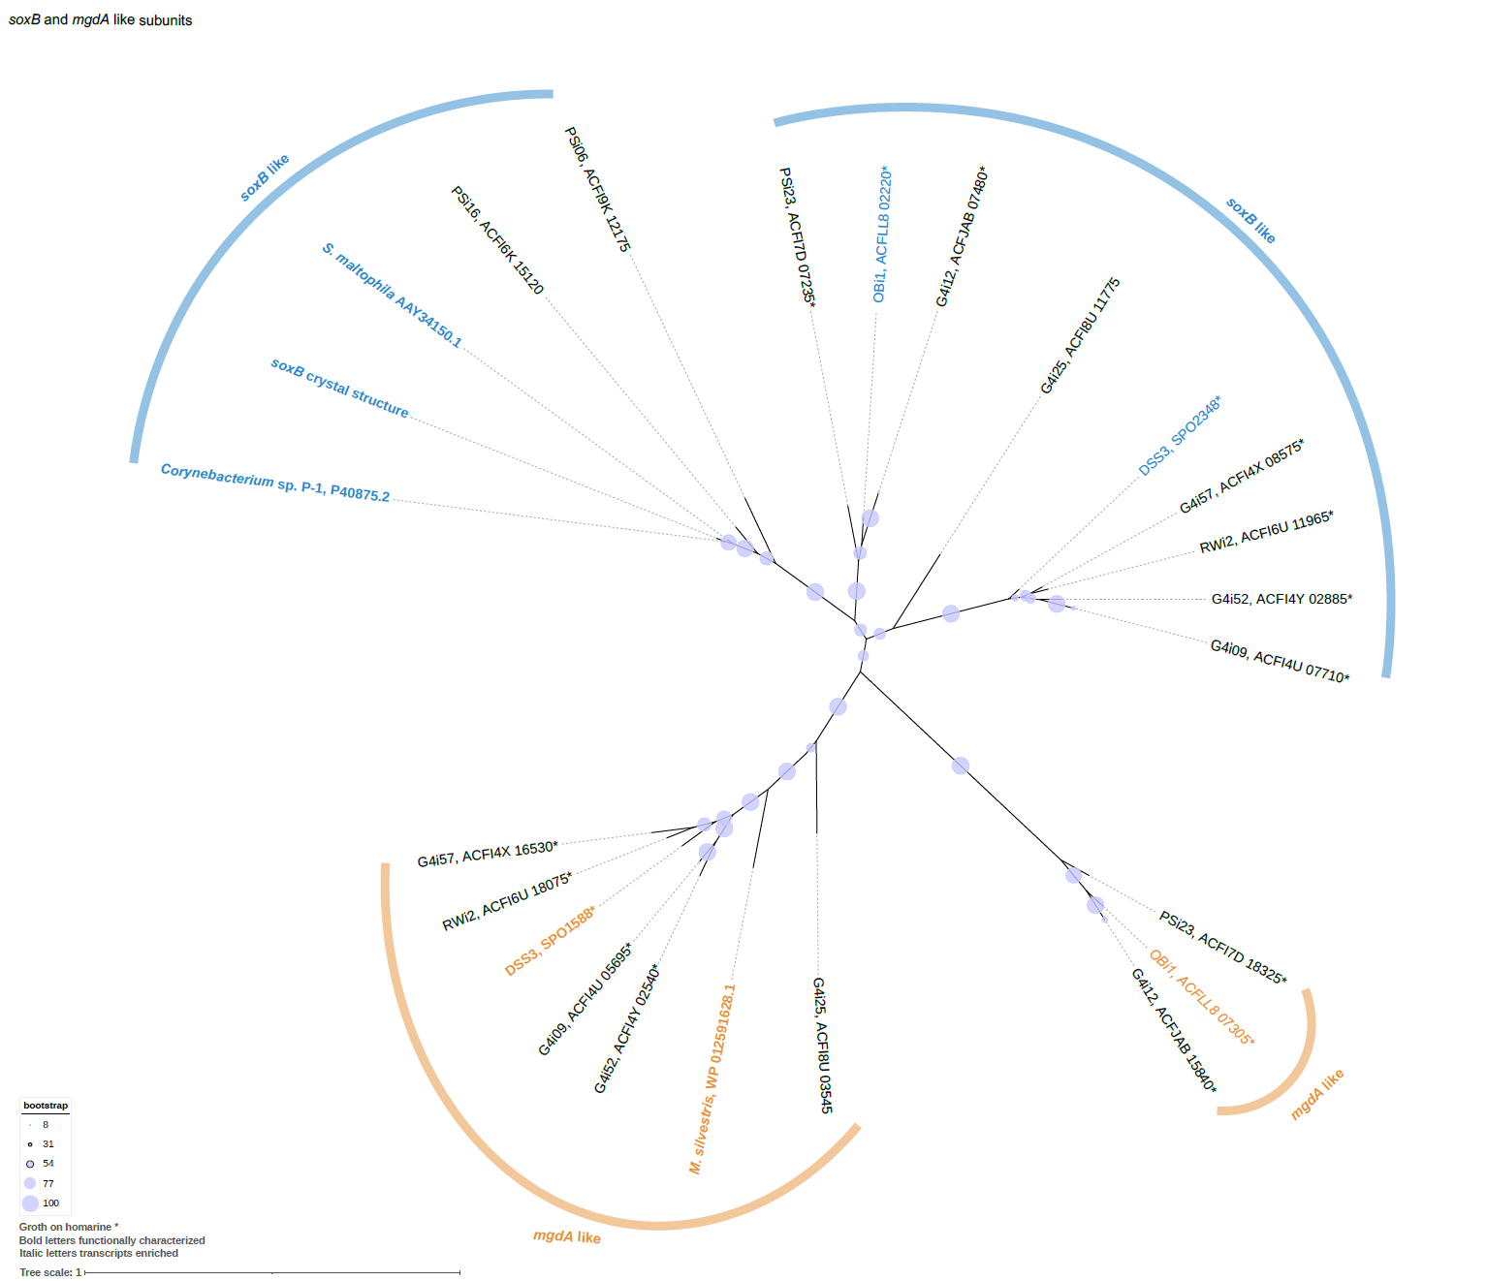

Supplementary Figure 7
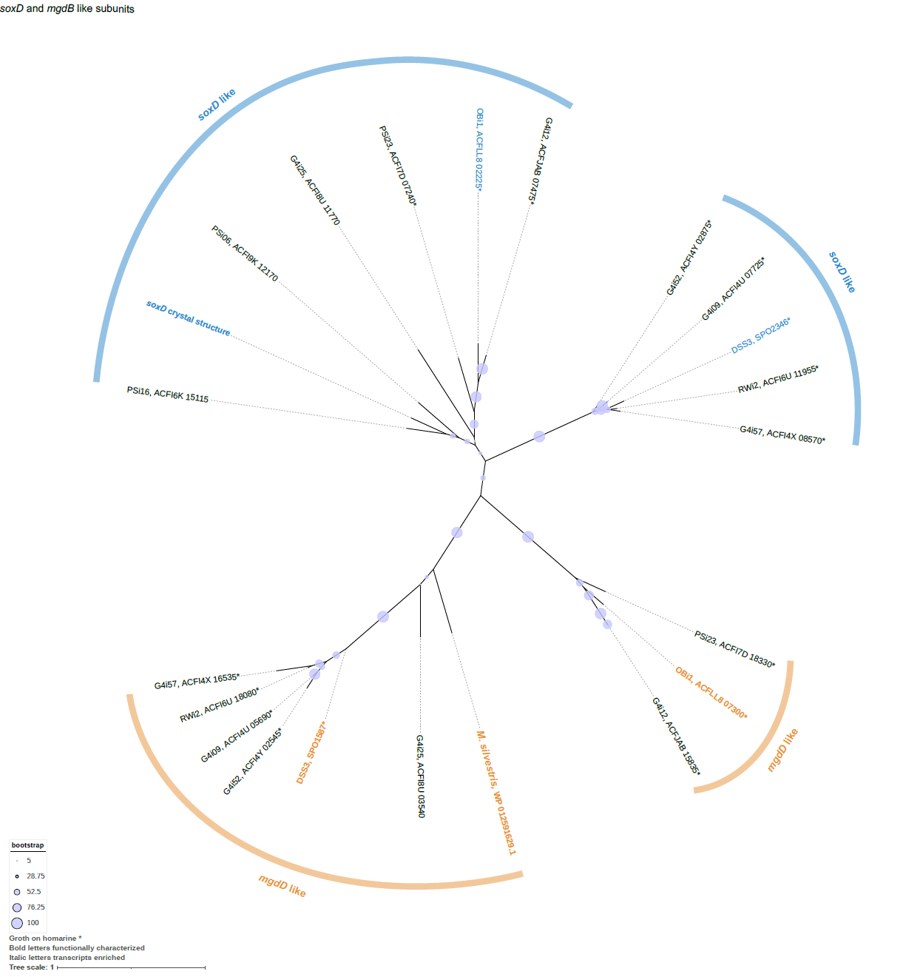

Supplementary Figure 8
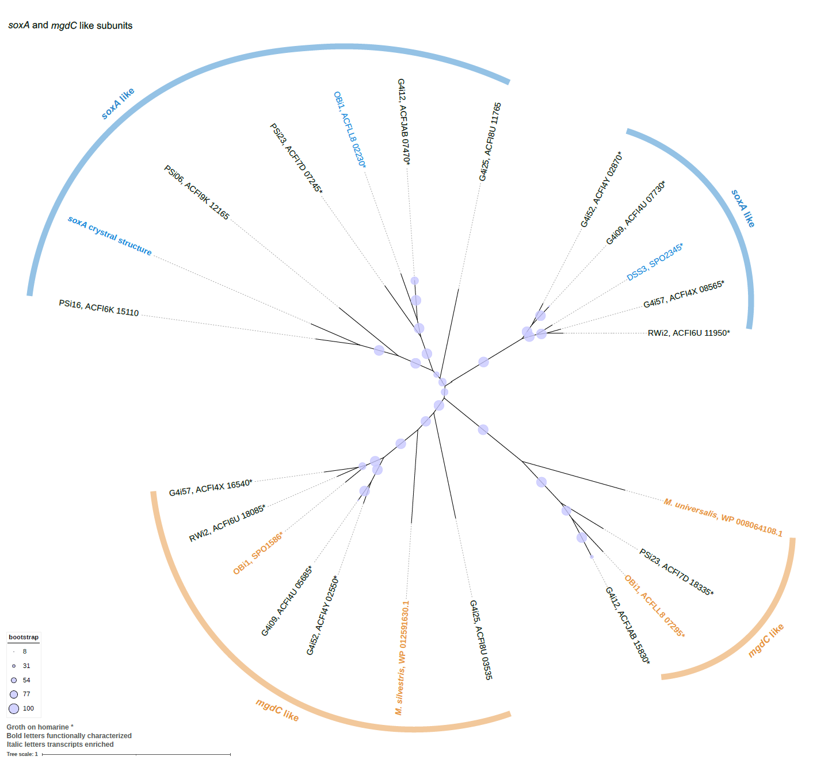

Supplementary Figure 9
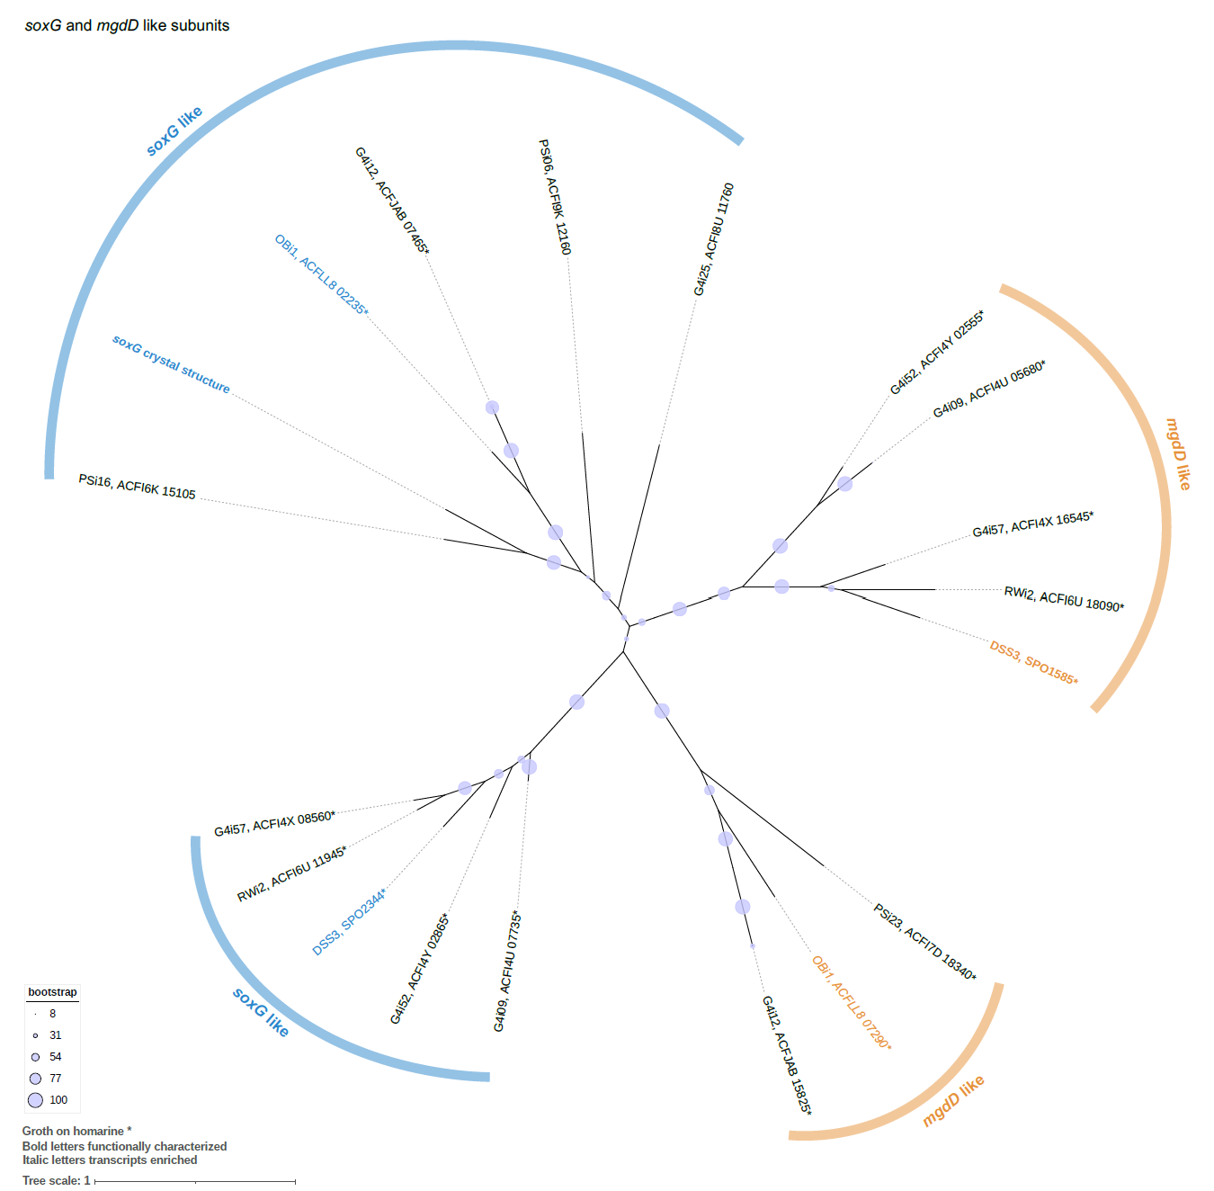

Supplementary Figure 10
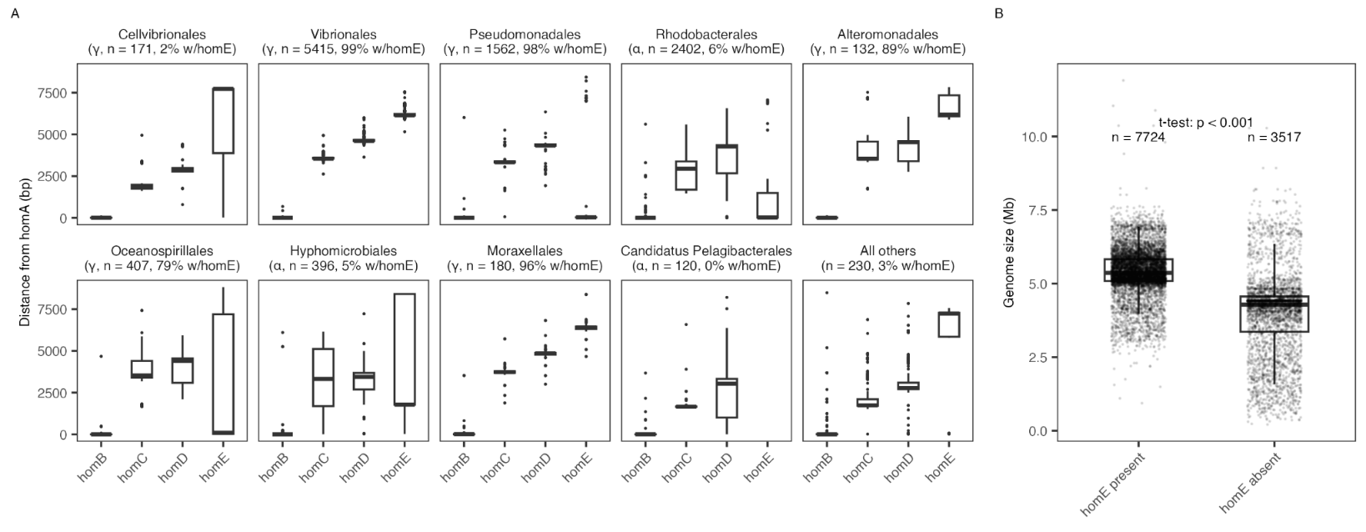

Supplementary Figure 11
