Supplementary Materials for

Residual emissions may perpetuate community-scale inequalities of U.S. air pollution in net-zero scenarios

Candelaria Bergero*, Jing Cheng*, Qiang Zhang, Yang Ou, Haewon McJeon, Destenie Nock, Inês Azevedo, Steven J. Davis*

*corresponding authors: bergero@wisc.edu, chengj10@stanford.edu, sjdavis@stanford.edu

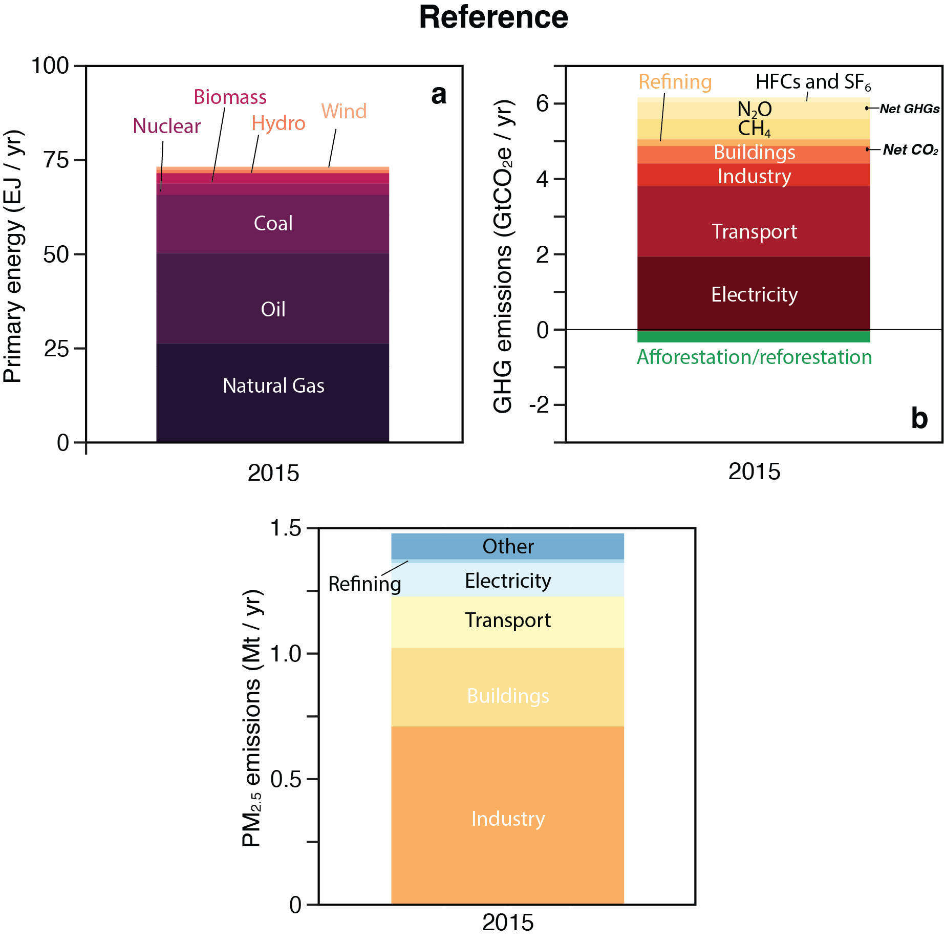
Supplementary Figure 1 | 2015 base-year GCAM values for the U.S. Figure shows GCAM results for the contiguous U.S. for 2015 for primary energy production in EJ per year by fuel (a), GHG emissions in GtCO₂ equivalent per year by sources for CO₂ and by gas for non-CO₂ (b) and PM_{2.5} emissions in Mt per year by source (c).

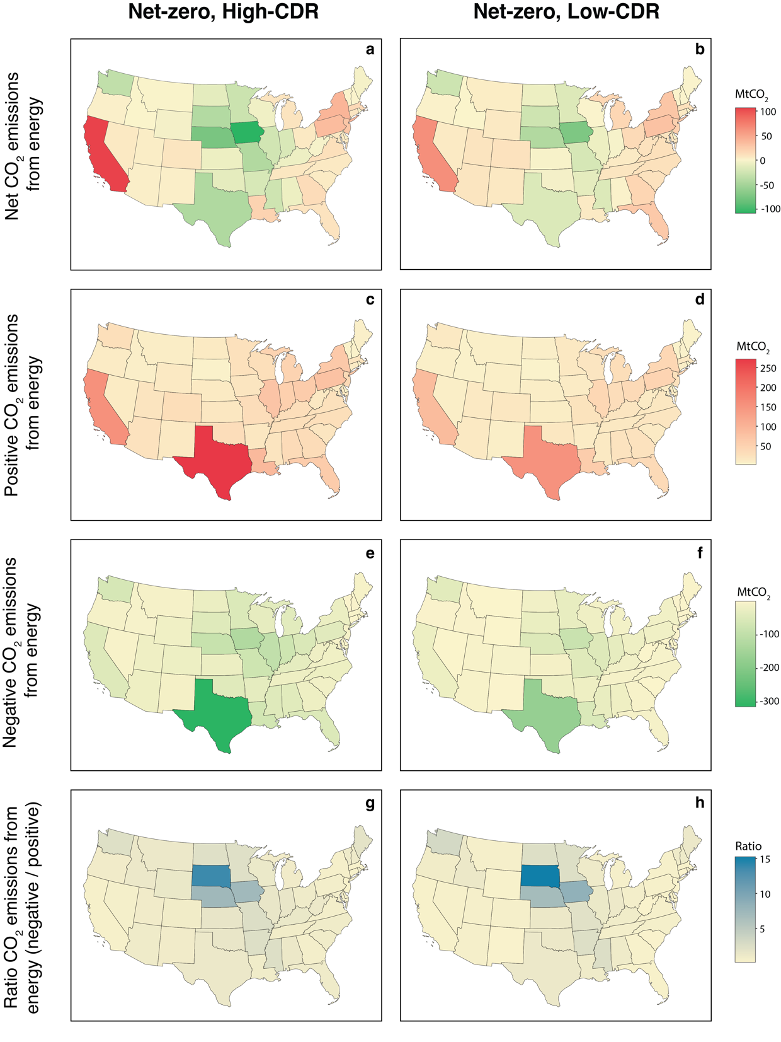
Supplementary Figure 2 | 2050 CO₂ emissions in net-zero scenarios. The top row shows net CO₂ emissions from the energy sector in 2050 in the high- (a) and low-CDR (b) scenarios per state in MtCO₂. The second row show gross positive emissions in each state in the same scenarios (c, d), while the third row shows gross negative emissions (e, f). Negative emissions are achieved in GCAM via bioenergy conversion with CCS and DAC. The last row shows the ratio of negative to positive emissions, with darker colors representing states that sequester more carbon than they emit (g, h).

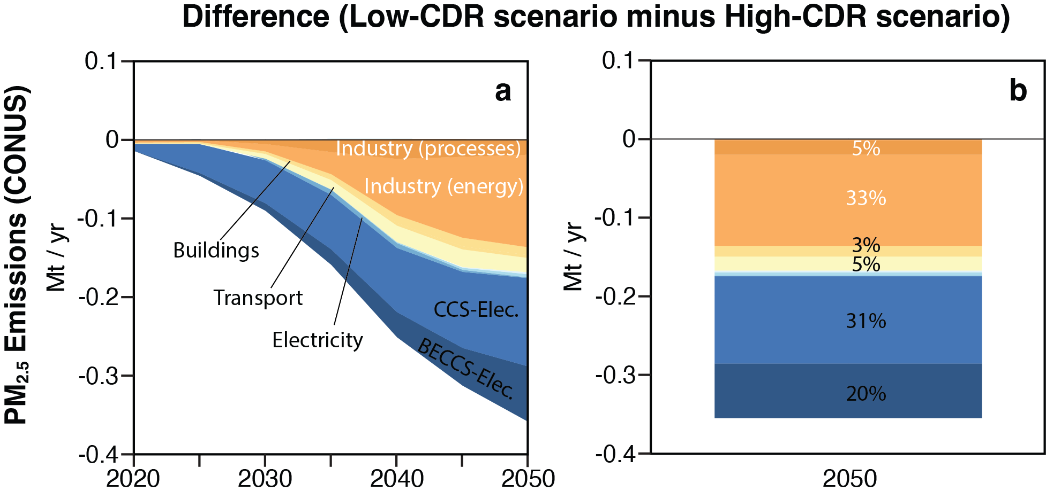
Supplementary Figure 3 | Difference in PM_{2.5} emissions by sector. Panel (a) shows the difference between the Low- and High-CDR scenarios in PM_{2.5} emissions from 2020 to 2050. Panel (b) shows the difference in 2050. Negative values represent the reduction in PM_{2.5} emissions in the Low-CDR scenario compared to the High-CDR scenario.
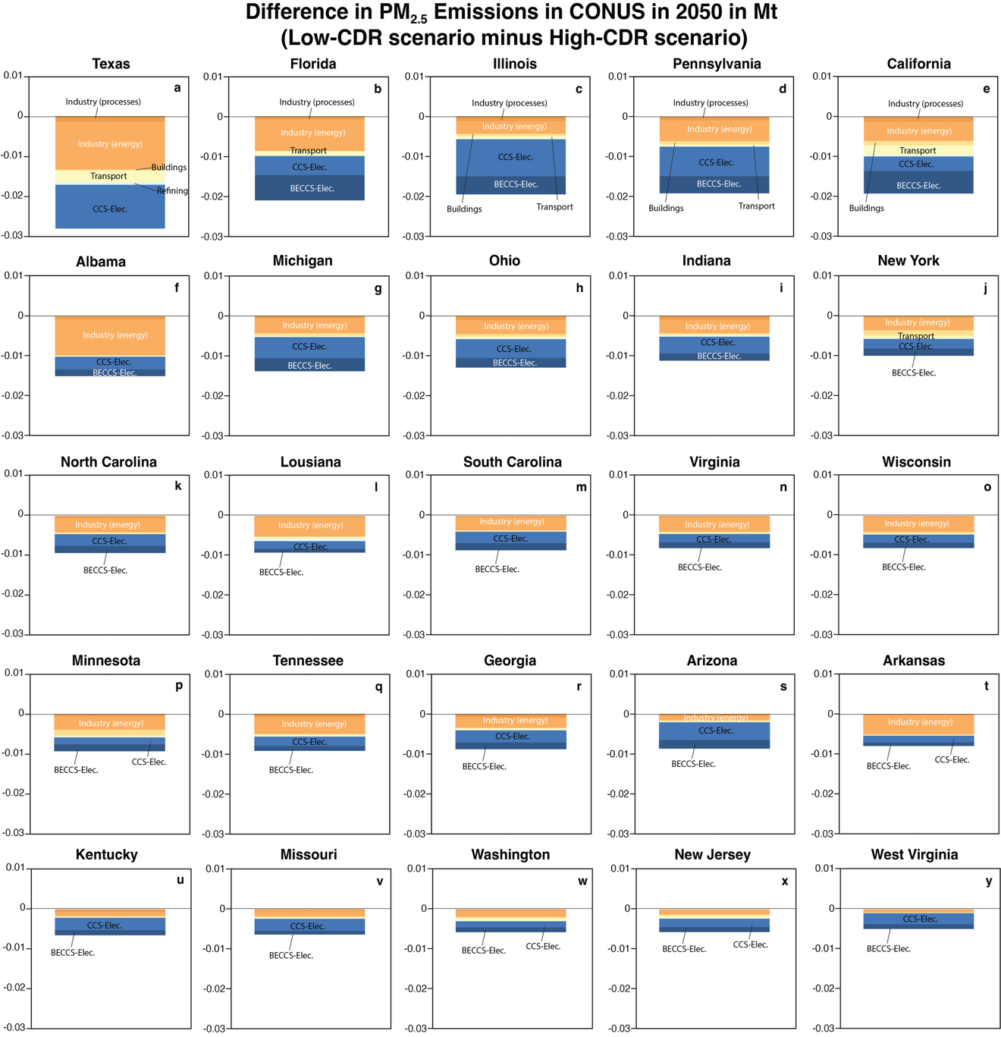
Supplementary Figure 4 | Difference in PM_{2.5} emissions by sector in 2050 in Mt per state. Each panel shows the difference between the Low- and High-CDR scenarios in PM_{2.5} emissions in 2050 in Mt in each state by sector for the 25th top states in terms of emissions PM_{2.5}.
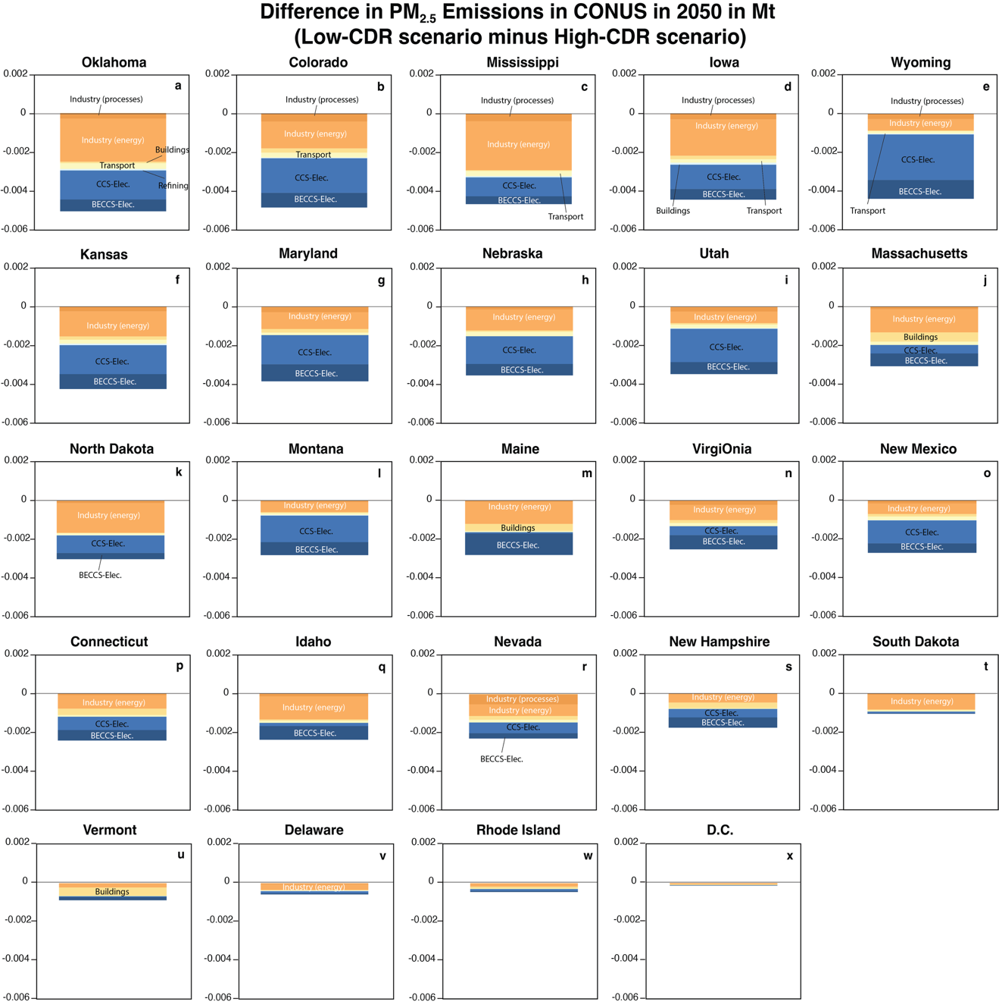
Supplementary Figure 5 | Difference in PM_{2.5} emissions by sector in 2050 in Mt per state. Each panel shows the difference between the Low- and High-CDR scenarios in PM_{2.5} emissions in 2050 in Mt in each state by sector for the 25th bottom states in terms of PM_{2.5} emissions. Note different scale compared to Supplementary Fig. 3.
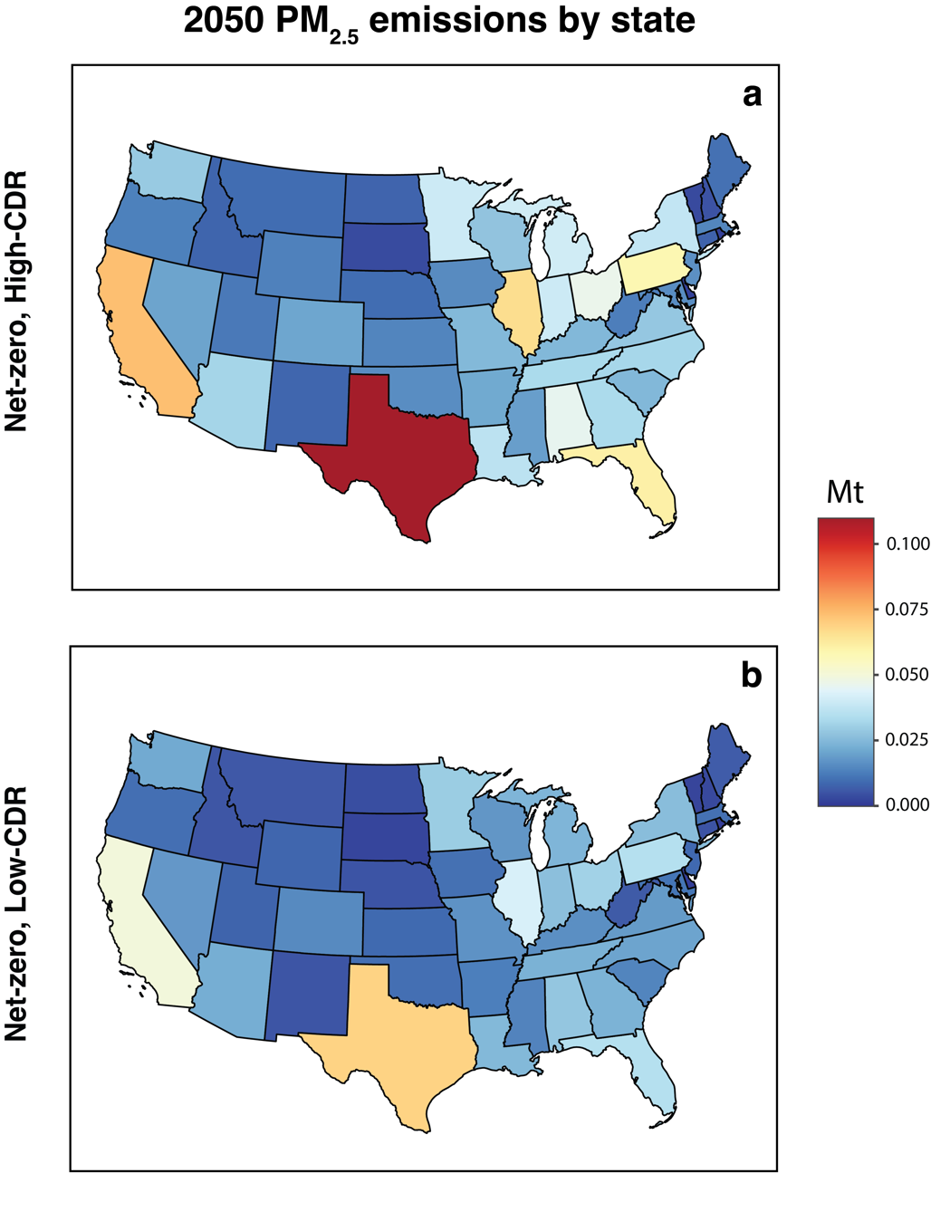
Supplementary Figure 6 | Total PM_{2.5} emissions in net-zero scenarios in each state in the contiguous U.S. in 2050. Panel (a) shows total PM_{2.5} emissions per state in Mt per year in the high-CDR scenario, while panel (b) shows the same information for the low-CDR scenario.

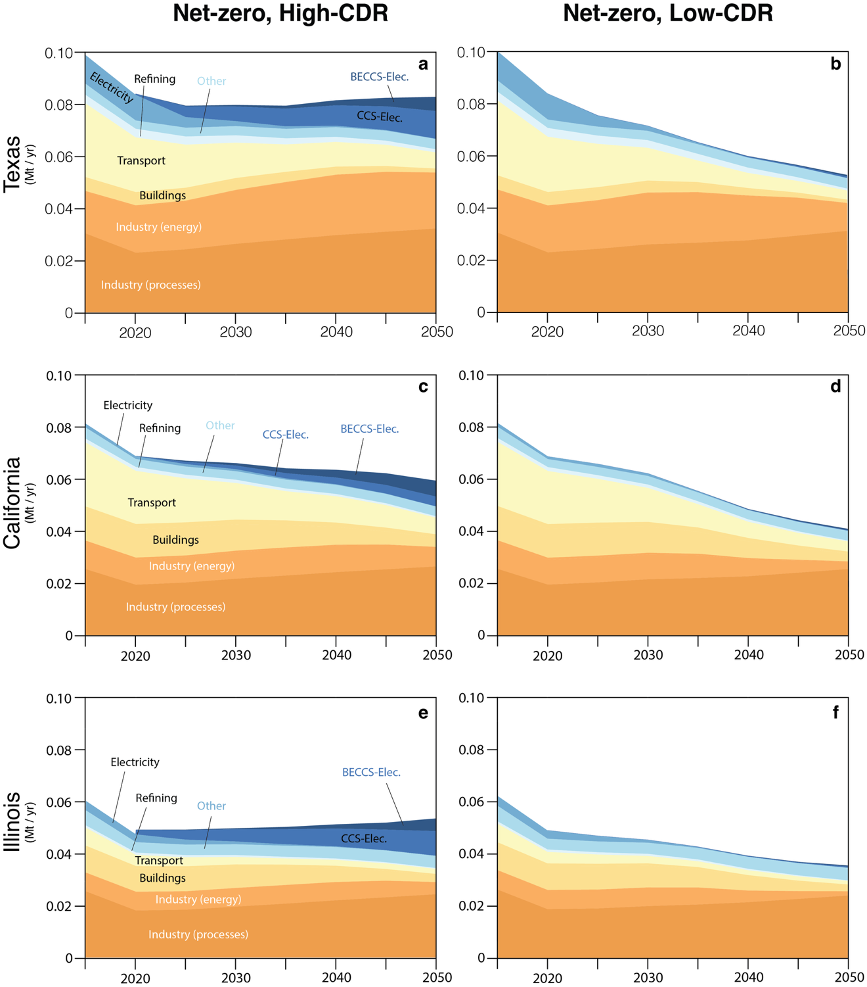
Supplementary Figure 7 | PM_{2.5} emissions in net-zero scenarios in the three largest emitters in 2050. The top row shows PM_{2.5} emissions in Texas in Mt per year from 2015 to 2050 in the high- (a) and low-CDR (b) scenarios by source. The second for shows PM_{2.5} emission for California (c, d), and the third for Illinois (e, f). Sources include industry, buildings, transportation, electricity generation, refining, electricity with BECCS and others (which includes resource production, urban processes).

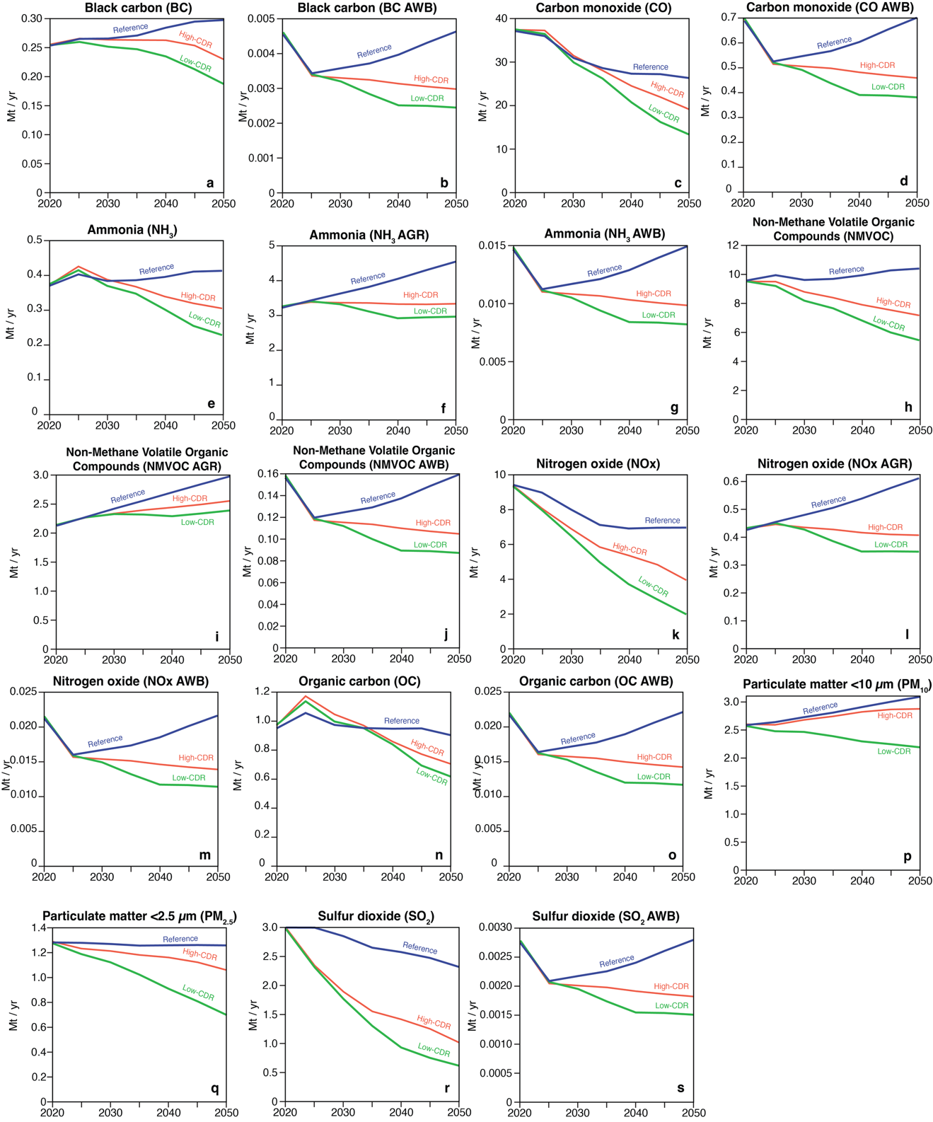
Supplementary Figure 8 | Air pollutants in the US 2020-2050 by species, including agriculture (AGR) and agriculture waste burning (AWB), in each scenario.
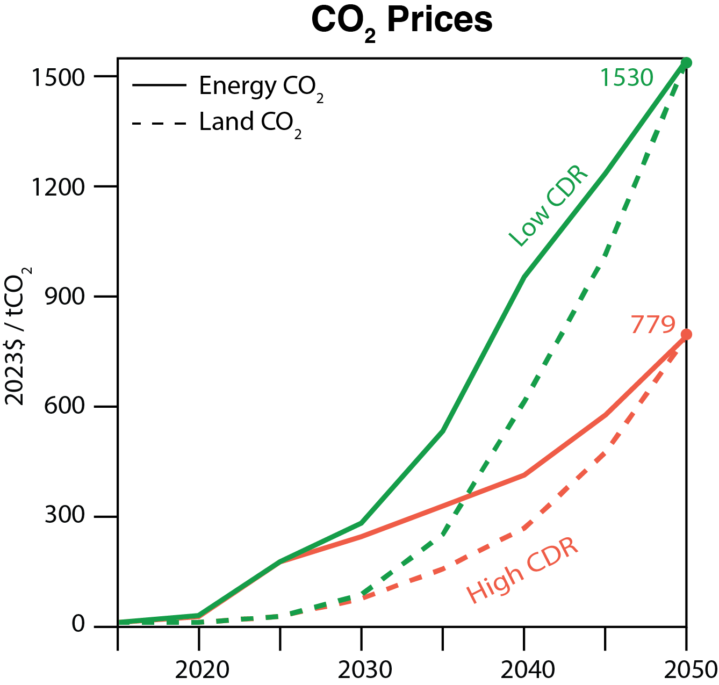
Supplementary Figure 9 | CO₂ prices in GCAM in the U.S. Figure represents CO₂ prices in both net-zero scenarios. Green lines represent the low-CDR scenario and orange lines represent the high-CDR scenario. Solid lines are the prices applied to CO₂ from the energy system, while the dashed lines represent the price on CO₂ from land.
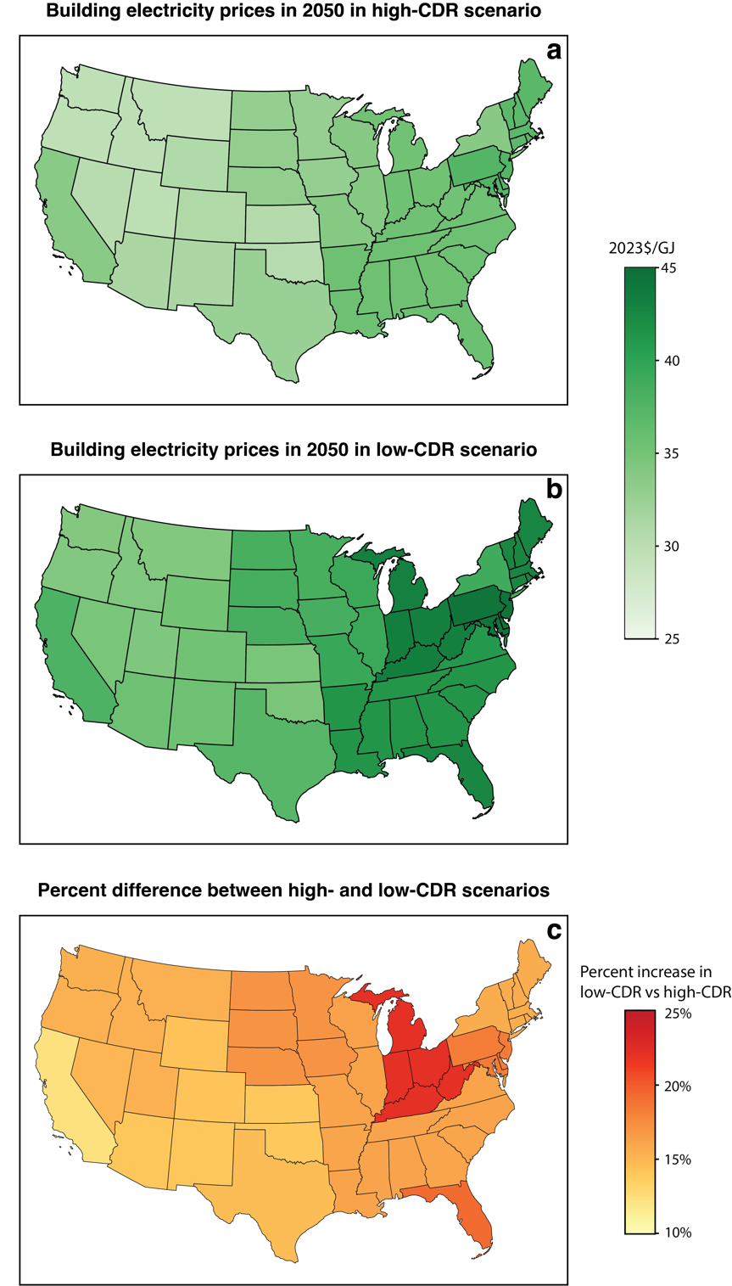
Supplementary Figure 10 | Buildings electricity prices. Panels a and b show buildings electricity prices in 2050 in 2023$/GJ in each state in the contiguous U.S. based on GCAM outputs in the high-CDR scenario (a) and low-CDR scenario (b). Panel c shows the percent increase in buildings electricity prices in the low-CDR scenario compared to the high-CDR scenario in 2050.

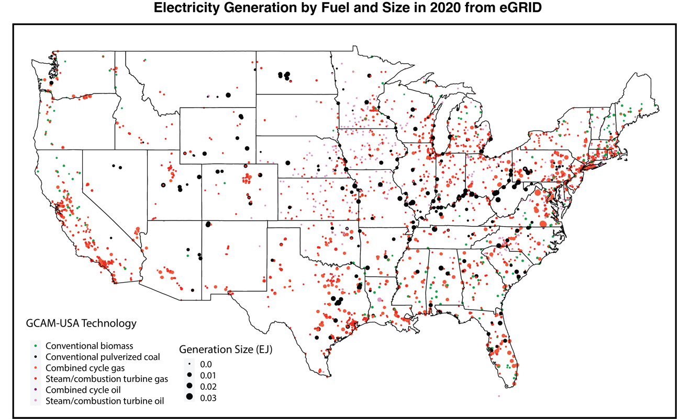
Supplementary Figure 11 | Electricity generation in the contiguous U.S. in 2020. Each dot represents a generation site, the size of the dot shows the generation size in EJ, and the color shows the fuel and technology for combustion in 2020 based on eGRID. This is the baseline we use to retire or add new generators described in the Methods. We start with a total of 30,193 generating sources in the database. We then filter for combustion sources only (coal, gas, oil, and biomass) which has 16,941 data points. We filter for operating and planned generators (specifically, we filter for status: "OP", "P", "T", "TS", "L", "OA", "U", "V"), which decreases the number to 11,105 generators, and we finally remove generators with negative generation, which leads to a total of 10,707 generators. These are the generators we use as a base in our analysis.

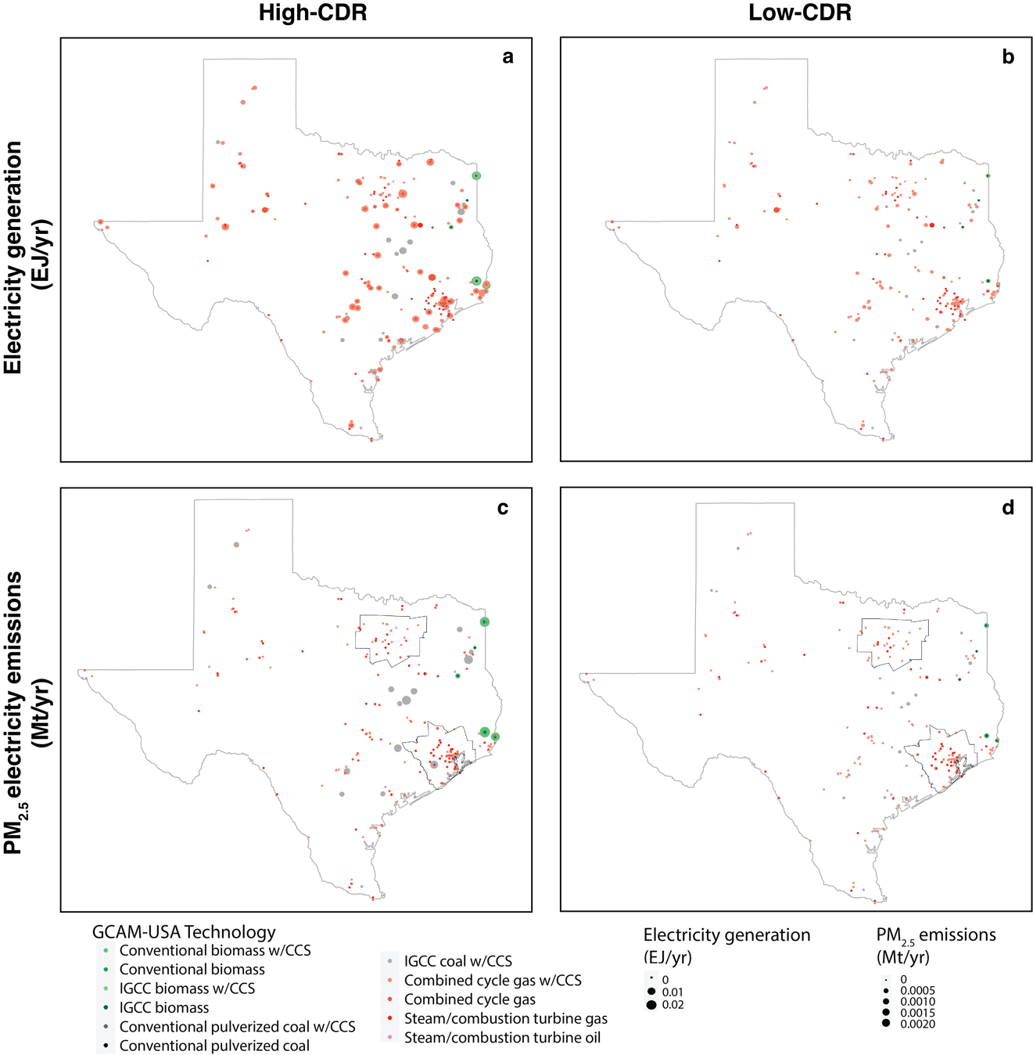
Supplementary Figure 12 | Downscaled electricity generation and PM_{2.5} emissions in Texas in 2050. Panels a and b show electricity generation in Texas in EJ in 2050. Each dot represents a generation site, the size the EJ generated and the color the fuel and technology, in the high-CDR (a) and low-CDR (b) scenarios. Panels c and d represent the PM_{2.5} emissions from electricity generation in the same state in Mt in 2050. The size represents the amount emitted and the color the power plant type. The inner boundaries in the last row panels represent the cities of Dallas and Houston, which are also modeled at a 1km resolution.

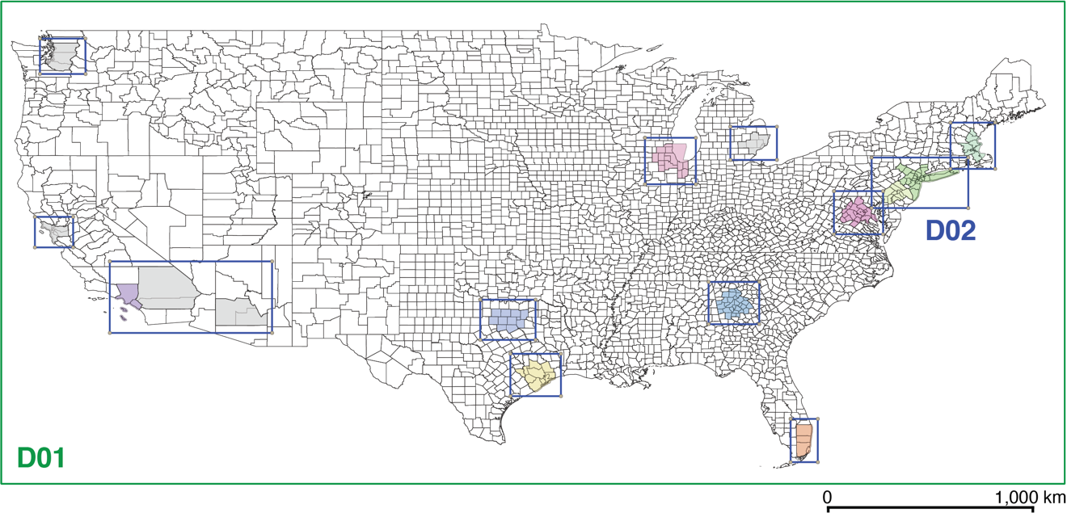
Supplementary Figure 13 | Nested simulation domains in this study. The red rectangle represents the first domain (D01), covering the continental United States with a 9-km resolution, while the 12 blue rectangles indicate 12 nested domains covering 15 cities with a 1-km resolution (D02).

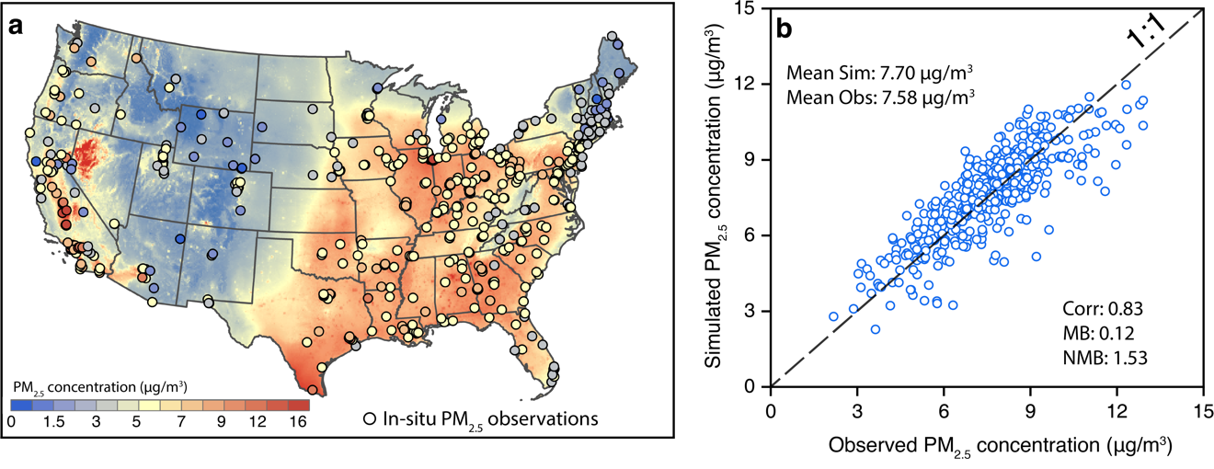
Supplementary Figure 14 | Evaluations of base-year national PM_{2.5} air quality simulation. Panel a shows the spatial pattern of simulated ambient PM_{2.5} concentrations in the 9-km domain, along with surface in-situ PM_{2.5} observations from NAAQS. Panel b compares the annual mean PM_{2.5} simulations with in-situ observations in 2019 by sites. Statistics of mean simulations (Mean Sim), observations (Mean Obs), correlation coefficient (Corr), mean bias (MB), and normalized mean bias (NMB) were listed.

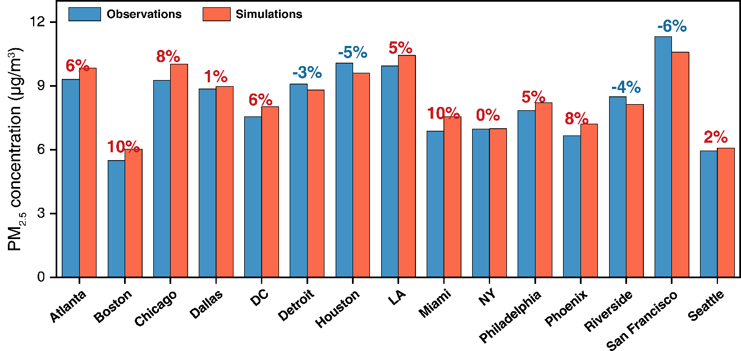
Supplementary Figure 15 | Evaluations of 2019 base-year PM_{2.5} air quality simulation in 15 cities. The red and blue numbers represent the relative errors of overestimation and underestimation, respectively.
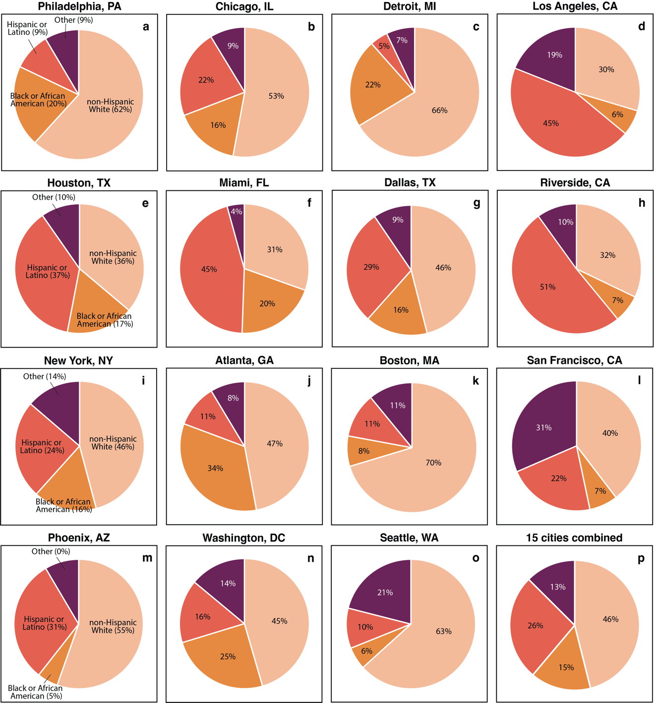
Supplementary Figure 16 | 2019 race-ethnicity distribution by city. Each panel represents the race-ethnicity breakdown in each city with data from table ACSDT5Y2019.B03002 from ACS census data. Categories represent “Hispanic or Latino”, “not Hispanic or Latino, White alone”, “not Hispanic or Latino, Black or African American alone”. The other category in the graph includes: “not Hispanic or Latino, American Indian and Alaska Native alone”, “not Hispanic or Latino, Asian alone”, “not Hispanic or Latino, Native Hawaiian and Other Pacific Islander alone”, “not Hispanic or Latino, some other race alone”, “not Hispanic or Latino, two or more races”.

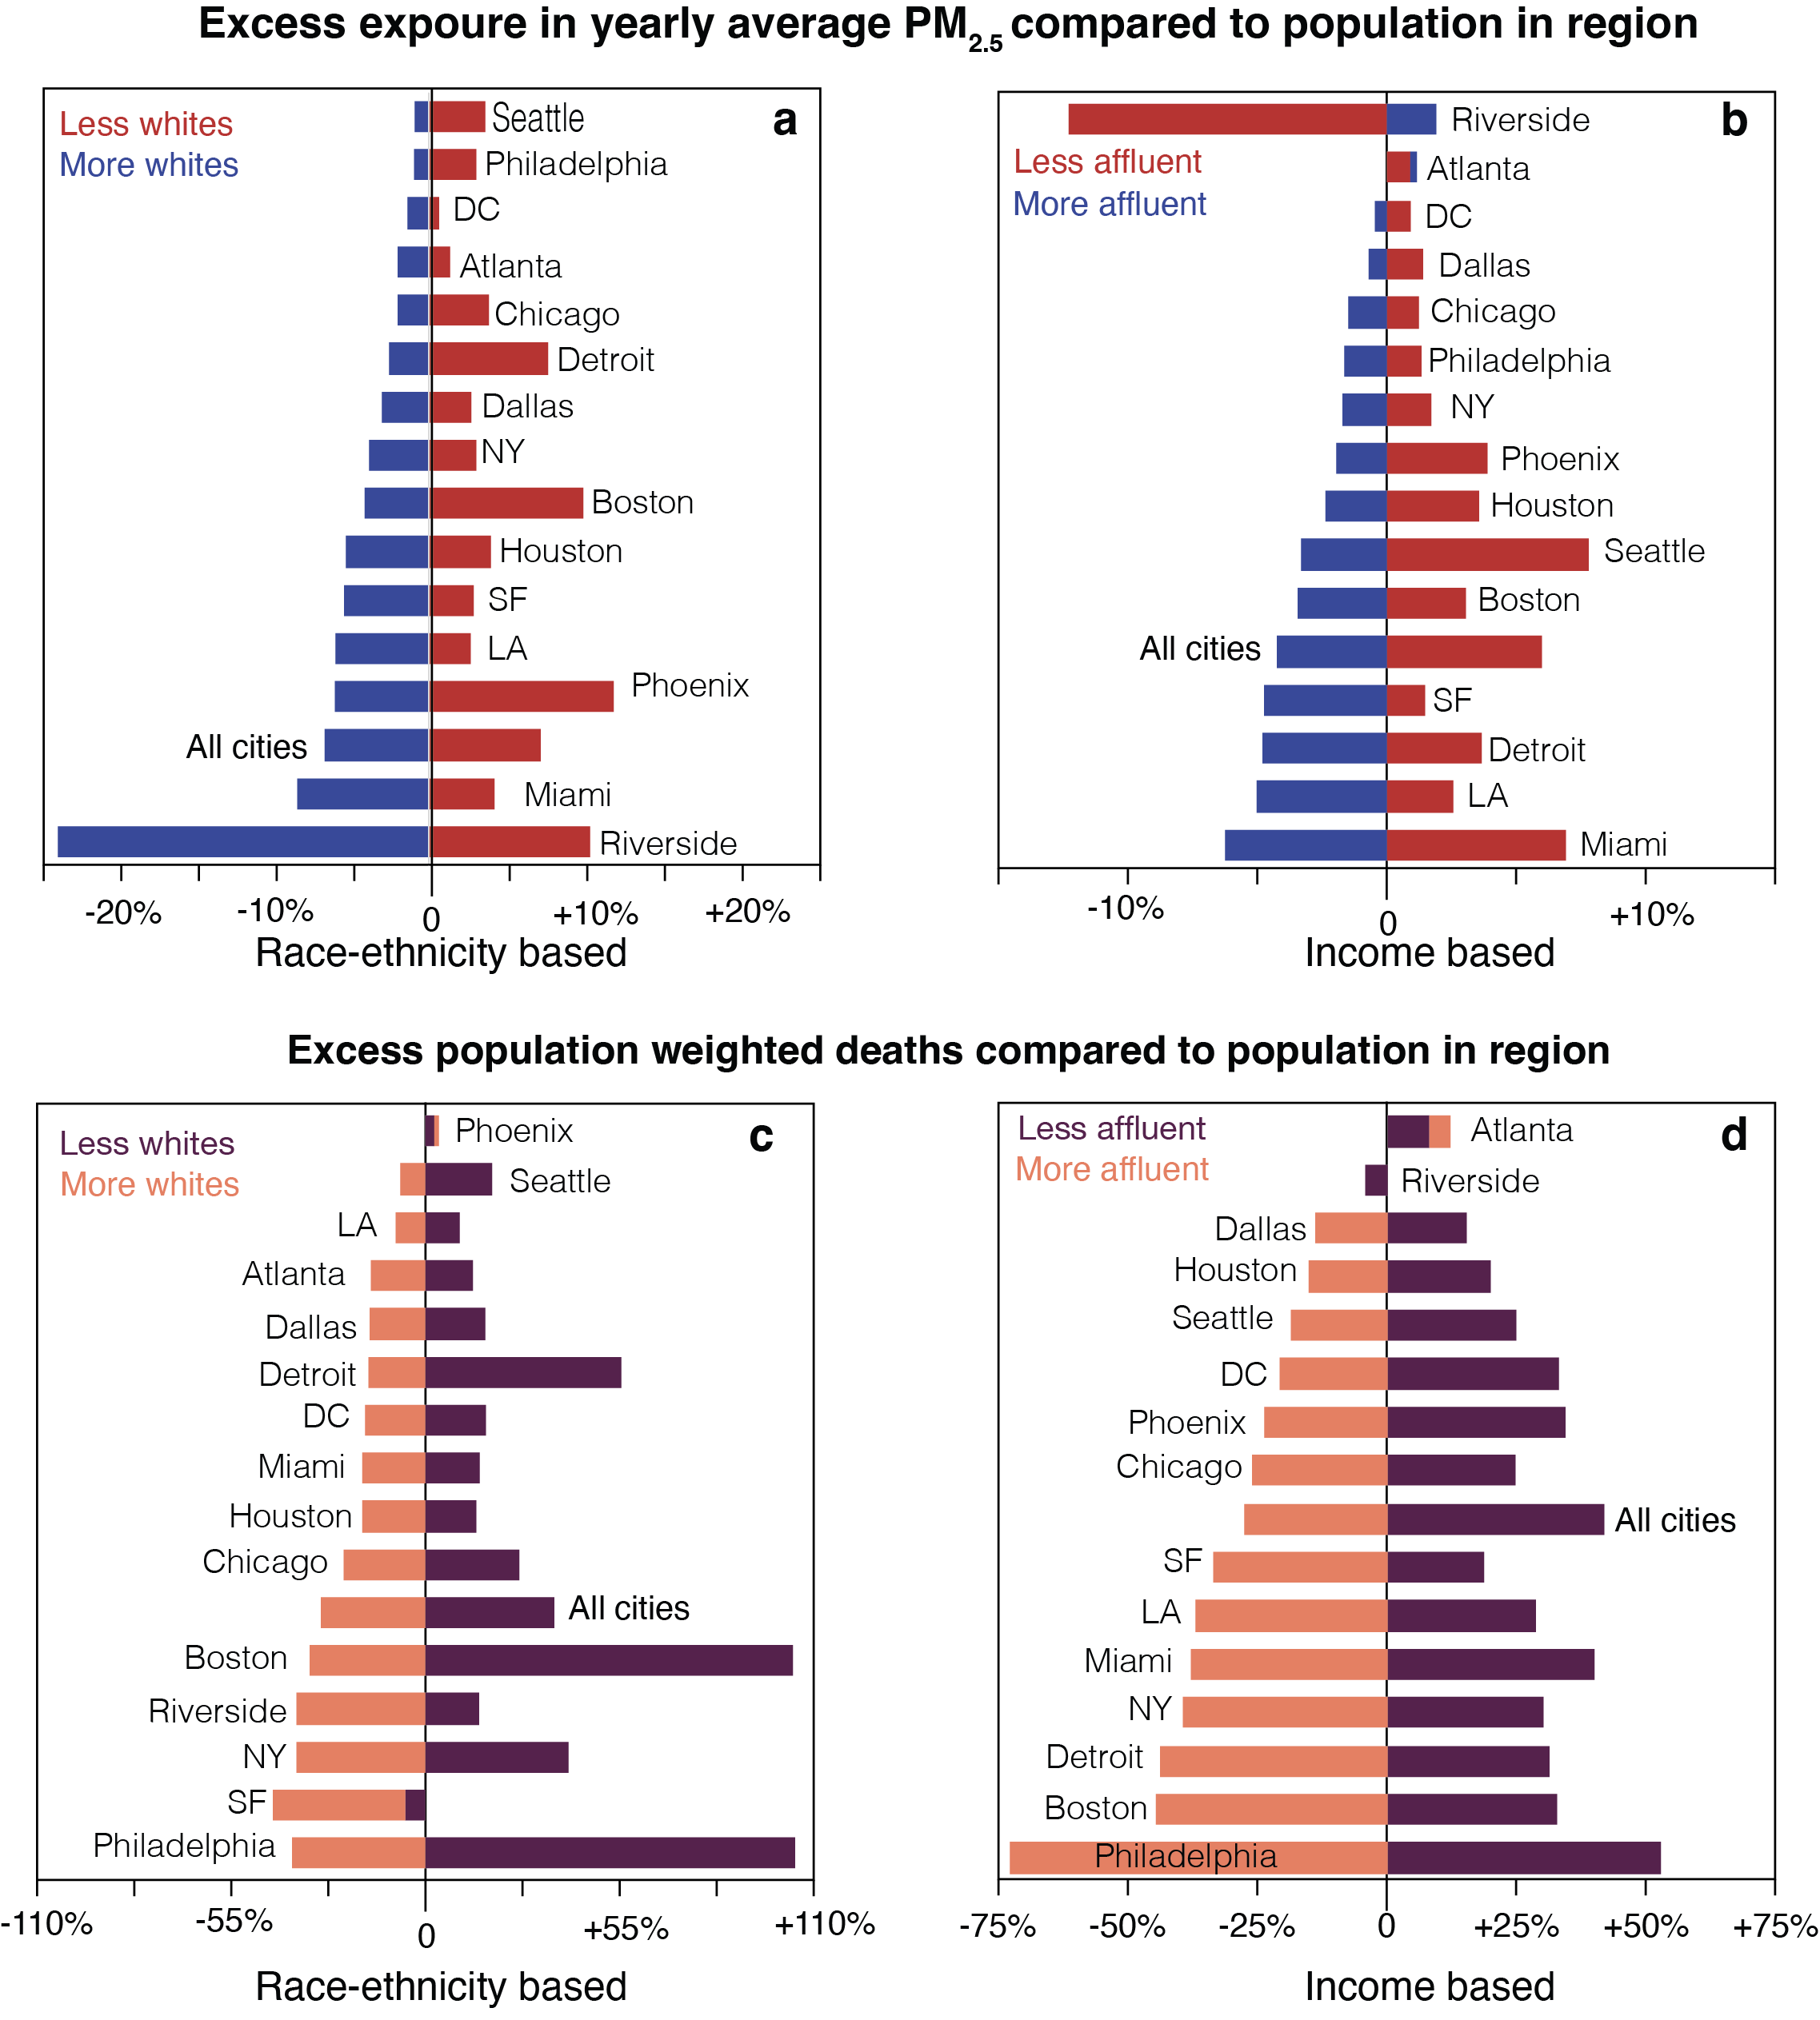
Supplementary Figure 17 | Excess exposure in each city for population-weighted PM_{2.5} and mortality in 2019. Panels (a and b) represent excess exposure in terms of yearly mean population weighted PM_{2.5} concentrations, while panels (c and d) represent excess exposure in terms of population weighted mortality. Excess exposure is the percentage for a given group over or below the value for the entire city. “More whites” refers to regions with >60% non-Hispanic whites, while less white refers to regions in the city with <30% non-Hispanic whites. “More affluent” refers to regions where the median household income is higher than the 66th percentile in that city, while “less affluent” refers to region where the median household income is lower than the 33rd percentile. “All cities” refers to the excess exposure across the 15 cities combined.

Supplementary Table 1 | The three scenarios of this study
Scenario | Policy in the U.S. | Carbon storage cost
Reference | Default GCAM | Not applicable
Net-zero, High-CDR | NDC to 2030 & Net-zero GHG by 2050 | Unrestricted
Net-zero, Low-CDR | NDC to 2030 & Net-zero GHG by 2050 | Restricted

Supplementary Table 2 | Scenario outputs for 2050 for different variables in GCAM
 |  | Reference | Net-zero, High-CDR | Net-zero, Low-CDR
Primary energy consumption in EJ | Natural gas | 31.3 | 20.9 | 10.8
Primary energy consumption in EJ | Oil | 15.4 | 10 | 5.6
Primary energy consumption in EJ | Coal | 6.4 | 4.6 | 0.3
Primary energy consumption in EJ | Biomass | 8.2 | 26.6 | 15.8
Primary energy consumption in EJ | Wind | 5.1 | 9.6 | 15.3
Primary energy consumption in EJ | Solar | 4.5 | 8.9 | 14.3
Primary energy consumption in EJ | Hydropower | 1 | 1 | 1
Primary energy consumption in EJ | Nuclear | 1 | 3 | 8.2
Primary energy consumption in EJ | Total | 72.9 | 84.6 | 71.3
Final energy in buildings in EJ | Refined liquids | 0.9 | 0.7 | 0.5
Final energy in buildings in EJ | Natural gas | 6.9 | 3.9 | 2.5
Final energy in buildings in EJ | Biomass | 0.5 | 0.2 | 0.1
Final energy in buildings in EJ | Electricity | 14.1 | 15.2 | 15.8
Final energy in buildings in EJ | Total | 22.4 | 20 | 18.9
Final energy in industry in EJ | Refined liquids | 10.2 | 9.4 | 8.1
Final energy in industry in EJ | Natural gas | 11.2 | 10.2 | 4.6
Final energy in industry in EJ | Biomass | 2.1 | 1.4 | 0.8
Final energy in industry in EJ | Electricity | 6.1 | 8.1 | 11.1
Final energy in industry in EJ | Coal | 1.9 | 0.5 | 0.1
Final energy in industry in EJ | Hydrogen | 0.1 | 0.3 | 0.3
Final energy in industry in EJ | Total | 31.6 | 29.9 | 25
Final energy in transport in EJ | Refined liquids | 20.6 | 13.5 | 6.5
Final energy in transport in EJ | Natural gas | 0 | 0 | 0
Final energy in transport in EJ | Electricity | 2.8 | 4.4 | 7.2
Final energy in transport in EJ | Hydrogen | 1.2 | 1.8 | 2.3
 | Total | 24.6 | 19.7 | 16
Electricity generation by source in EJ | Natural gas | 11.8 | 5.6 | 1.4
Electricity generation by source in EJ | Oil | 0 | 0 | 0
Electricity generation by source in EJ | Coal | 2 | 1.6 | 0.1
Electricity generation by source in EJ | Biomass | 0.2 | 1.5 | 0.3
Electricity generation by source in EJ | Wind | 5.1 | 9.5 | 14.6
Electricity generation by source in EJ | Solar | 4.3 | 8.3 | 13.4
Electricity generation by source in EJ | rooftop PV | 0.2 | 0.6 | 0.6
Electricity generation by source in EJ | Hydro | 1 | 1 | 1
Electricity generation by source in EJ | Nuclear | 1 | 2.9 | 7.4
Electricity generation by source in EJ | Geothermal | 0.1 | 0.1 | 0.1
Electricity generation by source in EJ | Total | 25.7 | 31.1 | 38.9
Refined liquids by technology in EJ | Oil | 26.1 | 12.6 | 7.2
Refined liquids by technology in EJ | Natural gas | 1.1 | 0 | 0
Refined liquids by technology in EJ | Coal | 0 | 0 | 0
Refined liquids by technology in EJ | Biodiesel | 0.4 | 0.3 | 0.4
Refined liquids by technology in EJ | Corn ethanol (no CCS) | 2.1 | 1.2 | 0.8
Refined liquids by technology in EJ | Cellulosic ethanol (no CCS) | 1.5 | 0 | 0
Refined liquids by technology in EJ | Cellulosic ethanol (with CCS) | 0 | 5.9 | 3.8
Refined liquids by technology in EJ | FT biofuel (no CCS) | 0.4 | 0 | 0
Refined liquids by technology in EJ | FT biofuel (with CCS) | 0 | 3.5 | 2.9
Refined liquids by technology in EJ | BTL with H2 (no CCS) | 0 | 0 | 0
Refined liquids by technology in EJ | Total | 31.6 | 23.5 | 15.1
Purpose-grown biomass production in EJ |  | 5.4 | 6.7 | 2.8
Land allocation by type in thousand km | Agriculture | 1118.8 | 685.5 | 565.9
Land allocation by type in thousand km | Other arable land | 321.8 | 260.4 | 262.8
Land allocation by type in thousand km | Biomass | 240.7 | 281.9 | 138.8
Land allocation by type in thousand km | Forest | 1915.2 | 2179.5 | 2335.4
Land allocation by type in thousand km | Foder | 238.8 | 136.3 | 106.0
Land allocation by type in thousand km | Grassland | 599.9 | 737.8 | 765.5
Land allocation by type in thousand km | Pasture | 1640.5 | 1813.3 | 1923.5
Land allocation by type in thousand km | Shrubland | 268.3 | 249.2 | 246.1
Land allocation by type in thousand km | Protected land | 2120.3 | 2120.3 | 2120.3
Land allocation by type in thousand km | Total | 8464.2 | 8464.2 | 8464.2
Food consumption in Pcal/yr | Staples | 165.7 | 165.7 | 165.6
Food consumption in Pcal/yr | Non-staples | 388.5 | 383.9 | 381.5
Food consumption in Pcal/yr | Total | 554.3 | 549.6 | 547.2
Water withdrawals for irrigation in km³ | Corn | 51.0 | 33.9 | 26.8
Water withdrawals for irrigation in km³ | Fiber Crop | 16.1 | 10.3 | 8.5
Water withdrawals for irrigation in km³ | Fodder Herb | 7.9 | 3.2 | 1.9
Water withdrawals for irrigation in km³ | Fruits | 8.8 | 8.3 | 7.9
Water withdrawals for irrigation in km³ | Legumes | 2.2 | 1.1 | 0.8
Water withdrawals for irrigation in km³ | Miscellaneous Crop | 0.1 | 0.1 | 0.1
Water withdrawals for irrigation in km³ | Nuts Seeds | 8.7 | 5.5 | 4.4
Water withdrawals for irrigation in km³ | Oil Crop | 1.1 | 0.7 | 0.6
Water withdrawals for irrigation in km³ | Other Grain | 4.7 | 3.7 | 3.3
Water withdrawals for irrigation in km³ | Rice | 15.1 | 8.5 | 7.0
Water withdrawals for irrigation in km³ | Root Tuber | 3.4 | 3.4 | 3.2
Water withdrawals for irrigation in km³ | Soybean | 16.8 | 7.6 | 6.3
Water withdrawals for irrigation in km³ | Sugar Crop | 3.5 | 3.9 | 4.1
Water withdrawals for irrigation in km³ | Vegetables | 4.9 | 4.9 | 4.7
Water withdrawals for irrigation in km³ | Wheat | 8.6 | 4.9 | 3.7
Water withdrawals for irrigation in km³ | biomass | 14.6 | 18.1 | 6.1
Water withdrawals for irrigation in km³ | Total | 167.7 | 118.2 | 89.4
Final energy in industry by sector in EJ | CO₂ removal | 0.00 | 0.71 | 0.00
Final energy in industry by sector in EJ | Nitrogen fertilizer | 0.57 | 0.42 | 0.27
Final energy in industry by sector in EJ | Cement | 0.07 | 0.04 | 0.03
Final energy in industry by sector in EJ | Other industrial energy use | 21.83 | 18.88 | 17.09
Final energy in industry by sector in EJ | Other industrial feedstocks | 8.58 | 7.68 | 7.36
Final energy in industry by sector in EJ | Process heat cement | 0.53 | 0.32 | 0.23
Final energy in industry by sector in EJ | Process heat DAC | 0.00 | 1.94 | 0.00

Supplementary Table 3 | Industry final energy by technology and fuel in EJ in 2050 from GCAM
Sector | Subsector | Technology | Reference | Net-zero, High-CDR | Net-zero, Low-CDR
Cement | Cement | Cement | 0.0724 | 0.0018 | 0.0107
Cement | Cement | Cement CCS | 0.0000 | 0.0413 | 0.0215
CO₂ removal | DAC | High temp DAC NG | 0.0000 | 0.4699 | 0.0000
CO₂ removal | DAC | High temp DAC elec | 0.0000 | 0.0127 | 0.0000
CO₂ removal | DAC | Low temp DAC heat pump | 0.0000 | 0.2271 | 0.0001
N fertilizer | gas | gas | 0.5715 | 0.0354 | 0.1088
N fertilizer | gas | gas CCS | 0.0000 | 0.3865 | 0.1587
other industrial energy use | biomass | biomass | 1.4475 | 0.9720 | 0.5868
other industrial energy use | biomass | biomass cogen | 0.6762 | 0.4250 | 0.1968
other industrial energy use | coal | coal | 1.2214 | 0.3971 | 0.0422
other industrial energy use | coal | coal cogen | 0.2215 | 0.0676 | 0.0063
other industrial energy use | electricity | electricity | 6.0443 | 7.3795 | 11.0646
other industrial energy use | gas | gas | 8.5015 | 6.5959 | 3.7902
other industrial energy use | gas | gas cogen | 1.4936 | 1.1968 | 0.4817
other industrial energy use | hydrogen | hydrogen | 0.0414 | 0.0834 | 0.1047
other industrial energy use | hydrogen | hydrogen cogen | 0.0472 | 0.1918 | 0.1852
other industrial energy use | refined liquids | refined liquids | 2.0322 | 1.5198 | 0.6168
other industrial energy use | refined liquids | refined liquids cogen | 0.1080 | 0.0502 | 0.0129
other industrial feedstocks | gas | gas | 0.6273 | 0.0891 | 0.0399
other industrial feedstocks | refined liquids | refined liquids | 7.9573 | 7.5886 | 7.3199
process heat cement | biomass | biomass | 0.0070 | 0.0057 | 0.0056
process heat cement | coal | coal | 0.4096 | 0.0223 | 0.0115
process heat cement | gas | gas | 0.0153 | 0.0094 | 0.0068
process heat cement | hydrogen | hydrogen | 0.0011 | 0.0110 | 0.0129
process heat cement | refined liquids | refined liquids | 0.0964 | 0.2678 | 0.1981
process heat DAC | gas CCS | gas CCS | 0.0000 | 1.9361 | 0.0000

Supplementary Table 4 | PM_{2.5} emissions in Mt in 2050 in the US by aggregate sector and technology
Sector | Technology | Reference | Net-zero, High-CDR | Net-zero, Low-CDR
Buildings (commercial) | fuel furnace | 0.00035 | 0.00030 | 0.00015
Buildings (commercial) | fuel water heater | 0.00005 | 0.00007 | 0.00004
Buildings (commercial) | gas | 0.00181 | 0.00128 | 0.00087
Buildings (commercial) | gas cooling | 0.00005 | 0.00004 | 0.00003
Buildings (commercial) | gas furnace | 0.00148 | 0.00052 | 0.00025
Buildings (commercial) | gas furnace hi-eff | 0.00136 | 0.00068 | 0.00035
Buildings (commercial) | gas range | 0.00017 | 0.00008 | 0.00004
Buildings (commercial) | gas range hi-eff | 0.00027 | 0.00018 | 0.00012
Buildings (commercial) | gas water heater | 0.00039 | 0.00019 | 0.00010
Buildings (commercial) | gas water heater hi-eff | 0.00074 | 0.00044 | 0.00024
Buildings (commercial) | refined liquids | 0.00213 | 0.00152 | 0.00099
Buildings (commercial) | wood furnace | 0.01636 | 0.00435 | 0.00289
Buildings (residential) | clothes dryer | 0.00005 | 0.00003 | 0.00002
Buildings (residential) | fuel furnace | 0.00067 | 0.00065 | 0.00053
Buildings (residential) | fuel furnace hi-eff | 0.00022 | 0.00026 | 0.00018
Buildings (residential) | fuel water heater | 0.00020 | 0.00014 | 0.00007
Buildings (residential) | fuel water heater hi-eff | 0.00005 | 0.00008 | 0.00007
Buildings (residential) | gas | 0.00021 | 0.00014 | 0.00009
Buildings (residential) | gas furnace | 0.00115 | 0.00063 | 0.00048
Buildings (residential) | gas furnace hi-eff | 0.00054 | 0.00038 | 0.00025
Buildings (residential) | gas oven | 0.00010 | 0.00006 | 0.00003
Buildings (residential) | gas oven hi-eff | 0.00007 | 0.00005 | 0.00003
Buildings (residential) | gas water heater | 0.00134 | 0.00081 | 0.00048
Buildings (residential) | gas water heater hi-eff | 0.00020 | 0.00033 | 0.00033
Buildings (residential) | lpg oven | 0.00003 | 0.00002 | 0.00001
Buildings (residential) | lpg oven hi-eff | 0.00002 | 0.00002 | 0.00001
Buildings (residential) | refined liquids | 0.00010 | 0.00007 | 0.00004
Buildings (residential) | wood furnace | 0.18022 | 0.07374 | 0.06473
Cement^ | cement | 0.01092 | 0.00027 | 0.00161
Electricity | biomass (conv) (cooling pond) | 0.00007 | 0.00001 | 0.00001
Electricity | biomass (conv) (dry cooling) | 0.00067 | 0.00005 | 0.00004
Electricity | biomass (conv) (once through) | 0.00006 | 0.00000 | 0.00000
Electricity | biomass (conv) (recirculating) | 0.00882 | 0.00071 | 0.00066
Electricity | biomass (conv) (seawater) | 0.00008 | 0.00001 | 0.00001
Electricity | biomass (IGCC) (dry cooling) | 0.00001 | 0.00000 | 0.00000
Electricity | biomass (IGCC) (recirculating) | 0.00001 | 0.00000 | 0.00000
Electricity | biomass (IGCC) (seawater) | 0.00000 | 0.00000 | 0.00000
Electricity | coal (conv pul) (cooling pond) | 0.00675 | 0.00001 | 0.00000
Electricity | coal (conv pul) (dry cooling) | 0.00007 | 0.00000 | 0.00000
Electricity | coal (conv pul) (once through) | 0.01187 | 0.00002 | 0.00000
Electricity | coal (conv pul) (recirculating) | 0.01924 | 0.00002 | 0.00000
Electricity | coal (conv pul) (seawater) | 0.00090 | 0.00000 | 0.00000
Electricity | gas (CC) (cooling pond) | 0.00059 | 0.00008 | 0.00002
Electricity | gas (CC) (dry cooling) | 0.00061 | 0.00008 | 0.00002
Electricity | gas (CC) (once through) | 0.00026 | 0.00004 | 0.00001
Electricity | gas (CC) (recirculating) | 0.00496 | 0.00069 | 0.00016
Electricity | gas (CC) (seawater) | 0.00046 | 0.00006 | 0.00001
Electricity | gas (steam/CT) (cooling pond) | 0.00006 | 0.00001 | 0.00000
Electricity | gas (steam/CT) (dry cooling) | 0.00001 | 0.00000 | 0.00000
Electricity | gas (steam/CT) (once through) | 0.00009 | 0.00000 | 0.00000
Electricity | gas (steam/CT) (recirculating) | 0.00017 | 0.00002 | 0.00001
Electricity | gas (steam/CT) (seawater) | 0.00004 | 0.00000 | 0.00000
Electricity | refined liquids (steam/CT) (cooling pond) | 0.00000 | 0.00000 | 0.00000
Electricity | refined liquids (steam/CT) (dry cooling) | 0.00000 | 0.00000 | 0.00000
Electricity | refined liquids (steam/CT) (once through) | 0.00004 | 0.00001 | 0.00000
Electricity | refined liquids (steam/CT) (recirculating) | 0.00002 | 0.00000 | 0.00000
Electricity | refined liquids (steam/CT) (seawater) | 0.00001 | 0.00000 | 0.00000
Electricity (BECCS) | biomass (conv CCS) (dry cooling) | 0.00000 | 0.00770 | 0.00075
Electricity (BECCS) | biomass (conv CCS) (recirculating) | 0.00000 | 0.07038 | 0.00763
Electricity (BECCS) | biomass (conv CCS) (seawater) | 0.00000 | 0.00051 | 0.00006
Electricity (BECCS) | biomass (IGCC CCS) (dry cooling) | 0.00000 | 0.00005 | 0.00001
Electricity (BECCS) | biomass (IGCC CCS) (recirculating) | 0.00000 | 0.00005 | 0.00001
Electricity (BECCS) | biomass (IGCC CCS) (seawater) | 0.00000 | 0.00002 | 0.00001
Electricity (CCS) | coal (conv pul CCS) (dry cooling) | 0.00000 | 0.00967 | 0.00042
Electricity (CCS) | coal (conv pul CCS) (recirculating) | 0.00000 | 0.01075 | 0.00046
Electricity (CCS) | coal (conv pul CCS) (seawater) | 0.00000 | 0.00331 | 0.00016
Electricity (CCS) | coal (IGCC CCS) (dry cooling) | 0.00000 | 0.03860 | 0.00206
Electricity (CCS) | coal (IGCC CCS) (recirculating) | 0.00000 | 0.04203 | 0.00228
Electricity (CCS) | coal (IGCC CCS) (seawater) | 0.00000 | 0.01332 | 0.00078
Electricity (CCS) | gas (CC CCS) (dry cooling) | 0.00000 | 0.00007 | 0.00001
Electricity (CCS) | gas (CC CCS) (recirculating) | 0.00000 | 0.00059 | 0.00012
Electricity (CCS) | gas (CC CCS) (seawater) | 0.00000 | 0.00004 | 0.00001
Industry (energy use) | biomass | 0.07591 | 0.05923 | 0.03526
Industry (energy use) | biomass cogen | 0.04927 | 0.03114 | 0.01471
Industry (energy use) | coal | 0.02508 | 0.00538 | 0.00054
Industry (energy use) | coal cogen | 0.00243 | 0.00066 | 0.00005
Industry (energy use) | gas | 0.04047 | 0.03167 | 0.01810
Industry (energy use) | gas cogen | 0.00732 | 0.00589 | 0.00239
Industry (energy use) | refined liquids | 0.11587 | 0.08090 | 0.02878
Industry (energy use) | refined liquids cogen | 0.00744 | 0.00307 | 0.00070
Industry (processes) | other industrial processes | 0.45202 | 0.40215 | 0.38401
Industry (processes) | solvents | 0.00443 | 0.00390 | 0.00372
Refining | biodiesel | 0.00000 | 0.00000 | 0.00000
Refining | corn ethanol | 0.00065 | 0.00043 | 0.00028
Refining | oil refining | 0.01155 | 0.00557 | 0.00320
Transportation | BEV | 0.00896 | 0.01047 | 0.01413
Transportation | FCEV | 0.00215 | 0.00238 | 0.00250
Transportation | Hybrid Liquids | 0.01323 | 0.01043 | 0.00614
Transportation | Liquids | 0.06947 | 0.03118 | 0.01365
Transportation | NG | 0.00001 | 0.00001 | 0.00001
Urban processes* | landfills | 0.00516 | 0.00516 | 0.00516
Urban processes* | waste_incineration | 0.07103 | 0.07103 | 0.07103
Urban processes* | wastewater | 0.00012 | 0.00012 | 0.00012
Resource production* | Crude oil | 0.00375 | 0.00336 | 0.00189
Resource production* | Natural gas | 0.00821 | 0.00549 | 0.00284
^Grouped into “industry (energy)” in Figure 1
*Grouped in “other” in Figure 1

Supplementary Table 5 | Carbon storage costs in GCAM in 2023$/tCO₂. We restrict CDR by artificially inflating the costs of sequestering carbon in the model
Scenario | 2015 | 2030 | 2050
Net-zero, high-CDR | 8.36 | 16.55 | 18.58
Net-zero, low-CDR | 624.10 | 629.36 | 620.64

Supplementary Table 6 | The 15 Metropolitan Statistical Areas (MSA). First column has the MSA name (in parenthesis how we refer to them in the manuscript). Second column includes the counties within that MSA. Third column has population in 2019 from census data (ACSDT5Y2019.B01003).
MSA name | Counties | Population
Atlanta–Sandy Springs–Roswell, GA  (Atlanta) | Haralson, Carroll, Heard, Bartow, Paulding, Douglas, Coweta, Meriwether, Pickens, Cherokee, Cobb, Fulton, Fayette, Spalding, Pike, Dawson, Forsyth, Gwinnett, DeKalb, Clayton, Henry, Butts, Lamar, Rockdale, Barrow, Walton, Newton, Morgan, Jasper | 5,862,424
Boston–Cambridge–Newton, MA-NH  (Boston) | Strafford, Rockingham, Suffolk, Norfolk, Essex, Plymouth, Middlesex | 4,832,346
Chicago–Naperville–Elgin, IL-IN  (Chicago) | Lake, Will, Cook, DuPage, Kendall, Kane, DeKalb, Grundy, McHenry, Jasper, Porter, Newton, Lake, Kenosha. | 9,508,605
Dallas–Fort Worth–Arlington, TX  (Dallas) | Wise, Denton, Collin, Hunt, Parker, Tarrant, Dallas, Rockwall, Johnson, Ellis, Kaufman | 7,320,663
Detroit–Warren–Dearborn, MI  (Detroit) | Wayne, St. Clair, Macomb, Oakland, Lapeer, Livingston | 4,317,848
Houston–Pasadena–The Woodlands, TX  (Houston) | Austin, Waller, Montgomery, Fort Bend, Harris, Chambers, Galveston, Brazoria, Liberty | 6,884,138
Los Angeles–Long Beach–Anaheim, CA  (Los Angeles) | Los Angeles, Orange | 13,249,614
Miami–Fort Lauderdale–West Palm Beach, FL  (Miami) | Palm Beach, Broward, Miami Dade | 6,090,660
New York–Newark–Jersey City, NY-NJ  (New York) | Pike, Sussex, Essex, Passaic, Somerset, Morris, Middlesex, Bergen, Ocean, Hudson, Union, Monmouth, Hunterdon, Westchester, Queens, Kings, New York, Bronx, Richmond, Rockland, Nassau, Suffolk, Putnam | 19,294,236
Philadelphia–Camden–Wilmington, PA-NJ-DE-MD  (Philadelphia) | Philadelphia, Chester, Delaware, Bucks, Montgomery, New Castle, Camden, Gloucester, Burlignton, Salem, Cecil | 6,079,130
Phoenix–Mesa–Chandler, AZ  (Phoenix) | Maricopa, Pinal | 4,761,603
Riverside–San Bernardino–Ontario, CA  (Riverside) | San Bernardino, Riverside | 4,560,470
San Francisco–Oakland–Fremont, CA  (San Francisco) | Alameda, Contra Costa, Marin, San Mateo, San Francisco | 4,701,332
Seattle–Tacoma–Bellevue, WA  (Seattle) | Pierce, King, Snohomish | 3,871,323
Washington–Arlington–Alexandria, DC-VA-MD-WV  (D.C.) | Frederick, Charles, Montgomery, Prince Georges, Calvert, Fairfax, Fauquier, Prince William, Stafford, Fairfax, Loudon, Culpeper, Clarke, Alexandria, Falls Church, Arlington, Manassas, Manasas Park, Warren, Rappahannock, Madison, Spotsylvania, Fredericksburg, D.C., Jefferson | 6,196,585

Supplementary Table 7 | City-average PM_{2.5} pollution and related mortality in 2050. Population-weighted PM_{2.5} concentrations (µg/m³) and population weighted mortality in the 15 most populous U.S. cities.
 | PM_{2.5} concentrations |  | PM_{2.5}-deaths
 | high-CDR | low-CDR | high-CDR | low-CDR
All 15 cities combined | 6.09 | 4.73 | 1.59 | 1.24
Atlanta | 6.52 | 5.19 | 0.37 | 0.3
Boston | 4.82 | 3.71 | 1.01 | 0.78
Chicago | 7.13 | 5.56 | 1.62 | 1.28
Dallas | 6.65 | 5.04 | 0.64 | 0.49
D.C. | 5.71 | 4.56 | 0.81 | 0.65
Detroit | 6.07 | 4.82 | 0.89 | 0.71
Houston | 7.07 | 5.37 | 0.69 | 0.53
Los Angeles | 7.94 | 6.23 | 2.12 | 1.68
Miami | 5.11 | 3.9 | 1.17 | 0.9
New York | 5.05 | 3.87 | 3.58 | 2.77
Philadelphia | 5.79 | 4.45 | 1.5 | 1.16
Phoenix | 5.21 | 4.09 | 0.61 | 0.48
Riverside | 6.76 | 5.31 | 0.76 | 0.6
San Francisco | 5.51 | 4.26 | 1.73 | 1.35
Seattle | 4.18 | 3.27 | 0.57 | 0.45

Supplementary Table 8 | High-CDR scenario population-weighted PM_{2.5} pollution in 2050. Population weighted pollution (µg/m³) for each bin across the 15 cities based on race-ethnicity and median household income
 | 2050 High-CDR
 | Percent non-Hispanic white |  |  | Median household income percentile
 | 0-30% | 31-60% | 61-100% | 0-33rd | 33-66th | 66-100th
All 15 cities combined | 6.52 | 6.06 | 5.64 | 6.39 | 6.18 | 5.87
Atlanta | 6.60 | 6.59 | 6.40 | 6.57 | 6.43 | 6.53
Boston | 5.24 | 5.23 | 4.64 | 4.93 | 4.72 | 4.69
Chicago | 7.36 | 7.16 | 7.00 | 7.23 | 7.1 | 7.03
Dallas | 6.81 | 6.67 | 6.46 | 6.73 | 6.59 | 6.61
D.C. | 5.75 | 5.75 | 5.64 | 5.76 | 5.71 | 5.69
Detroit | 6.48 | 6.22 | 5.93 | 6.26 | 5.9 | 5.83
Houston | 7.33 | 6.94 | 6.74 | 7.29 | 7 | 6.92
Los Angeles | 8.10 | 7.74 | 7.69 | 8.07 | 7.97 | 7.67
Miami | 5.28 | 4.90 | 4.81 | 5.31 | 5.09 | 4.85
New York | 5.18 | 5.12 | 4.88 | 5.13 | 4.94 | 4.97
Philadelphia | 5.96 | 5.77 | 5.74 | 5.86 | 5.72 | 5.71
Phoenix | 5.78 | 5.32 | 4.91 | 5.37 | 5.22 | 5.12
Riverside | 7.41 | 6.20 | 5.25 | 6.06 | 6.38 | 6.87
San Francisco | 5.62 | 5.56 | 5.20 | 5.6 | 5.52 | 5.31
Seattle | 4.29 | 4.18 | 4.18 | 4.42 | 4.19 | 4.06

Supplementary Table 9 | High-CDR scenario population-weighted PM_{2.5} mortality in 2050. Population weighted mortality for each bin across the 15 cities based on race-ethnicity and median household income
 | 2050 High-CDR
 | Percent non-Hispanic white |  |  | Median household income percentile
 | 0-30% | 31-60% | 61-100% | 0-33rd | 33-66th | 66-100th
All 15 cities combined | 2.17 | 1.46 | 1.1 | 2.27 | 1.72 | 1.15
Atlanta | 0.42 | 0.39 | 0.31 | 0.4 | 0.32 | 0.38
Boston | 2.06 | 1.65 | 0.67 | 1.31 | 0.85 | 0.57
Chicago | 2.06 | 1.88 | 1.24 | 2.02 | 1.43 | 1.22
Dallas | 0.75 | 0.63 | 0.54 | 0.74 | 0.63 | 0.55
D.C. | 0.95 | 0.8 | 0.67 | 1.06 | 0.82 | 0.66
Detroit | 1.38 | 0.96 | 0.74 | 1.15 | 0.71 | 0.51
Houston | 0.8 | 0.63 | 0.57 | 0.82 | 0.67 | 0.59
Los Angeles | 2.32 | 1.73 | 2 | 2.68 | 2 | 1.35
Miami | 1.35 | 0.91 | 0.97 | 1.52 | 1.07 | 0.73
New York | 5.06 | 3.35 | 2.26 | 4.64 | 2.23 | 2.23
Philadelphia | 3.09 | 1.72 | 0.92 | 2.27 | 0.84 | 0.43
Phoenix | 0.62 | 0.59 | 0.62 | 0.79 | 0.76 | 0.47
Riverside | 0.88 | 0.65 | 0.48 | 0.72 | 0.77 | 0.76
San Francisco | 1.62 | 2.25 | 1.06 | 2.06 | 1.68 | 1.17
Seattle | 0.67 | 0.62 | 0.53 | 0.7 | 0.64 | 0.47

Supplementary Table 10 | Low-CDR scenario population-weighted PM_{2.5} pollution in 2050. Population weighted pollution (µg/m³) for each bin across the 15 cities based on race-ethnicity and median household income
 | 2050 Low-CDR
 | Percent non-Hispanic white |  |  | Median household income percentile
 | 0-30% | 31-60% | 61-100% | 0-33rd | 33-66th | 66-100th
All 15 cities combined | 5.06 | 4.71 | 4.38 | 4.95 | 4.8 | 4.56
Atlanta | 5.25 | 5.25 | 5.09 | 5.23 | 5.12 | 5.2
Boston | 4.03 | 4.02 | 3.57 | 3.8 | 3.63 | 3.61
Chicago | 5.74 | 5.58 | 5.45 | 5.63 | 5.53 | 5.48
Dallas | 5.16 | 5.06 | 4.89 | 5.1 | 4.99 | 5
D.C. | 4.58 | 4.59 | 4.5 | 4.59 | 4.55 | 4.54
Detroit | 5.15 | 4.95 | 4.71 | 4.97 | 4.69 | 4.64
Houston | 5.56 | 5.27 | 5.11 | 5.53 | 5.31 | 5.25
Los Angeles | 6.36 | 6.07 | 6.03 | 6.33 | 6.26 | 6.02
Miami | 4.03 | 3.74 | 3.66 | 4.05 | 3.88 | 3.69
New York | 3.97 | 3.93 | 3.75 | 3.93 | 3.79 | 3.81
Philadelphia | 4.57 | 4.43 | 4.41 | 4.5 | 4.39 | 4.38
Phoenix | 4.54 | 4.18 | 3.85 | 4.21 | 4.1 | 4.02
Riverside | 5.82 | 4.87 | 4.12 | 4.76 | 5.01 | 5.39
San Francisco | 4.34 | 4.3 | 4.02 | 4.33 | 4.27 | 4.11
Seattle | 3.35 | 3.27 | 3.26 | 3.45 | 3.28 | 3.18

Supplementary Table 11 | Low-CDR scenario population-weighted PM_{2.5} mortality in 2050. Population weighted mortality for each bin across the 15 cities based on race-ethnicity and median household income
 | 2050 Low-CDR
 | Percent non-Hispanic white |  |  | Median household income percentile
 | 0-30% | 31-60% | 61-100% | 0-33rd | 33-66th | 66-100th
All 15 cities combined | 1.69 | 1.14 | 0.86 | 1.77 | 1.34 | 0.89
Atlanta | 0.34 | 0.31 | 0.25 | 0.32 | 0.26 | 0.3
Boston | 1.59 | 1.28 | 0.52 | 1.01 | 0.66 | 0.44
Chicago | 1.62 | 1.48 | 0.98 | 1.59 | 1.13 | 0.96
Dallas | 0.57 | 0.48 | 0.41 | 0.56 | 0.48 | 0.42
D.C. | 0.76 | 0.64 | 0.54 | 0.85 | 0.66 | 0.53
Detroit | 1.11 | 0.77 | 0.59 | 0.92 | 0.57 | 0.41
Houston | 0.61 | 0.48 | 0.44 | 0.63 | 0.51 | 0.45
Los Angeles | 1.84 | 1.37 | 1.58 | 2.12 | 1.58 | 1.07
Miami | 1.03 | 0.7 | 0.75 | 1.17 | 0.82 | 0.56
New York | 3.91 | 2.59 | 1.75 | 3.59 | 1.72 | 1.72
Philadelphia | 2.4 | 1.33 | 0.71 | 1.76 | 0.65 | 0.33
Phoenix | 0.49 | 0.46 | 0.49 | 0.62 | 0.6 | 0.37
Riverside | 0.7 | 0.52 | 0.38 | 0.57 | 0.61 | 0.6
San Francisco | 1.26 | 1.75 | 0.83 | 1.6 | 1.31 | 0.91
Seattle | 0.53 | 0.49 | 0.42 | 0.55 | 0.5 | 0.37

Supplementary Table 12 | Slopes of the lines connecting high- and low-CDR scenarios. Slope of the line connecting the points between high- and low-CDR scenarios for city-level differences in population weighted PM_{2.5} and mortality for Figure 5 and Extended Data Figs. 7-8.
 | PM_{2.5} concentrations |  | PM_{2.5}-deaths
 | Based on race | Based on income | Based on race | Based on income
All 15 cities combined | 0.86 | 0.91 | 0.50 | 0.52
Atlanta | 0.97 | 0.99 | 0.75 | 1.00
Boston | 0.88 | 0.96 | 0.32 | 0.43
Chicago | 0.96 | 0.97 | 0.59 | 0.60
Dallas | 0.95 | 0.99 | 0.72 | 0.72
D.C. | 0.97 | 0.98 | 0.68 | 0.62
Detroit | 0.92 | 0.92 | 0.56 | 0.43
Houston | 0.92 | 0.95 | 0.68 | 0.74
Los Angeles | 0.95 | 0.95 | 0.88 | 0.50
Miami | 0.92 | 0.92 | 0.69 | 0.49
New York | 0.93 | 0.97 | 0.44 | 0.49
Philadelphia | 0.96 | 0.98 | 0.30 | 0.20
Phoenix | 0.85 | 0.95 | 1.00 | 0.59
Riverside | 0.71 | 1.14 | 0.56 | 1.07
San Francisco | 0.92 | 0.94 | 0.64 | 0.57
Seattle | 0.98 | 0.91 | 0.79 | 0.67

Supplementary Table 13 | Reduction per race-ethnicity and income group between high- and low-CDR scenarios for PM_{2.5} pollution in 2050. Difference between the high- and low-CDR scenarios (high-CDR minus low-CDR) for each city for regions that are less than 30% white and more than 60% white, and regions below the 33rd median household income percentile for the city and above the 66th percentile for population-weighted PM_{2.5} concentrations (µg/m³). Values to calculate differences for each bin are in Supplementary Tables 8 and 10.
 | Percent non-Hispanic white |  | Median household income percentile
 | 0-30% | 61-100% | 0-33rd | 66-100th
All 15 cities combined | 1.46 | 1.26 | 1.44 | 1.31
Atlanta | 1.35 | 1.31 | 1.34 | 1.33
Boston | 1.21 | 1.07 | 1.13 | 1.08
Chicago | 1.62 | 1.55 | 1.6 | 1.55
Dallas | 1.65 | 1.57 | 1.63 | 1.61
D.C. | 1.17 | 1.14 | 1.17 | 1.15
Detroit | 1.33 | 1.22 | 1.29 | 1.19
Houston | 1.77 | 1.63 | 1.76 | 1.67
Los Angeles | 1.74 | 1.66 | 1.74 | 1.65
Miami | 1.25 | 1.15 | 1.26 | 1.16
New York | 1.21 | 1.13 | 1.2 | 1.16
Philadelphia | 1.39 | 1.33 | 1.36 | 1.33
Phoenix | 1.24 | 1.06 | 1.16 | 1.1
Riverside | 1.59 | 1.13 | 1.3 | 1.48
San Francisco | 1.28 | 1.18 | 1.27 | 1.2
Seattle | 0.94 | 0.92 | 0.97 | 0.88
Supplementary Table 14 | Reduction per race-ethnicity and income group between high- and low-CDR scenarios for mortality in 2050. Difference between the high- and low-CDR scenarios (high-CDR minus low-CDR) for each city for regions that are less than 30% white and more than 60% white, and regions below the 33rd median household income percentile for the city and above the 66th percentile for population-weighted mortality (deaths). Values to calculate differences for each bin are in Supplementary Tables 9 and 11.
 | Percent non-Hispanic white |  | Median household income percentile
 | 0-30% | 61-100% | 0-33rd | 66-100th
All 15 cities combined | 0.48 | 0.24 | 0.5 | 0.26
Atlanta | 0.08 | 0.06 | 0.08 | 0.08
Boston | 0.47 | 0.15 | 0.3 | 0.13
Chicago | 0.44 | 0.26 | 0.43 | 0.26
Dallas | 0.18 | 0.13 | 0.18 | 0.13
D.C. | 0.19 | 0.13 | 0.21 | 0.13
Detroit | 0.27 | 0.15 | 0.23 | 0.1
Houston | 0.19 | 0.13 | 0.19 | 0.14
Los Angeles | 0.48 | 0.42 | 0.56 | 0.28
Miami | 0.32 | 0.22 | 0.35 | 0.17
New York | 1.15 | 0.51 | 1.05 | 0.51
Philadelphia | 0.69 | 0.21 | 0.51 | 0.1
Phoenix | 0.13 | 0.13 | 0.17 | 0.1
Riverside | 0.18 | 0.1 | 0.15 | 0.16
San Francisco | 0.36 | 0.23 | 0.46 | 0.26
Seattle | 0.14 | 0.11 | 0.15 | 0.1

Supplementary Table 15 | GCAM total mitigation costs for the U.S. Mitigation costs for our net-zero scenarios for 2020-2050 in trillion 2023 USD. For discounted value we discount for 2050 (27-year time).
 | No discount rate | 3% discount rate | 7 % discount rate
Net-zero High-CDR | 1.87 | 0.84 | 0.30
Net-zero Low-CDR | 3.37 | 1.52 | 0.54

Supplementary Table 16 | Economic valuation. 9km value of statistical life (VSL) for our scenarios in trillion 2023 USD. We use the EPA’s VSL of $8.7 million embedded in BenMAP-CE (in 2015 USD, or 11.2 million in 2023 USD). We discount values for 2050 (27-year time) and show the 95% confidence intervals.
 | No discount rate |  | 3% discount rate |  | 7 % discount rate
 | Value | 95% CI | Value | 95% CI | Value | 95% CI
Reference-BAU | 2.49 | 0.22-6.64 | 1.12 | 0.10-2.99 | 0.40 | 0.04-1.07
Net-zero High-CDR | 1.95 | 0.17-5.20 | 0.88 | 0.08-2.34 | 0.31 | 0.03-0.84
Net-zero Low-CDR | 1.56 | 0.14-4.17 | 0.70 | 0.06-1.88 | 0.25 | 0.0.2-0.67

Supplementary Table 17 | Modified emission factors. New emission factors for electricity generation with carbon capture and storage modified in GCAM following technical report No. 14 from the European Environment Agency⁶⁷
Fuel | Technology |  | Emission Factors (Mt/EJ)
Fuel | Technology |  | SO₂ | NOx | PM_{2.5} | PM₁₀
Biomass | Conventional CCS | original | 0.03440 | 0.00861 | 0.03110 | 0.03470
Biomass | Conventional CCS | modified | 0.00516 | 0.00809 | 0.02208 | 0.02464
Biomass | IGCC CCS | original | 0.00000 | 0.00473 | 0.00013 | 0.00013
Biomass | IGCC CCS | modified | 0.00000 | 0.00445 | 0.00009 | 0.00009
Coal | Conventional CCS | original | 0.02580 | 0.03010 | 0.01600 | 0.02130
Coal | Conventional CCS | modified | 0.00387 | 0.02829 | 0.01136 | 0.01512
Coal | IGCC CCS | original | 0.00645 | 0.00559 | 0.06960 | 0.23900
Coal | IGCC CCS | modified | 0.00097 | 0.00525 | 0.04942 | 0.16969
Gas | CC CCS | original | 0.00000 | 0.00473 | 0.00013 | 0.00013
Gas | CC CCS | modified | 0.00000 | 0.00445 | 0.00009 | 0.00009
Oil | CC CCS | original | 0.03110 | 0.24300 | 0.00623 | 0.02460
Oil | CC CCS | modified | 0.00467 | 0.22842 | 0.00442 | 0.01747

Supplementary Table 18 | Horizontal configuration of 12 nested 1-km domains in CMAQ simulations
Domain | X_start | Y_start | X_end | Y_end | Resolution (m) | Columns | Rows | Main cities
1 | -2001000 | 945000 | -1700000 | 1245000 | 1000 | 301 | 300 | Seattle–Tacoma–Bellevue, WA
2 | -2140000 | -790000 | -1150000 | -172000 | 1000 | 990 | 618 | Los Angeles–Long Beach–Anaheim, CA  Riverside–San Bernardino–Ontario, CA  Phoenix–Mesa–Chandler, AZ
3 | -165000 | -940000 | 170000 | -660000 | 1000 | 335 | 280 | Dallas–Fort Worth–Arlington, TX
4 | -10000 | -1272000 | 297000 | -990000 | 1000 | 307 | 282 | Houston–Pasadena–The Woodlands, TX
5 | 1560000 | -1554000 | 1782000 | -1217000 | 1000 | 222 | 337 | Miami–Fort Lauderdale–West Palm Beach, FL
6 | 1017000 | -761000 | 1317000 | -453000 | 1000 | 300 | 308 | Atlanta–Sandy Springs–Roswell, GA
7 | 610000 | 57000 | 891000 | 388000 | 1000 | 281 | 331 | Chicago–Naperville–Elgin, IL-IN
8 | 1456000 | -112000 | 1826000 | 214000 | 1000 | 370 | 326 | Washington–Arlington–Alexandria, D.C.-VA-MD-WV
9 | 1604000 | 67000 | 2187000 | 532000 | 1000 | 583 | 465 | Philadelphia–Camden–Wilmington, PA-NJ-DE-MD  New York–Newark–Jersey City, NY-NJ
10 | 1938000 | 400000 | 2239000 | 759000 | 1000 | 301 | 359 | Boston–Cambridge–Newton, MA-NH
11 | 957000 | 260000 | 1239000 | 506000 | 1000 | 282 | 246 | Detroit–Warren–Dearborn, MI
12 | -2306000 | -61000 | -2033000 | 176000 | 1000 | 273 | 237 | San Francisco–Oakland–Fremont, CA

Supplementary Table 19 | Configurations of the WRF-CMAQ modelling
Model | Parameter | Configuration schemes
WRF | Horizontal resolution | First domain: 9km, 612 (column) × 399 (row)
WRF | Horizontal resolution | Nested domain: 1km, 12 nested domains
WRF | Vertical resolution | 23 sigma levels from surface to tropopause
WRF | Simulation cases | All fixed with the meteorology in 2019 (Base-year)
WRF | Simulation period | The whole year with one-month spin-up
WRF | IC and BC | Final analysis data from NCEP
WRF | Shortwave radiation | New Goddard scheme
WRF | Longwave radiation | RRTM scheme
WRF | Surface layer | Pleim–Xiu scheme
WRF | Planetary boundary layer | ACM2 scheme
WRF | Cumulus | Kain–Fritsch scheme
WRF | Cloud microphysics | WSM6 scheme
WRF | Nudging | Analysis nudging, observational nudging, soil nudging were conducted
CMAQ | Horizontal resolution | First domain: 9km, 612 (column) × 399 (row)
CMAQ | Horizontal resolution | Nested domain: 1km, 12 nested domains (Supplementary Table 18)
CMAQ | Vertical resolution | 14 sigma levels from surface to tropopause: 1.000, 0.9975, 0.995, 0.992, 0.986, 0.980, 0.970, 0.965, 0.938, 0.916, 0.893, 0.868, 0.808, 0.777, 0.744, 0.648, 0.500, 0.400, 0.300, 0.200, 0.120, 0.052, 0.000.
CMAQ | Simulation cases | Historical: 2019 (Base-year)  Future: Three future scenarios in 2050
CMAQ | Simulation period | The whole year with one-month spin-up
CMAQ | IC and BC | Dynamic GEOS-Chem global simulation outputs
CMAQ | Gas-phase mechanism | CB05
CMAQ | Aqueous-phase mechanism | RADM
CMAQ | Aerosol module | AERO6
CMAQ | Cloud module | ACM_AE6 ACM cloud processor
CMAQ | Photolytic rate | In-line calculation
CMAQ | Anthropogenic emissions | Historical: NEI for U.S.; CEDS for other countries  Future: NEI+GCAM for U.S.; CMIP6 for other countries
CMAQ | Biogenic emissions | MEGANv2.1
CMAQ | Open biomass burning | GFED4 (fixed in base-year level)
CMAQ | Dust | In-line calculation
CMAQ | Lightning | Not included

Supplementary Table 20 | Income cutoff thresholds. Median household income ranges for income bins specific to each MSA in 2019 USD with data from ACSDT5Y2019.B19013
MSA name | 0 – 33rd | 33rd – 66th | 66th – 100th
Atlanta–Sandy Springs–Roswell, GA | 9,792 – 56,049 | 56,050 – 72,583 | 72,584 – 250,000
Boston–Cambridge–Newton, MA-NH | 22,375 – 96,071 | 96,072 – 121,602 | 121,603 – 250,000
Chicago–Naperville–Elgin, IL-IN | 8,865 – 70,820 | 70,821 – 93,780 | 93,781 – 250,000
Dallas–Fort Worth–Arlington, TX | 11,978 – 63,333 | 63,334 – 84,038 | 84,039 – 250,000
Detroit–Warren–Dearborn, MI | 13,638 – 66,562 | 66,563 – 85,893 | 85,893 – 246,868
Houston–Pasadena–The Woodlands, TX | 15,568 – 58,256 | 58,256 – 82,188 | 82,189 – 250,000
Los Angeles–Long Beach–Anaheim, CA | 12,661 – 70,589 | 70,590 – 102,559 | 102,560 – 250,000
Miami–Fort Lauderdale–West Palm Beach, FL | 16,168 – 59,547 | 59,548 – 75,556 | 75,557 – 250,000
New York–Newark–Jersey City, NY-NJ | 14,167 – 90,961 | 90,962 – 127,661 | 127,662 – 250,000
Philadelphia–Camden–Wilmington, PA-NJ-DE-MD | 15,250 – 82,732 | 82,733 – 105,266 | 105,267 – 250,000
Phoenix–Mesa–Chandler, AZ | 14,474 – 50,714 | 50,715 – 64,468 | 64,469 – 250,000
Riverside–San Bernardino–Ontario, CA | 8,888 – 40,887 | 40,888 – 47,112 | 47,113 – 190,114
San Francisco–Oakland–Fremont, CA | 17,283 – 112,188 | 112,189 – 149,205 | 149,206 – 250,000
Seattle–Tacoma–Bellevue, WA | 20,600 – 71,797 | 71,798 – 95,188 | 95,189 – 250,000
Washington–Arlington–Alexandria, DC-VA-MD-WV | 24,055 – 85,417 | 85,418 – 118,511 | 118,512 – 250,000
All 15 MSAs combined | 8,865 – 55,655 | 55,656 – 84,768 | 84,769 – 250,000

