Extended Data for

Residual emissions may perpetuate community-scale inequalities of U.S. air pollution in net-zero scenarios

Candelaria Bergero*, Jing Cheng*, Qiang Zhang, Yang Ou, Haewon McJeon, Destenie Nock, Inês Azevedo, Steven J. Davis*

*corresponding authors: bergero@wisc.edu, chengj10@stanford.edu, sjdavis@stanford.edu

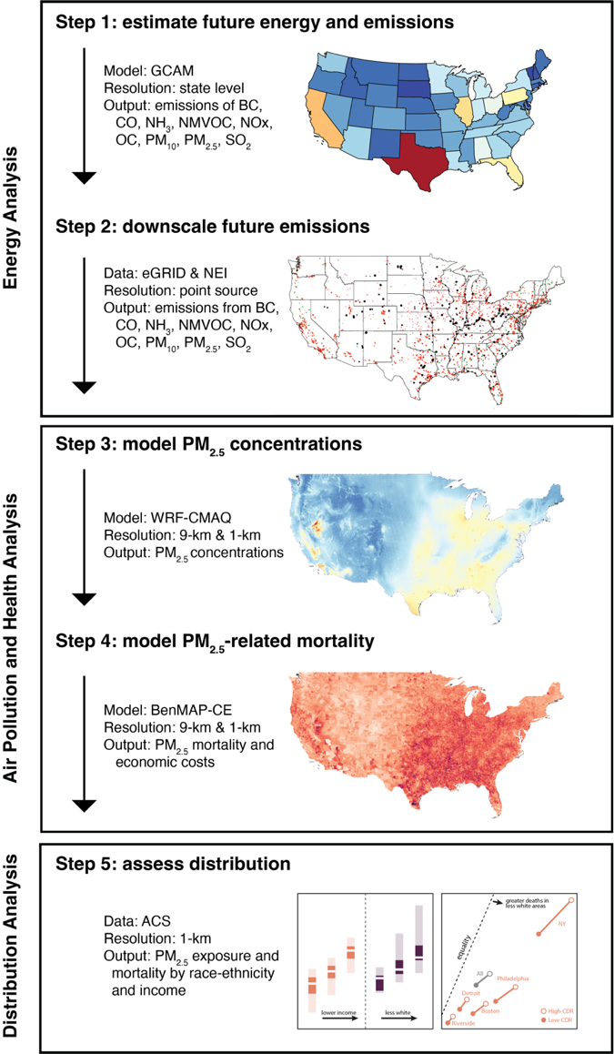

Extended Data Figure 1 | Methodological framework for this research. The approach includes an integrated assessment model, the downscaling of energy emissions, a chemical transport model, an epidemiological model, and a distributional analysis.
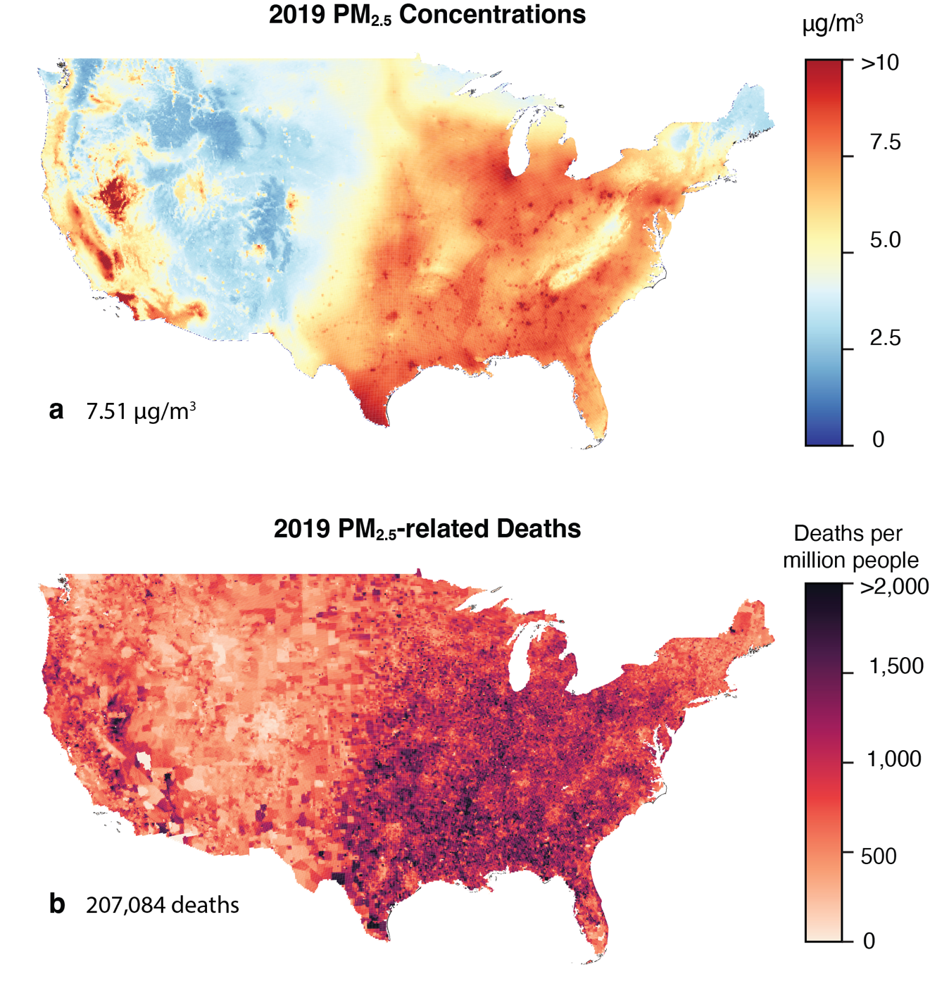
Extended Data Figure 2 | Yearly mean PM_{2.5} concentrations and related mortality in the contiguous U.S. in 2019 at a 9km resolution. Panel (a) shows total PM_{2.5} concentrations in 2019 in µg/m³ at a 9km resolution for the contiguous U.S. The population weighted PM_{2.5} yearly mean concentration is 7.51 µg/m³. Panel (b) shows the PM_{2.5}-related mortality in 2019 at the same resolution in deaths per million people. The mean estimate for mortality in 2019 is 207,084 (95% confidence interval 150,106–260,650).

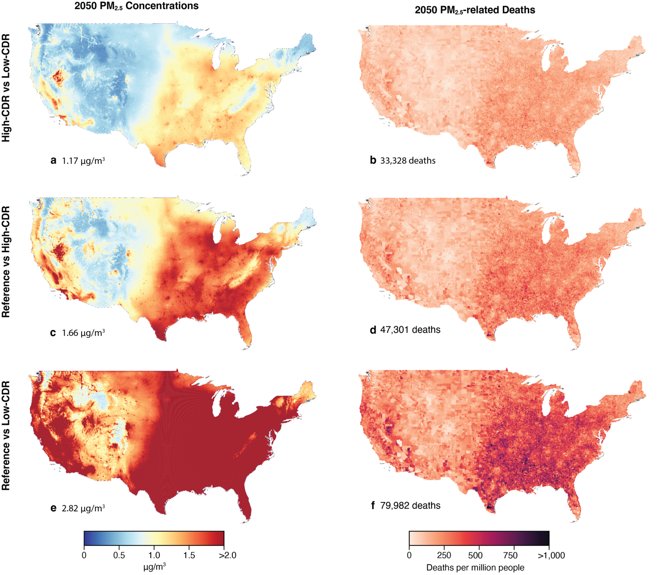
Extended Data Figure 3 | Yearly mean PM_{2.5} concentrations and related mortality in the contiguous U.S. in 2050 between scenarios at a 9km resolution. Panels (a and b) show the difference between the high- and low-CDR scenarios in yearly mean population weighted PM_{2.5} concentrations in 2050 in µg/m³ at a 9km resolution for the contiguous U.S. and its related mortality. The difference in population weighted PM_{2.5} yearly mean concentration is 1.17 µg/m³ and the difference in mortality is 33,328 (95% CI 23,909–42,368). Panels (c and d) show the difference between reference and the high-CDR scenarios, with a difference in population weighted yearly mean PM_{2.5} concentrations in 2050 of 1.66 µg/m³ and a difference in deaths of 47,301 (95% CI 33,961–60,083). Panels (e and f) show the difference between reference and low-CDR scenarios with a difference in population weighted yearly mean PM_{2.5} concentrations in 2050 of 2.82 µg/m³ and a difference in deaths of 79,982 (95% CI 57,536–101,406).

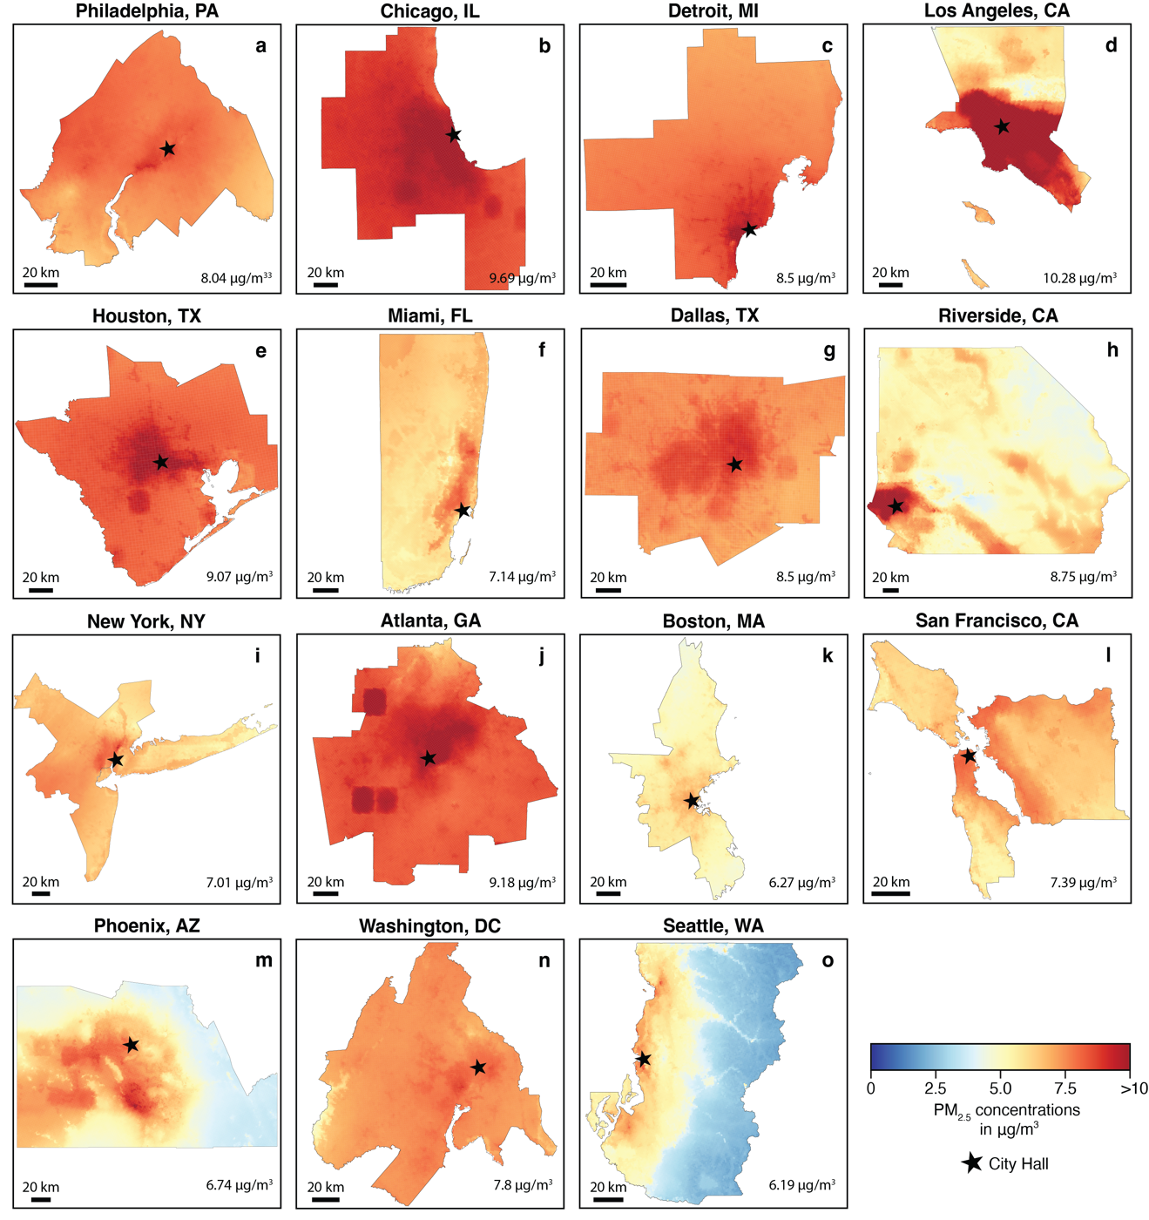
Extended Data Figure 4 | 2019 yearly mean PM_{2.5} concentrations in µg/m³ for the 15 most populated metropolitan statistical areas in the U.S. at a 1km resolution. Each panel represents one of the cities, ordered from highest to lowest mortality rates (deaths per million people) consistent with Figure 3. Values in the bottom right corner of each panel represent the population-weighted yearly mean PM_{2.5} concentration in that city in 2019. Stars represent city hall for reference (and the White House in the case of D.C.).

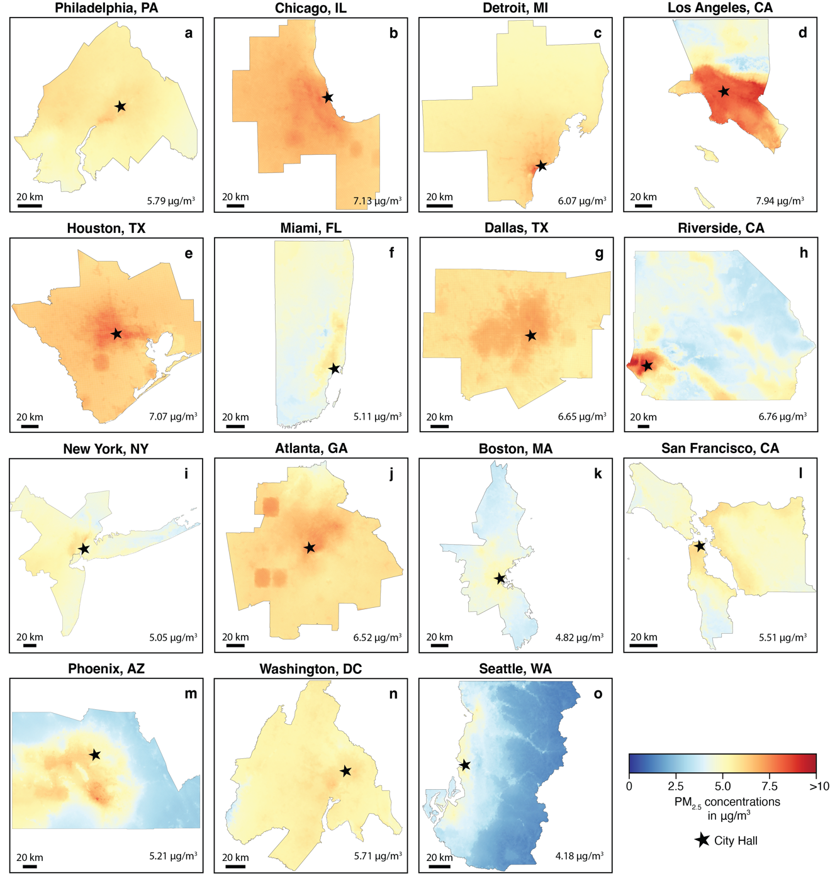
Extended Data Figure 5 | 2050 high-CDR scenario yearly mean PM_{2.5} concentrations in µg/m³ for the 15 most populated metropolitan statistical areas in the U.S. at a 1km resolution. Each panel represents one of the cities, ordered from highest to lowest mortality rates (deaths per million people) consistent with Figure 3. Values in the bottom right corner of each panel represent the population-weighted yearly mean PM_{2.5} concentration in that city in 2050 for the high-CDR scenario. Stars represent city hall for reference (and the White House in the case of D.C.).

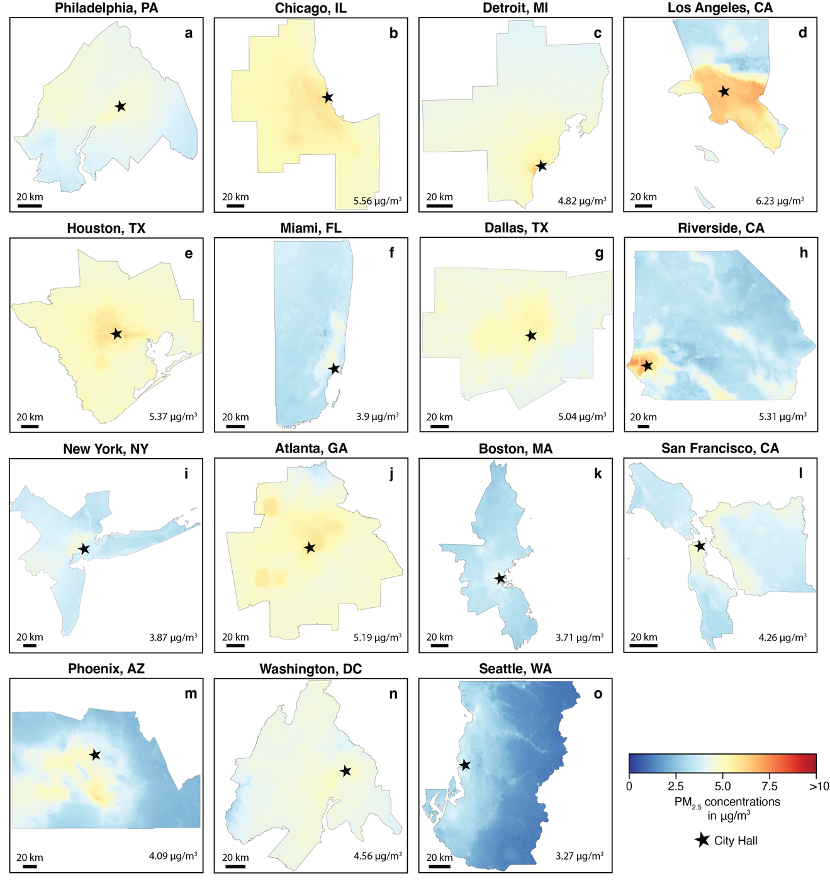
Extended Data Figure 6 | 2050 low-CDR scenario yearly mean PM_{2.5} concentrations in µg/m³ for the 15 most populated metropolitan statistical areas in the U.S. at a 1-km resolution. Each panel represents one of the cities, ordered from highest to lowest mortality rates (deaths per million people) consistent with Figure 3. Values in the bottom right corner of each panel represent the population-weighted yearly mean PM_{2.5} concentration in that city in 2050 for the low-CDR scenario. Stars represent city hall for reference (and the White House in the case of D.C.).

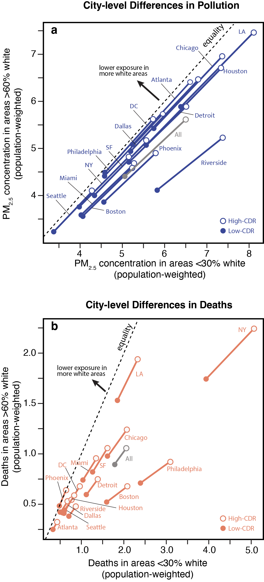
Extended Data Figure 7 | City-level differences in pollution and deaths across race-ethnicity groups. Panel (a) shows differences in population-weighted PM_{2.5} concentrations across areas within cities that have <30% non-Hispanic whites and areas with >60% whites. Panel (b) shows differences across the same groups for population-weighted deaths from PM_{2.5} concentrations. Hollow dots represent high-CDR scenarios and colored dots represent low-CDR scenarios. The dashed line represents perfect equality across both groups; anything below the line represents a higher exposure on areas with <30% non-Hispanic whites. The grey dots and lines represent the values when analyzing areas from all 15 cities together.

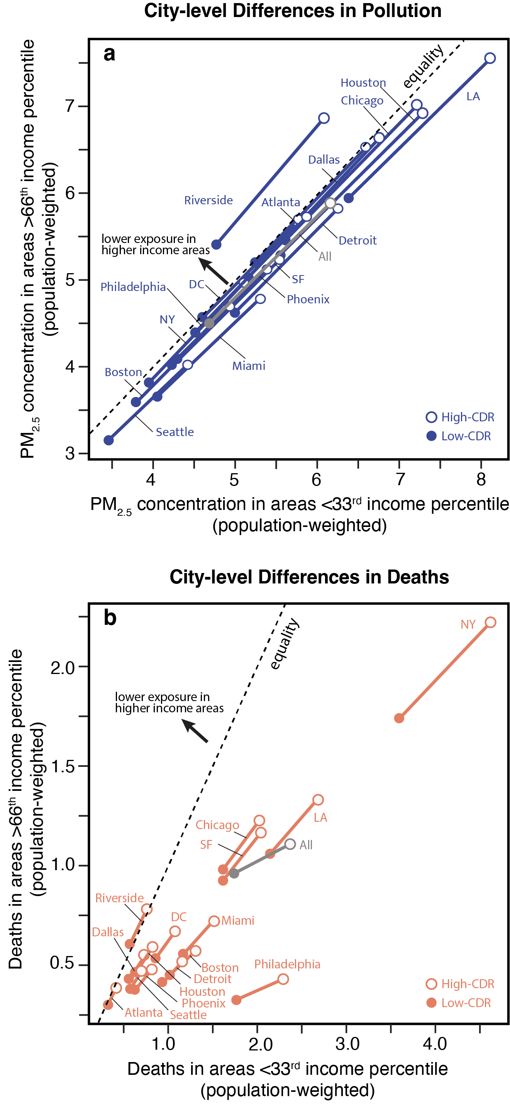
Extended Data Figure 8 | City-level differences in pollution and deaths across income groups. Panel (a) shows differences in population-weighted PM_{2.5} concentrations across areas within cities that are below the 33rd median household income percentile and areas above the 66th median household income percentile. Panel (b) shows differences across the same groups for population-weighted deaths from PM_{2.5} concentrations. Hollow dots represent high-CDR scenarios and colored dots represent low-CDR scenarios. The dashed line represents perfect equality across both groups; anything below the line represents a higher exposure on areas below the 33rd median household income percentile. The grey dots and lines represent the values when analyzing areas from all 15 cities together.

