Effects of wildfire on streambed sediment in the Cascades and Klamath provinces of the Pacific Northwest

Wall et al., 2025

SUPPLEMENTAL MATERIALS

APPENDIX A. Table of model fit parameters
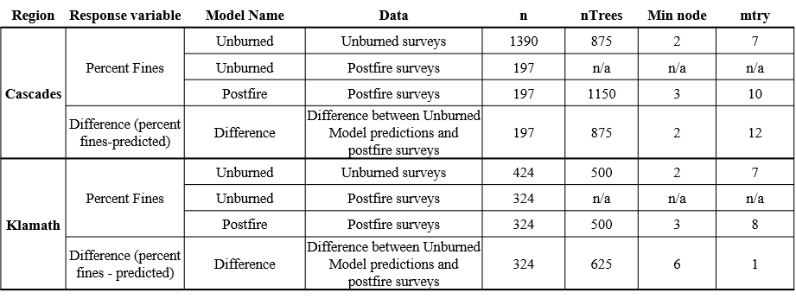

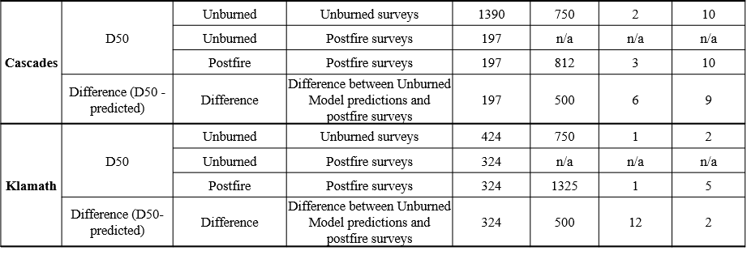

APPENDIX B. Key for covariate abbreviations

Variables | Abbreviation | Unit | Spatial Extent | Category
SITE ID | SITE_ID | Categorical | Reach | Location
Watershed ID | CREEK_CODE | Categorical | HUC12 Watershed | Location
Survey Year | Survey_year | years | Reach | Temporal
Mean Bankfull Width | Bankfull_mean | m | Reach | Stream Morphology
Relative bankfull | Relative_bankfull | - | Reach | Temporal
Streambed Slope | Stream_slope | degrees | Reach | Stream Morphology
Valley Confinement | Confinement | Categorical | Reach | Stream Morphology
In-Stream Large Wood | Frequency_km | Units/km | Reach | Stream Morphology
High Flow Count | High_flow_count | - | Nearest USGS Gage | Climate
Subwatershed Area | Area_sqkm.x | Km² | Subwatershed | Topography
% of subwatershed with slopes  > 23 degrees | Slope23d_perc_greater | % | Subwatershed | Topography
Mean Elevation | Elev_mean | m | Subwatershed | Topography
Baseflow Index | BFIWS | % | Subwatershed | Climate
30-year Normal Precipitation | PRECIP8110WS | mm | Subwatershed | Climate
30-year Mean Temperature | TMEAN8110WS | celsius | Subwatershed | Climate
Mean Rock Compressive Strength | COMPSTRGTHWS | megaPascals | Subwatershed | Lithology/Soils
Mean Lithological Hydraulic Conductivity | HYDRLCONDWS | micrometers/s | Subwatershed | Lithology/Soils
Dominant Geology | Dom_geology | Categorical | Subwatershed | Lithology/Soils
Mean Soil Erodibility Factor | KFFACTWS | - | Subwatershed | Lithology/Soils
Soil Permeability | PERMWS | cm/hr | Subwatershed | Lithology/Soils
Mean Soil Depth to Bedrock | RCKDEPWS | cm | Subwatershed | Lithology/Soils
Soil Organic Matter Content | OMWS | % | Subwatershed | Lithology/Soils
Mean Tree Age | Mean_ad | years | Subwatershed | Land Cover
Mean Canopy Cover | Mean_cc | % | Subwatershed | Land Cover
Road Crossings | RDCRSWS | crossings/sqkm | Subwatershed | Land Cover
Upslope Road Density | RDDENSWS | km/sqkm | Subwatershed | Land Cover
Years Between Survey and Fire | YPF | Years | Subwatershed | Fire
Area of Subwatershed Burned | Ppc_burned_sqkm | Sqkm | Subwatershed | Fire
Area of Subwatershed Burned at Himod | Ppc_himod_sqkm | Sqkm | Subwatershed | Fire
Area of Riparian Area Burned | Rip_burned_sqkm | Sqkm | Riparian | Fire
Area of Riparian Area Burned at Himod | Rip_himod_sqkm | Sqkm | Riparian | Fire
Area of Reach Burned | Reach_burned_sqkm | Sqkm | Reach | Fire
Area of Reach Burned at Himod | Reach_himod_sqkm | Sqkm | Reach | Fire
Fire Rank | Rank.x | Count | Subwatershed | Fire

APPENDIX C. Full Variable Importance Plots for the Unburned and Post-fire Percent Fines and D50 models
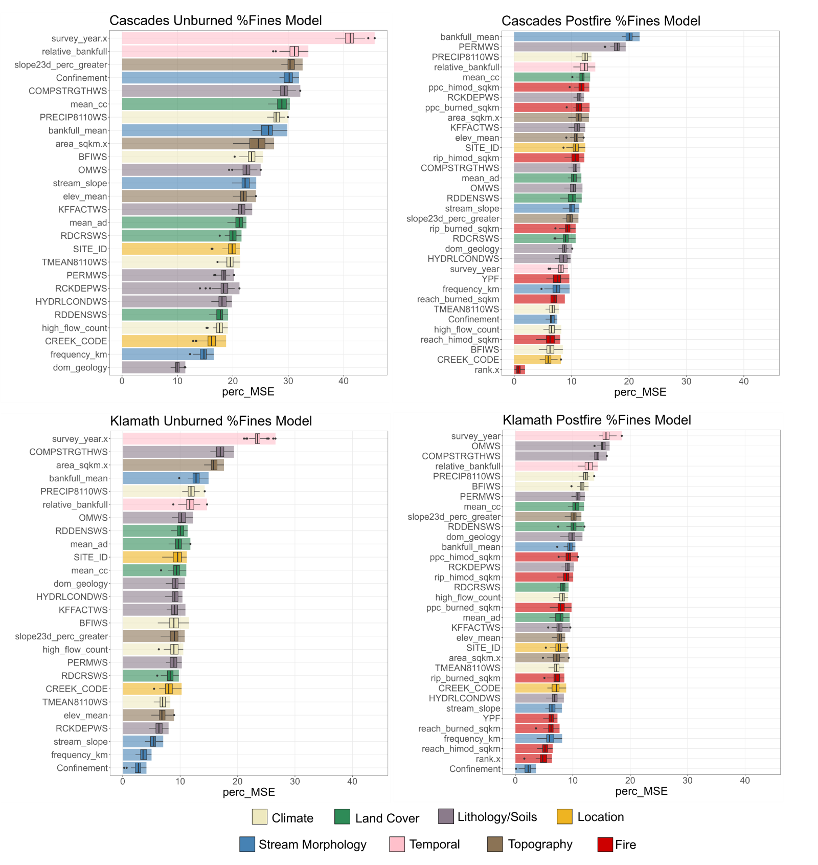Figure 1. Full variable importance plots for the Unburned and Post-fire Percent Fines models. This Figure complements Figure 3 in the text. Boxplots summarize the importance output from 50 model runs. Variable Important plot for the Unburned Percent Fines model that was trained using solely unburned and pre-fire data for the Cascades (upper left) and Klamath (lower left) regions. Variable Important plot for the Post-fire Percent Fines model that was trained using solely postfire data for the Cascades (upper right) and Klamath (bottom right) regions.
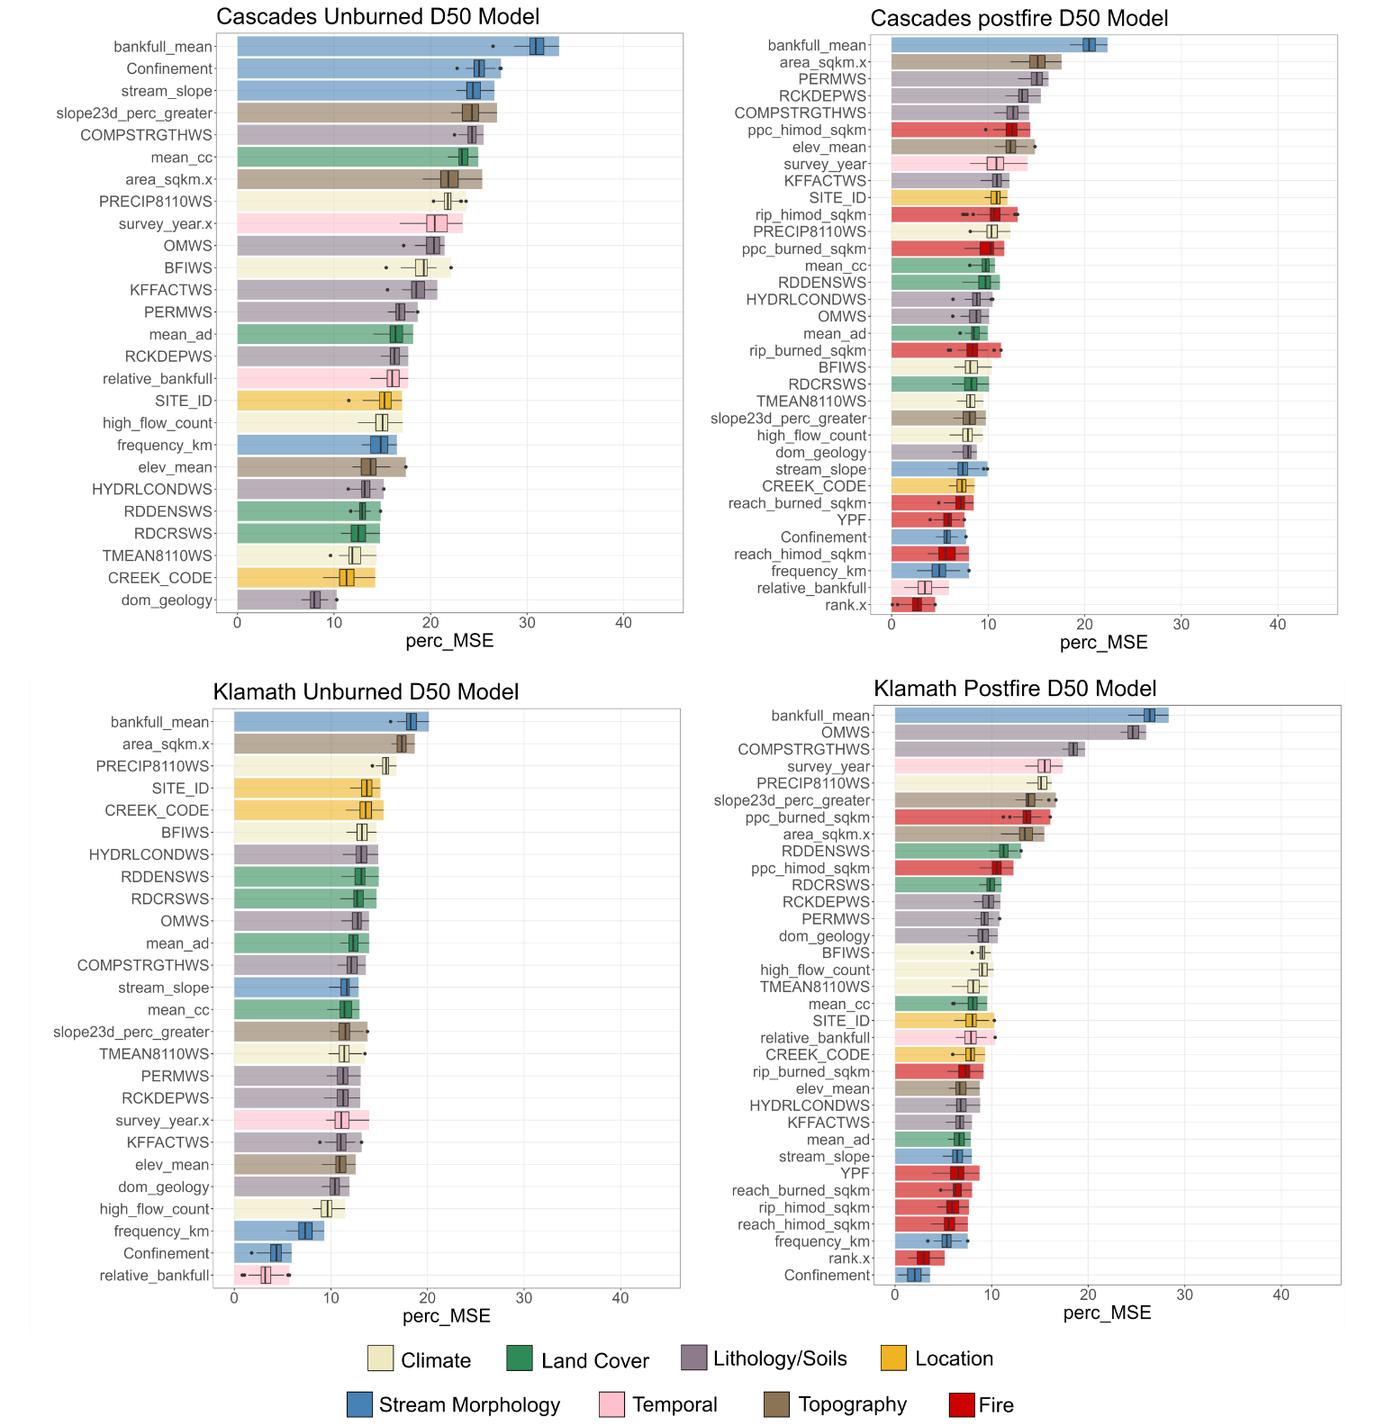

Figure 2. Full variable importance plots for the Unburned and Post-fire D50 models. This Figure complements Figure 4 in the text. Boxplots summarize the importance output from 50 model runs. Variable Important plot for the Unburned D50 model that was trained using solely unburned and pre-fire data for the Cascades (upper left) and Klamath (lower left) regions. Variable Important plot for the Post-fire D50 model that was trained using solely postfire data for the Cascades (upper right) and Klamath (bottom right) regions.

APPENDIX D. Partial Dependence Plots for the top ten most important variables for the Unburned and Post-fire Percent Fines models.

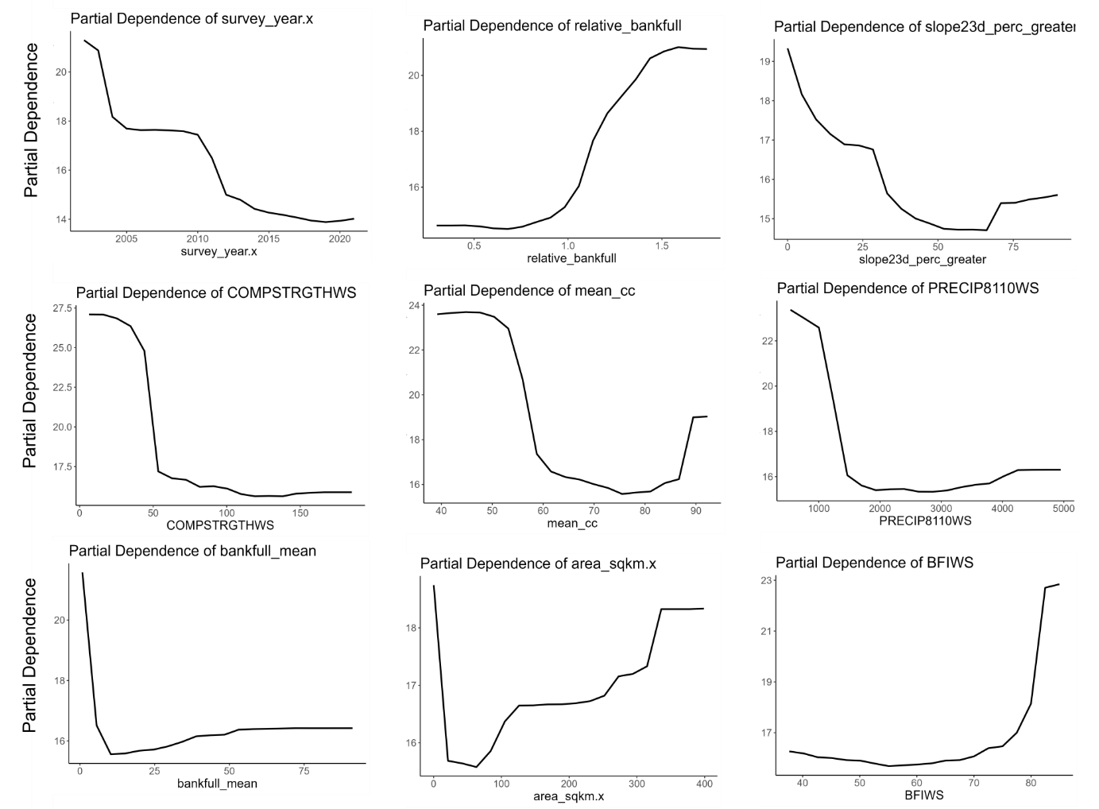
Figure 3. Partial dependence plots for the nine most important variables for the Cascades Unburned Percent Fines model. One of the top ten most important variables was categorical and therefore removed from this figure. This figure corresponds to Figure 3A in the text.

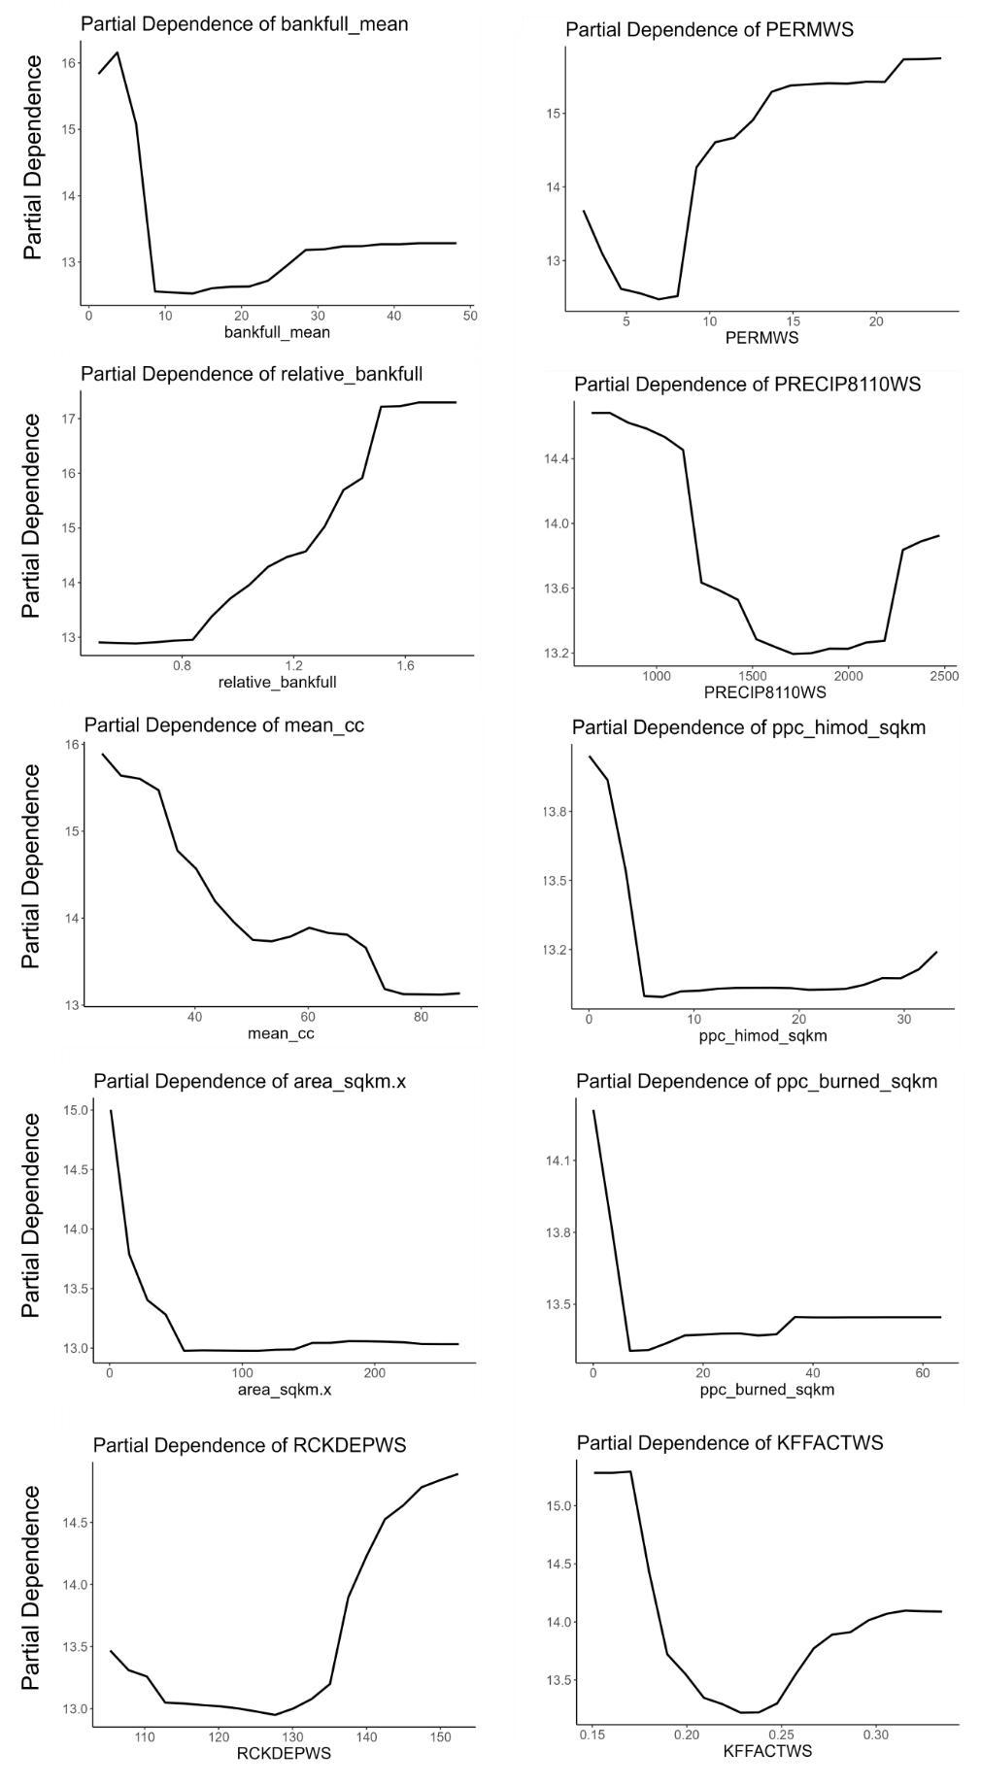
Figure 4. Partial dependence plots for the ten most important variables for the Cascades Post-fire Percent Fines model. This figure corresponds to Figure 3B in the text.

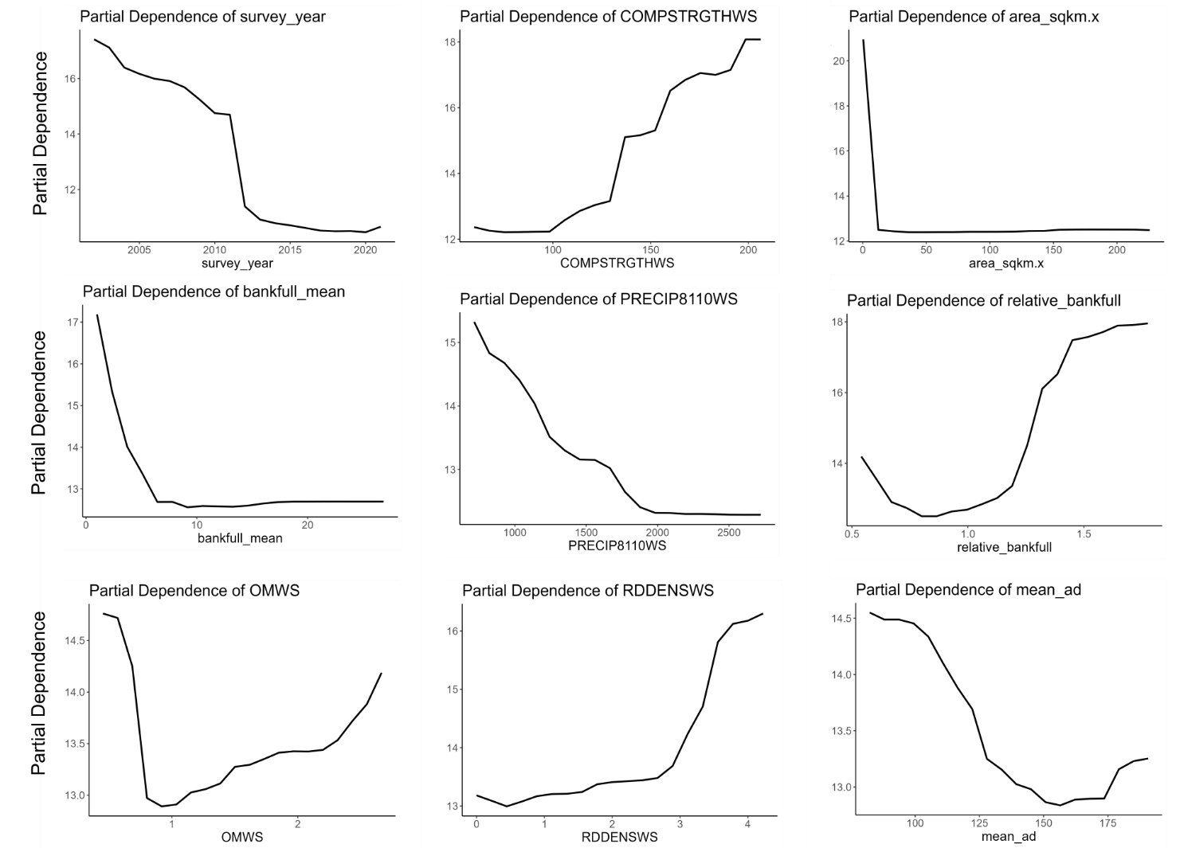
Figure 5. Partial dependence plots for the nine most important variables for the Klamath Unburned Percent Fines model. One of the top ten most important variables was categorical and therefore removed from this figure. This figure corresponds to Figure 3A in the text.

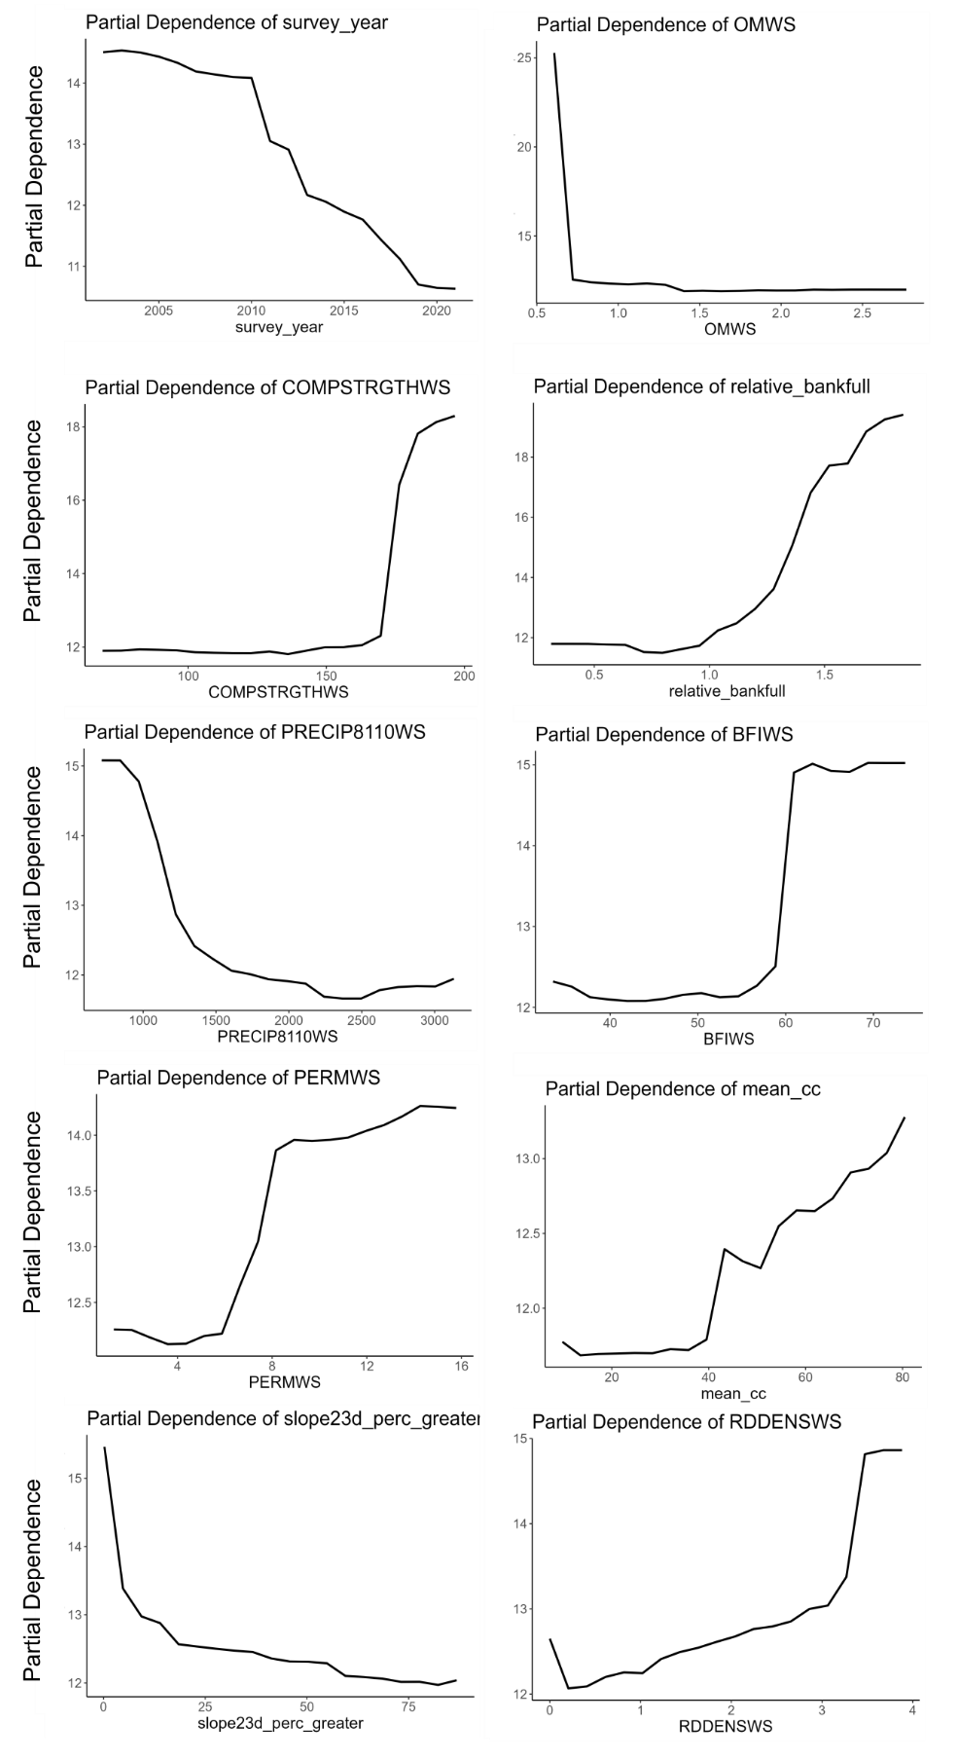
Figure 6. Partial dependence plots for the ten most important variables for the Klamath Post-fire Percent Fines model. This figure corresponds to Figure 3B in the text.

APPENDIX E. Partial Dependence Plots for the top ten most important variables for the Unburned and Post-fire D50 models.

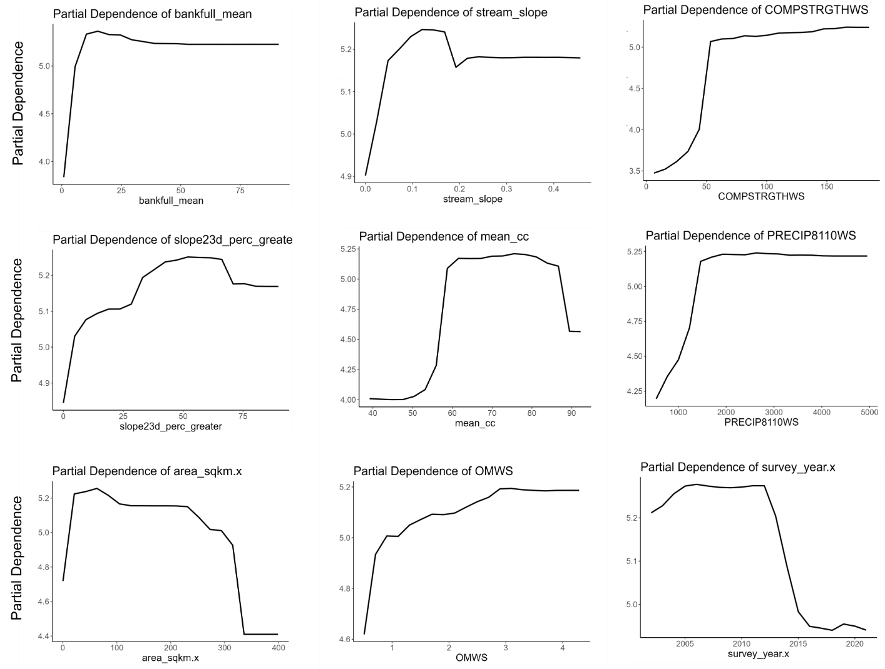
Figure 5. Partial dependence plots for the nine most important variables for the Cascades Unburned D50 model. One of the top ten most important variables was categorical and therefore removed from this figure. This figure corresponds to Figure 4A in the text.

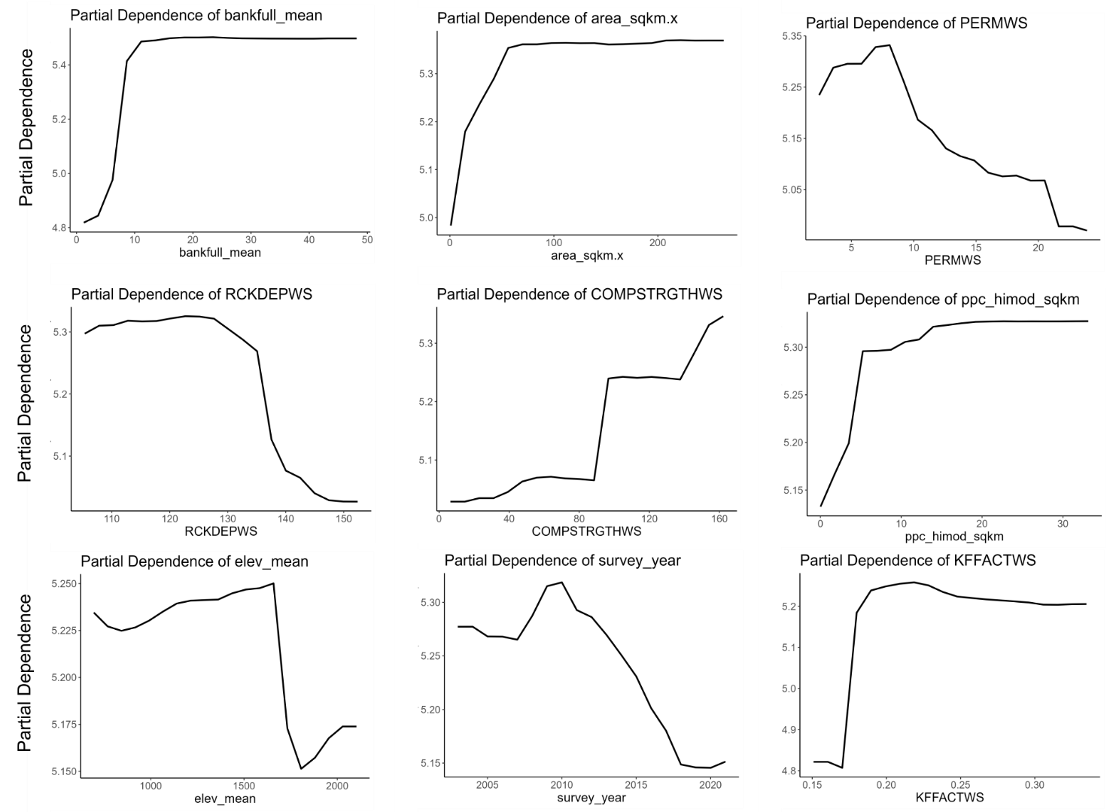
Figure 6. Partial dependence plots for the nine most important variables for the Cascades Post-fire D50 model. One of the top ten most important variables was categorical and therefore removed from this figure. This figure corresponds to Figure 4B in the text.

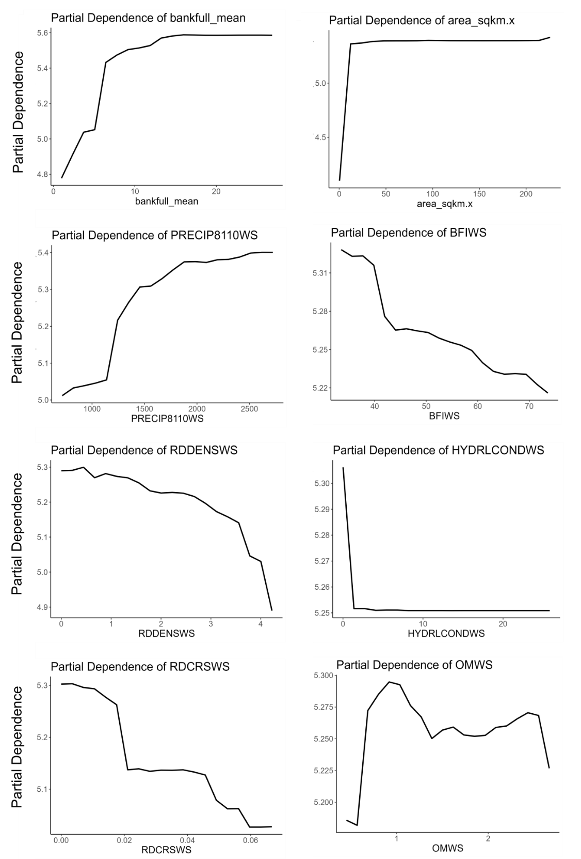

Figure 7. Partial dependence plots for the nine most important variables for the Klamath Unburned D50 model. Two of the top ten most important variables were categorical and therefore removed from this figure. This figure corresponds to Figure 4A in the text.

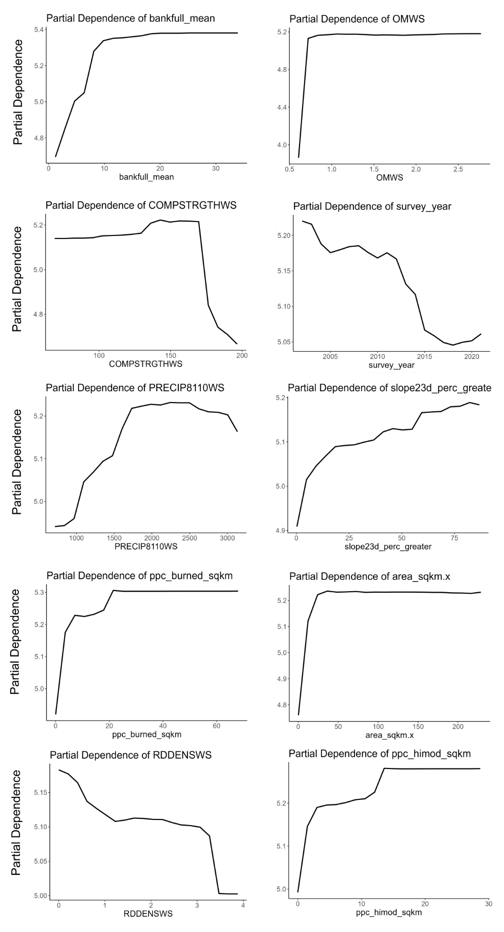
Figure 8. Partial dependence plots for the ten most important variables for the Klamath Post-fire D50 model. This figure corresponds to Figure 4B in the text.

