Additional File 2
Manuscript: Evolution of the immune system of bees: A story of conservation, gains, and losses
Authors: Hongfei Xu¹*, Ina Köhler¹ & Thomas J. Colgan^{1,2}*.
- Institute of Organismic and Molecular Evolution, Johannes Gutenberg University Mainz, Hanns-Dieter-Hüsch-Weg 15, 55128 Mainz, Germany.
- Institute of Quantitative and Computational Biosciences (IQCB), Johannes Gutenberg University Mainz, Hanns-Dieter-Hüsch-Weg 15, 55128 Mainz, Germany.
Email address:
Hongfei Xu: honxu@uni-mainz.de
Ina Köhler: inkoehle@uni-mainz.de
Thomas J. Colgan: tcolgan@uni-mainz.de
Corresponding authors: Hongfei Xu and Thomas J. Colgan

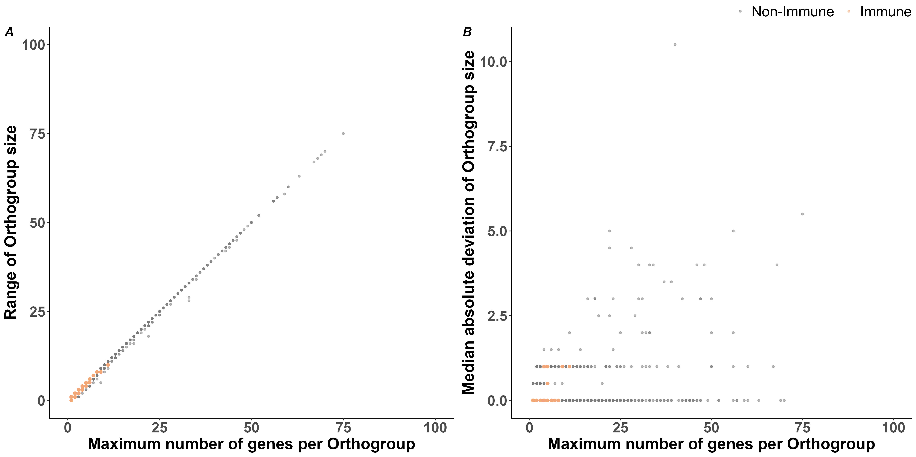
Fig. S1. Larger orthogroups have greater range in gene copy number across species. Scatterplots displaying: A) the near-linear relationship between the range and the maximum number of genes in an orthogroup (i.e., orthogroup size) across all species; and B) the relationship between the median absolute deviation and the maximum value of orthogroup size across all species. The orthogroups containing canonical immune genes are highlighted in tan while non-immune-containing orthogroups are displayed in blue.

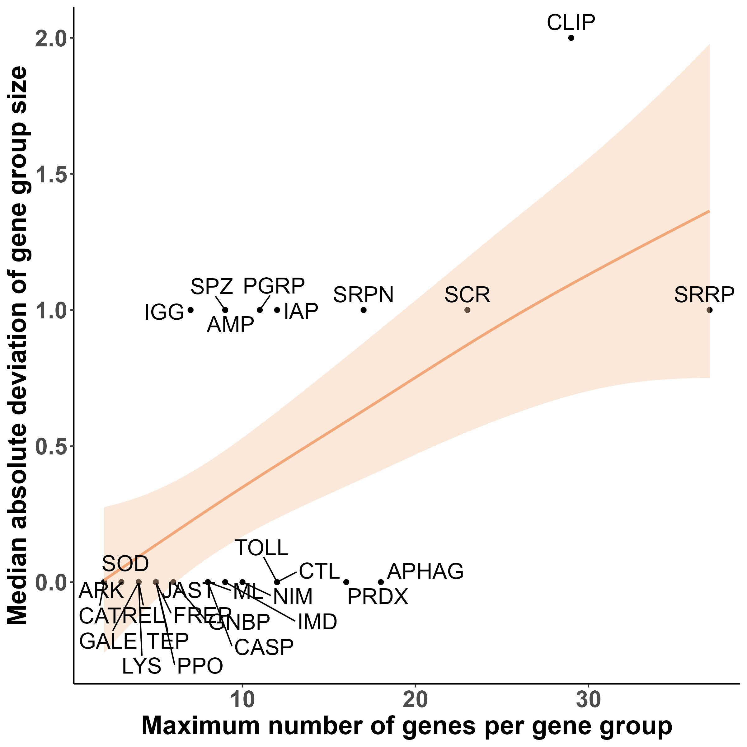
Fig. S2. Larger immune-related functional gene groups generally show higher median absolute deviation (MAD) in gene copy number across species. A scatterplot displaying the relationship between the maximum gene number (i.e., size) in each immune-related functional gene group (x-axis) and the MAD of copy number for each gene group across bee species (n = 70). Each dot represents an individual functional gene group. A non-linear best fit line, and associated confidence intervals, generated using a generalised additive model (GAM), illustrate the relationship between the MAD and the maximum value of gene count across species (Abbreviations for functional gene groups: AMP = Antimicrobial peptide; APHAG = Autophagy; ARK = Death-associated APAF1-related killer; CASP = Caspase; CAT = Catalase; CLIP = CLIP-domain serine protease; CTL = C-type lectin; FREP = Fibrinogen-like; GALE = Galectin; GNBP = Gram-negative binding protein/Beta-glucan recognition protein; IAP = IAP repeat, inhibitor of apoptosis domain; IGG = Immunoglobulin; IMD = Imd pathway; JAST = JAKSTAT; LYS = Lysozyme; ML = MD-2-related lipid recognition; NIM = NIMROD; PGRP = Peptidoglycan recognition protein; PPO = Prophenoloxidase; PRDX = Peroxidase; REL = Relish; SCR = Scavenger receptor; SOD = Superoxide dismutase; SPZ = Spaetzle; SRPN = Serine protease inhibitor; SRRP = Small RNA regulatory pathway; TEP = Thioester-containing protein; TOLL = Toll genes, Toll pathway).
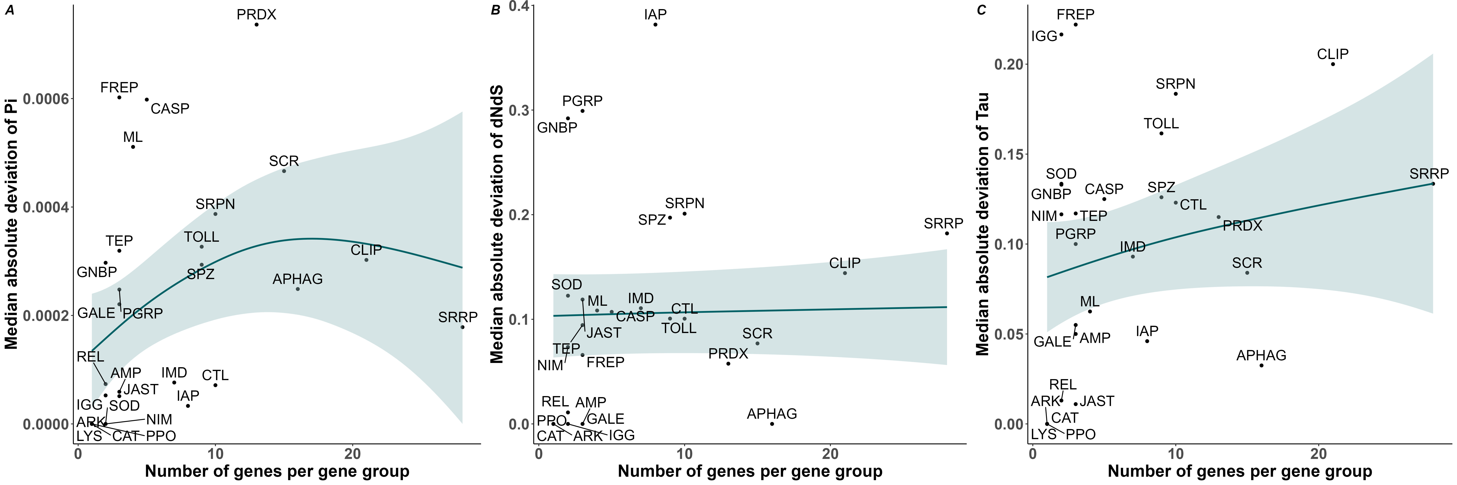
Fig. S3. Medium absolute deviation of nucleotide diversity, interspecific differentiation, and tissue-specificity scale non-linearly with immune-related functional gene group size in Bombus terrestris. Scatterplots displaying: A) the non-linear relationship between the MAD of genetic diversity (measured in Pi) and the maximum number of genes in each immune-related functional gene group; B) the non-linear relationship between the MAD of interspecific differentiation (measured in dNdS) and the maximum number of genes in each immune-related functional gene group; and C) the non-linear relationship for the MAD of tissue-specificity (measured in tau) and the maximum number of genes in each immune-related functional gene group. For each scatterplot, a best fit line and associated confidence intervals generated by a generalised additive model (GAM) are shown (Abbreviations for functional gene groups: AMP = Antimicrobial peptide; APHAG = Autophagy; ARK = Death-associated APAF1-related killer; CASP = Caspase; CAT = Catalase; CLIP = CLIP-domain serine protease; CTL = C-type lectin; FREP = Fibrinogen-like; GALE = Galectin; GNBP = Gram-negative binding protein/Beta-glucan recognition protein; IAP = IAP repeat, inhibitor of apoptosis domain; IGG = Immunoglobulin; IMD = Imd pathway; JAST = JAKSTAT; LYS = Lysozyme; ML = MD-2-related lipid recognition; NIM = NIMROD; PGRP = Peptidoglycan recognition protein; PPO = Prophenoloxidase; PRDX = Peroxidase; REL = Relish; SCR = Scavenger receptor; SOD = Superoxide dismutase; SPZ = Spaetzle; SRPN = Serine protease inhibitor; SRRP = Small RNA regulatory pathway; TEP = Thioester-containing protein; TOLL = Toll genes, Toll pathway).
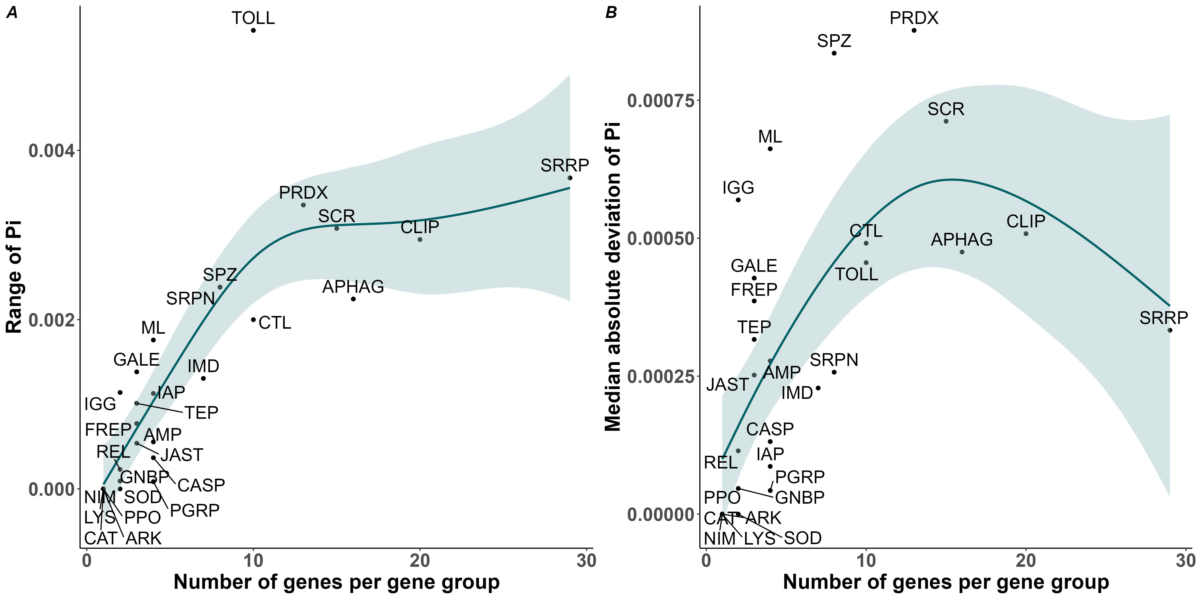
Fig. S4. Nucleotide diversity scales non-linearly with immune-related functional gene group size in the solitary bee Megachile rotundata. Scatterplots displaying: A) the non-linear relationship between the range of nucleotide diversity (measured in Pi) and the maximum number of genes in each immune-related functional gene group; and B) the non-linear relationship between median absolute deviation (MAD) of nucleotide diversity (measured in Pi) and the maximum number of genes in each immune-related functional gene group. For each scatterplot, a best fit line and associated confidence intervals generated by a generalised additive model (GAM) are shown (Abbreviations for functional gene groups: AMP = Antimicrobial peptide; APHAG = Autophagy; ARK = Death-associated APAF1-related killer; CASP = Caspase; CAT = Catalase; CLIP = CLIP-domain serine protease; CTL = C-type lectin; FREP = Fibrinogen-like; GALE = Galectin; GNBP = Gram-negative binding protein/Beta-glucan recognition protein; IAP = IAP repeat, inhibitor of apoptosis domain; IGG = Immunoglobulin; IMD = Imd pathway; JAST = JAKSTAT; LYS = Lysozyme; ML = MD-2-related lipid recognition; NIM = NIMROD; PGRP = Peptidoglycan recognition protein; PPO = Prophenoloxidase; PRDX = Peroxidase; REL = Relish; SCR = Scavenger receptor; SOD = Superoxide dismutase; SPZ = Spaetzle; SRPN = Serine protease inhibitor; SRRP = Small RNA regulatory pathway; TEP = Thioester-containing protein; TOLL = Toll genes, Toll pathway).
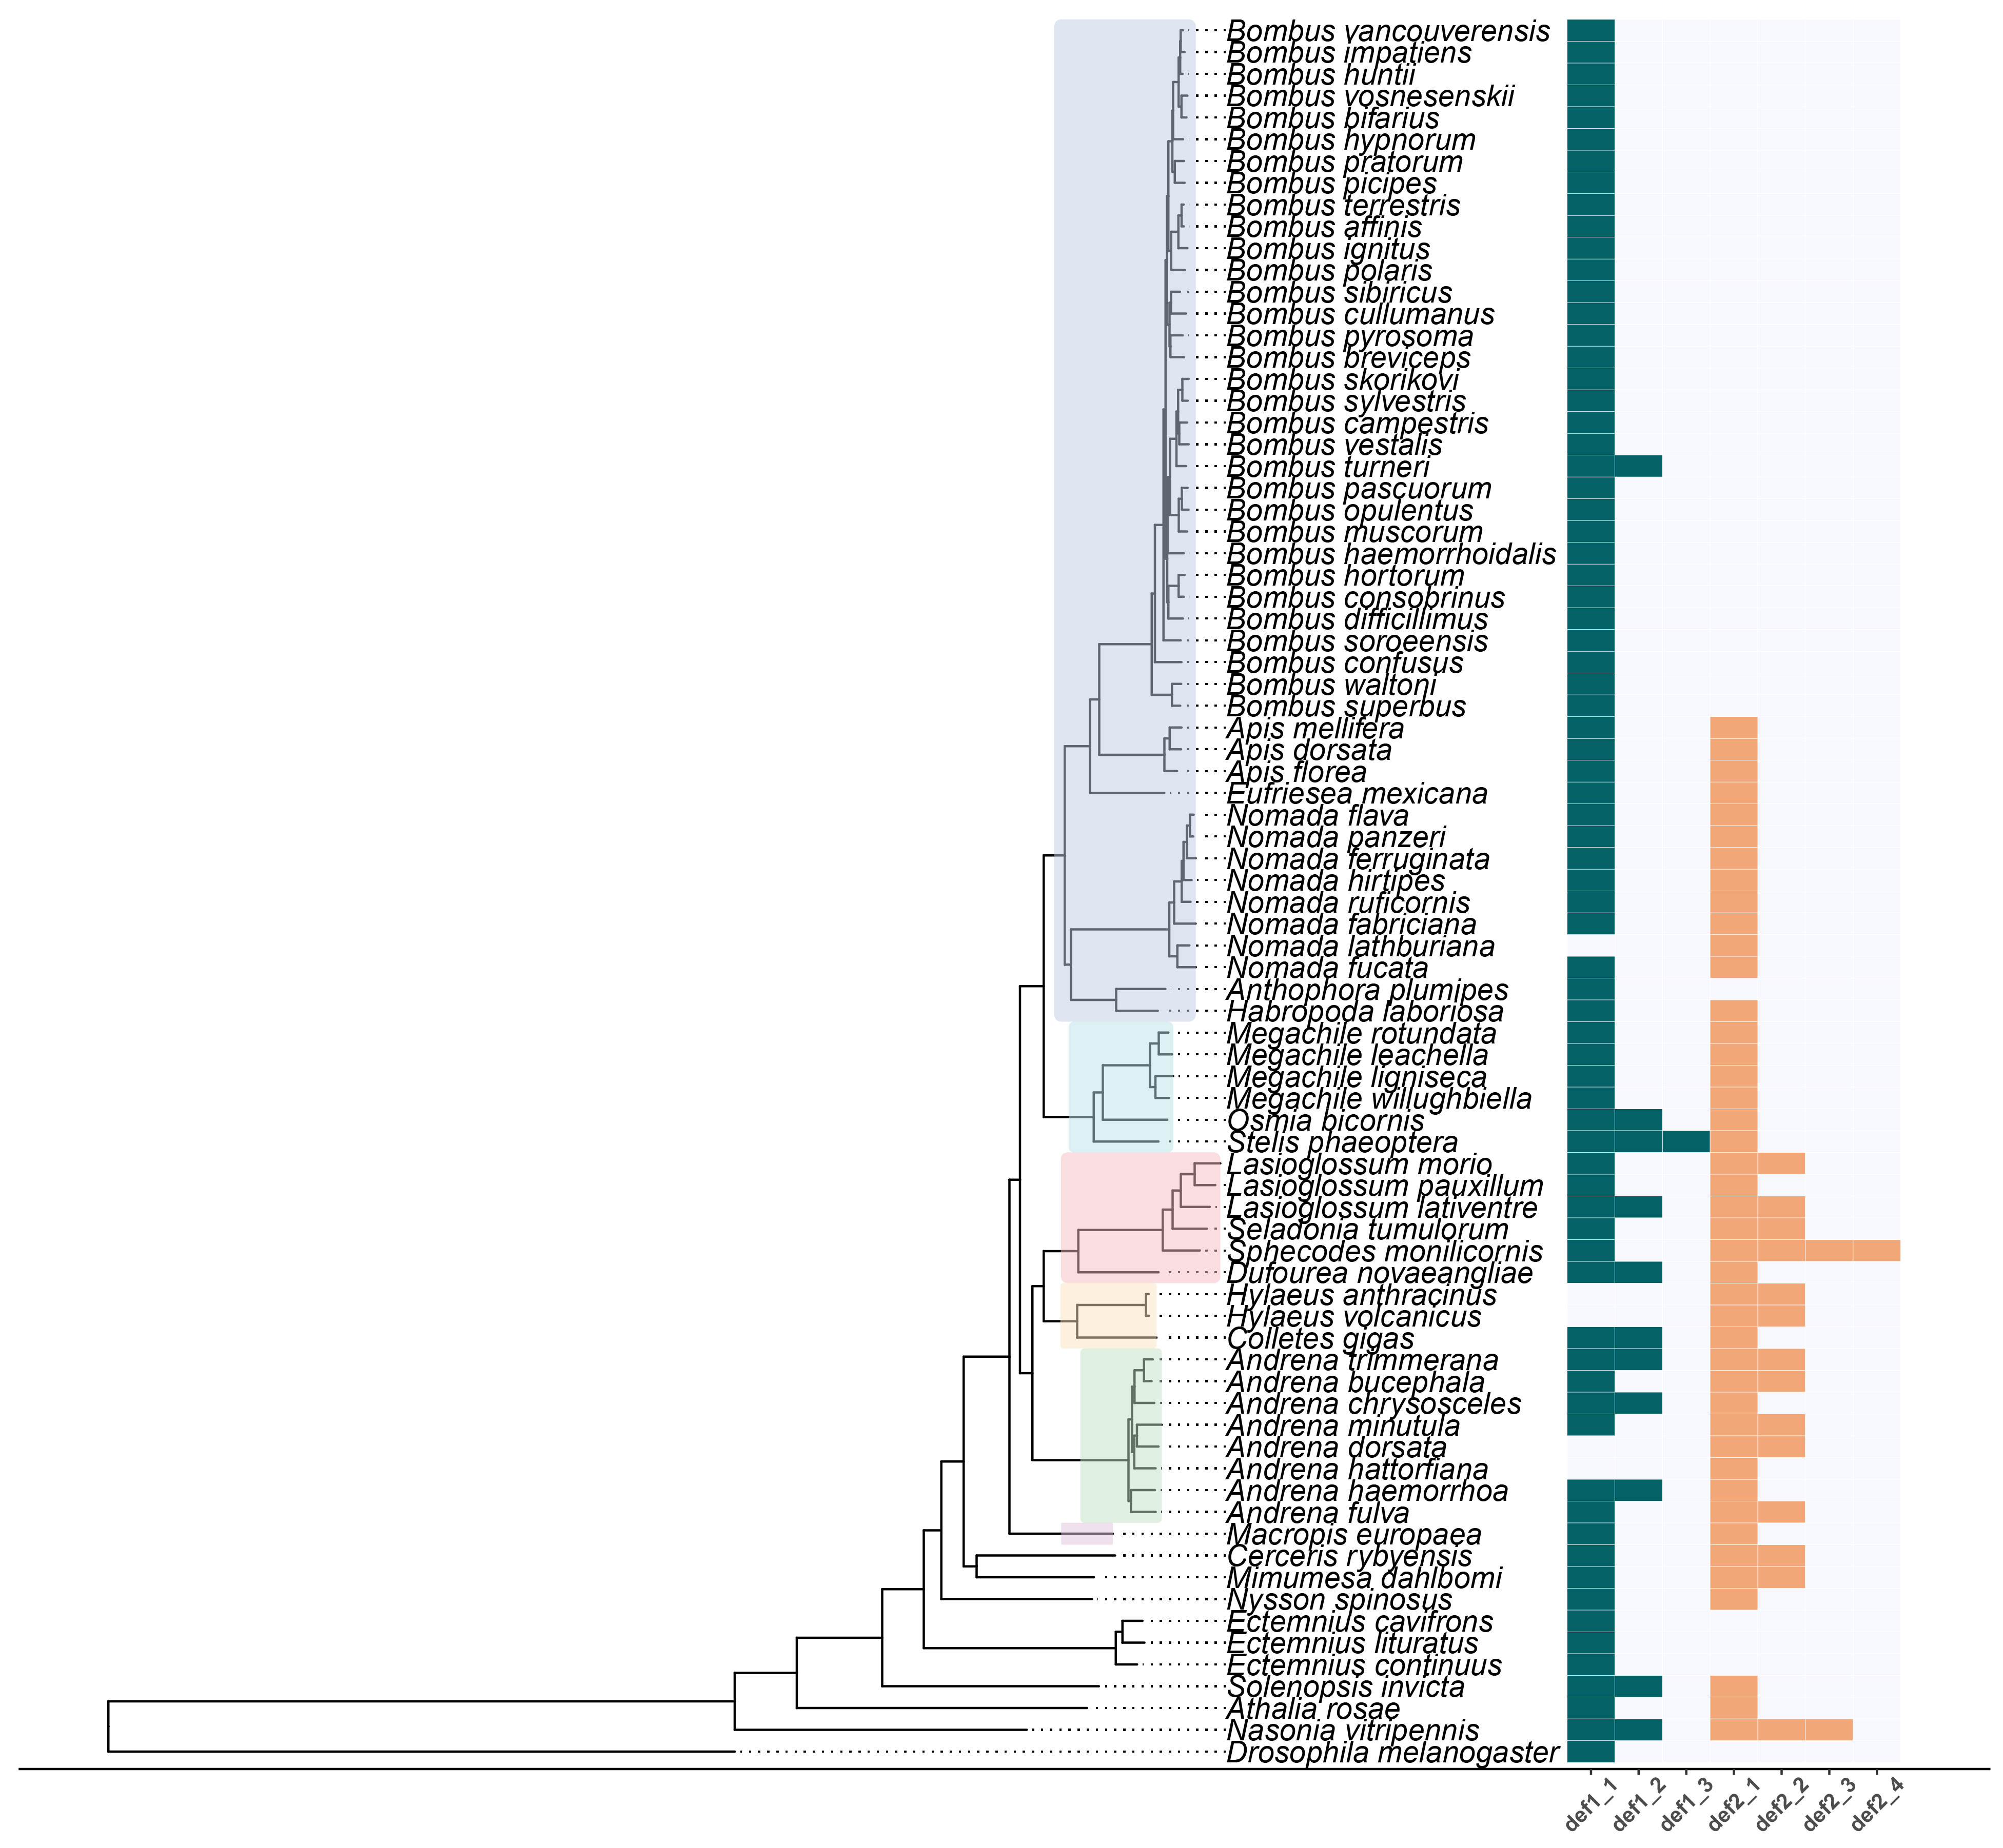
Fig. S5. Conservation and loss of defensin across bee species. A combined multi-panel plot displaying: the phylogenetic relationships between investigated species based on a homology-based comparative analysis of predicted proteomes for 80 species, including representatives of six bee families (Apidae = blue; Megachilidae = light blue; Halictidae = pink; Colletidae = light yellow; Andrenidae = light green; Melittidae = light purple); and a heatmap depicting the two defensin gene copies (Def1 (green) and Def2 (tan)) in extant bee species, which were identified using our homology-based method. An undetected match is recorded in grey. For certain species, duplicate copies of Def1 and Def2 were identified, which are presented by underscores in their names on the x-axis.
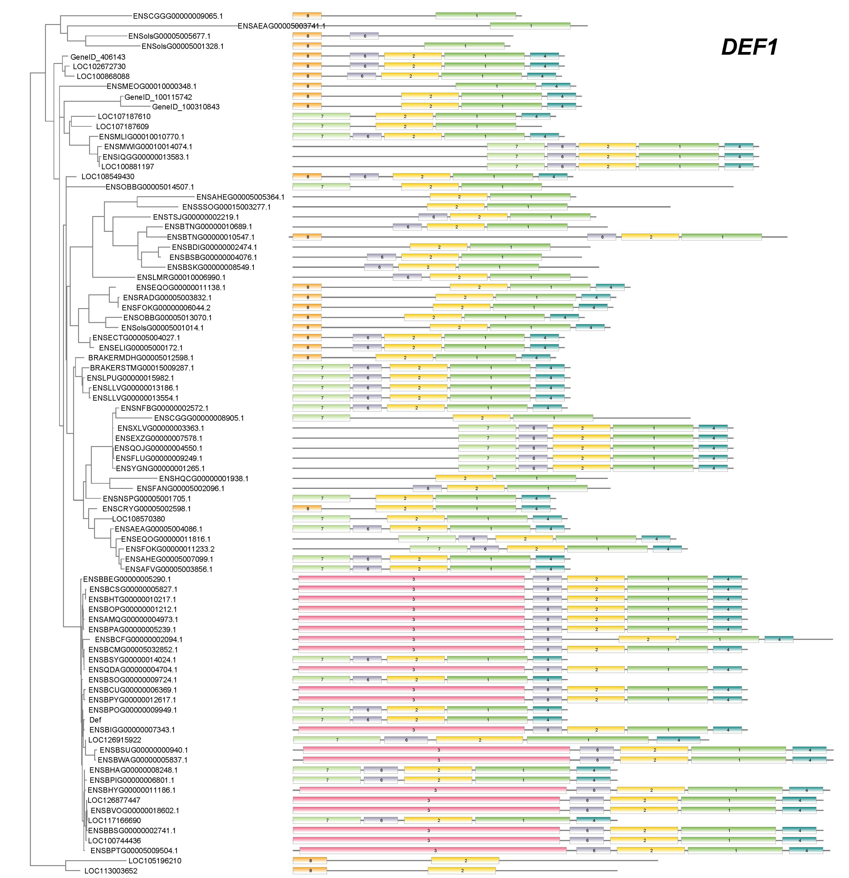
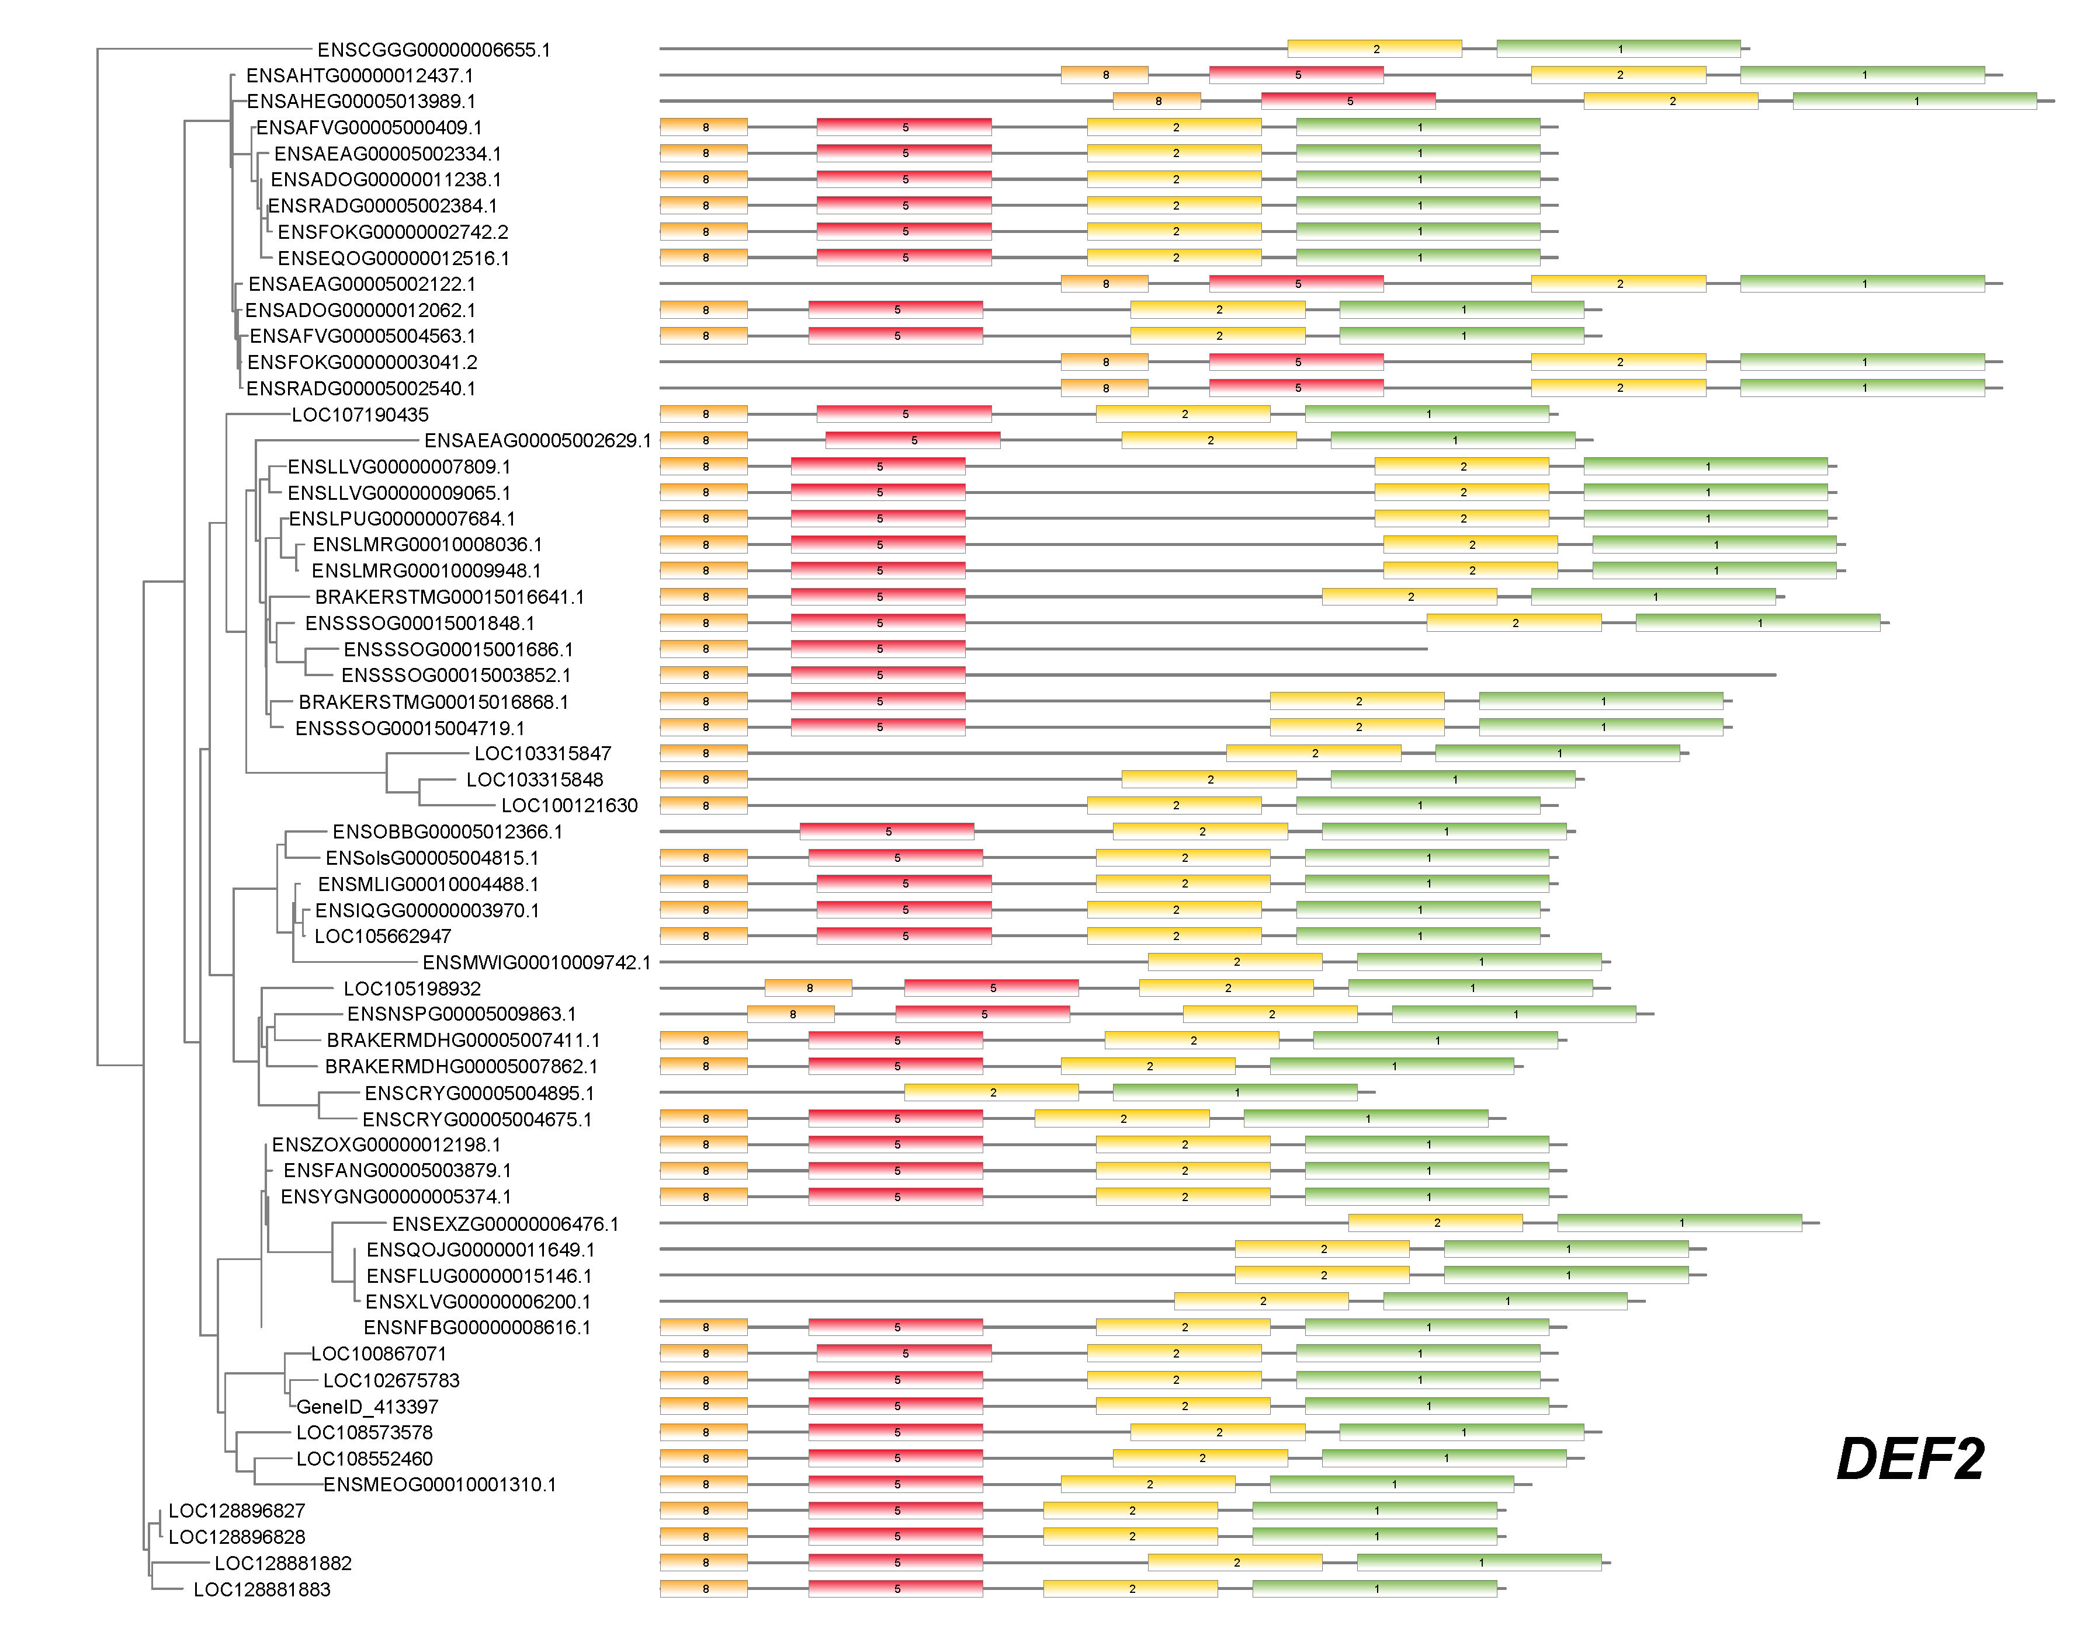
Fig. S6. Conserved and copy-specific protein motifs of defensins across bee species. Phylogenetic relationship of the two defensin copies (Def1 and Def2) identified in bee species, including graphical representation of the conserved and copy-specific protein motifs identified using MEME. Sub-clustering of defensin copies is showed in two figures. For each protein, individual motifs are represented by rectangles with different colours and length. The gene identifiers for defensin copies are provided on the y-axis while protein length (aa) is provided on the x-axis.
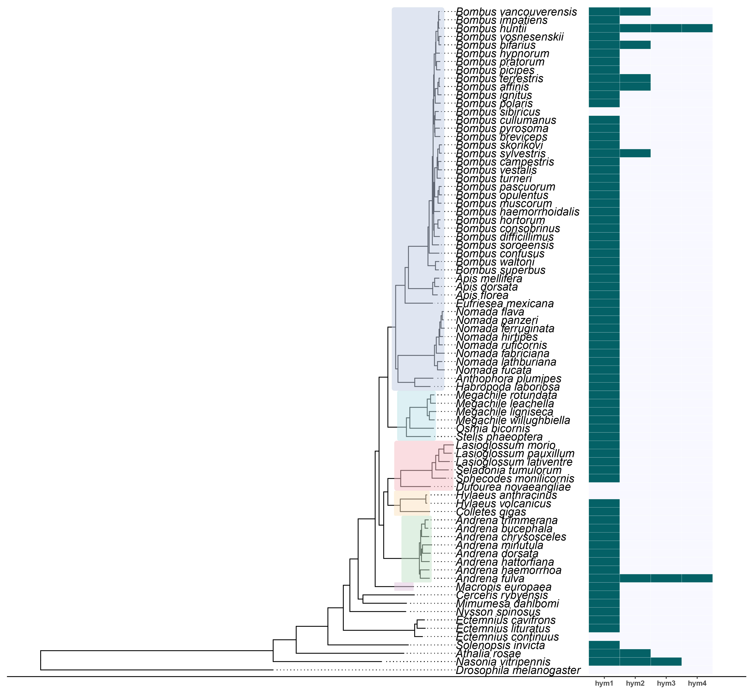
Fig. S7. Conservation of hymenoptaecin across bee species. A combined multi-panel plot displaying: the phylogenetic relationship between investigated species based on a homology-based comparative analysis of predicted proteomes for 80 species, including representatives of six bee families (Apidae = blue; Megachilidae = light blue; Halictidae = pink; Colletidae = light yellow; Andrenidae = light green; Melittidae = light purple); and a heatmap depicting the detected presence of hymenoptaecin gene copies, which were identified using a homology-based method. A successful match is indicated in dark green while an undetected match is recorded in grey. For certain species, duplicate copies of hymenoptaecin were identified, which are presented by underscores in their names on the x-axis.
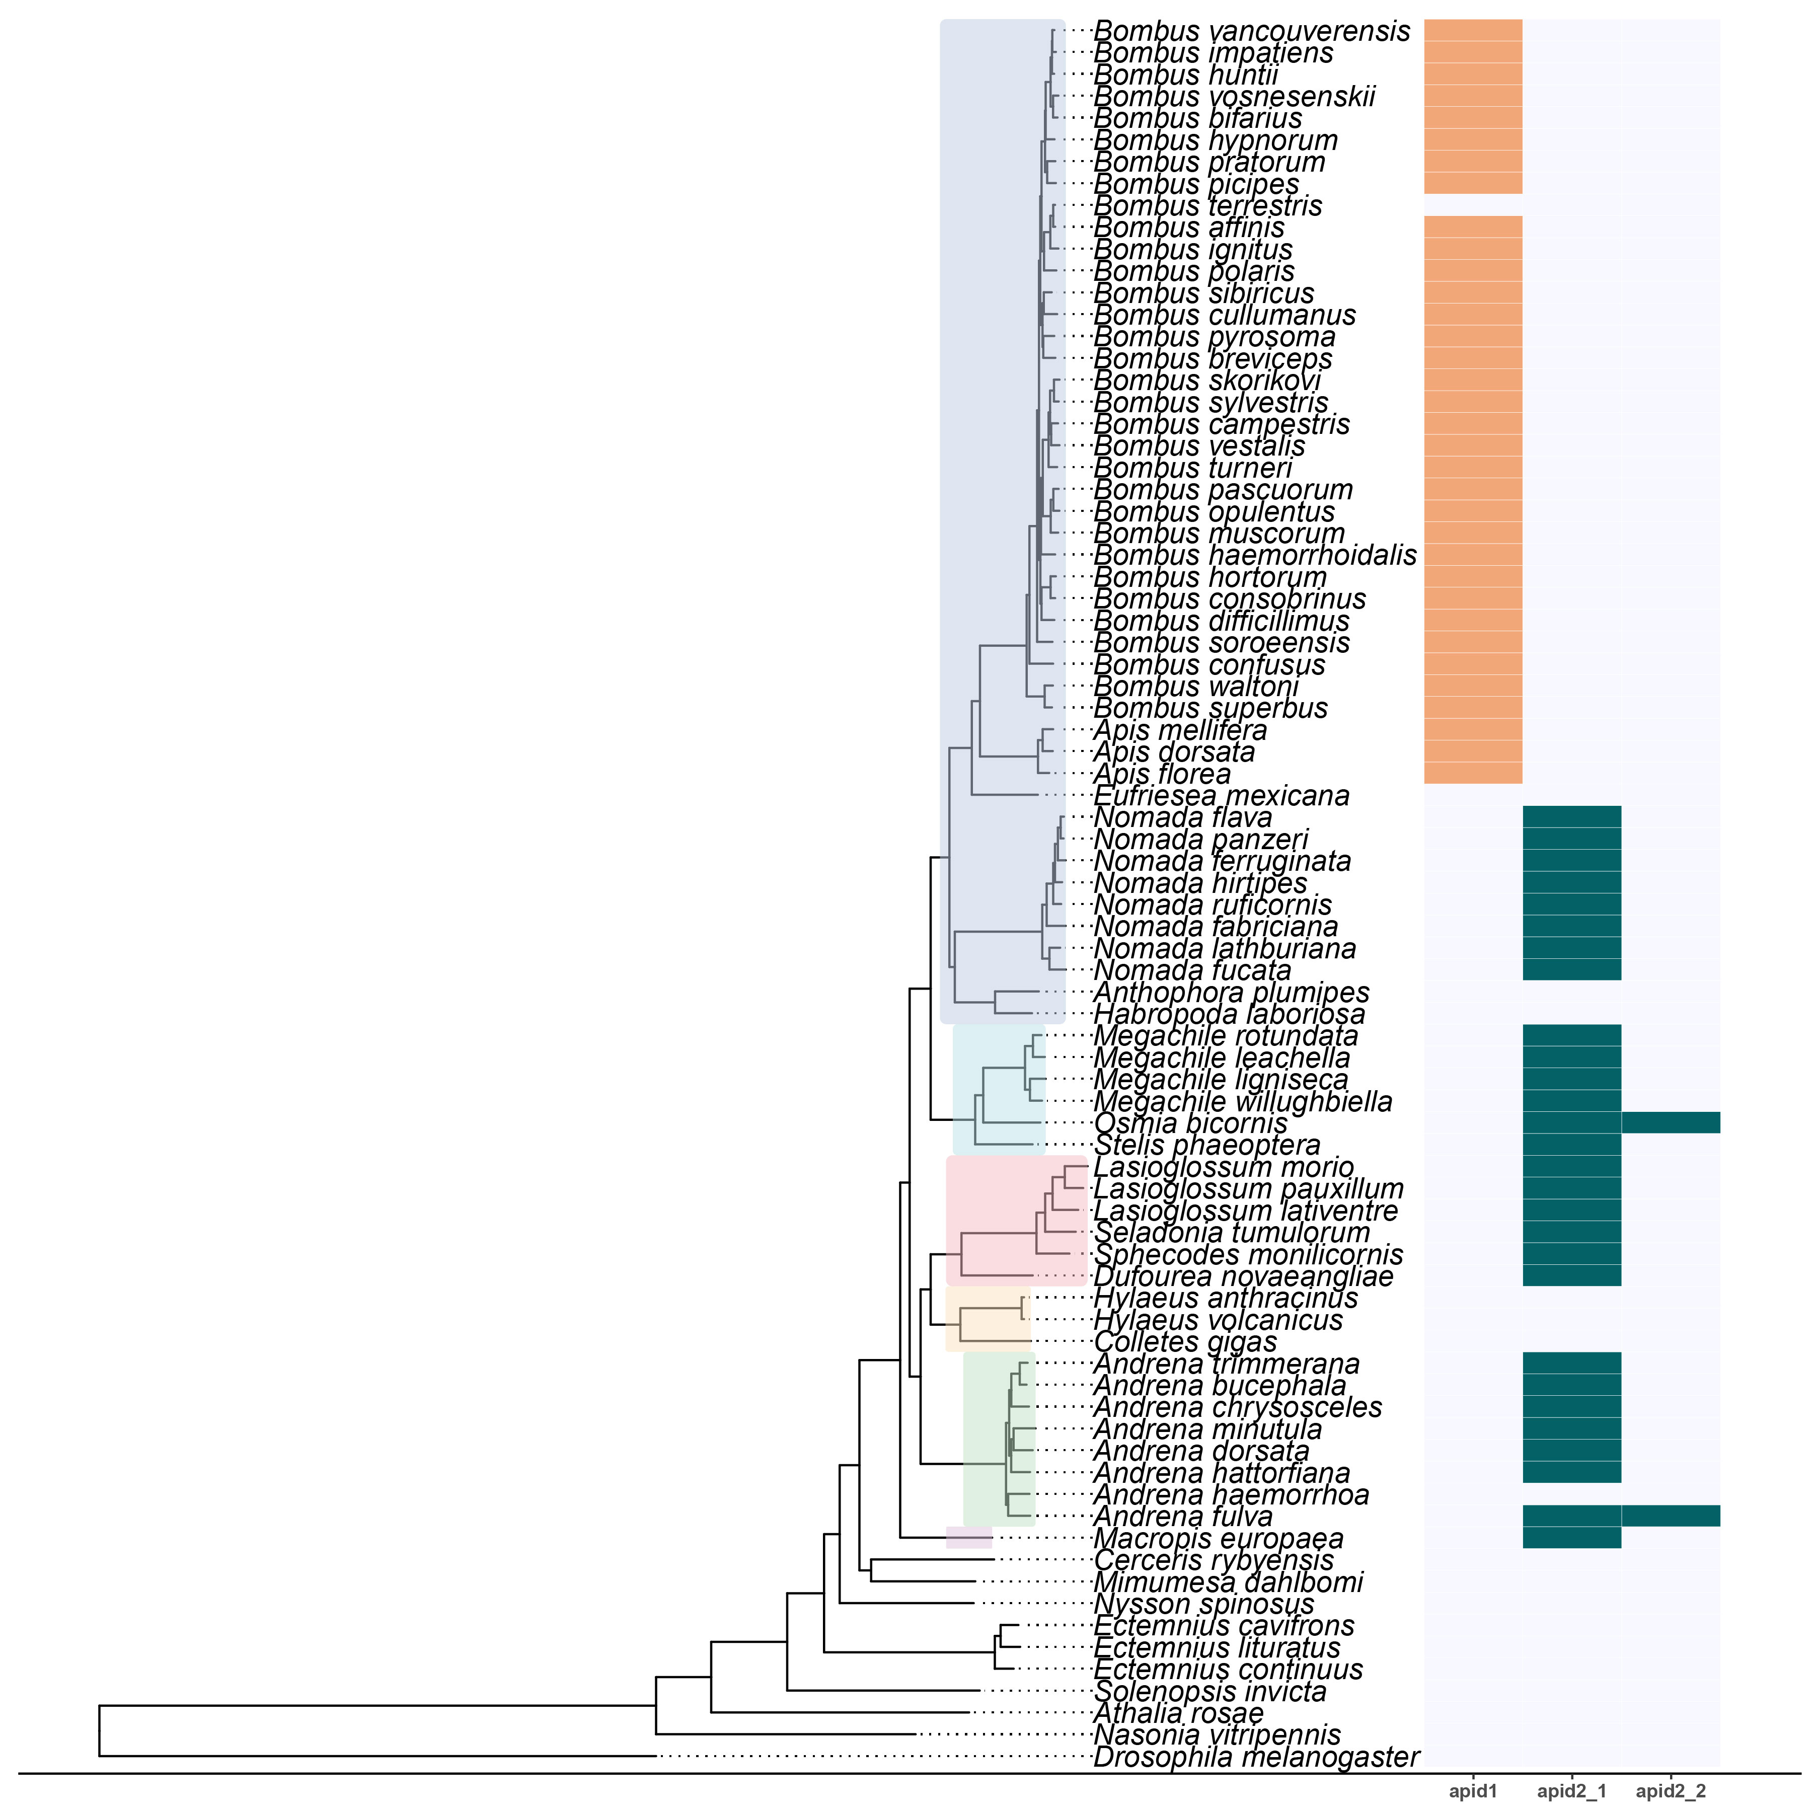
Fig. S8. Conservation of apidaecin across bee species. A combined multi-panel plot displaying: the phylogenetic relationship between investigated species based on a homology-based comparative analysis of predicted proteomes for 80 species, including representatives of six bee families (Apidae = blue; Megachilidae = light blue; Halictidae = pink; Colletidae = light yellow; Andrenidae = light green; Melittidae = light purple); and a heatmap depicting the detected presence of apidaecin gene copies, which were identified using a homology-based method. Homologues of apidaecin were grouped into two orthogroups, which grouped either members of the genera Bombus and Apis together (orange) or were identified in other bee species (dark green). An undetected match is recorded in grey. For certain species, duplicate copies of apidaecin were identified, which are presented by underscores in their names on the x-axis.
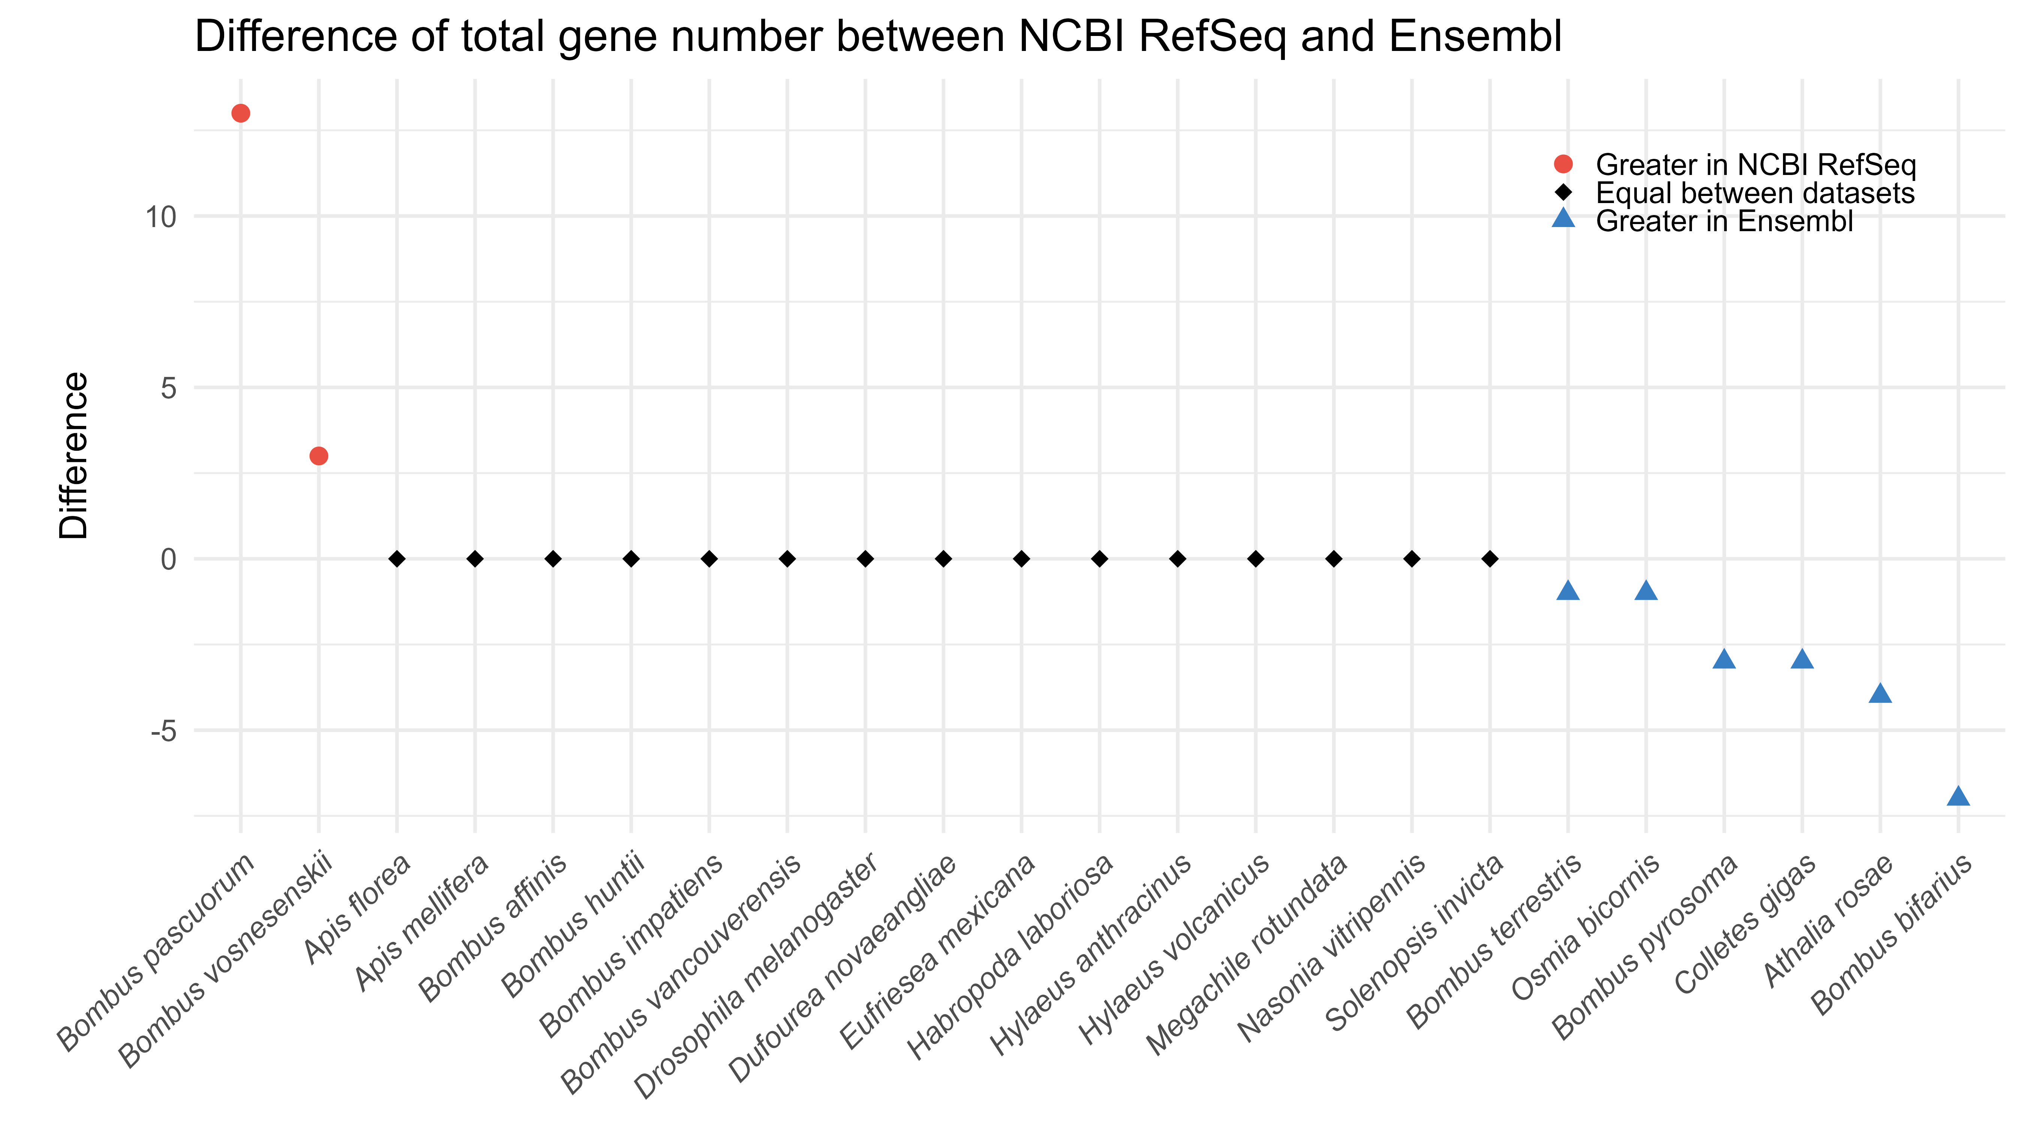
Fig. S9. Conservation of canonical immune genes in the genome annotations of bee species. A scatterplot displaying the difference in the number of putative homologues of canonical immune genes detected in available annotations from the NCBI RefSeq and Ensembl for bee and other insect species. Species names are listed on the x-axis while the difference in copy number between the annotations is provided on the y-axis. A positive value (red circle) indicates higher copy numbers for immune genes in gene annotations from the NCBI RefSeq while a negative value (blue triangle) indicates higher copy number in Ensembl-based gene predictions.

