SUPPLEMENTAL MATERIALS
Table of Contents
Table 1. Method for calculating predictors of wildfire smoke protective behaviors. 1
Table 2: Pairwise correlations between all predictors of protective actions investigated in regression models. 6
Table 3: Associations between potential predictors and frequency of specific protective actions 7
Figure 1. Assessment of WFS knowledge: True/false questions. 11
Figure 2. Assessment of participants’ knowledge about mask effectiveness. 12
Figure 3. Sources of information about wildfire smoke in Yakima Valley 13
Figure 4. Participant likeliness to make use of community programs and resources. 14

Table 1. Method for calculating predictors of wildfire smoke protective behaviors. N=11 predictors were selected through application of the RANAS framework and the conceptual model of barriers and facilitators to action developed with the community advisory board. Survey questions used to ascertain each predictor are shown, mapped to 10 RANAS factors and one possible predictor (past experiences with wildfire smoke) not part of the RANAS framework. Predictors marked with an asterisk (*) were included only in secondary analyses of specific actions. Abbreviations: RANAS = Risk, Attitudes, Norms, Abilities and Self-regulation; WFS = wildfire smoke; COPD = chronic obstructive pulmonary disease
Hypothesized predictor of protective actions | RANAS factor | Survey question(s) used to assess predictor | Calculation of corresponding raw variable (prior to standardization)
General WFS knowledge | Risks: Knowledge | Some of the following statements are true and some are false. Indicate which you believe are true and which are false. If you don’t know, select “Don’t know.”  1. It is possible for people to reduce their exposure to wildfire smoke.  2. Every person has the same sensitivity to wildfire smoke.  3. Indoor air cleaners can be effective in removing wildfire smoke from inside your home. (Pictures of air cleaners provided)  4. Putting your car air in the “recirculate” mode (picture of button/icon provided) can reduce the amount of wildfire smoke in the car.  5. Exposure to smoke during pregnancy can harm a growing fetus.  6. Wildfire smoke can affect a person’s mental health, for example, by causing increased sadness, worrying or irritation.  7. A small N95 mask can be useful for children who are at least 7 years old. | Count of correct answers to true/false questions. Range from 0 to 7.
Mask-specific knowledge* | Risks: Knowledge | Some people cover their nose and mouth to protect from smoke exposure. How effective is each of these in reducing smoke exposure? Response options: not effective, somewhat effective, or very effective.  1. Surgical mask  2. Cloth mask  3. Bandana  4. N95 mask  Photos provided. | Count of correct answers to questions about face covering effectiveness. Range from 0 to 4.
Child health vulnerability | Risks: Vulnerability | Do any of your children have the following conditions? SELECT ALL. Response options: Asthma, allergies, eczema, diabetes, heart condition | Total count of conditions. Range from 0 to 5.
Parent health vulnerability | Risks: Vulnerability | Do you have any of the following health conditions? Check all that apply. Response categories: Asthma; COPD; other disease that affects breathing; hypertension; other heart disease; type II diabetes; anxiety or depression; allergies; problems with itchy skin, irritated skin or other skin problem | Total count of conditions. Range from 0 to 9.
Perceived threat to child health | Risks: Severity | On a scale of 1 to 5, how much do you view wildfire smoke as a threat to the health of your children? | Numerical response. Range from 1 to 5.
Perceived expense | Attitudes: Beliefs about costs | One a scale of 1 to 5, how much do you think it would cost to keep the air inside your house clean during wildfires? | Numerical response. Range from 1 to 5.
Feelings about masks* | Attitudes: Feelings | How do you feel about wearing masks when the air is smoky due to wildfires? Check all that apply. Response categories reflecting negative feelings about masks.  They are uncomfortable  It is not convenient to wear a mask  Masks are not helpful in reducing smoke exposure | Count of statements reflecting negative feelings selected. Range from 0 to 3.
Community members taking action | Norms: Others' behaviors | How many people in your community take action to avoid smoke exposure? Response categories: Very few, some, almost everyone | Assigned based on response: Very few = 0, some = 1, almost everyone = 2
Stigma about masks* | Norms: Others' disapproval | If you wear a mask when it is smoky outdoors, would your friends, family or co-workers disapprove? Response categories: No, not at all; some might disapprove; yes, many would disapprove | Assigned based on response: No, not at all = 0; some might disapprove = 1; yes, many would disapprove = 2
Practical WFS knowledge | Ability: How-to-do knowledge | Some of the following statements are true and some are false. Indicate which you believe are true and which are false. If you don’t know, select “Don’t know.”  1. It is possible for people to reduce their exposure to wildfire smoke.  2. Indoor air cleaners can be effective in removing wildfire smoke from inside your home.  3. A small N95 mask can be useful for children who are at least 7 years old. | Count of correct answers. Range from 0 to 3.
Confidence to reduce WFS exposure | Ability: Confidence in performance | For each of the following, how confident are you in your ability to do each when the air outside is smoky?  A. Set up and use a portable air cleaner in my home, if provided one to use. (Photos of air cleaners provided)  B. Check current information on outdoor air quality in my neighborhood.  C. Help my child wear a mask that will effectively reduce their smoke exposure. | Total sum of responses assigned as follows: Not confident at all = 0; Somewhat confident = 1; Very confident = 2. Range = 0 to 6.
Confidence to use air cleaner* | Ability: Confidence in performance | Response to question A above | See above. Range =0 to 2.
Confidence to look up local air quality* | Ability: Confidence in performance | Response to question B above | See above. Range =0 to 2.
Confidence to help child use mask* | Ability: Confidence in performance | Response to question C above | See above. Range =0 to 2.
Household income | Ability: Financial resources | What is the total income of your household in the last year? Include income from all household members who help with family expenses. Response categories: LESS THAN $4,999; $5,000 - $9,999; $10,000 - $19,999; $20,000 - $29,999; $30,000 - $39,999; $40,000 - $49,999; $50,000 - $74,999; $75,000 - $99,999; $100,000 - $199,999; $200,000 OR MORE | Assigned based on response: LESS THAN $4,999 = 0; $5,000 - $9,999 = 1; $10,000 - $19,999 = 2; $20,000 - $29,999 = 3; $30,000 - $39,999 = 4; $40,000 - $49,999 = 5; $50,000 - $74,999 = 6; $75,000 - $99,999 = 7; $100,000 - $199,999 = 8; $200,000 OR MORE = 9
Child health problems in past smoke events | N/A (Past experiences) | Do any of your children experience health problems when it is smoky outside? Response categories: None, a little, a lot | Assigned based on response: None = 0; A little = 1; A lot = 2
Family member symptoms in past smoke events | N/A (Past experiences) | Did you or your children (if any) experience any of the following health effects during wildfire smoke days? Response categories: Difficulty breathing, coughing, burning eyes, runny nose, headache, sore throat, itchy skin, poor sleep, feeling sad or anxious | Total count of symptoms selected. Range = 0 to 9

Table 2: Pairwise correlations between all predictors of protective actions investigated in regression models.
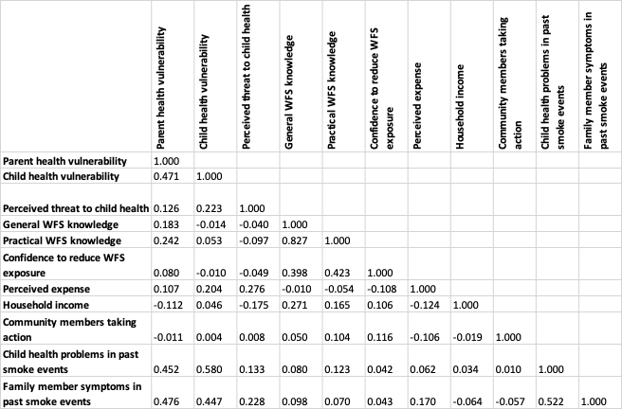
Abbreviation: WFS = wildfire smoke

Table 3: Associations between potential predictors and specific protective actions. Each predictor was standardized in the study sample as a z-score, and associations with the action-specific frequency (0 = never; 1 = sometimes; 2 = often) were estimated in linear regression with robust standard errors. Coefficients represent the difference in protective action score associated with a 1-unit increase in the z-score of each predictor. Associations are crude, not adjusted for other factors.

Action = Stay indoors more than usual
Predictor | Coef. | Std. Err. | p-value | Lower CI | Upper CI
General WFS knowledge | 0.02 | 0.02 | 0.432 | -0.03 | 0.06
Parent health vulnerability | 0.03 | 0.03 | 0.32 | -0.03 | 0.09
Child health vulnerability | 0.08 | 0.04 | 0.044 | 0.00 | 0.16
Perceived threat to child health | 0.09 | 0.05 | 0.055 | 0.00 | 0.18
Perceived expense | 0.04 | 0.04 | 0.323 | -0.04 | 0.13
Community members taking action | -0.02 | 0.07 | 0.759 | -0.15 | 0.11
Practical WFS knowledge | 0.03 | 0.03 | 0.427 | -0.04 | 0.10
Confidence to reduce WFS exposure | 0.02 | 0.03 | 0.548 | -0.04 | 0.08
Household income | -0.01 | 0.02 | 0.576 | -0.06 | 0.03
Child health problems in past smoke events | 0.08 | 0.06 | 0.174 | -0.04 | 0.21
Family member symptoms in past smoke events | 0.01 | 0.02 | 0.682 | -0.02 | 0.04
Action = Wear a mask
Predictor | Coef. | Std. Err. | p-value | Lower CI | Upper CI
Mask-specific knowledge* | -0.03 | 0.06 | 0.565 | -0.14 | 0.08
Parent health vulnerability | 0.04 | 0.03 | 0.228 | -0.03 | 0.11
Child health vulnerability | 0.03 | 0.05 | 0.522 | -0.06 | 0.12
Perceived threat to child health | 0.08 | 0.04 | 0.061 | 0.00 | 0.17
Feelings about masks* | -0.17 | 0.08 | 0.036 | -0.32 | -0.01
Community members taking action | 0.15 | 0.08 | 0.054 | 0.00 | 0.30
Stigma about masks* | 0.10 | 0.07 | 0.165 | -0.04 | 0.25
Practical WFS knowledge | 0.03 | 0.03 | 0.361 | -0.04 | 0.10
Confidence to help child use a mask* | 0.10 | 0.07 | 0.187 | -0.05 | 0.24
Household income | -0.02 | 0.02 | 0.393 | -0.06 | 0.02
Child health problems in past smoke events | 0.09 | 0.06 | 0.12 | -0.02 | 0.21
Family member symptoms in past smoke events | 0.02 | 0.02 | 0.38 | -0.02 | 0.05
Action = Talk to a health care provider about WFS
Predictor | Coef. | Std. Err. | p-value | Lower CI | Upper CI
General WFS knowledge | 0.01 | 0.02 | 0.539 | -0.03 | 0.05
Parent health vulnerability | 0.10 | 0.04 | 0.02 | 0.02 | 0.18
Child health vulnerability | 0.22 | 0.05 | <0.0001 | 0.13 | 0.32
Perceived threat to child health | 0.13 | 0.06 | 0.038 | 0.01 | 0.25
Perceived expense | 0.06 | 0.05 | 0.213 | -0.04 | 0.16
Community members taking action | 0.22 | 0.08 | 0.004 | 0.07 | 0.38
Practical WFS knowledge | 0.08 | 0.03 | 0.027 | 0.01 | 0.14
Confidence to reduce WFS exposure | -0.01 | 0.04 | 0.751 | -0.08 | 0.06
Household income | -0.02 | 0.02 | 0.423 | -0.07 | 0.03
Child health problems in past smoke events | 0.30 | 0.07 | <0.0001 | 0.18 | 0.43
Family member symptoms in past smoke events | 0.04 | 0.02 | 0.045 | 0.00 | 0.08
Action = Check local air quality (e.g., AQI)
Predictor | Coef. | Std. Err. | p-value | Lower CI | Upper CI
General WFS knowledge | 0.08 | 0.03 | 0.007 | 0.02 | 0.13
Parent health vulnerability | 0.07 | 0.04 | 0.088 | -0.01 | 0.16
Child health vulnerability | 0.07 | 0.05 | 0.206 | -0.04 | 0.17
Perceived threat to child health | -0.01 | 0.06 | 0.793 | -0.13 | 0.10
Perceived expense | -0.01 | 0.05 | 0.825 | -0.12 | 0.09
Community members taking action | 0.12 | 0.08 | 0.142 | -0.04 | 0.29
Practical WFS knowledge | 0.15 | 0.04 | <0.0001 | 0.07 | 0.23
Confidence to look up local air quality | 0.13 | 0.08 | 0.124 | -0.04 | 0.29
Household income | 0.07 | 0.03 | 0.008 | 0.02 | 0.12
Child health problems in past smoke events | 0.06 | 0.07 | 0.405 | -0.08 | 0.20
Family member symptoms in past smoke events | 0.00 | 0.02 | 0.908 | -0.05 | 0.04
Action = Leave the region for a place with cleaner air
Predictor | Coef. | Std. Err. | p-value | Lower CI | Upper CI
General WFS knowledge | -0.01 | 0.02 | 0.507 | -0.05 | 0.03
Parent health vulnerability | 0.05 | 0.04 | 0.214 | -0.03 | 0.12
Child health vulnerability | 0.04 | 0.04 | 0.316 | -0.04 | 0.12
Perceived threat to child health | -0.04 | 0.04 | 0.293 | -0.12 | 0.04
Perceived expense | -0.03 | 0.04 | 0.338 | -0.11 | 0.04
Community members taking action | 0.16 | 0.06 | 0.017 | 0.03 | 0.28
Practical WFS knowledge | -0.02 | 0.03 | 0.412 | -0.08 | 0.03
Confidence to reduce WFS exposure | 0.02 | 0.02 | 0.464 | -0.03 | 0.06
Household income | 0.01 | 0.02 | 0.554 | -0.02 | 0.04
Child health problems in past smoke events | 0.02 | 0.05 | 0.728 | -0.08 | 0.12
Family member symptoms in past smoke events | 0.01 | 0.01 | 0.424 | -0.02 | 0.04
Action = Use an indoor air cleaner
Predictor | Coef. | Std. Err. | p-value | Lower CI | Upper CI
General WFS knowledge | 0.08 | 0.03 | 0.004 | 0.03 | 0.13
Parent health vulnerability | 0.17 | 0.04 | <0.0001 | 0.08 | 0.26
Child health vulnerability | 0.16 | 0.06 | 0.008 | 0.04 | 0.27
Perceived threat to child health | 0.09 | 0.07 | 0.197 | -0.05 | 0.22
Perceived expense | -0.02 | 0.06 | 0.748 | -0.14 | 0.10
Community members taking action | 0.07 | 0.09 | 0.44 | -0.11 | 0.25
Practical WFS knowledge | 0.17 | 0.04 | <0.0001 | 0.09 | 0.25
Confidence to use in indoor air cleaner | 0.20 | 0.10 | 0.051 | 0.00 | 0.39
Household income | 0.04 | 0.03 | 0.145 | -0.01 | 0.10
Child health problems in past smoke events | 0.34 | 0.07 | <0.0001 | 0.19 | 0.49
Family member symptoms in past smoke events | 0.06 | 0.02 | 0.009 | 0.01 | 0.10

Figure 1. Assessment of WFS knowledge: True/false questions. Participants responded to several questions about WFS health impacts and methods for exposure reduction. Correct and incorrect responses are shown in green and red, respectively.

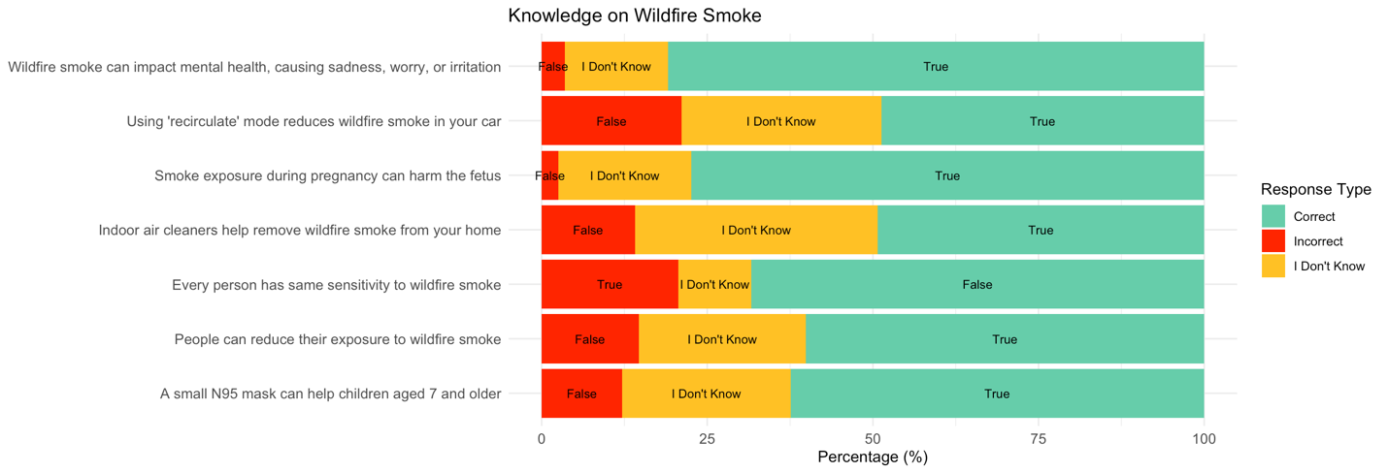

Figure 2. Assessment of participants’ knowledge about mask effectiveness. To assess participant knowledge about methods of self-protection against wildfire smoke, they were asked about the effectiveness of each type of mask. The percentage of participants giving each response are shown in the figure, and the most correct answer is displayed on the left, next to the type of mask.
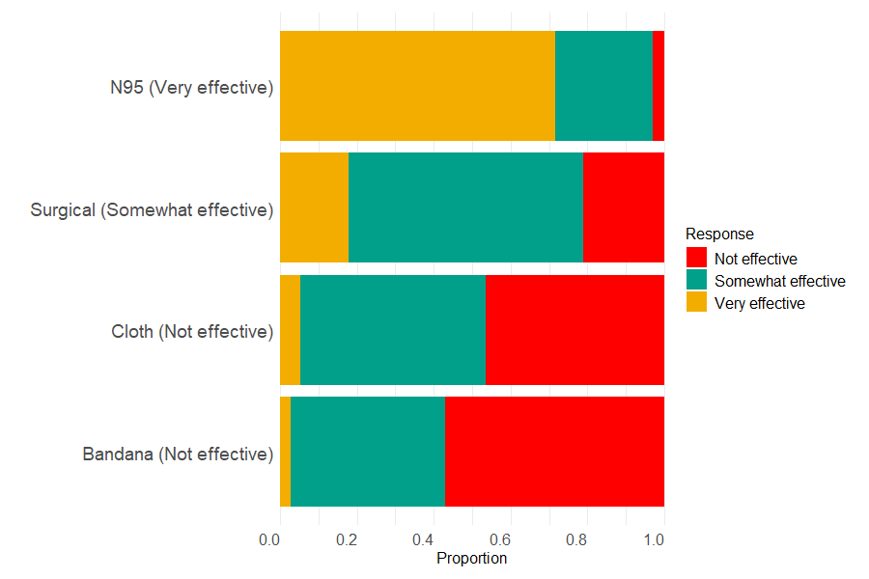

Figure 3. Sources of information about wildfire smoke in Yakima Valley. Participants were asked what sources of information about wildfire smoke they feel to be the most useful.

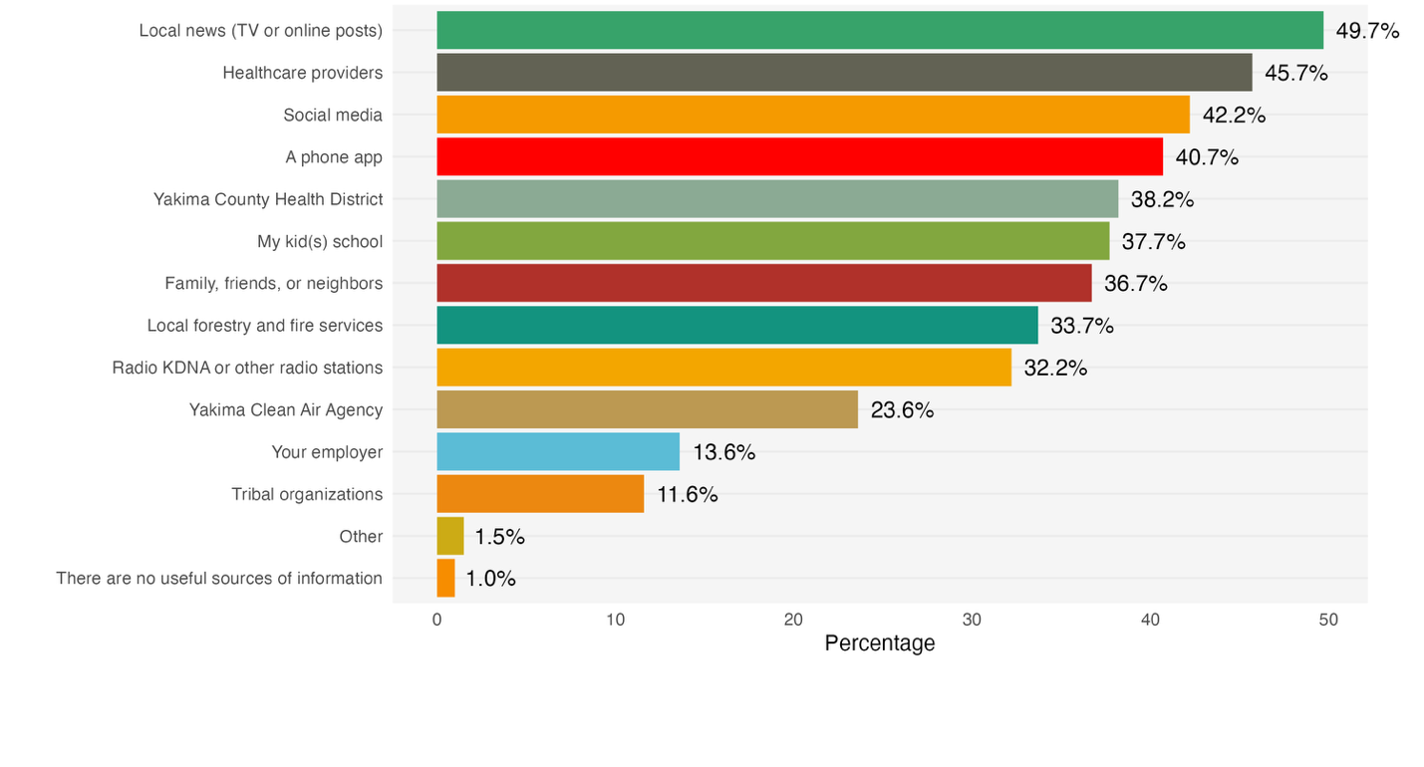

Figure 4. Participant likeliness to make use of community programs and resources. Participants were asked how likely they would be to use each of the following to help them with wildfire smoke, if they were available to them in the future. This figure displays the proportion of reporting each level of likelihood, from very unlikely to highly likely.

