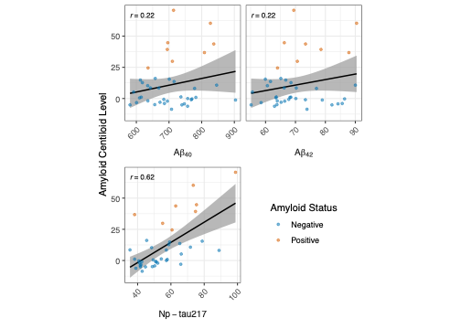
Suppl, Figure 1. Scatter plot of plasma biomarkers with standardized centiloids on amyloid PET.
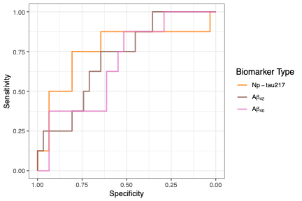
Suppl, Figure 2. ROC curves for plasma biomarkers with amyloid status as the outcome variable.

Biomarkers | Threshold | Accuracy  (95% CI) | AUC (95% CI) | Sensitivity (95% CI) | Specificity (95% CI) | Youden | PPV | NPV
Np-tau217 | 59.95 pg/mL | 0.79 (0.67, 0.92) | 0.76 (0.53,0.99) | 0.75 (0.38, 1.00) | 0.81 (0.65, 0.94) | 0.56 | 0.50 | 0.93
Aβ42 | 68.97 pg/mL | 0.67 (0.51, 0.82) | 0.71 (0.52,0.90) | 0.75 (0.38, 1.00) | 0.65 (0.48, 0.81) | 0.40 | 0.35 | 0.91
Aβ40 | 690.34 pg/mL | 0.59 (0.44, 0.74) | 0.67 (0.47,0.87) | 0.88 (0.62, 1.00) | 0.52 (0.35, 0.68) | 0.39 | 0.32 | 0.94

Suppl, Table 1. Summary statistics on the diagnostic ability of the biomarkers using maximized Youden index cutpoints for predicting amyloid status.

Biomarkers | Threshold | Accuracy  (95% CI) | AUC (95% CI) | Sensitivity (95% CI) | Specificity (95% CI) | Youden | PPV | NPV
p-tau217/Np-tau217 | 4.2 | 0.95 (0.87, 1.00) | 0.89 (0.69, 1.00) | 0.75 (0.38, 1.00) | 1.00 (1.00, 1.00) | 0.75 | 1 | 0.94
APS2 | 47.5 | 0.90 (0.82, 0.97) | 0.90 (0.74,1.00) | 0.50 (0.12, 0.88) | 1.00 (1.00, 1.00) | 0.50 | 1 | 0.89

Suppl. Table 2. Diagnostic performance of APS2 and ptau217 for predicting amyloid-PET status using pre-specified CLIA thresholds (PrecivityAD2), ranked by descending order of Youden index.
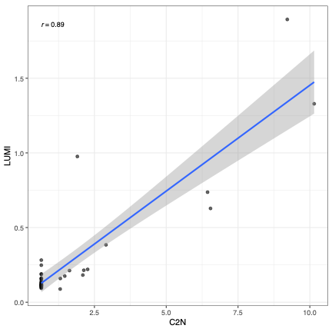
Suppl. Figure 3. P-tau217 levels in TRC-DS participants were measured by MS (C2N) and Lumipulse. MS p-tau217 below the minimum detectable threshold of 1.3 is set to be 0.65. Note the accumulation of points on the left-hand side due to C2N values determined to be below the level of quantitation. This occurred for N=26 (67%) samples, for which the value 1.3 pg/ml was imputed.
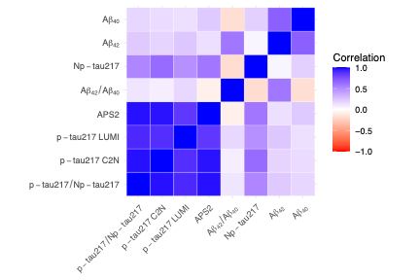
Suppl. Figure 4. Correlation plot of all measured biomarkers and their composite measures.

