Supplementary material
Definitions
Bronchopulmonary dysplasia (BPD) was defined by the use of oxygen or respiratory support at 36 weeks postmenstrual age [supp1].
Of particular relevance to this study were the forced expiratory volume in one second (FEV₁), the forced expiratory volume in one second as a percentage of predicted (FEV₁%), and the forced vital capacity as a percentage of predicted (FVC%).
Small for gestational age (SGA) was defined as birth weight <10th percentile according to population based birth weight reference values [supp2].
Clinical chorioamnionitis was defined as suspected chorioamnionitis based on clinical signs as maternal fever, uterine tenderness, malodorous discharge, and maternal and fetal tachycardia with laboratory abnormalities (ie, leucocytosis).
The cut-off value for a CrP increase was set > 10 mg/l. Multiple CrP elevations were defined as two CrP measurements > 10 mg/l at least 14 days apart.

[supp1] Isayama T, Lee SK, Yang J, Lee D, Daspal S, Dunn M, et al. Revisiting the Definition of Bronchopulmonary Dysplasia. JAMA Pediatr. 2017 Mar;171(3):271.
[supp2] Voigt M, Rochow N, Schneider KT, Hagenah H-P, Straube S, Scholz R, et al. New percentile values for the anthropometric dimensions of twin neonates: analysis of perinatal survey data of 2007-2011 from all 16 states of Germany. Z Geburtshilfe Neonatol. 2014;218(06):254–60.

Supplementary Table 1: Univariate analyses of outcome parameters and CrP levels
Variable | No Elevation of CrP (reference)  n = 265 | Single elevation of CrP > 10mg/l  n = 46 | Recurrent elevation of CrP > 10 mg/l  n = 42 | p-value¹
BPD | 44 (17.3 [13.1-22.3]) | 16 (34.8 [22.3-49.1]) | 25 (59.5 [44.5-73.3]) | 0.006  < 0.001  0.020
Oxygen need at discharge | 4 (1.5 [0.5-3.5]) | 4 (8.7 [3.0-19.4]) | 6 (14.3 [6.2-27.1]) | 0.004  < 0.001  0.409
Non-invasive ventilation at discharge | 3 (1.1 [0.3-3.0]) | 0 | 2 (4.8 [1.0-14.4]) | 0.468  0.085  0.134
Weight at 5YFU [kg] | 18.6 (16.7-20.7) | 18.6 (16.6-19.3) | 16.6 (15.1-19.2) | 0.332  < 0.001  0.034
IQ < 85 | 37 (15.0 [11.0-19.9]) | 8 (22.2 [11.1-37.6]) | 6 (18.8 [8.2-34.6]) | 0.272  0.585  0.724
GMFCS ≥ 1 | 41 (16.6 [12.6-22.0]) | 9 (20.5 [10.6-34.0]) | 17 (43.6 [28.9-59.1]) | 0.564  < 0.001  0.023
FEV₁ [litres] | 0.97 (0.85-1.12) | 0.93 (0.80-1.06) | 0.77 (0.67-0.91) | 0.205  < 0.001  0.009
FVC [l] | 1.06 (0.92-1.23) | 1.01 (0.83-1.15) | 0.8 (0.66-0.94) | 0.251  < 0.001  0.002
z-score (FEV₁) 50th percentile | -1.3 (-2.0-(-0.5)) | -1.7 (-2.2 –(-0.7)) | -2.5 (-3.0-(-1.5)) | 0.262  < 0.001  0.002
z-score (FVC) 50th percentile | -1.3 (-2.1-(-0.5)) | -1.7 (-2.4 –(-0.6)) | -2.7 (-3.3-(-1.9)) | 0.360  < 0.001  < 0.001
z-score (FEV₁) < 5th percentile | 72 (35.3 [29.0-42.0]) | 21 (61.8 [45.0-76.6]) | 23 (71.9 [54.9-85.1]) | < 0.001  < 0.001  0.384
z-score (FVC) < 5th percentile | 76 (37.3 [30.8-44.0]) | 17 (50.0 [33.8-66.2]) | 26 (81.3 [65.4-91.8]) | < 0.001  < 0.001  0.008
Supplementary table 1: Descriptive outcome of former preterm infants at the age of five to six years stratified by amount of CrP levels > 10 mg/l; categorical variables are given as n(%) with corresponding 95% confidence interval [95CI], continuous variables as median (IQR) if appropriate. ¹upper line: p-value of single CrP > 10 mg/l vs. no elevation of CrP, middle line: p-value of recurrent CrP > 10 mg/l vs. no elevation of CrP, lower line: p-value of recurrent CrP > 10 mg/l vs. single elevation of CrP. P-values derived from Pearson’s Chi-square test or Mann-Whitney U-Test for continuous outcome. Abbreviation: 5YFU: five to six year follow-up examination, IQ: intelligence quotient, GMFCS: gross motor function scale, FEV₁: forced expiratory volume in one second

Supplementary Table 2a: Linear regression model for respiratory long-term outcome and single CrP elevations > 10 mg/l

Variables | z-score of FEV₁
Variables | B (SD) | Beta | T | p-value
GMFCS ≥ 1 | -0.174 (0.219) | -0.060 | -0.793 | 0.429
Weight at 5YFU [kg] | 0.028 (0.020) | 0.104 | 1.433 | 0.153
IQ | 0.009 (0.006) | 0.110 | 1.547 | 0.124
Duration of mechanical ventilation [days] | -0.346 (0.248) | -0.162 | -1.398 | 0.164
Single CrP > 10 mg/l | -0.082 (0.235) | -0.024 | -0.350 | 0.727
Supplementary table 2a: Linear regression model for respiratory long-term outcome. Model further adjusted for gestational age, birth weight, antenatal administration of steroids, IVH, surgical treatment for necrotizing enterocolitis, birth weight < 10th percentile, duration of mechanical ventilation, duration of oxygen therapy within the first 28 days, BPD and PVL (data not shown). R²: 0.187; Durbin-Watson: 1.921; F=2.934 with p < 0.001; Abbreviation: B: unstandardized coefficients, Beta: standardized coefficients, IQ: intelligence quotient

Supplementary Table 2b: Linear regression model for respiratory long-term outcome
Variables | z-score of FVC
Variables | B (SD) | Beta | T | p-value
GMFCS ≥ 1 | -0.432 (0.234) | -0.140 | -1.849 | 0.066
Weight at 5YFU [kg] | 0.041 (0.021) | 0.140 | 1.917 | 0.057
IQ | 0.010 (0.006) | 0.116 | 1.619 | 0.107
Duration of mechanical ventilation [days] | -0.110 (0.264) | -0.040 | -0.416 | 0.678
Single CrP > 10 mg/l | -0.032 (0.251) | -0.009 | -0.128 | 0.898
Supplementary table 2b: Linear regression model for respiratory long-term outcome. Model further adjusted for gestational age, birth weight, antenatal administration of steroids, IVH, surgical treatment for necrotizing enterocolitis, birth weight < 10th percentile, duration of mechanical ventilation, duration of oxygen therapy within the first 28 days, BPD and PVL (data not shown). R²: 0.179; Durbin-Watson: 1.851; F=2.772 with p = 0.001; Abbreviation: B: unstandardized coefficients, Beta: standardized coefficients, IQ: intelligence quotient

Supplementary Table 3: Blood count grouped by single and recurrent CrP elevations
Variable | Single CrP elevation | Recurrent CrP elevations | p-value
Leukocytes | 8627 (5760-12727) | 16470 (11080-18430) | 0.003
Neutrophils | 4179 (2940-8460) | 3612 (3227-9257) | 1.00
Segmented neutrophils | 3824 (1717-5418) | 6133 (5385-10264) | 0.011
Banded neutrophils | 210 (114-345) | 738 (335-1084) | 0.003
Eosinophils | 343 (194-473) | 445 (350-705) | 0.118
Lymphocytes | 4018 (2450-4534) | 4053 (3582-5441) | 0.374
Platelets | 196 (149-426) | 263 (195-348) | 0.631
Supplementary table 3: White blood count measurements differentiated by single and recurrent CrP elevations > 10 mg/l. Values given as median (IQR). P-values derived from Mann-Whitney U-Test.

Supplementary Table 4a: Linear regression model for respiratory long-term outcome and median CrP levels

Variables | z-score of FEV₁
Variables | B (SD) | Beta | T | p-value
GMFCS ≥ 1 | -0.039 (0.198) | -0.014 | -0.196 | 0.845
Weight at 5YFU [kg] | 0.023 (0.019) | 0.082 | 1.204 | 0.230
IQ | 0.008 (0.006) | 0.086 | 1.315 | 0.190
Duration of mechanical ventilation [days] | -0.479 (0.236) | -0.216 | -2.033 | 0.043
Median CrP levels | -0.009 (0.019) | -0.034 | -0.464 | 0.643
Supplementary table 4a: Linear regression model for respiratory long-term outcome. Model further adjusted for gestational age, birth weight, antenatal administration of steroids, IVH, surgical treatment for necrotizing enterocolitis, birth weight < 10th percentile, duration of mechanical ventilation, duration of oxygen therapy within the first 28 days, BPD and PVL (data not shown). R²: 0.221; Durbin-Watson: 1.880; F=4.095 with p < 0.001; Abbreviation: B: unstandardized coefficients, Beta: standardized coefficients, IQ: intelligence quotient

Supplementary Table 4b: Linear regression model for respiratory long-term outcome
Variables | z-score of FVC
Variables | B (SD) | Beta | T | p-value
GMFCS ≥ 1 | -0.486 (0.227) | -0.148 | -2.144 | 0.033
Weight at 5YFU [kg] | 0.051 (0.021) | 0.164 | 2.391 | 0.018
IQ | 0.009 (0.007) | 0.086 | 1.323 | 0.187
Duration of mechanical ventilation [days] | -0.155 (0.270) | -0.061 | -0.574 | 0.567
Median CrP levels | -0.017 (0.021) | -0.061 | -0.816 | 0.416
Supplementary table 4b: Linear regression model for respiratory long-term outcome. Model further adjusted for gestational age, birth weight, antenatal administration of steroids, IVH, surgical treatment for necrotizing enterocolitis, birth weight < 10th percentile, duration of mechanical ventilation, duration of oxygen therapy within the first 28 days, BPD and PVL (data not shown). R²: 0.219; Durbin-Watson: 1.905; F=4.045 with p < 0.001; Abbreviation: B: unstandardized coefficients, Beta: standardized coefficients, IQ: intelligence quotient

Supplementary Table 5: Characterization of infants with single and recurrent CrP elevations but no diagnosis of BPD
Variable | No Elevation of CrP (reference)  n = 227 | Single elevation of CrP > 10mg/l  n = 34 | Recurrent elevation of CrP > 10 mg/l  n = 23 | p-value*
Gestational age [weeks]# | 28.4 (26.9-29.9) | 27.4 (25.3-29.1) | 25.9 (24.4-27.3) | 0.037
Birth weight [g]# | 1050 (830-1285) | 923 (730-1210) | 780 (595-970) | 0.118
SGA (<10th percentile) | 25 (11.0 [7.4-15.6]) | 8 (23.5 [11.8-39.5]) | 5 (21.7 [8.8-41.3]) | 0.064
Female sex | 116 (51.1 [44.6-57.6]) | 17 (50.0 [33.8-66.2]) | 8 (34.8 [18.0-55.1]) | 0.328
Multipara | 90 (39.6 [33.4-46.1]) | 15 (44.1 [28.5-60.7]) | 7 (30.4 [14.8-50.7]) | 0.578
Antenatal administration of steroids | 202 (89.0 [84.4-92.6]) | 32 (94.1 [82.4-98.8]) | 21 (91.3 [74.9-98.1]) | 0.634
Surfactant administration | 162 (71.4 [65.2-76.9]) | 28 (82.5 [67.2-92.3]) | 22 (95.7 [81.4-99.5]) | 0.021
ICH | 27 (11.9 [8.2-16.6]) | 3 (8.8 [2.5-21.7]) | 3 (13.0 [3.8-30.9]) | 0.852
PVL | 2 (0.9 [0.2-2.8]) | 2 (5.9 [1.2-17.6]) | 1 (4.3 [0.5-18.6]) | 0.074
NEC requiring surgery | 1 (0.4 [0-2.0]) | 0 | 5 (21.7 [8.8-41.3]) | < 0.001
SIP requiring surgery | 2 (0.9 [0.2-2.8]) | 1 (2.9 [0.3-12.9]) | 2 (8.7 [1.9-25.1]) | 0.022
invasive ventilation | 86 (38.1 [31.9-44.5]) | 20 (58.8 [42.1-74.1]) | 22 (95.7 [81.4-99.5]) | < 0.001
Clinical signs of chorioamnionitis | 51 (22.5 [17.4-28.2]) | 8 (23.5 [11.8-39.5]) | 6 (26.1 [11.7-46.1]) | 0.921
Oxygen need at discharge | 2 (0.9 [0.2-2.8]) | 0 | 1 (4.3 [0.5-18.6]) | 0.882
Non-invasive ventilation at discharge | 2 (0.9 [0.2-2.8]) | 0 | 1 (4.3 [0.5-18.6]) | 0.247
Weight at 5YFU# [kg] | 18.8 (16.9-20.9) | 18.7 (16.3-19.4) | 17.2 (14.3-19.7) | 0.306
IQ# | 101 (92-107) | 102 (91-115) | 95 (84-98) | 0.055
IQ < 85 | 29 (13.5 [9.4-18.5]) | 6 (21.4 [9.5-38.9]) | 5 (27.8 [11.5-50.6]) | 0.173
GMFCS ≥ 1 | 26 (12.5 [8.5-17.5]) | 5 (15.6 [6.2-30.9]) | 7 (35.0 [17.2-56.8]) | 0.024
FEV₁# [litres] | 1.00 (0.86-1.12) | 0.96 (0.80-1.06) | 0.82 (0.62-0.95) | 0.077
FVC# [l] | 1.09 (0.93-1.25) | 1.02 (0.83-1.18) | 0.83 (0.62-0.97) | 0.014
z-score (FEV₁) < 5th percentile | 55 (32.0 [25.4-39.2]) | 14 (53.8 [35.1-71.8]) | 12 (63.2 [40.9-81.8]) | 0.005
z-score (FVC) < 5th percentile | 57 (33.1 [26.4-40.4]) | 12 (46.2 [28.2-64.9]) | 15 (78.9 [57.4-92.4]) | < 0.001
Supplementary table 5: Baseline data and descriptive outcome of former preterm infants at the age of five to six years stratified by amount of CrP levels > 10 mg/l, categorical variables are given as n(%) with corresponding 95% confidence interval [95CI], continuous variables as median (IQR) if appropriate (#). P-values derived from Pearson’s Chi-square test or Mann-Whitney U-Test for continuous outcome. * p-values given for single CrP > 10 mg/l vs. recurrent CrP > 10 mg/l. Abbreviation: 5YFU: five to six year follow-up examination, IQ: intelligence quotient, GMFCS: gross motor function scale, FEV₁: forced expiratory volume in one second

Supplementary Table 6: Receiver operating characteristic (ROC) analysis on respiratory outcome prediction
Variable | Area Under Curve (AUC) | Std. Error | 95% CI Lower | 95% CI Upper | p-Value
Birth weight [g] | 0.376 | 0.040 | 0.299 | 0.454 | 0.003
Antenatal administration of steroids | 0.526 | 0.041 | 0.445 | 0.607 | 0.533
ICH | 0.496 | 0.042 | 0.415 | 0.578 | 0.933
PVL | 0.497 | 0.042 | 0.416 | 0.579 | 0.957
Gestational age [weeks] | 0.351 | 0.039 | 0.275 | 0.428 | < 0.001
Any mechanical ventilation | 0.643 | 0.039 | 0.566 | 0.720 | 0.001
GMFSCS >=1 | 0.537 | 0.042 | 0.455 | 0.620 | 0.369
SGA (<10th percentile) | 0.490 | 0.042 | 0.409 | 0.572 | 0.811
Recurrent CrP > 10 mg/l | 0.582 | 0.042 | 0.499 | 0.664 | 0.050
Duration of mechanical ventilation | 0.694 | 0.038 | 0.618 | 0.769 | < 0.001
Weight at 5YFU [kg] | 0.475 | 0.041 | 0.393 | 0.556 | 0.545
IQ | 0.439 | 0.042 | 0.357 | 0.520 | 0.144
Surgery requiring NEC | 0.510 | 0.042 | 0.428 | 0.592 | 0.808
BPD | 0.608 | 0.042 | 0.526 | 0.690 | 0.010
Duration of oxygen therapy during first 28 days | 0.571 | 0.041 | 0.491 | 0.651 | 0.088
Supplementary table 6: Predictive power of neonatal variables for FEV1 at 5 years (ROC Analysis). This table summarizes the results of the ROC analysis evaluating the predictive power of neonatal variables for z-scores of FEV1 < 5th percentile at 5 years of age. The Area Under the Curve (AUC), along with standard error, significance, and confidence intervals, is reported for each variable. Higher AUC values indicate greater predictive capacity, while p-values below 0.05 denote statistical significance.

Supplementary table 7: Predictive power of neonatal variables for FVC at 5 years (ROC Analysis).
Variable | Area Under Curve (AUC) | Std. Error | 95% CI Lower | 95% CI Upper | p-Value
Birth weight [g] | 0.410 | 0.041 | 0.329 | 0.490 | 0.030
Antenatal administration of steroids | 0.478 | 0.042 | 0.396 | 0.559 | 0.589
ICH | 0.502 | 0.041 | 0.421 | 0.584 | 0.953
PVL | 0.508 | 0.042 | 0.426 | 0.589 | 0.855
Gestational age [weeks] | 0.399 | 0.041 | 0.319 | 0.478 | 0.015
Any mechanical ventilation | 0.634 | 0.040 | 0.556 | 0.711 | 0.001
GMFSCS >=1 | 0.593 | 0.041 | 0.511 | 0.674 | 0.025
SGA (<10th percentile) | 0.516 | 0.042 | 0.435 | 0.598 | 0.699
Recurrent CrP > 10 mg/l | 0.608 | 0.042 | 0.526 | 0.689 | 0.009
Duration of mechanical ventilation | 0.672 | 0.039 | 0.596 | 0.748 | < 0.001
Weight at 5YFU [kg] | 0.455 | 0.042 | 0.373 | 0.536 | 0.273
IQ | 0.416 | 0.041 | 0.335 | 0.496 | 0.042
Surgery requiring NEC | 0.509 | 0.042 | 0.428 | 0.591 | 0.824
BPD | 0.600 | 0.041 | 0.519 | 0.681 | 0.015
Duration of oxygen therapy during first 28 days | 0.561 | 0.041 | 0.481 | 0.641 | 0.143
Supplementary table 7: Predictive power of neonatal variables for FVC at 5 years (ROC Analysis). This table summarizes the results of the ROC analysis evaluating the predictive power of neonatal variables for z-scores of FVC < 5th percentile at 5 years of age. The Area Under the Curve (AUC), along with standard error, significance, and confidence intervals, is reported for each variable. Higher AUC values indicate greater predictive capacity, while p-values below 0.05 denote statistical significance.

Supplementary figure 1: Frequency of CrP determinations

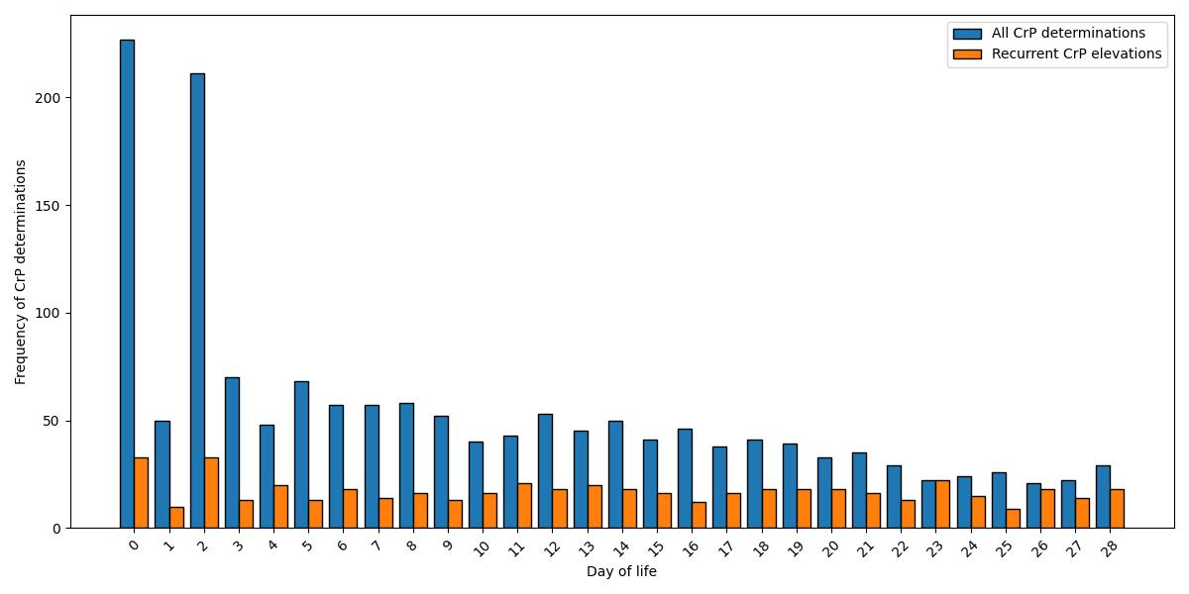

Supplementary figure 1: Frequency of CrP determinations within the first 28 days of life by day of life and grouped by recurrent elevations > 10 mg/l against all other infants. Absolute number of determinations in our cohort is presented.

Supplementary figure 2: CrP course over the first 28 days of life
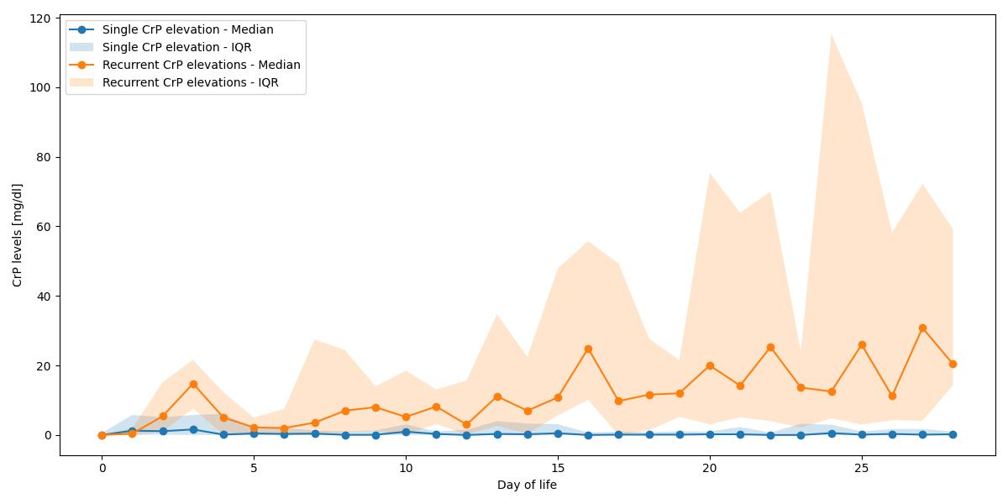
Supplementary figure 2: Course of median CrP levels with corresponding IQR over the first 28 days of life grouped by single and recurrent elevations of CrP.

Supplementary figure 3: CrP course over the first 28 days of life
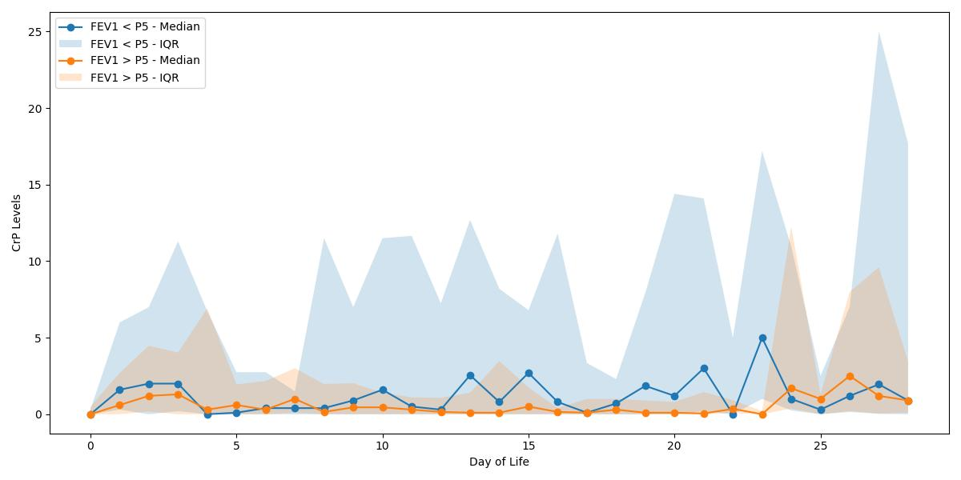
Supplementary figure 3: Course of median CrP levels with corresponding IQR over the first 28 days of life grouped by FEV1 < 5th percentile and FEV1 > 5th percentile.

Supplementary figure 4: CrP course over the first 28 days of life
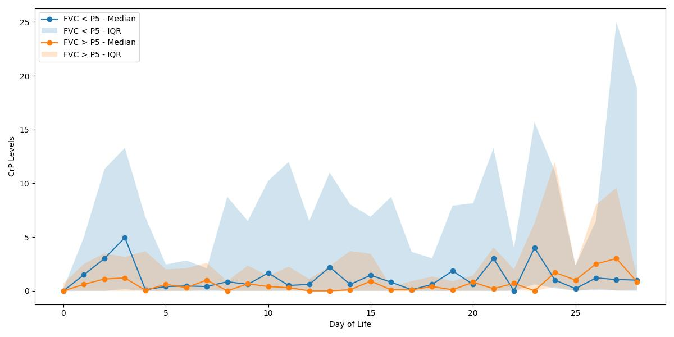
Supplementary figure 4: Course of median CrP levels with corresponding IQR over the first 28 days of life grouped by FVC < 5th percentile and FVC > 5th percentile.

