Figure 1.
Graphical view with information per phase.
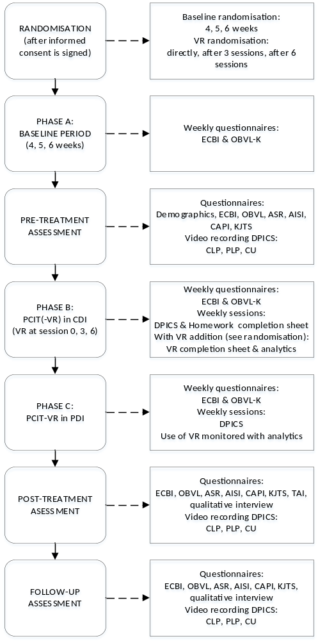
*Definitions: VR = Virtual Reality, ECBI = Eyberg Childhood Behaviour Inventory, OBVL-K = opvoedingsbelasting vragenlijst (– kort) [in Dutch]/parenting stress questionnaire, ASR = Adult Self Report, AISI = Attachment Insecurity Screening Inventory, CAPI = Child Abuse Potential Inventory, KJTS = Kind en Jeugd Trauma Screener, DPICS = Dyadic Parent-Child Interaction Coding System, CLP = Child Led Play, PLP = Parent Led Play, CU = Clean Up.

Figure 2.
Three separate examples of the multiple baseline SCED in phases.
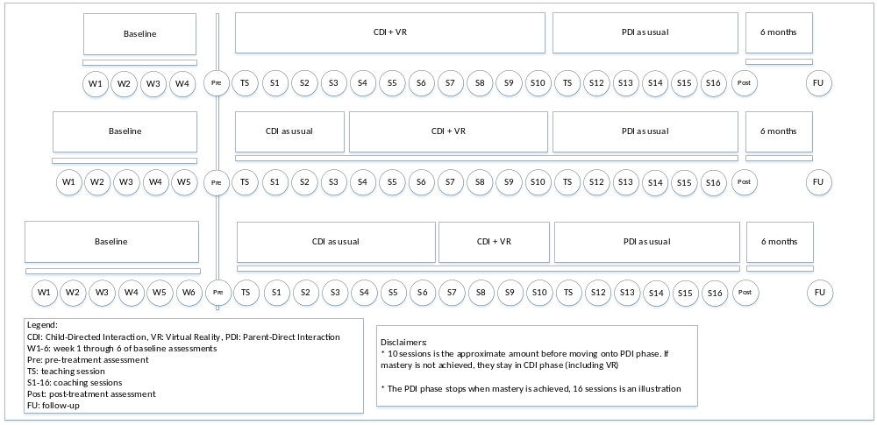

Table 1. Parent and Child behaviours as coded in the DPICS.
Parent Behaviours | Child Behaviours
Direct Command  - Compliance  - Non Compliance  - No Opportunity to Comply | Negative Talk
 | Prosocial Talk
 | Question
Indirect Command  - Compliance  - Non Compliance  - No Opportunity to Comply | Command
 | Whine
 | Yell
Question
Behavioural Description
Reflective Statement
Labelled Praise
Unlabelled Praise
Neutral Talk
Negative Talk

Author information:
Iza C.A. Scherpbier (MSc) ^{1,2,3}, PhD candidate, corresponding author
dr. Mariëlle E. Abrahamse (PhD) ^{1,2,3}, Postdoc researcher
dr. Robert G. Belleman (PhD) ⁴, Computer Scientist
Prof. dr. Arne Popma ^{1,2}, Child and Adolescent psychiatrist
Prof. dr. Ramón J.L. Lindauer ^{1,2,3}, Child and Adolescent psychiatrist

- Amsterdam University Medical Center (AUMC)
- Levvel, Academic Centre for Child and Adolescent Psychiatry Amsterdam
- University of Amsterdam’s Faculty of Medicine (AMC-UvA)
- University of Amsterdam’s, Computational Science Lab (CSL-UvA)

