Impact of reduced idea density on pharmacy students' attainment in pharmaceutical calculations: a multicentre randomised controlled trial.
Andrew M. Lunn ª*, Alice McCloskey ª, Craig Russell ^{b}, Babir Malik ^{c}, Louise Siobhan Cogan ^{d}, Philip Crilly ^{e}, Adam Pattison Rathbone ^{f}, Johanne Barry ^{g}, Brian Addison ^{h}, Aaron Courtenay ^{i}, Ruth Edwards ^{j} and Andrea Manfrin ^{d}
Appendices
Appendix A1. Demographic information collection form
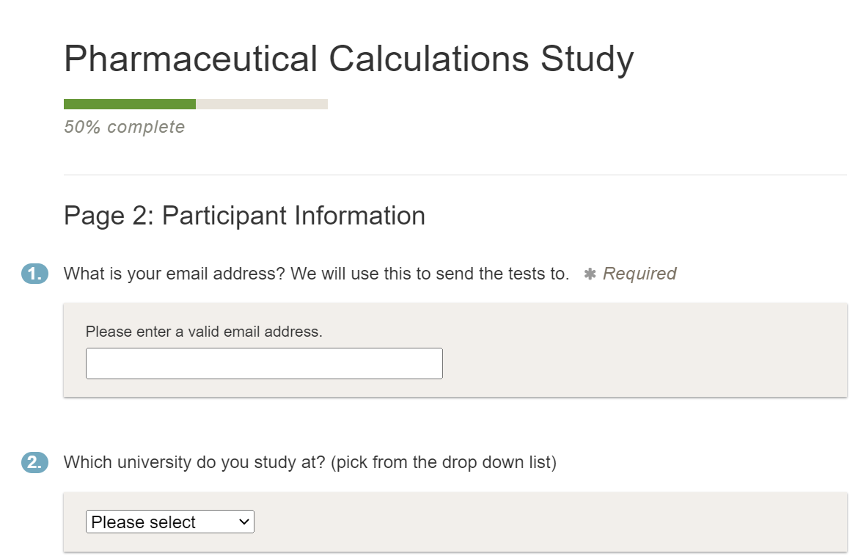
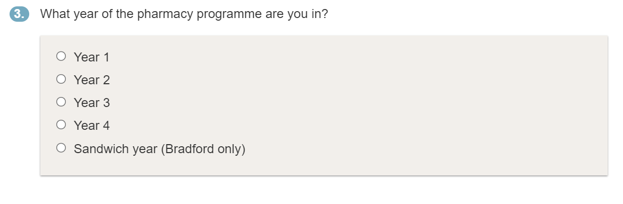

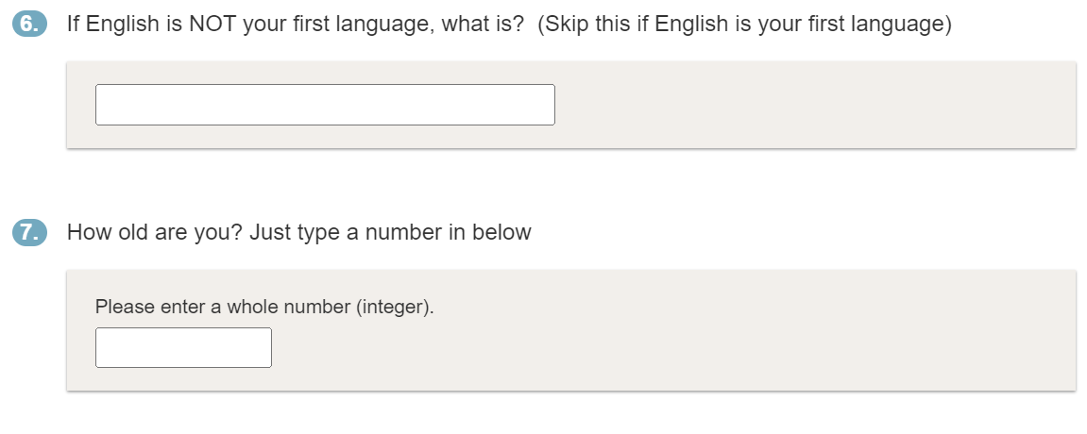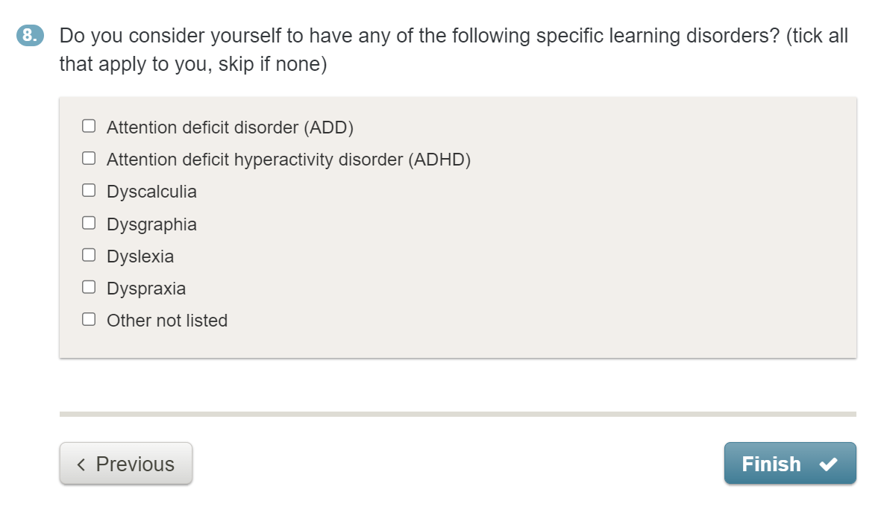
N.B. The sex of the participant was asked on a welcome screen before entering the full demographics survey.
Appendix A2. Full list of test questions.
Pharmaceutical Calculations 1a
Question 1/12
A 9-year-old child, weighing 28 kg is prescribed erythromycin by intravenous infusion for a campylobacter
enteritis infection, administered at 12.5 mg/kg every 6 hours (max. per dose 1 g). Erythromycin is diluted in
sodium chloride 0.9% to a concentration of 5 mg/mL and given over 20-60 minutes.
What volume of liquid will the child receive over a single 24-hour period? Round each dose to the nearest
whole mL.
............................................................
Question 2/12
NICE recommends that UK adults take oral vitamin D supplementation throughout winter. The recommendation
is to take a formulation containing 400 International Units (IU) daily.
1 IU = 0.025 mcg
How many micrograms of vitamin D will an adult following these guidelines take in 28 days? Give your
answer as an exact number
............................................................
Question 3/12
A 78-year-old man weighing 73 kg, with a serum creatinine of 242 micromoles/L has been prescribed
trimethoprim 200 mg twice a day for seven days.
The manufacturer of trimethoprim advises:
A dose reduction to half normal dose after 3 days if eGFR 15–30 mL/minute/1.73 m2
A dose reduction to half normal dose if eGFR less than 15 mL/minute/1.73 m2
Male creatinine clearance is given by the formula below.
Using creatinine clearance as an estimate for eGFR, how much trimethoprim in mg would this patient
receive during his course?
............................................................
Question 4/12
You are preparing instructions for a suspension formulation of amoxicillin, reconstituted from a dry powder to a
total of 100 mL by the addition of water, with a final concentration of 250 mg/5 mL.
The dry powder consists of amoxicillin and various excipients, has a total mass of 32 g and a displacement value
of 1.85 mL/g.
How much water is required to reconstitute the amoxicillin? Give your answer in mL rounded to the
nearest whole number
............................................................
Pharmaceutical Calculations 1
Question 5/12
A 24-year-old patient who weighs 78 kg has been prescribed ciclosporin at a dose of 2 mg/kg by intravenous
infusion for acute severe ulcerative colitis that is unresponsive to corticosteroids.
IV ciclosporin is administered as a 0.05 %w/v solution in normal saline.
What is the total volume required for this intravenous infusion in mL?
............................................................
Question 6/12
You are preparing 100 mL of a 1 mg/5 mL oral solution of chloral hydrate for a pharmaceutical specials
manufacturer.
You have a higher concentration of 200 mg/5 mL and a suitable diluent available.
What volume of chloral hydrate 200 mg/5 mL is required to make this product in mL?
............................................................
Question 7/12
A 6-year-old child has diarrhoea for which he is being given Dioralyte oral rehydration sachets. One sachet,
when correctly prepared contains 13.04 mmol of sodium, and the maximum to be taken in a day is five sachets.
The recommended daily allowance (RDA) of salt for a 6-year-old child is 3 g, equivalent to 1.2 g sodium per
day.
Sodium relative atomic mass = 23.
What percentage of the child’s recommended daily sodium allowance is in the maximum daily dose? Give
your answer to the nearest whole number.
............................................................
Question 8/12
A 58-year-old woman who weighs 75 kg and is 5 foot 2 inches tall has been prescribed hydroxychloroquine
sulfate for rheumatoid arthritis. The dose for an adult is 200-400 mg daily up to a maximum of 6.5 mg/kg per
day based on ideal body weight (IBW).
IBW for women is given by the following formula
IBW (kg) = 45.5 kg + 2.3 kg for every inch over 5 feet tall
Hydroxychloroquine sulfate is available as 200 and 300 mg tablets.
What should this patient’s daily dose of hydroxychloroquine sulfate be?
............................................................
Question 9/12
A 54-year-old man requires an emergency loading dose of digoxin for atrial fibrillation. The dose is 0.75 mg,
given as an infusion over two hours.
The digoxin is to be administered in normal saline at a concentration of 15 mcg/mL.
At what rate in mL/min should the infusion be given? Give your answer to two decimal places.
............................................................
Question 10/12
A patient has been given a 15 mg bolus dose of intra-muscular methotrexate, reaching peak serum concentration
two hours post administration. Methotrexate's serum half-life is 3 hours post intra-muscular administration.
Assume the full dose is in the serum two hours post administration and clearance follows first order kinetics.
How long will it take for the total amount of methotrexate to fall to 0.47 mg? Give your answer to the
nearest hour
............................................................
Question 11/12
200 dose Clenil 100 mcg/dose inhalers are usually available at a cost of £26.40 per inhaler. The manufacture of
Clenil has offered you a discounted rate of £25.80 per inhaler.
Your patient group has 654 patients who are prescribed the inhaler, and on average 236 generic inhalers are
prescribed every four weeks.
Annually, how much would your CCG save by switching to Clenil? Give your answer to the nearest
pound
............................................................
Question 12/12
A 23-year-old patient who has recently been taking a long course of oral prednisolone is now starting on a
reducing dosing regimen taken using only 5 mg tablets.
The prescribed regimen is: Take 40 mg as a single dose in the morning, reducing by 5 mg every 7 days, to 0
tablets.
How many 5 mg prednisolone tablets will this patient require to finish the course?
............................................................
Pharmaceutical Calculations 2
Question 1/12
A 26-year-old woman is prescribed intravenous (IV) labetalol for hypertension. Labetalol is administered
initially at 20 mg/hour for 30 minutes, then increased to 40 mg/hour for 30 minutes and finally increased to 80
mg/hour for an hour at a concentration of 1 mg/mL in normal saline.
What is the total volume of liquid in mL that the patient will receive?
............................................................
Question 2/12
A patient who has been receiving intravenous hydrocortisone for life threatening severe-acute asthma is to be
switched to oral prednisolone given using 5 mg tablets. They have been receiving 100 mg hydrocortisone every
6 hours.
20 mg IV hydrocortisone = 5 mg oral prednisolone
How many 5 mg prednisolone tablets will this patient require daily?
............................................................
Question 3/12
A 54-year-old man weighing 82 kg with a serum creatinine of 142 micromoles/L is prescribed Truvada
(tenofovir 200 mg/emtricitabine 245 mg), the standard dose of which is ONE tablet daily.
The manufacturer of Truvada advises:
To take one tablet every other day in moderate renal impairment (GFR of 30-50 mL/min)
To take one tablet over 3 days in severe renal impairment (GFR of 15-30 mL/min)
To avoid if GFR is below 15 mL/min
Male creatinine clearance is given by the formula below
How many tablets are required for 28 days of treatment?
............................................................
Question 4/12
Cefalexin 125 mg/5 mL suspension comes as a bottle containing 20 g of dry powder consisting of cefalexin and
excipients, to be reconstituted by adding 70 mL of water to a final volume of 100 mL.
What is the displacement value of the powder for reconstitution in mL/g? Give your answer to 1 decimal
place.
............................................................
Question 5/12
A 43-year-old woman, who weighs 87 kg is prescribed acetylcysteine at 150 mg/kg over 1 hour, for a
paracetamol overdose. Acetylcysteine comes as 2 g/10 mL ampoules of solution to be added into a 200 mL
infusion bag of glucose 5%.
What will the final infusion concentration be? Give your answer in mg/mL to the nearest whole number.
............................................................
Question 6/12
You are preparing 70 mL of a 5 mg/5 mL oral suspension of omeprazole for a pharmaceutical specials
manufacturer. You have a higher concentration of 40 mg/5 mL and a suitable diluent available.
What volume of omeprazole 40 mg/5 mL is required to make this product? Give your answer to one
decimal place.
............................................................
Question 7/12
A 26-year-old woman has mild cystitis for which she is taking cystitis relief sachets. One sachet, when correctly
prepared contains 40.8 mmol of sodium, and the maximum dose is three sachets daily.
The recommended daily allowance (RDA) of salt for an adult woman is 6 g, equivalent to 2.4 g of sodium per
day.
Sodium relative atomic mass = 23.
What percentage of the woman’s recommended daily allowance of sodium is in the maximum dose? Give
your answer to the nearest whole number.
............................................................
Question 8/12
A 62-year-old woman who weighs 72 kg and is 1.62 metres tall is being treated for non-Hodgkin lymphoma and
has been prescribed rituximab. Rituximab is given at a dose of 375 mg/m2 body surface area (BSA) per cycle for
up to 8 cycles.
BSA can be calculated using the formula below.
Assuming this patient receives the maximum cycles of treatment, how much rituximab will she receive in
total in grams? Give your answer to one decimal place.
............................................................
Question 9/12
A 37-year-old diabetic woman, who weighs 70 kg is prescribed vancomycin intravenous infusion (IVI) for an
infected leg ulcer. Vancomycin is prescribed at a dose of 15 mg/kg twice a day (max. 2g per dose) and is
available as 10 mL ampoules containing 500 mg vancomycin to be diluted to a concentration of 5 mg/mL using
normal saline and given over 120 minutes.
What will the resulting infusion rate be in mL/min? Give your answer to two decimal places.
............................................................
Question 10/12
A patient has been given a 2 mg bolus dose of intra-articular dexamethasone in their knee, reaching peak serum
concentration one hour post administration. Dexamethasone serum half-life is 180 minutes post intra-articular
administration.
Assume the full dose is in the serum one hour after administration and that clearance follows first order kinetics.
How long, in hours, will it take for the total amount of dexamethasone to fall to 0.125 mg?
............................................................
Question 11/12
You have recently trained a 16-year-old patient who regularly takes fluoxetine 20 mg daily to swallow capsules.
Previously the patient was taking their fluoxetine using a 20 mg/5 mL solution, which is available at £4.19 for a
70 mL bottle.
She will now be taking her dose as a single 20 mg capsule, which is available at £0.83 for a pack of 30 capsules.
How much money will be saved annually by making this switch? Give your answer to the nearest pound.
You should determine the saving by rounding to the minimum full pack size that would last 365 days.
............................................................
Question 12/12
A 27-year-old patient is on a maintenance and reliever (MART) regimen for asthma, meaning they use a single
inhaler as both their preventer and reliever. They regularly use a 120 dose Fostair (100/6) pMDI, ONE puff to be
taken TWICE a day, increased to a maximum of EIGHT puffs a day if symptoms exacerbate.
Assuming they take the inhaler as prescribed and experience exacerbated symptoms resulting in them
taking the maximum dose for FOUR days, how long will one inhaler last? Give your answer as the
maximum number of full days treatment.
............................................................
Pharmaceutical Calculations 2a
Question 1/12
You are reviewing a 26-year-old woman. She has been prescribed intravenous (IV) labetalol, this is to treat
hypertension.
The labetalol is administered to the woman at:
20 mg/hour for 30 minutes,
then 40 mg/hour for 30 minutes
and finally 80 mg/hour for an hour
The labetalol is administered at a concentration of 1 mg/mL in normal saline.
What is the total volume of liquid that will be administered to the patient?
Give your answer in mL
............................................................
Question 2/12
A patient has been receiving intravenous hydrocortisone. This was for life threatening severe-acute asthma.
They have been receiving a dose of 100 mg hydrocortisone every 6 hours.
They are now being switched to oral prednisolone at an equivalent total daily dose to be given using 5 mg
tablets.
20 mg IV hydrocortisone = 5 mg oral prednisolone
How many 5 mg prednisolone tablets will this patient require per day?
............................................................
Question 3/12
A man is going to be prescribed Truvada.
He:
is 54-years-old
weighs 82 kg
has a serum creatinine of 142 micromoles/L
The standard dose of Truvada is ONE tablet a day. However, the manufacturer of Truvada advises:
To take one tablet every other day in moderate renal impairment (GFR of 30-50 mL/min)
To take one tablet over 3 days in severe renal impairment (GFR of 15-30 mL/min)
To avoid if GFR is below 15 mL/min
Male creatinine clearance is given by the formula below
How many tablets will this patient need for 28 days of treatment?
............................................................
Question 4/12
Cefalexin 125 mg/5 mL suspension is supplied as a bottle containing 20 g of dry powder. The powder contains
cefalexin plus excipients.
The suspension is reconstituted by adding 70 mL of water taking the total volume to 100 mL.
What is the displacement value of the powder used for reconstitution?
Give your answer in mL/g.
Give your answer to one decimal place.
............................................................
Question 5/12
A 43-year-old woman has been prescribed acetylcysteine. This is for a paracetamol overdose.The acetylcysteine
dose is 150 mg/kg over 1 hour.
She weighs 87 kg.
The acetylcysteine is available as 10 mL ampoules at a concentration of 2g/10mL.
The required volume of acetylcysteine solution is to be added into a 200 mL infusion bag of glucose 5%.
What will the final concentration of the resulting infusion be?
Give your answer in mg/mL
Give your answer to the nearest whole number
............................................................
Question 6/12
You have been requested to prepare an oral suspension of omeprazole, to:
a concentration of 5 mg/5 mL
a volume of 70 mL
You have a higher concentration of 40 mg/5 mL omeprazole suspension available and a suitable diluent to
prepare the product with by diluting the higher concentration suspension.
What volume of the omeprazole 40 mg/5 mL will you need to make the requested product?
Give your answer in mL
Give your answer to one decimal place.
............................................................
Question 7/12
A 26-year-old woman is taking cystitis relief sachets.
One sachet contains 40.8 mmol of sodium.The maximum dose is three sachets a day.
The recommended daily allowance (RDA) of salt for an adult woman is 6 g, which is equivalent to 2.4 g of
sodium.
The relative atomic mass of sodium is 23.
The woman is taking the maximum daily dose of the sachets.
What percentage of the woman’s recommended daily allowance of sodium is she taking?
Give your answer to the nearest whole number.
............................................................
Question 8/12
A 62-year-old woman has been prescribed rituximab; this is for non-Hodgkin lymphoma.
The patient:
weighs 72 kg
is 1.62 metres tall
Rituximab is administered at a dose of 375 mg/m2 of body surface area (BSA), which is one cycle of treatment.
A patient may receive a maximum of 8 cycles.
BSA can be calculated using the formula below.
Assuming this patient receives the maximum number of treatment cycles, how much rituximab will she
receive in total?
Give your answer in grams
Give your answer to one decimal place
............................................................
Question 9/12
A 37-year-old woman with diabetes is prescribed a vancomycin intravenous infusion. This is to treat an infected
leg ulcer.
The vancomycin is prescribed at a dose of 15 mg/kg to be given twice a day, up to a maximum of 2 g per dose.
The woman weighs 70 kg.
Vancomycin is available as 10 mL ampoules, each containing 500 mg vancomycin. The infusion must be diluted
to a final concentration of 5 mg/mL using normal saline.
The infusion must be given over 120 minutes
What will be the resulting infusion rate?
Give your answer in mL/min
Give your answer to two decimal places
............................................................
Question 10/12
A patient has been given a 2 mg bolus dose of intra-articular dexamethasone in their knee.
The dexamethasone will reach peak serum concentration one hour after administration.
The serum half-life of dexamethasone is 180 minutes.
The full dose of dexamethasone will be found in the serum one hour after administration.
The clearance follows first order kinetics.
How many hours will it take for the total concentration of dexamethasone to fall to 0.125 mg?
............................................................
Question 11/12
You have trained a 16-year-old patient to swallow capsules. They regularly take fluoxetine at a dose of 20 mg a
day.
Previously the patient was taking their fluoxetine using a 20 mg/5 mL solution. The solution is available at a cost
of £4.19 for a 70 mL bottle.
They will now be taking their dose as a single 20 mg capsule, which comes in a pack size of 30 capsules. These
are available at cost of £0.83 for a packet of 30 capsules.
How much money will be saved per year by switching from the solution to the capsules?
Round to the minimum full pack size that would last 365 days.Give your answer to the nearest pound.
............................................................
Question 12/12
A 27-year-old patient is on a maintenance and reliever (MART) regimen for asthma. MART regimens use a
single inhaler as the preventer and reliever.
They are regularly prescribed a 120 dose Fostair (100/6) pMDI.
The patient instructions are to: Inhale ONE puff TWICE a day, this can be increased to a maximum of EIGHT
puffs a day if symptoms exacerbate.
The patient takes the inhaler as prescribed.
Assume the patient increases their use to the maximum dose for FOUR days for symptom exacerbations.
How many days will one inhaler last?
Give your answer as the maximum number of full days of treatment.
............................................................
Appendix A3. Post Kruskal-Wallis Pairwise median testing with Bonferroni correction.
3A.
Group A Test 1
Demographic | Other | Arabic | Black | Asian | White
White | 0.68 | 0.111 | 0.002 | 0.027
Asian | 0.232 | 0.758 | 0.194
Black | 0.038 | 0.57
Arabic | 0.269
Other
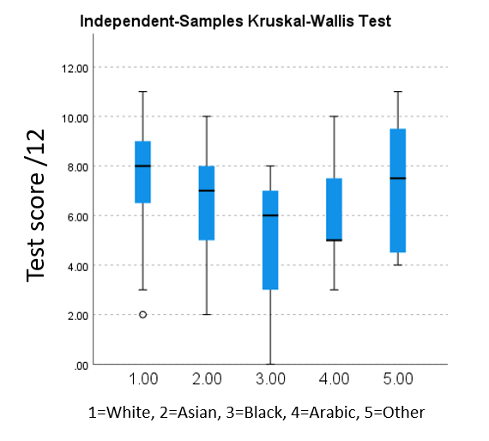
Y-axis: Showing score out of 12 in test 1, with box plots showing minimum score, Q1, Q2, Q3 and maximum score. X-axis: 1= White students, 2= Asian students, 3=Black African Caribbean students, 4 = Arabic students, 5 = Other
3B.
Group A Test 2
Demographic | Other | Arabic | Black | Asian | White
White | 0.225 | 0.149 | <0.001 | 0.009
Asian | 0.509 | 0.943 | 0.118
Black | 0.71 | 0.276
Arabic | 0.689
Other
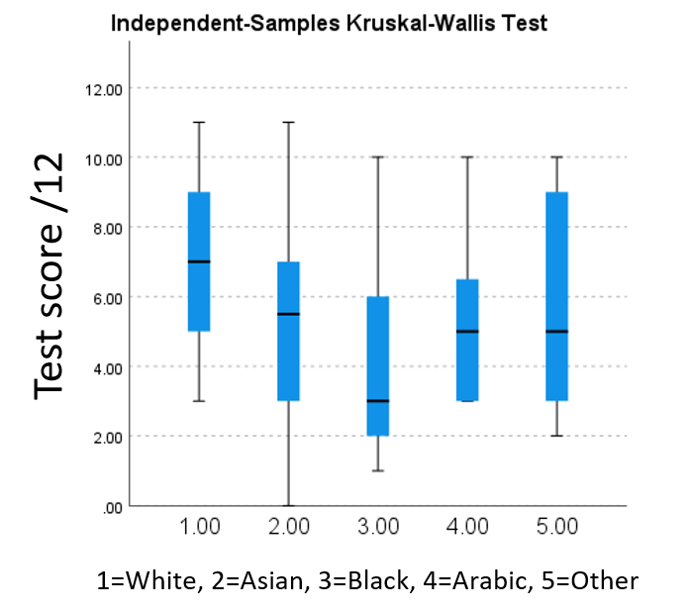
Y-axis: Showing score out of 12 in test 2, with box plots showing minimum score, Q1, Q2, Q3 and maximum score. X-axis: 1= White students, 2= Asian students, 3=Black African Caribbean students, 4 = Arabic students, 5 = Other
3C.
Group B Test 1
Demographic | Other | Arabic | Black | Asian | White
White | 0.148 | 0.975 | 0.311 | 0.578
Asian | 0.304 | 0.742 | 0.54
Black | 0.749 | 0.451
Arabic | 0.285
Other
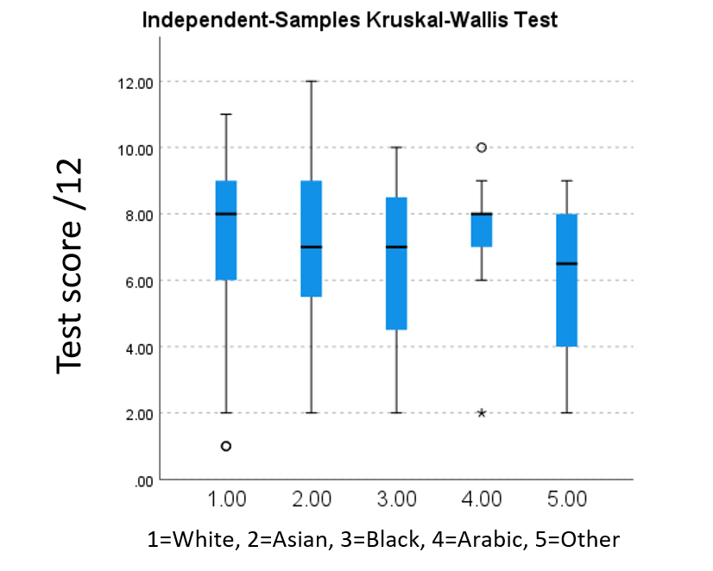
Y-axis: Showing score out of 12 in test 1, with box plots showing minimum score, Q1, Q2, Q3 and maximum score. X-axis: 1= White students, 2= Asian students, 3=Black African Caribbean students, 4 = Arabic students, 5 = Other
3D.
Group B Test 2a
Demographic | Other | Arabic | Black | Asian | White
White | 0.233 | 0.425 | 0.129 | 0.225
Asian | 0.762 | 0.997 | 0.514
Black | 0.764 | 0.614
Arabic | 0.818
Other
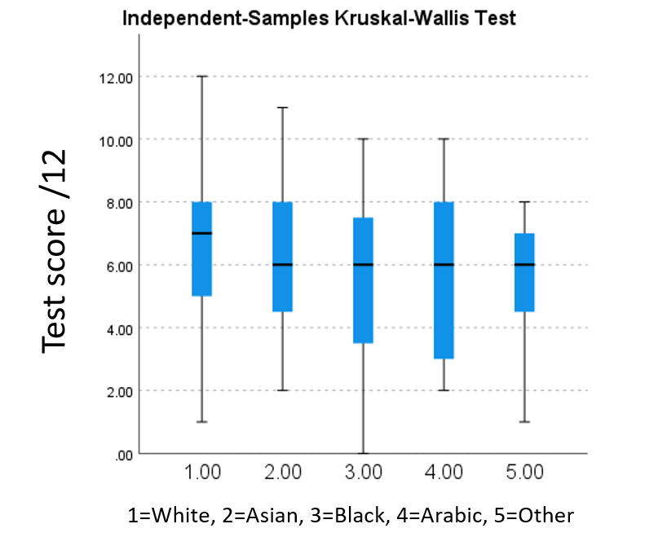
Y-axis: Showing score out of 12 in test 2a, with box plots showing minimum score, Q1, Q2, Q3 and maximum score. X-axis: 1= White students, 2= Asian students, 3=Black African Caribbean students, 4 = Arabic students, 5 = Other

