Additional information
Supplementary Table 1. Viral antigenic distribution in tissues of minks experimentally infected with H5N1/gull or H5N1/mink H5N1 HPAIVs. Results are expressed as the number of positive minks per total number of minks, and the average antigen detection score in brackets according to the following criteria: focal/oligofocal (+), multifocal (++), coalescing to diffuse (+++). For each tissue and group, absence of brackets indicates absence of immunodetection (-). Neg = negative controls; Inoc3 = inoculated euthanised at 3 dpi; Inoc16 = inoculated euthanised at 16 dpi; InocCl = Inoculated and clinically affected minks euthanised at 5 dpi (n=2), 6 dpi (n=1), 7 dpi (n=1); DC = direct contacts; AC = aerosol contacts.
 | H5N1/gull |  |  |  |  | H5N1/mink
Tissue | Neg | Inoc3 | Inoc16 | DC16 | AC16 | Neg | Inoc3 | InocCl | DC | AC
Nasal Cavity | 0/3 | 2/3 (+) | 0/4 | 0/2 | 0/6 | 0/2 | 1/3 (+) | 4/4 (++) | 0/2 | 0/6
Lung | 0/3 | 0/3 | 0/4 | 0/2 | 0/6 | 0/2 | 1/3 (+) | 4/4 (++) | 0/2 | 0/6
Brain | 0/3 | 0/3 | 1/4 (+) | 0/2 | 0/6 | 0/2 | 0/3 | 4/4 (++) | 0/2 | 0/6

Supplementary Table 2. Total reads, mean coverage, and name of fastq file stored in ENA repository (check data availability section) of all the samples sequenced.
Sample | Total reads | Mean coverage | Fastq file (ENA)
inoculum H5N1/mink | 1109994 | 17073 | H5N1_mink_inoc.fastq
inoculum H5N1/gull | 2293245 | 56777 | H5N1_gull_inoc.fastq
mink #2 brain | 1339928 | 945 | mink2_brain.fastq
mink #4 brain | 1460345 | 16864 | mink4_brain.fastq
mink #2 OP | 228346 | 1362 | mink2_OPswab_7dpi.fastq
mink #4 OP | 310817 | 3842 | mink4_OPswab_7dpi.fastq
mink #19 OP | 153002 | 2694 | mink19_OPswab_4dpi.fastq
mink #20 OP | 302248 | 4280 | mink20_OPswab_4dpi.fastq
mink #23 OP | 345232 | 984 | mink23_OPswab_4dpi.fastq

Supplementary Table 3. Variants detected in the brain of mink #4 inoculated with the H5N1/gull virus. The table includes the viral genome segment, position (POS), reference (REF) and alternate (ALT) nucleotides, the variant frequency in mink brain (FREQ_mink), total sequencing depth (DEPTH_mink), number of reads supporting the variant (VARIANT_DEPTH_mink), and the corresponding amino acid substitution (PROTEIN_CHANGE_mink).
Segment | POS | REF | ALT | FREQ_mink | DEPTH_mink | VARIANT_DEPTH_mink | PROTEIN_CHANGE_mink
M | 610 | G | A | 0.9754 | 17208 | 16785 | E204K
PB2 | 811 | A | G | 0.9637 | 634 | 611 | T271A
HA | 878 | A | G | 0.957 | 6442 | 6165 | K293R

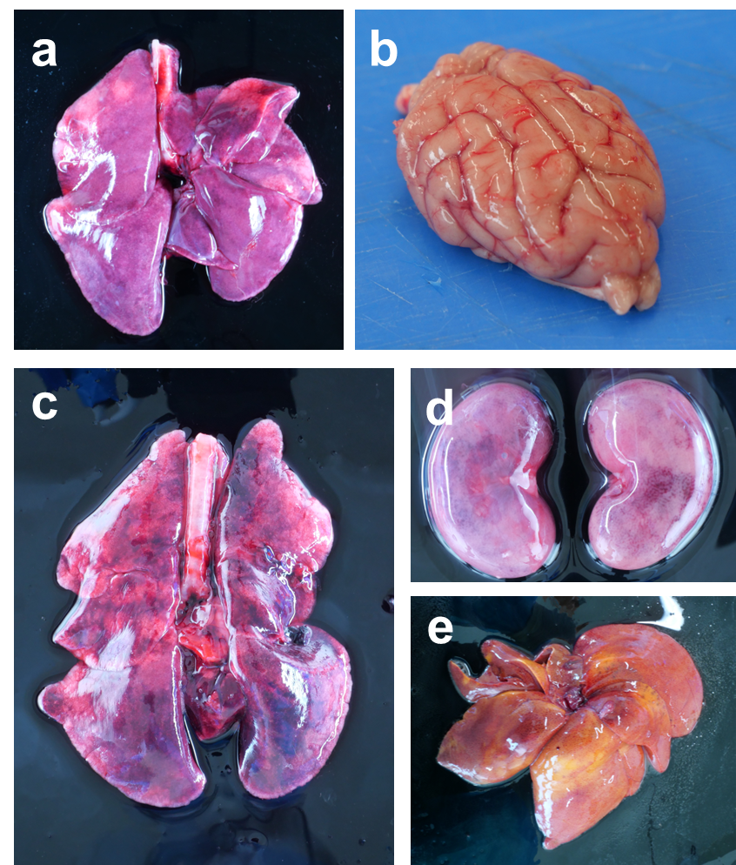
Supplementary Figure 1. Gross lesions observed in H5N1/mink-inoculated minks during necropsy. a, Lung, within normal limits (uninfected control). b, Brain, within normal limits (uninfected control). c, Lung, red necrotic foci scattered in parenchyma. d, Kidney, red necrotic foci scattered in parenchyma. e, Liver, icteric and friable.
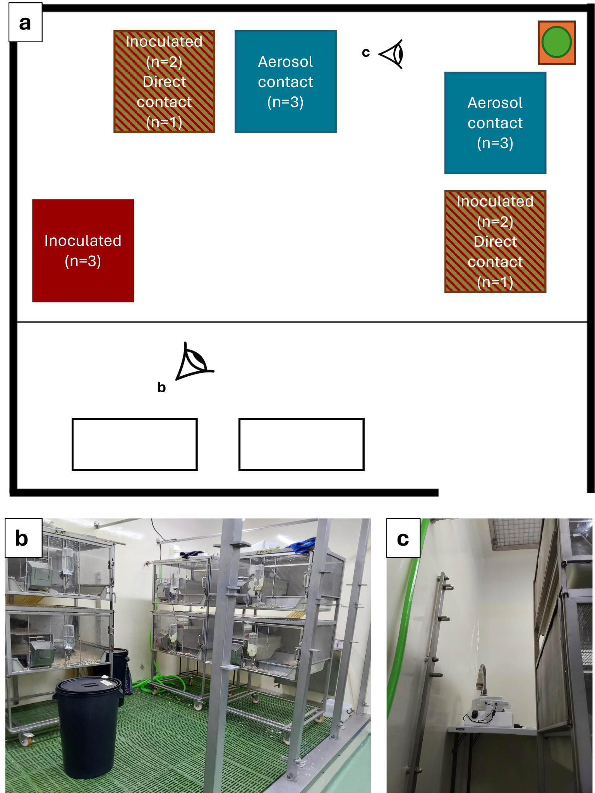
Supplementary Figure 2. Mink housing and distribution in the experimental room. a, Top view schematics. Each of the two experimental rooms (one per virus) had two transmission settings. Each transmission setting consisted of two cages: i) Inoculated (n=2) and direct contacts (n=1) (red and gold stripes); ii) Aerosol contacts (n=3) (blue). Cages were set favouring aerosol transmission, with aerosol contacts and the Coriolis µ active air sampler (green) being closer to the exhaust (orange). b, Transmission setting. c, Location of the Coriolis µ active air sampler below the exhaust.
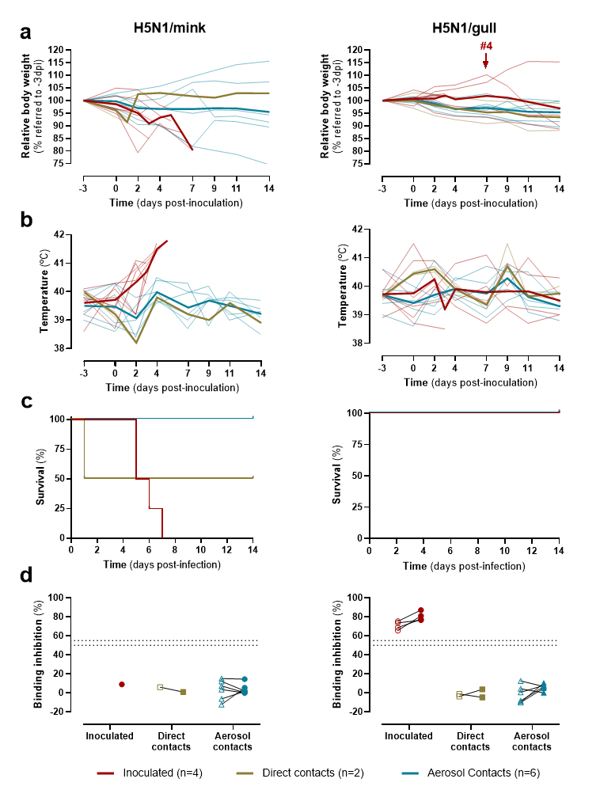
Supplementary Figure 3. Clinical signs, percentage of survival, and seroconversion in minks experimentally infected with A/Mink/Spain/3691-8_22VIR10586-10/2022 (H5N1/mink, left) or A/Larus ridibundus/Spain/CR4063/2023 (H5N1/gull, right) H5N1 HPAIV. a, Body weight variation (relative to -3 dpi). Thick lines represent mean values and thin lines represent individual values. b, Rectal temperature variation. Thick lines represent mean values and thin lines represent individual values. c, Kaplan-Meier survival curve. d, Detection of anti-nucleoprotein antibodies in serum. Dotted lines represent the positivity threshold. Empty symbols represent samples collected at 7 dpi, while solid symbols represent samples collected at humane or experimental endpoints. Experimental endpoint is 14 dpi for H5N1/mink and 16 dpi for H5N1/gull.
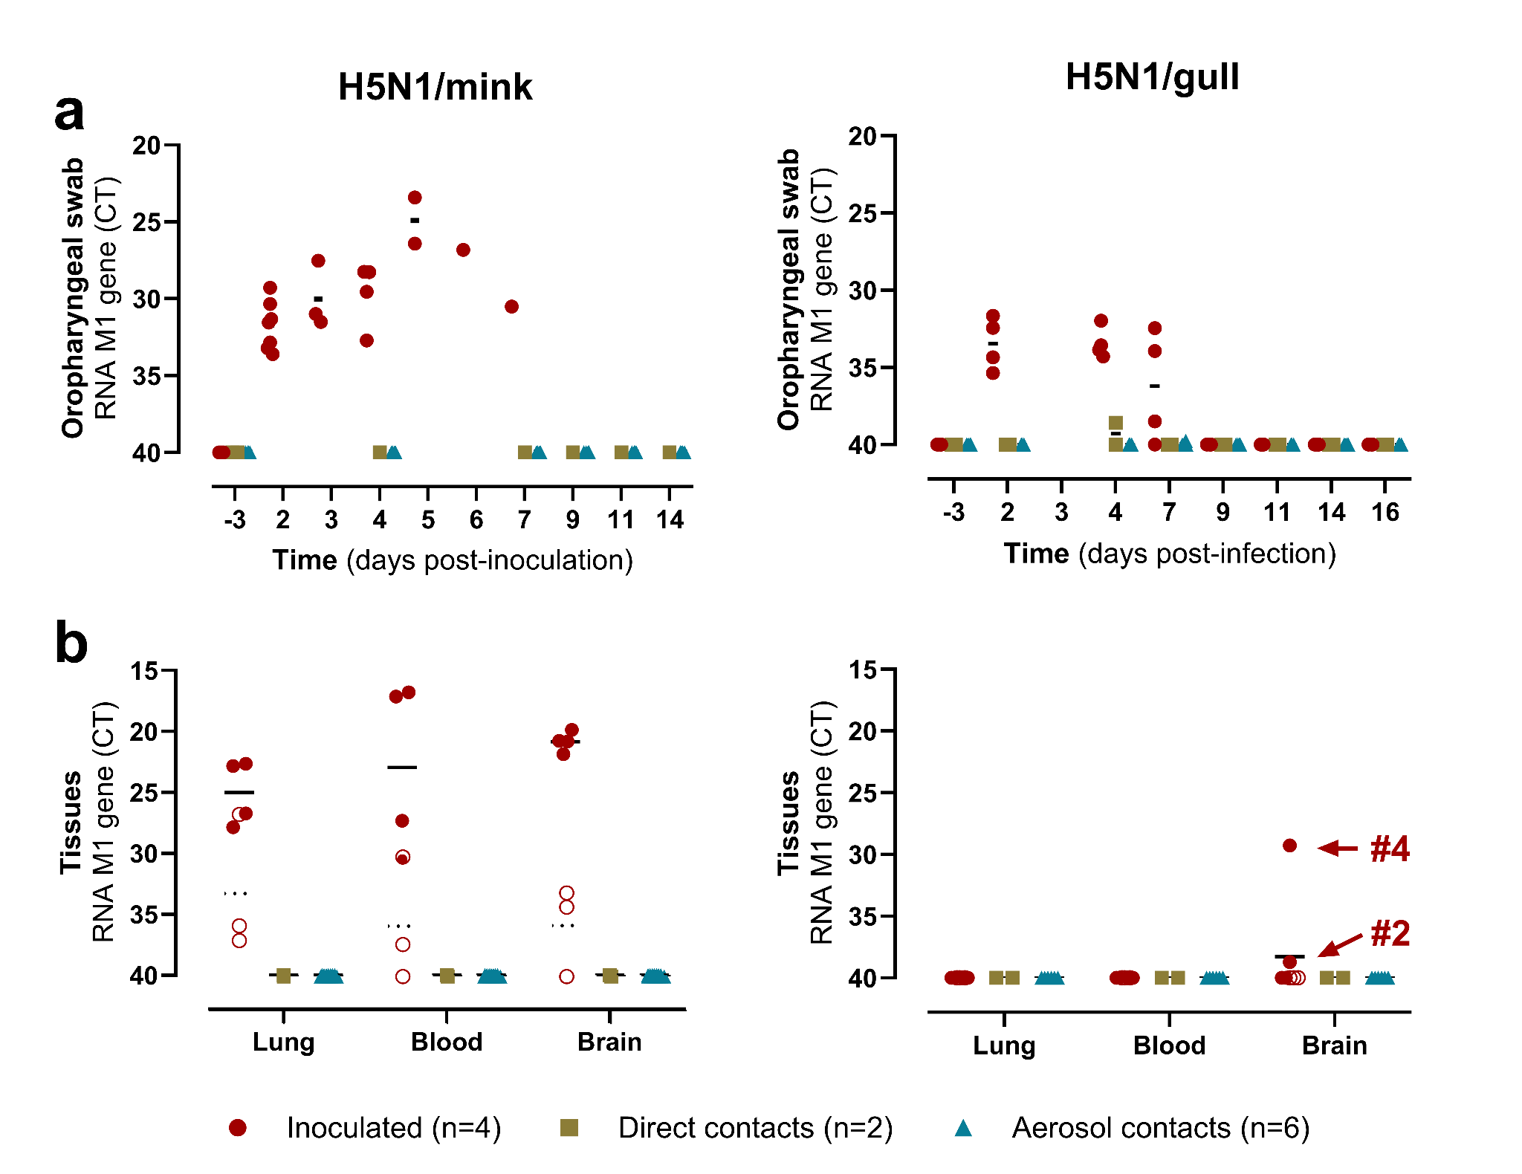
Supplementary Figure 4. Viral RNA detection in samples from minks experimentally infected with A/Mink/Spain/3691-8_22VIR10586-10/2022 (H5N1/mink, left) or A/Larus ridibundus/Spain/CR4063/2023 (H5N1/gull, right) H5N1 HPAIV. a, Oropharyngeal swabs. b, Tissue samples collected at necropsy. Data presented as individual values; empty symbols represent animals euthanised at 3 dpi (n=3) with their mean in dashed lines, while solid symbols represent animals euthanised at endpoint (experimental or humane) with their mean in solid lines.

Supplementary Data 1. Pairwise nucleotide comparison of original H5N1/gull and H5N1/mink viruses used in experimental infections. Eight plain-text files (.txt), each corresponding to one genomic segment (HA, NA, PB2, PB1, PA, NP, M, NS). Each file includes alignment length, percentage nucleotide identity, and list of nucleotide differences between A/Larus ridibundus/Spain/CR4063/2023 (EPI_ISL_18983379) and A/Mink/Spain/3691-8_22VIR10586-10/2022 (EPI_ISL_15878539). Data available at Zenodo repository [https://zenodo.org/records/16813242].

