Memristance and transmemristance in multiterminal memristive systems – Supplementary Information
Gianluca Milano^{1*}, Davide Pilati^{1,2}, Fabio Michieletti², Alessandro Cultrera³, Carlo Ricciardi,² Enrique Miranda⁴
¹Advanced Materials Metrology and Life Sciences Division, INRiM (Istituto Nazionale di Ricerca Metrologica), Strada delle Cacce 91, 10135 Torino, Italy.
²Department of Applied Science and Technology, Politecnico di Torino, C.so Duca degli Abruzzi 24, 10129 Torino, Italy.
³Quantum Metrology and Nanotechnologies Division, INRiM (Istituto Nazionale di Ricerca Metrologica), Strada delle Cacce 91, 10135 Torino, Italy.
⁴Departament d’Enginyeria Electrònica, Universitat Autònoma de Barcelona (UAB), 08193 Cerdanyola del Vallès, Spain

Email: g.milano@inrim.it

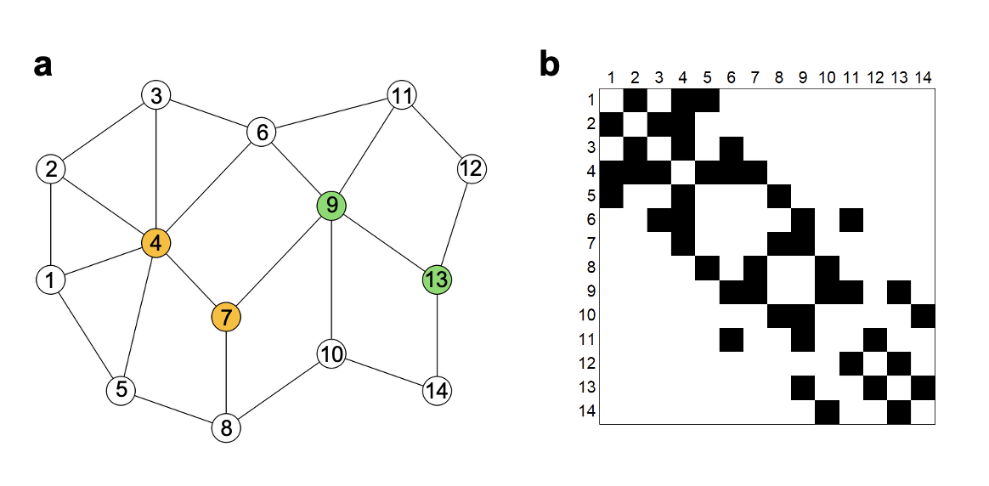
Supplementary Figure S1. Node labelling. a. Graph reported in Figure 2a with labelled nodes and b. corresponding adjacency matrix (unweighted) of the graph according to node labelling. The here reported the node labelling scheme that has been exploited in the adjacency matrices and Laplacian matrices reported in Figure 3.

Supplementary Table 1. Parameters that regulate the evolution of the conductivity of each edge of the grid graph model.

Parameters | Value
$$G_{min}$$ | 0.001 S
$$G_{max}$$ | 0.1 S
$$η_{P}$$ | 1.5 V⁻¹
$$η_{D}$$ | 1 V⁻¹
$$κ_{P0}$$ | 0.001 s⁻¹
$$κ_{D0}$$ | 0.5 s⁻¹

