Supplementary Materials for
Protectionism in critical minerals supply chains exacerbates inequalities in the global energy transition

This PDF file includes:

Text S1 to S5
Figs. S1 to S8
Tables S1 to S9

Supplementary Text

S1. Extended details of National Policy Actions in Critical Metals Markets
In this section, we present a detailed account of national policy actions targeting critical minerals since 2008. This includes annual developments for each mineral, the application of various policy instruments, and the distribution of policy bundles we constructed. We also provide granular information on each bundle, including the number and types of policies it comprises and their effective timeframes. Additionally, we examine the geographic origins of these policies, shedding light on the countries driving critical mineral interventions.

Table S1: The distribution of metal policy every year

Table S2: Policy instruments based on Global Trade Alert Initiative Dataset
Trade Policy Instruments | Amber | Green | Red
Financial grant | 1 | 0 | 261
Import tariff | 3 | 142 | 80
State loan | 0 | 0 | 59
Financial assistance in foreign market | 0 | 0 | 46
Tax or social insurance relief | 1 | 1 | 27
Export licensing requirement | 0 | 18 | 25
Trade finance | 1 | 0 | 24
Export tax | 5 | 13 | 23
Export ban | 2 | 7 | 22
Tax-based export incentive | 0 | 4 | 19
Anti-dumping | 6 | 0 | 17
Export quota | 0 | 10 | 11
Public procurement localisation | 0 | 0 | 11
State aid, unspecified | 4 | 0 | 9
Capital injection and equity stakes (including bailouts) | 0 | 0 | 8
Import ban | 0 | 4 | 8
Import licensing requirement | 0 | 8 | 8
Internal taxation of imports | 0 | 9 | 8
Export subsidy | 0 | 0 | 6
FDI: Entry and ownership rule | 2 | 0 | 6
Export-related non-tariff measure, nes | 0 | 2 | 5
Loan guarantee | 1 | 0 | 4
FDI: Treatment and operations, nes | 0 | 0 | 3
Import tariff quota | 3 | 25 | 3
Import-related non-tariff measure, nes | 2 | 1 | 3
Interest payment subsidy | 0 | 0 | 3
Public procurement preference margin | 0 | 0 | 3
Competitive devaluation | 0 | 0 | 2
Production subsidy | 0 | 0 | 2
Public procurement access | 0 | 1 | 2
Import incentive | 0 | 3 | 1
Intellectual property protection | 0 | 0 | 1
Local content incentive | 1 | 0 | 1
Other export incentive | 0 | 0 | 1
Public procurement, nes | 0 | 0 | 1
Import quota | 0 | 1 | 0
Instrument unclear | 2 | 0 | 0
Safeguard | 1 | 0 | 0
State aid, nes | 1 | 0 | 0
Trade payment measure | 1 | 2 | 0
Data sources: Simon J. Evenett and Johannes Fritz (2020). The Global Trade Alert database handbook. Manuscript, 26 October 2022.
Red: The intervention almost certainly discriminates against foreign commercial interests.
Amber: The intervention likely involves discrimination against foreign commercial interests.
Green: The intervention liberalises on a non-discriminatory (i.e., most favoured nation) basis; or improves the transparency of a relevant policy.

Table S3: Policy sets design for analysis about metal market
Policy set | End Data | Num policies | Red | Green | Amber | Sector
Aluminum_set1 | 2009/5/1 | 6 | 5 | 0 | 1 | 52
Aluminum_set2 | 2023/8/1 | 147 | 113 | 34 | 0 | 179
Chromium_set5 | 2016/7/1 | 5 | 3 | 2 | 0 | 49
Chromium_set6 | 2017/2/1 | 4 | 3 | 1 | 0 | 7
Chromium_set7 | 2018/2/1 | 2 | 2 | 0 | 0 | 2
Chromium_set8 | 2019/6/1 | 5 | 2 | 3 | 0 | 70
Chromium_set9 | 2020/2/1 | 5 | 3 | 2 | 0 | 91
Chromium_set10 | 2021/2/1 | 2 | 1 | 1 | 0 | 35
Chromium_set11 | 2023/2/1 | 8 | 5 | 3 | 0 | 90
Cobalt_set1 | 2009/2/1 | 2 | 1 | 0 | 1 | 10
Cobalt_set2 | 2010/2/1 | 1 | 0 | 1 | 0 | 3
Cobalt_set3 | 2011/2/1 | 1 | 0 | 1 | 0 | 21
Cobalt_set4 | 2013/8/1 | 2 | 1 | 0 | 1 | 1
Cobalt_set5 | 2016/2/1 | 1 | 0 | 1 | 0 | 97
Cobalt_set6 | 2017/2/1 | 1 | 0 | 1 | 0 | 98
Cobalt_set7 | 2020/12/1 | 1 | 0 | 1 | 0 | 1
Cobalt_set8 | 2023/7/1 | 5 | 5 | 0 | 0 | 4
Copper_set1 | 2012/2/1 | 23 | 16 | 7 | 0 | 135
Copper_set2 | 2021/5/1 | 53 | 41 | 10 | 2 | 174
Copper_set3 | 2023/9/1 | 16 | 11 | 4 | 1 | 125
Gold_set1 | 2010/2/1 | 1 | 1 | 0 | 0 | 1
Gold_set2 | 2011/2/1 | 2 | 2 | 0 | 0 | 1
Gold_set3 | 2012/2/1 | 1 | 1 | 0 | 0 | 1
Gold_set4 | 2013/2/1 | 2 | 2 | 0 | 0 | 5
Gold_set5 | 2014/2/1 | 3 | 3 | 0 | 0 | 6
Gold_set6 | 2015/4/1 | 2 | 2 | 0 | 0 | 6
Gold_set7 | 2019/2/1 | 16 | 15 | 1 | 0 | 5
Gold_set8 | 2020/3/1 | 5 | 5 | 0 | 0 | 26
Gold_set9 | 2021/5/1 | 2 | 2 | 0 | 0 | 3
Gold_set10 | 2023/2/1 | 1 | 1 | 0 | 0 | 1
Lead_set1 | 2009/2/1 | 1 | 0 | 1 | 0 | 15
Lead_set2 | 2011/8/1 | 4 | 3 | 1 | 0 | 1
Lead_set3 | 2013/2/1 | 1 | 1 | 0 | 0 | 1
Lead_set4 | 2014/5/1 | 4 | 3 | 1 | 0 | 1
Lead_set5 | 2017/2/1 | 6 | 3 | 2 | 1 | 37
Lead_set6 | 2018/2/1 | 3 | 2 | 1 | 0 | 1
Lead_set7 | 2020/2/1 | 7 | 5 | 2 | 0 | 14
Lead_set8 | 2022/2/1 | 1 | 1 | 0 | 0 | 1
Lead_set9 | 2022/11/1 | 1 | 1 | 0 | 0 | 3
Lead_set10 | 2023/8/1 | 1 | 1 | 0 | 0 | 8
Lithium_set2 | 2012/8/1 | 3 | 2 | 1 | 0 | 47
Lithium_set3 | 2013/8/1 | 1 | 0 | 0 | 1 | 2
Lithium_set4 | 2016/10/1 | 1 | 0 | 1 | 0 | 9
Lithium_set5 | 2018/2/1 | 2 | 1 | 1 | 0 | 54
Lithium_set6 | 2019/2/1 | 3 | 2 | 1 | 0 | 18
Lithium_set7 | 2020/2/1 | 2 | 2 | 0 | 0 | 2
Lithium_set8 | 2021/4/1 | 2 | 2 | 0 | 0 | 31
Manganese_set4 | 2018/2/1 | 1 | 0 | 1 | 0 | 9
Manganese_set5 | 2018/11/1 | 1 | 1 | 0 | 0 | 1
Manganese_set6 | 2020/2/1 | 3 | 3 | 0 | 0 | 4
Manganese_set7 | 2022/4/1 | 6 | 5 | 1 | 0 | 25
Manganese_set8 | 2023/7/1 | 12 | 11 | 1 | 0 | 139
Molybdenum_set4 | 2014/2/1 | 1 | 0 | 1 | 0 | 3
Molybdenum_set5 | 2016/1/1 | 1 | 0 | 1 | 0 | 41
Molybdenum_set6 | 2017/2/1 | 3 | 2 | 1 | 0 | 21
Molybdenum_set7 | 2018/12/1 | 1 | 1 | 0 | 0 | 19
Molybdenum_set8 | 2020/4/1 | 2 | 1 | 1 | 0 | 99
Nickel_set1 | 2009/3/1 | 1 | 1 | 0 | 0 | 1
Nickel_set2 | 2010/2/1 | 3 | 1 | 2 | 0 | 15
Nickel_set3 | 2012/6/1 | 6 | 5 | 1 | 0 | 8
Nickel_set4 | 2013/6/1 | 2 | 1 | 1 | 0 | 7
Nickel_set5 | 2015/2/1 | 3 | 2 | 1 | 0 | 18
Nickel_set6 | 2016/2/1 | 1 | 0 | 1 | 0 | 4
Nickel_set7 | 2017/3/1 | 1 | 1 | 0 | 0 | 1
Nickel_set8 | 2020/2/1 | 2 | 2 | 0 | 0 | 7
Nickel_set9 | 2021/5/1 | 1 | 1 | 0 | 0 | 10
Nickel_set10 | 2022/8/1 | 3 | 2 | 1 | 0 | 57
Nickel_set11 | 2023/4/1 | 2 | 2 | 0 | 0 | 5
Potassium_set1 | 2010/2/1 | 7 | 6 | 1 | 0 | 6
Potassium_set2 | 2011/4/1 | 2 | 1 | 1 | 0 | 1
Potassium_set3 | 2012/3/1 | 3 | 3 | 0 | 0 | 76
Potassium_set4 | 2015/2/1 | 26 | 20 | 6 | 0 | 28
Potassium_set5 | 2016/5/1 | 12 | 9 | 3 | 0 | 112
Potassium_set6 | 2017/2/1 | 1 | 1 | 0 | 0 | 5
Potassium_set7 | 2018/3/1 | 5 | 4 | 1 | 0 | 47
Potassium_set8 | 2019/2/1 | 2 | 2 | 0 | 0 | 7
Potassium_set9 | 2021/8/1 | 16 | 15 | 1 | 0 | 55
Potassium_set10 | 2023/3/1 | 10 | 10 | 0 | 0 | 53
Potassium_set11 | 2023/11/1 | 1 | 1 | 0 | 0 | 2
REE_set3 | 2016/4/1 | 7 | 4 | 3 | 0 | 120
REE_set4 | 2017/2/1 | 9 | 8 | 1 | 0 | 179
REE_set5 | 2018/2/1 | 7 | 6 | 1 | 0 | 158
REE_set6 | 2024/2/1 | 55 | 49 | 6 | 0 | 201
Silver_set1 | 2010/3/1 | 1 | 0 | 1 | 0 | 1
Silver_set2 | 2011/2/1 | 1 | 0 | 1 | 0 | 2
Silver_set3 | 2013/3/1 | 3 | 3 | 0 | 0 | 1
Silver_set4 | 2016/2/1 | 2 | 1 | 1 | 0 | 7
Silver_set5 | 2017/3/1 | 1 | 1 | 0 | 0 | 1
Silver_set6 | 2018/3/1 | 3 | 2 | 1 | 0 | 25
Silver_set7 | 2020/6/1 | 2 | 1 | 1 | 0 | 33
Silver_set8 | 2021/2/1 | 1 | 1 | 0 | 0 | 6
Uranium_set1 | 2009/3/1 | 2 | 2 | 0 | 0 | 2
Uranium_set2 | 2011/2/1 | 1 | 1 | 0 | 0 | 10
Uranium_set3 | 2012/6/1 | 3 | 1 | 2 | 0 | 3
Uranium_set4 | 2013/2/1 | 1 | 0 | 1 | 0 | 12
Uranium_set5 | 2014/1/1 | 1 | 1 | 0 | 0 | 1
Uranium_set6 | 2016/2/1 | 4 | 1 | 3 | 0 | 94
Uranium_set7 | 2017/10/1 | 5 | 5 | 0 | 0 | 35
Uranium_set8 | 2019/8/1 | 1 | 0 | 1 | 0 | 1
Uranium_set9 | 2021/2/1 | 1 | 1 | 0 | 0 | 1
Uranium_set10 | 2023/7/1 | 8 | 8 | 0 | 0 | 111
Vanadium_set4 | 2017/3/1 | 4 | 0 | 4 | 0 | 17
Vanadium_set5 | 2018/2/1 | 2 | 2 | 0 | 0 | 5
Vanadium_set6 | 2019/2/1 | 2 | 1 | 1 | 0 | 12
Vanadium_set7 | 2020/3/1 | 1 | 0 | 1 | 0 | 1
Vanadium_set8 | 2022/2/1 | 1 | 0 | 1 | 0 | 1
Vanadium_set9 | 2023/5/1 | 1 | 1 | 0 | 0 | 1
Zinc_set1 | 2009/3/1 | 3 | 1 | 2 | 0 | 48
Zinc_set2 | 2010/2/1 | 3 | 2 | 1 | 0 | 65
Zinc_set3 | 2013/6/1 | 15 | 12 | 2 | 1 | 139
Zinc_set4 | 2014/2/1 | 3 | 2 | 1 | 0 | 56
Zinc_set5 | 2017/2/1 | 16 | 10 | 6 | 0 | 183
Zinc_set6 | 2018/5/1 | 6 | 4 | 2 | 0 | 128
Zinc_set7 | 2019/6/1 | 3 | 2 | 1 | 0 | 4
Zinc_set8 | 2023/3/1 | 22 | 15 | 7 | 0 | 131

As the global energy transition accelerates and geopolitical dynamics evolve, national policy interventions targeting critical metals have increased significantly. The number of policy bundles addressing critical minerals has shown a clear upward trend over time. Analysis of their distribution reveals a strong concentration on metals such as aluminum, copper, manganese, potassium, rare earth elements, uranium, and zinc—resources that play essential roles in new energy systems, clean technologies, and high-tech manufacturing. Their strategic importance has made them primary targets of government action.
With the growing implementation of export controls, tariff adjustments, and market interventions, the spillover effects of these policies have become increasingly apparent. These effects now extend far beyond traditional metal sectors, reaching multiple layers of upstream and downstream industries. This broadening scope underscores the fact that critical mineral governance is no longer merely an issue of resource management—it has become a strategic component of national industrial security and global supply chain resilience.

Table S4: Who is taking the most direct hit
Freq | Affected Jurisdiction
61 | China
35 | South Africa
32 | Russia
30 | Germany; United States of America
28 | Chile; India; Republic of Korea
27 | Philippines; Spain
26 | Brazil
24 | Mexico
23 | Kazakhstan; Malaysia
22 | Netherlands; Peru
21 | Bulgaria
20 | Australia; France
19 | Belgium; Canada; Japan
18 | Chinese Taipei; Portugal; United Kingdom
17 | Vietnam
16 | Greece; Turkey
14 | Poland; Ukraine
13 | Thailand
12 | Slovenia; United Arab Emirates
11 | Armenia; Finland; Indonesia; Morocco; Serbia; Tanzania
10 | Ecuador; Romania
9 | Argentina; DPR Korea; Jamaica; Papua New Guinea; Sweden; Tajikistan; Zambia
8 | Italy; Macedonia; Montenegro; North Macedonia; Norway; Sierra Leone
7 | DR Congo; Guatemala; Iran; Ireland; Kyrgyzstan
6 | Colombia; Czechia; Gabon; Guinea; Jordan; Lao; Zimbabwe
5 | Bolivia; Congo; Dominican Republic; Eritrea; Georgia; Ghana; Honduras; Madagascar; Mongolia; Mozambique; Myanmar; Namibia; Oman; Saudi Arabia; Senegal; Sri Lanka
4 | Botswana; Guyana
3 | Albania; Cambodia; Hungary; Kenya; Lithuania; Mauritania; Suriname; Tunisia; Venezuela
2 | Algeria; Austria; Bahrain; Burkina Faso; Croatia; Cyprus; Estonia; Hong Kong; Ivory Coast; Luxembourg; Nepal; Nigeria; Pakistan; Qatar; Singapore; Switzerland; Uzbekistan
1 | Bosnia & Herzegovina; Denmark; Egypt; Kuwait; Latvia; Malta; Mauritius; New Caledonia; Niger; Panama; Republic of the Sudan; Slovakia; Turkmenistan; Uganda

We analyzed a dataset of 1,000 policy actions related to the trade of critical metals. A subset of these policies explicitly identified the affected countries. Based on frequency statistics, we find that China, South Africa, the United States, and Germany—all industrialized or resource-intensive economies—are the most frequently and directly impacted by these interventions.

Fig S1: The distribution of country in Exiobase dataset

EXIOBASE includes 43 countries (95% of global GDP) and 5 RoW regions (150 smaller countries in clusters). The number of countries is limited (like WIOD), but at least five RoW sectors are available. Fig S1. illustrates which countries have been grouped into each aggregate category.

Fig S2: The distribution of resources nationalism

Compared to trade measures such as tariffs, resource nationalism represents a distinct and significant form of protectionism. Fig S2 presents selected statistical results derived from our analysis of policy texts.

S2. Extended Theoretical Analysis of Price Dynamics in Critical Metal Markets
Tariffs and export controls are among the most used policy tools by national governments, often employed to achieve strategic or market-specific objectives. For example, Indonesia has implemented raw mineral export bans to promote its domestic refining industry, while China has used rare earth export restrictions to strengthen its geopolitical bargaining position. However, in global critical mineral markets, such tools not only reshape market equilibrium but also intensify supply chain volatility and undermine overall market stability.

S2.1. Impacts of Tariffs and Export Taxes on Market Equilibrium
As a traditional trade protection instrument, tariffs raise the cost of imported products, thereby altering domestic supply–demand dynamics. When domestic prices are lower than international prices, tariffs further increase the cost of importing metals. As shown in Figure (a), imposing a tariff effectively shifts the supply curve upward, creating a price wedge that moves the market equilibrium from (P2, Q3) to (P3, Q2). This results in higher equilibrium prices and reduced traded quantities.
In the case of importing countries (Figure b), export taxes imposed by trading partners can lower welfare in the exporting country by restricting supply and diminishing domestic surplus. Conversely, export rebates or subsidies can distort international markets through other protectionist channels.

S.2.2. Effects of Import and Export Controls on Market Equilibrium
Import and export controls on critical minerals have increasingly become strategic tools. Governments impose such measures to manage the flow of resources, reduce dependency, and secure domestic supply.
Import controls—including quotas, high tariffs, and non-tariff barriers—aim to limit foreign product penetration and encourage domestic capacity-building. Figure (c) illustrates that when import restrictions are applied, domestic demand shifts upward due to reduced access to foreign supply. Under a fixed supply curve, this leads to a price increase from P2 to P3 and a quantity contraction from Q3 to Q2.
When large importing economies implement aggressive barriers, the global supply–demand balance is disrupted, forcing exporters to seek alternative markets. This realignment can generate global price fluctuations and market rebalancing.
Export controls, on the other hand, are used to safeguard domestic availability or suppress domestic inflation. In critical mineral markets, such controls often serve geopolitical purposes. Figure (d) shows the dynamic impact: restrictions on outbound supply increase domestic availability, causing the domestic equilibrium to shift from point B to C (price drops from P2 to P3). Simultaneously, global supply tightens, prices rise, and supply chain stability deteriorates. While such policies may enhance short-term industrial competitiveness, they may also incentivize long-term supply chain diversification and external market realignment, reducing the exporter’s strategic leverage.

S.2.3 Structural Features of Critical Metal Markets That Amplify Policy Effects
Critical minerals such as lithium, cobalt, and nickel are characterized by high international dependency and supply concentration. Trade policies like tariffs and export controls intensify cross-border price disparities, trigger supply rerouting, and lead to global market fragmentation. Price shocks in upstream supply chains transmit to downstream industries—especially clean energy and advanced technology sectors—causing rising production costs and output delays.
Uncertainty surrounding trade policy often fuels panic buying and stockpiling, which further exacerbates price volatility. While tariffs and export controls can secure domestic access to strategic materials, they are also double-edged swords, potentially fueling global market instability, triggering trade disputes, and accelerating structural decoupling.

Fig S3 Shifts in Market Equilibrium Points for Critical Metals Under Different Policy Scenarios
The vertical axis denotes price, and the horizontal axis denotes quantity. The effectiveness of policy interventions is heterogeneous, with outcomes depending on both the direction and magnitude of equilibrium shifts.
Panel (a) illustrates a conventional scenario in which policy-induced supply reductions (e.g., export controls) lead to higher equilibrium prices and lower equilibrium quantities, shifting the market from point A to point B under constant demand.
Panel (b) reflects an alternative scenario relevant to critical metals, where demand is rapidly rising due to clean energy and technological deployment. In this case, the equilibrium may shift anywhere between point B and point C. Two possible outcomes emerge: quantity decreases while price increases, or both price and quantity increase.
When demand is price-inelastic, price movements tend to be larger than quantity adjustments. If both supply and demand fluctuate simultaneously, the market becomes inherently unstable and the equilibrium point becomes indeterminate. This underscores the volatility and uncertainty that characterize contemporary critical mineral markets.

Fig S4: Theoretical analysis of market equilibrium shocks from tariffs, export taxes, and import and export controls

Table S5: Trade elasticity of critical metal products
Metal | Stage I | Stage II | Stage III
Aluminum | -37.94 | -22.80 | -10.67
Antimony | -32.77 | -28.02
Barium |  | -12.38
Beryllium |  |  | -15.17
Bismuth |  |  | -19.52
Boron |  | -15.26
Cadmium |  |  | -24.46
Chromium | -32.74 | -20.13
Cobalt | -32.77 | -16.22 | -20.81
Copper | -37.94 | -21.32 | -16.91
Gold | -43.39 | -21.89
Iron | -32.77
lead | -19.57 | -15.03 | -15.99
Lithium |  | -24.48
Magnesium |  | -13.02 | -20.83
Manganese | -35.95 | -8.73 | -16.13
Molybdenum | -42.05 | -22.77 | -17.22
Nickel | -32.77 | -19.57 | -22.39
Niobium | -35.01
Palladium |  | -34.74
Platinum |  | -29.60
Potassium |  | -15.36
Rare Earths |  | -27.57 | -34.16
Silver | -43.39 | -18.66
Strontium |  | -13.12
Tantalum |  |  | -10.14
Thorium | -32.77
Tin | -32.77 |  | -21.62
Titanium | -32.77 | -16.22 | -6.45
Tungsten | -30.83 | -22.91 | -20.81
uranium (chemistry) | -32.77 | -16.22
Vanadium |  | -28.02
Zinc | -38.68 | -11.78 | -28.00
Zirconium | -35.01 |  | -17.54

Upstream resource extraction and primary processing (Stage I). Midstream refining and semi-finished product manufacturing (Stage II). And downstream manufacturing of end products and market applications (Stage III)

Table S6: Pricing mechanisms for critical metals

Critical mineral | Pricing mechanisms
Lithium | Underwriting agreements, futures (2021), auction pricing (2021)
Manganese | Long-term agreements
Chromium | Base prices are mainly set by Canon and Samanco through consultations with counterparty enquiries
Phosphorus | Gradually shifting from cost-based to market-based
Copper | Futures
Nickel | Futures
Cobalt | MB (Metal Bulletin) quotes are used as the core pricing mechanism for cobalt. Futures can refer to the London Metal Exchange LME cobalt price.
Rhenium | Two pricing mechanisms, long term agreement price and spot price, with long term agreement price as the main one
Tin | Futures
Zinc | Futures. London Metal Exchange (LME) is the global pricing center for zinc futures
Germanium | Spot market prices are based on the Chinese and Rotterdam markets and are published regularly by London Metal Guide (MB), Shanghai Nonferrous Network (SMM) and ATK.
Gallium | Trade is mostly spot and zero order
Graphite | Direct negotiations between buyers and sellers
Beryllium | Manufacturers' quotations
Hafnium | Corporate offers and negotiated bargains. The hafnium spot market is based on the European, American and Asian markets and is published regularly by Metal Guide (MB) in London, UK.
Lead | Futures
Boron | Agreed pricing. Restricted by the distribution of boron reserves, the supply side of boron resources is concentrated in a few international resource companies, whose supply-side pricing model is agreement pricing.

Bulk critical minerals tend to Favor futures pricing. As metal scarcity and use decline, pricing power is centralized to suppliers. And there is a lack of transparency in the pricing of minor metals. This difference in price adjustment cycles can lead to heterogeneity in the response of different metals to national policy actions. The prices of bulk metals will be more sensitive to policy factors. In a sense, bulk minerals have financial properties.

Table S7: Implied volatility distribution of different metals
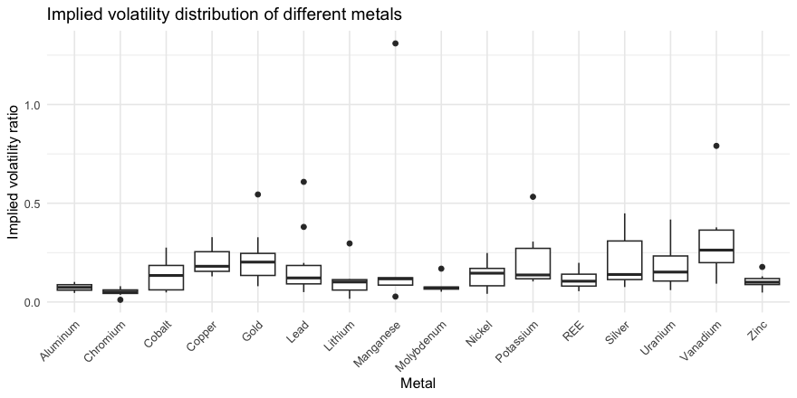
Kruskal-Wallis rank sum test
data: Implied volatility ratio by Metal
Kruskal-Wallis chi-squared = 37.755, df = 15, p-value = 0.0009807***

S3. Extended details and result of Metal Price Counterfactual Analysis

To assess the robustness of the Synthetic Control Method (SCM), we conducted a Root Mean Square Prediction Error (RMSPE) Ratio test on 115 policy sets. The RMSPE Ratio measures the deviation between the synthetic control group and actual observed data, with values closer to 1 indicating a better fit between the synthetic control and real-world outcomes.
A total of 21 policy sets had an RMSPE Ratio below 1, accounting for 18.26%. These sets demonstrated higher post-intervention fit accuracy, suggesting that SCM reliably simulated the market impact of these specific policies. Another 70 policy sets had RMSPE Ratios between 0.9 and 2, making up 61%. These cases exhibited relatively modest discrepancies between the synthetic controls and actual market performance, indicating stable fitting results and a reasonable representation of policy-induced market changes.
Overall, SCM effectively captured the market responses to most policy interventions. Particularly in sets where the RMSPE Ratio was close to 1, the synthetic controls closely tracked actual post-policy market trends, underscoring the method’s robustness in policy evaluation.
However, 18.26% of policy sets had RMSPE Ratios exceeding 2, reflecting significantly higher fitting errors. These outliers may be due to external shocks or limitations in the model specification. This highlights the high volatility of critical mineral markets, which tend to react more sensitively to policy interventions compared to traditional industrial goods or bulk commodities. Factors such as high market concentration, lack of substitutes, and strong geopolitical influences can cause actual market behavior to rapidly diverge from synthetic predictions—indicating greater policy impact, stronger nonlinear responses, and more pronounced price fluctuations in these cases.

Table S8: Robustness Tests for Synthetic Control Methods
Metal | End Data | Policy set | RMSPE Ratio
Molybdenum | 2014/2/1 | Molybdenum_set4 | 7.49890741
Lithium | 2021/4/1 | Lithium_set8 | 4.30236739
Manganese | 2020/2/1 | Manganese_set6 | 4.27101784
Manganese | 2018/11/1 | Manganese_set5 | 3.51606131
Manganese | 2018/2/1 | Manganese_set4 | 3.40957108
Gold | 2020/3/1 | Gold_set8 | 3.34071177
Gold | 2023/2/1 | Gold_set10 | 2.87227222
Uranium | 2021/2/1 | Uranium_set9 | 2.76064275
Lithium | 2020/2/1 | Lithium_set7 | 2.67373271
Nickel | 2022/8/1 | Nickel_set10 | 2.65996389
Chromium | 2019/6/1 | Chromium_set8 | 2.60526882
Vanadium | 2017/3/1 | Vanadium_set4 | 2.49286608
Lithium | 2013/8/1 | Lithium_set3 | 2.4261786
Zinc | 2017/2/1 | Zinc_set5 | 2.42156592
Molybdenum | 2017/2/1 | Molybdenum_set6 | 2.3725542
Aluminum | 2009/5/1 | Aluminum_set1 | 2.36328851
Molybdenum | 2016/1/1 | Molybdenum_set5 | 2.3545234
Gold | 2019/2/1 | Gold_set7 | 2.34672128
Lithium | 2018/2/1 | Lithium_set5 | 2.32416642
Nickel | 2013/6/1 | Nickel_set4 | 2.30928059
Lithium | 2016/10/1 | Lithium_set4 | 2.29592314
Lead | 2020/2/1 | Lead_set7 | 2.24386314
Lithium | 2019/2/1 | Lithium_set6 | 2.2417368
REE | 2016/4/1 | REE_set3 | 2.23372487
Molybdenum | 2020/4/1 | Molybdenum_set8 | 2.23195012
Vanadium | 2018/2/1 | Vanadium_set5 | 2.17263036
Nickel | 2012/6/1 | Nickel_set3 | 2.1689623
Potassium | 2021/8/1 | Potassium_set9 | 2.12127906
Cobalt | 2011/2/1 | Cobalt_set3 | 2.11677291
Lithium | 2012/8/1 | Lithium_set2 | 2.09553766
Manganese | 2022/4/1 | Manganese_set7 | 2.06442906
Uranium | 2014/1/1 | Uranium_set5 | 2.05671292
Chromium | 2016/7/1 | Chromium_set5 | 1.99335674
Lead | 2014/5/1 | Lead_set4 | 1.98816214
Nickel | 2010/2/1 | Nickel_set2 | 1.96528763
Uranium | 2013/2/1 | Uranium_set4 | 1.95736785
Cobalt | 2010/2/1 | Cobalt_set2 | 1.95315218
Copper | 2012/2/1 | Copper_set1 | 1.93119047
Silver | 2011/2/1 | Silver_set2 | 1.92679391
Copper | 2021/5/1 | Copper_set2 | 1.90699727
Uranium | 2012/6/1 | Uranium_set3 | 1.8942737
Nickel | 2009/3/1 | Nickel_set1 | 1.89323951
Nickel | 2021/5/1 | Nickel_set9 | 1.88320445
Cobalt | 2009/2/1 | Cobalt_set1 | 1.86545825
Cobalt | 2013/8/1 | Cobalt_set4 | 1.86139453
Nickel | 2016/2/1 | Nickel_set6 | 1.86033269
Zinc | 2010/2/1 | Zinc_set2 | 1.84017801
Lead | 2013/2/1 | Lead_set3 | 1.83098845
Gold | 2013/2/1 | Gold_set4 | 1.82257292
Silver | 2017/3/1 | Silver_set5 | 1.79138049
Zinc | 2009/3/1 | Zinc_set1 | 1.78001377
Uranium | 2011/2/1 | Uranium_set2 | 1.75175404
Molybdenum | 2018/12/1 | Molybdenum_set7 | 1.75034873
REE | 2017/2/1 | REE_set4 | 1.72919309
Gold | 2010/2/1 | Gold_set1 | 1.71064488
REE | 2018/2/1 | REE_set5 | 1.7000825
Gold | 2011/2/1 | Gold_set2 | 1.68143062
Gold | 2012/2/1 | Gold_set3 | 1.65507211
Silver | 2020/6/1 | Silver_set7 | 1.65397863
Silver | 2010/3/1 | Silver_set1 | 1.64376448
Zinc | 2019/6/1 | Zinc_set7 | 1.64211858
Gold | 2021/5/1 | Gold_set9 | 1.64160803
Gold | 2015/4/1 | Gold_set6 | 1.62838719
Cobalt | 2017/2/1 | Cobalt_set6 | 1.62723814
Silver | 2018/3/1 | Silver_set6 | 1.62627534
Uranium | 2009/3/1 | Uranium_set1 | 1.61818327
Potassium | 2019/2/1 | Potassium_set8 | 1.6048227
Cobalt | 2020/12/1 | Cobalt_set7 | 1.57163103
Gold | 2014/2/1 | Gold_set5 | 1.55796858
Lead | 2011/8/1 | Lead_set2 | 1.53748608
Lead | 2009/2/1 | Lead_set1 | 1.52024561
Uranium | 2019/8/1 | Uranium_set8 | 1.45771951
Lead | 2022/11/1 | Lead_set9 | 1.42046157
Silver | 2016/2/1 | Silver_set4 | 1.39472776
Vanadium | 2022/2/1 | Vanadium_set8 | 1.37214317
Silver | 2021/2/1 | Silver_set8 | 1.36231101
Zinc | 2018/5/1 | Zinc_set6 | 1.35169935
Nickel | 2020/2/1 | Nickel_set8 | 1.34189956
Nickel | 2023/4/1 | Nickel_set11 | 1.3213748
Chromium | 2021/2/1 | Chromium_set10 | 1.27660372
Cobalt | 2016/2/1 | Cobalt_set5 | 1.25496144
Chromium | 2018/2/1 | Chromium_set7 | 1.22999906
Zinc | 2013/6/1 | Zinc_set3 | 1.2008201
Zinc | 2014/2/1 | Zinc_set4 | 1.15175148
Vanadium | 2023/5/1 | Vanadium_set9 | 1.15092155
Potassium | 2012/3/1 | Potassium_set3 | 1.14420381
Potassium | 2011/4/1 | Potassium_set2 | 1.13594851
Chromium | 2020/2/1 | Chromium_set9 | 1.128066
Lead | 2023/8/1 | Lead_set10 | 1.12590456
Uranium | 2017/10/1 | Uranium_set7 | 1.11277992
Nickel | 2017/3/1 | Nickel_set7 | 1.10987063
Silver | 2013/3/1 | Silver_set3 | 1.09253347
Chromium | 2017/2/1 | Chromium_set6 | 1.07393321
Uranium | 2023/7/1 | Uranium_set10 | 1.05269589
Nickel | 2015/2/1 | Nickel_set5 | 0.99831885
Potassium | 2023/3/1 | Potassium_set10 | 0.99427081
Vanadium | 2019/2/1 | Vanadium_set6 | 0.9813365
Zinc | 2023/3/1 | Zinc_set8 | 0.950758
Vanadium | 2020/3/1 | Vanadium_set7 | 0.93314832
Cobalt | 2023/7/1 | Cobalt_set8 | 0.92053272
Potassium | 2018/3/1 | Potassium_set7 | 0.9157411
Lead | 2022/2/1 | Lead_set8 | 0.909982
Lead | 2017/2/1 | Lead_set5 | 0.874546
Potassium | 2017/2/1 | Potassium_set6 | 0.86983482
REE | 2024/2/1 | REE_set6 | 0.86207321
Lead | 2018/2/1 | Lead_set6 | 0.83749759
Potassium | 2010/2/1 | Potassium_set1 | 0.80712759
Aluminum | 2023/8/1 | Aluminum_set2 | 0.7801987
Potassium | 2016/5/1 | Potassium_set5 | 0.77939505
Potassium | 2015/2/1 | Potassium_set4 | 0.73180765
Chromium | 2023/2/1 | Chromium_set11 | 0.69421873
Copper | 2023/9/1 | Copper_set3 | 0.68901251
Uranium | 2016/2/1 | Uranium_set6 | 0.66196893
Potassium | 2023/11/1 | Potassium_set11 | 0.34191408
Manganese | 2023/7/1 | Manganese_set8 | 0.25247057

S4. Extended Result of Distribution of risk costs due to market uncertainty
This section presents extended results on the distributional patterns of risk costs induced by market uncertainty in the global critical minerals trade. Using counterfactual simulations and price volatility estimates, we quantify how different countries absorb or transmit economic losses when exposed to external market shocks.
Our analysis reveals a highly uneven global landscape of risk exposure. The results display the distribution of welfare losses across countries under different pooled shocks to metals policies, include the direct, indirect and total risk cost.
These findings underscore the asymmetric nature of market risk in the global critical minerals supply chain and highlight the need for tailored risk-mitigation strategies in policy design, particularly for vulnerable economies embedded in the downstream of mineral value chains.

Table S9: Scenario Setting for Metal Event Shocks
Metal | Year | Scenario | Metal | Year | Scenario | Metal | Year | Scenario
Aluminum | 2009 | s1 | Lithium | 2012 | s35 | REE | 2016 | s70
Chromium | 2016 | s2 | Lithium | 2013 | s36 | REE | 2017 | s71
Chromium | 2017 | s3 | Lithium | 2016 | s37 | REE | 2018 | s72
Chromium | 2018 | s4 | Lithium | 2018 | s38 | Silver | 2010 | s73
Chromium | 2019 | s5 | Lithium | 2019 | s39 | Silver | 2011 | s74
Chromium | 2020 | s6 | Lithium | 2020 | s40 | Silver | 2013 | s75
Chromium | 2021 | s7 | Lithium | 2021 | s41 | Silver | 2016 | s76
Cobalt | 2009 | s8 | Manganese | 2018 | s42 | Silver | 2017 | s77
Cobalt | 2010 | s9 | Manganese | 2018 | s43 | Silver | 2018 | s78
Cobalt | 2011 | s10 | Manganese | 2020 | s44 | Silver | 2020 | s79
Cobalt | 2013 | s11 | Manganese | 2022 | s45 | Silver | 2021 | s80
Cobalt | 2016 | s12 | Molybdenum | 2014 | s46 | Uranium | 2009 | s81
Cobalt | 2017 | s13 | Molybdenum | 2016 | s47 | Uranium | 2011 | s82
Cobalt | 2020 | s14 | Molybdenum | 2017 | s48 | Uranium | 2012 | s83
Copper | 2012 | s15 | Molybdenum | 2018 | s49 | Uranium | 2013 | s84
Copper | 2021 | s16 | Molybdenum | 2020 | s50 | Uranium | 2014 | s85
Gold | 2010 | s17 | Nickel | 2009 | s51 | Uranium | 2016 | s86
Gold | 2011 | s18 | Nickel | 2010 | s52 | Uranium | 2017 | s87
Gold | 2012 | s19 | Nickel | 2012 | s53 | Uranium | 2019 | s88
Gold | 2013 | s20 | Nickel | 2013 | s54 | Uranium | 2021 | s89
Gold | 2014 | s21 | Nickel | 2015 | s55 | Vanadium | 2017 | s90
Gold | 2015 | s22 | Nickel | 2016 | s56 | Vanadium | 2018 | s91
Gold | 2019 | s23 | Nickel | 2017 | s57 | Vanadium | 2019 | s92
Gold | 2020 | s24 | Nickel | 2020 | s58 | Vanadium | 2020 | s93
Gold | 2021 | s25 | Nickel | 2021 | s59 | Vanadium | 2022 | s94
Lead | 2009 | s26 | Nickel | 2022 | s60 | Zinc | 2009 | s95
Lead | 2011 | s27 | Potassium | 2010 | s61 | Zinc | 2010 | s96
Lead | 2013 | s28 | Potassium | 2011 | s62 | Zinc | 2013 | s97
Lead | 2014 | s29 | Potassium | 2012 | s63 | Zinc | 2014 | s98
Lead | 2017 | s30 | Potassium | 2015 | s64 | Zinc | 2017 | s99
Lead | 2018 | s31 | Potassium | 2016 | s65 | Zinc | 2018 | s100
Lead | 2020 | s32 | Potassium | 2017 | s66 | Zinc | 2019 | s101
Lead | 2022 | s33 | Potassium | 2018 | s67
Lead | 2022 | s34 | Potassium | 2019 | s68
 |  |  | Potassium | 2021 | s69
Distribution of risk costs due to market uncertainty
Because the Exiobase data ends in 2022, a portion of the policy set of scenarios (16) is removed

Fig S5: Distribution of Welfare Loss Densities across Countries under Different Pooled Metal Policy Shocks (PEE Direct)

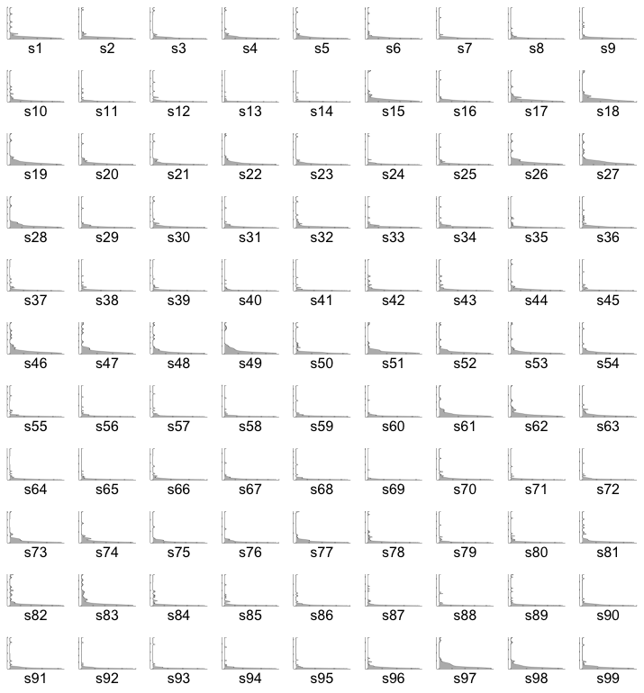

Fig S6: Distribution of Welfare Loss Densities across Countries under Different Pooled Metal Policy Shocks (PEE indirect)

Fig S7: Distribution of Welfare Loss Densities across Countries under Different Pooled Metal Policy Shocks (PEE total)

Fig S8: Distribution of Welfare Losses across Countries under Different Pooled Shocks to Metals Policies
(We have divided the welfare losses by quartiles of 6 and assigned different colors)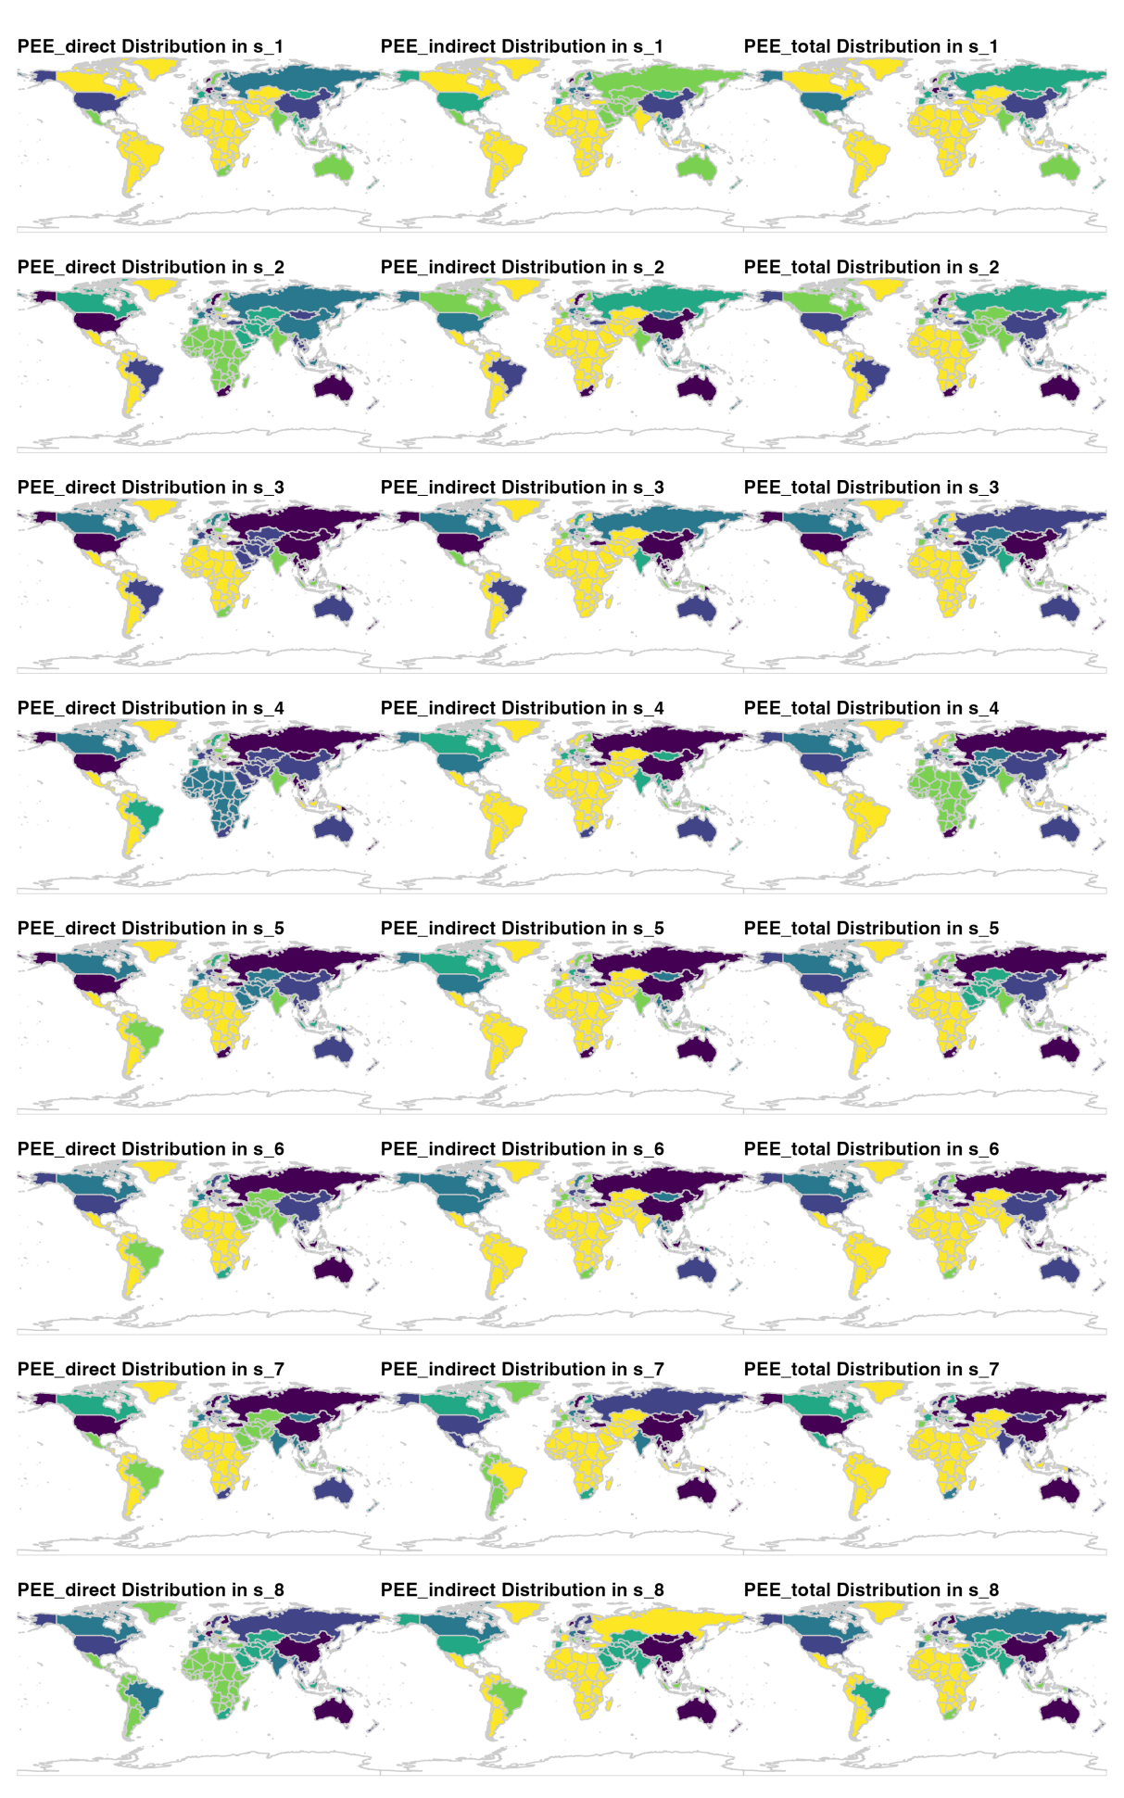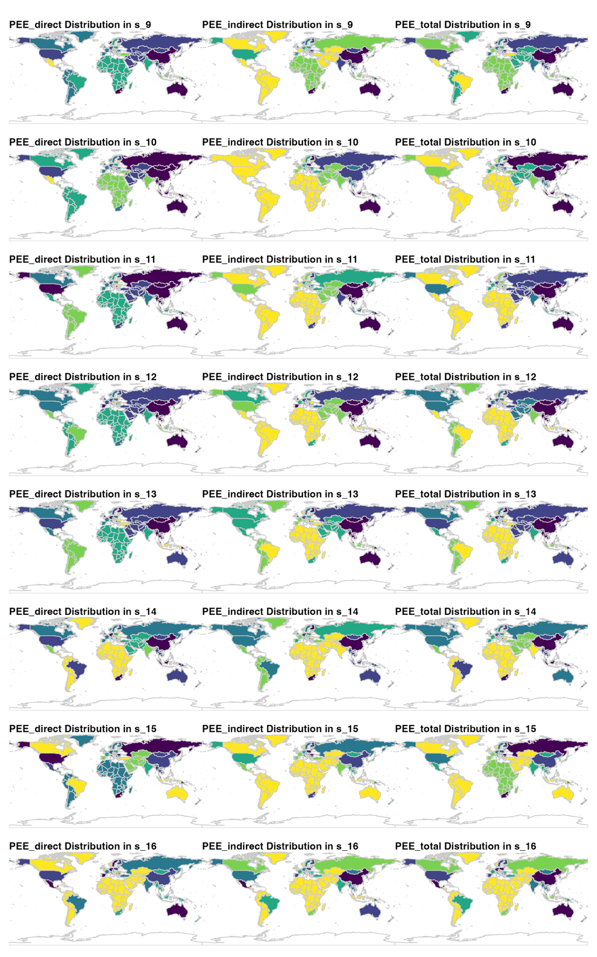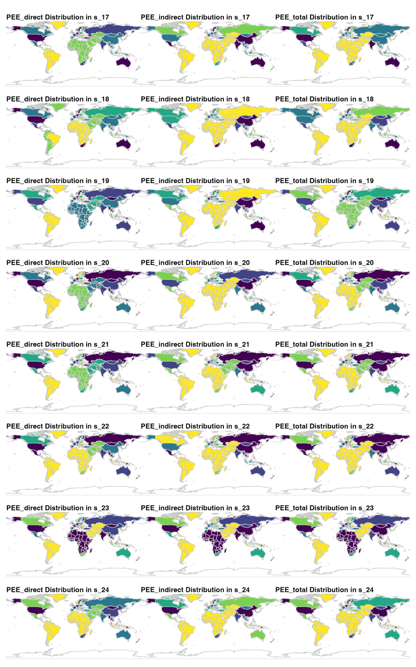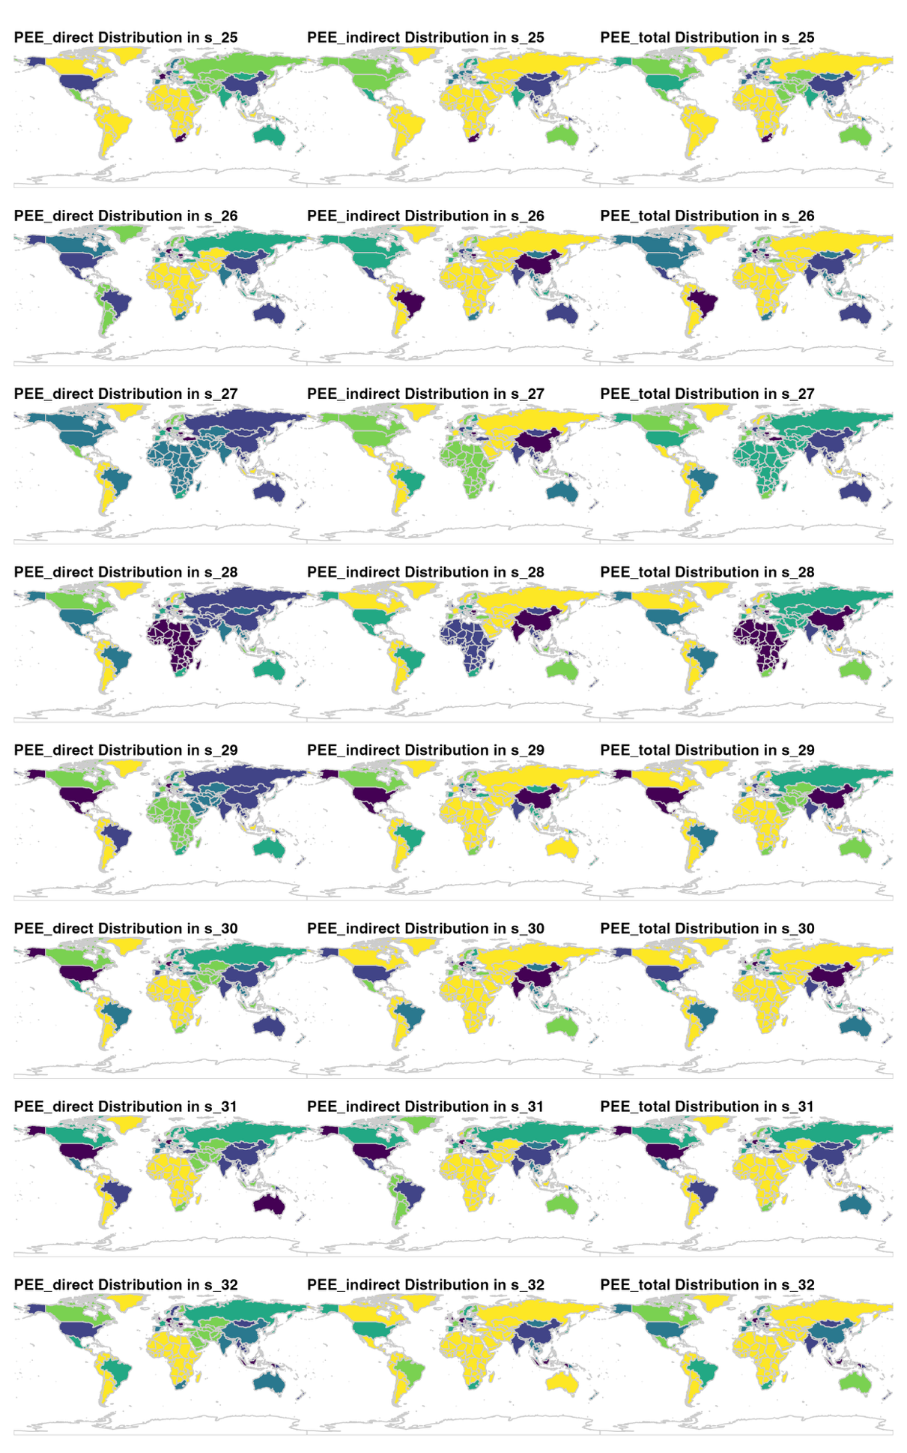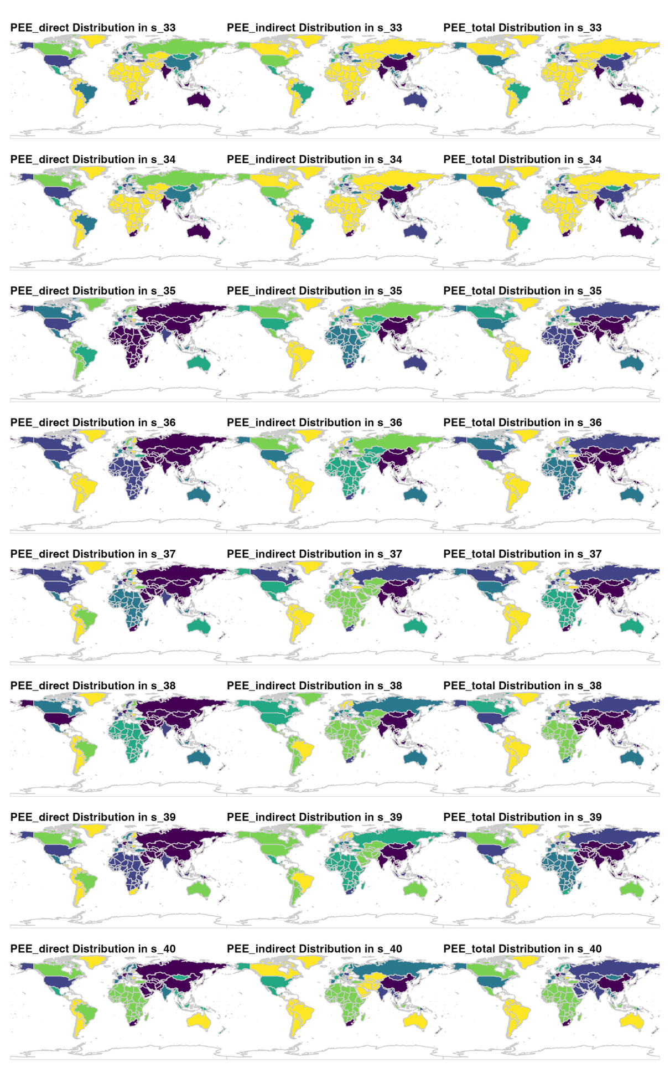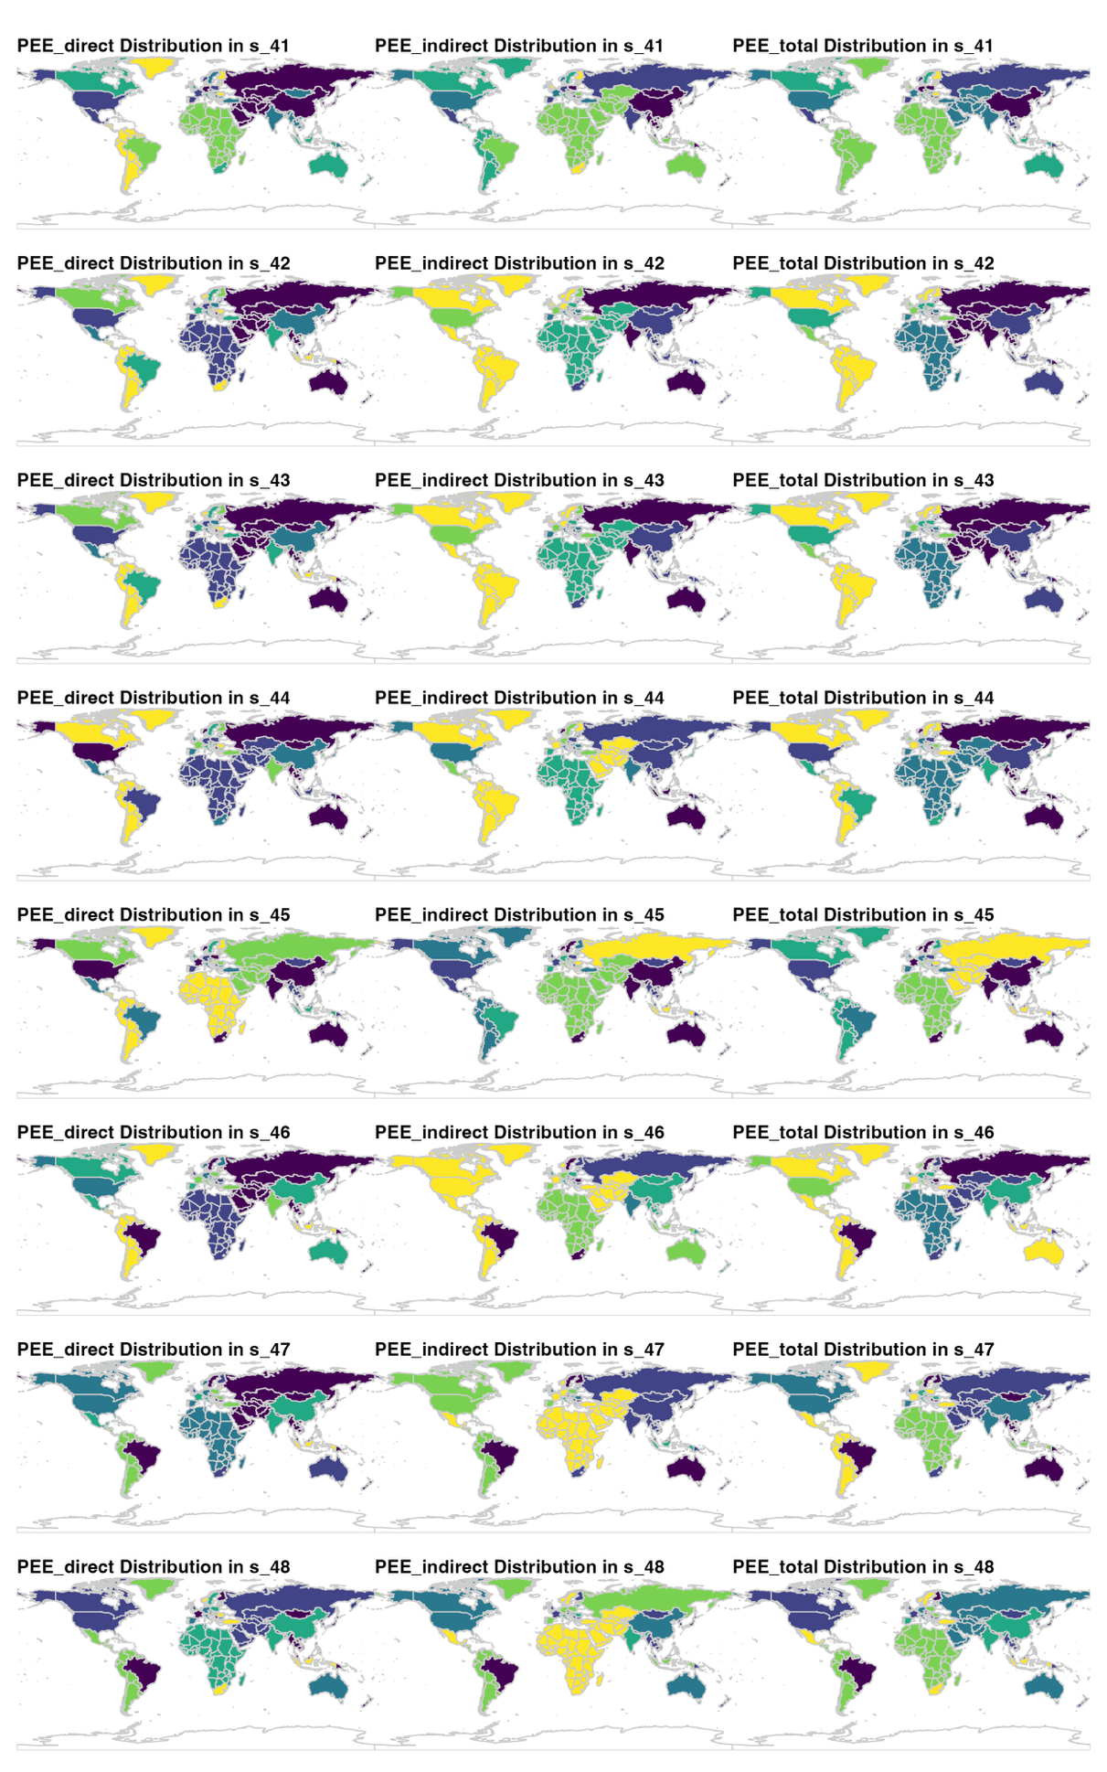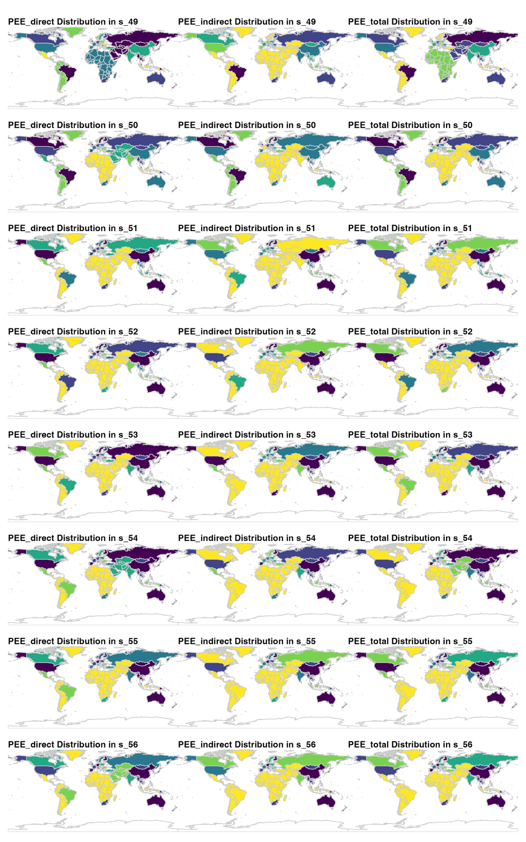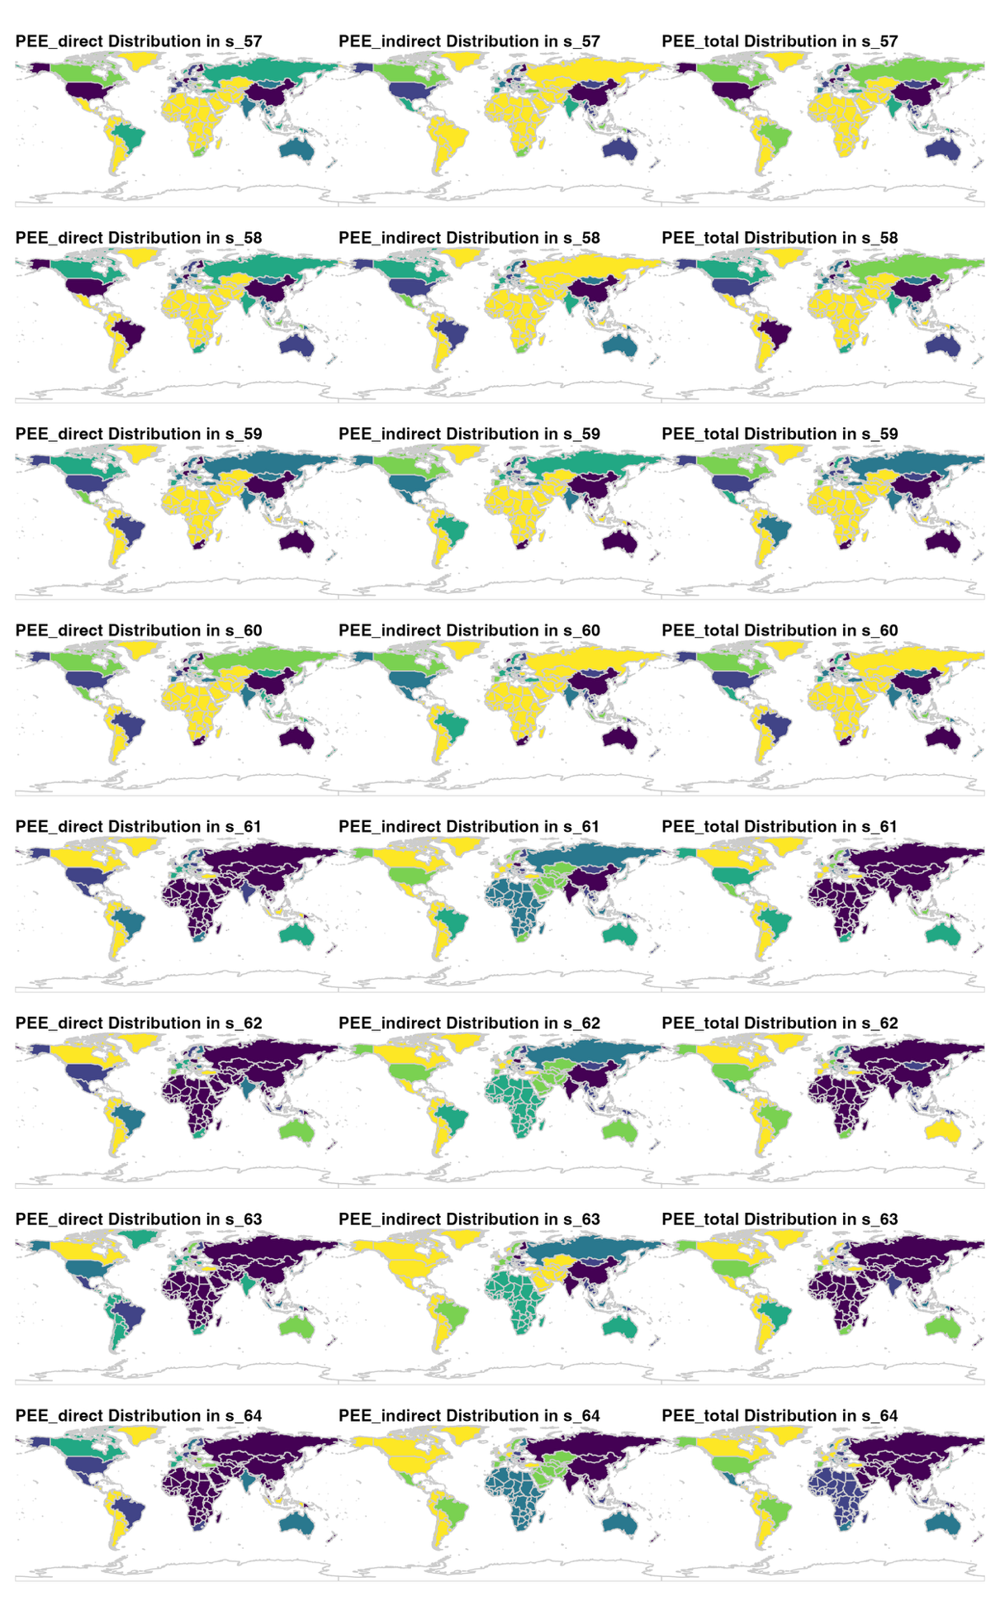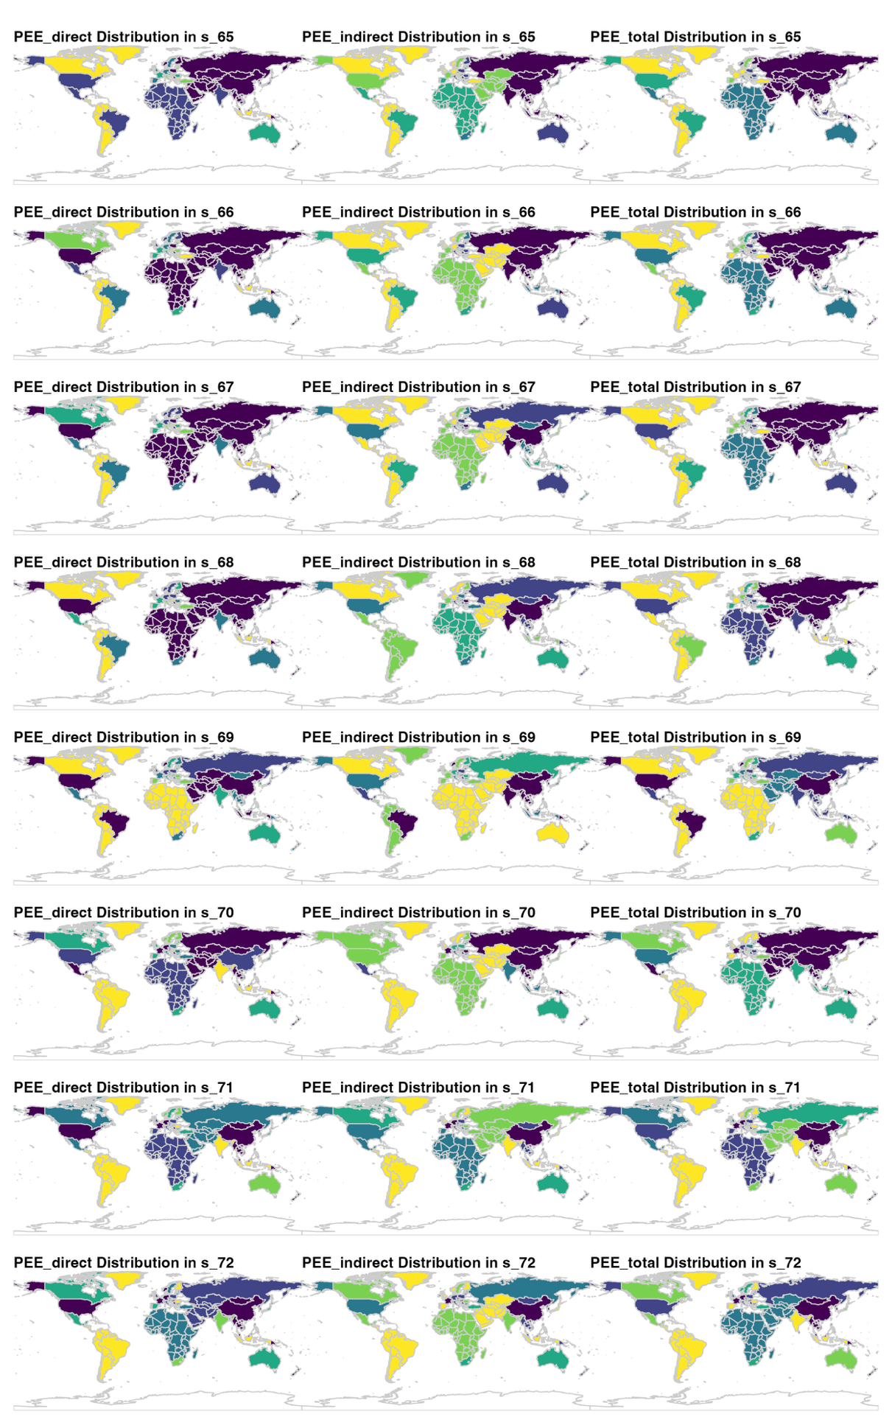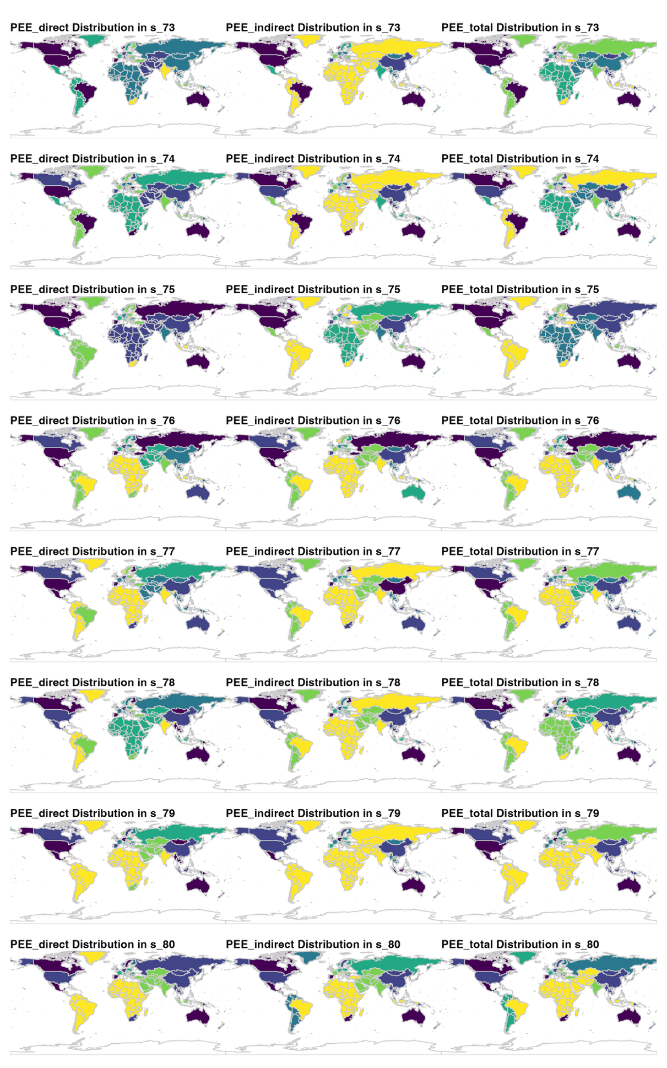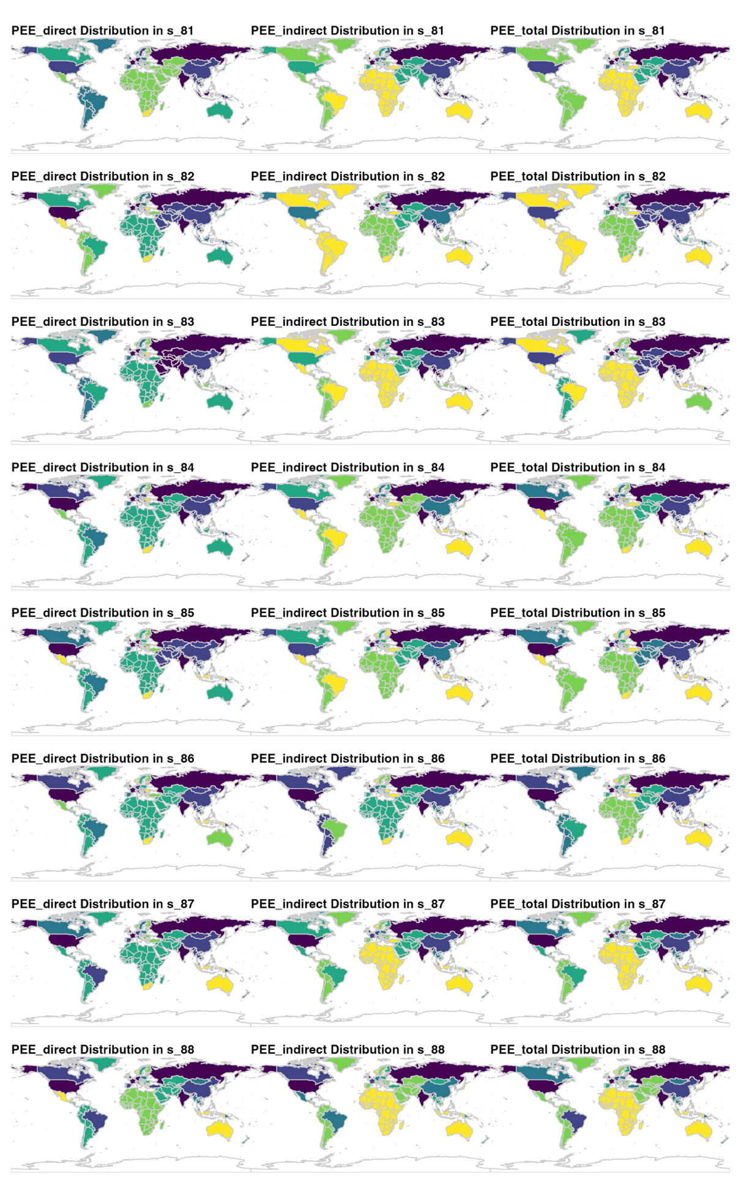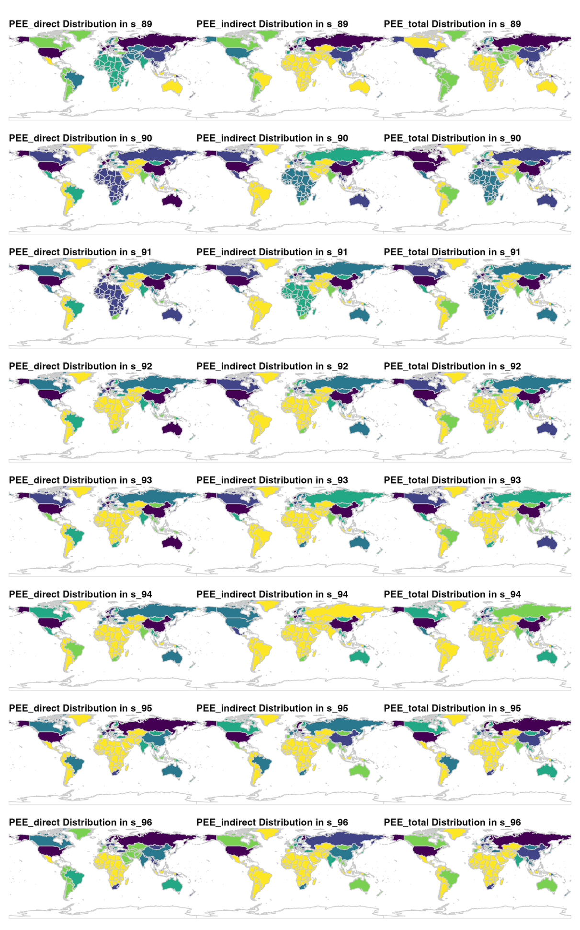

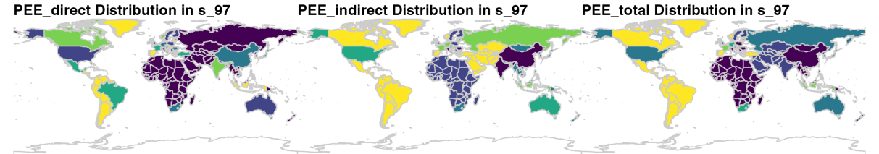

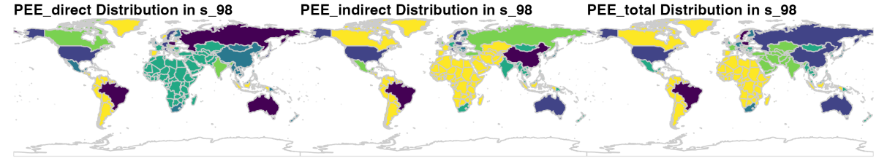
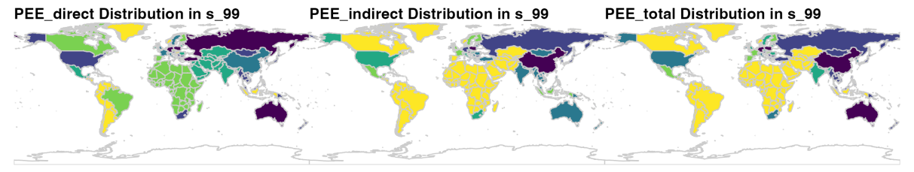

S5. Extended details of Sources and Processing of Primary Data

Table S10: Sources of metal content data

Metal | References
Aluminum | Liu, Gang, and Daniel B. Müller. "Mapping the global journey of anthropogenic aluminum: a trade-linked multilevel material flow analysis." Environmental science & technology 47.20 (2013): 11873-11881.
Chromium | Gao, Ziyan, et al. "Mapping the global anthropogenic chromium cycle: implications for resource efficiency and potential supply risk." Environmental Science & Technology 56.15 (2022): 10904-10915.
Cobalt | Liu, Litao, et al. "Spatiotemporal and Multilayer Trade Network Patterns of the Global Cobalt Cycle." Environmental Science & Technology 58.34 (2024): 15066-15077.
Copper | Liu, Litao, et al. "Spatiotemporal and Multilayer Trade Network Patterns of the Global Cobalt Cycle." Environmental Science & Technology 58.34 (2024): 15066-15077.
Gold | Liu, Sijie, et al. "Uncovering the key features of gold flows and stocks in China." Resources Policy 82 (2023): 103584.
Lead | Johnson, Jeremiah, and T. E. Graedel. "The “hidden” trade of metals in the United States." Journal of Industrial Ecology 12.5‐6 (2008): 739-753.
Lithium | Yang, Ping, et al. "Lithium resource allocation optimization of the lithium trading network based on material flow." Resources Policy 74 (2021): 102356.
Manganese | Sun, Xin, et al. "Insights into the global flow pattern of manganese." Resources policy 65 (2020): 101578.
Molybdenum | Nakajima, Kenichi, et al. "Simultaneous material flow analysis of nickel, chromium, and molybdenum used in alloy steel by means of input–output analysis." Environmental science & technology 47.9 (2013): 4653-4660.
Nickel | Sun, Xin, et al. "Physical and monetary characterization of global nickel flow network." Resources Policy 94 (2024): 105130.
Potassium | Song, Xiaoqian, et al. "Dynamic potassium flows analysis in China for 2010–2019." Resources Policy 78 (2022): 102803.
REE | Haque, N., Hughes, A., Lim, S., & Vernon, C. (2014). Rare earth elements: Overview of mining, mineralogy, uses, sustainability and environmental impact. Resources, 3(4), 614-635.  Guyonnet, D., Planchon, M., Rollat, A., Escalon, V., Tuduri, J., Charles, N., ... & Fargier, H. (2015). Material flow analysis applied to rare earth elements in Europe. Journal of Cleaner Production, 107, 215-228.  Chen, P., Ilton, E. S., Wang, Z., Rosso, K. M., & Zhang, X. (2024). Global rare earth element resources: A concise review. Applied Geochemistry, 106158.  Zhou, B., Li, Z., & Chen, C. (2017). Global potential of rare earth resources and rare earth demand from clean technologies. Minerals, 7(11), 203.  Balaram, V. (2019). Rare earth elements: A review of applications, occurrence, exploration, analysis, recycling, and environmental impact. Geoscience Frontiers, 10(4), 1285-1303.  Gkika, D. A., Chalaris, M., & Kyzas, G. Z. (2024). Review of methods for obtaining rare earth elements from recycling and their impact on the environment and human health. Processes, 12(6), 1235.  Bown, C. P. (2020). US-China trade war tariffs: An up-to-date chart. Peterson Institute for International Economics, 14.  Mayer, T., & Zignago, S. (2011). Notes on CEPII’s distances measures: The GeoDist database.  Klein, J. P. (2020). Depending on China for rare earth elements: an acceptable strategic vulnerability for the United States? (Doctoral dissertation, Fort Leavenworth, KS: US Army Command and General Staff College).  Zhang, H., Cao, H., & Guo, Y. (2024). The time-varying impact of geopolitical relations on rare earth trade networks: What is the role of China's rare earth export restrictions?. Technological Forecasting and Social Change, 206, 123550.  U.S. Geological Survey. (2024). Rare earths statistics and information. Retrieved from https://www.usgs.gov/centers/national-minerals-information-center/mineral  Raimi, D., Zhu, Y., Newell, R. G., & Prest, B. C. (2024). Global Energy Outlook 2024: Peaks or Plateaus. Resources for the future.
Silver | Johnson, Jeremiah, and T. E. Graedel. "The “hidden” trade of metals in the United States." Journal of Industrial Ecology 12.5‐6 (2008): 739-753.
Uranium | International Atomic Energy Agency
Vanadium | Graedel, T. E., and Alessio Miatto. "Vanadium: A US perspective on an understudied metal." Environmental Science & Technology 57.24 (2023): 8933-8942.
Zinc | Rostek, Leon, and Antonia Loibl. "Linking regional MFA models: Understanding disparities within the global zinc cycle." Journal of Industrial Ecology 29.1 (2025): 173-184.

The data of Price：
- Gruss, Bertrand, and Suhaib Kebhaj. Commodity terms of trade: A new database. International Monetary Fund, 2019. https://www.imf.org/en/Research/commodity-prices#:~:text=Use%20the%20Commodity%20Data%20Portal%20to%20visualize%20and,commodity%20asset%20classes%3A%20energy%2C%20agriculture%2C%20fertilizers%2C%20and%20metals.
- National Minerals Information Center, USGS. Historical Statistics for Mineral and Material Commodities in the United States, https://www.usgs.gov/centers/national-minerals-information-center/historical-statistics-mineral-and-material-commodities

