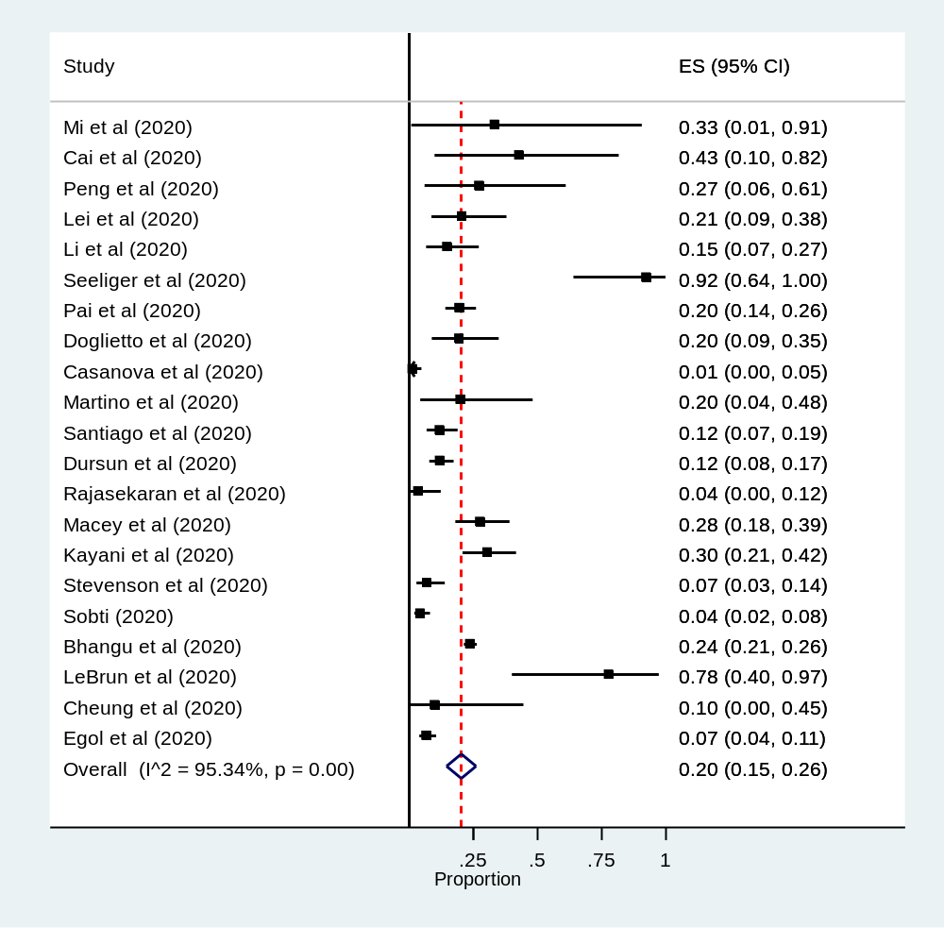Fig 2: Forest plot for the global prevalence of perioperative mortality among surgical patients with COVID-19: The midpoint of each line illustrates the prevalence; the horizontal line indicates the confidence interval, and the diamond shows the pooled prevalence.

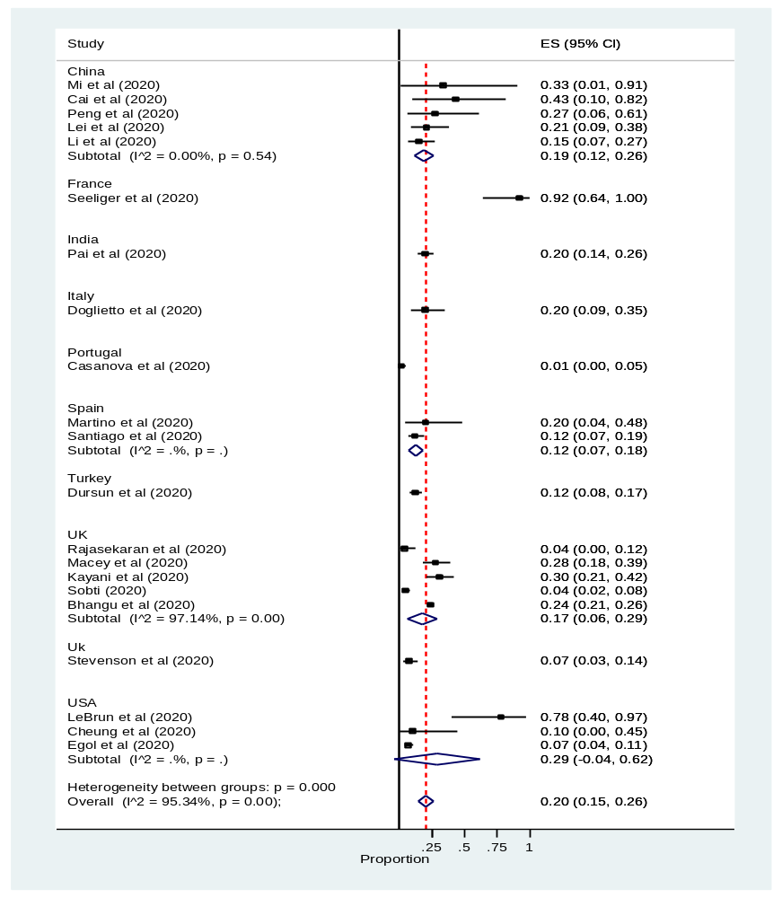Supplemental Fig 1: Forest plot for subgroup analysis of the prevalence of mortality among surgical patients with COVID-19 by country. The midpoint of each line illustrates the prevalence; the horizontal line indicates the confidence interval, and the diamond shows the pooled prevalence
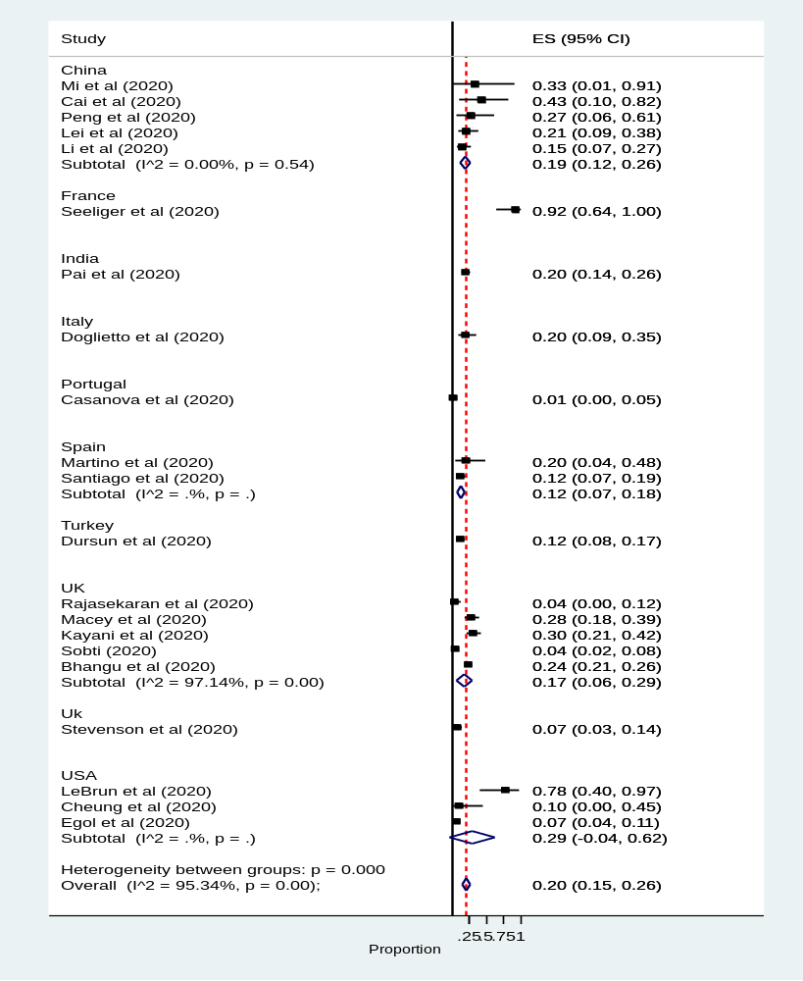Fig 3: Forest plot for the global prevalence of perioperative mortality among surgical patients with COVID-19 by types of surgery: The midpoint of each line illustrates the prevalence; the horizontal line indicates the confidence interval, and the diamond shows the pooled prevalence.

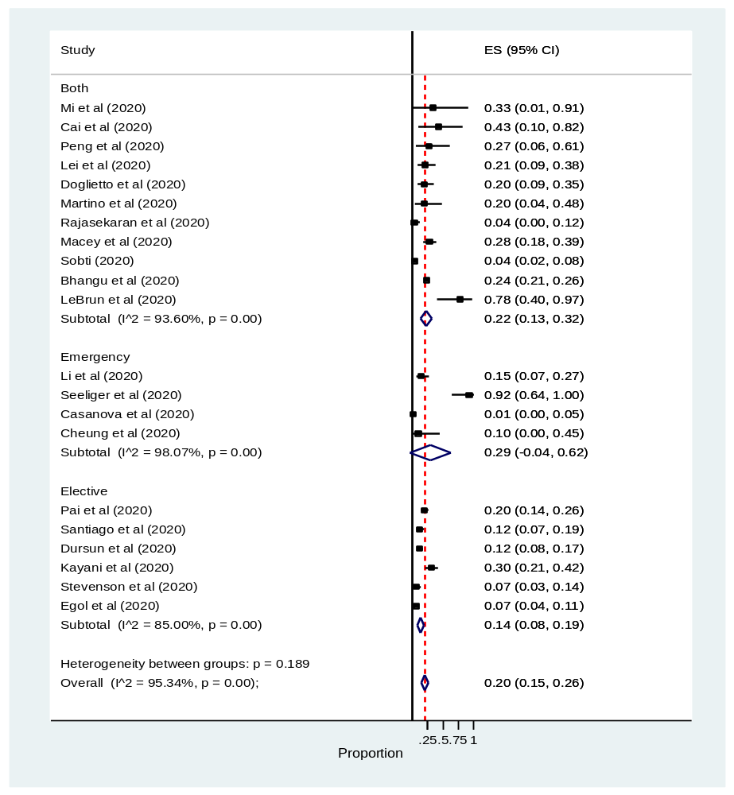Fig 4: Forest plot for the global prevalence of perioperative mortality among surgical patients with COVID-19 by urgency of surgery: The midpoint of each line illustrates the prevalence; the horizontal line indicates the confidence interval, and the diamond shows the pooled prevalence.

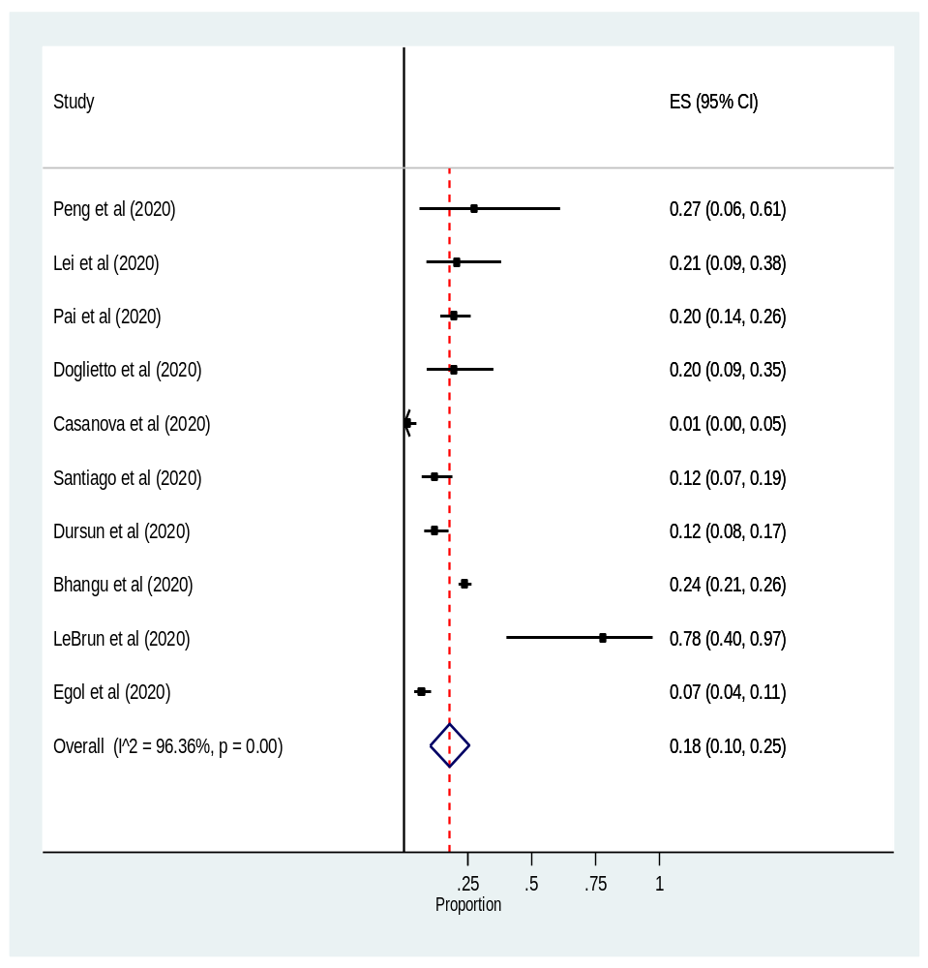
Fig 4: Forest plot for the prevalence of perioperative comorbidity among surgical patients with COVID-19: The midpoint of each line illustrates the prevalence; the horizontal line indicates the confidence interval, and the diamond shows the pooled prevalence.

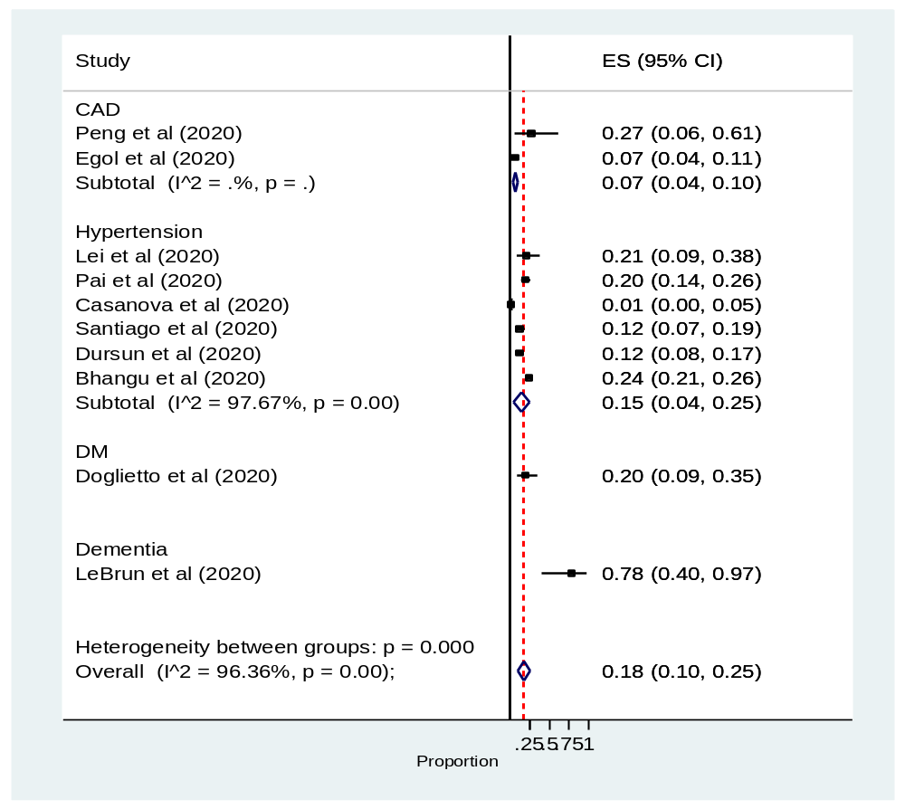Fig 5: Forest plot for the subgroup analysis of prevalence of perioperative comorbidity among surgical patients with COVID-19 by types of comorbidity: The midpoint of each line illustrates the prevalence; the horizontal line indicates the confidence interval, and the diamond shows the pooled prevalence.

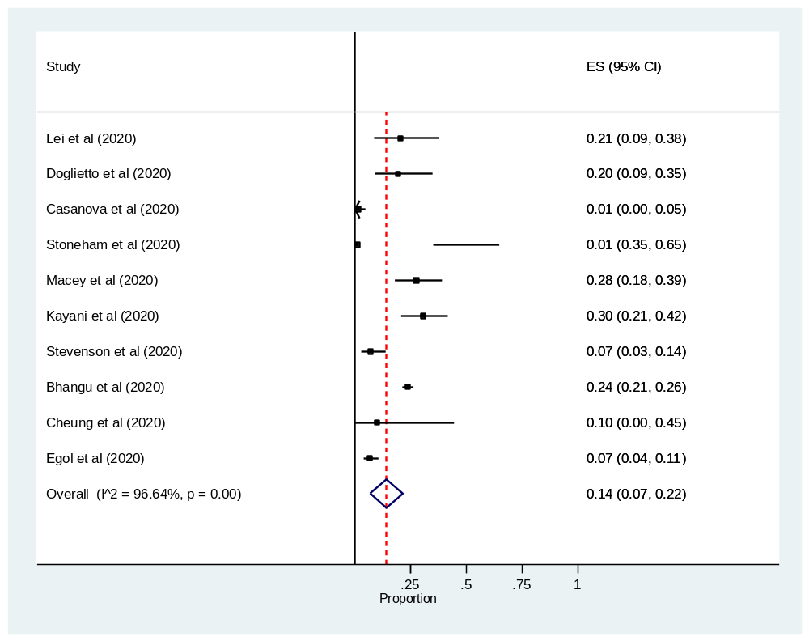Fig 5: Forest plot for prevalence of perioperative complication among surgical patients with COVID-19: The midpoint of each line illustrates the prevalence; the horizontal line indicates the confidence interval, and the diamond shows the pooled prevalence

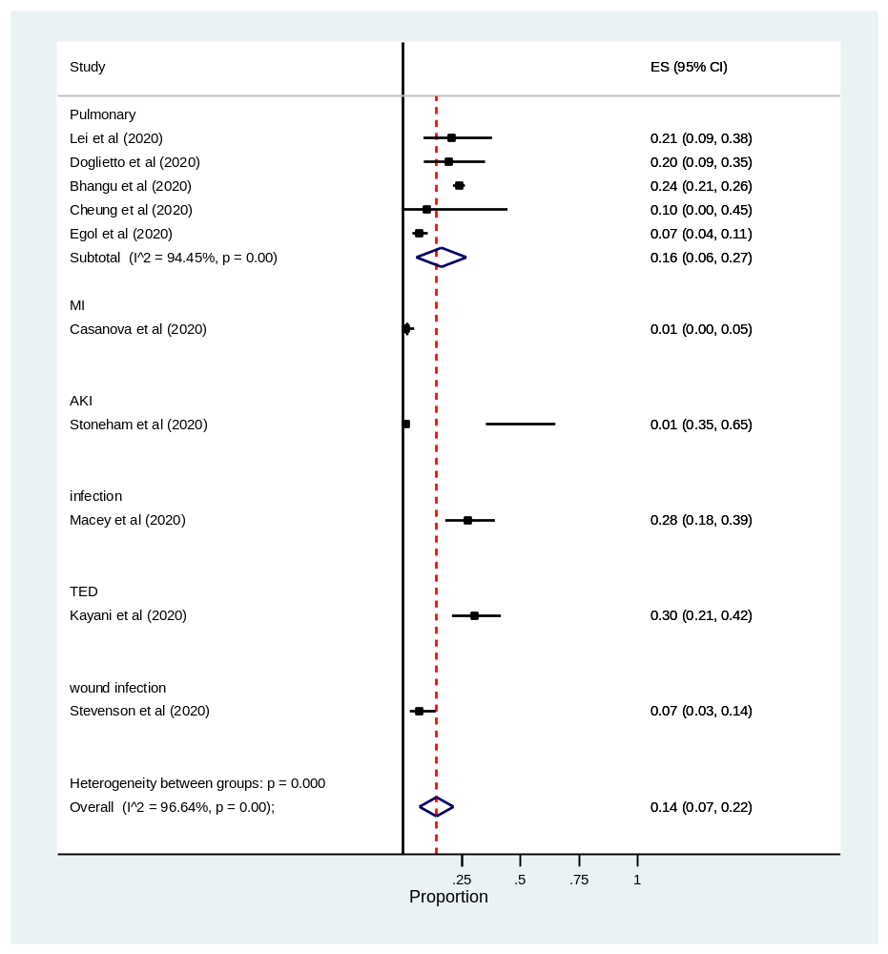
Fig 6: Forest plot for sub-group analysis of prevalence of perioperative complication among surgical patients with COVID-19 by types of complication: The midpoint of each line illustrates the prevalence; the horizontal line indicates the confidence interval, and the diamond shows the pooled prevalence

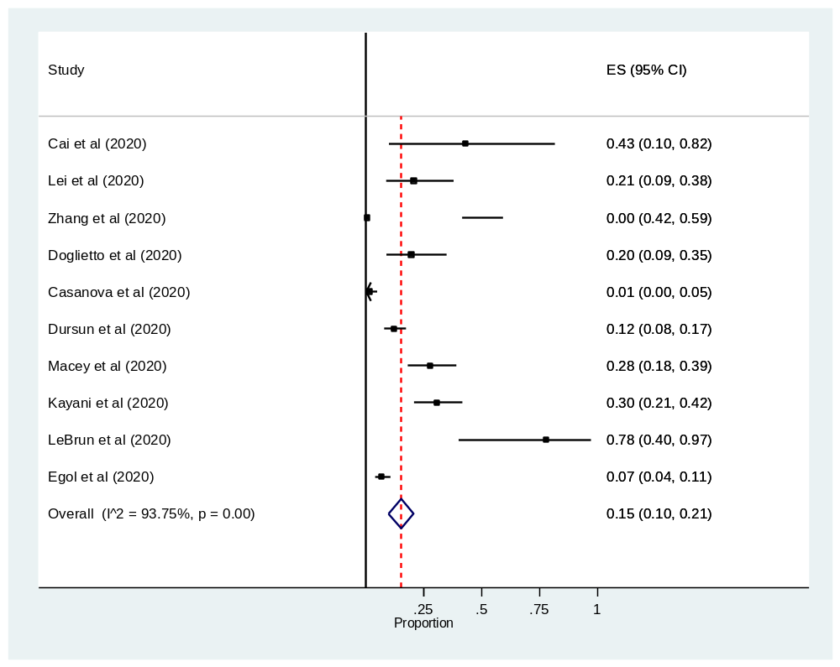
Fig 7: Forest plot for rates postoperative ICU admission among surgical patients with COVID-19: The midpoint of each line illustrates the prevalence; the horizontal line indicates the confidence interval, and the diamond shows the pooled prevalence

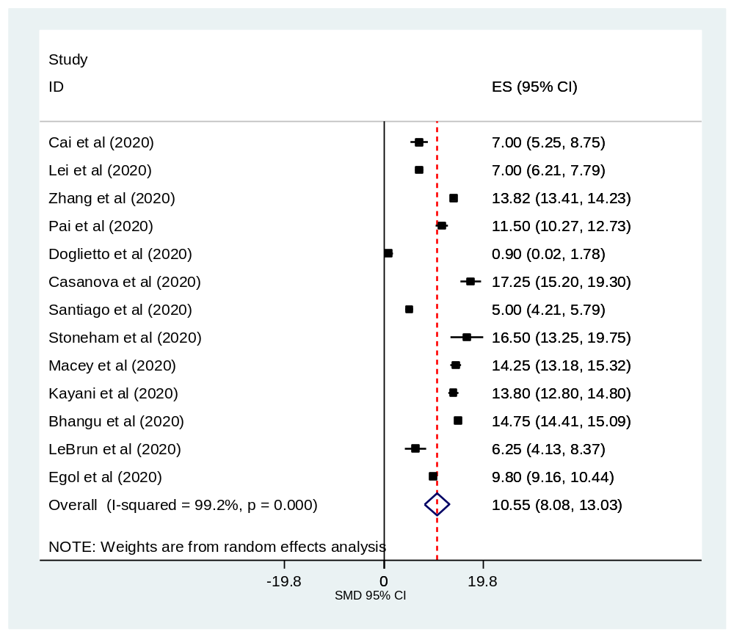Fig 8: Forest plot for length of hospital stay among surgical patients with COVID-19: The midpoint of each line illustrates the prevalence; the horizontal line indicates the confidence interval, and the diamond shows the pooled prevalence

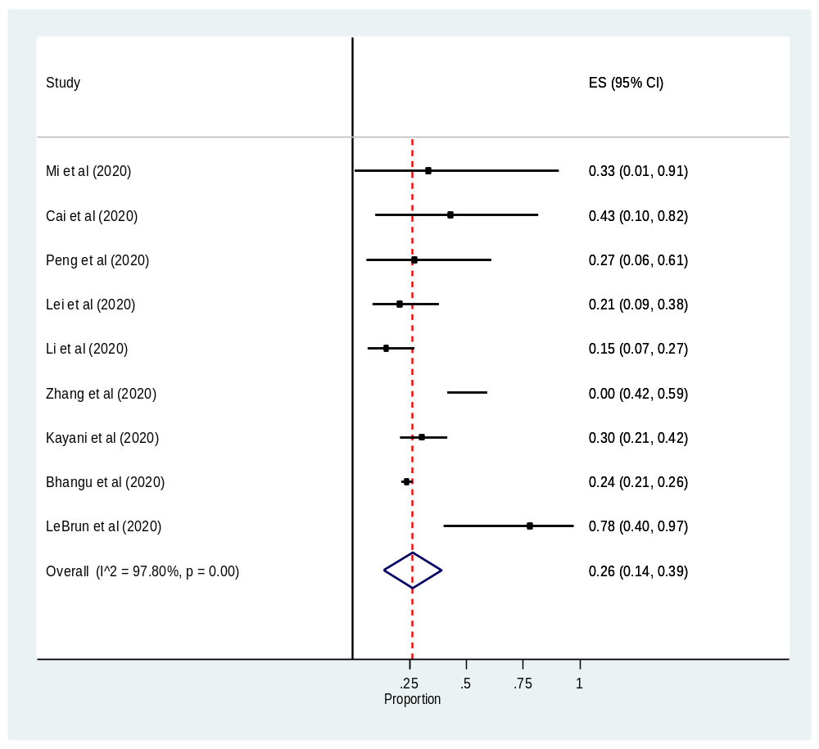
Fig 8: Forest plot for prevalence of clinical presentation among surgical patients with COVID-19: The midpoint of each line illustrates the prevalence; the horizontal line indicates the confidence interval, and the diamond shows the pooled prevalence

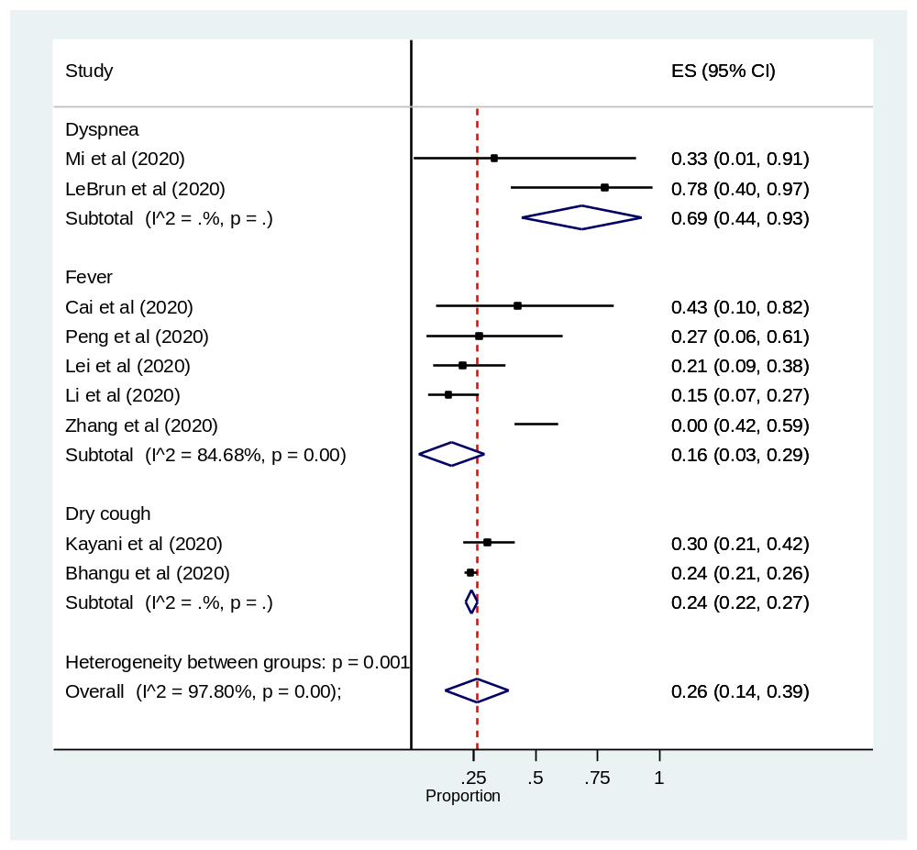
Fig 9: Forest plot for subgroup analysis of prevalence of clinical presentation among surgical patients with COVID-19 by types of presentations: The midpoint of each line illustrates the prevalence; the horizontal line indicates the confidence interval, and the diamond shows the pooled prevalence

