Supplementary File

Supplementary Fig 1:Number of rare and unique alleles from 16 loci of Pterocarpus santalinus

Supplementary Fig 2 a. Genetic diversity analysis of Pterocarpus santalinusacross the different altitude groups in the Eastern Ghats, Andhra Pradesh. b. Map showing populations under three latitude groups, L1(14.5 to 15.3 °N), L2(14.0 to 14.5 °N), and L3(13.0 to 13.9°N).Ne: number of effective alleles, I: Shannon's Information Index, Ho: observed heterozygosity, He: expected heterozygosity, F: fixation index, Pa: number of private alleles.

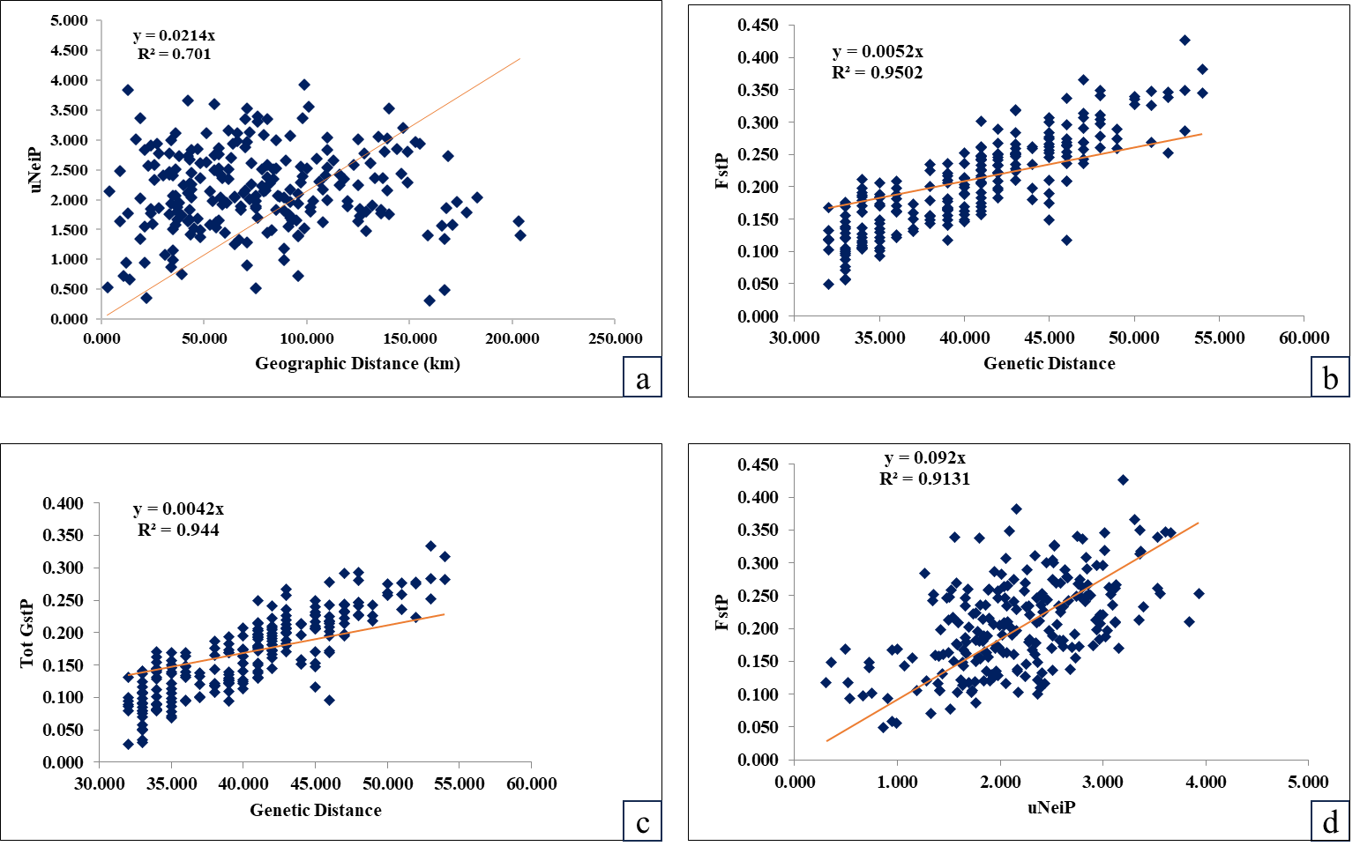
Supplementary Fig 3: Mantel test for a relationship between a. Pairwise population matrix of Nei’s unbiased genetic distance and geographic distance. b. Pairwise F_{ST}and genetic distance. c. G_{ST} matrix and genetic distance. d. Pairwise F_{ST} and Pairwise population matrix of Nei’s unbiased genetic distance.

Supplementary Fig 4: Major environmental factors over three decades (1981 to 2022) inthe distribution range of Pterocarpus santalinus populations in Eastern Ghats, Andhra Pradesh, India. a. Temperature, b. Relative humidity, c. Wind direction, d. Precipitation of all data presented in annual mean with standard deviation.

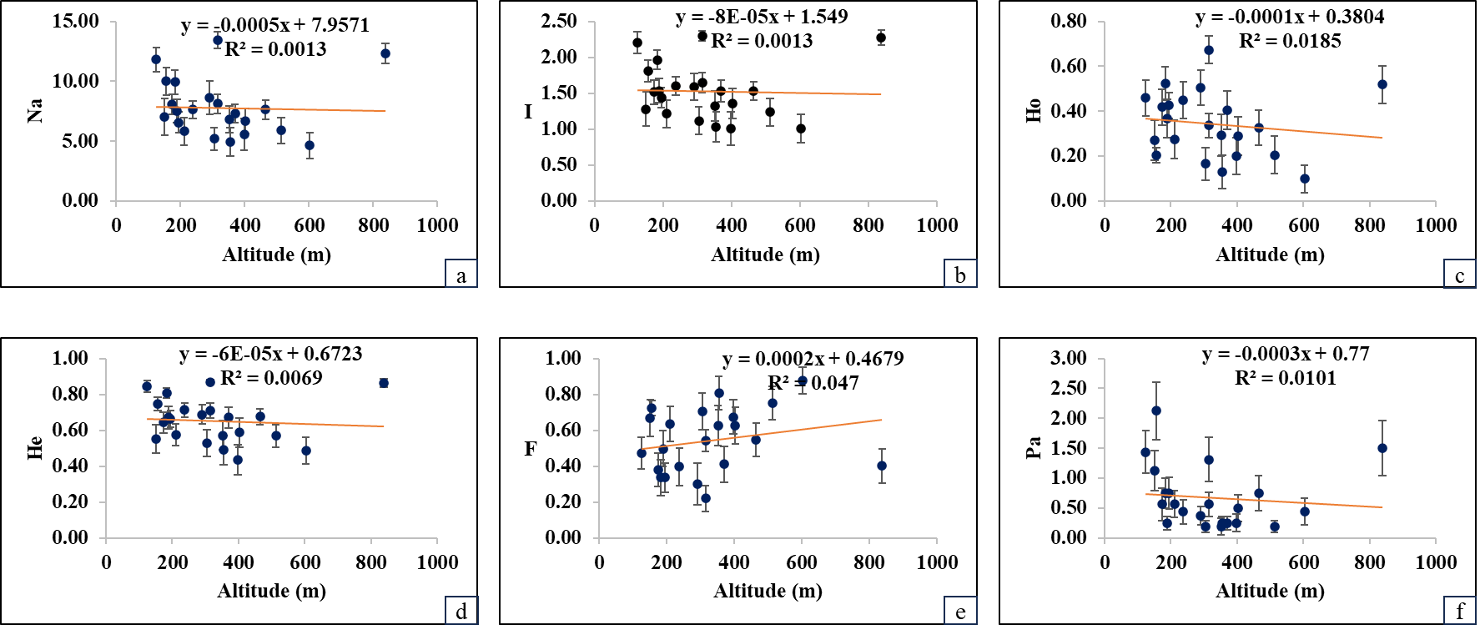
Supplementary Fig 5: Altitude with Genetic diversity indices (a to f) of Pterocarpus santalinus populations in Eastern Ghats,Andhra Pradesh, India. No significant relationship was found between them. Na: number of alleles, Ho: observed heterozygosity, He: expected heterozygosity, I: Shannon's Information Index, F: fixation index, Pa: number of private alleles.

Supplementary Fig 6: Latitude with Genetic diversity indices (a to f) of Pterocarpus santalinus populations in Eastern Ghats, Andhra Pradesh, India. Na: number of alleles, Ho: observed heterozygosity, He: expected heterozygosity, I: Shannon's Information Index, F: fixation index, Pa: number of private alleles.

Supplementary Fig 7: Mean Annual Temperature with Genetic Diversity Indices of Pterocarpus santalinus populations in Eastern Ghats,Andhra Pradesh, India. No significant relationship was found between the genetic parameters. Na: number of alleles, Ho: observed heterozygosity, He: expected heterozygosity, I: Shannon's Information Index, F: fixation index, Pa: number of private alleles.

Supplementary Fig 8: Mean Relative Humidity with Genetic Diversity Indices of Pterocarpus santalinus populations in Eastern Ghats, Andhra Pradesh, India. No significant relationship was found between the genetic parameters.. Na: number of alleles, Ho: observed heterozygosity, He: expected heterozygosity, I: Shannon's Information Index, F: fixation index, Pa: number of private alleles.

Supplementary Fig 9: Mean Annual Precipitation with Genetic diversity indices of Pterocarpus santalinus populations in Eastern Ghats, Andhra Pradesh, India. A positive and significant relationship was found between genetic parameters. Na: number of alleles, Ho: observed heterozygosity, He: expected heterozygosity, I: Shannon's Information Index, F: fixation index, Pa: number of private alleles.

Supplementary Fig 10: Mean Annual Precipitation with Genetic diversity indices for three latitude groups of Pterocarpus santalinus populations in Eastern Ghats, Andhra Pradesh, India. A positive and trend of significant relationship was found between the genetic parameters. Na: number of alleles, Ho: observed heterozygosity, He: expected heterozygosity, I: Shannon's Information Index, F: fixation index, Pa: number of private alleles.

b
a
Supplementary Fig 11: a.Genetic diversity analysis of Pterocarpus santalinus across thethree Circles of forest classification based on Andhra Pradesh Forest Department. b. Map showing populations under three different forest circles in the Eastern Ghats, Andhra Pradesh, India. Na: number of alleles, Ne: number of effective alleles, I: Shannon's Information Index, Ho: observed heterozygosity, He: expected heterozygosity, F: fixation index, Pa: number of private alleles.

b
a

Supplementary Fig 12. a.Genetic diversity analysis of Pterocarpus santalinus across theDivision-Wise Forest classification based on Andhra Pradesh Forest Department. b. Mapshowcases the population distribution across various forest divisions in the Eastern Ghats region of Andhra Pradesh, India.

CTR-Chitoor; NLR-Nellore; GDR-Giddaluru; KDP-Kadapa; NDL- Nandyal; PDT-Podratur; RJT-Rajampet; TPT-Tirupati. N: mean number of samples, Na: number of alleles, Ne: number of effective alleles, I: Shannon's Information Index, Ho: observed heterozygosity, He: expected heterozygosity, F: fixation index, Pa: number of private alleles.

