Pathology slides;

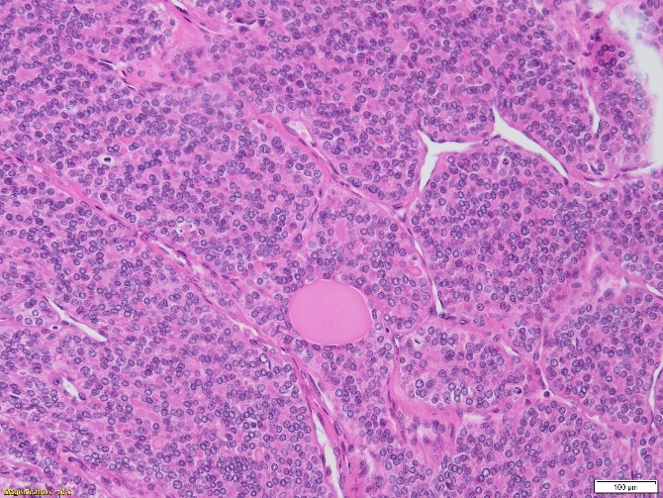
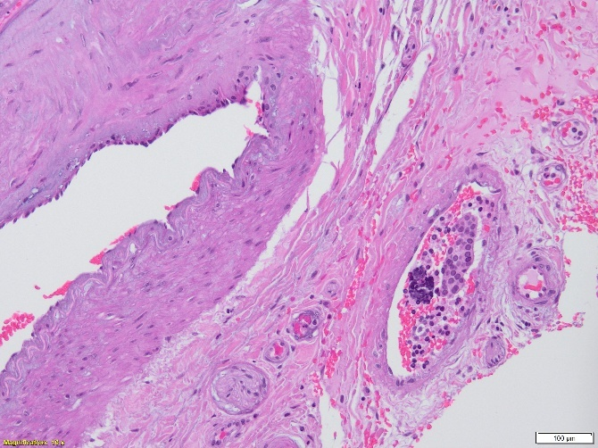
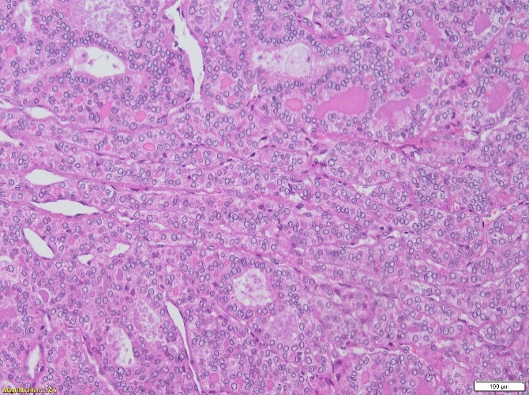
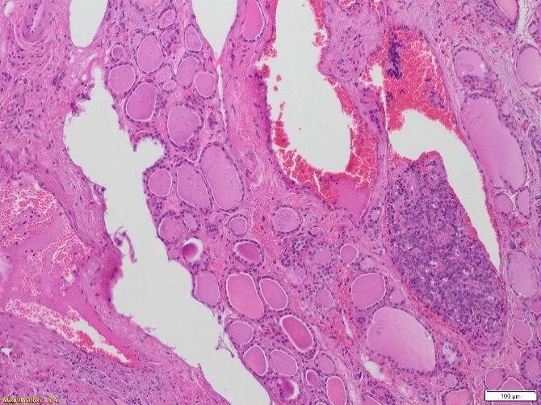
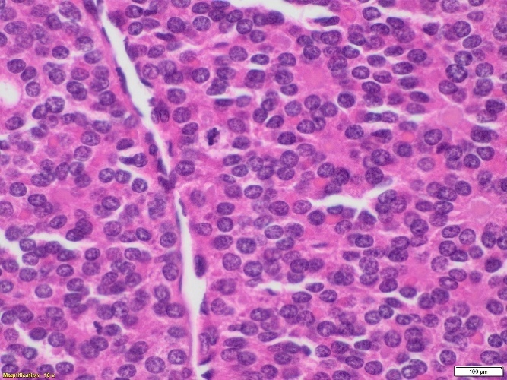
C
D
B
A
A & B: The tumor in patient A has a solid/trabecular growth pattern.
C: Tumor cells from patient A are small and uniform with round nuclei and inconspicuous nucleoli. There are no anaplastic features and no conventional papillary carcinoma nuclear alterations. Mitotic activity is brisk.
D & E: Extensive angioinvasion is identified in patient A tumor.

E

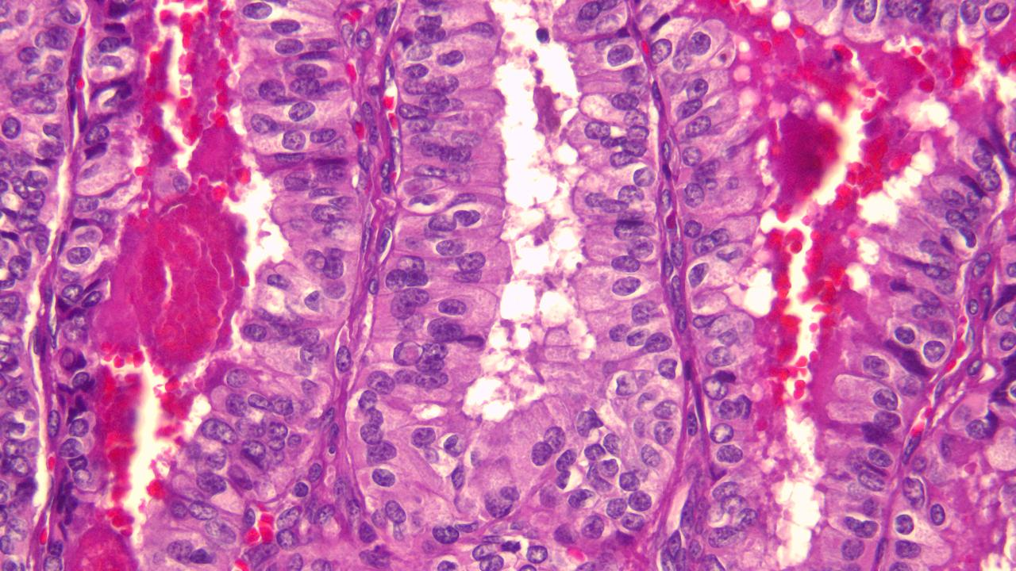
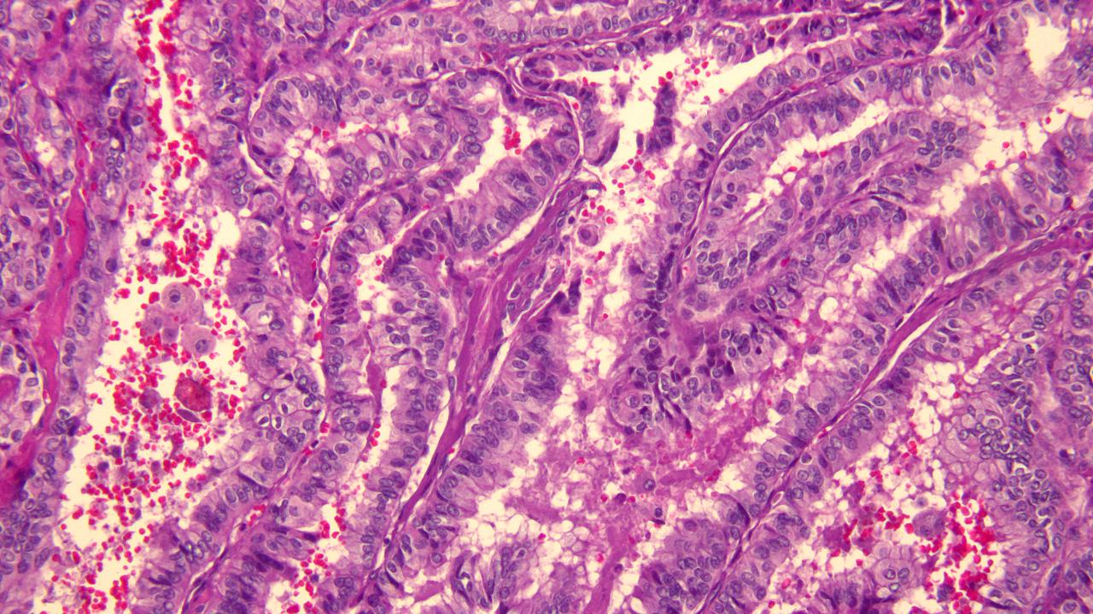
B

A

2 A & B: The tumor cells in patient B are 2 to 3 times taller than wide with abundant granular eosinophilic cytoplasm and the typical nuclear changes of papillary thyroid carcinoma.

