Supplementary Fig
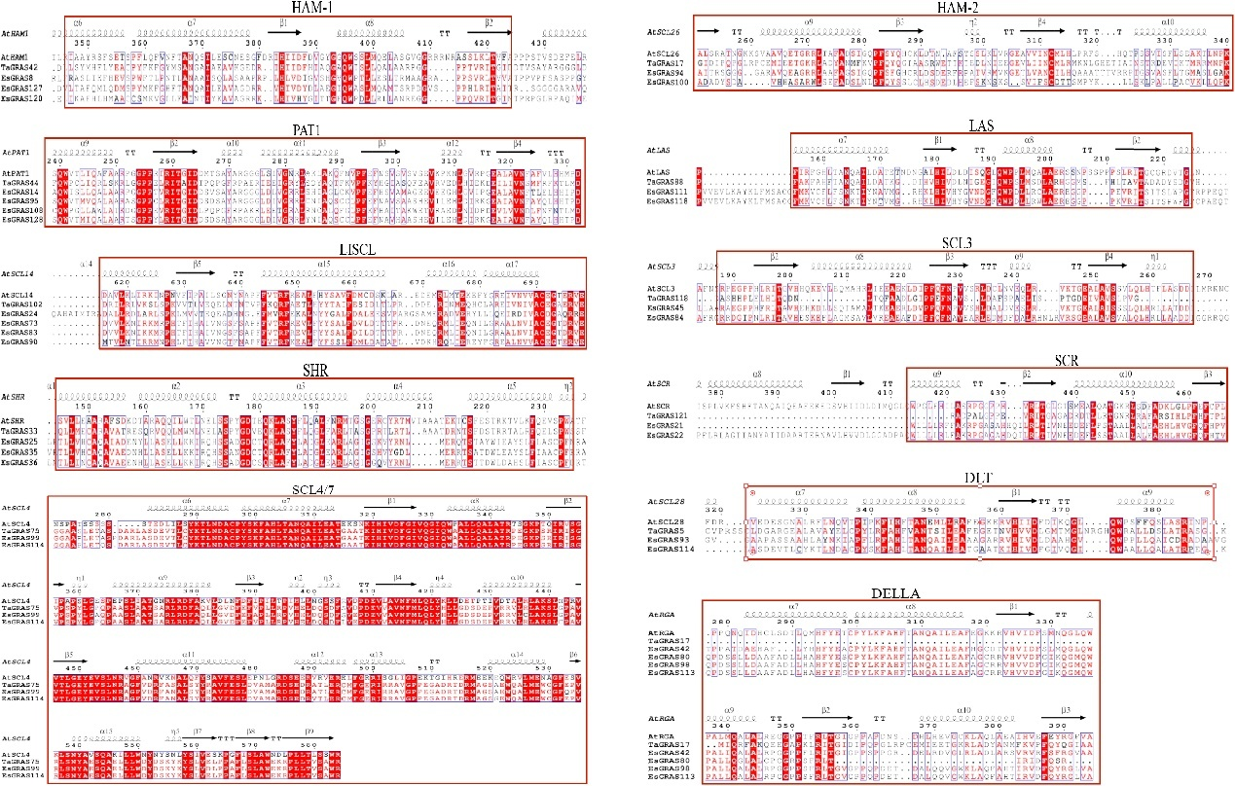
Supplementary Fig 1. Multiple sequence alignment of GRAS genes in E.sibiricus

