Appendix
A1. An alternative presentation of Table 1.

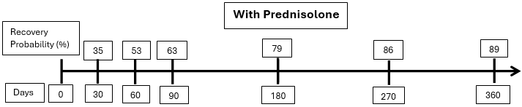

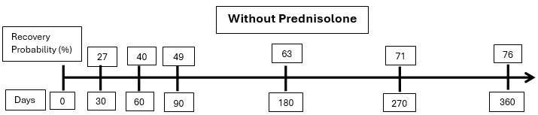

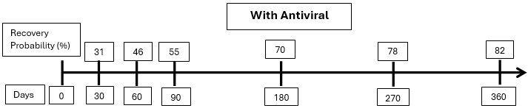

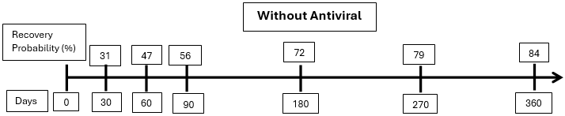

A2. Recovery statistics: proportions recovered at 9 months (Sullivan)
Table A1 mimics the presentation in Sullivan (2007) but with 4 aberrant patients removed from the analysis. The primary finding of the effectiveness of prednisolone and the lack of utility of antiviral treatment is unaltered.
AP  114/122  0.9344 | AO  95/122  0.7787 | A  209/244  0.8566
OP  122/127  0.9606 | OO  103/121  0.8512 | not A  225/248  0.9073
P  236/249  0.9478 | not P  198/243  0.8148 | 434/492  0.8821
Table A1 – Proportion of participants recovered at 9 months by treatment group. Sullivan dataset.
interaction (A x P) = 1.12 ; p = 0.855
P v not P:
OR = 4.13 (2.13, 7.89); p < 0.001; diff = +13.3% (+ 7.7%, +18.9%)
NNT = 8 (6, 14)
A v not A:
OR = 0.61 (0.35, 1.08); p = 0.094; diff = - 5.1% (-10.8%, + 0.6%)
Table A2 provides the same presentation for the Engstrom study, which was not addressed in the original 2009 publication (where the emphasis was entirely on duration).

AP  164/206  0.7961 | AO  133/207  0.6425 | A  297/413  0.7191
OP  160/210  0.7619 | OO  133/206  0.6456 | not A  293/416  0.7043
P  324/416  0.7788 | not P  266/413  0.6441 | 590/829  0.7117
Table A2 - Proportion of participants recovered at 9 months by treatment group. Engstrom dataset.
interaction (A x P) = 0.85 ; p = 0.471
P v not P:
OR = 1.95 (1.42, 2.66); p < 0.001; diff = +13.5% (+ 7.4%, + 19.6%)
NNT = 8 (6, 14)
A v not A:
OR = 1.07 (0.79, 1.46); p = 0.646; diff = + 1.5% (- 4.7%, + 7.6%)
For the pooled data set the numbers are shown in Table A3:

AP  278/328  0.8476 | AO  228/329  0.6930 | A  506/657  0.7702
OP  282/337  0.8368 | OO  236/327  0.7217 | not A  518/664  0.7801
P  560/665  0.8421 | not P  464/656  0.7073 | 1024/1321  0.7752
Table A3 - Proportion of participants recovered at 9 months by treatment group. Combined dataset.
interaction (A x P) = 0.85 ; p = 0.442
P v not P:
OR = 2.21 (1.68, 2.89); p < 0.001; diff = +13.5% (+ 9.0%, + 17.9%)
NNT = 8 (6, 12)
A v not A:
OR = 0.94 (0.73, 1.23); p = 0.693; diff = - 1.0% (- 5.5%, + 3.5%)
We also computed the Mantel-Haenszel estimates for the odds ratio for steroid versus no steroid for the merged data set (Cochrane Handbook Chapter 10: Analysing data and undertaking meta-analyses: Jonathan J Deeks, Julian PT Higgins, Douglas G Altman, Joanne E McKenzie and Areti Angeliki Veroniki; on behalf of the Cochrane Statistical Methods Group) with associated confidence intervals (Clayton D. & Hills M. (1993) Statistical Methods in Epidemiology. Oxford University Press, Oxford.)
OR = 2.27 ; 95% CI (1.78 , 2.91) SP < 0.001.

A3 Kaplan-Meier plots
We include the conventional K-M plots for the merged data sets:
All 4 trts (AP, AO, OP, OO) compared:
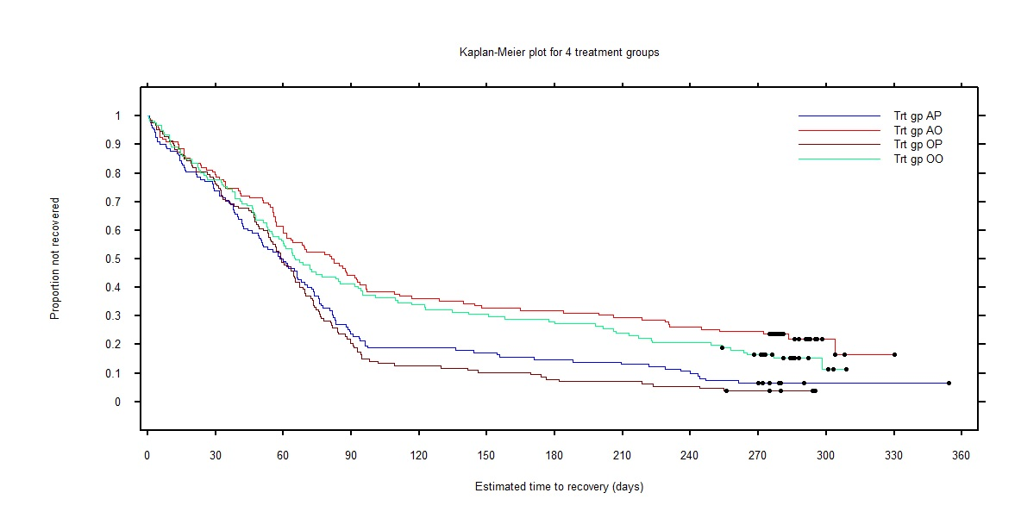
P vs not-P:
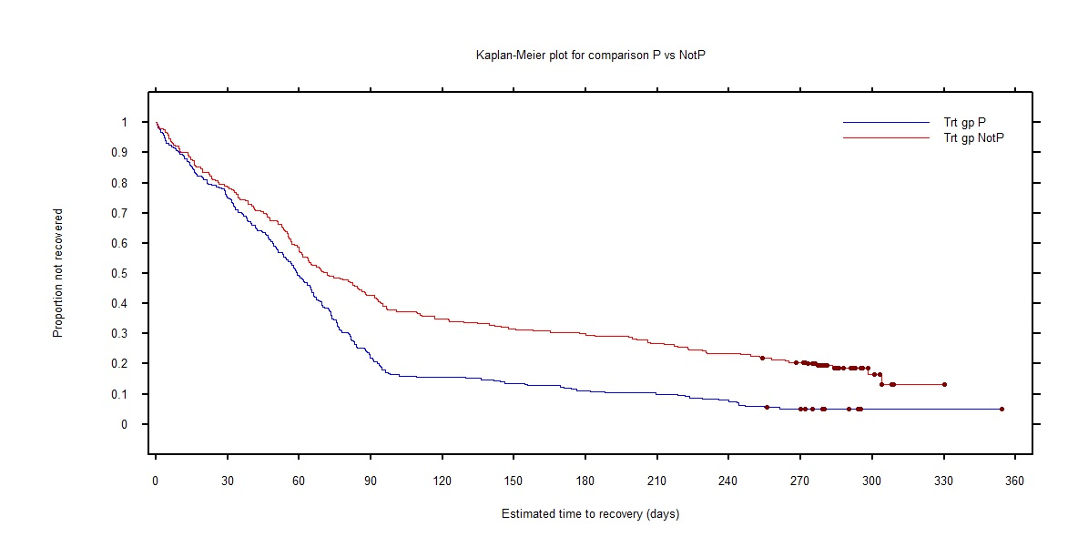

A vs not-A:
