SUPPLEMENTARY MATERIAL

for

Integrated Spatiotemporal and Statistical Approach for Ecological Livability Index Mapping in semi/ arid urban environments

List of Supplementary Figures:

Figure SM1. …..
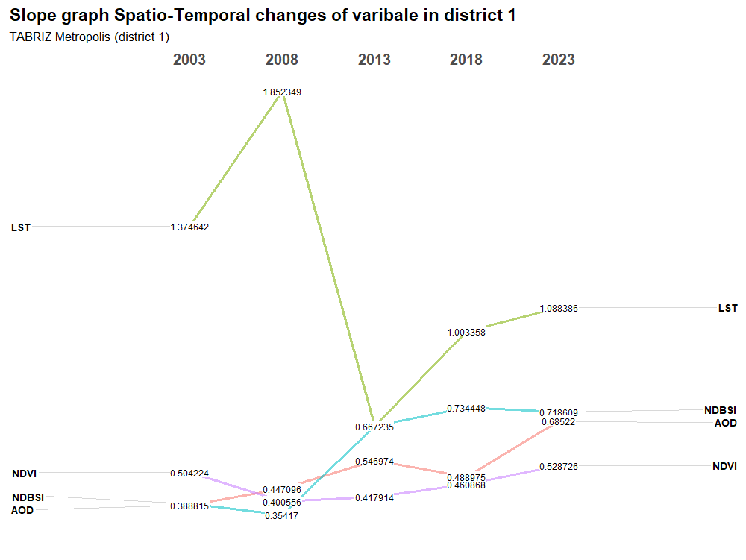

Figure SM2. …..
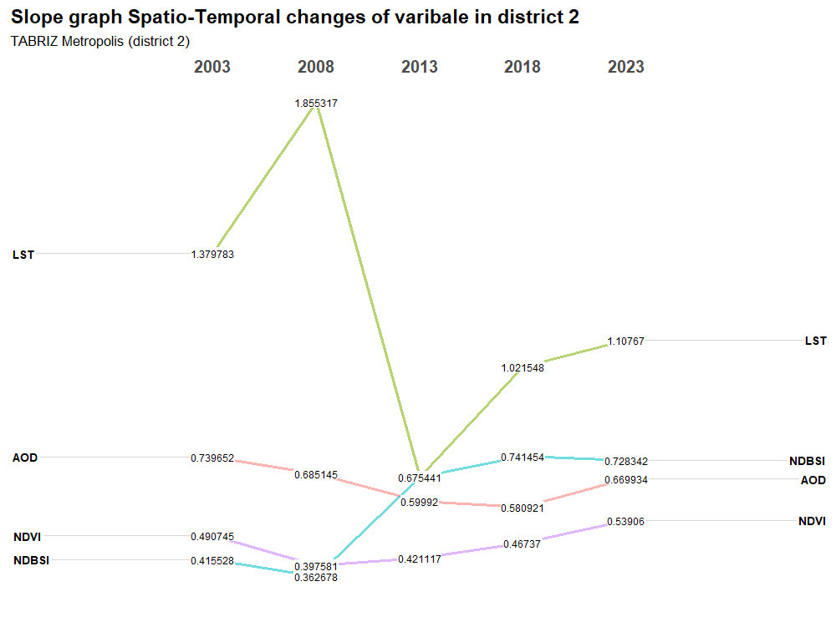
Figure SM3. …..
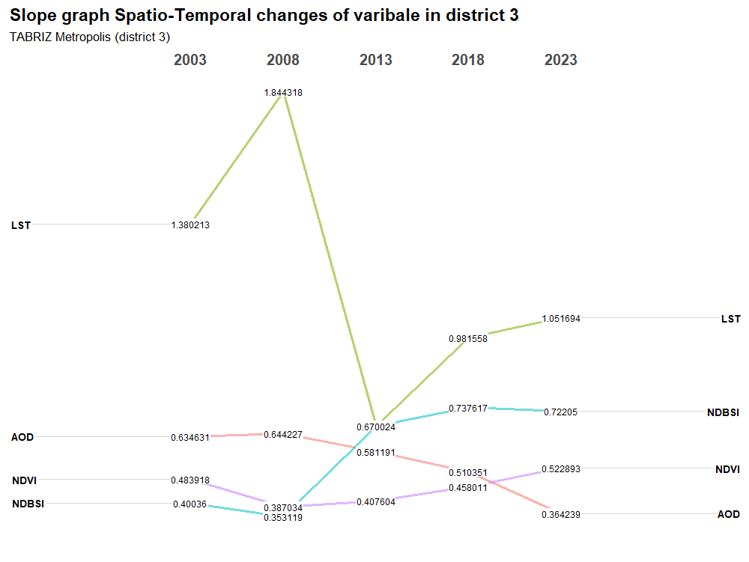

Figure SM4. …..
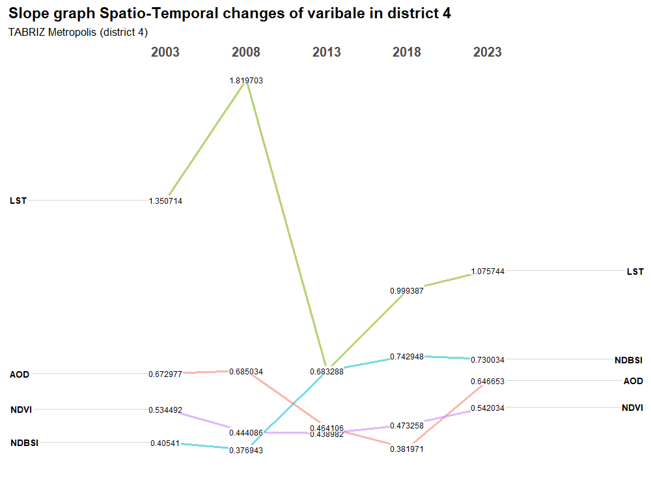
Figure SM5. …..
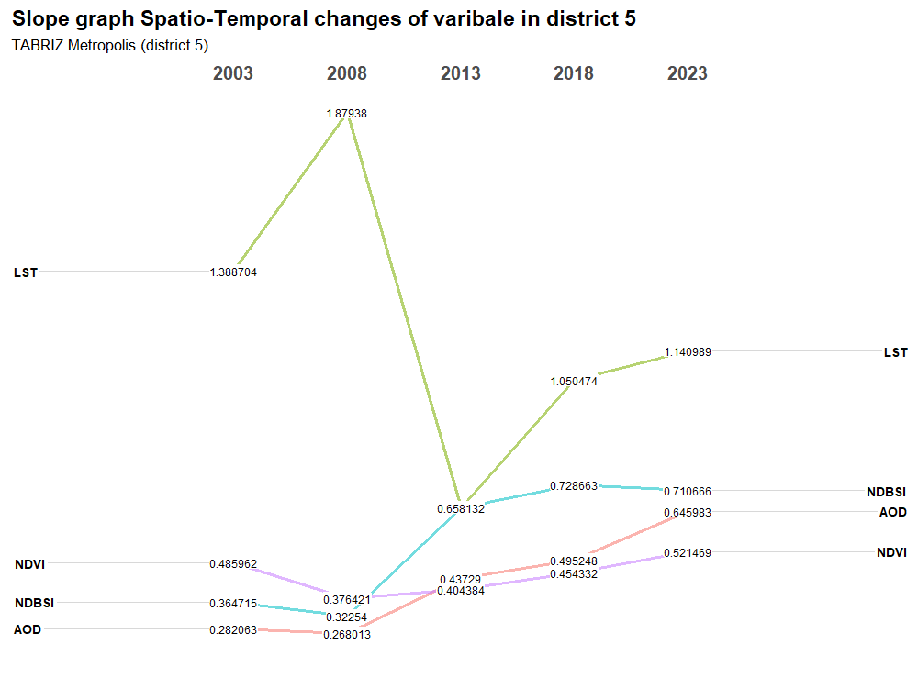

Figure SM6. …..
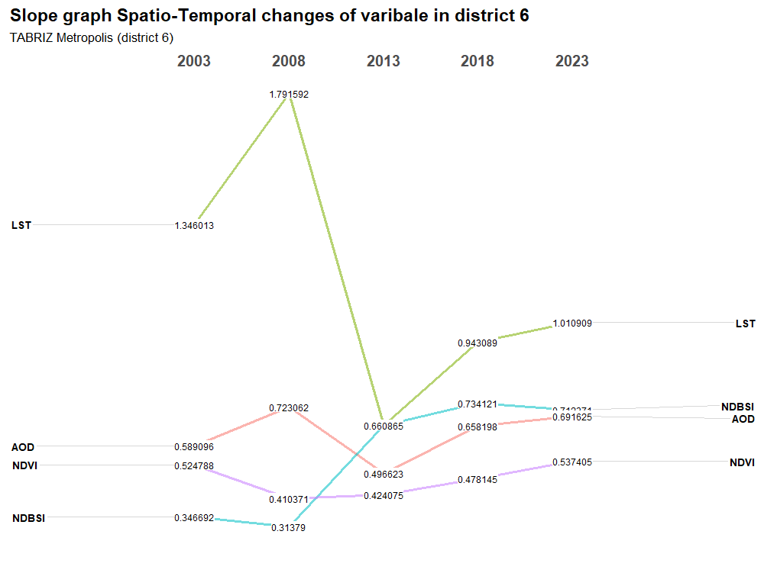
Figure SM7. …..
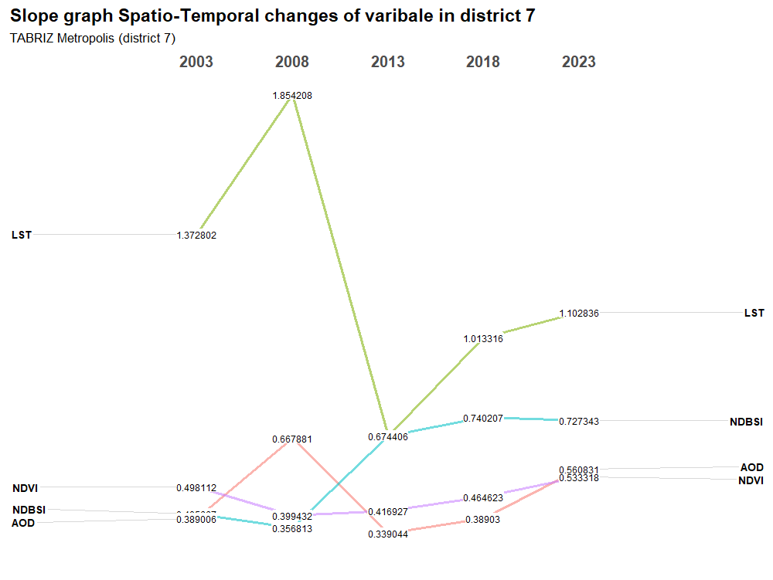

Figure SM8. …..
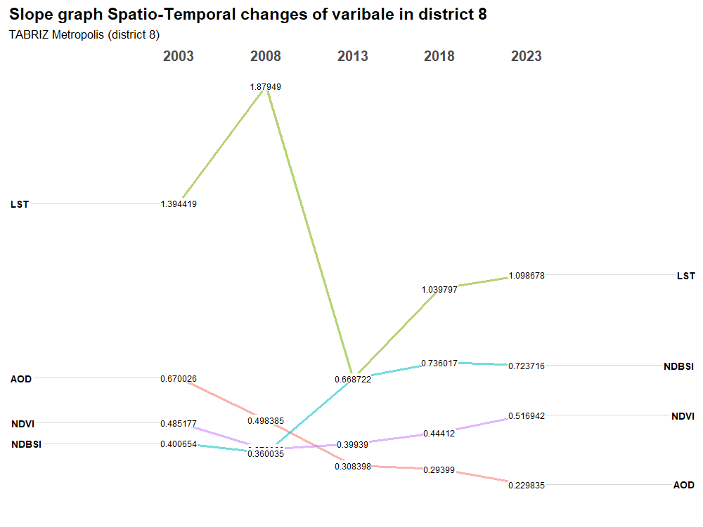
Figure SM9. …..
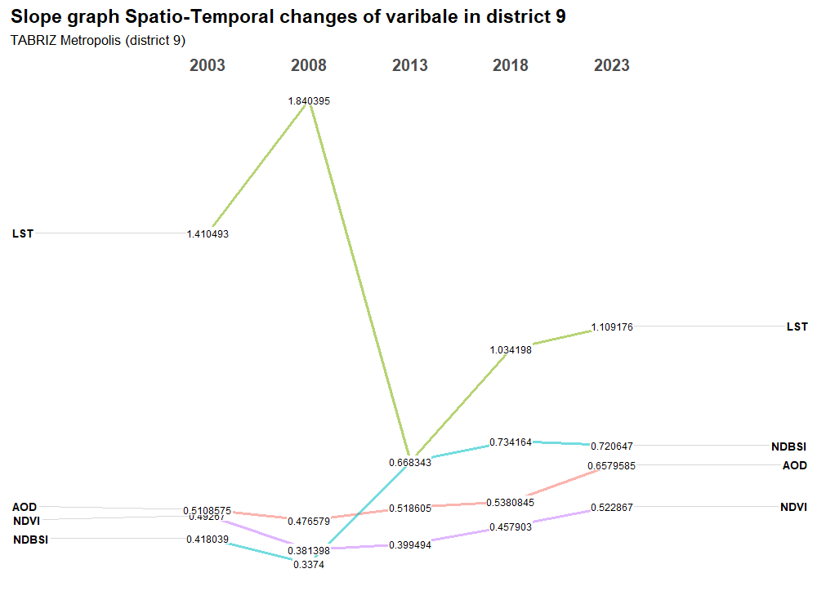

Figure SM10. …..
