Supplementary data

Anti-inflammatory Sesquiterpene Coumarins from the Active Fractions of Ferula assa-foetida: In Silico Analysis Endorse Experimental data
Mubarak A. Alamri¹, Gamal A. Soliman^{2*}, Mohammed A. Alamri², Rehab F. Abdel-Rahman³, Ahmed W. Alhalabi⁴, Raid S. Almahmoud⁴, Ibrahim M. Alsagheir⁴, Abdulrahman G. Alharbi ⁵, Maged S. Abdel-Kader⁶

¹Department of Pharmaceutical Chemistry, College of Pharmacy, Prince Sattam Bin Abdulaziz University, Al-Kharj 11942, Saudi Arabia.
²Department of Pharmacology and Toxicology, College of Pharmacy, Prince Sattam Bin Abdulaziz University, Al-Kharj 11942, Saudi Arabia.
³Department of Pharmacology, National Research Centre, Giza 12622, Egypt.
⁴College of Pharmacy, Prince Sattam Bin Abdulaziz University, Al-Kharj 11942, Saudi Arabia.
⁵ Maternity and Children’s Hospital, Ministry of Health, Al-Kharj 11942, Saudi Arabia.
⁶ Department of Pharmacognosy, College of Pharmacy, Prince Sattam Bin Abdulaziz University, Al-Kharj 11942, Saudi Arabia.

*Author to whom correspondence should be addressed: g.soliman@psau.edu.sa

Table of contents

Title Page
Figure S1: ¹HNMR spectrum of 1 in C6D6. | 4
Figure S2: ¹HNMR spectrum of 1 in C6D6 (Exp.). | 4
Figure S3: ¹HNMR spectrum of 1 in C6D6 (Exp.). | 5
Figure S4: ¹HNMR spectrum of 1 in C6D6 (Exp.). | 5
Figure S5: ¹³CNMR spectrum of 1 in C6D6. | 6
Figure S6: ¹³CNMR spectrum of 1 in C6D6. | 6
Figure S7: ¹³CNMR spectrum of 1 in C6D6 (Exp.). | 7
Figure S8: DEPT135 spectrum of 1 in C6D6. | 7
Figure S9: COSY spectrum of 1in C6D6. | 8
Figure S10: HSQC spectrum of 1 in C6D6. | 8
Figure S11: HRESIMS spectrum of 1 (Negative mode). | 9
Figure S12: HRESIMS spectrum of 1 (Positive mode). | 9
Figure S13: ¹HNMR spectrum of 2 in C6D6. | 10
Figure S14: ¹HNMR spectrum of 2 in C6D6 (Exp.). | 10
Figure S15: ¹HNMR spectrum of 2 in C6D6 (Exp.). | 11
Figure S16: ¹³CNMR spectrum of 2 in C6D6. | 11
Figure S17: ¹³CNMR spectrum of 2 in C6D6 (Exp.). | 12
Figure S18: ¹³CNMR spectrum of 2 in C6D6 (Exp.). | 12
Figure S19: ¹³CNMR spectrum of 2 in C6D6 (Exp.). | 13
Figure S20: DEPT135 spectrum of 2 in C6D6. | 13
Figure S21: COSY spectrum of 2 in C6D6. | 14
Figure S22: HSQC spectrum of 2 in C6D6. | 14
Figure S23: HRESIMS spectrum of 2. | 15
Figure S24: ¹HNMR spectrum of 3 in C6D6. | 16
Figure S25: ¹HNMR spectrum of 3 in C6D6 (Exp.). | 16
Figure S26: ¹HNMR spectrum of 3 in C6D6 (Exp.). | 17
Figure S27: ¹³CNMR spectrum of 3 in C6D6. | 17
Figure S28: ¹³CNMR spectrum of 3 in C6D6 (Exp.). | 18
Figure S29: ¹³CNMR spectrum of 3 in C6D6 (Exp.). | 18
Figure S30: DEPT135 spectrum of 3 in C6D6. | 19
Figure S31: COSY spectrum of 3 in C6D6. | 19
Figure S32: COSY spectrum of 3 in C6D6 (Exp.). | 20
Figure S33: HSQC spectrum of 3 in C6D6. | 20
Figure S34: ¹HNMR spectrum of 3 in CD3OD. | 21
Figure S35: ¹HNMR spectrum of 3 in CD3OD (Exp.). | 21
Figure S36: ¹HNMR spectrum of 3 in CD3OD (Exp.). | 22
Figure S37: ¹³CNMR spectrum of 3 in CD3OD. | 22
Figure S38: ¹³CNMR spectrum of 3 in CD3OD (Exp.). | 23
Figure S39: DEPT135 spectrum of 3 in CD3OD. | 23
Figure S40: COSY spectrum of 3 in CD3OD. | 24
Figure S41: COSY spectrum of 3 in CD3OD (Exp.). | 24
Figure S42: COSY spectrum of 3 in CD3OD (Exp.). | 25
Figure S43: HSQC spectrum of 3 in CD3OD. | 25
Figure S44: HSQC spectrum of 3 in CD3OD (Exp.). | 26

Figure S45: HRESIMS spectrum of 3 (Negative mode). | 27
Figure S46: HRESIMS spectrum of 3 (Positive mode). | 27
Figure S47: ¹HNMR spectrum of 4 in CD3OD. | 28
Figure S48: ¹HNMR spectrum of 4 in CD3OD (Exp.). | 28
Figure S49: ¹³CNMR spectrum of 4 in CD3OD. | 29
Figure S50: ¹³CNMR spectrum of 4 in CD3OD (Exp.). | 29
Figure S51: DEPT135 spectrum of 4 in CD3OD. | 30
Figure S52: COSY spectrum of 4 in CD3OD. | 30
Figure S53: HSQC spectrum of 4 in CD3OD. | 31
Figure S54: HSQC spectrum of 4 in CD3OD (Exp.). | 31
Figure S55: ¹HNMR spectrum of 4 in Pyridine d5. | 32
Figure S56: ¹HNMR spectrum of 4 in Pyridine d5 (Exp.). | 32
Figure S57: ¹³CNMR spectrum of 4 in Pyridine d5. | 33
Figure S58: ¹³CNMR spectrum of 4 in Pyridine d5 (Exp.). | 33
Figure S59: DEPT135 spectrum of 4 in Pyridine d5. | 34
Figure S60: DEPT135 spectrum of 4 in Pyridine d5 (Exp.). | 34
Figure S61: HRESIMS spectrum of 4. | 35

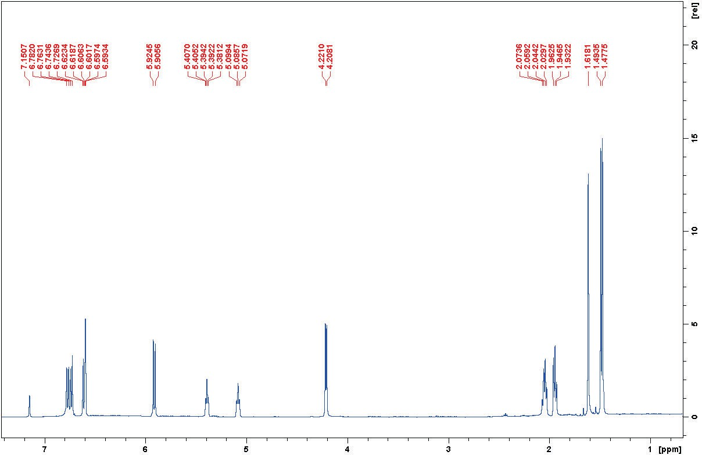
Figure S1: ¹HNMR spectrum of 1 in C6D6.

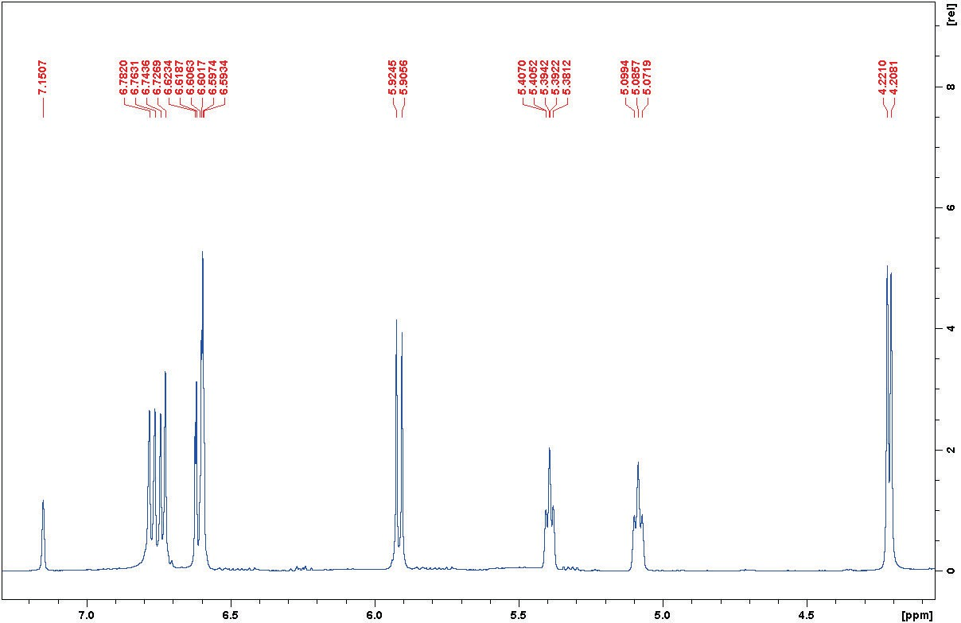
Figure S2: ¹HNMR spectrum of 1 in C6D6 (Exp.).

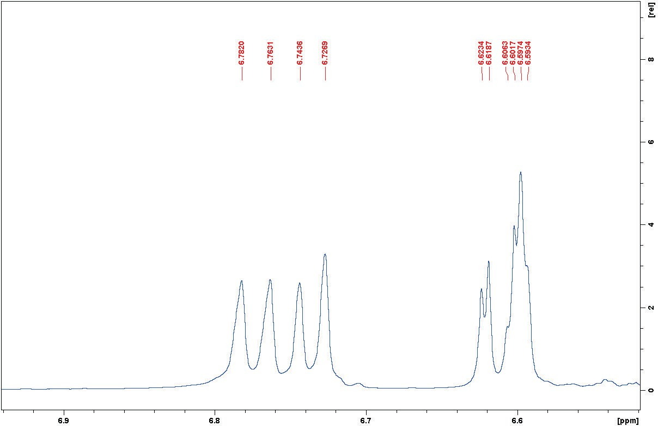
Figure S3: ¹HNMR spectrum of 1 in C6D6 (Exp.).

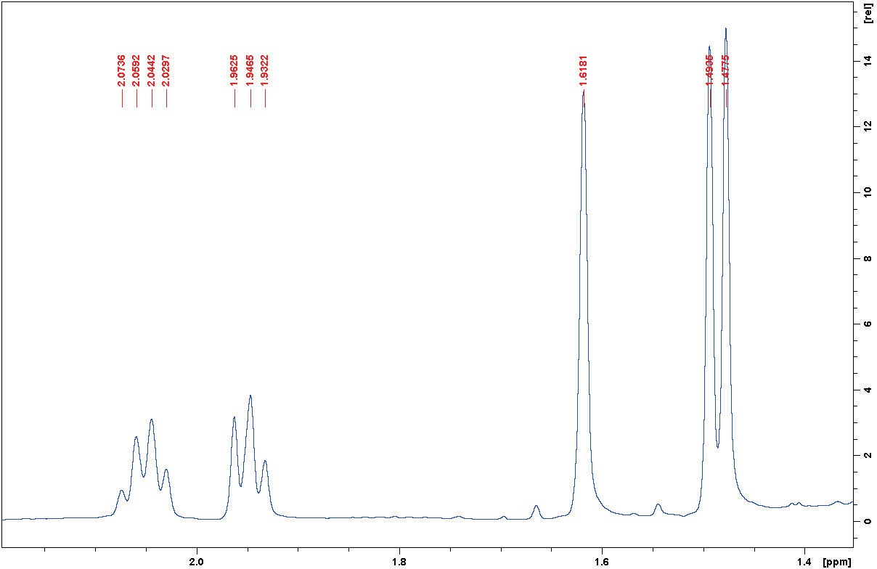
Figure S4: ¹HNMR spectrum of 1 in C6D6 (Exp.).

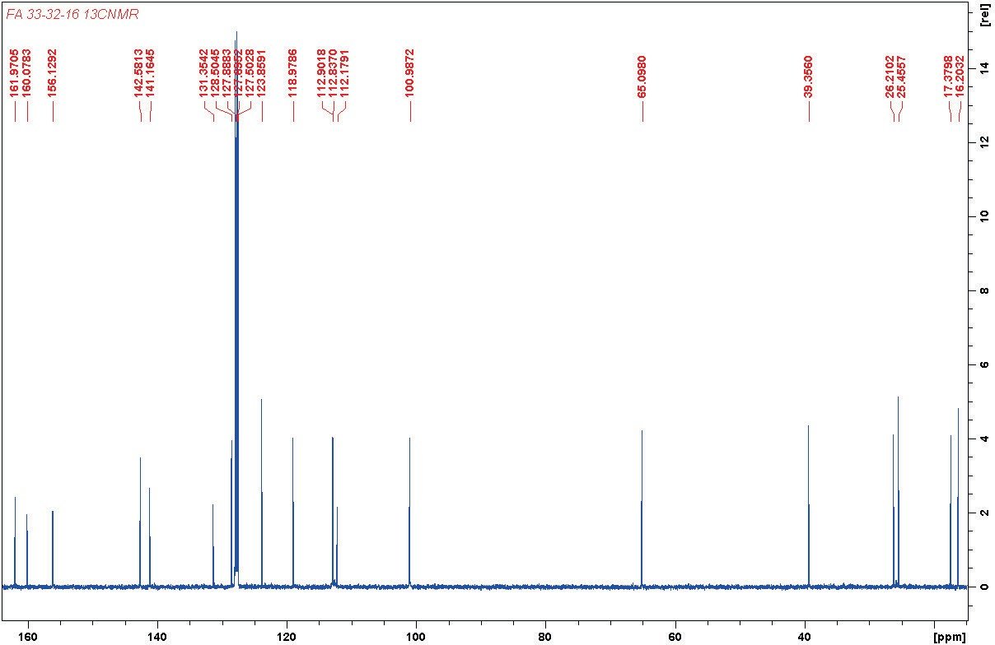
Figure S5: ¹³CNMR spectrum of 1 in C6D6.

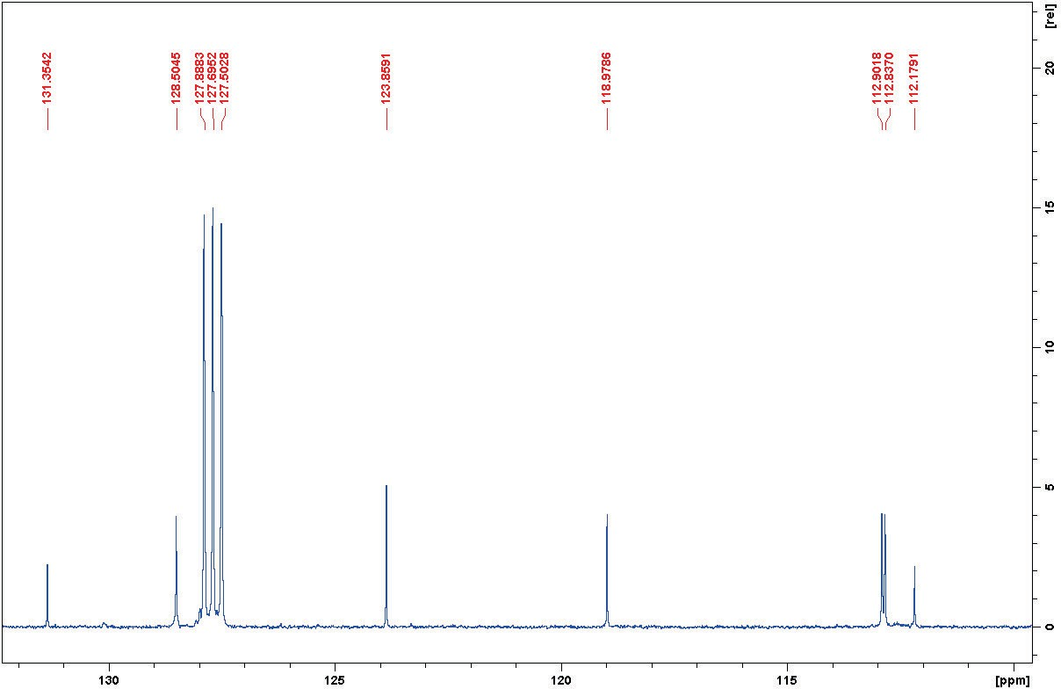
Figure S6: ¹³CNMR spectrum of 1 in C6D6.

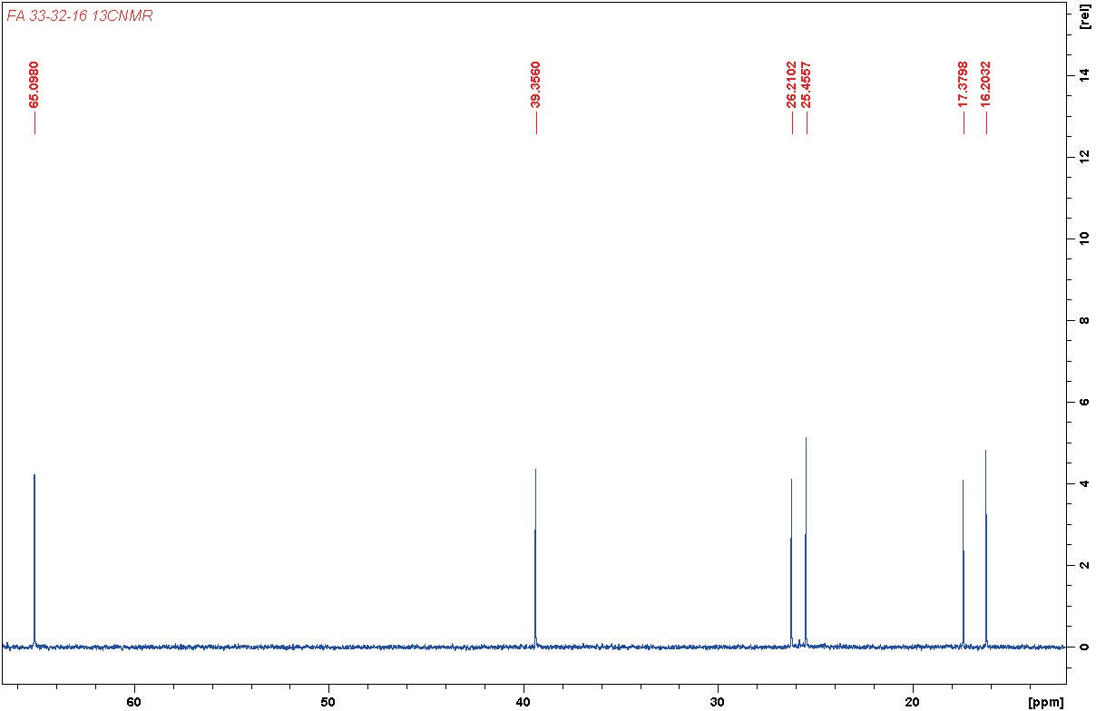
Figure S7: ¹³CNMR spectrum of 1 in C6D6 (Exp.).

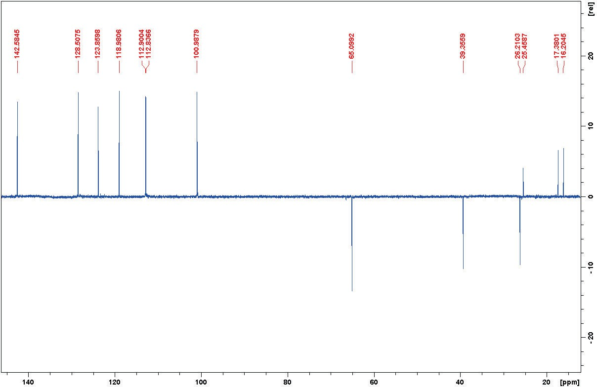
Figure S8: DEPT135 spectrum of 1 in C6D6.

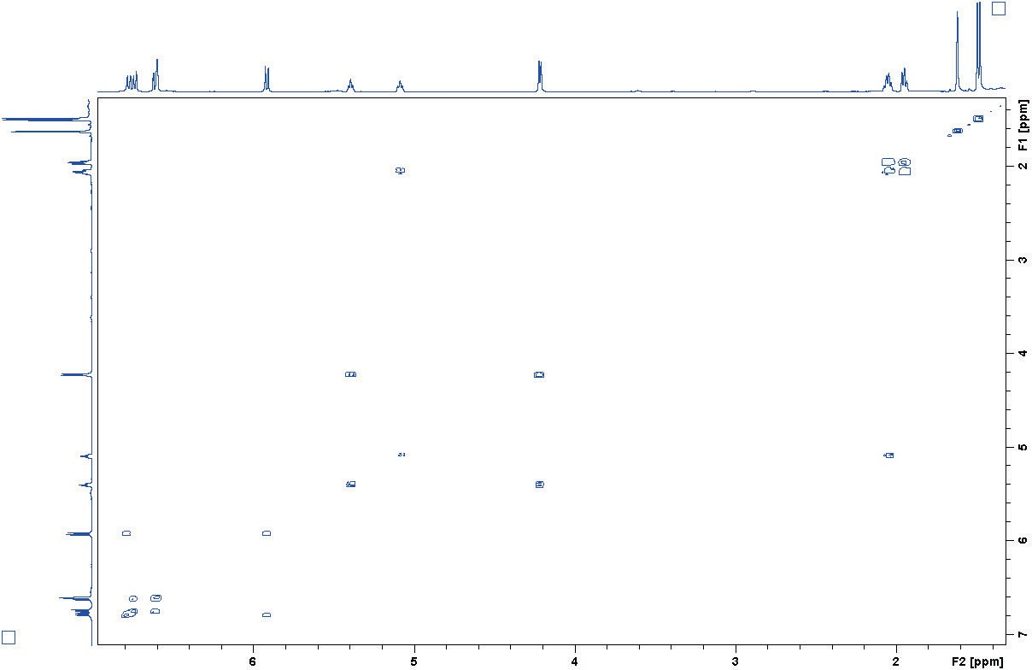
Figure S9: COSY spectrum of 1in C6D6.

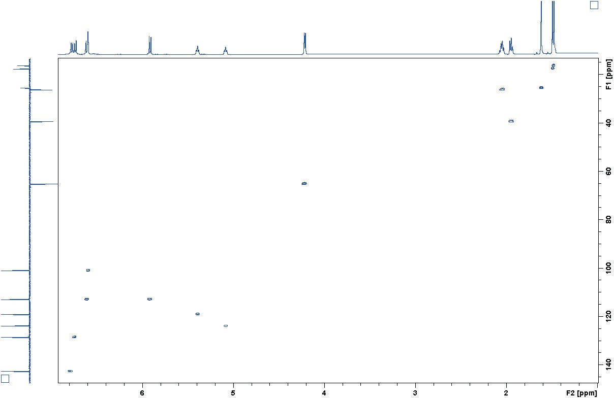
Figure S10: HSQC spectrum of 1 in C6D6.

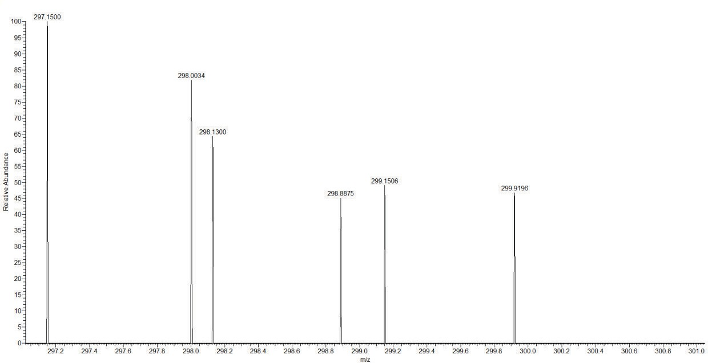
Figure S11: HRESIMS spectrum of 1 (Negative mode).

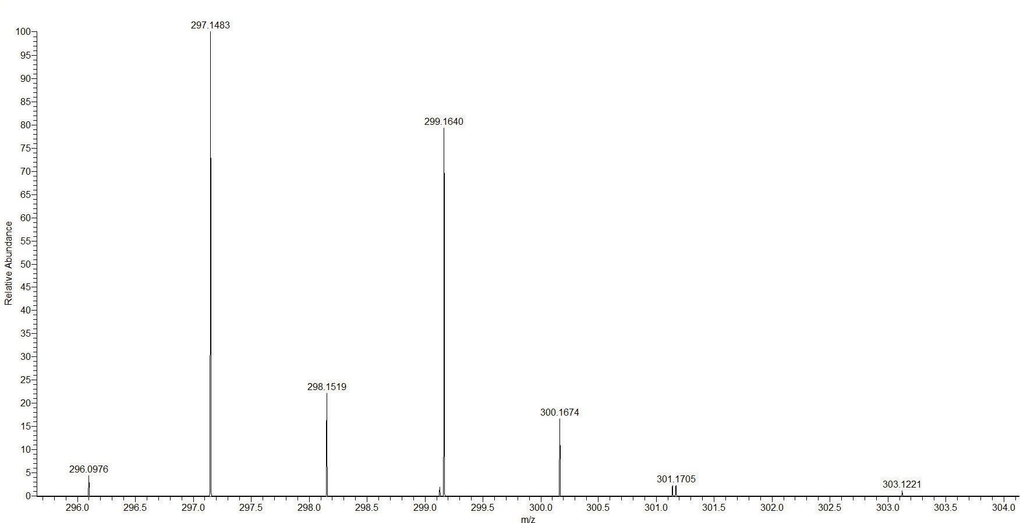

Figure S12: HRESIMS spectrum of 1 (Positive mode).

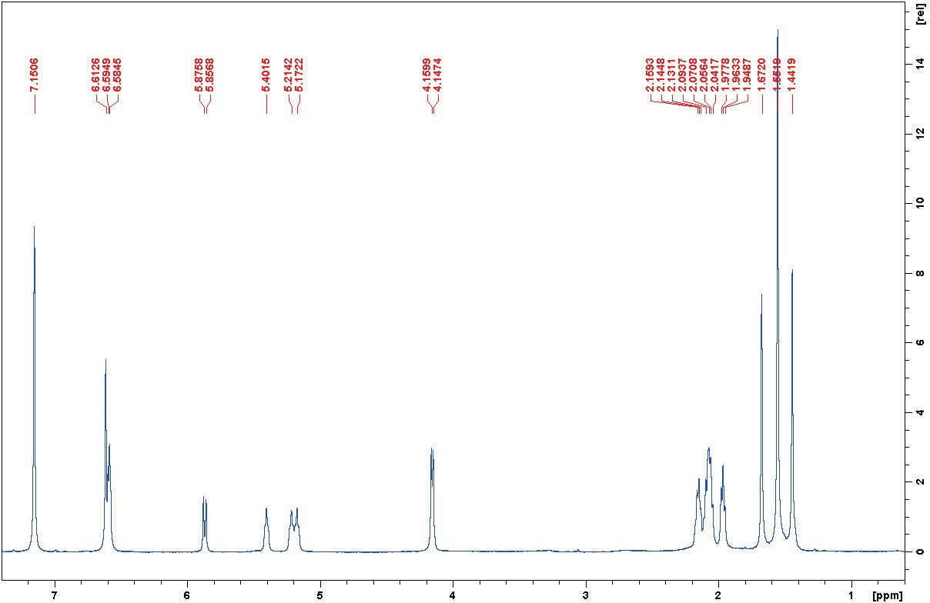
Figure S13: ¹HNMR spectrum of 2 in C6D6.

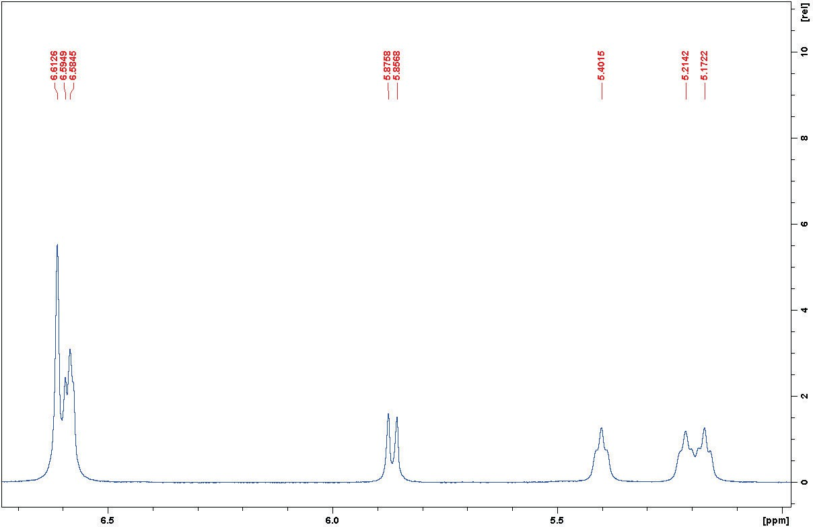
Figure S14: ¹HNMR spectrum of 2 in C6D6 (Exp.).

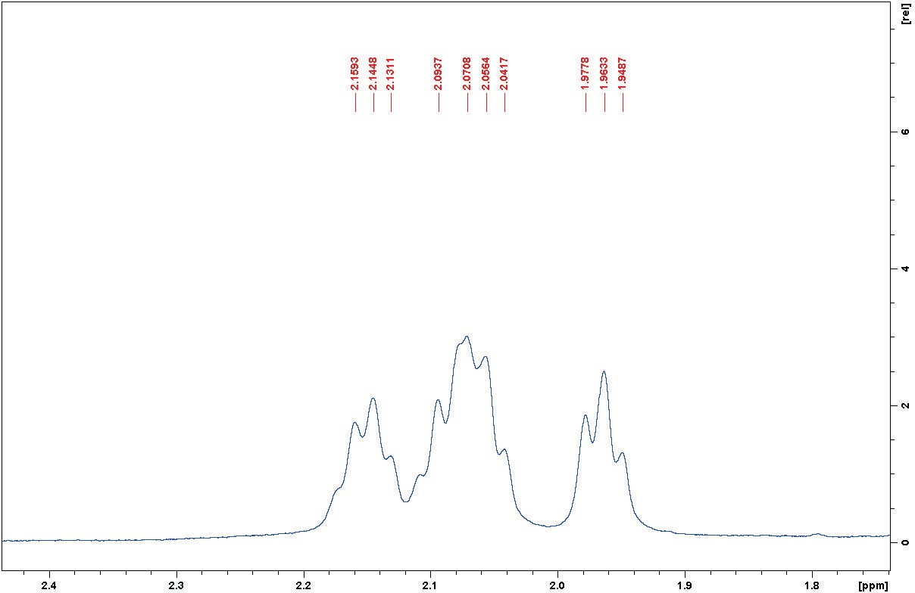
Figure S15: ¹HNMR spectrum of 2 in C6D6 (Exp.).

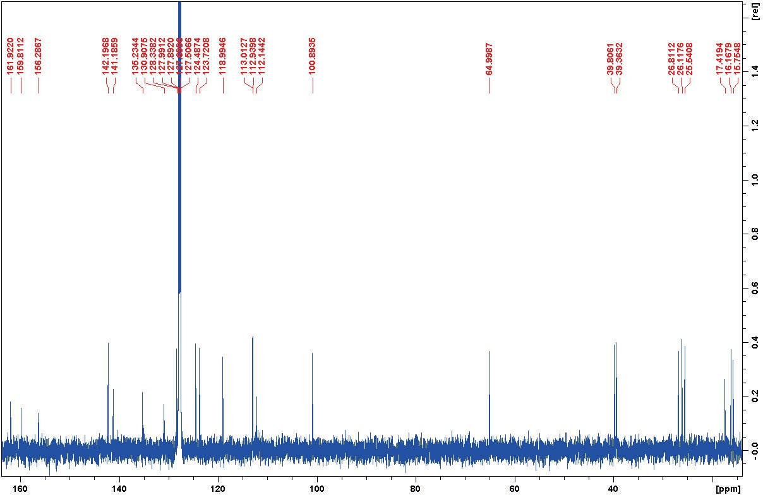
Figure S16: ¹³CNMR spectrum of 2 in C6D6.

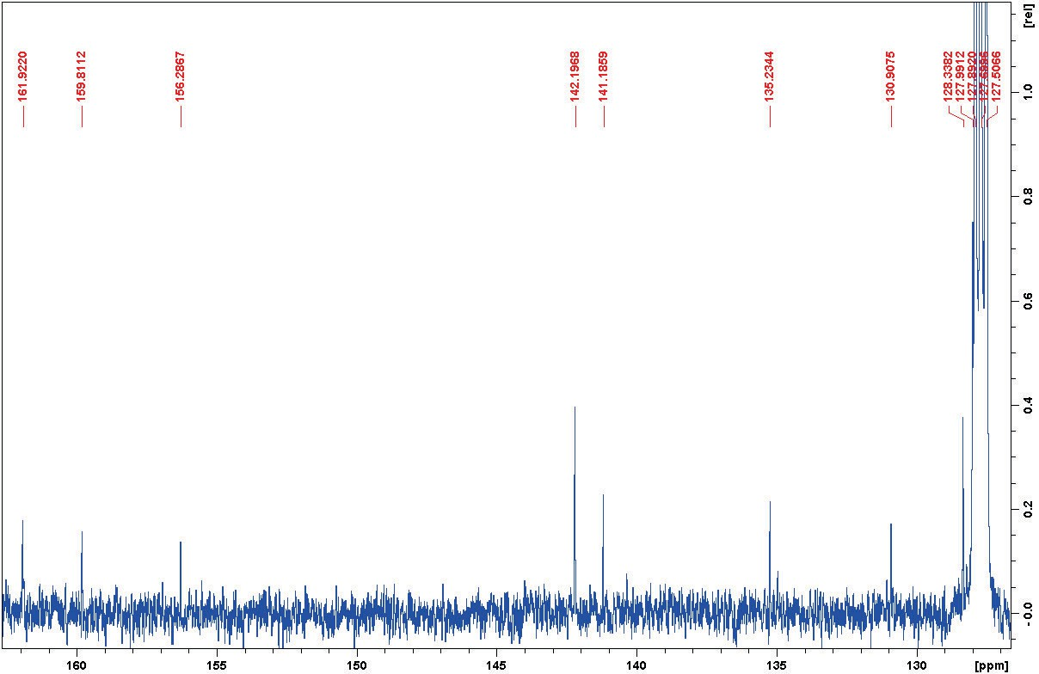
Figure S17: ¹³CNMR spectrum of 2 in C6D6 (Exp.).

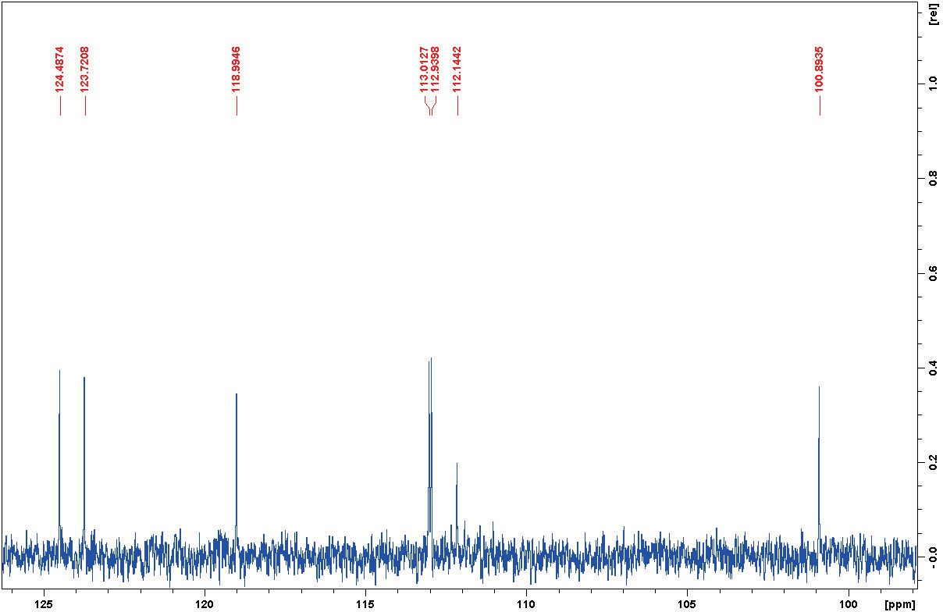
Figure S18: ¹³CNMR spectrum of 2 in C6D6 (Exp.).

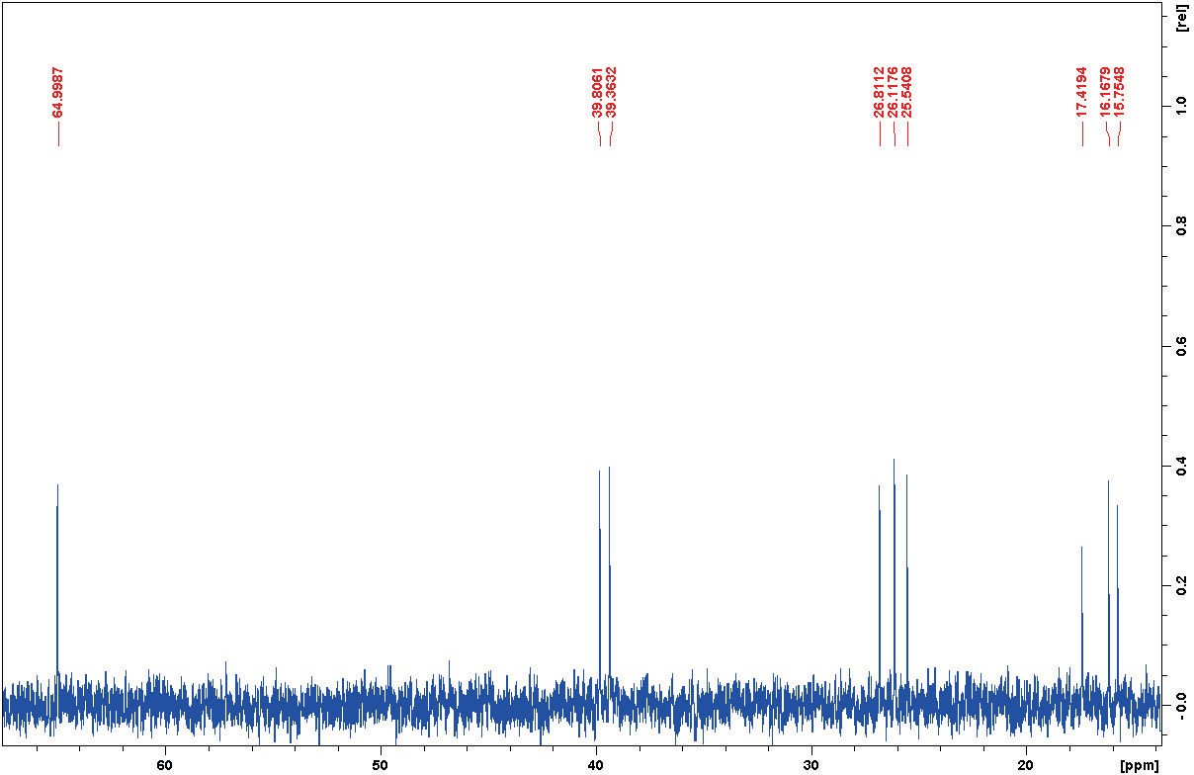
Figure S19: ¹³CNMR spectrum of 2 in C6D6 (Exp.).

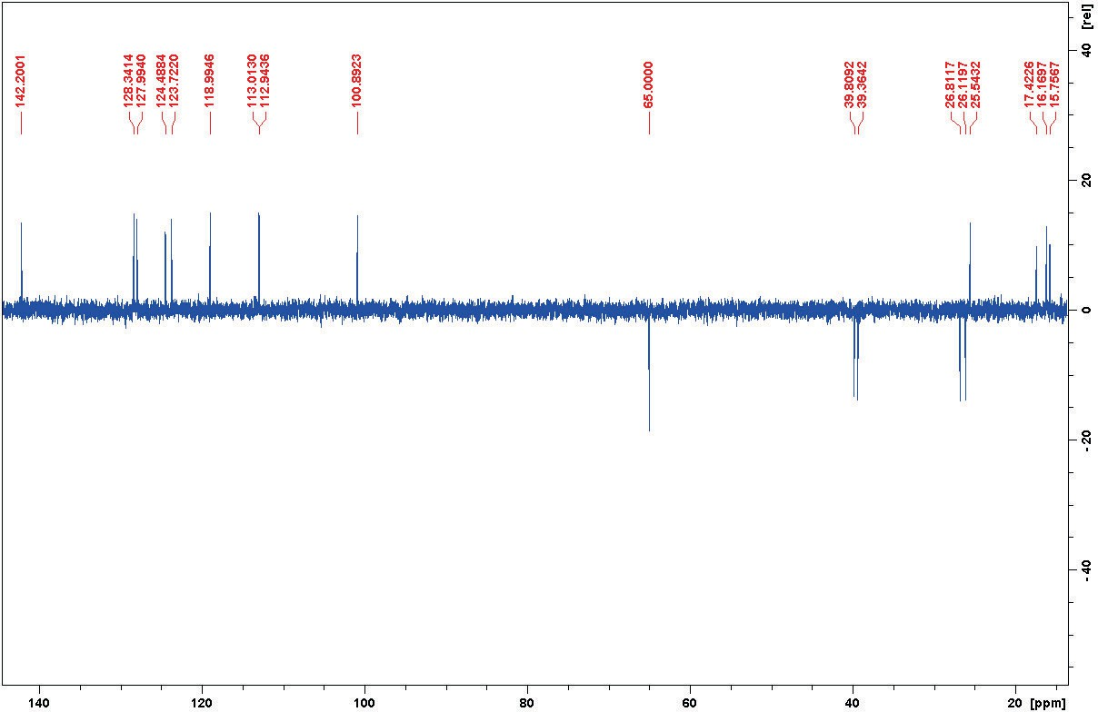
Figure S20: DEPT135 spectrum of 2 in C6D6.

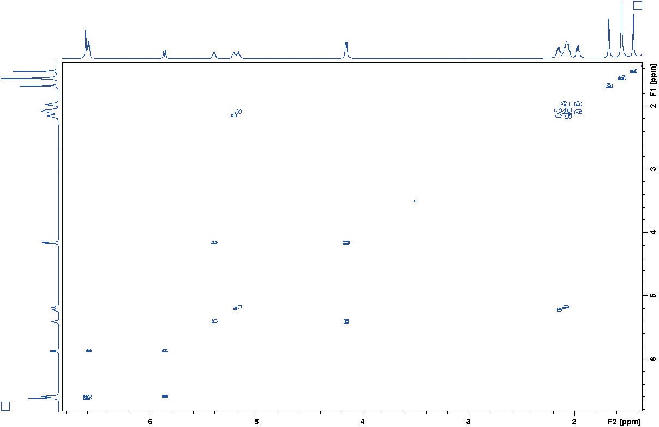
Figure S21: COSY spectrum of 2 in C6D6.

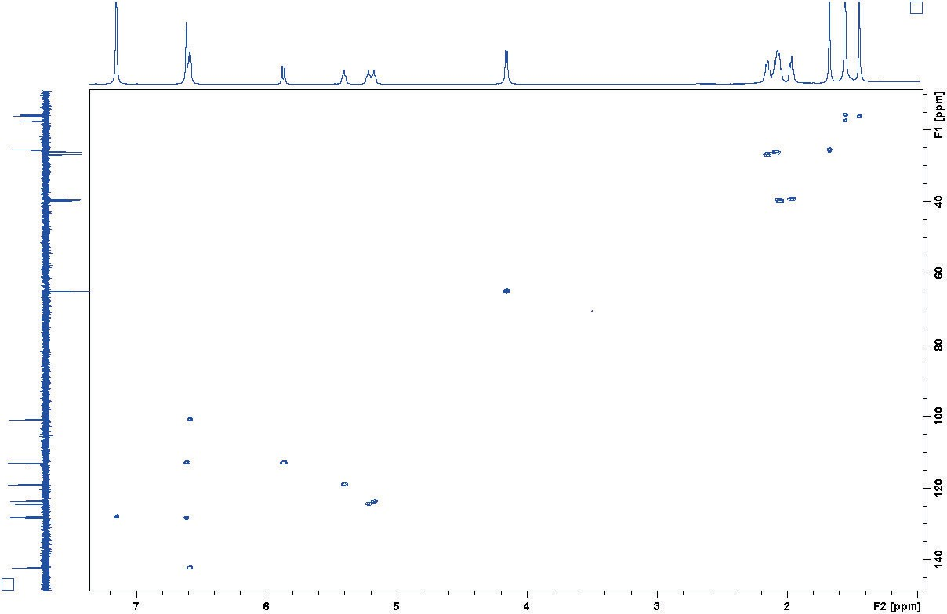
Figure S22: HSQC spectrum of 2 in C6D6.

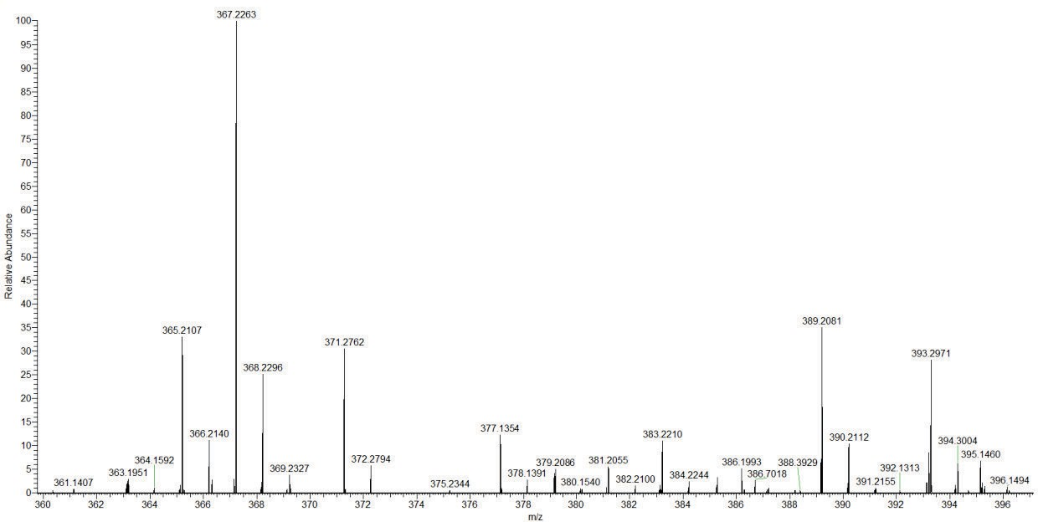
Figure S23: HRESIMS spectrum of 2.

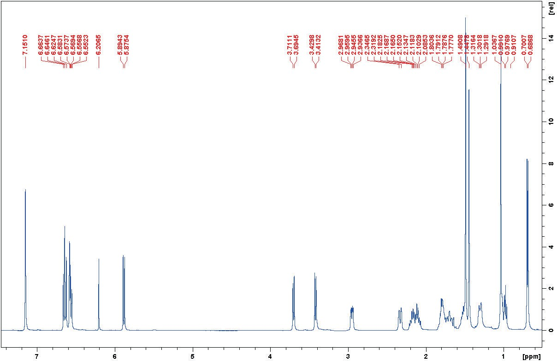
Figure S24: ¹HNMR spectrum of 3 in C6D6.

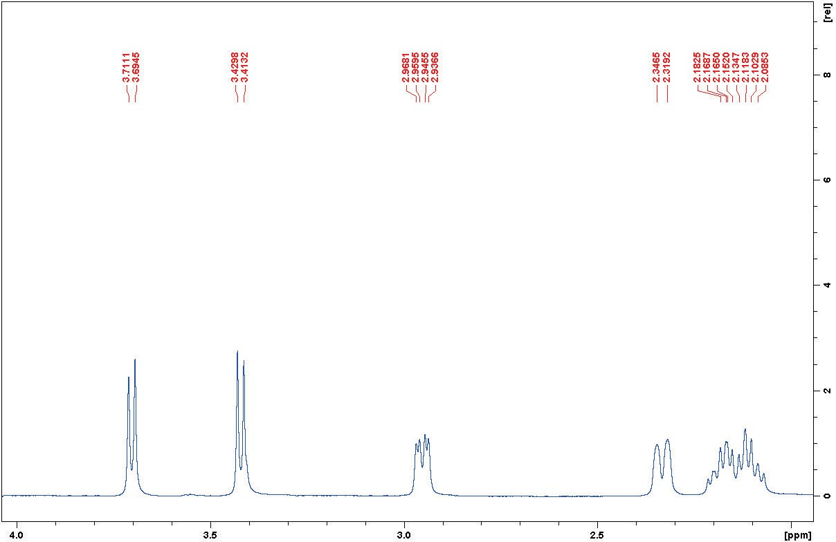
Figure S25: ¹HNMR spectrum of 3 in C6D6 (Exp.).

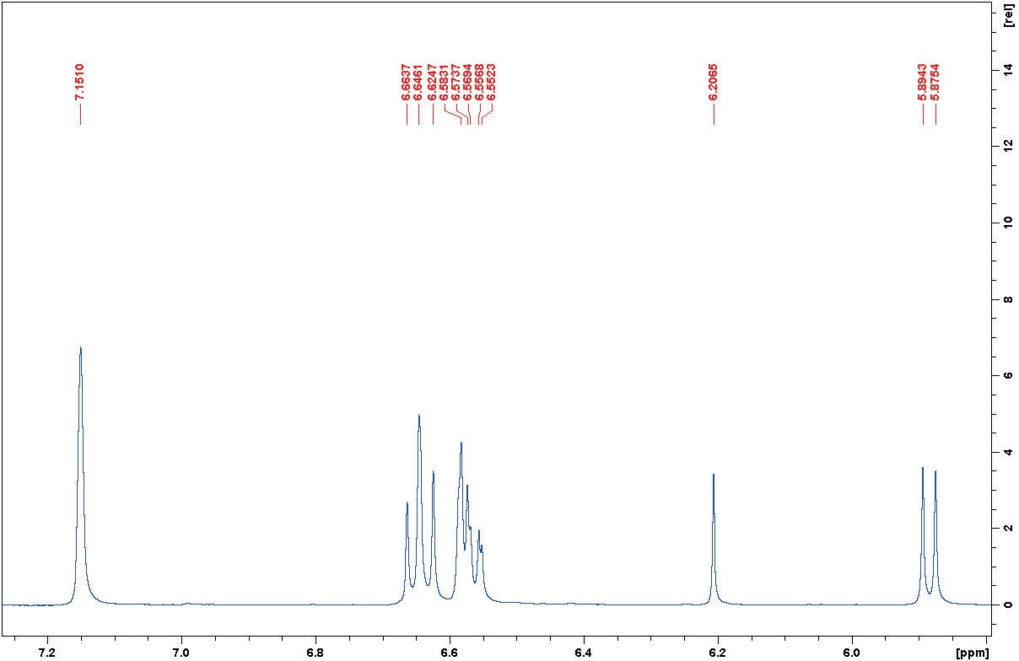
Figure S26: ¹HNMR spectrum of 3 in C6D6 (Exp.).

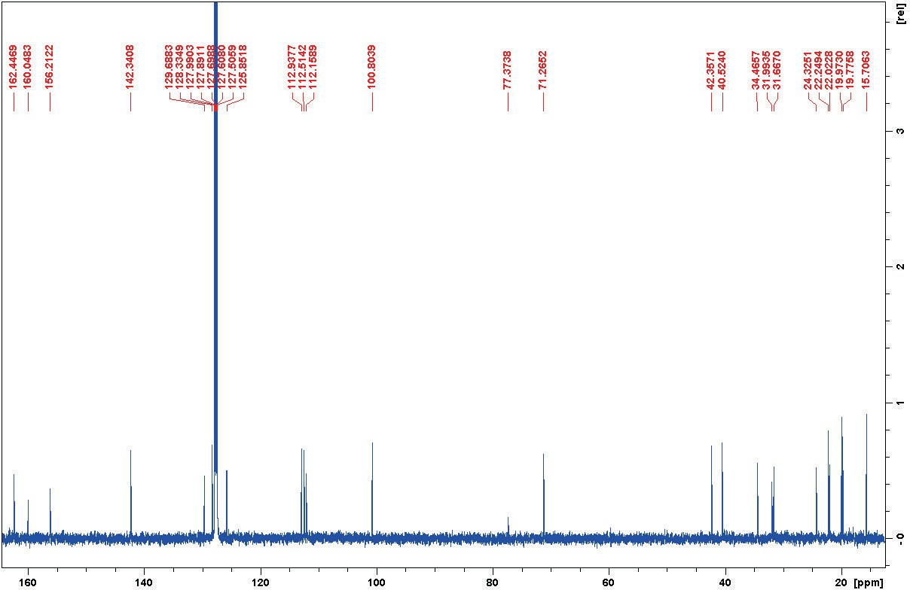
Figure S27: ¹³CNMR spectrum of 3 in C6D6.

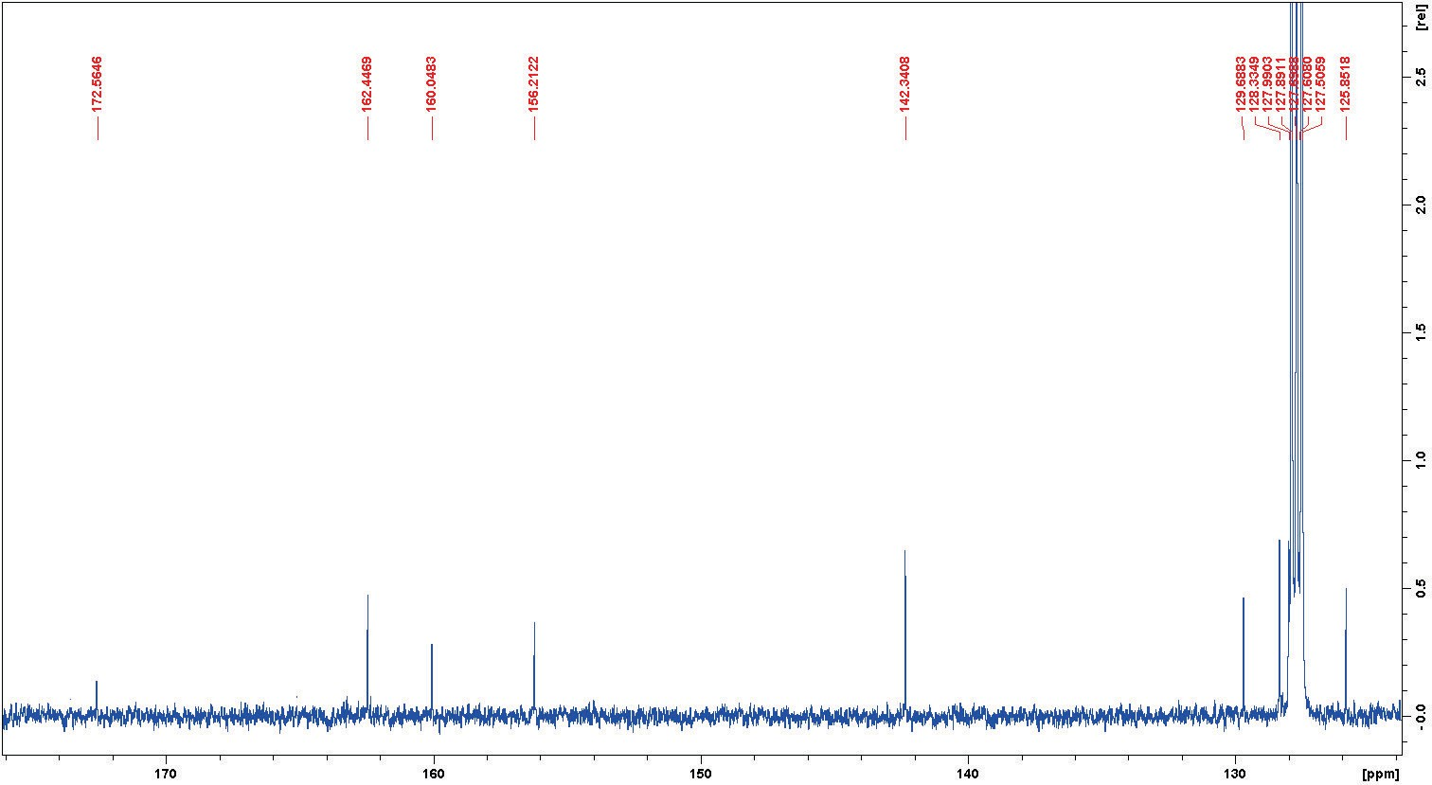
Figure S28: ¹³CNMR spectrum of 3 in C6D6 (Exp.).

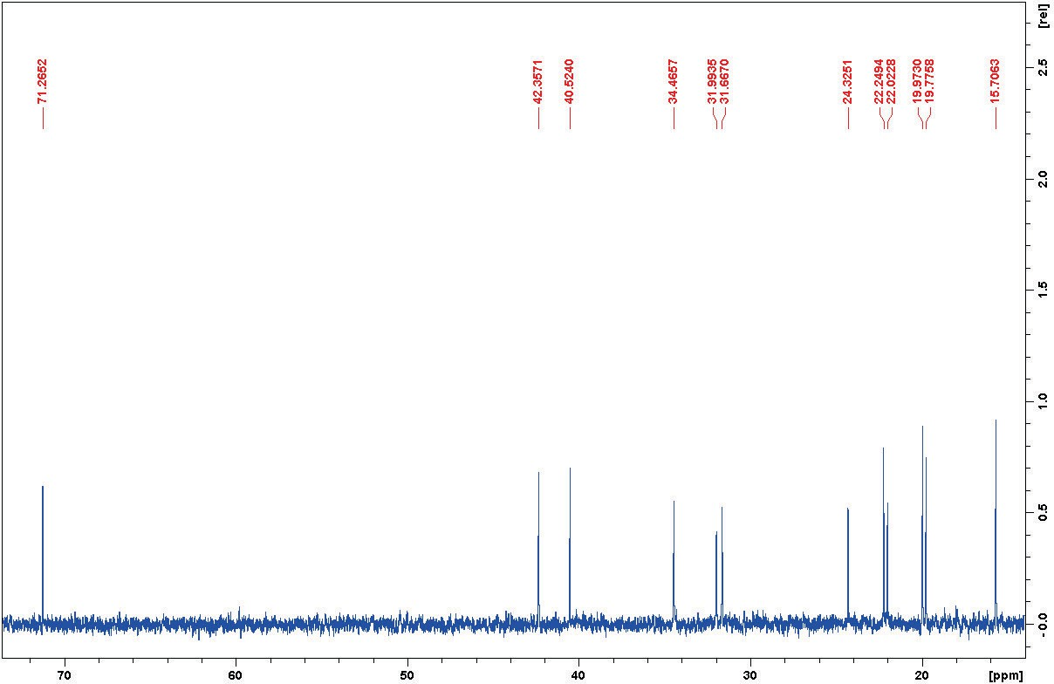
Figure S29: ¹³CNMR spectrum of 3 in C6D6 (Exp.).

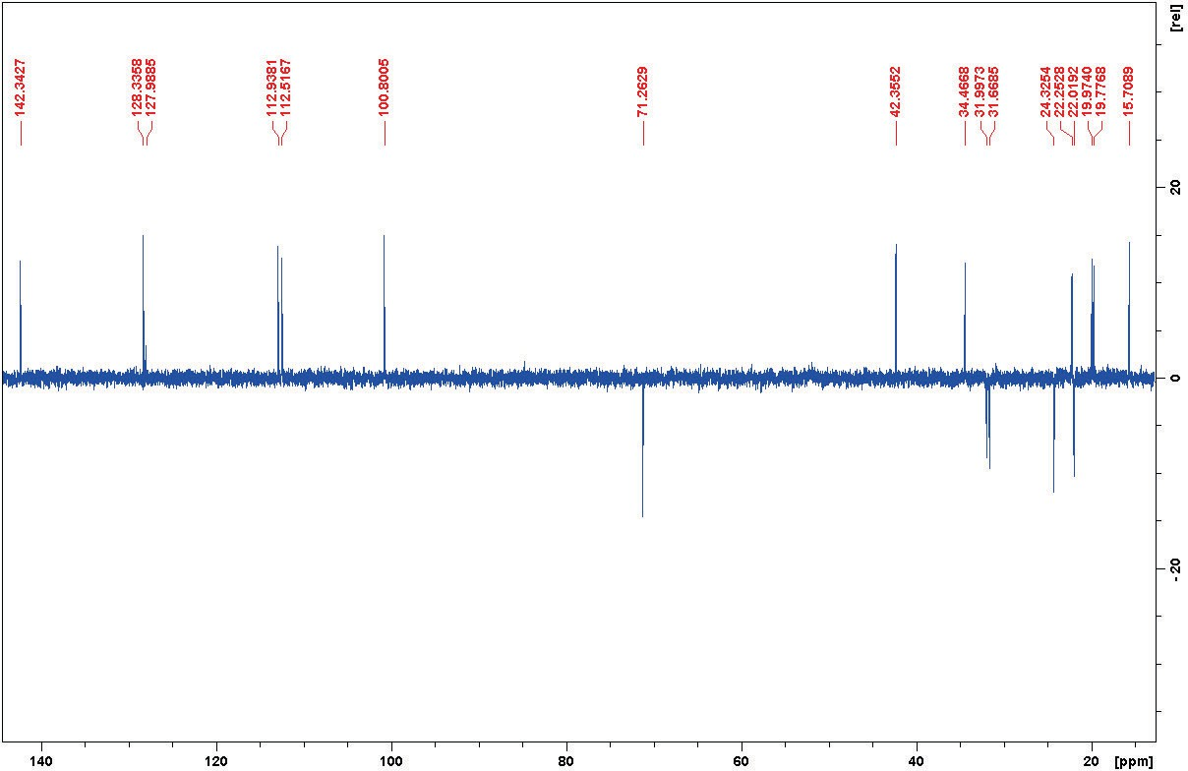
Figure S30: DEPT135 spectrum of 3 in C6D6.

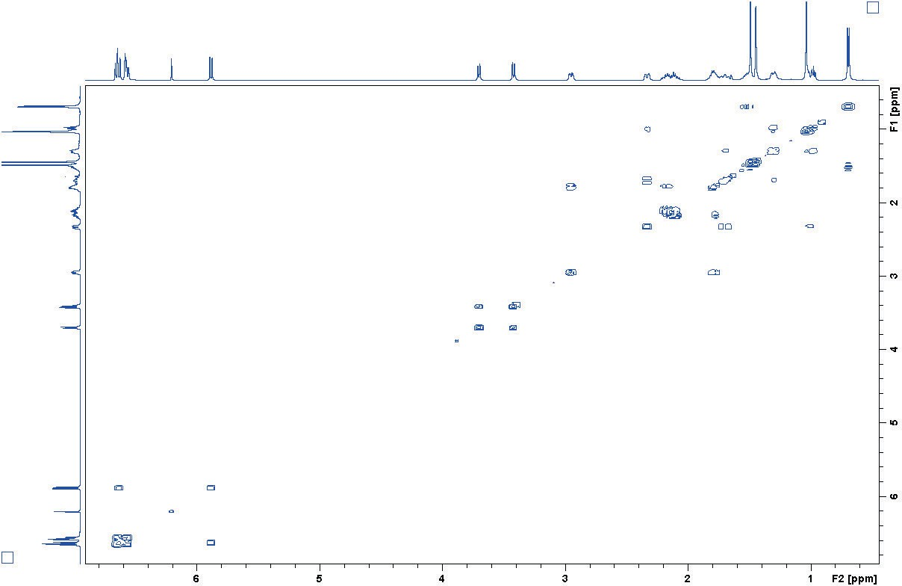
Figure S31: COSY spectrum of 3 in C6D6.

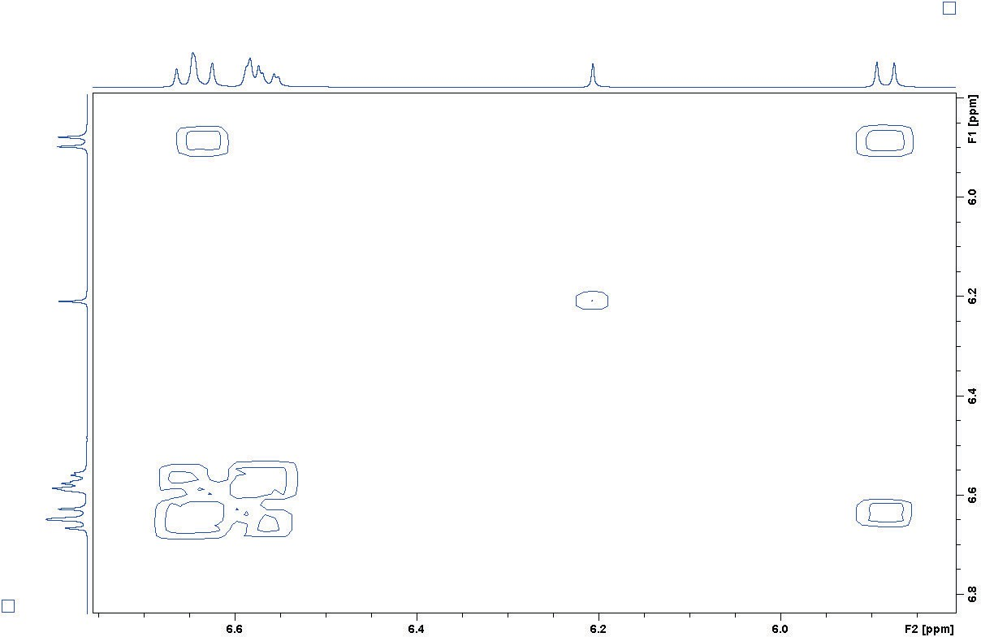
Figure S32: COSY spectrum of 3 in C6D6 (Exp.).

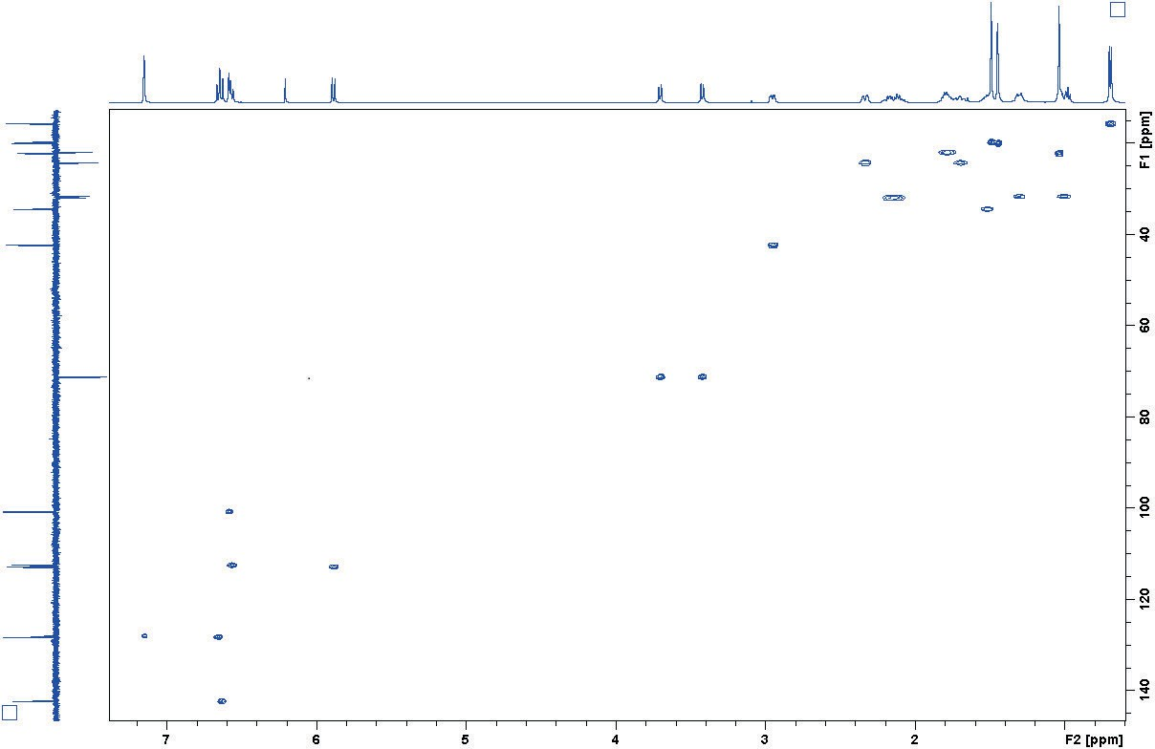
Figure S33: HSQC spectrum of 3 in C6D6.

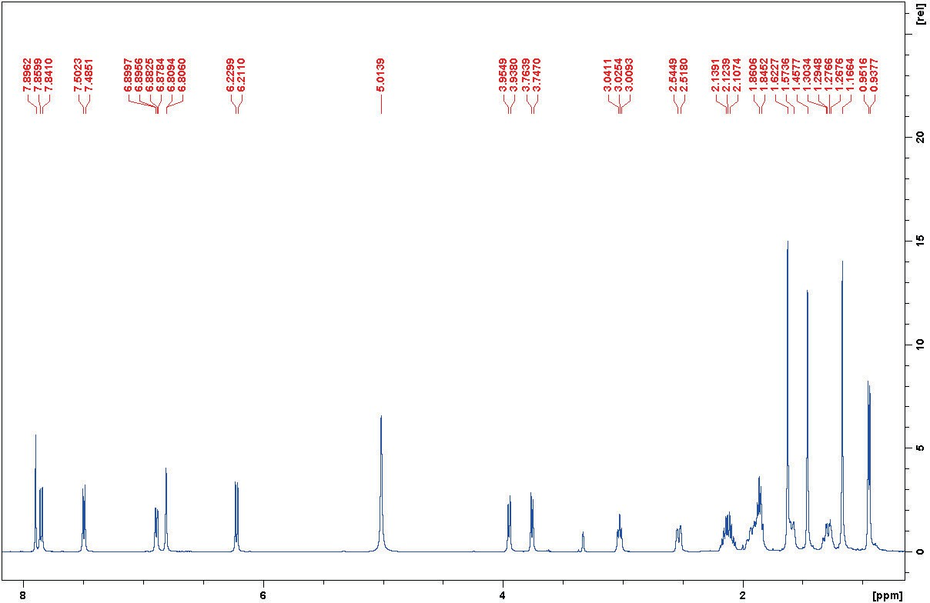
Figure S34: ¹HNMR spectrum of 3 in CD3OD.

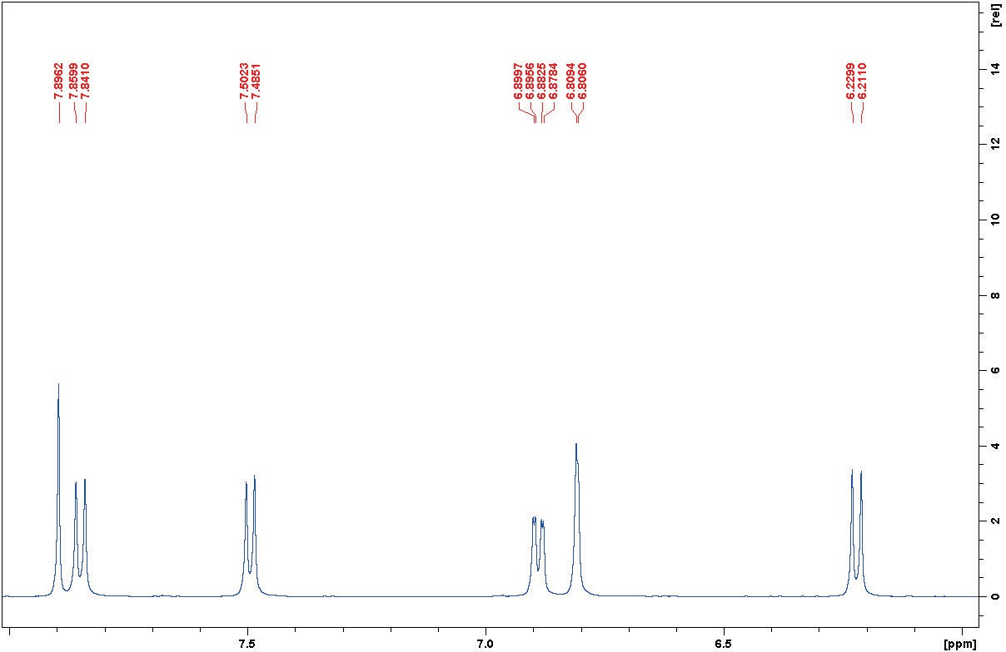
Figure S35: ¹HNMR spectrum of 3 in CD3OD (Exp.).

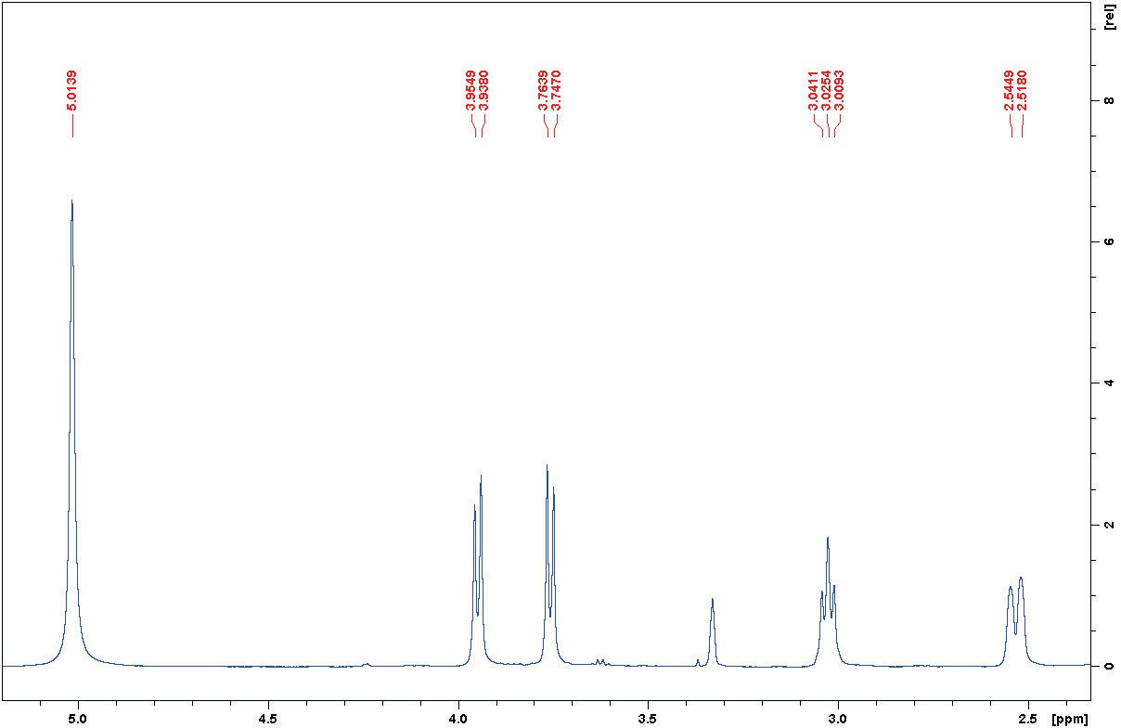
Figure S36: ¹HNMR spectrum of 3 in CD3OD (Exp.).

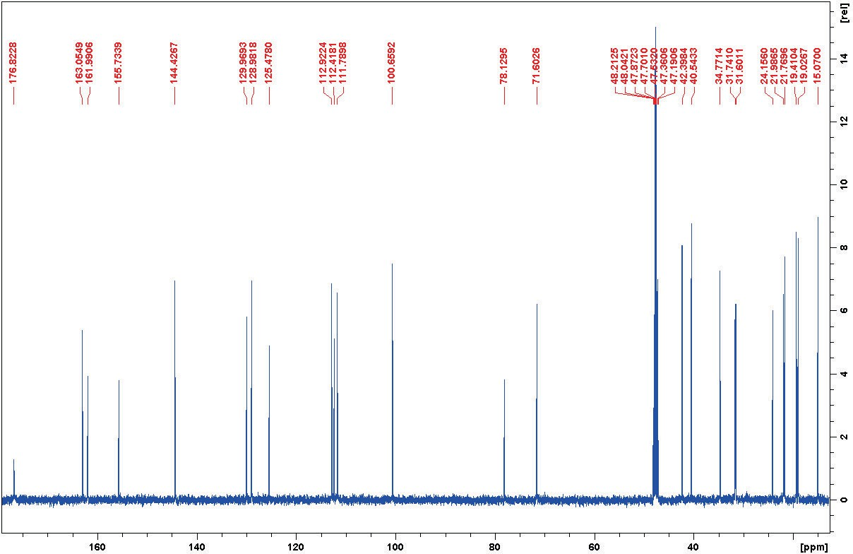
Figure S37: ¹³CNMR spectrum of 3 in CD3OD.

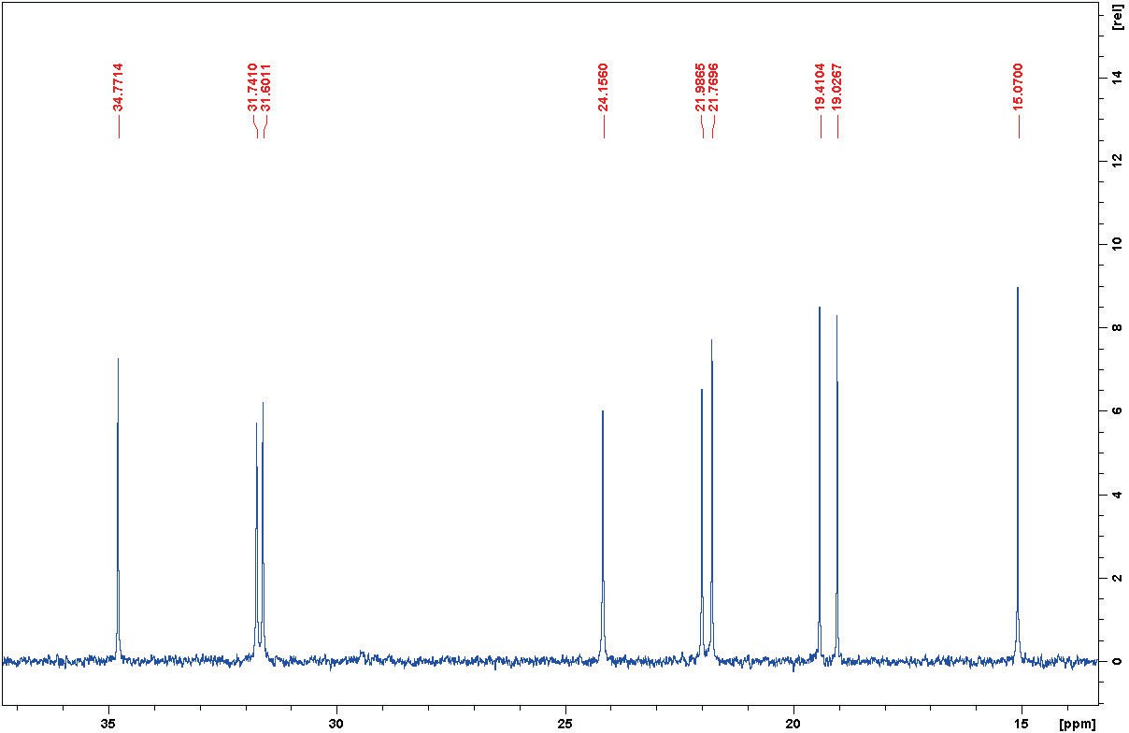
Figure S38: ¹³CNMR spectrum of 3 in CD3OD (Exp.).

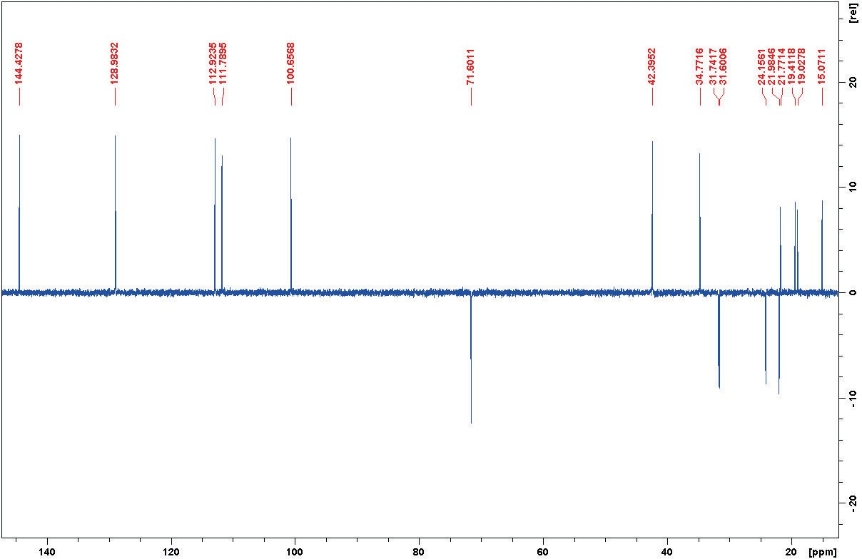
Figure S39: DEPT135 spectrum of 3 in CD3OD.

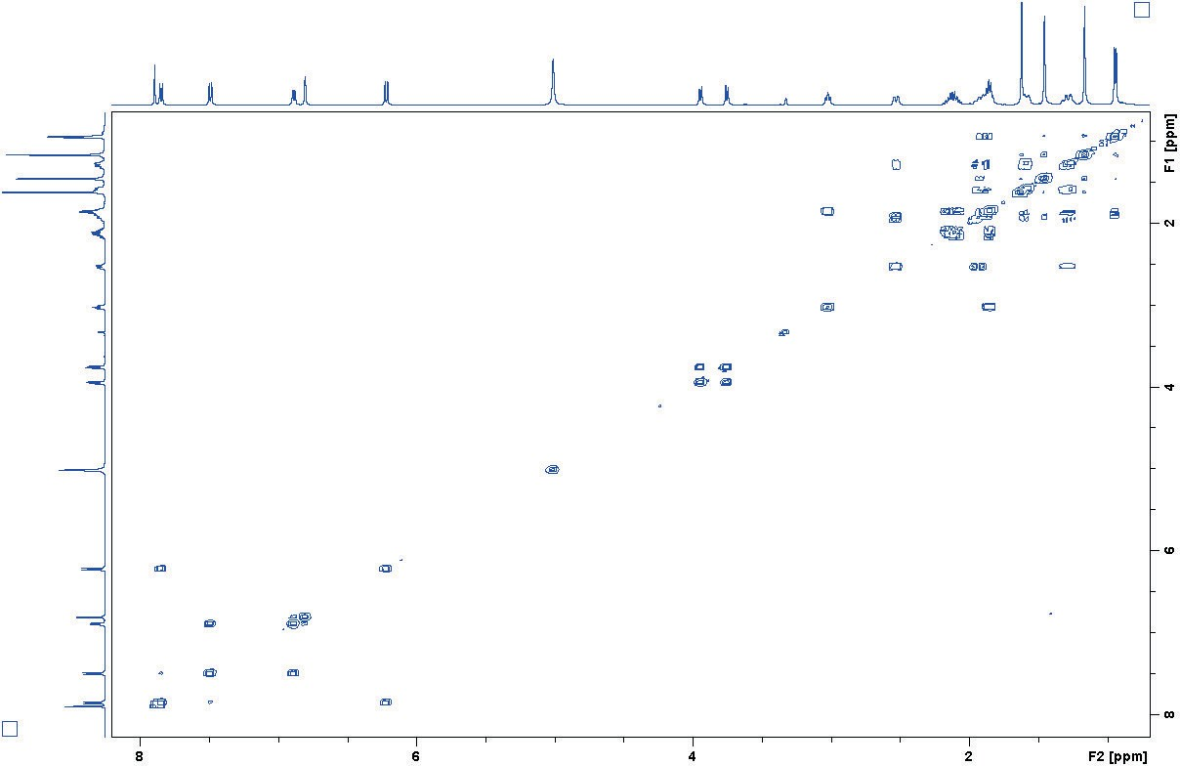
Figure S40: COSY spectrum of 3 in CD3OD.

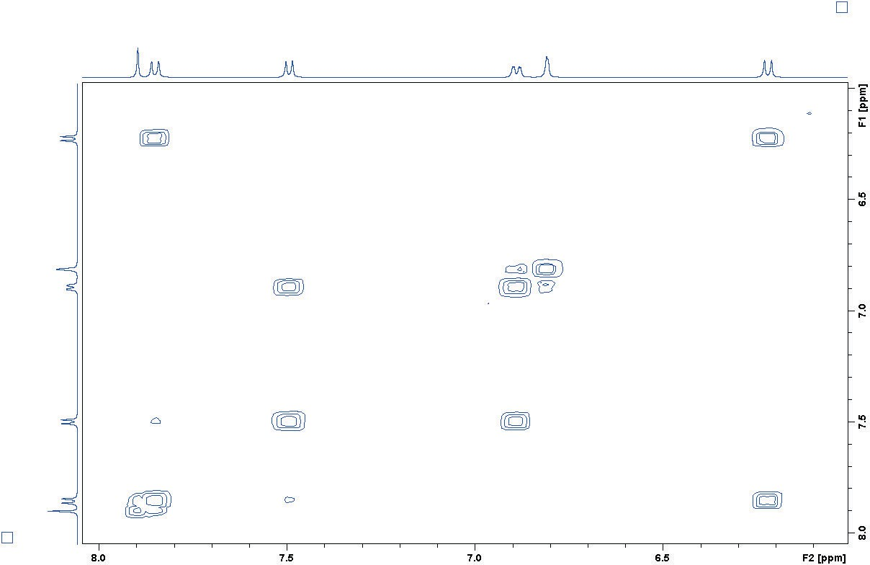
Figure S41: COSY spectrum of 3 in CD3OD (Exp.).

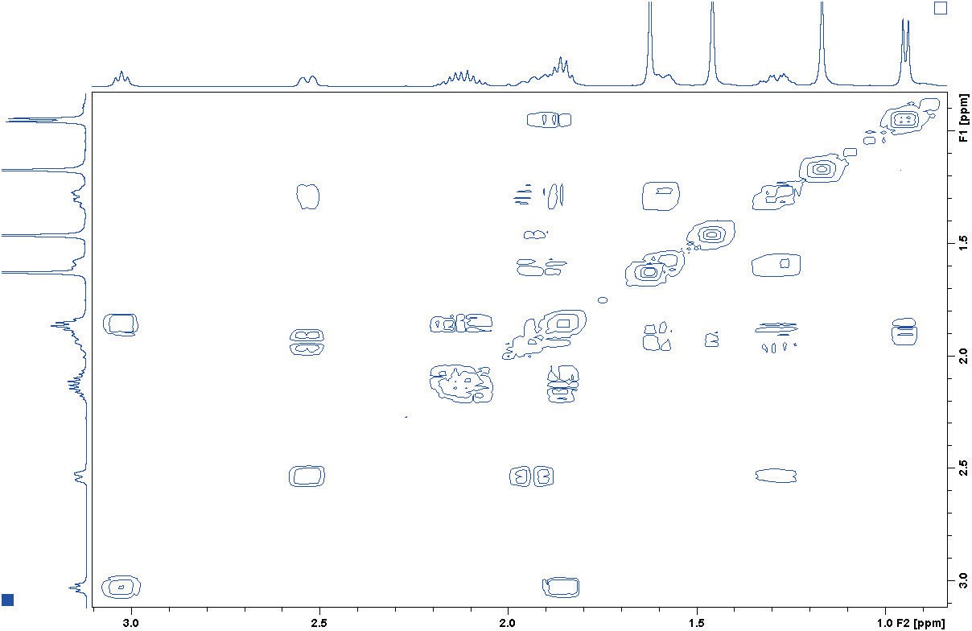
Figure S42: COSY spectrum of 3 in CD3OD (Exp.).

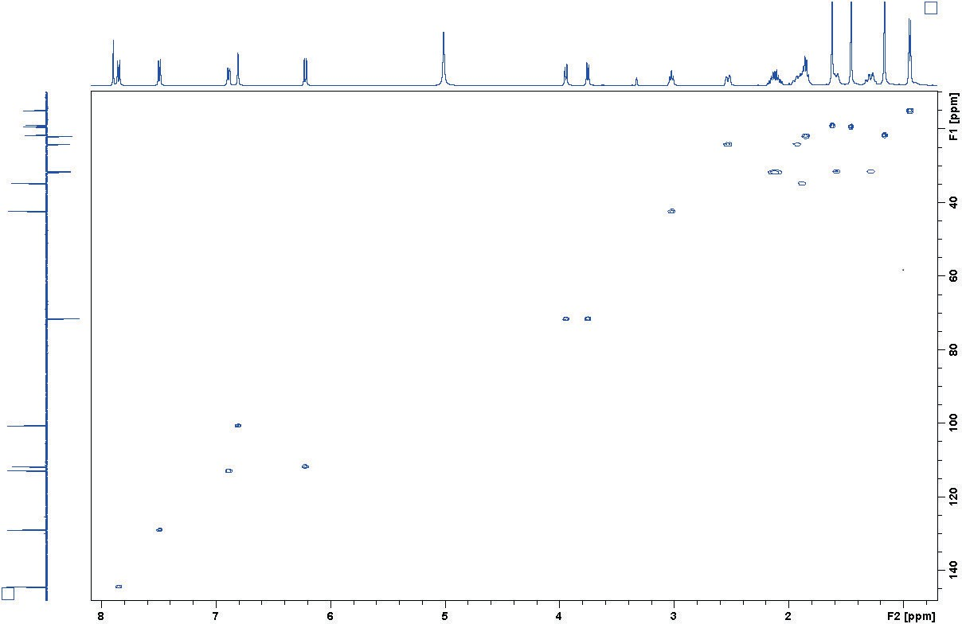
Figure S43: HSQC spectrum of 3 in CD3OD.

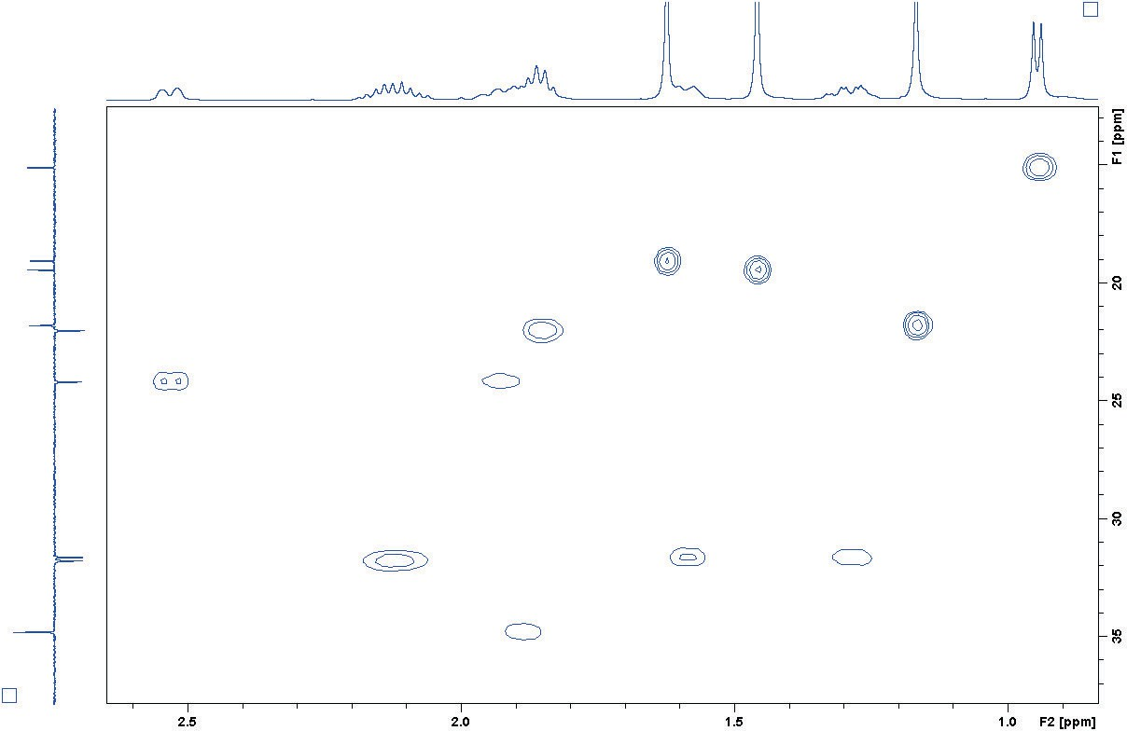
Figure S44: HSQC spectrum of 3 in CD3OD (Exp.).

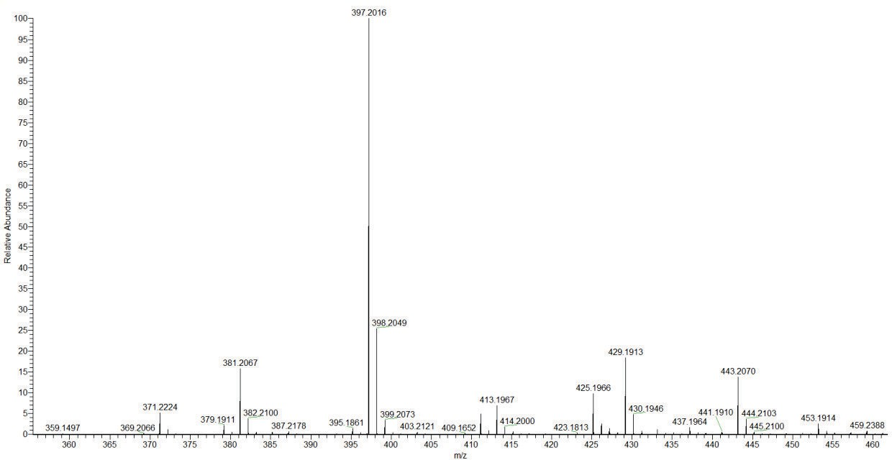

Figure S45: HRESIMS spectrum of 3 (Negative mode).

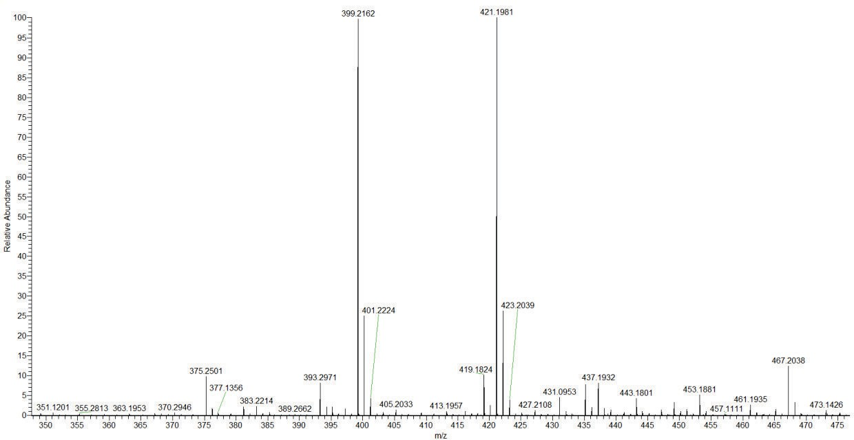
Figure S46: HRESIMS spectrum of 3 (Positive mode).

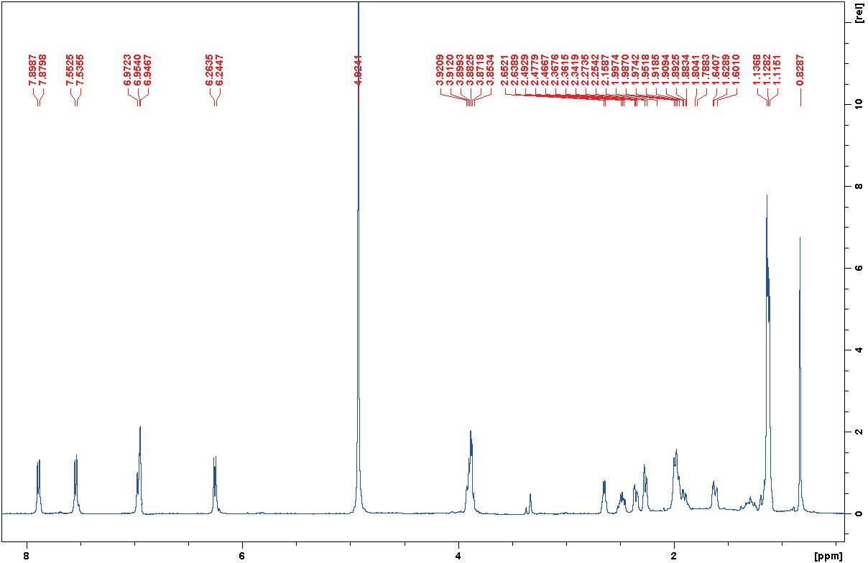
Figure S47: ¹HNMR spectrum of 4 in CD3OD.

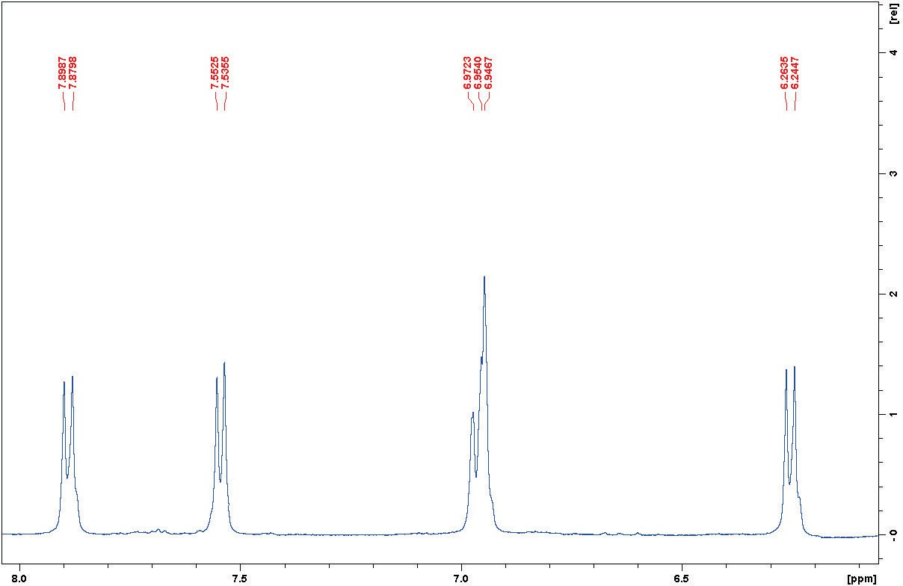
Figure S48: ¹HNMR spectrum of 4 in CD3OD (Exp.).

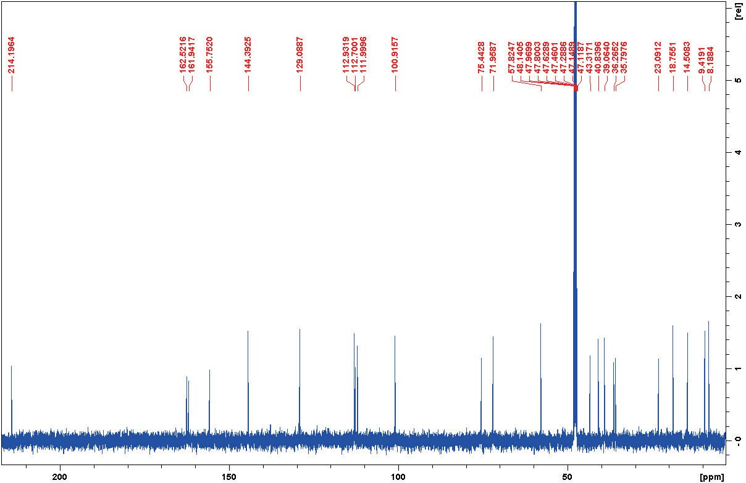
Figure S49: ¹³CNMR spectrum of 4 in CD3OD.

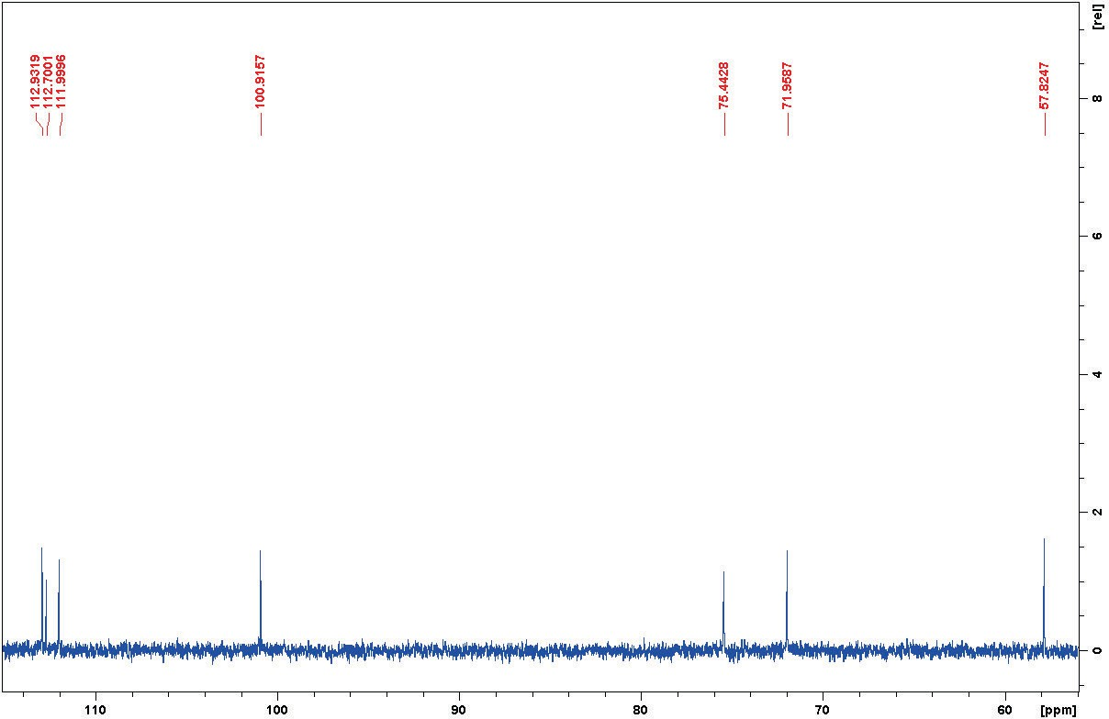
Figure S50: ¹³CNMR spectrum of 4 in CD3OD (Exp.).

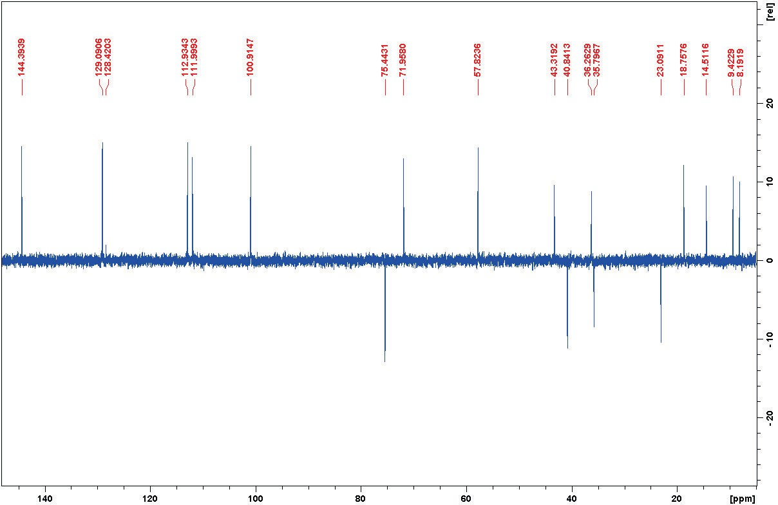
Figure S51: DEPT135 spectrum of 4 in CD3OD.

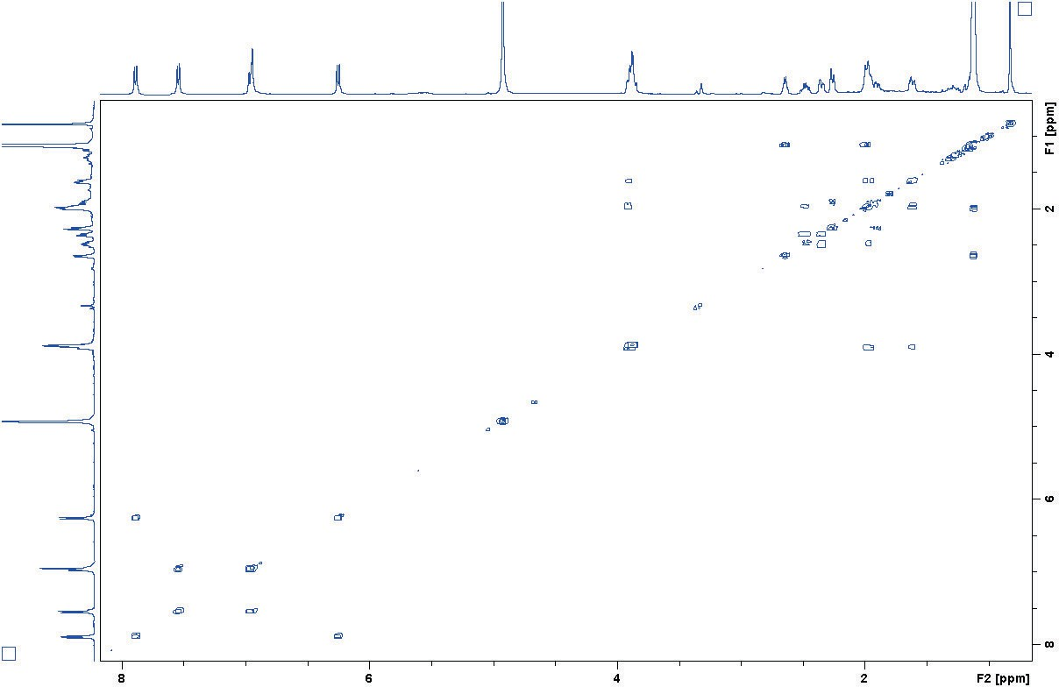
Figure S52: COSY spectrum of 4 in CD3OD.

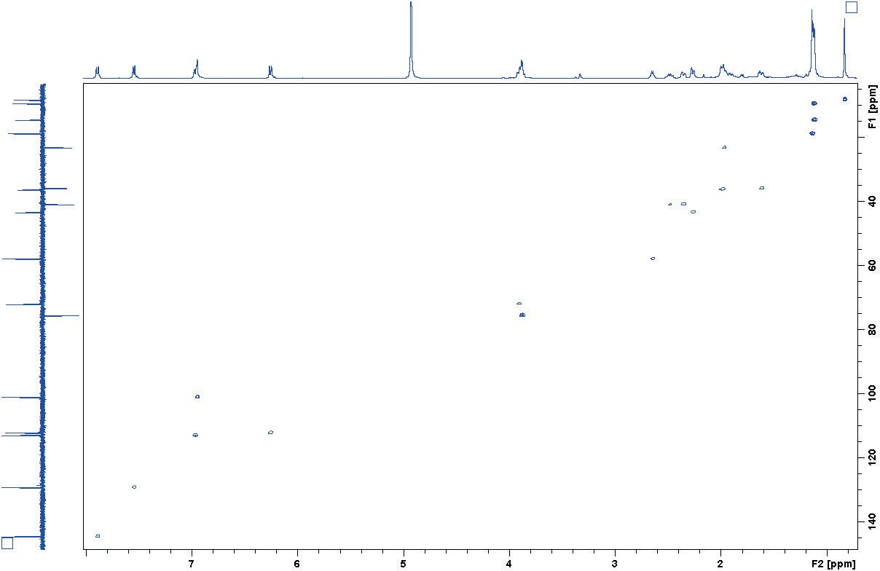
Figure S53: HSQC spectrum of 4 in CD3OD.

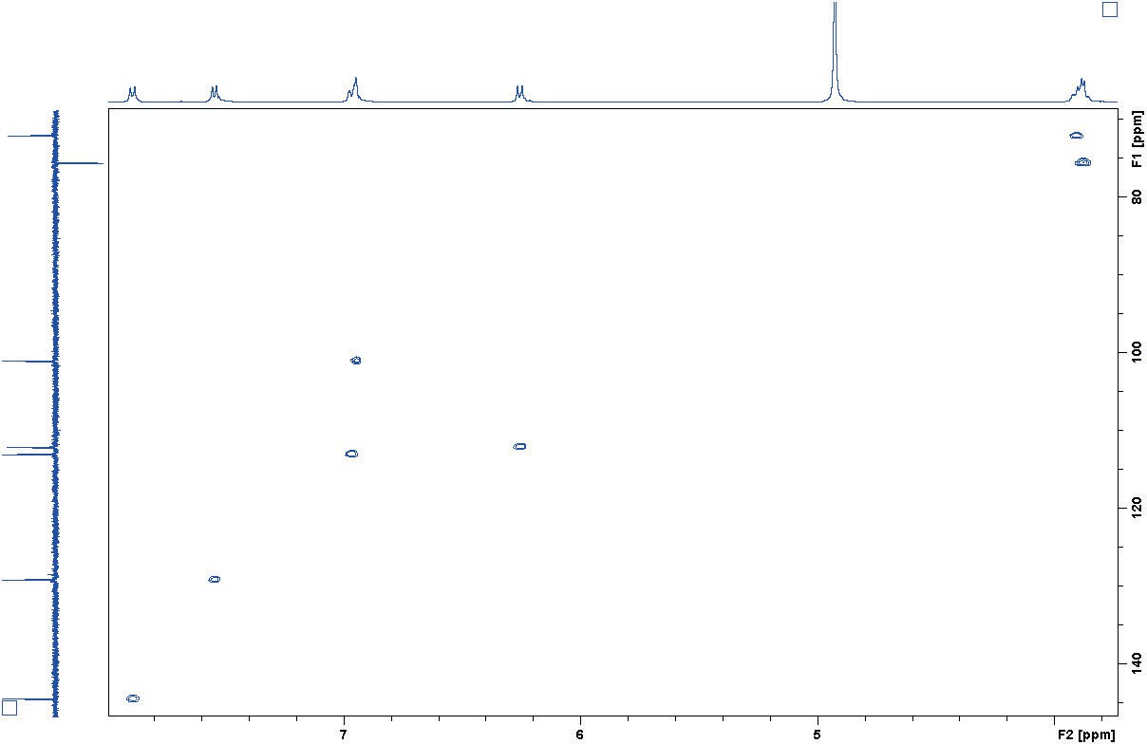
Figure S54: HSQC spectrum of 4 in CD3OD (Exp.).

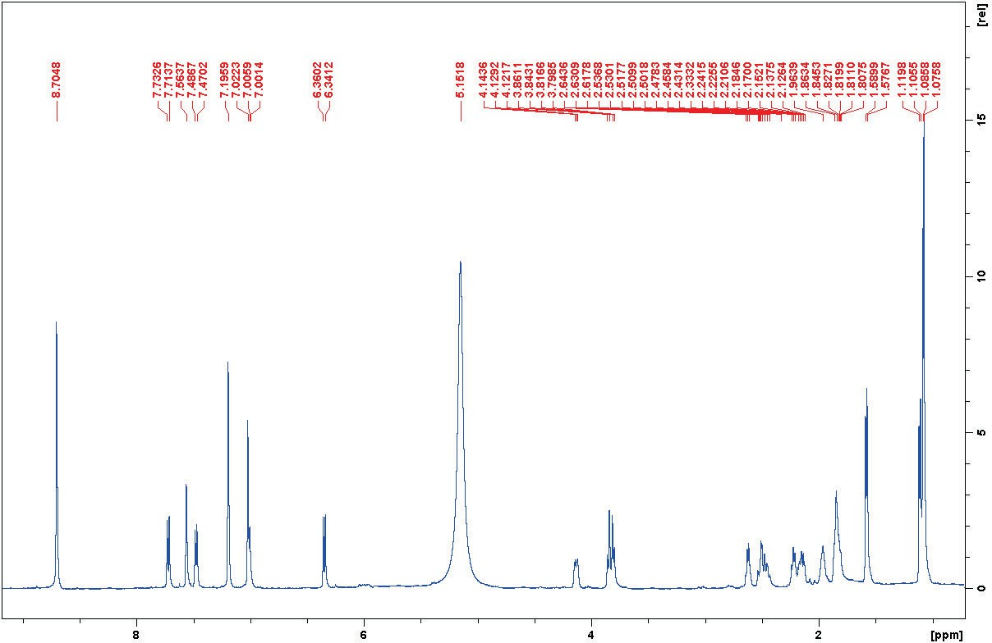
Figure S55: ¹HNMR spectrum of 4 in Pyridine d5.

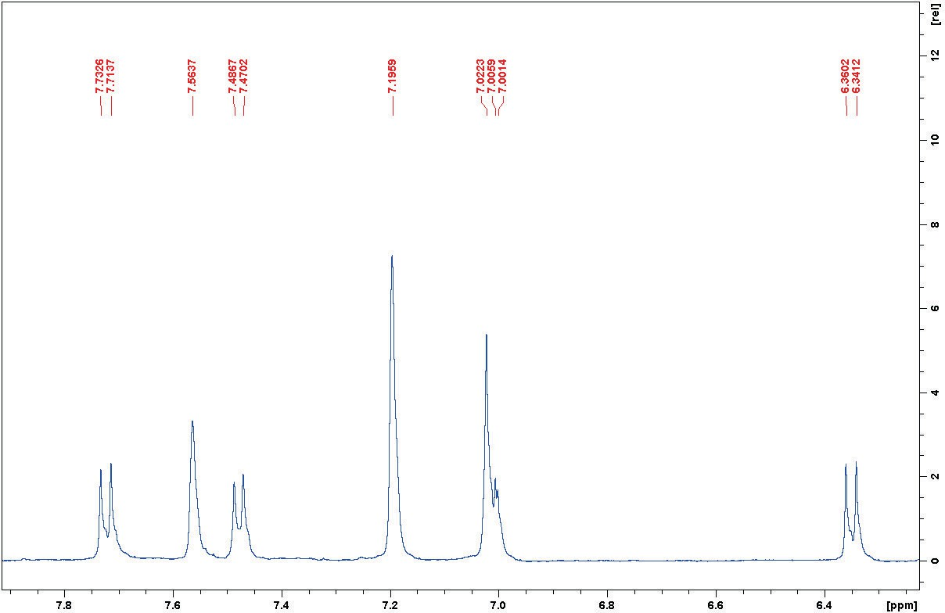
Figure S56: ¹HNMR spectrum of 4 in Pyridine d5 (Exp.).

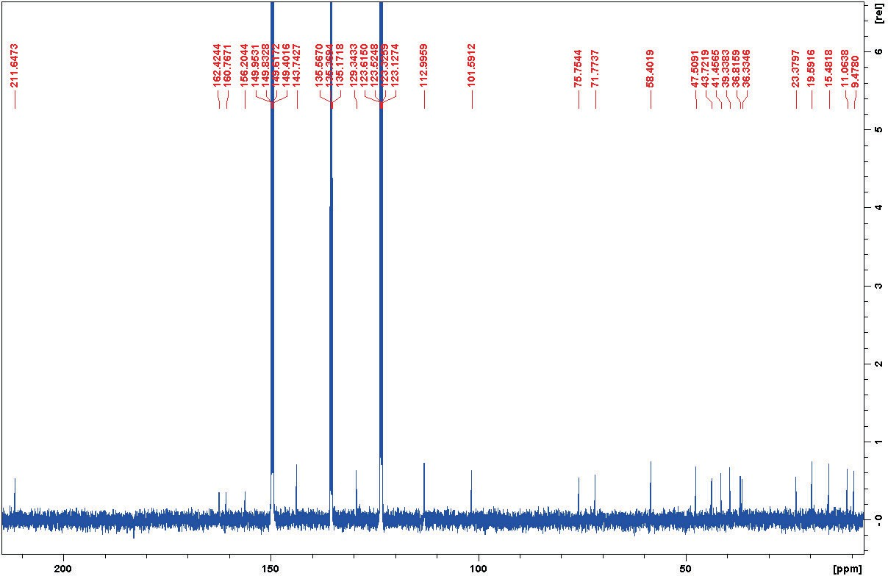
Figure S57: ¹³CNMR spectrum of 4 in Pyridine d5.

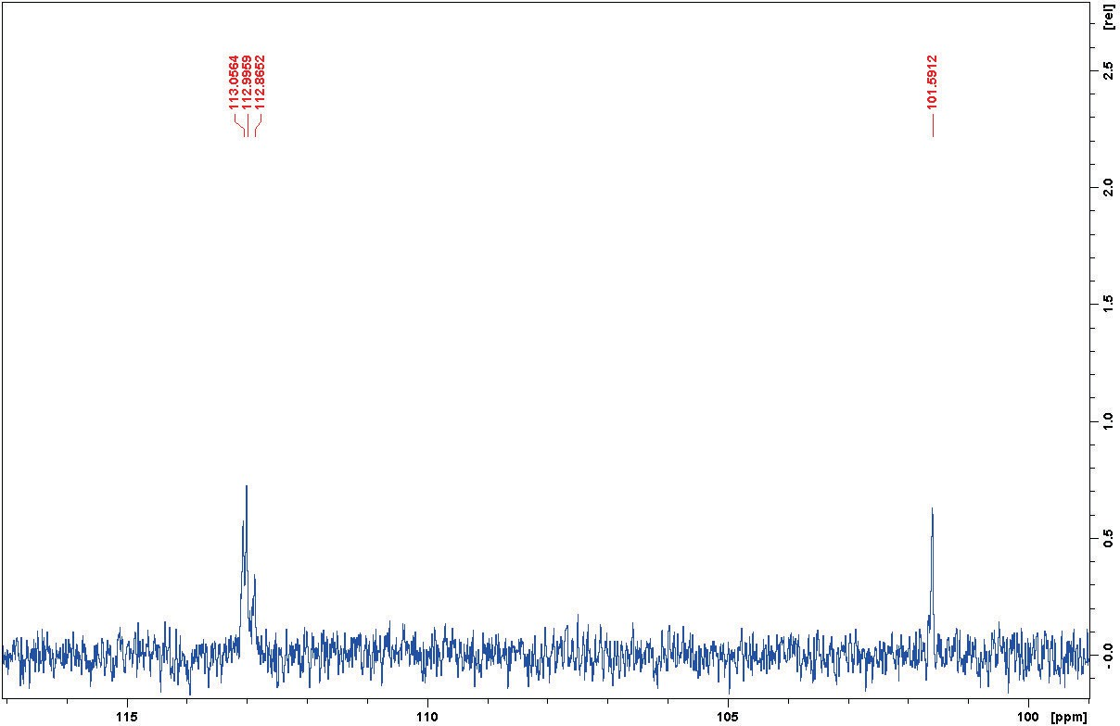
Figure S58: ¹³CNMR spectrum of 4 in Pyridine d5 (Exp.)

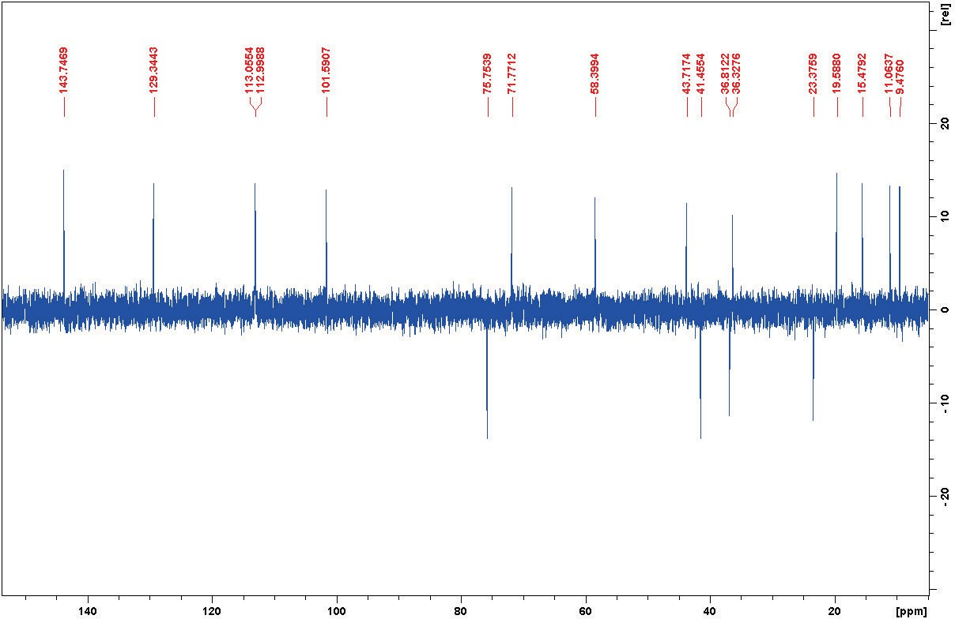
Figure S59: DEPT135 spectrum of 4 in Pyridine d5.

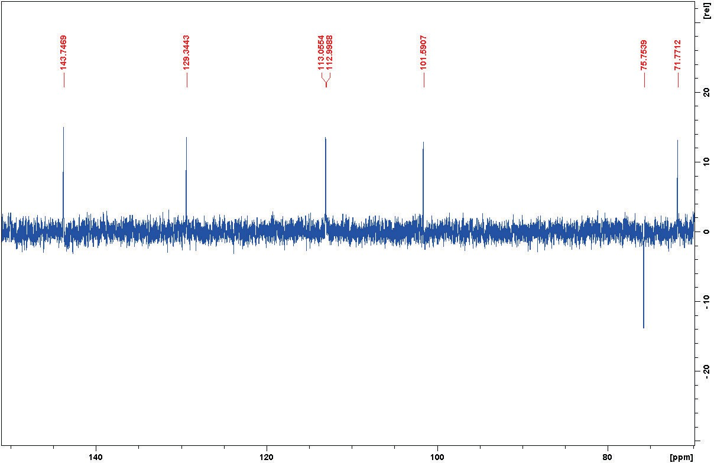
Figure S60: DEPT135 spectrum of 4 in Pyridine d5 (Exp.).

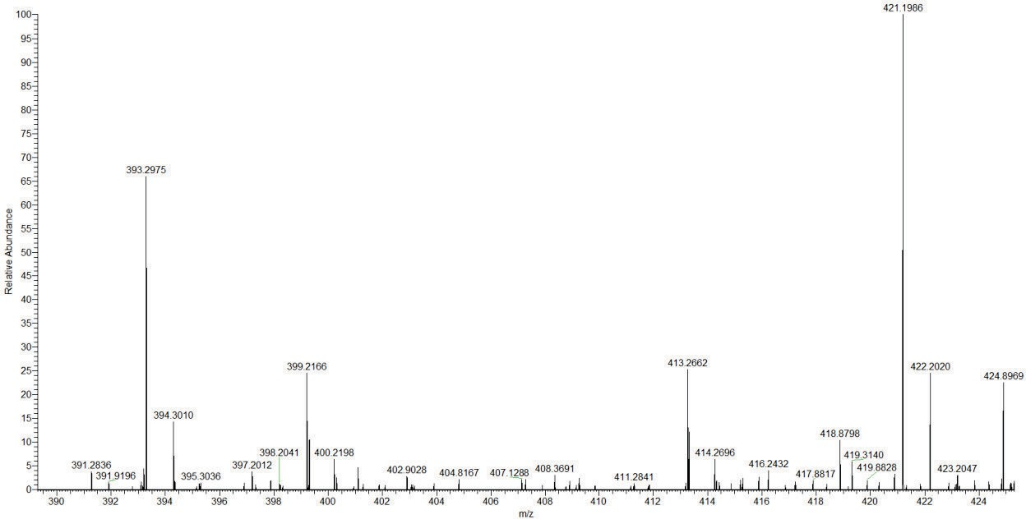
Figure S61: HRESIMS spectrum of 4.

