1. Accelerometry Data Collection
Raw data were collected by an ActiGraph device after it was assigned to a subject. The monitor measured accelerations in three individual axes (vertical, horizontal, perpendicular), with a dynamic range of ± 6 units of gravity and was set to record at a frequency of 30 Hz. Parents and children were instructed to wear the ActiGraph 24 h per day, 7 days, on the iliac crest on the right hip with an elastic belt. The device could be removed only during shower or nocturnal rest (if the instrument caused discomfort during sleep).

2. Accelerometry Data Processing and Cut-off Points Selection.
Summary of 'epoch' data is essentially raw data that has been filtered in order to run it through algorithms to produce outputs. An epoch is a date and time from which a computer measures time; in practice, it is the number of seconds that have elapsed between two consecutive measurements. The raw data are summed into chunks of data ('epochs') and the G values (universal gravitational constant to determine the intensity of the gravitational acceleration force) are converted to activity counts. Summary data is used to generate the results shown in ActiLife. ActiLife version 6.13.3 (ActiGraph Software Department: Pensacola, FL, USA) was used to download these data from the monitor at 15 epochs.

3. Non-wear-time validation
The non-wear-time (NWT) validation tool in ActiLife allows users to easily flag invalid data (or data collected when a device was unworn) for exclusion from further analysis. The NWT was defined as an interval of consecutive min (min) of zero activity intensity counts.ActiLife offers the possibility to schedule the Data Screening Criteria or establish default options to determine NWT. As default, the program provides two possibilities: a) Troiano 2007 criteria [15] included a minimum length of 60 min, 2 min of spike tolerance [16], 100 counts per min of spike level to stop and require consecutive epochs outside the activity threshold (this criterion is cataloged as NWT-60 from now onwards); b) Choi et al. 2011 criteria [17] included a minimum length of 90 min (NWT-90), a small window length of 30 and 2 min of spike tolerance. Trying to select one of them, a random selected subsample was analyzed using those authors' criteria (NWT-60 vs NWT-90) obtaining very similar results. Following with the Data Screening Criteria, a growing trend recommends establishing as criteria a minimum length of 20 min and 0 min for the rest of the options in children (this criterion is cataloged as NWT-20 from now onwards) [7]. ActiLife allows users to customize the non-wear periods, but only under Troiano and Choi’s algorithms [15,17]. Hence, the random subsample was analyzed again by both algorithms but schedule by the NWT-20 criteria. Selecting the option by Choi et al. [17], the software did not distinguish between wear and no-wear, understanding all-time analyzed as wear period. Therefore, it was decided to include in the final analysis only Troiano’s algorithms by NWT-20 [7] and NWT-60 [15]. In addition to the previously described criteria, Vector Magnitude and the following Optional Screen Parameters were selected: ignoring wear periods less than 20 min and sleep periods; performing a minimum of 8 h of monitoring per day for at least 3 days, including at least 1 weekend day [18]. These periods were replaced as missing data codes before downstream analysis.
4. Scoring
Traditionally, SB and PA have been estimated based on the number of CPM accumulated in a given period (length of time). The cut-off points are the thresholds of the activity counts used to categorize the activity as LPA, MPA and VPA
Exclusion criteria for this analysis included unavailability of valid data, non-compliance with the minimum number of hours set or if there was not enough time on valid days during the week or weekend, described above. All cut-off point values in ActiLife are based on 60-sec epoch lengths. When sub-60-sec files are used, ActiLife scales the epoch count level up to its 60-sec equivalent before performing the cut point categorization. Files using epochs larger than 60-sec have not been calculated. Also, to exclude low-quality records, all negative counts were replaced by missing data code.
The ActiLife data scoring program was used to determine daily minspent in SB, light PA, MPA, VPA, MVPA for each epoch length dataset, using the Evenson et al. [18], Pulsford et al. [19], Freedson et al. [20], Puyau et al. [21], Mattocks et al. [22], Troiano et al. [15] activity cut-off points accelerometry protocols that were defined as different intervals of counts per minute (CPM). Those cut-off points were available to ActiLife's users. For those accelerometry protocols with criteria established in 15-seconds, it was necessary to transform to 4 periods of 15 epoch in one period of 60 epoch (Table Supplementry 1).
Table Supplementary 1. Characteristics for different accelerometry protocols and data for physical activity intensity levels in children from the Genobox study according to them.
Accelerometry protocol |  | Population (age) | Sample (n) | Placement | Epoch (sec)‡ | Device used | Sedentary CPM | Light PA CPM | Moderate PA CPM | Vigorous PA CPM | Very-Vigorous PA CPM
Evenson et al. 2008 [18] |  | 5-8 years | 33 | Right hip | 15* | ActiGraph MT1 7164 | ≤100 | 101–2295 | 2296–4011 | ≥4012 | NE
Freedson et al. 2005 [20] |  | 6-18 years | 538^ | Right hip | 60 | ActiGraph /Actical / Actiwatch / RT3 Triaxial. | ≤149 | 150–499 | 500–3999 | 4000–7599 | ≥7600
Mattocks et al. 2007 [22] |  | 12 years | 83 | Right hip | 60 | ActiGraph MT1 7164 | ≤100 | 101-3580 | 3581-6129 | ≥6130 | NR
Pulsford et al. 2011 [19] |  | 7-8 years | 53 | Right hip | 15* | Actigraph GT1M 1X | ≤100 | 101-2240 | 2241-3840 | ≥3841 | NR
Puyau et al. 2002 [21] |  | 6-16 years | 26 | Right hip | 60 | ActiGraph MT1 7164 | ≤799 | 800-3199 | 3200-8200 | ≥8200 | NR
Troiano et al. 2008 [15] |  | 6-11 years / 12-19 / 20+ | 6329† | Right hip | 60 | ActiGraph MT1 7164 | ≤99 | 100-2019 | 2020-5998 | ≥5999 | NR
CPM: counts per min; NE: non-established category by original authors; PA: physical activity.
^ The sample size was composed of the sum of different studies selected to establish the validation protocol.
† Data are described from 6329 participants who provided at least 1 d of accelerometer data and from 4867 participants who provided four or more days of accelerometer data.
‡Number of seconds that have elapsed between two consecutive measurements.
*These units were initially displayed in Epoch 15 sec and transformed to Epoch 60 sec in ActiLife.

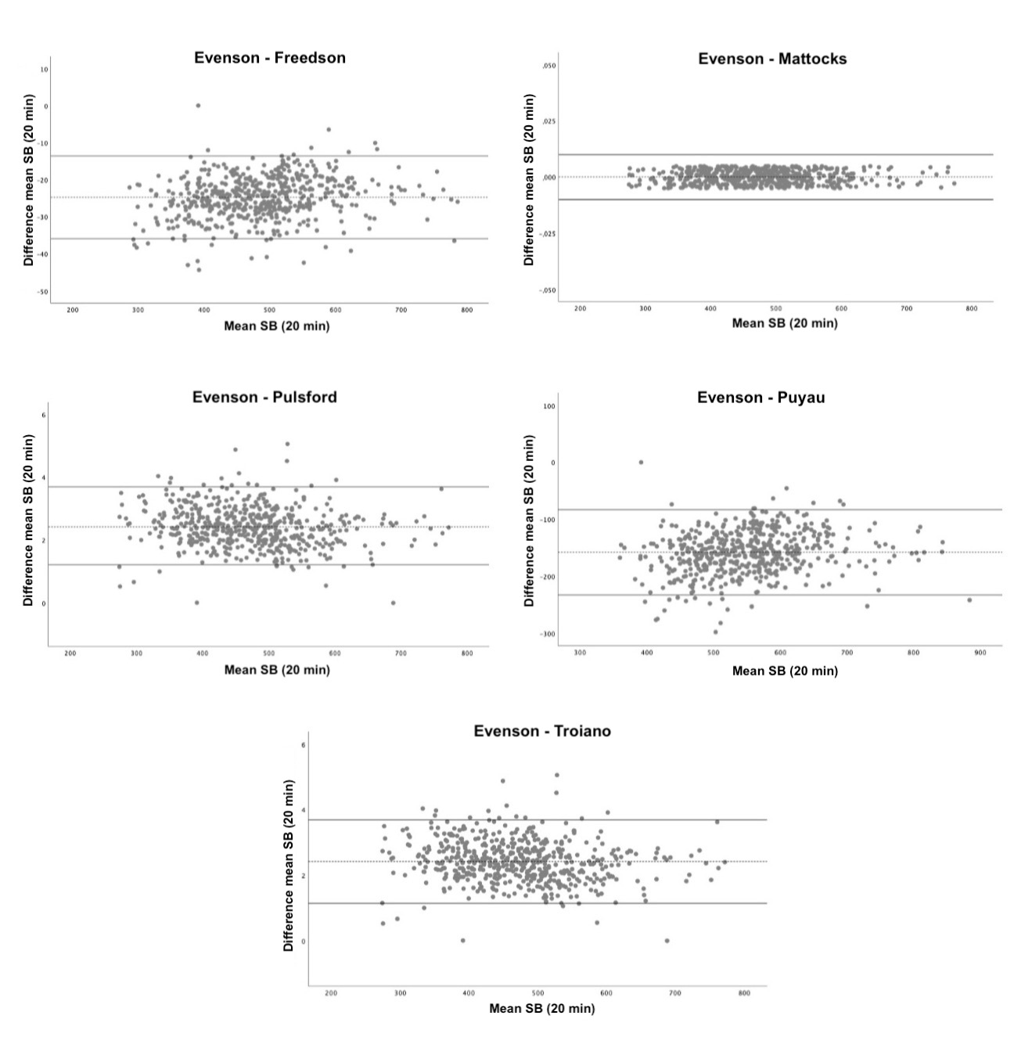

Supplementary Figure 1. Bland-Altman plots of sedentary behavior measurement agreement between the Evenson et al. and Freedson et al.; Mattocks et al.: Pulsford et al.; Puyau et al.; Troiano et al. accelerometry protocols. SB; sedentary behavior.

Note: Data in this figure had the same behavior as that obtained with the 60-min of non-wear-time (results not shown).

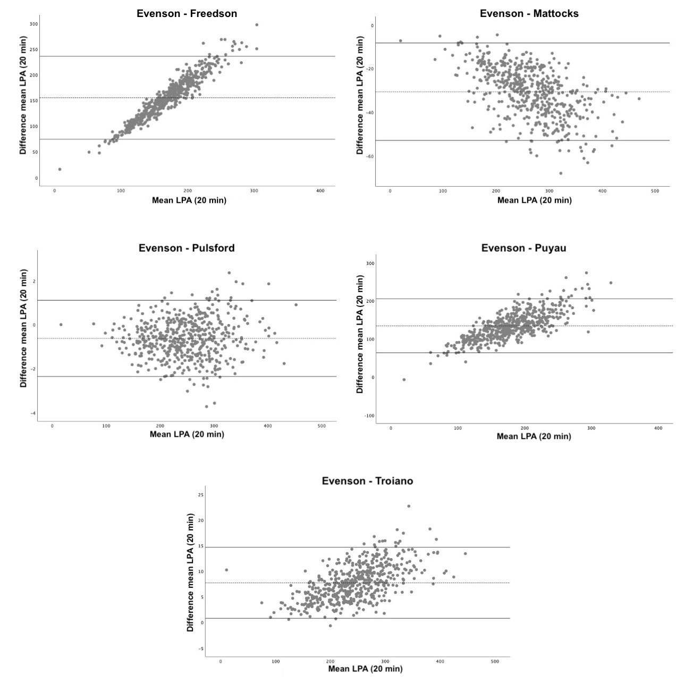

Supplementary Figure 2. Bland-Altman plots of light activity measurement agreement between the Evenson et al. and Freedson et al., Mattocks et al., Pulsford et al., Puyau et al., Troiano et al. accelerometry protocols. LPA: light physical activity.

Note: Data in this figure had the same behavior as that obtained with the 60-min of non-wear-time (results not shown).

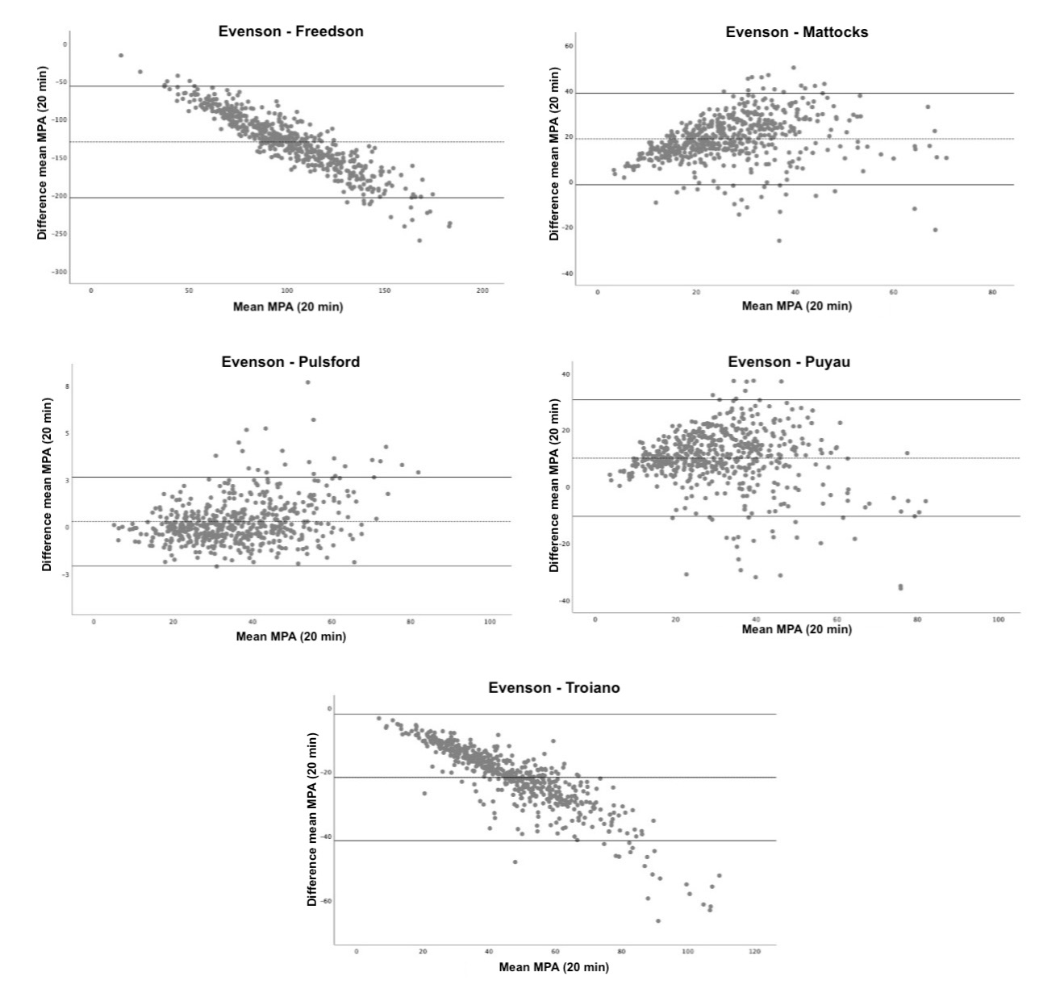

Supplementary Figure 3. Bland-Altman plots of moderate physical activity measurement agreement between the Evenson et al. and Freedson et al., Mattocks et al., Pulsford et al., Puyau et al., Troiano et al. accelerometry protocols. MPA: moderate physical activity

Note: Data in this figure had the same behavior as that obtained with the 60-min of non-wear-time (results not shown).
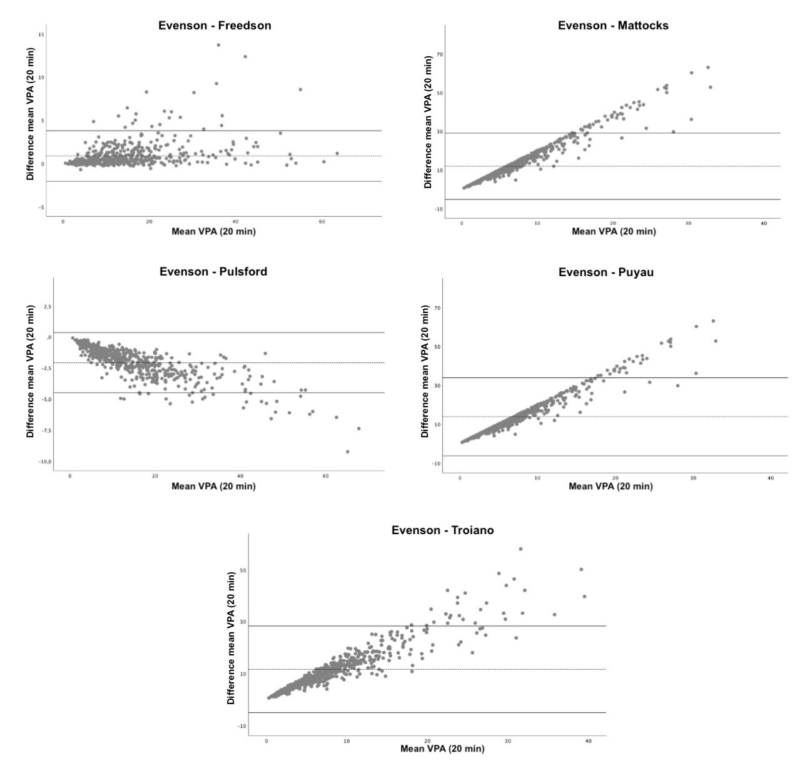

Supplementary Figure 4. Bland-Altman plots of vigorous physical activity measurement agreement between the Evenson et al. and Freedson et al., Mattocks et al., Pulsford et al., Puyau et al., Troiano et al. accelerometry protocols. VPA: vigorous physical activity.

Note: Data in this figure had the same behavior as that obtained with the 60-min of non-wear-time (results not shown).

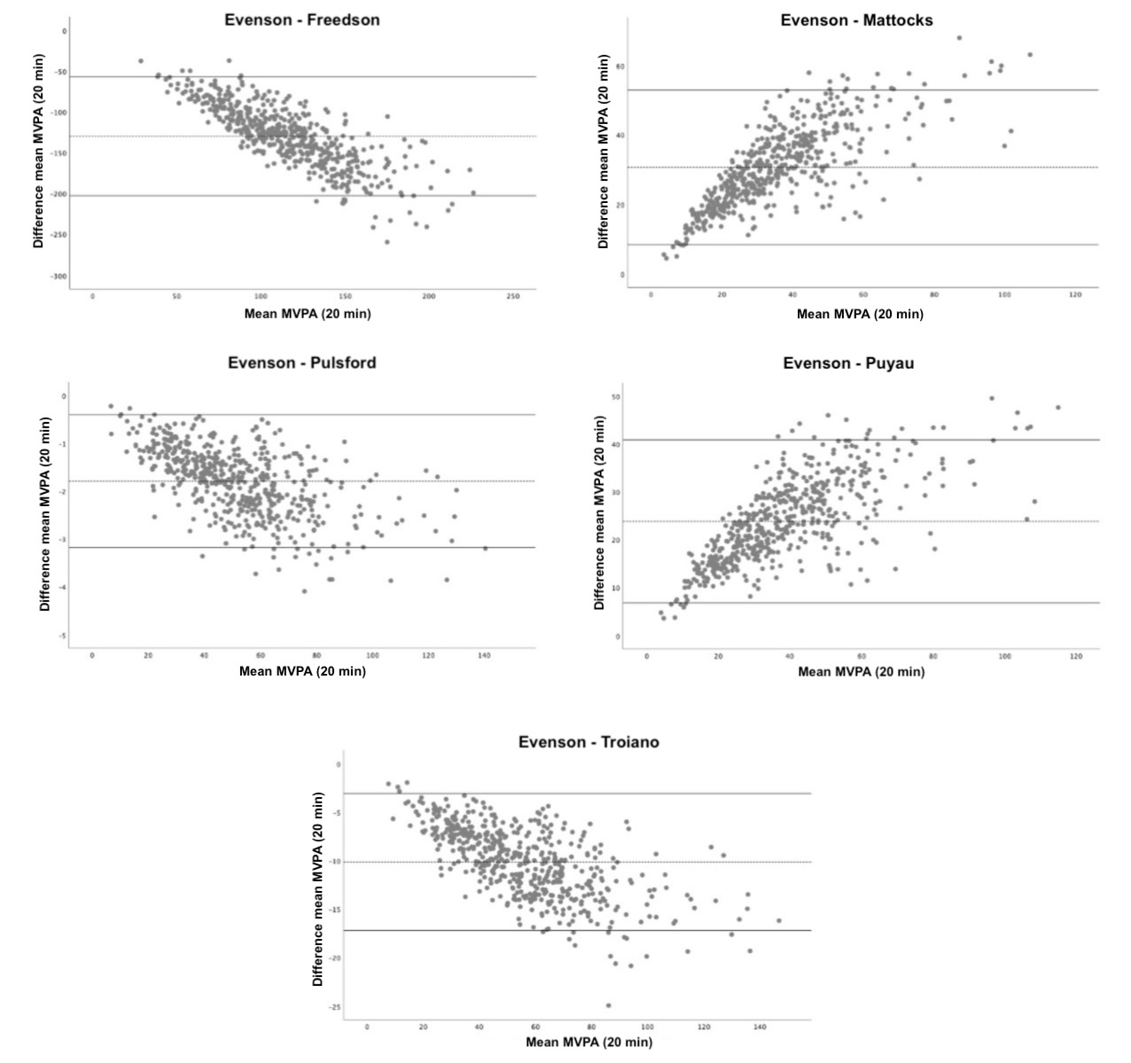

Supplementary Figure 5. Bland-Altman plots of moderate-vigorous physical activity measurement agreement between the Evenson et al. and Freedson et al., Mattocks et al., Pulsford et al., Puyau et al., Troiano et al. accelerometry protocols. MVPA: moderate-vigorous physical activity

Note: Data in this figure had the same behavior as that obtained with the 60-min of non-wear-time (results not shown).

