Extended data figures and tables
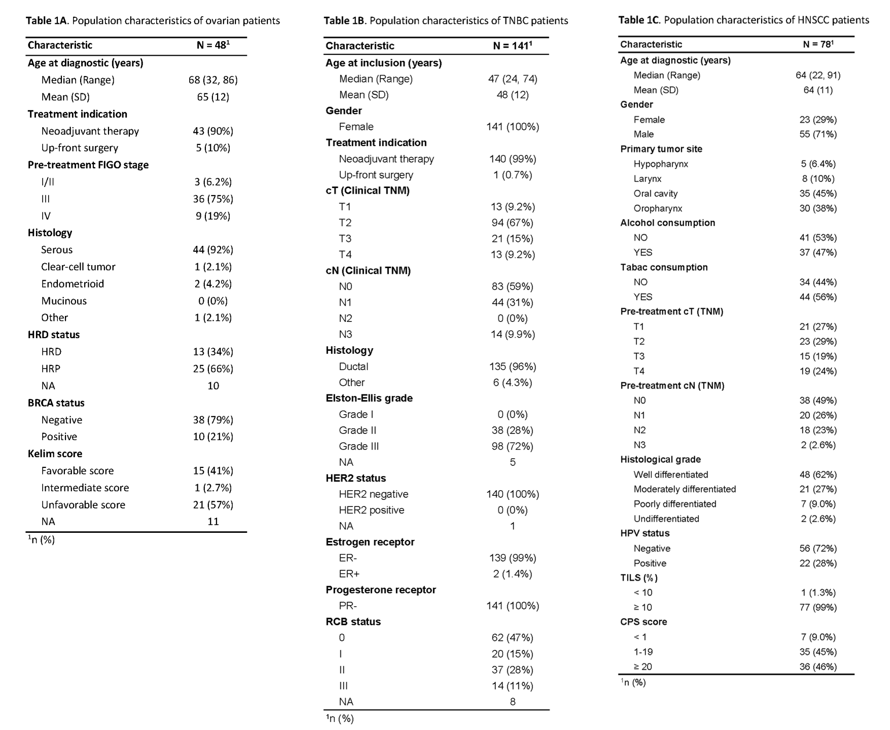
Extended Data Table 1. Patient characteristics of SCANDARE cohorts.

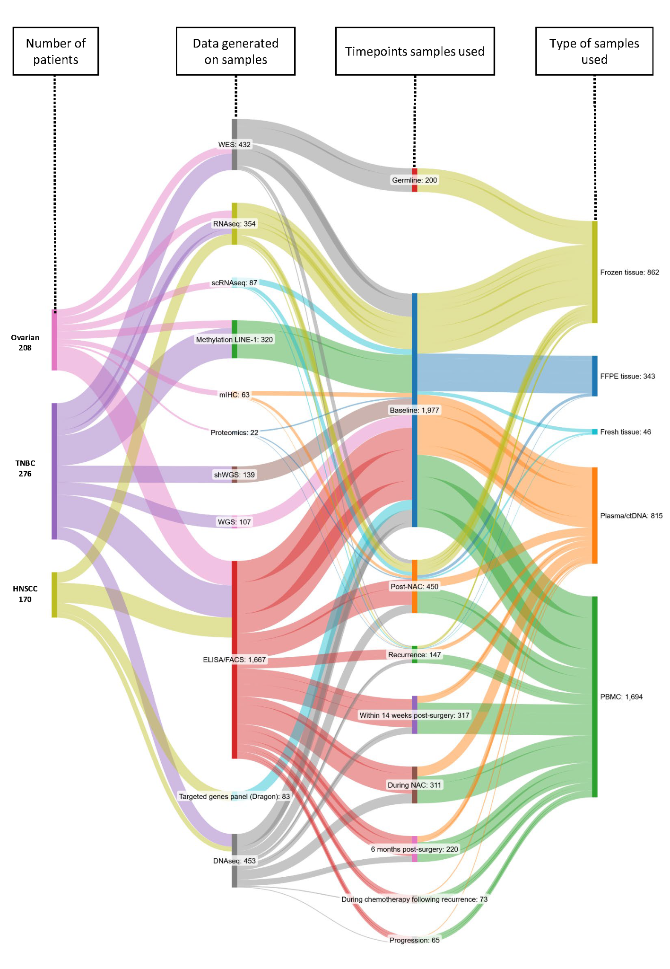
Extended Data Fig. 1. Sankey plot of available data and timepoints

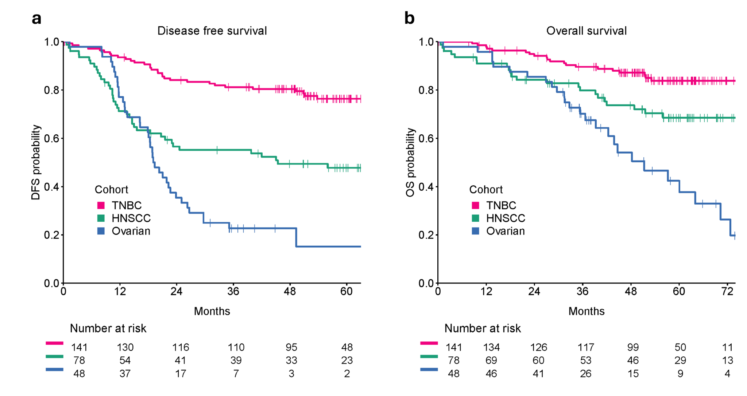
Extended Data Fig. 2. Disease-free survival and overall survival in SCANDARE cohorts.

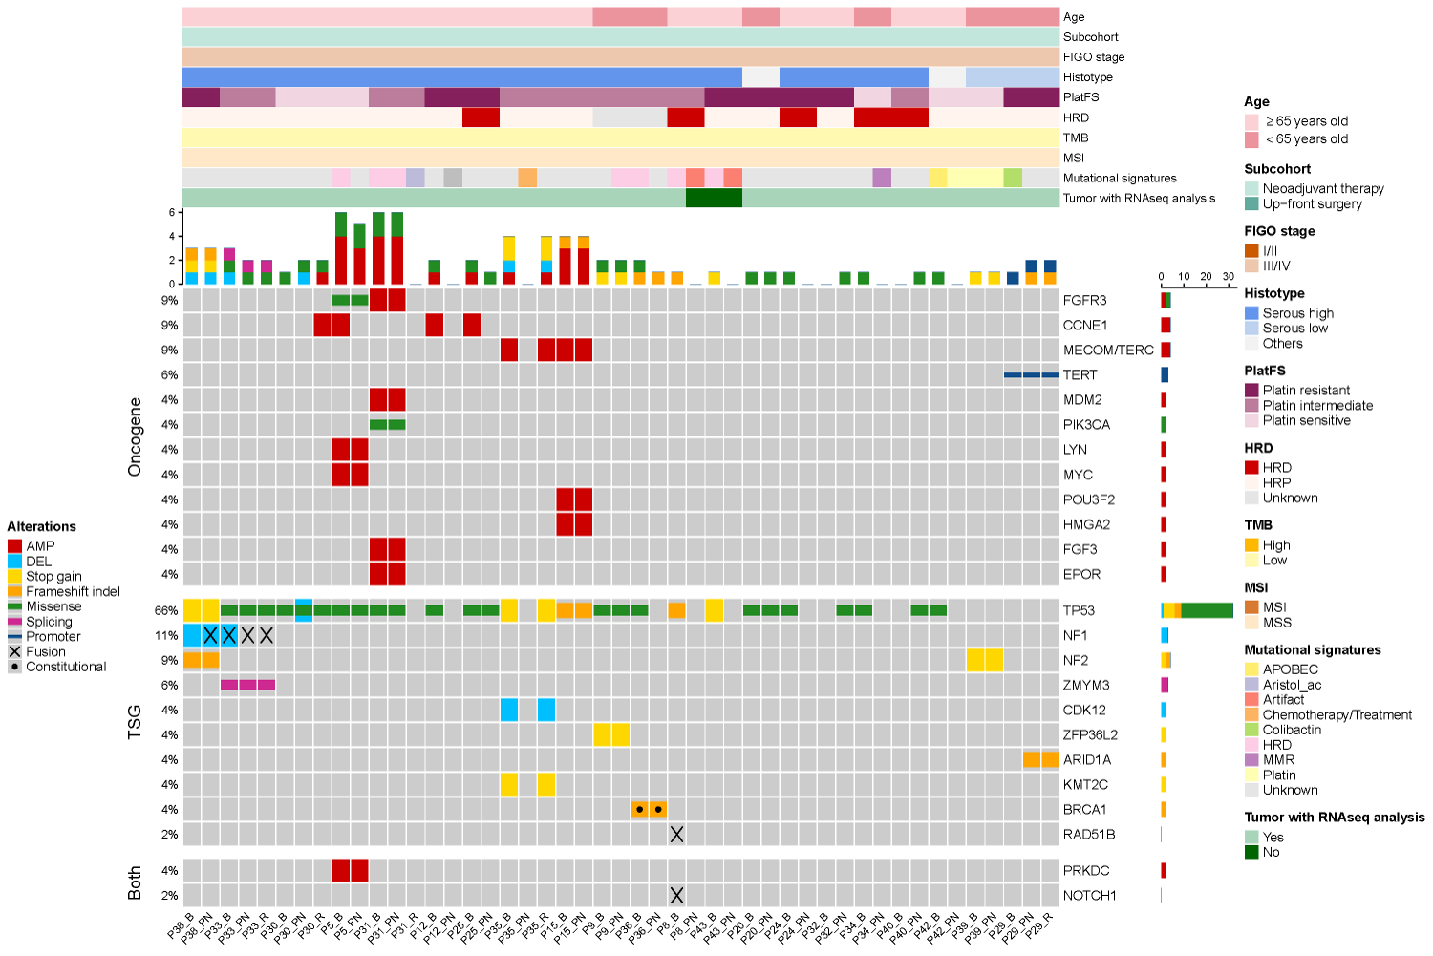
Extended Data Fig. 3. Mutational background in post-neoadjuvant chemotherapy and recurrent patient samples. Oncoprints displaying genetic alterations identified from WES were generated for longitudinal ovarian cancer samples (n = 47) using ComplexHeatmap R package (version 2.22.0).
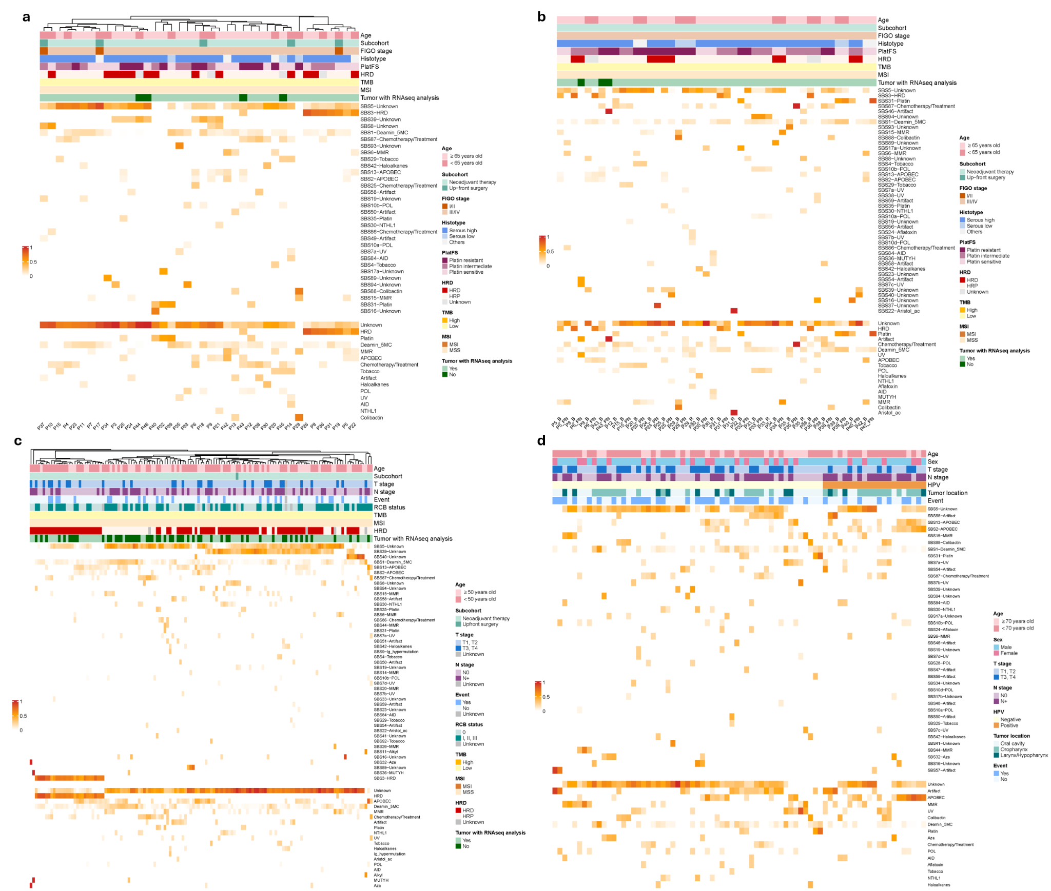
Extended Data Fig. 4. Mutational signatures in SCANDARE cohorts. Mutational signatures were characterized from WES using SigProfilerAssignment (version 0.1.8) according to COSMIC mutational signatures (version 3.3) for ovarian baseline samples (a) (n = 40), ovarian longitudinal samples (b) (n = 40 for baseline, n = 21 for post-NAC, n = 5 for recurrence), TNBC baseline (c) (n = 133), and HSNCC baseline (d) (n = 76).

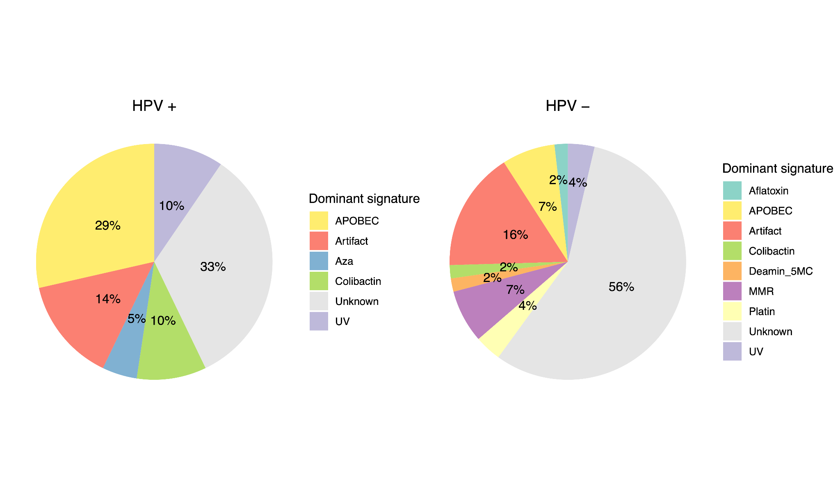
Extended Data Fig. 5. Dominant mutational signatures detected in HPV-associated and HPV-independant HNSCC patients. Dominant mutational signatures are defined as the signatures representing at least ≥20% of all mutations.
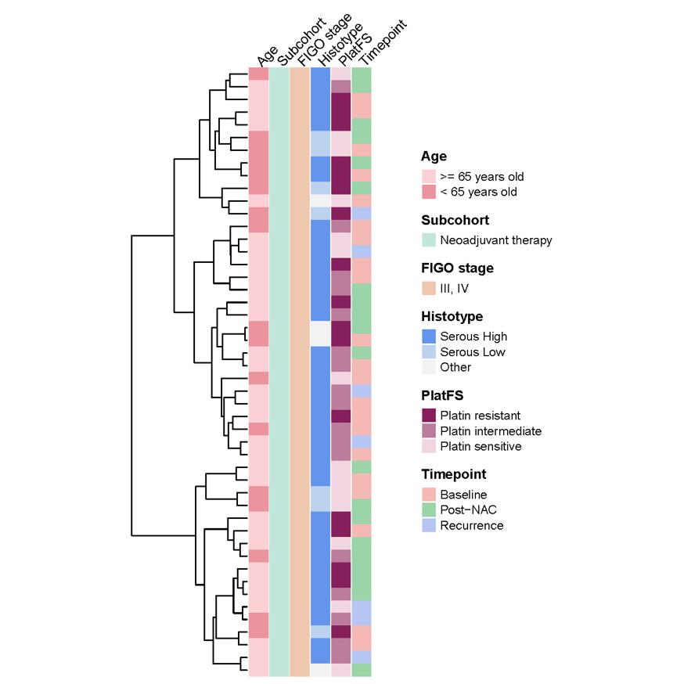
Extended Data Fig. 6. Transcriptional clustering of longitudinal ovarian cancer patient samples. Dendrograms and heatmaps were generated from RNA-seq data for ovarian longitudinal samples (b) (n = 21 for baseline, n = 20 for post-NAC, n = 7 for recurrence) Dendrograms were generated with the ComplexHeatmap R package (version 2.20.0), using Pearson correlation as the clustering distance and Ward.D2 as the clustering method.
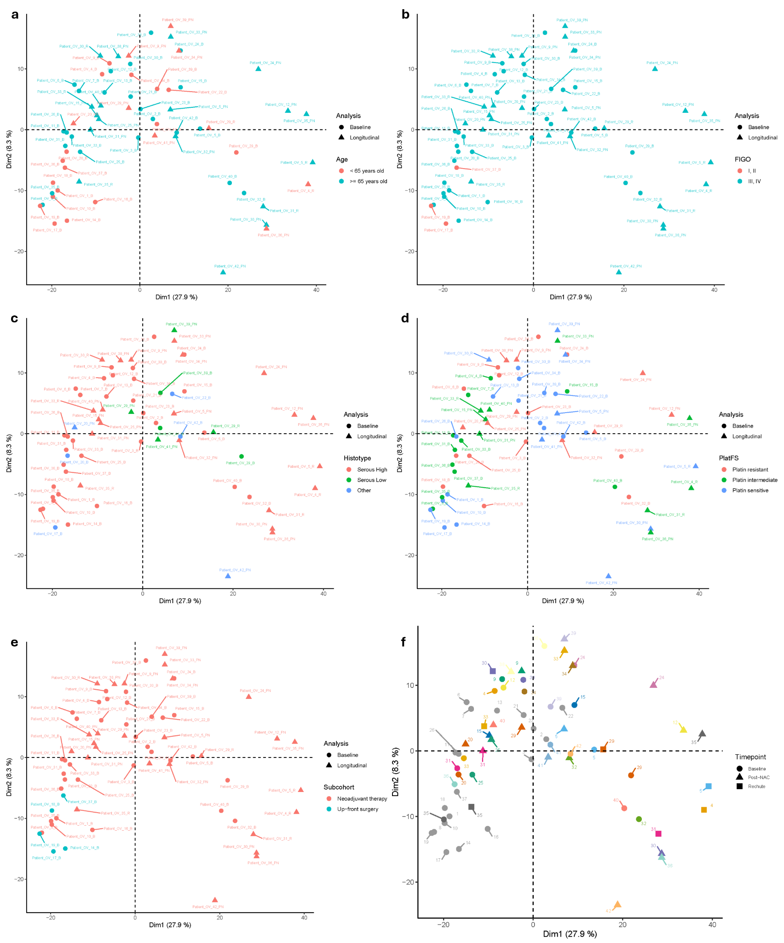
Extended Data Fig. 7. Principal component analysis of gene expression in ovarian cancer cohort. Principal component analysis was performed on ovarian cancer cohort (n = 40 for baseline, n = 20 for post-NAC, n = 7 for recurrence) RNA-seq data using FactoMineR R package (version 2.11) on the 1,000 most variable genes and ggplot2 R package (version 3.5.1) with patients subdivided based on age (a), FIGO stage (b), histotype (c), platinum resistance (d), treatment (e), and timepoint (f).

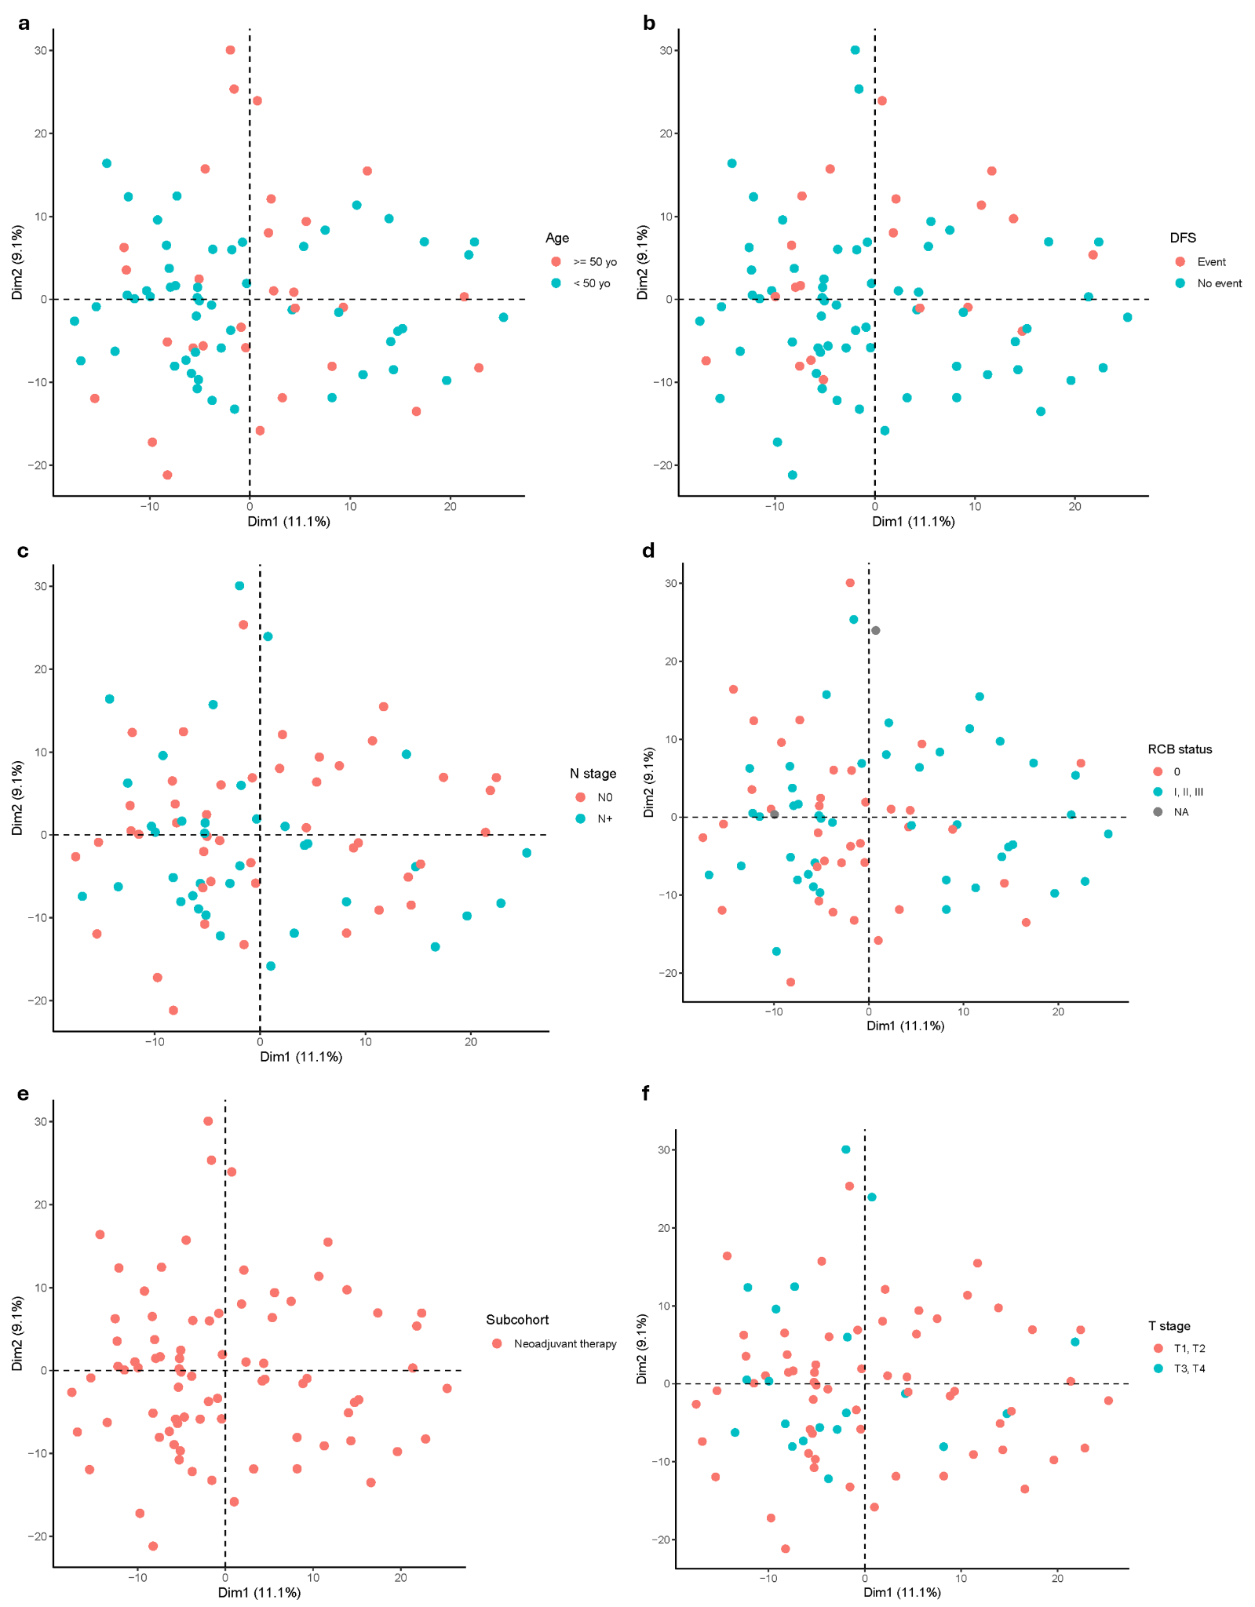
Extended Data Fig. 8. Principal component analysis of gene expression in TNBC cohort. Principal component analysis was performed on TNBC cohort (n = 81) RNA-seq data using using FactoMineR R package (version 2.11) on the 1,000 most variable genes and ggplot2 R package (version 3.5.1) with patients subdivided based on age (a), DFS event (b), N stage (c), RCB status (d), treatment (e), and T stage (f).
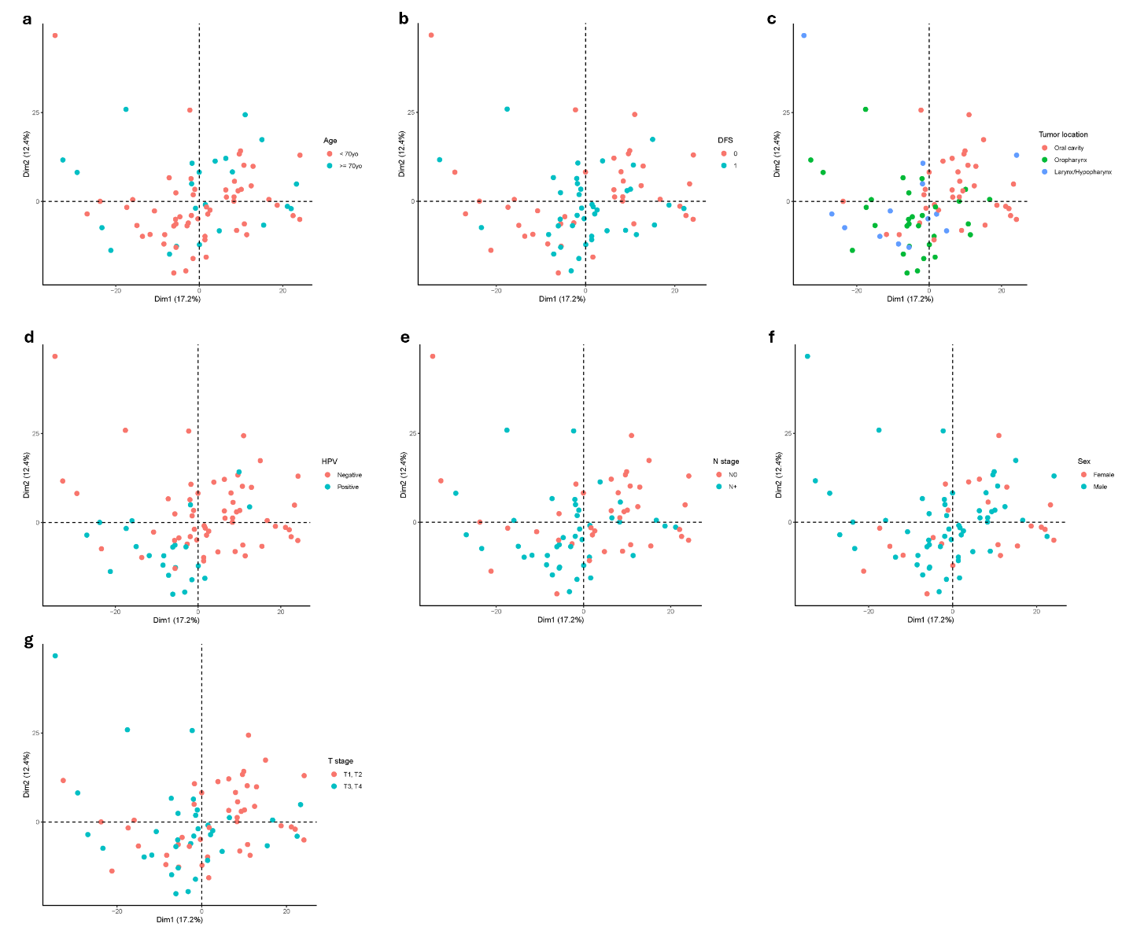
Extended Data Fig. 9. Principal component analysis of gene expression in HNSCC cohort. Principal component analysis was performed on HNSCC cohort (n = 78) RNA-seq data using using FactoMineR R package (version 2.11) on the 1,000 most variable genes and ggplot2 R package (version 3.5.1) with patients subdivided based on age (a), DFS event (b), tumor location (c), HPV status (d), N stage (e), sex (f), and T stage (g).

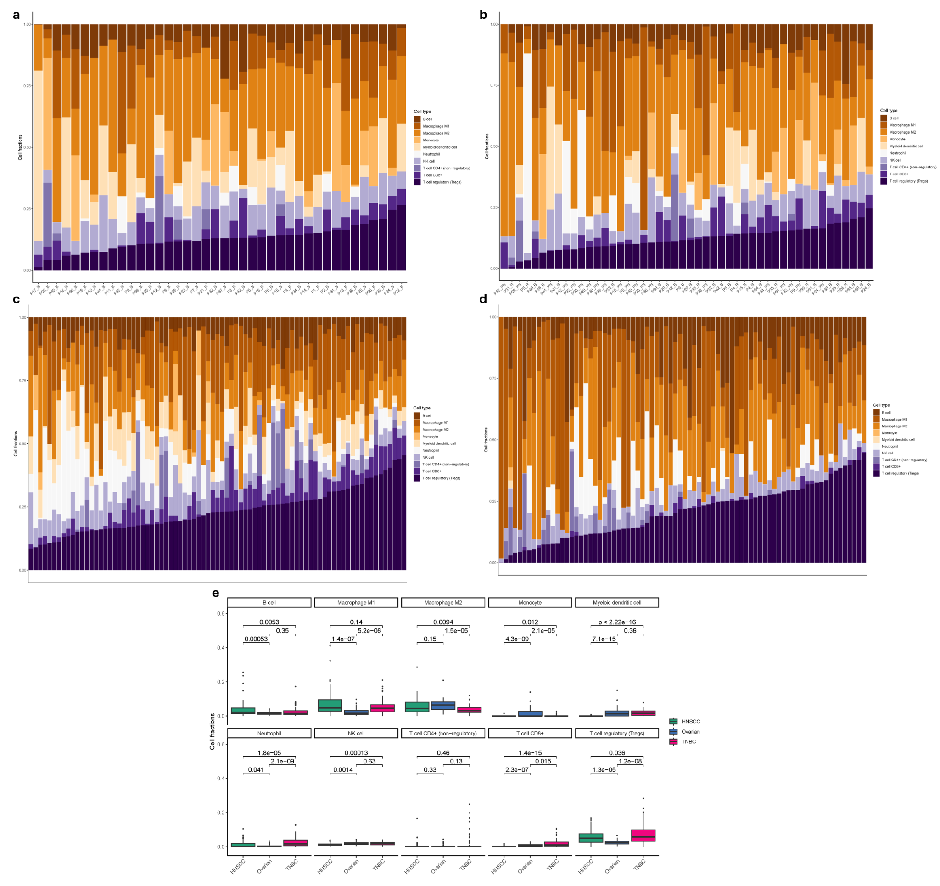
Extended Data Fig. 10. Deconvolution of SCANDARE patient samples. Deconvolution was performed on RNA-seq data for ovarian (a) (n = 40), ovarian longitudinal (b) (n = 21 for baseline, n = 20 for post-NAC, n = 7 for recurrence), TNBC (c) (n = 81), and HNSCC (d) (n = 78). Deconvolution was performed using quanTIseq from the immunedeconv R package (version 2.1.0) using the TPM (transcripts per million) counts. Uncharacterized cell type, corresponding to the tumor fraction, was filtered out to retain only stromal cell types. Barplots were generated based on the cellular fraction of the remaining cell types using the ggplot2 R package (version 3.5.1). Boxplot of the cellular fraction per cohort (e) was generated for each cell type using the ggplot2 R package (version 3.5.1). Cellular fraction distributions were compared in a pairwise manner between cohorts using the Wilcoxon test (stat_compare_means() function from the ggpubr R package, version 0.6.0).

Supplementary Figures
Supplementary Fig. 1. Enrichment score profiles for pathways in ovarian baseline samples vs post-NAC.
Supplementary Fig. 2. Enrichment score profiles for pathways in TNBC ‘other’ samples vs unexpected long survivors.
Supplementary Fig. 3. Enrichment score profiles for pathways in TNBC samples of unexpected long survivors vs unexpected short survivors.

Supplementary Tables
Supplementary Table 1. Position of SCANDARE among biobanking studies and/or public datasets
Supplementary Table 2. Details of raw data currently available
Supplementary Table 3. SCANDARE Projects overview
Supplementary Table 4. List of genes differentially expressed in baseline and post-neoadjuvant chemotherapy ovarian patients.
Supplementary Table 5. List of genes differentially expressed in baseline and post-neoadjuvant chemotherapy samples among ovarian patients with good prognosis.
Supplementary Table 6. List of genes differentially expressed in baseline and post-neoadjuvant chemotherapy samples among ovarian patients with poor prognosis.
Supplementary Table 7. List of pathways differentially enriched by GSEA analyses between baseline and post-NAC ovarian patients.
Supplementary Table 8. List of genes differentially expressed between unexpected long survivors vs other TNBC patients.
Supplementary Table 9. List of genes differentially expressed between unexpected long survivors vs unexpected short TNBC patients
Supplementary Table 10. List of pathways differentially enriched by GSEA analyses between unexpected long survivors vs other TNBC patients
Supplementary Table 11. List of pathways differentially enriched by GSEA analyses between unexpected long survivors vs unexpected short TNBC patients

