Supplementary Information

Chromosome-resolved genome assemblies of Rhodotorula toruloides reveal abnormal chromosomal evolution under artificial culture conditions

Yuuki Kobayashi, Moriya Ohkuma, Keita Aoki, Naoto Tanaka, and Masako Takashima

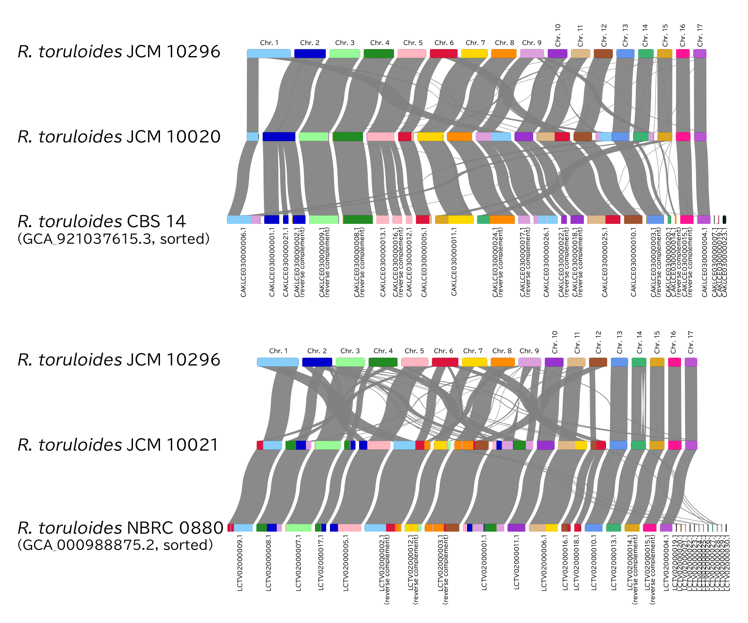
Figure S1. Comparison of chromosome macrosynteny among R. toruloides strains regarded as the same isolate. Upper panel: Comparison between JCM 10020 and CBS 14, along with JCM 10296, which exhibits canonical chromosome macrosynteny. Lower panel: Comparison between JCM 10021 and NBRC 0880, along with JCM 10296.
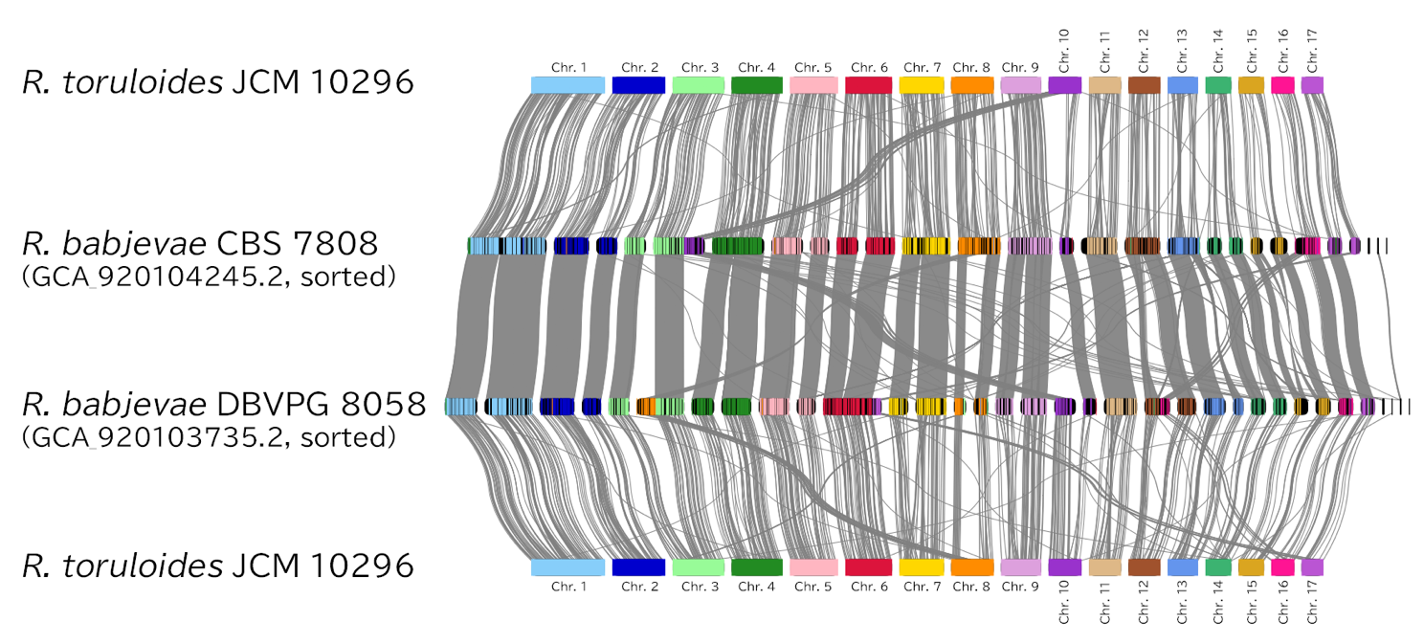
Figure S2. Comparison of R. babjevae genomes [26] with R. toruloides JCM 10296, which has canonical chromosome macrosynteny.
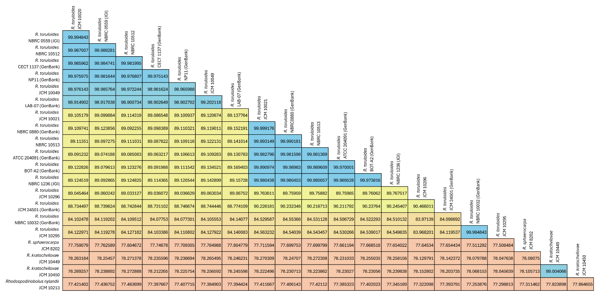
Figure S3. ANI matrix of R. toruloides and related strains. ANI, Average nucleotide identity

