Electronic Supplementary Information (ESI)
Preparation of tree-structured ZnO films and application in quantum dots sensitized solar cells
Shaokang Dong, Shengjun Li*, Junhao Cai, Zeng Chen*, Fuhao Sun, Pin Lv
Henan Key Laboratory of Photovoltaic Materials, Henan University, Kaifeng 475001, China
*Corresponding author: Zeng Chen, Shengjun Li

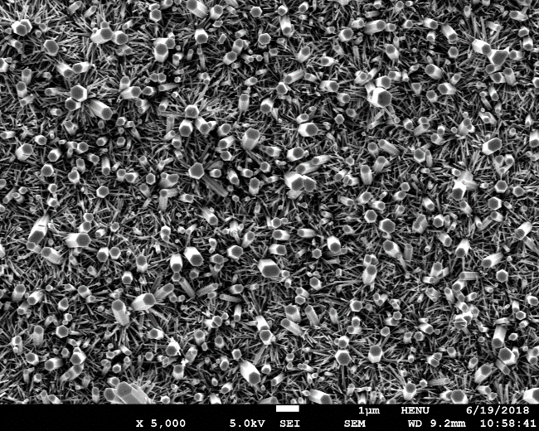
Fig. S1 SEM micrographs of tree-structured ZnO films prepared with 0.24 M Zn(CH₃COO)₂ in the seed precursor solution

