Supplementary figure 1: overall time course of the modified FI
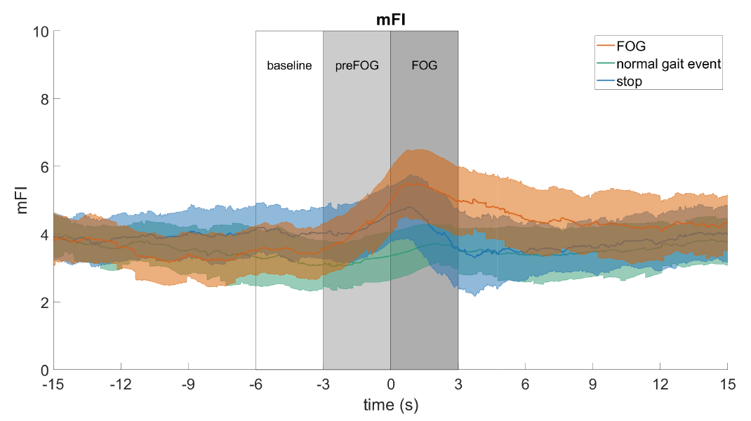
Supplementary figure 1: Overall time course of the “modified” FI (mFI) for FOG (orange), normal gait events (green), and, stopping (blue). The lines with the shaded areas represent the mean values with confidence intervals over the 15 included participants (n=15). To calculate the mFI, we defined a total power threshold as the mean plus one standard deviation of the total power (0.5-8 Hz) during the 10 seconds of standing preceding each round(1). Only when the total power (0.5-8 Hz) exceeded this threshold, the FI was calculated, otherwise the FI was set at zero. The figures were created with MATLAB (R2019a) and the Fieldtrip toolbox. (FI = Freezing Index; mFI = modified Freezing Index; FOG = Freezing of Gait)

Supplementary figure 2: Overall time course of the heart rate for participant 8 and 15
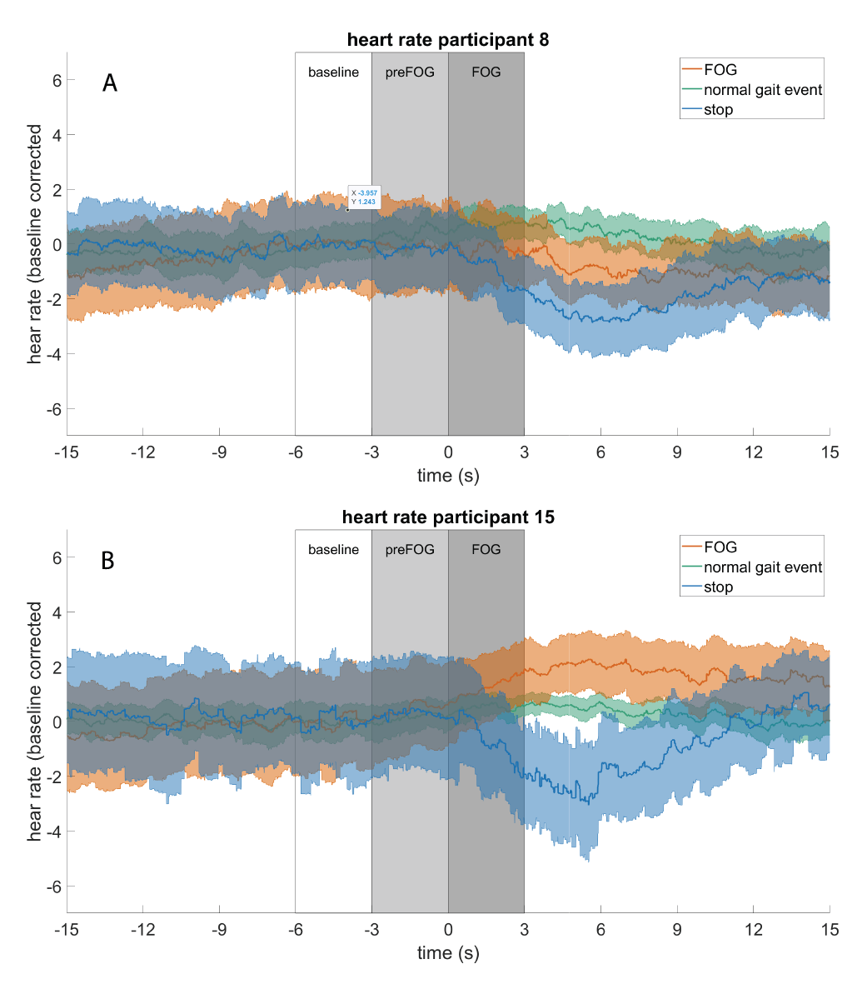
Supplementary figure 2: Overall time course of baseline corrected (-6 to -3 sec.) heart rate for participant 8 (A) and participant 15 (B) during FOG (orange), normal gait events (green), and stopping (blue). The lines with the shaded areas represent the mean values with confidence intervals over the included events. (FOG = Freezing of Gait)

