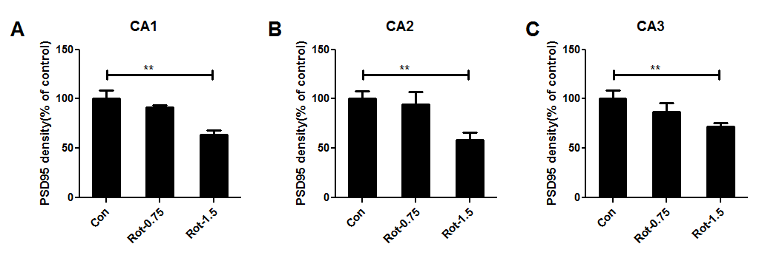
Supplementary Fig 1. Rotenone dose-dependently reduces the expressions of PSD-95 in CA1, CA2 and CA3 regions of mice. Quantitative analysis of PSD95 immunostaining density in CA1 (A), CA2 (B) and CA3 (C) regions of mice. ** p < 0.01.

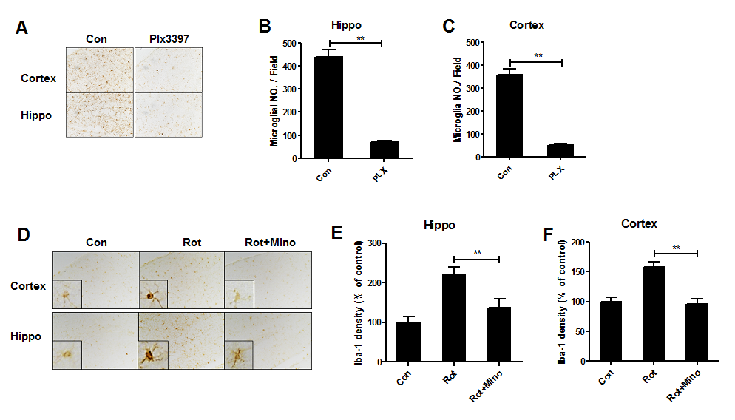
Supplementary Fig 2. The effects of PLX3397 and minocycline on microglial number and activation, respectively. (A) Mice were administrated with PLXX3397 for 1 week and the representative images of Iba-1 immunostaining were shown. (B, C) Quantitative analysis of Iba-1⁺ cell number. (D) The representative images of Iba-1 immunostaining in rotenone-treated mice with or without minocycline were shown. (E, F) Quantitative analysis of Iba-1 immunostaining density. * * p < 0.01; Scale bar= 50 μm.

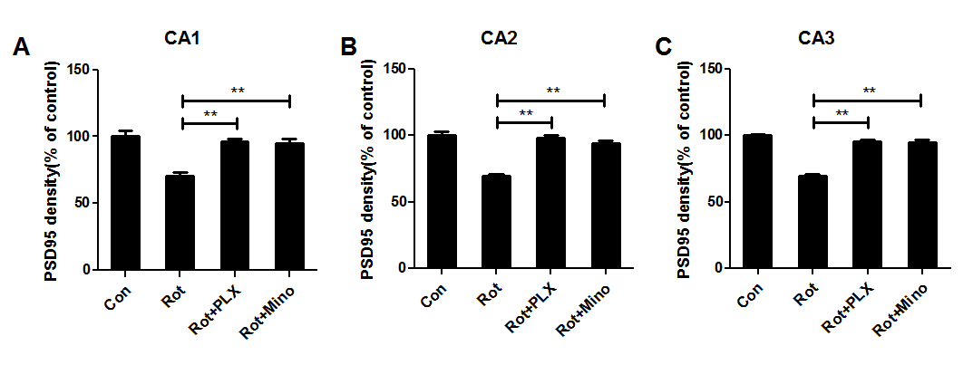
Supplementary Fig 3. PLX3397 and minocycline attenuate rotenone-induced reduction of PSD95 in CA1, CA2 and CA3 regions of mice. Quantitative analysis of PSD95 immunostaining density in CA1 (A), CA2 (B) and CA3 (C) regions of mice. ** p < 0.01.

