Supplementary Table 1 Formula used for analysis of variability components, phenotypic and genotypic variance, phenotypic and genotypic coefficient of variance, heritability in broad sense, genetic advance and genetic advance as percentage of mean (references related to the citations are given in the main manuscript).
Variance components | Abbreviations | Formula used^{y} | References
Phenotypic variance | PV | $σ_{g}^{2} =\frac{\left[\left(MSG\right)– \left(MSE\right)\right]}{r}$ | (Syukur et al. 2012)
Genotypic variance | GV | $σ_{p}^{2} = [σ_{g}^{2} + (\frac{σ_{e}^{2}}{r})]$ | (Syukur et al. 2012)
Phenotypic Coefficient of variance | PCV | $GCV\% = \left[\frac{\left(σ_{g}\right)}{X}\right] × 100$ | (Syukur et al. 2012)
Genotypic coefficient of variance | GCV | $$PCV\% = \left[\frac{σ_{p}}{X}\right] × 100$$ | (Burton 1952)
Heritability in a broad sense | H²B | $$H^{2}B= \left[\frac{σ_{g}^{2}}{σ_{p}^{2}}\right] × 100\%$$ | (Allard 1960)
Genetic advance | GA | $GA = K×σ_{p}×h^{2}B$ | (Johnson et al. 1955)
Genetic advance as percentage mean | GAM% | $$GAM\left(\%\right)=\frac{GA}{X}×100$$ | (Johnson et al. 1955)
^{y}$σ_{g}^{2}$ : genotypic variance; $σ_{p}^{2}$: phenotypic variance; $σ_{e}^{2}$: environmental variance (error mean square from the analysis of variance); MSG: mean square of genotypes; MSE: error mean square; r: number of replications); $σ_{g}$: genotypic standard deviation,$σ_{p}$: phenotypic standard deviation, $X$: grand mean of the character; $K$: the selection differential constant (K=2.06 at 5% selection intensity.

Supplementary Table 2 Accessions used in this study with latitude, longitude, detailed address origin and collection date
Accession No | Collection site code^{y} | Location | Origin^{z} | Collection /date
1 | Chunam1 | 317-4, Massanli, Shinpyeong-myeon, Dangjin, Chungnam | Natural field | 5/23/2015
3 | Chunam2 | 31-7 Yuguri, Yugu-eup, Gongju-city, Chungnam | Natural field | 5/23/2015
4 | Chunam3 | 339-5, Gamam-ri, Chungsan-myeon, Cheongyang-gun, Chungnam | Natural field | 5/23/2015
6 | Chunam4 | 1-65 Mount Wakamiri, Seocheon, Seocheon-gun, Chungnam | Natural field | 5/23/2015
7 | Jebuk1 | 108 Baeksong-ri, Shinlim-myeon, Gochang-gun, Jeonbuk | Natural field | 5/23/2015
8 | Jenam1 | 346-1, Jinyang-ri, Hampyeong-eup, Hampyeong-gun, Jeonnam | Natural field | 5/23/2015
11 | Jenam2 | 897, Dongho-ri, Samho-eup, Yeongam-gun, Jeonnam | Natural field | 5/23/2015
12 | Jenam3 | 1850-4 Yeongam-gun, Jeonnam | Natural field | 5/24/2015
14 | Jenam4 | 661-9, Chungdong-ri, Bupyeong-eup, Boseong-gun, Jeonnam | Natural field | 5/24/2015
15 | Jenam5 | 4-1, Doi-dong, Gwangyang, Jeonnam | Natural field | 5/24/2015
16 | Jenam6 | 1191-1 Shindori, Yongbang-myeon, Gurye-gun, Jeonnam | Natural field | 5/24/2015
19 | Jebuk2 | 243-3, Suejeon-dong, Namwon-city, Jeonbuk | Natural field | 5/24/2015
25 | Chbuk1 | 974, Gyepcheonri, Jipyeong-eup, Jipyeong-gun, Chungbuk | Natural field | 5/24/2015
31 | Gynam1 | 93, Changseon-myeon, Namhae-gun, Gyeongnam | Natural field | 5/24/2015
32 | Gynam2 | 713, gyeongnam mil-yangsi san-oemyeon namgili, Gyeongnam | Natural field | 5/30/2015
34 | Gybuk1 | 1233-1, Palace Geonjeong-ri, Ulju-gun, Gyeongbuk | Natural field | 5/30/2015
36 | Gybuk2 | 467-3, Sanbu-myeon, Gyeongju, Gyeongju, Gyeongbuk | Natural field | 5/30/2015
37 | Gawon1 | 75-1, Haoanri Mountain, Hongcheon-eup, Hongcheon-gun, Gangwon | Natural field | 6/5/2015
38 | Gybuk3 | 61-2, Samseori, Ganggu-myeon, Youngdeok-gun, Gyeongbuk | Natural field | 6/5/2015
39 | Gybyk4 | 223 Sechon-ri, Dankun-myeon, Gyeongbuk | Natural field | 6/5/2015
42 | Gybuk5 | 574-9 Maegok-ri, Poongsan-eup, Andong-si, Gyeongbuk | Natural field | 6/6/2015
44 | Gybuk6 | 441-11 Daechon-ri, Bonghyun-myeon, Yeongju, Gyeongbuk | Natural field | 6/6/2015
45 | Gyggi1 | 0Seongdong-ri, Tonghyeon-myeon, Paju City, Gyeonggi | Natural field | 6/6/2015
46 | Gyggi2 | 292 Jeongok-ri, Jeongeup-eup, Yeoncheon-gun, Gyeonggi | Natural field | 6/6/2015
51 | Gawon2 | 673-14 Ojiri, Dongsong-eup, Cheolwon-gun, Gyeonggi | Natural field | 6/13/2015
54 | Chbuk5 | Baeun-gun, Chungbuk | Natural field | 6/13/2015
52 | Gawon4 | Hoengseong-gu, Gangwon | Natural field | 6/13/2015
55 | Gawon3 | Yanggu-gun, Gangwon-do | Seed bank2 | 6/13/2015
58 | Gyggi3 | Goryeok Arboretum in Soehleok, Pocheon, Gyeonggi | Seed bank 1 | 9/10/2001
59 | Gyggi4 | Goryeok Arboretum in Soehleok, Pocheon, Gyeonggi | Seed bank 1 | 2002
61 | Gyggi5 | Igeok Elementary School, Icheon-ri, Soheu-eup, Pocheon, Gyeonggi | Seed bank 1 | 9/12/2005
63 | Gynam3 | Sangju-myeon, Namhae-gun, Gyeongsangnam-do | Seed bank2 | 10/19/2006
64 | Gynam4 | Dae Seong-myeon of Sancheong-gun, Gyeongnam | Seed bank 1 | 9/24/2004
65 | Gybuk7 | Jyangyang-myeon, Yeongcheon City, Gyeongbuk | Seed bank2 | 10/17/2007
68 | Jenam7 | Dae Mun-Wando, Wando-gun, Jeonnam | Seed bank 1 | 2012/10/11
69 | Chunam5 | Boseok-myeon, Seosan-si, Chungnam | Seedbank2 | 10/22/2009
70 | Chunam6 | Chungnam | Seed bank 1 | 10/09/2013
72 | Chbuk4 | Baeun-gun, Chuncheongbuk-do, Chungbuk | Seed bank 1 | 10/11/2006
^{y}for respected GPS coordinate please refer to supplementary table (Table S1) in (Oliya et al 2018)
^{z}Seed bank1 abbreviated here is Korean National Arboretum (http://www.forest.go.kr) and seed bank 2 is Wild Plant Seed Bank of Korea (http://www.seedbank.re.kr

Supplementary Table-3 Accession membership to quartile in evaluated morphological traits
Acc. | TLL^{x} | LTL | LBW | LOB | TB | PH | BSD | TNN | BB | BIND | MIND | BOLT | FF | FSD | FMD | SPC | SL | PL | TSW | Quartile count
 |  |  |  |  |  |  |  |  |  |  |  |  |  |  |  |  |  |  |  | Q1 | Q2 | Q3 | Q4
1 | Q4 | Q4 | Q2 | Q1 | Q4 | Q1 | Q3 | Q1 | Q4 | Q2 | Q2 | Q1 | Q2 | Q2 | Q3 | Q1 | Q2 | Q3 | Q1 | 6 | 6 | 3 | 4
3 | Q1 | Q3 | Q3 | Q1 | Q2 | Q2 | Q1 | Q1 | Q4 | Q4 | Q2 | Q1 | Q1 | Q1 | Q1 | Q1 | Q4 | Q2 | Q3 | 9 | 4 | 3 | 3
4 | Q2 | Q4 | Q2 | Q1 | Q4 | Q2 | Q2 | Q3 | Q1 | Q4 | Q2 | Q4 | Q3 | Q4 | Q4 | Q1 | Q3 | Q2 | Q3 | 3 | 6 | 4 | 6
6 | Q3 | Q3 | Q2 | Q4 | Q4 | Q3 | Q4 | Q2 | Q3 | Q1 | Q2 | Q1 | Q1 | Q1 | Q1 | Q1 | Q4 | Q2 | Q1 | 7 | 4 | 4 | 4
7 | Q4 | Q4 | Q3 | Q1 | Q3 | Q2 | Q3 | Q3 | Q3 | Q2 | Q3 | Q3 | Q3 | Q2 | Q2 | Q3 | Q4 | Q4 | Q3 | 1 | 4 | 10 | 4
8 | Q3 | Q4 | Q1 | Q2 | Q3 | Q2 | Q4 | Q4 | Q4 | Q4 | Q4 | Q4 | Q4 | Q4 | Q3 | Q4 | Q4 | Q4 | Q3 | 1 | 2 | 4 | 12
11 | Q4 | Q1 | Q1 | Q1 | Q2 | Q2 | Q2 | Q4 | Q4 | Q4 | Q3 | Q4 | Q3 | Q3 | Q3 | Q1 | Q1 | Q4 | Q3 | 5 | 3 | 5 | 6
12 | Q4 | Q3 | Q3 | Q1 | Q2 | Q4 | Q2 | Q4 | Q2 | Q3 | Q3 | Q4 | Q4 | Q4 | Q4 | Q2 | Q1 | Q4 | Q4 | 2 | 4 | 4 | 9
14 | Q2 | Q2 | Q4 | Q3 | Q1 | Q1 | Q1 | Q1 | Q1 | Q1 | Q1 | Q2 | Q3 | Q3 | Q4 | Q1 | Q3 | Q1 | Q2 | 9 | 4 | 4 | 2
15 | Q2 | Q3 | Q3 | Q3 | Q2 | Q4 | Q4 | Q2 | Q4 | Q2 | Q2 | Q3 | Q3 | Q3 | Q3 | Q2 | Q1 | Q4 | Q2 | 1 | 7 | 7 | 4
16 | Q1 | Q2 | Q4 | Q4 | Q4 | Q4 | Q2 | Q2 | Q2 | Q2 | Q3 | Q3 | Q4 | Q4 | Q4 | Q2 | Q3 | Q2 | Q2 | 1 | 8 | 3 | 7
19 | Q1 | Q1 | Q2 | Q2 | Q1 | Q1 | Q1 | Q1 | Q4 | Q1 | Q2 | Q2 | Q2 | Q2 | Q2 | Q4 | Q3 | Q2 | Q2 | 7 | 9 | 1 | 2
25 | Q4 | Q3 | Q3 | Q3 | Q2 | Q3 | Q3 | Q4 | Q1 | Q3 | Q4 | Q1 | Q2 | Q3 | Q2 | Q1 | Q2 | Q3 | Q2 | 3 | 5 | 8 | 3
31 | Q2 | Q2 | Q4 | Q1 | Q1 | Q1 | Q1 | Q3 | Q4 | Q4 | Q4 | Q4 | Q3 | Q3 | Q3 | Q1 | Q4 | Q4 | Q4 | 5 | 2 | 4 | 8
32 | Q1 | Q3 | Q4 | Q2 | Q1 | Q4 | Q2 | Q2 | Q3 | Q4 | Q1 | Q3 | Q3 | Q4 | Q4 | Q4 | Q1 | Q2 | Q2 | 4 | 5 | 4 | 6
34 | Q1 | Q1 | Q4 | Q3 | Q2 | Q1 | Q1 | Q1 | Q4 | Q1 | Q4 | Q4 | Q2 | Q3 | Q3 | Q2 | Q2 | Q3 | Q2 | 6 | 5 | 4 | 4
36 | Q1 | Q1 | Q4 | Q3 | Q3 | Q3 | Q4 | Q4 | Q1 | Q4 | Q4 | Q3 | Q4 | Q4 | Q3 | Q3 | Q1 | Q1 | Q4 | 5 | 0 | 6 | 8
37 | Q2 | Q1 | Q4 | Q4 | Q1 | Q2 | Q1 | Q4 | Q1 | Q3 | Q4 | Q4 | Q4 | Q4 | Q4 | Q4 | Q1 | Q1 | Q1 | 7 | 2 | 1 | 9
38 | Q2 | Q3 | Q2 | Q4 | Q1 | Q1 | Q1 | Q1 | Q1 | Q4 | Q1 | Q3 | Q4 | Q3 | Q4 | Q2 | Q4 | Q4 | Q4 | 6 | 3 | 3 | 7
39 | Q1 | Q1 | Q1 | Q2 | Q3 | Q3 | Q4 | Q1 | Q1 | Q4 | Q2 | Q3 | Q4 | Q3 | Q3 | Q3 | Q3 | Q3 | Q3 | 5 | 2 | 9 | 3
42 | Q1 | Q2 | Q1 | Q1 | Q4 | Q3 | Q2 | Q3 | Q3 | Q2 | Q3 | Q1 | Q2 | Q2 | Q2 | Q3 | Q4 | Q4 | Q2 | 4 | 7 | 5 | 3
44 | Q3 | Q4 | Q3 | Q4 | Q1 | Q1 | Q1 | Q2 | Q2 | Q3 | Q3 | Q3 | Q2 | Q2 | Q2 | Q3 | Q2 | Q3 | Q3 | 3 | 6 | 8 | 2
45 | Q2 | Q1 | Q1 | Q4 | Q1 | Q1 | Q3 | Q1 | Q3 | Q1 | Q3 | Q1 | Q1 | Q1 | Q1 | Q3 | Q3 | Q3 | Q1 | 11 | 1 | 6 | 1
46 | Q3 | Q1 | Q2 | Q3 | Q4 | Q3 | Q4 | Q2 | Q1 | Q1 | Q1 | Q2 | Q1 | Q1 | Q1 | Q2 | Q2 | Q1 | Q4 | 8 | 5 | 3 | 3
51 | Q3 | Q2 | Q1 | Q1 | Q4 | Q2 | Q4 | Q3 | Q1 | Q1 | Q1 | Q4 | Q4 | Q4 | Q4 | Q2 | Q4 | Q1 | Q3 | 6 | 3 | 3 | 7
52 | Q4 | Q3 | Q1 | Q3 | Q3 | Q3 | Q3 | Q3 | Q4 | Q4 | Q1 | Q1 | Q1 | Q1 | Q2 | Q4 | Q3 | Q3 | Q2 | 5 | 2 | 8 | 4
54 | Q1 | Q1 | Q1 | Q3 | Q4 | Q1 | Q3 | Q2 | Q2 | Q1 | Q4 | Q2 | Q1 | Q1 | Q1 | Q1 | Q1 | Q1 | Q2 | 11 | 4 | 2 | 2
55 | Q4 | Q4 | Q1 | Q3 | Q4 | Q4 | Q4 | Q4 | Q4 | Q4 | Q4 | Q3 | Q3 | Q3 | Q4 | Q3 | Q3 | Q3 | Q4 | 1 | 0 | 7 | 11
58 | Q3 | Q3 | Q2 | Q2 | Q2 | Q3 | Q2 | Q2 | Q1 | Q1 | Q3 | Q4 | Q4 | Q4 | Q4 | Q4 | Q1 | Q1 | Q1 | 5 | 5 | 4 | 5
59 | Q1 | Q2 | Q3 | Q2 | Q3 | Q2 | Q1 | Q1 | Q3 | Q3 | Q2 | Q2 | Q2 | Q2 | Q1 | Q4 | Q1 | Q2 | Q1 | 6 | 8 | 4 | 1
61 | Q4 | Q4 | Q2 | Q2 | Q3 | Q4 | Q3 | Q2 | Q2 | Q1 | Q2 | Q1 | Q1 | Q1 | Q1 | Q4 | Q1 | Q3 | Q1 | 7 | 5 | 3 | 4
63 | Q4 | Q4 | Q3 | Q1 | Q1 | Q3 | Q1 | Q3 | Q3 | Q2 | Q3 | Q1 | Q1 | Q1 | Q1 | Q3 | Q2 | Q3 | Q1 | 8 | 2 | 7 | 2
64 | Q3 | Q2 | Q4 | Q1 | Q1 | Q1 | Q1 | Q1 | Q3 | Q2 | Q1 | Q2 | Q3 | Q2 | Q2 | Q1 | Q4 | Q3 | Q4 | 7 | 5 | 4 | 3
65 | Q2 | Q1 | Q3 | Q2 | Q4 | Q4 | Q2 | Q3 | Q2 | Q4 | Q1 | Q2 | Q2 | Q2 | Q2 | Q4 | Q3 | Q1 | Q1 | 4 | 8 | 3 | 4
68 | Q3 | Q4 | Q2 | Q1 | Q3 | Q4 | Q3 | Q4 | Q2 | Q4 | Q1 | Q1 | Q1 | Q1 | Q1 | Q2 | Q1 | Q2 | Q4 | 7 | 4 | 3 | 5
69 | Q3 | Q4 | Q3 | Q2 | Q2 | Q4 | Q4 | Q4 | Q2 | Q2 | Q1 | Q2 | Q2 | Q2 | Q2 | Q4 | Q2 | Q1 | Q4 | 2 | 9 | 2 | 6
70 | Q4 | Q2 | Q1 | Q1 | Q2 | Q2 | Q3 | Q4 | Q3 | Q3 | Q4 | Q4 | Q3 | Q4 | Q3 | Q2 | Q2 | Q1 | Q4 | 3 | 5 | 5 | 6
72 | Q2 | Q2 | Q2 | Q4 | Q3 | Q3 | Q4 | Q3 | Q2 | Q2 | Q4 | Q2 | Q1 | Q1 | Q1 | Q2 | Q2 | Q2 | Q1 | 4 | 9 | 3 | 3
^{x}LL: leaf length, LTL: leaf tip length, LBW: leaf blade width, LOB: leaf lobe number, BB: basal branch , TB: total branch, PH: plant height, BSD: basal stem diameter, TNN: total node number, BIND: basal internode distance, MIND: median internode distance; BOLT: duration to bolting, FFD: duration to first flowering, FSD: duration to first seed set, FMD: duration to fifty percent seed maturity, SPC: seed per capitulum (head), SL: seed length, PL: pappus length, TWS: thousand seed weight
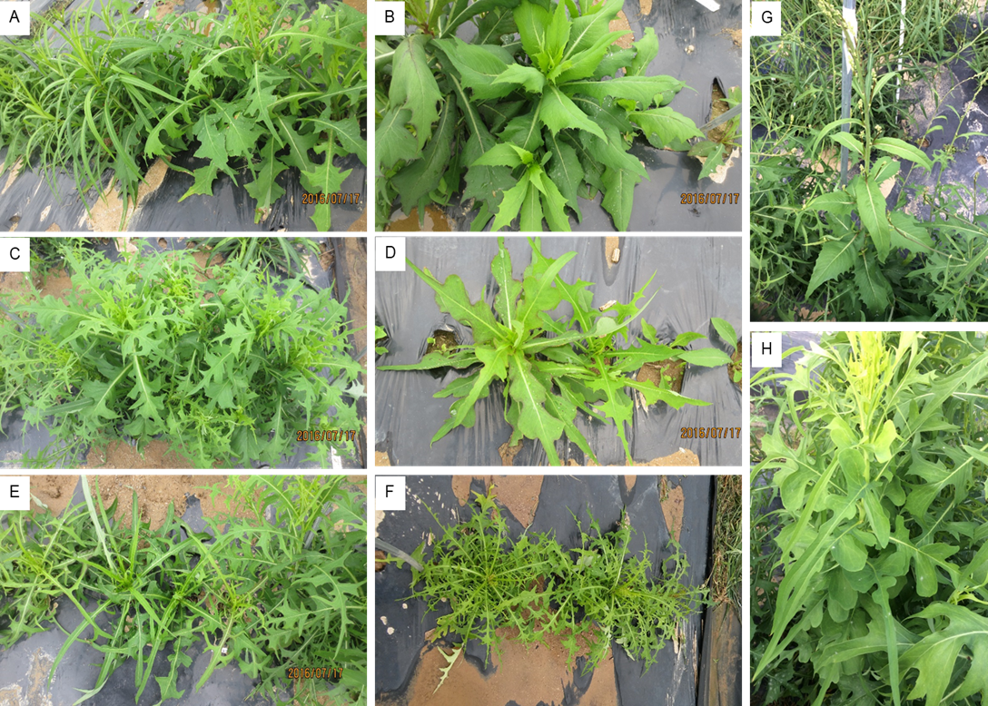
Supplementary Figure 1 Example of leaf shape variation (intra- and inter- accession) in the studied L. indica accessions grown in Suwon. (A-H), some of the representative individuals belonging to different accessions: A, acc. 70; B, G, H, acc.16; C, acc. 6; D, acc.61; E, acc.7; F, acc. 52

