Supplementary Information

CMOS-Compatible FTJ Hardware Unifying Stochastic Sampling and Deterministic Computing for On-Chip Image Generation

Ryun-Han Koo^{1†}, Jonghyun Ko^{1†}, Sangwoo Ryu^{1,2}, Jiseong Im¹, Sung-Ho Park¹, Minsuk Song³, Jangsaeng Kim⁴, Gyuweon Jung¹, Wonjun Shin^{5*}, Daewoong Kwon^{3*}and Jong-Ho Lee^{1*}

¹Department of Electrical and Computer Engineering and Inter-university Semiconductor Research Center, Seoul National University, Seoul 08826, Republic of Korea
²SK Hynix Inc, Icheon 17336, Republic of Korea
³Department of Nanoscale Semiconductor Engineering, Hanyang University, Seoul 04763, Republic of Korea
⁴Department of Electronic Engineering, Sogang University, Seoul 04107, Republic of Korea
⁵Department of Semiconductor Convergence Engineering, Sungkyunkwan University, Suwon 16419, Republic of Korea

† These authors contributed equally: Ryun-Han Koo, Jonghyun Ko

* Corresponding author (e-mail: swj0107@skku.edu, dw79kwon@hanyang.ac.kr, jhl@snu.ac.kr)

Keywords: Ferroelectrics, Low-frequency Noise (LFN), Random Telegraph Noise (RTN), Variational Autoencoder (VAE), Hardware computing

Contents
Supplementary Figure 1–16
Supplementary Table 1
Supplementary Flow 1
Supplementary Note 1–2
Supplementary References

Supplementary Figures
Supplementary Figure 1. Schematic illustration of the fabrication process for the MFIS-FTJ array. (a) A 200-nm SiO₂ layer is thermally grown on an RCA-cleaned Si wafer, followed by the deposition of a 100-nm polycrystalline silicon (poly-Si) layer using low-pressure chemical vapor deposition (LPCVD). The poly-Si bottom electrode is doped with n-type dopants to ensure conductivity. (b) Photolithography and dry etching processes are performed to define the patterned bottom electrode structure. (c) A thin tunneling oxide (SiO₂, ~1.2 nm) is grown by chemical oxidation. (d) A 7-nm-thick Hf_{0.5}Zr_{0.5}O₂ (HZO) ferroelectric film is deposited using thermal atomic layer deposition (ALD) with alternating cycles of Hf and Zr precursors at a ratio of 1:1 for 44 cycles. (e) A 100-nm-thick TiN top electrode is deposited using sputtering. (f) The top electrode pattern is defined through photolithography and dry etching. Finally, a rapid thermal annealing (RTA) treatment at 700°C for 30 s is conducted to crystallize the HZO layer into its ferroelectric phase.

Supplementary Figure 2. Grazing-incidence X-ray diffraction (GIXRD) patterns of HZO films. (a) As-deposited HZO without annealing, showing no evidence of the orthorhombic phase. (b) HZO capped with TiN and subjected to rapid thermal annealing, where strain induced by the TiN overlayer stabilizes the ferroelectric orthorhombic o-(111) phase along with the tetragonal t-(011) reflection.

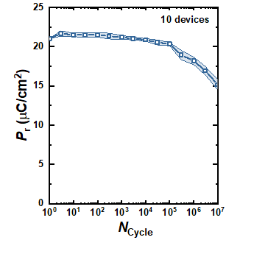
Supplementary Figure 3. Polarization endurance characteristics of the fabricated FTJ device. P_{r} values are normalized by the initial P_{r} (P_{r,initial}). One rectangular program pulse (5 V, 10 μs) followed by one erase pulse (−5 V, 10 μs) constitutes a single cycle (N_{cycle} = 1). The devices exhibit a slight initial increase in polarization, indicative of a wake-up phenomenon, followed by minor degradation beyond 10⁵ cycles, demonstrating robust and stable endurance characteristics. The measurements were performed on 10 devices, and the standard deviation is represented by error bars (shaded in light blue).

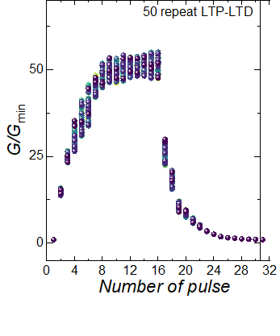
Supplementary Figure 4. Repetitive long-term potentiation (LTP) and long-term depression (LTD) characteristics of the HZO-based FTJ device. Normalized conductance (G/G_{min}​) as a function of the number of applied pulses over 50 consecutive LTP–LTD cycles.

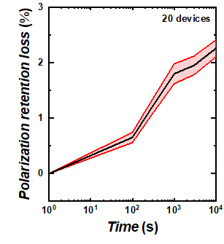
Supplementary Figure 5. Retention characteristics of polarization in 20 HZO-based FTJ devices. Polarization retention loss (%) as a function of elapsed time (log scale) measured across 20 devices. The average trend (black line) and standard deviation (shaded area) indicate minimal polarization loss (< 3%) up to 10⁴s.

Supplementary Figure 6. Experimental setup for low-frequency noise (LFN) and random telegraph noise (RTN) measurements in HZO-based FTJ devices. Schematic of the measurement configuration integrating a semiconductor parameter analyzer (B1500A) for DC bias application, a low-noise current preamplifier (SR570) for signal amplification, and a dynamic signal analyzer (35670A) for power spectral density (PSD) analysis. Representative current–time waveforms with and without RTN and their corresponding PSD plots are shown to illustrate the signal acquisition process.

Supplementary Figure 7. Low-frequency noise spectra of 10 HZO-based FTJ devices at I = 8 nA. S_{I}/I² versus frequency for 10 different devices, all exhibiting 1/f noise behavior in the low-current regime. The consistency across devices confirms the reproducibility of the low-noise operating region suitable for deterministic non-volatile memory operations.

Supplementary Figure 8. Low-frequency noise spectra of 10 HZO-based FTJ devices exhibiting 1/f ² behavior. S_{I}/I² versus frequency for 10 different devices measured in the high-current regime, where random telegraph noise (RTN) dominates. The clear 1/f ² dependence across all devices confirms the stochastic switching dynamics between discrete current states.

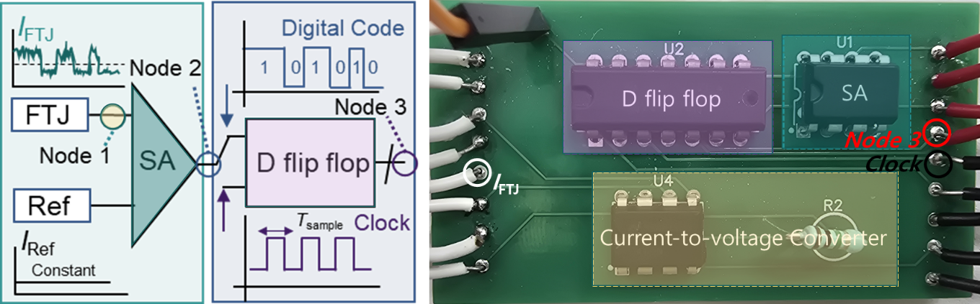
Supplementary Figure 9. Custom PCB implementation for RTN-based random bitstream generation. (Left) Block diagram of the measurement circuit integrating an FTJ device, sense amplifier (SA), D flip-flop, and current-to-voltage converter for converting RTN-induced current fluctuations into digital bit sequences. (Right) Photograph of the fabricated PCB, highlighting the main functional blocks including the D flip-flop (U2), sense amplifier (U1), and current-to-voltage converter (U4).

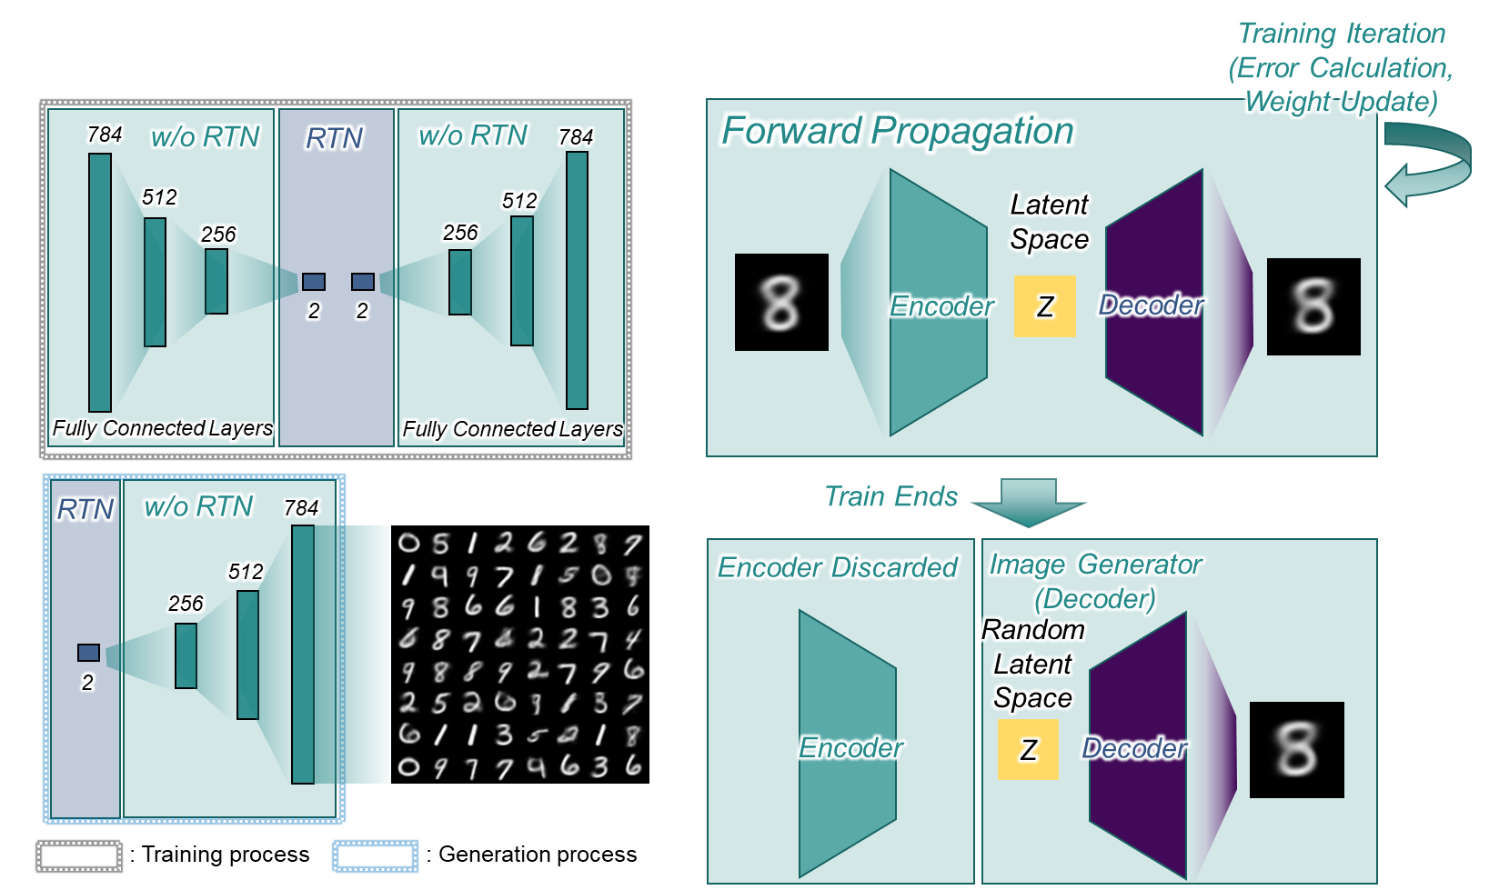
Supplementary Figure 10. Schematic of the variational autoencoder (VAE) architecture incorporating RTN-based latent space sampling. (Left) Network structure used during training, consisting of an encoder (784–512–256–2), RTN-based stochastic latent vector generator, and decoder (2–256–512–784). Fully connected layers without RTN are used for deterministic vector–matrix multiplications, while the RTN block enables stochastic latent space sampling. (Right) VAE training process, where the encoder maps input images to the latent space, followed by decoding and weight updates through forward propagation. After training, the encoder is discarded, and the decoder alone is used to generate images from random latent vectors provided by the FTJ-based RTN source.

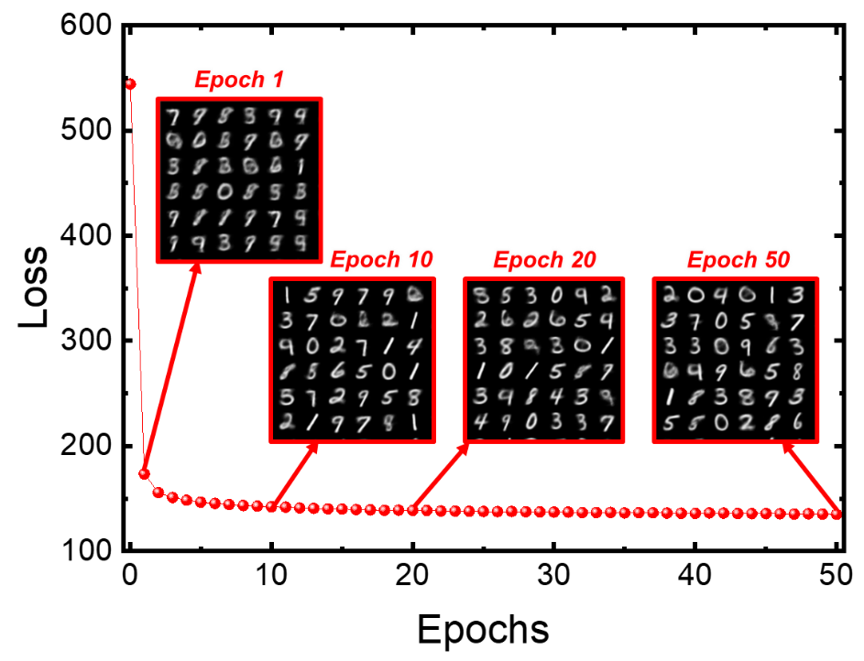
Supplementary Figure 11. Training loss evolution and generated image quality during VAE training on the MNIST dataset. Total training loss (sum of binary cross-entropy and KL divergence) plotted as a function of training epochs, showing rapid convergence within the first few epochs followed by gradual refinement. Insets display representative generated images at epochs 1, 10, 20, and 50, illustrating progressive improvement in digit clarity and diversity as training proceeds.

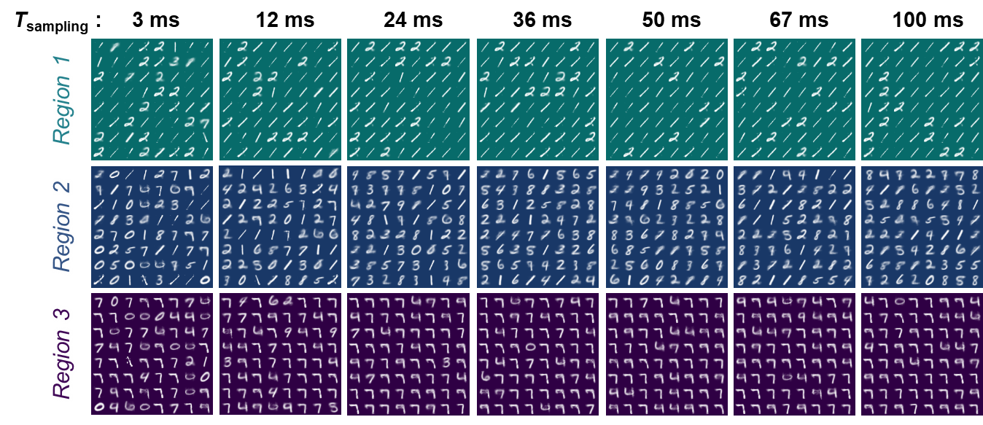
Supplementary Figure 12. Effect of RTN operating region and sampling time on VAE-generated MNIST images. Generated images from the trained VAE using FTJ-based latent vector sampling under three different RTN operating regions (Region 1–3) and varying sampling times. Region 2 produces the most diverse and balanced digit distribution when the sampling time is optimized (e.g., 36 ms), whereas Region 1 and Region 3 show strong biases toward specific digits due to inherent imbalances in the high/low current state probabilities.

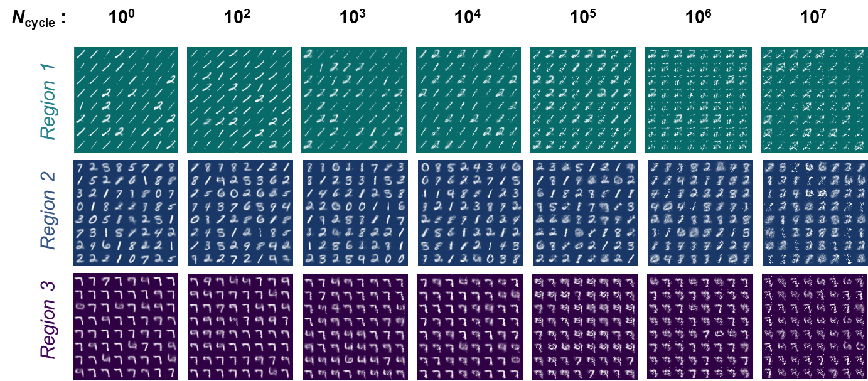
Supplementary Figure 13. Effect of RTN operating region and write cycle count on VAE-generated MNIST images. Generated images from the trained VAE using FTJ-based latent vector sampling under three RTN operating regions (Region 1–3) after different numbers of write cycles applied to the FTJ devices in the decoder array. Region 2 maintains high image diversity and clarity even after extended cycling (up to 10⁵ cycles), whereas Regions 1 and 3 exhibit strong bias toward specific digits and degraded generative quality due to inherent current state imbalance.

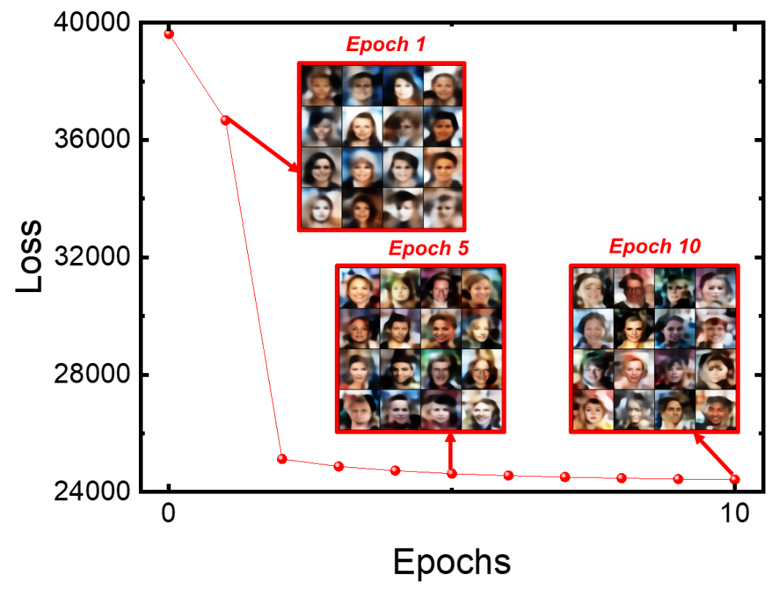
Supplementary Figure 14. Training loss evolution and generated image quality during VAE training on the CelebA dataset. Total training loss (sum of binary cross-entropy and KL divergence) plotted over training epochs. Insets show representative generated face images at epochs 1, 5, and 10, demonstrating progressive improvement in facial detail, diversity, and realism as the training proceeds.

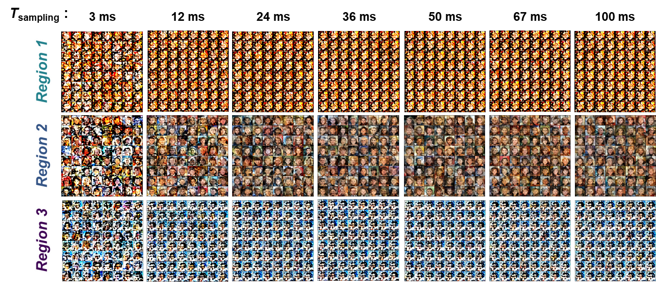
Supplementary Figure 15. Effect of RTN operating region and sampling time on VAE-generated CelebA images. Generated face images from the trained VAE using FTJ-based latent vector sampling under three RTN operating regions (Region 1–3) and varying sampling times. Region 2 produces the most diverse and realistic facial features when the sampling time is optimized, whereas Regions 1 and 3 exhibit color and pose biases due to imbalances in the high/low current state distribution.
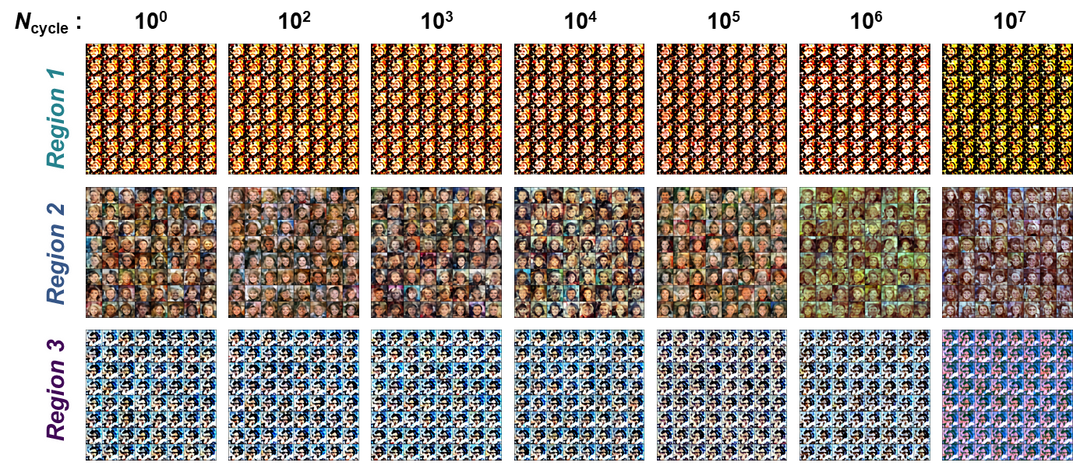
Supplementary Figure 16. Effect of RTN operating region and write cycle count on VAE-generated CelebA images. Generated face images from the trained VAE using FTJ-based latent vector sampling under three RTN operating regions (Region 1–3) after different numbers of write cycles applied to the FTJ devices in the decoder array. Region 2 maintains high image diversity and realism even after extended cycling (up to 10⁵ cycles), whereas Regions 1 and 3 show noticeable color and feature biases caused by imbalanced high/low current state distributions.

Supplementary Note 1. Detailed Explanation of the VAE training and image generation simulation of the MNIST dataset.
In this study, we employ a VAE to model the distribution of handwritten digits in the MNIST dataset and to generate novel samples that reflect the learned manifold [1,2]. The MNIST dataset comprises 60,000 training and 10,000 test images, each of size 28×28 pixels in grayscale. We load both splits using the torchvision. MNIST class with a ToTensor() transform function, which scales pixel intensities to the [0, 1] range. We use a batch size of 64 for both training and evaluation, shuffling the training set at each epoch to ensure stochasticity.
Our VAE architecture for MNIST is a three-layer fully connected network. The encoder begins by flattening each input image into a 784-dimensional vector and then projecting it through two successive linear layers of size 512 and 256, each followed by a ReLU activation. From the 256-dimensional hidden layer, two separate linear layers output the latent mean vector μ and the log-variance vector log σ², each of dimension 2. We then apply the reparameterization trick by sampling ε from a standard normal distribution and computing z = μ + exp(0.5 log σ²) ⊙ ε, which allows back-propagation through the stochastic sampling step [1,2]. The decoder mirrors the encoder: it maps the 2-dimensional latent code z through linear layers of size 256 and 512 with ReLU activations, and finally reconstructs a 784-dimensional output via a linear layer followed by a sigmoid nonlinearity, producing pixel intensities in [0, 1].
Training proceeds for 50 epochs using the Adam optimizer with a learning rate of 1 × 10⁻³. At each iteration, we compute the total loss as the sum of two terms: (1) the binary cross-entropy reconstruction loss (BCE) between the original and reconstructed pixel values, summed over all pixels in the batch; and (2) the Kullback–Leibler divergence (KLD) between the approximate posterior and the unit normal prior, given by –0.5 ∑(1 + log σ² – μ² – σ²) [1,2]. Gradients of the combined loss are back-propagated and the network weights are updated accordingly. After each epoch, we switch to evaluation mode and compute the average loss over the entire test set without gradient updates. This monitoring ensures that the model generalizes beyond the training data and avoids overfitting.
To visualize the learned latent space and the model’s generative capabilities, we sample 256 latent vectors at the end of every epoch, decode them into 784-dimensional outputs, reshape them to 28 × 28 images, and arrange them into a 16 × 16 grid. Qualitatively, the progression of grids across epochs reveals increasingly realistic digit shapes and clearer separation between digit classes in the generated samples, confirming that the VAE captures the underlying structure of the MNIST manifold even with a two-dimensional latent representation. Optionally, we implemented a weight-noise injection mechanism in the decoder whereby each weight tensor is multiplicatively perturbed by samples from N(1, σ²).

Supplementary Note 2. Detailed explanation of the VAE training and image generation simulation on the CelebA dataset.
We extend our VAE framework from the MNIST digit domain to high-resolution face images drawn from the CelebA dataset [3]. All experiments were implemented in PyTorch and run on GPUs when available. The CelebA dataset, consisting of over 200,000 celebrity face images with each image randomly horizontally flipped and resized to 128×128 pixels before conversion to a tensor. We used a batch size of 128 and eight worker threads for data loading, enabling efficient I/O and augmentation on the fly.
Our VAE architecture is a convolutional encoder–decoder augmented with residual blocks [4] to stabilize deep feature extraction. The encoder begins with a 4×4 convolution (stride 2, padding 1) mapping three-channel inputs (128 × 128) to 64 feature maps (64 × 64 × 64), each followed by batch normalization and ReLU activations. A residual block preserves identity mapping while adding representational capacity at 64 channels. We then successively downsample to 128 and 256 channels via 4 × 4 strided convolutions, each paired with batch normalization, ReLU, and another residual block at 128 channels. A final 4 × 4 convolution brings the spatial resolution to 8 × 8 with 512 channels; after flattening (producing 32,768 features), a fully connected layer reduces to a 2,048-dimension latent embedding. From this shared representation, two linear projections compute the 256-dimension latent mean vector μ and log-variance vector log σ2.
For latent sampling, we apply the reparameterization trick: ε ∼ 𝒩(0, I) is drawn each forward pass, and z = μ + exp(0.5 · log σ²) ⊙ ε allows gradients to flow through the stochastic node. The decoder mirrors the encoder with transposed convolutions: z is first linearly expanded back to 512 × 8 × 8 features, batch-normalized, and activated by ReLU. We upsample via ConvTranspose2d layers to 256 × 16 × 16 and 128 × 32 × 32 channels, interleaving residual refinement at 128 channels, before reconstructing to 64 × 64 and finally back to 3 × 128 × 128 outputs. A final sigmoid activation ensures reconstructed pixels lie in [0, 1].
We trained this network for 10 epochs using the Adam optimizer (learning rate 2 × 10⁻³). At each minibatch, the total loss combines a BCE summing reconstruction error over all pixels and a KLD measuring deviation of the approximate posterior N (μ, σ²) from the unit Gaussian prior. Although an MSE term is also computed in the code, our reported results use only BCE + KLD. After every epoch, we switched to evaluation mode and sampled 64 latent vectors to generate synthetic face images.

Supplementary Table
Learning Parameter
Dataset | MNIST | Celeb-A
Epochs | 50 | 10
Learning Rate | 0.001 | 0.002
Batch Size | 64 | 128
Optimizer | Adam

Supplementary Table 1. Learning parameters of the VAE for different datasets. Summary of training configurations for MNIST and CelebA datasets, including network architecture, learning rate, optimizer type, batch size, number of epochs, and latent space dimensionality. These parameters were optimized to achieve stable convergence and high-quality image generation for each dataset.

Supplementary Flow
Supplementary Flow 1. Latent vector mapping algorithm using FTJ RTN. Flowchart describing the process of generating and mapping latent vectors from FTJ-based random telegraph noise (RTN) for use in variational autoencoder (VAE) image generation. The algorithm includes RTN signal acquisition, binary sequence conversion via threshold comparison, bitstream sampling, normalization to the latent space range, and feeding the resulting vectors into the VAE decoder for image synthesis.

Supplementary References
- Kingma, D. P., & Welling, M. (2013). Auto-encoding variational bayes. arXiv preprint arXiv:1312.6114.
- Doersch, C. (2016). Tutorial on variational autoencoders. arXiv preprint arXiv:1606.05908.
- Liu, Z., Luo, P., Wang, X., & Tang, X. (2015). Deep learning face attributes in the wild. In Proceedings of the IEEE international conference on computer vision (pp. 3730-3738).
- He, K., Zhang, X., Ren, S., & Sun, J. (2016). Deep residual learning for image recognition. In Proceedings of the IEEE conference on computer vision and pattern recognition (pp. 770-778).

