Table 1 Phytocompounds positive drug-like property and their toxicity profile
Plant name | Phytocompounds | PubChem CID | MF | MW  (g/mol) | HBA | HBD | LogP | DLS | Pa (≤0.5) | Pi | Side effect | Structure
Aloe vera | 2-Methyl-2-Phytyl-6-Chromanol | 9865117 | C₂₆H₄₄O₂ | 388.33 | 2 | 1 | 10.24 | 0.83 | 0.421 | 0.244 | Hepatotoxicity | 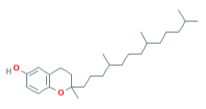
Centella asiatica | 3-Glucosylkaempferol | 5282102 | C₂₁H₂₀O₁₁ | 488.1 | 11 | 7 | -0.26 | 0.8 | 0.35 | 0.3 | Hepatotoxicity | 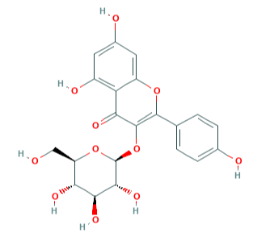
 |  |  |  |  |  |  |  |  | 0.332 | 0.127 | Nephrotoxicity
Centella asiatica | 3-Glucosylquercetin | 5280804 | C₂₁H₂₀O₁₂ | 464.1 | 12 | 8 | -0.64 | 0.89 | 0.369 | 0.282 | Hepatotoxicity | 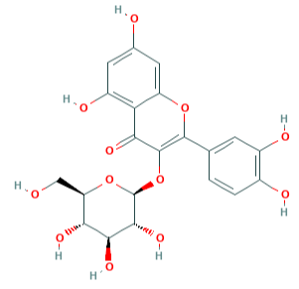
 |  |  |  |  |  |  |  |  | 0.302 | 0.155 | Nephrotoxicity
Andrographis paniculata | 5-Hydroxy-7,8,2',3'-Tetramethoxyflavone | 5319878 | C₁₉H₁₈O₇ | 358.11 | 7 | 1 | 3.46 | 0.5 | Nil |  |  | 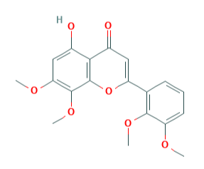
Andrographis paniculata | 5-Hydroxy-7,8,2'-Trimethoxyflavone | 5318506 | C₁₈H₁₆O₆ | 328.09 | 6 | 1 | 3.49 | 0.61 | Nil |  |  | 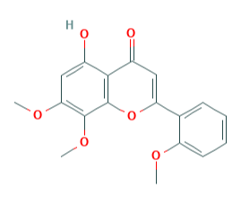
Aloe vera | Aloe-Emodin | 10207 | C₁₅H₁₀O₅ | 270.05 | 5 | 3 | 1.91 | 0.25 | 0.5 | 0.05 | Cardiac failure | 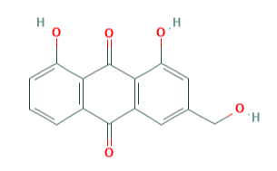
 |  |  |  |  |  |  |  |  | 0.426 | 0.24 | Hepatotoxicity
 |  |  |  |  |  |  |  |  | 0.263 | 0.198 | Nephrotoxicity
Aloe vera | Aloenin | 162305 | C₁₉H₂₂O₁₀ | 410.12 | 10 | 5 | -1.36 | 0.73 | 0.36 | 0.108 | Nephrotoxicity | 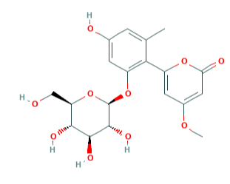
Mangifera indica | Cyanidin 3-arabinoside | 74079809 | C₂₀H₁₉O₁₀ | 419.1 | 10 | 7 | -0.07 | 0.38 | Nil |  |  | 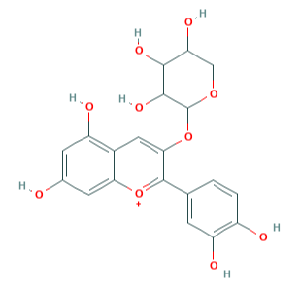
Aloe vera | Feralolide | 5317333 | C₁₈H₁₆O₇ | 344.09 | 7 | 4 | 1.58 | 0.82 | 0.281 | 0.178 | Nephrotoxicity | 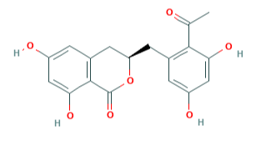
 |  |  |  |  |  |  |  |  | 0.242 | 0.229 | Cardiac failure
Thespesia populnea | Gossypetin | 5280647 | C₁₅H₁₀O₈ | 318 | 8 | 6 | 1.61 | 0.62 | 0.392 | 0.265 | Hepatotoxicity | 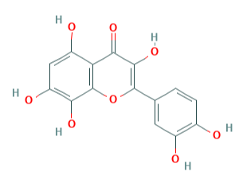
Thespesia populnea | Herbacetinz | 5280544 | C₁₅H₁₀O₇ | 302.04 | 7 | 5 | 1.99 | 0.63 | 0.411 | 0.25 | Hepatotoxicity | 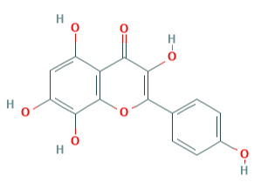
Aerva lanata | Isorhamnetin | 5281654 | C₁₆H₁₂O₇ | 316.06 | 7 | 4 | 2.46 | 0.67 | 0.245 | 0.231 | Nephrotoxicity | 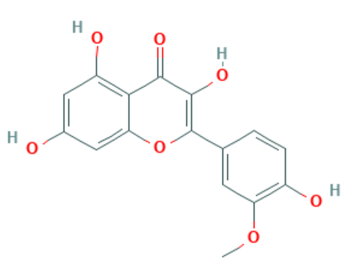
Phyllanthus virgatus | Kaempferol 8-C-sulfate | 10500456 | C₁₅ H₁₀O₉S | 366 | 9 | 5 | 0.41 | 0.27 | Nil |  |  | 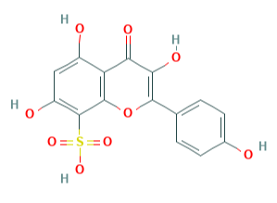
Thespesia populnea | Kaempferol-7-Glucoside | 10095180 | C₂₁H₂₀O₁₁ | 448.1 | 11 | 7 | -0.26 | 0.81 | 0.363 | 0.288 | Hepatotoxicity | 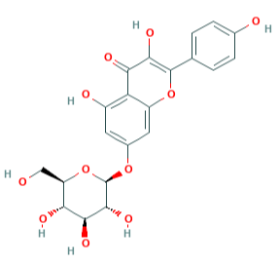
 |  |  |  |  |  |  |  |  | 0.329 | 0.129 | Nephrotoxicity
Vernonia cinerea | Luteolin-7-Mono-Beta-D-Glucoside | 5280637 | C₂₁H₂₀O₁₁ | 448.1 | 11 | 7 | -0.07 | 0.86 | 0.395 | 0.262 | Hepatotoxicity | 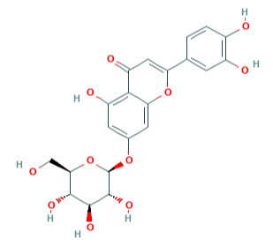
 |  |  |  |  |  |  |  |  | 0.373 | 0.1 | Nephrotoxicity
Mangifera indica | Myrtillin | 165558 | C₂₁H₂₁ O₁₂.Cl | 500.07 | 12 | 9 | -0.76 | 0.29 | Nil |  |  | 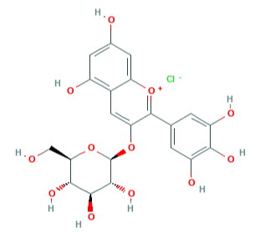
Andrographis paniculata | Neoandrographolide | 9848024 | C₂₆H₄₀O₈ | 480.27 | 8 | 4 | 2.17 | 0.17 | 0.424 | 0.075 | Nephrotoxicity | 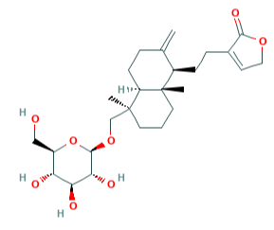
Andrographis paniculata | Paniculide-B | 101289823 | C₁₅H₂₀O₅ | 280.13 | 5 | 2 | 0.72 | 0.09 | Nil |  |  | 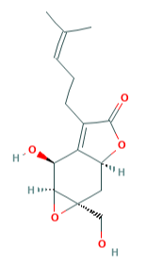
Cassia auriculata | Pelargonidin 5-galactoside | 44256698 | C₂₁H₂₁O₁₀ | 433.11 | 10 | 7 | -0.26 | 0.32 | Nil |  |  | 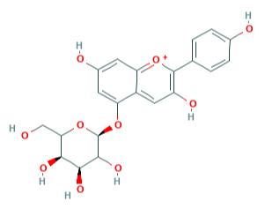
Mangifera indica | Peonidin galactoside | 91810512 | C₂₂H₂₃ O₁₁.Cl | 498.09 | 11 | 7 | -0.04 | 0.08 | Nil |  |  | 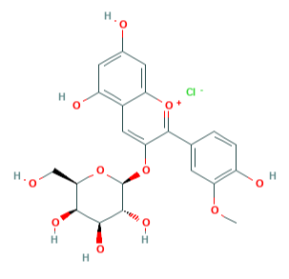
Mangifera indica | Petunidin 3-glucoside | 176449 | C₂₂ H₂₃ O₁₂.Cl | 514.09 | 12 | 8 | -0.41 | 0.42 | Nil |  |  | 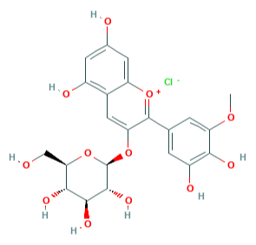
Pongamia pinnata | Pinnatin | 5320607 | C₁₈H₁₂O₄ | 292.07 | 4 | 0 | 4.42 | 0.24 | Nil |  |  | 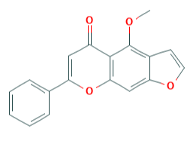
Pongamia pinnata | Pongamone A | 11588678 | C₂₂H₂₂O₅ | 366.15 | 5 | 0 | 5.32 | 0.47 | 0.397 | 0.106 | Cardiac failure | 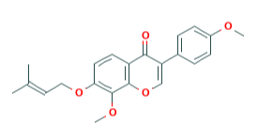
Aerva lanata | Tiliroside | 5320686 | C₃₀H₂₆O₁₃ | 594.14 | 13 | 7 | 2.49 | 0.85 | 0.263 | 0.198 | Nephrotoxicity | 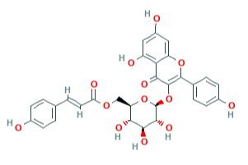
Andrographis paniculata | Andrographiside | 44593583 | C₂₆H₄₀O₁₀ | 512.26 | 10 | 6 | 0.55 | 0.08 | 0.333 | 0.126 | Nephrotoxicity | 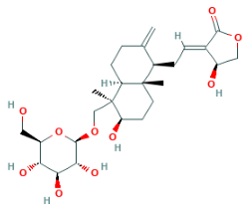
Andrographis paniculata | Altisin | 15100719 | C₁₉H₁₈O₇ | 358.11 | 7 | 1 | 2.81 | 0.03 | 0.306 | 0.296 | Arrhythmia | 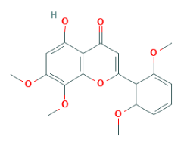
Andrographis paniculata | 2'-hydroxy-5,7,8- trimethoxyflavone | 21668878 | C₁₈H₁₆O₆ | 328.09 | 6 | 1 | 3.9 | 0.2 | Nil |  |  | 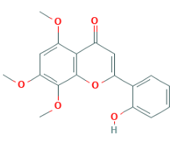
Andrographis paniculata | 5-hydroxy-7,8,2',3',4'- pentamethoxyflavone | 12315479 | C₂₀H₂₀O₈ | 388.12 | 8 | 1 | 3.4 | 0.36 | Nil |  |  | 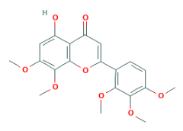
Andrographis paniculata | Wightin | 12444943 | C₁₈H₁₆O₇ | 344.09 | 7 | 2 | 3.08 | 0.19 | 0.342 | 0.308 | Hepatotoxicity | 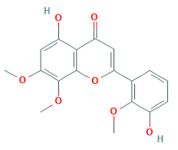
Andrographis paniculata | 5-hydroxy-7,8-dimethoxyflavanone | 13963770 | C₁₇H₁₆O₅ | 300.1 | 5 | 1 | 3.02 | 0.48 | 0.322 | 0.269 | Arrhythmia | 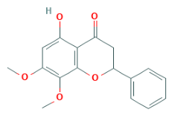
Andrographis paniculata | 5-hydroxy-7,8-dimethoxyflavone | 188316 | C₁₇H₁₄O₅ | 298.08 | 5 | 1 | 3.74 | 0.17 | 0.309 | 0.291 | Arrhythmia | 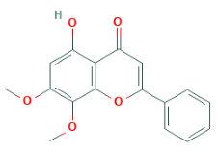
Andrographis paniculata | Skullcapflavone I | 5320399 | C₁₇H₁₄O₆ | 314.08 | 6 | 2 | 3.71 | 0.33 | Nil |  |  | 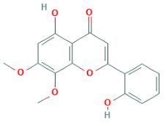
Andrographis paniculata | 5-hydroxy-7,8,2',5'- tetramethoxyflavone | 10948318 | C₁₉H₁₈O₇ | 358.11 | 7 | 1 | 3.41 | 0.11 | Nil |  |  | 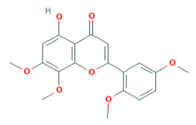
Andrographis paniculata | 5,4'-dihydroxy-7,8,2',3'- tetramethoxyflavone | 13963777 | C₁₉H₁₈O₈ | 374.1 | 8 | 2 | 3.02 | 0.31 | Nil |  |  | 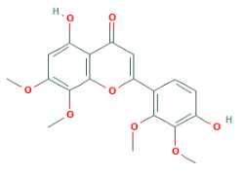
Andrographis paniculata | Andrographidine A | 13963762 | C₂₃H₂₆O₁₀ | 462.15 | 10 | 4 | 0.91 | 0.38 | 0.43 | 0.072 | Nephrotoxicity | 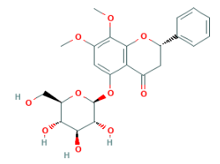
Andrographis paniculata | Andrographidine C | 5318484 | C₂₃H₂₄O₁₀ | 460.14 | 1 | 4 | 1.67 | 0.24 | 0.348 | 0.116 | Nephrotoxicity | 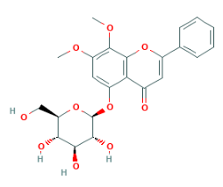
MF Molecular formula; MW Molecular weight; HBA Hydrogen bond acceptor; HBD Hydrogen bond donor; LogP Partition co-efficient; DLS Druglikeness score; Nil Non-toxic; Pa Probable activity to cause toxicity; Pi Probable inactivity for non-toxicity

